NeuroFleetX AI-Driven Urban Mobility Optimization
Abstract
NeuroFleetX is an AI-driven fleet intelligence platform designed to optimize urban transportation systems. The system uses machine learning models to analyze fleet data, traffic patterns, and driver behavior to improve efficiency, reduce costs, and promote sustainability.

Core Objectives

Real-time monitoring of urban fleets (e.g., delivery trucks, taxis, public transport)

Predictive analytics using AI (e.g., traffic prediction, fuel usage, route optimization)

Visual dashboards for fleet managers

User management (Admin, Driver, Analyst roles)

Core Features
🧠 AI + Analytics

Predictive route optimization

Vehicle health monitoring

Driver behavior scoring

Anomaly detection (e.g., idle time, route deviations)

📈 Fleet Dashboard

Overview of all fleet vehicles

KPIs: Avg fuel usage, delivery times, incidents

Map-based vehicle tracking

👥 User Management

Admins: Full access to data and AI models

Analysts: Read-only access to dashboards

Drivers: Limited access to routes and schedules

🚚 Fleet Operations

Add/Remove/Edit Vehicles

Assign Drivers to Vehicles

Route assignment and history

Technologies
Tech Stack (MERN)
Layer Technology
Frontend React.js, Redux, Chart.js, Mapbox
Backend Node.js, Express.js
Database MongoDB (Vehicles, Users, Logs)
AI Layer Integrated via RESTful API or Python microservice
Auth JWT-based authentication

UI Pages (React)

🔐 Login/Register Page

📊 Dashboard (Graphs + Map)

🚚 Fleet Overview

📍 Vehicle Detail (Map + Logs)

👤 User Management Panel

📈 AI Prediction Results

Roles & Permissions
Role Permissions
Admin Full CRUD on all resources
Analyst Read-only on analytics and fleet data
Driver View assigned routes and profile only
Login Page:
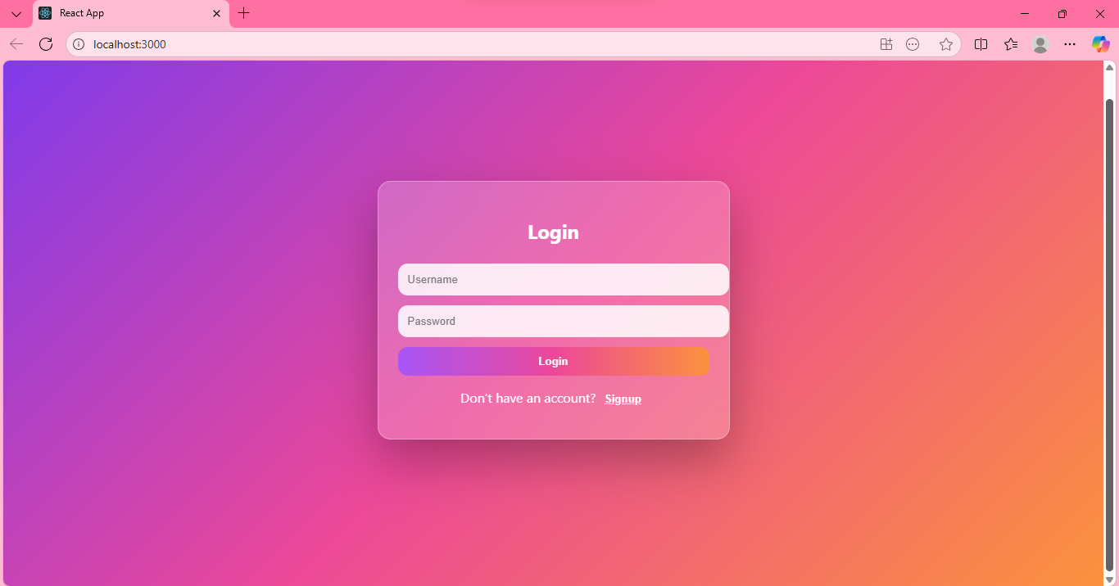

Sign up Page:
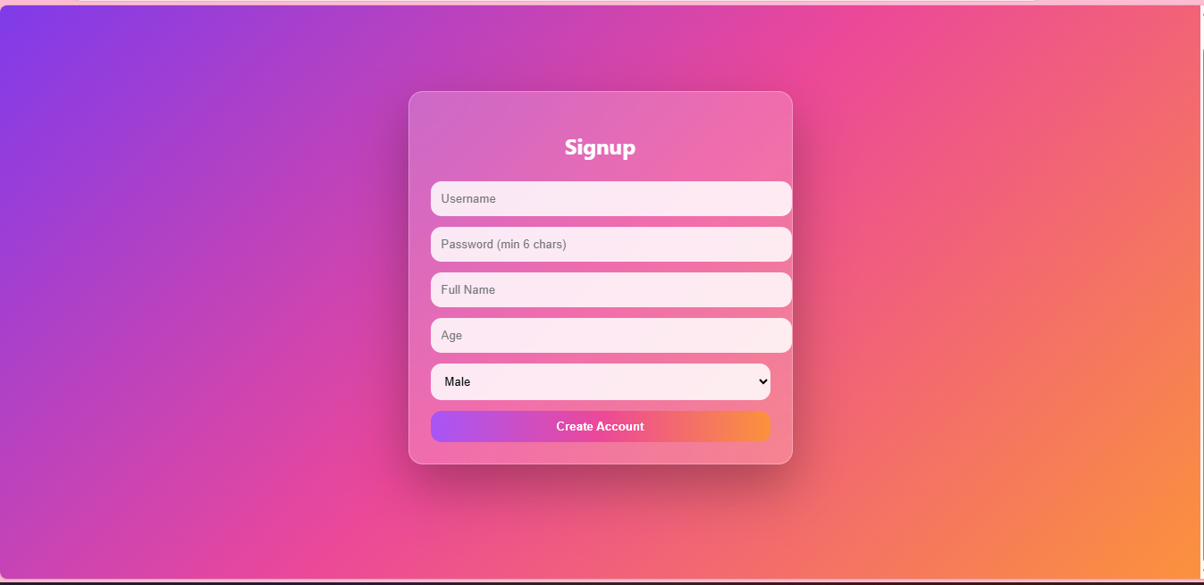

Valid Test Case:

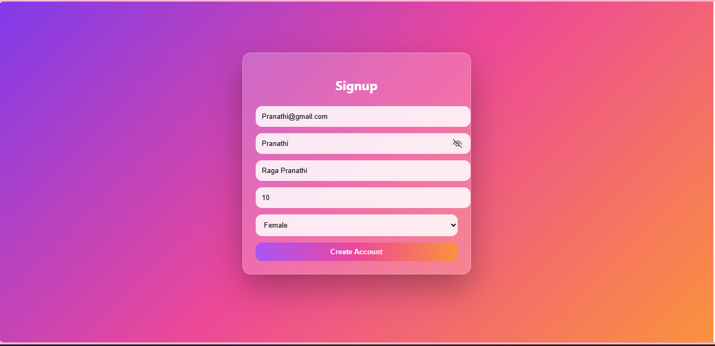

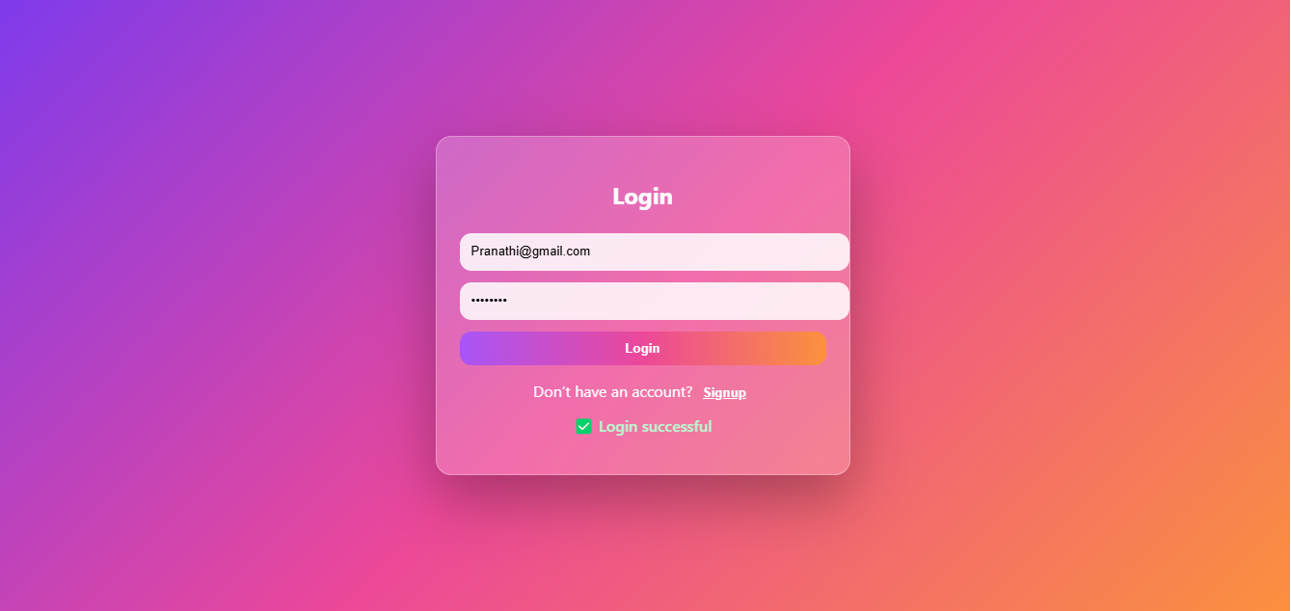

Database Information:
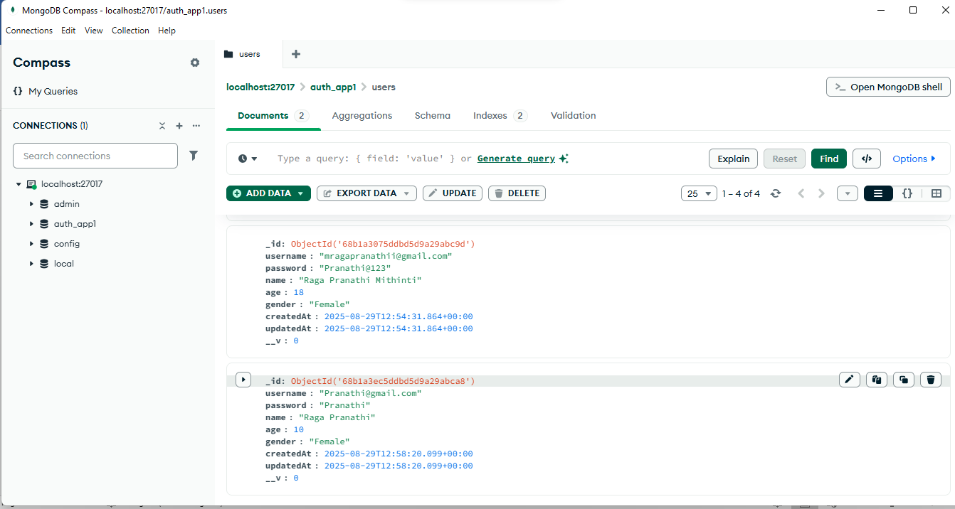

Invalid Test Case:
