CREATING THE 9630 TEMPLATE 2

USING THE 9630 TEMPLATE 11

# CREATING THE 9630 TEMPLATE

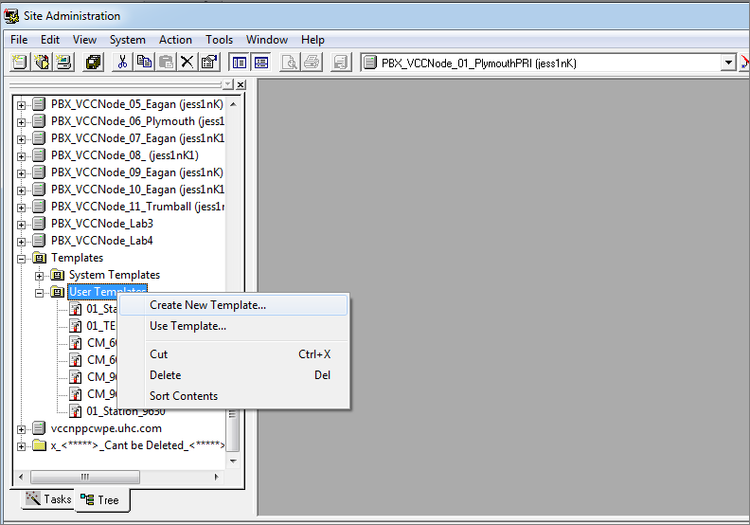

Template name: “9630_OneX_Fix_Template_01”

Can we all use the same name to keep it consistent.

Enter details as below. Hit OK

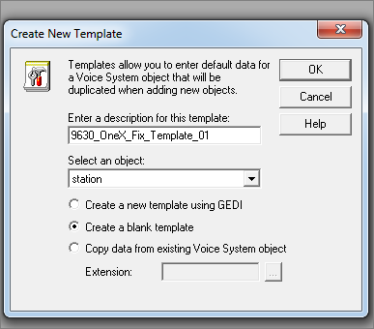

Click OK

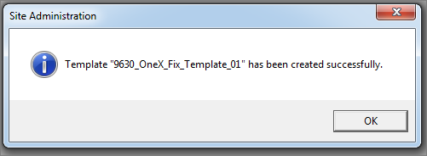

Edit the Template Properties

Right Click / Properties

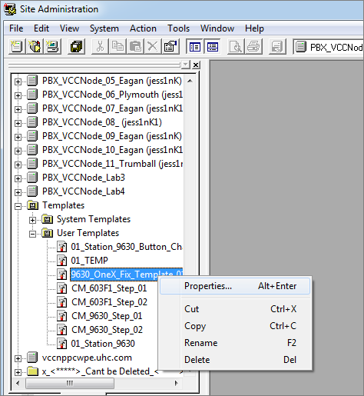

Select the ‘Fields’ tab / enter the 9630 station type as below.

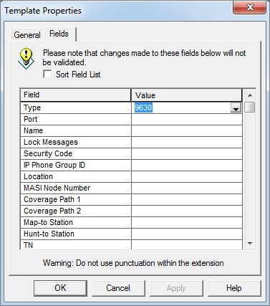

Click on the ‘General’ Tab / Click ‘Buttons’

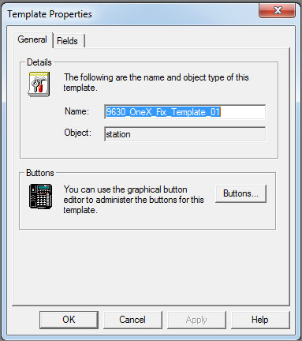

You’ll see button softkeys 1 to 6.

Button 5 highlighted in Blue should be set to <release>

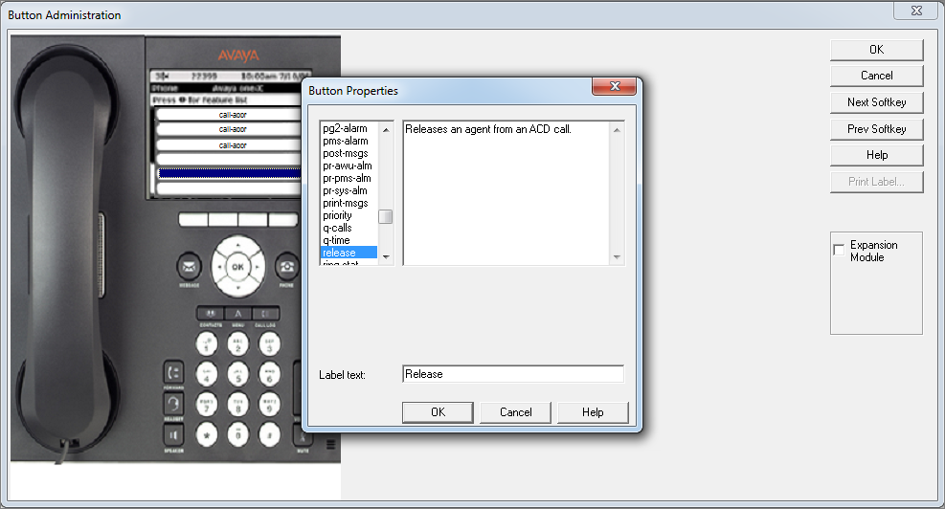

Click on ‘NextSoftkey’

 (gives you buttons 7 – 12)

Click on ‘NextSoftkey’ AGAIN

 (gives you buttons 13 – 18)

Button 17 highlighted in Blue should be set to <clear field>

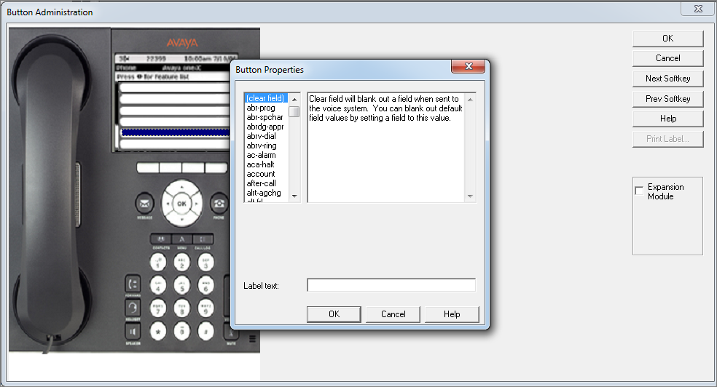

Button 18 highlighted in Blue should be set to <clear field>

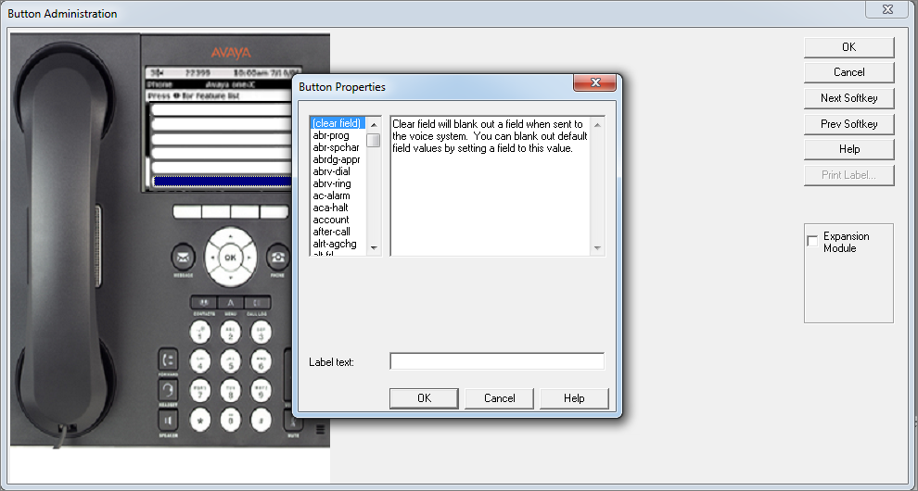

Click ‘Next Softkey’ for the next set of buttons

 (gives you buttons 19 – 24)

Button 19 highlighted in Blue should be set to <clear field>. Click OK

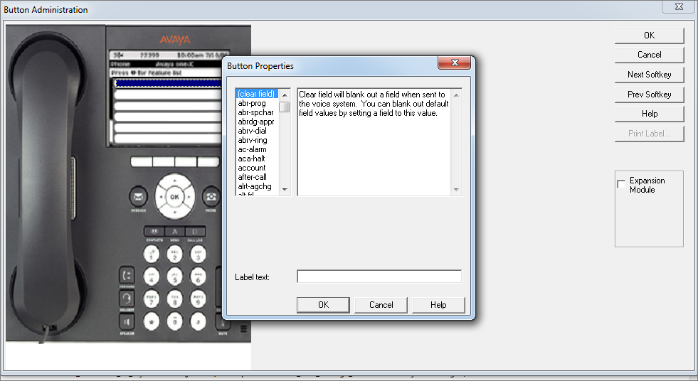

Button 20 highlighted in Blue should be set to <clear field>. Click OK

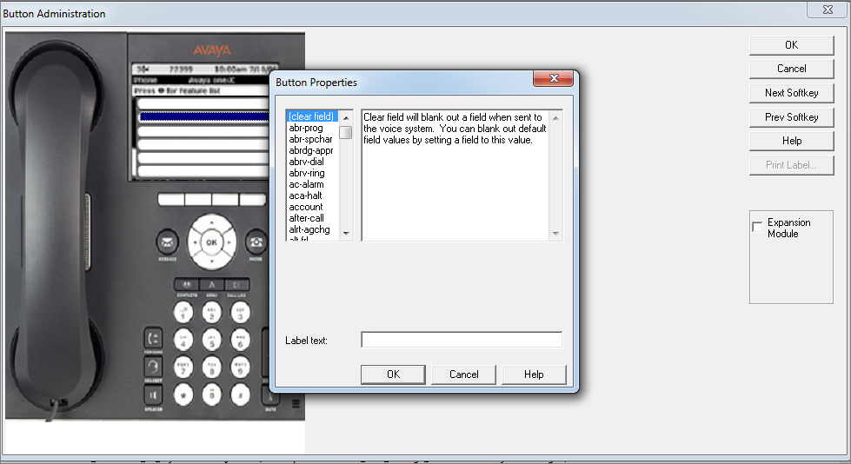

Button 21 highlighted in Blue should be set to <clear field>. Click OK

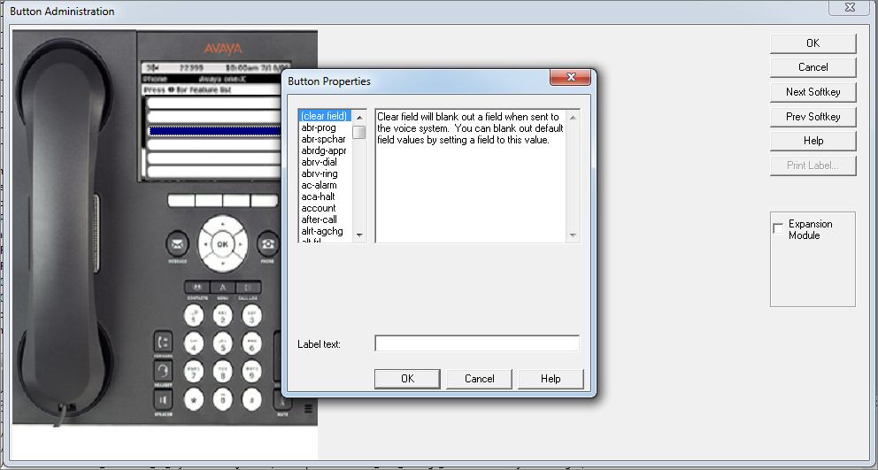

Button 23 highlighted in Blue should be set to <clear field>. Click OK

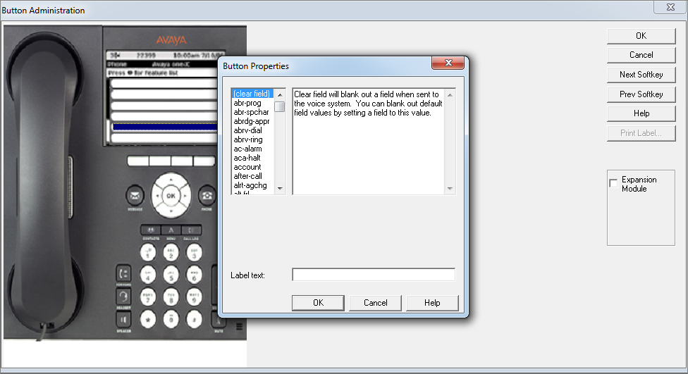

Button 24 highlighted in Blue should be set to <clear field>. Click OK

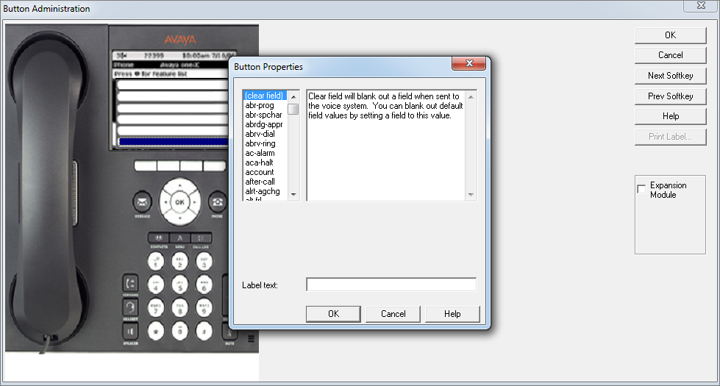

Click OK on the Button Administration Window

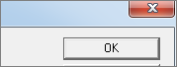

Click OK to save and exit

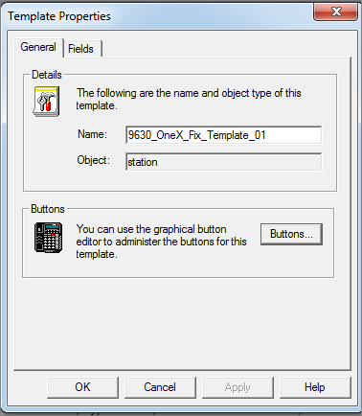

# USING THE 9630TEMPLATE

Open ASA

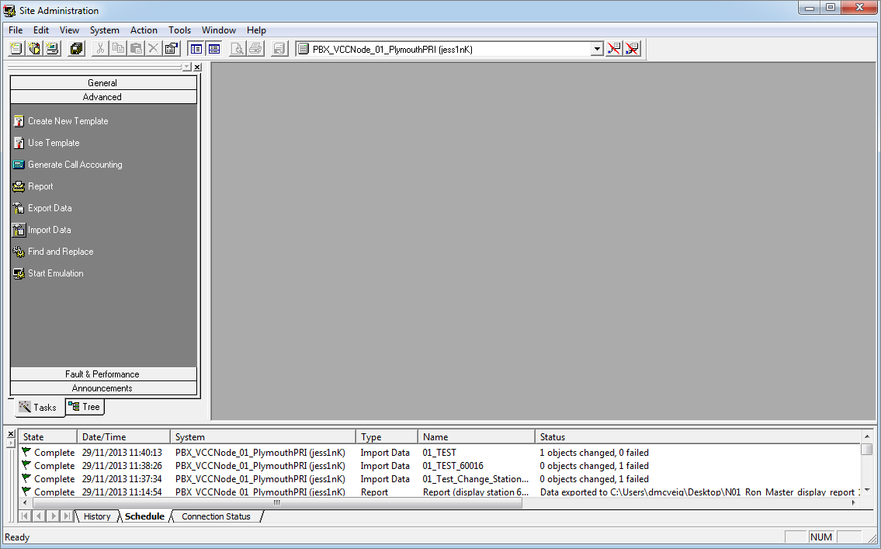

Click on ‘Import Data’



Enter a description

Object should be: ‘station’

Under ‘Select a template’ choose your template i.e. “9630_OneX_Fix_Template_01”

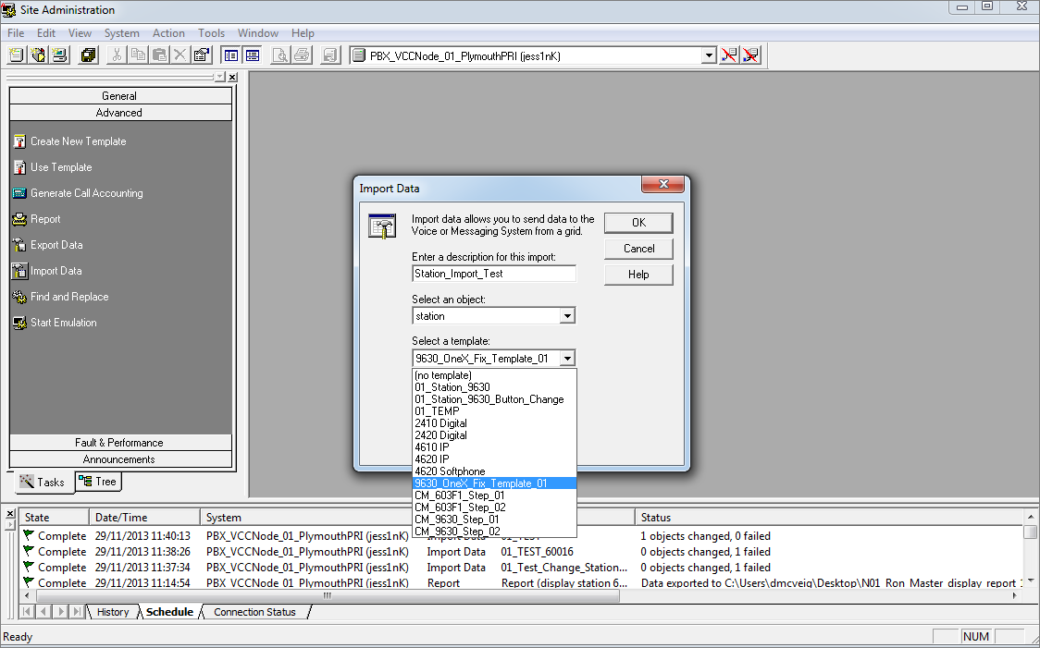

Tick the “Change Command” checkbox.

Click OK

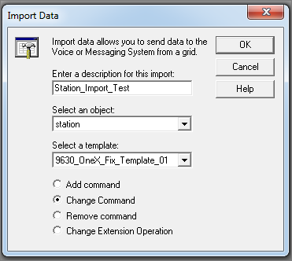

Enter the stations you want to change in the “Extension” column

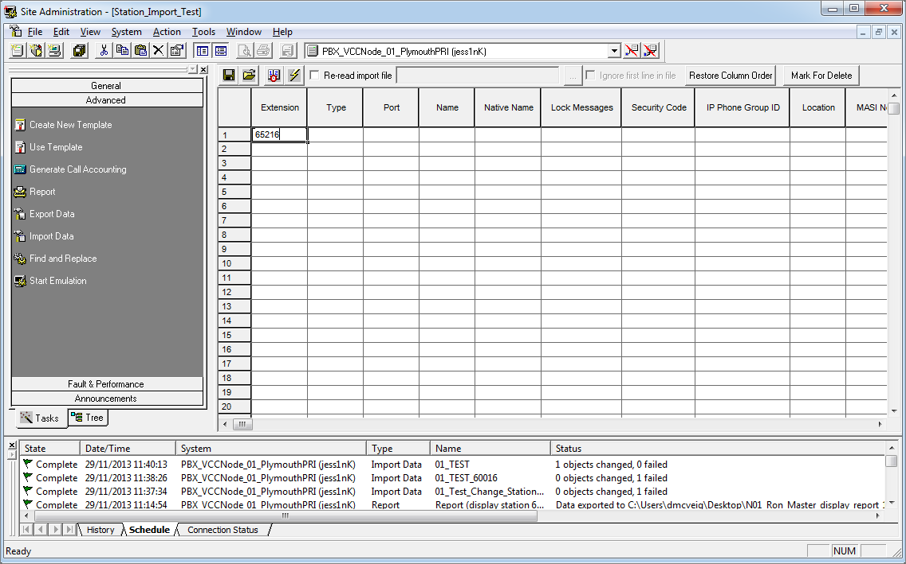

Click the Save button



Click the Execute Button



You’ll see the task running in the schedule window at the bottom of ASA

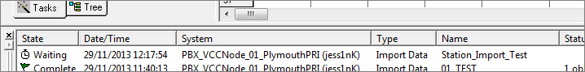

It will change to ‘Complete’ once complete

