Stadium Booking ER Diagram
Generated on 2026-05-03 22:47
This ER diagram is prepared from the current database schema in stadium_booking.sql.

ER Diagram
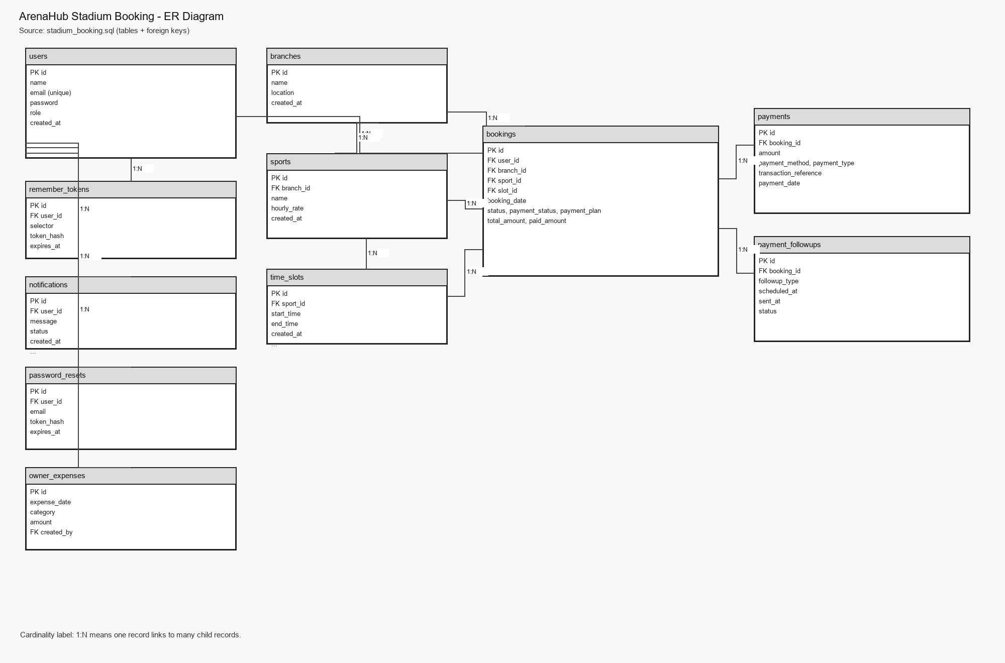

Key Relationships
- users (1) -> (N) bookings
- branches (1) -> (N) sports
- sports (1) -> (N) time_slots
- branches (1) -> (N) bookings
- sports (1) -> (N) bookings
- time_slots (1) -> (N) bookings
- bookings (1) -> (N) payments
- bookings (1) -> (N) payment_followups
- users (1) -> (N) remember_tokens
- users (1) -> (N) notifications
- users (1) -> (N) password_resets
- users (1) -> (N) owner_expenses (created_by)

