**EXPERIMENT NO - 01**

**AIM OF THE EXPERIMENT**: To read and display gray and color images and convert colour image to gray image using MATLAB.

**OBJECTIVE:** To read, and display an image and image format information generation using MATLAB.

**EQUIPMENT REQUIRED:**

* A personal computer installed with Windows 10
* MATLAB /SCILAB
* IMAGE PROCESSING TOOLBOX

**THEORY:**

Image: An image is defined as a two-dimensional function f (x, y), where x and y are spatial coordinates and f (x, y) is the amplitude.

Images may be two or three-[dimensional](https://en.wikipedia.org/wiki/Dimensional), such as a [photograph](https://en.wikipedia.org/wiki/Photograph) or screen display, or three-dimensional, such as a [statue](https://en.wikipedia.org/wiki/Statue) or [hologram](https://en.wikipedia.org/wiki/Hologram). They may be captured by [optical](https://en.wikipedia.org/wiki/Optics) devices –such as [cameras](https://en.wikipedia.org/wiki/Camera), [mirrors](https://en.wikipedia.org/wiki/Mirror), [lenses](https://en.wikipedia.org/wiki/Lens_(optics)), [telescopes](https://en.wikipedia.org/wiki/Telescope), [microscopes](https://en.wikipedia.org/wiki/Microscope), etc. and natural objects and phenomena, such as the [human eye](https://en.wikipedia.org/wiki/Human_eye) or water.

Pixel: A digital image composed of a finite number of elements, each of which has a particular location and value. These elements are known as pixels, and picture elements.

The pixels of a color image using the RGB model has three components, Red, Green and Blue. We can see an RGB image as made of three planes, one for eachcomponents.

rgb2gray converts RGB values to grayscale values by forming a weighted sum of the R, G, and B components:

0.2989 * R + 0.5870 * G + 0.1140 * B

**PROGRAM :**

clc

clear all

close all

% read an image

a=imread('Cameraman.tif');

%display image

figure

imshow(a)

title('Original Image')

%resize an image

[r c]=size(a);

b=imresize(a,[50,50]);

%display resized image

figure

imshow(b)

title('Resized Image')

% Intensity of an image

E=a+128;

figure

imshow(E)

title('Increased Brightness')

%read colour image

D=imread('peppers.png');

%display colour image

figure

imshow(D)

title('Original Colour Image')

%read colour image

D=imread('peppers.png');

%display colour image

figure

imshow(D)

title('Original Colour Image')

%RGB to gray

F=rgb2gray(D);

figure

%display rgb to gray

imshow(F)

title('Gray Image')

%compare image

figure

imshowpair(D,F,'montage')

title('Colour Image vs Gray Image')

%r component

r=D(:,:,1);

figure

% display r component

imshow(r)

title('Red Component')

%g component

g=D(:,:,2);

figure

% display g component

imshow(g)

title('Green Component')

%b component

b=D(:,:,3);

figure

% display b component

imshow(b)

title('Blue Component')

%add r,g,b component and divide by 3

X=(r+g+b)/3;

figure

%display X

imshow(X)

title('Addition of three components')

%subtraction

Y=X-F;

figure

%display Y

imshow(Y)

title('Compared Image')

**OBSERVATIONS:**

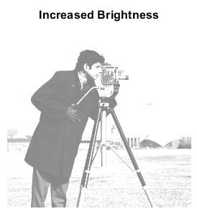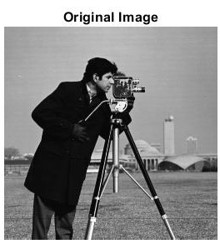



**(a) (b) (c)**

**Fig.1: (a) Test image “Cameraman” size 256x256, (b) Resized image of Cameraman size 50x50**

**(c) Increased Intensity image of Cameraman**

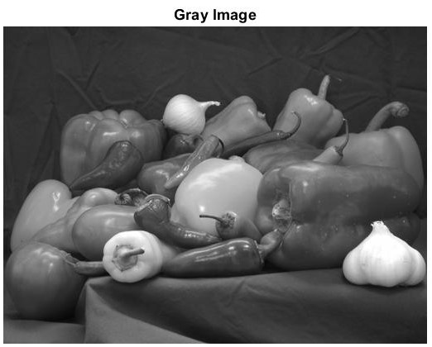

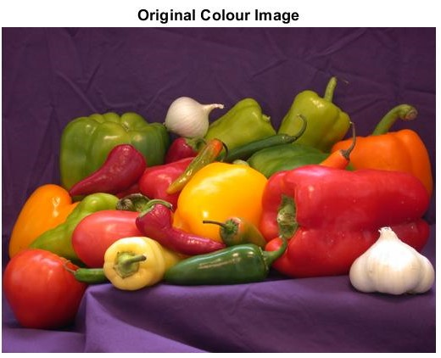

1. **(b)**

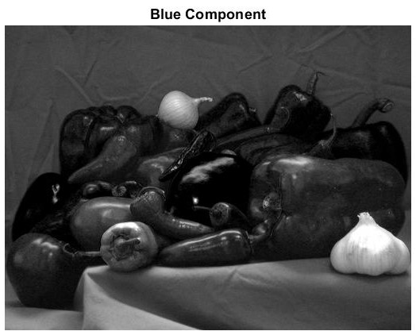 **Fig.2: (a) Test Colour image “peppers” (b) Grayscale Image**

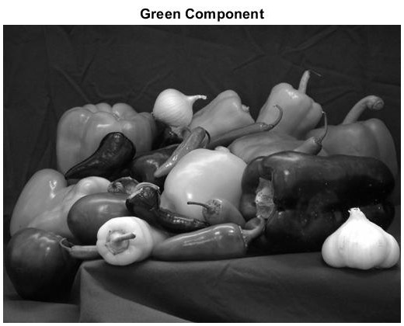

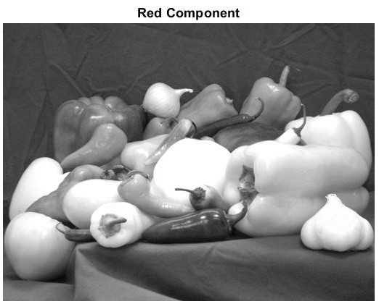  **(a) (b) (c)**

**Fig.3: (a) R-plane image (b) G-plane image (c) B-plane image**

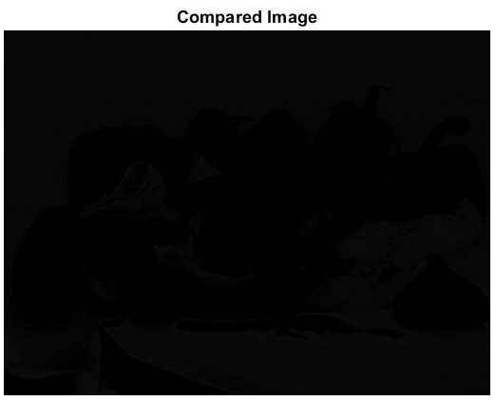 **Fig.4 Comparison between colour image and grayscale image**

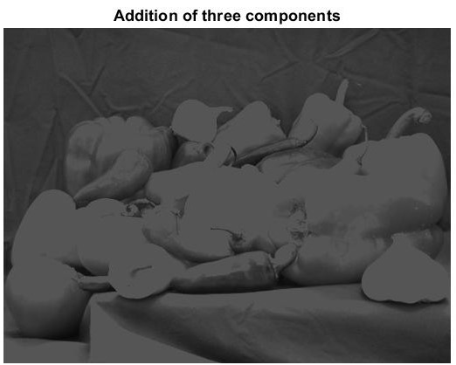**(a) (b)**

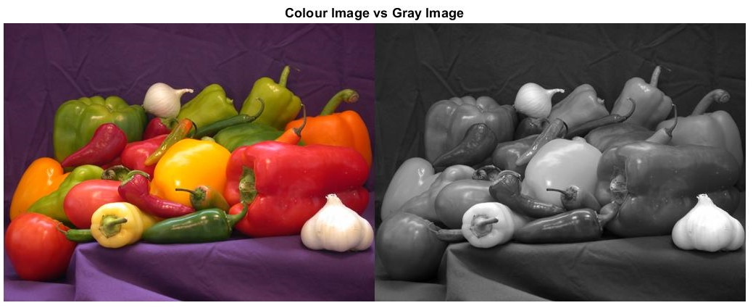**Fig.5 (a) Addition of all the three components R G B, (b) Comparison between 5(a) and 2(b)**

**CONCLUSION**:

In the above experiment, we perform the image reading, image display ,Image resize, increasing intensity. We also perform how to convert an RGB image to gray image. Then we split original color image into its 3 plane i.e. R-plane, G-plane, B-plane. Finally we added the mean of all the three planes.

In Fig. 1(b) as compared to Fig. 1(a), we observed that due to resizing of image some information gets lost.

In Fig. 1(c) as compared to Fig. 1(a), we observed that increasing brightness of an image will light out all colors so the original light ones will become up to white.

In Fig. 3(a) as compared to Fig. 1(a), we observed that the intensity closer to red will appear brighter and vise-versa. Similarly Fig. 3(b) and 3(c) will have same case.

When subtracting Fig. 5(a) from Fig. 2(b), we are not getting all pixels zero (See Fig. 5(b)). Thus we can conclude that addition of mean of R- Plane, G-Plane and B-Plane is not equal to actual gray image of original image.

NAME: Abhishek Kumar

Date Of Submission: REG. NO.:20010679

26/07/2022 ROLL NO: ECE20019

GROUP: ‘ A’

SIGNATURE: