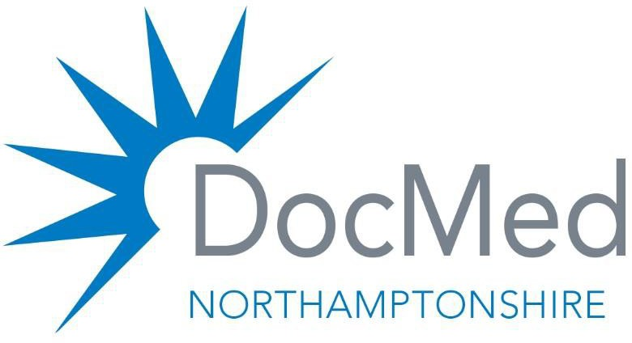
Programme Board SDA Innovator Site
Rural South and East
Face to Face Board 23/12/25
Brackley Medical Centre, Brackley. First Floor Meeting Room
12.30pm to 13.00 hrs Lunch available
Programme Board meeting starts13.00 – 14.30

 | Item | Owner
13.00 – 14.30 hrs | Same Day Access Programme Board, Rural South and East Neighbourhood  - Welcome to the Meeting  - Apologies  - Attendance Matrix  - Minutes of the last meeting (attached)  - Updated Terms of Reference (ToR’s) (attached)  - Project Timeline (attached)  - Risk Register –( to follow)  - Finance overview  - Actions –  - VCSE update  - Recruitment update  - Contract Variation update  - Employment contract overhead  - Hub and Spoke update and Digital update  - Population Health update  - Agree next steps  10 . AOB | Dr Mark Gray  Dr Mark Gray  Dr Mark Gray  Dr Mark Gray  Dr Mark Gray  Anshal Pratyush  Maureen Green  Maureen Green  Dr Mark Gray  Dr Mark Gray/ Dr Simon Ellis  Dr Mark Gray/ Dr Simon Ellis  Dr Mark Gray  Malcom Railson  Dr Mark Gray
Date of next Programme Board meeting – virtual 13th January 2026 13.00 to 14.30

All meetings have been sent to the Programme Board membership until end of March 2026.

