Risk Stratification – Foundry Continuity of Care - EMIS
Safety Alert
EMIS bubble>Configuration>Resource Publisher>Protocols and templates>Shared Folders>Ardens Main>Ardens Live National Content>Optional Protocols (inactive by default)>Continuity of Care (Foundry Model)
Activate the Template and Alert Protocol (recommend leaving the Protocol inactive), click on each one and click activate
Searches & Reports
Population Reporting>Ardens>1.37 Administration – Risk Strat> Continuity of Care RAG>Registers
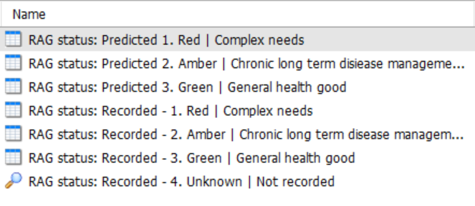
The ‘Predicted’ are your patients who potentially need coding
The ‘Recorded’ will activate the Patient Alert in the patients Alert Pop up Box
If the clinician wants to change this to amber or green they can double click on the alert and the template will open
There are also reports for Data Quality and Review
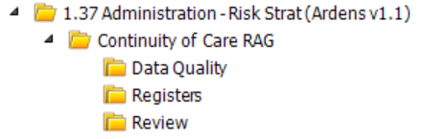

Batch Coding
Run the relevant report e.g. RAG status: Predicted – 1. Red | Complex needs
Goto Batch Data Manager
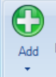
Click the dropdown arrow under Add

Select Clinical Code, the Add Batch Data box appears:
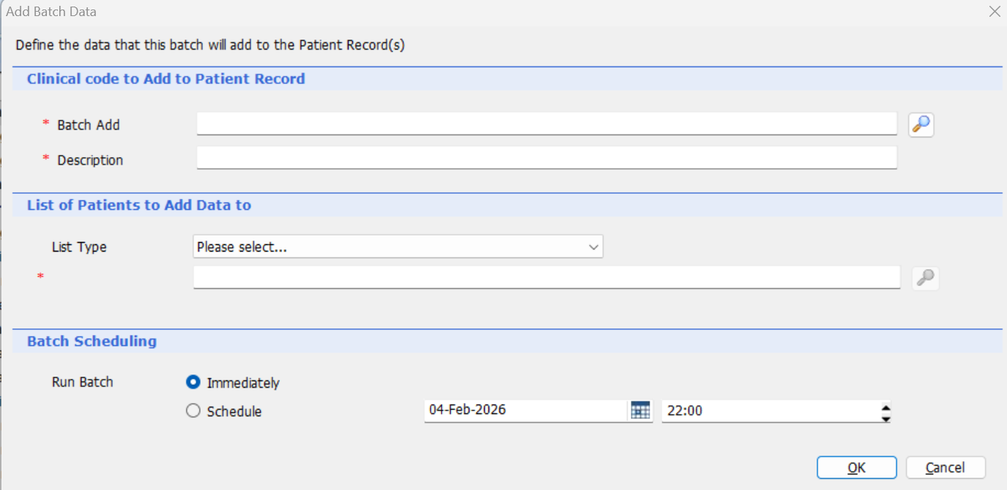
Click the magnifying glass next to Batch Add
Enter search 416357003 this should bring up the complex needs code
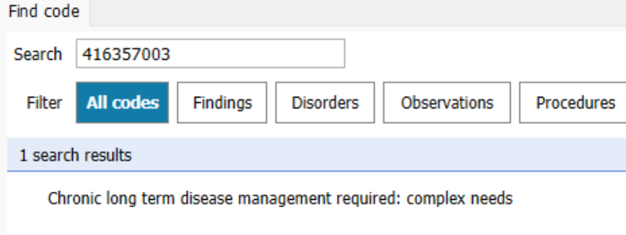
Double click to select, enter relevant descriptive text (seen next to code in pts record), select an appropriate authorising user e.g. GP on PCN board, click Ok to accept
Enter Description (only seen in batch list)
Select List Type Search Population (included)
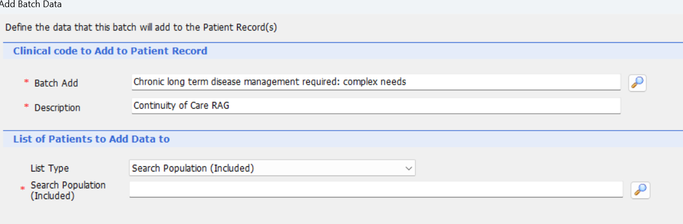
Click on the magnifying glass next to Search Population (Included)
Select search Ardens>1.37 Administration – Risk Strat> Continuity of Care RAG>zSubreports>Report Searches>Report searches: Registers>RAG status: Predicted – 1. Red | Complex needs
Click Ok
You will now see how many patients the clinical code will be added to
You can leave the batch to run Immediately or Schedule for a later date and time, e.g. to run outside working hours
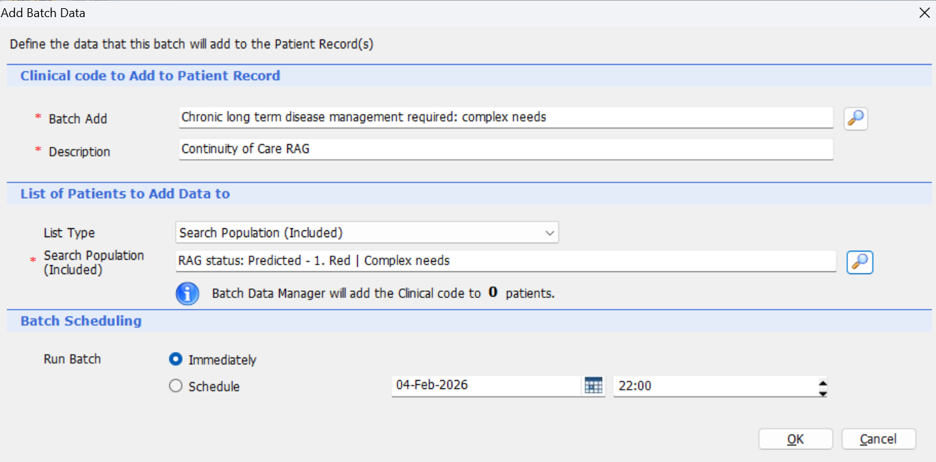
When you’ve checked everything is correct click OK
You get 7 days to Undo if you’ve made an error or change your mind
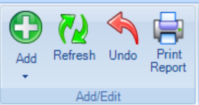
The 3 relevant risk stratification codes are:
Risk | Code | Description
Red | 416357003 | Chronic long term disease management required: complex needs
Amber | 416239002 | Chronic long term disease management required
Green | 135815002 | General good health

NB: Conflicting advice as to whether the code is visible to the patient in their online record, NHS App etc (no queries received by our EMIS practices)

