Risk Stratification – Foundry Continuity of Care - SystmOne
Safety Alert
Setup>Data Output>Patient Safety Alert>Continuity of Care
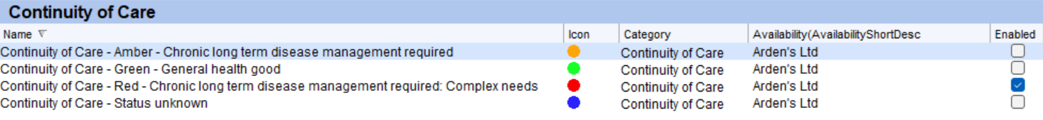
To only use the alert for patients classified as Red untick Enabled next to Amber, Green and Blue (unknown)
Searches & Reports
Reporting>Clinical Reporting>Arden’s Ltd>Registration>Continuity of Care | Registers
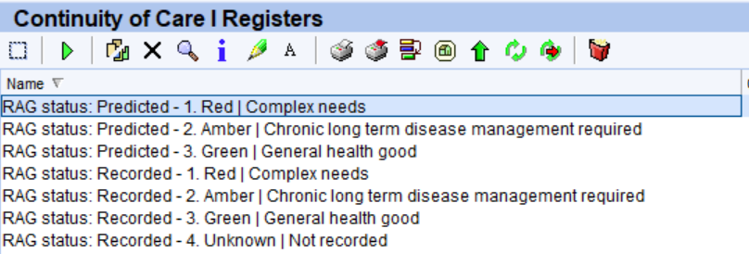
The ‘Predicted’ are your patients who potentially need coding
The ‘Recorded’ will activate the Patient Alert on the Patient Home page and Demographic Box when you run the search, signified by 
NB: If the traffic light system is already used by practices to indicate something else the patient will have multiple dots in their demographic box, hovering over the dot explains what it means.
The code can be amended in the patient record by clicking Action next to the relevant alert on the Patient Home page
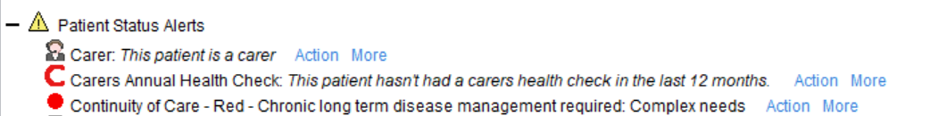

There are also searches for Data Quality and Review
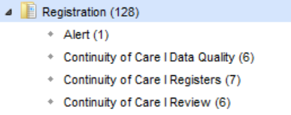
Batch Coding
Run the relevant search e.g. RAG status: Predicted – 1. Red | Complex needs

Click the  to Show the patients in the selected report
For each page of the resulting list select all  click Add a Read Code to patient record.
Search for the relevant code
Enter text to search 416357003 this should bring up the complex needs code
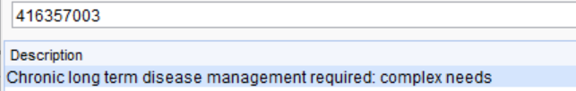
Select and click Ok to accept

You should be able to leave other settings as they are, click Ok
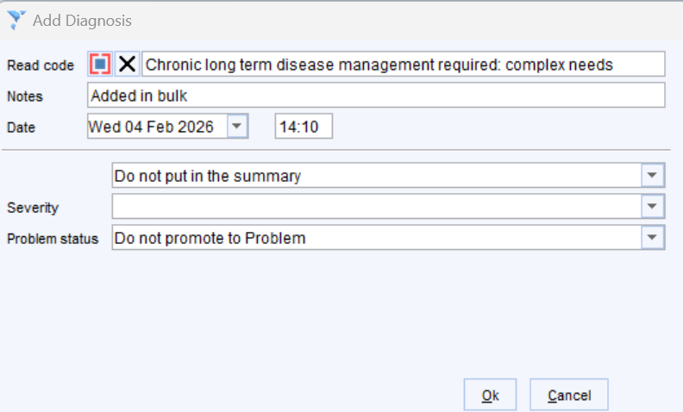

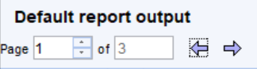
Repeat for each page in this example there are 3 pages

The 3 relevant risk stratification codes are:
Risk | Code | Description
Red | 416357003 | Chronic long term disease management required: complex needs
Amber | 416239002 | Chronic long term disease management required
Green | 135815002 | General good health

NB: Code is visible to patient in their online record NHS App etc, to hide it requires a manual change by patient

