NRES Neighbourhood
SDA Rota Management System
Operational Specification & System Build Reference
Northamptonshire Rural East & South • 7 Practices • 89,584 Patients • £2.36M Contract
Version 2.3 • February 2026
Contents
Project Overview 3
Core Data Model 3
7 NRES Member Practices 3
Key Contract Parameters 4
Staff Type Session Configuration 4
Period Definitions 4
On-Site Clinical Room Capacity (Available Appointments by Day & Session) 5
Staff Types 5
Session Structure 5
Buy-Back Scheme Logic 6
Buy-Back Rules 6
Open Book Accounting Principle 6
Buy-Back Application Workflow 6
Example: Denton Village Surgery Buy-Back & Recruitment Proposal 6
System Pages & Features 7
1. Dashboard / Overview Page 7
2. Rota Management Page 7
3. Buy-Back Management Page 10
4. Capacity Planning Page 11
5. Practice Detail Page (per practice) 11
6. Compliance & Reporting Page 12
7. Workforce Directory 13
8. Settings Page 13
UI/UX Requirements 18
Design System 18
Navigation Structure 18
Key Interactions 18
Data Persistence 18
Business Logic 20
Weekly Target Calculation (Dynamic — Driven by List Sizes) 20
Financial Allocation (Dynamic — Driven by List Sizes) 20
Period Detection 20
Compliance Status per Practice 21
Room Capacity Validation 21
Remote Ratio Check 21
Permission Resolution 21
Buy-Back Value Calculation 21
Practice Financial Tracking (Dynamic) 21
Monthly Cash Flow & Max Claimable Value 22
Seed Data 22
Priority Build Order 22
Build Effort Estimate 23
Summary 23
Phase 1: Initial UI Build with Lovable (55–80 hrs) 23
Phase 2: Supabase Backend & Schema (22–35 hrs) 23
Phase 3: Business Logic & Refinement (35–50 hrs) 24
Phase 4: Email Automation (20–30 hrs) 24
Phase 5: Testing & UAT (40–60 hrs) 24
Phase 6: Go-Live & First Month Support (25–40 hrs) 24
Recommended Phased Launch Plan 24
Milestone Schedule 24
Recommendations to Reduce Risk & Time 25
Ongoing Support (Post Go-Live) 25

Project Overview
This document describes the operational management of Same Day Access (SDA) appointment delivery across 7 GP practices in the Northamptonshire Rural East & South (NRES) neighbourhood. This is an NHS-funded 12-month pilot Local Enhanced Service (LES) commissioned by the ICB, worth £2.36M annually serving 89,584 patients.
The system must track two distinct provision types: 1. New SDA Provision — New staff/sessions funded directly by the contract 2. Buy-Back Provision — Existing practice staff whose same-day reactive work is “bought back” by the scheme, freeing funds for the practice to reinvest in new proactive care recruitment
Every session must be tracked against contractual minimum appointment targets per practice per week, with different targets for Non-Winter (39 weeks) and Winter (13 weeks) periods.
The entire scheme operates on an open book accounting basis — full financial transparency across all practices, the NRES board, and the ICB. Every allocation, cost, buy-back claim, and reinvestment must be visible, itemised, evidenced, and auditable.

Primary Operations Tool — Excel Workbook V3.1
The primary operational tool for the NRES SDA programme is the NRES SDA Rota Management Workbook V3.1 — a formula-driven Excel workbook with 20 tabs covering practice allocations, rota planning, buy-back accounting, compliance tracking, DNA rates, absence management, cash flow, and individual practice dashboards for all seven practices. This workbook is complete, tested, and ready for service launch on 1st April 2026 with no additional funding, licensing, or infrastructure costs required.
Malcolm Railson and Amanda Palin will manage the workbook centrally, populating it directly where possible and working with practices to gather any data they cannot source themselves. The aim is to minimise the burden on practices while maintaining accurate, real-time operational oversight.

Gold Standard Option — Live Dashboard System (For Programme Board Consideration Post Go-Live If Needed)
The remainder of this specification describes a web-based live dashboard system (Notewell AI) that could progressively replace the Excel workbook over time. This is not a requirement of the NRES project. The Excel workbook provides everything needed to operate the service. However, should the Programme Board consider that gold standard management of the operational detail would benefit the programme post go-live, a live system could provide real-time dashboards, automated compliance alerts, audit trails, and multi-user access with role-based permissions. This would be a decision for the board based on perceived value, not a project dependency.

Core Data Model

7 NRES Member Practices
IMPORTANT: List sizes are configurable and must be editable in Settings. NHS practice list sizes change quarterly (published by NHS Digital). The list sizes below are the confirmed initial seed values (1st January 2026, approved by all practices with Amanda) — they will be updated quarterly. When list sizes change, all derived values must auto-recalculate across the entire system: % of total, weekly appointment targets, F2F/Remote splits, financial allocations, and compliance thresholds.
Practice | Initial List Size (Jan 2026) | % of Total | Hub/Spoke | Clinical System | Appts/Wk (Non-Winter) | F2F (50%) | Remote (50%) | Appts/Wk (Winter) | F2F (50%) | Remote (50%) | Annual Target
The Parks MC (4 sites: Roade, Blisworth, Grange Park, Hanslope) | 22,827 | 25.5% | HUB | SystmOne | 347.0 | 173.5 | 173.5 | 415.5 | 207.7 | 207.7 | 18,933
Brackley MC | 16,212 | 18.1% | HUB | SystmOne | 246.4 | 123.2 | 123.2 | 295.1 | 147.5 | 147.5 | 13,446
Springfield Surgery | 12,611 | 14.1% | SPOKE | EMIS | 191.7 | 95.8 | 95.8 | 229.5 | 114.8 | 114.8 | 10,460
Towcester MC | 11,748 | 13.1% | SPOKE | EMIS | 178.6 | 89.3 | 89.3 | 213.8 | 106.9 | 106.9 | 9,744
Bugbrooke Surgery | 10,788 | 12.0% | SPOKE | SystmOne | 164.0 | 82.0 | 82.0 | 196.3 | 98.2 | 98.2 | 8,948
Brook Health Centre | 9,069 | 10.1% | SPOKE | SystmOne | 137.8 | 68.9 | 68.9 | 165.1 | 82.5 | 82.5 | 7,522
Denton Village Surgery | 6,329 | 7.1% | SPOKE | SystmOne | 96.2 | 48.1 | 48.1 | 115.2 | 57.6 | 57.6 | 5,249
TOTALS | 89,584 | 100% |  |  | 1,362 | 681 | 681 | 1,631 | 815 | 815 | 74,302
All appointment targets, %-of-total, F2F/Remote splits, and financial allocations in this table are dynamically calculated from list sizes — not hardcoded. List sizes confirmed 1st January 2026 by all practices and approved by Amanda Taylor.

Key Contract Parameters
- Contract value: £2.36 million per year (89,584 patients × £26.33)
- Per patient rate: £26.33 per registered patient per year
- Overheads/buffer: 25% of allocation (remaining 75% = recruitment budget)
- 50% remote consultations mandatory (telephone or video)
- Hub & Spoke model: Hubs = The Parks MC + Brackley MC; Spokes = all other practices
- Annual capacity target: 74,302 additional appointments across neighbourhood
- 1 session = configurable number of appointments × configurable duration per staff type (see Staff Type Session Configuration below; defaults: GP = 12 appts × 15 mins clinical time within a BMA standard 4hr 10min session; board may adjust independently)

Staff Type Session Configuration
Different clinical roles may have different appointment counts per session and consultation durations. These are independently configurable per staff type in Settings.
Important: BMA standard session = 4 hours 10 minutes (250 minutes). This includes clinical appointment time plus admin/handover/breaks. The “Session Length” column below shows total clinical contact time only — the system records sessions as the BMA standard 4hr 10min block for employment/rota purposes, while tracking appointments delivered within that block for target compliance.
Staff Type | Default Appts/Session | Default Duration (mins) | Clinical Contact Time | BMA Session Length | Notes
GP | 12 | 15 | 3 hours | 4 hrs 10 mins | BMA standard; 70 mins admin/handover
ACP | 12 | 15 | 3 hours | 4 hrs 10 mins | Board may adjust
ANP | 12 | 15 | 3 hours | 4 hrs 10 mins | Configurable
Paramedic | 12 | 15 | 3 hours | 4 hrs 10 mins | Configurable
Clinical Pharmacist | 12 | 15 | 3 hours | 4 hrs 10 mins | Configurable
Physician Associate | 12 | 15 | 3 hours | 4 hrs 10 mins | Configurable
First Contact Physio | 12 | 15 | 3 hours | 4 hrs 10 mins | Configurable
Mental Health Practitioner | 12 | 15 | 3 hours | 4 hrs 10 mins | Configurable
The system stores both the BMA session duration (for employment cost calculations and rota planning) and the clinical appointment count (for target compliance). When appointment duration or count changes, all capacity calculations, target compliance figures, and room utilisation numbers must auto-recalculate.
The rota system must use the staff type of the assigned clinician to determine how many appointments that session contributes — not a single global figure.

Period Definitions
- Non-Winter period: 39 weeks — Rate: 15.2 SDA appointments per 1,000 patients per week — Neighbourhood total: 1,362 appointments/week
- Winter period: 13 weeks — Rate: 18.2 SDA appointments per 1,000 patients per week — Neighbourhood total: 1,631 appointments/week

On-Site Clinical Room Capacity (Available Appointments by Day & Session)
This is the maximum on-site capacity across all practice sites. The rota system must respect these room limits.
Session | The Parks (4 sites) | Springfield | Brackley | Brook | Bugbrooke | Denton | Towcester | Total
Monday AM | 12 | 12 | 24 | 12 | 12 | 0 | 12 | 84
Monday PM | 36 | 12 | 24 | 12 | 12 | 0 | 36 | 132
Tuesday AM | 60 | 12 | 24 | 12 | 12 | 12 | 0 | 132
Tuesday PM | 72 | 12 | 24 | 12 | 12 | 12 | 24 | 168
Wednesday AM | 0 | 12 | 24 | 12 | 12 | 0 | 12 | 72
Wednesday PM | 0 | 12 | 24 | 12 | 12 | 0 | 48 | 108
Thursday AM | 48 | 12 | 24 | 12 | 12 | 0 | 0 | 108
Thursday PM | 48 | 12 | 24 | 12 | 12 | 12 | 0 | 120
Friday AM | 36 | 12 | 24 | 12 | 12 | 0 | 24 | 120
Friday PM | 36 | 12 | 24 | 12 | 12 | 0 | 48 | 144
Weekly Total | 348 | 120 | 240 | 120 | 120 | 36 | 204 | 1,188
Total on-site capacity: 1,188 appointments/week
The shortfall between on-site capacity and the required target is met by remote appointments: - Non-Winter: 1,362 required − 1,188 on-site = 174 remote minimum (actual modelled at 180) - Winter: 1,631 required − 1,188 on-site = 443 remote minimum (actual modelled at 444)
The rota system must flag when scheduled F2F appointments exceed room capacity for any session/practice.

Staff Types
- GP (General Practitioner)
- ACP (Advanced Clinical Practitioner)
- ANP (Advanced Nurse Practitioner)
- Paramedic
- Clinical Pharmacist
- Physician Associate
- First Contact Physio
- Mental Health Practitioner

Session Structure
- Days: Monday to Friday (+ Saturday if needed)
- Sessions: AM, PM, Evening
- Each session’s appointment count and duration is determined by the staff type of the assigned clinician (see Staff Type Session Configuration above)
- Default: 12 appointment slots × 15 minutes per session, but this varies by role
- Sessions are either Face-to-Face (at Hub or Spoke site) or Remote (Telephone/Video)
- Remote appointments may have a different duration to F2F for the same staff type (configurable separately in Settings)

Buy-Back Scheme Logic
The buy-back scheme allows practices to claim reimbursement from the SDA contract for existing staff who already deliver same-day reactive care. The reimbursed money must then be reinvested in new proactive care recruitment. The principle is: new money for currently unfunded work — not paying practices to continue doing the same things.

Buy-Back Rules
- Practice submits a buy-back application identifying existing staff member(s) and their same-day workload
- Application specifies: staff role, current salary/session cost, on-costs %, percentage of time spent on same-day reactive work, number of SDA-equivalent appointments delivered per week
- Buy-back value = (total staff cost including on-costs) × % same-day work time
- Application must be approved and signed off by Dr Mark Gray (SNO / Clinical Lead) to ensure uniformity and equity across practices
- Approved buy-back value must be reinvested in new proactive care recruitment — practices cannot pocket it
- Buy-back appointments count toward the practice’s weekly SDA minimum target
- Standard buy-back GP rate: £11,000 per session (fixed rate for all practices)
- Standard on-costs: 29.38% on top of salary/session costs
- GP Partners doing same-day work have no direct salary cost — flag as “Partner Buy-Back — Pending Agreement” (mechanism TBC)

Open Book Accounting Principle
The entire NRES SDA scheme operates on an open book accounting basis. This means: - Full financial transparency — every practice’s allocation, spend, buy-back claims, and reinvestment are visible to all NRES board members and the ICB - No hidden costs — all salary figures, on-costs, session rates, and overheads must be itemised and evidenced - Shared visibility — every practice can see every other practice’s financial position within the scheme (allocations, claims, remaining budgets) - ICB auditability — all financial data must be exportable and structured for ICB review at any time - Buy-back evidence trail — every buy-back claim must include verifiable salary/cost documentation and proof of reinvestment spend - This principle applies across the entire system: dashboard, rota costs, buy-back applications, workforce costs, and compliance reports

Buy-Back Application Workflow
Draft → Submitted → Board Review → Approved / Rejected

Example: Denton Village Surgery Buy-Back & Recruitment Proposal
- List size: ~6,300 (actual 6,329)
- Contract allocation: £165,879 (£26.33 × 6,300)
- Recruit budget (75%): £124,409.25
- Currently providing: 204 GP SDA appts/week (full staff), 165/week (GP on leave), 303/week (with ANPs & Paramedics)
- Standard weekly minimum: 95.76 appts
- Winter weekly minimum: 114.66 appts
Buy-back calculation (existing staff claimed at standard GP rate): - Buy-back GP rate: £11,000 per session (standard fixed rate) - Plus 29.38% on-costs
New recruitment proposal (what Denton plans to spend freed-up funds on): - Recruit an 8-session GP, advertised at £11K–£12K per session depending on experience (DOE) - At £11K/session: £88,000 salary + 29.38% on-costs = £113,854.40 total → leaving £10,554.85 from recruit budget - At £12K/session: £96,000 salary + 29.38% on-costs = £124,204.80 total → leaving £204.80 from recruit budget - Session standard: BMA Standard of 4 hours and 10 minutes per session
Note: The buy-back rate (£11K fixed) and the new recruitment salary (£11K–£12K DOE) are two separate figures. The buy-back rate is what the scheme reimburses for existing same-day GP work. The recruitment salary is what the practice chooses to pay a new hire with the freed-up funds.

System Pages & Features
Note: The pages described below are part of the optional live dashboard system (gold standard option). These screens would only be built if the Programme Board approves the system development post go-live. The Excel Workbook V3.1 covers all equivalent functionality for service launch.

1. Dashboard / Overview Page
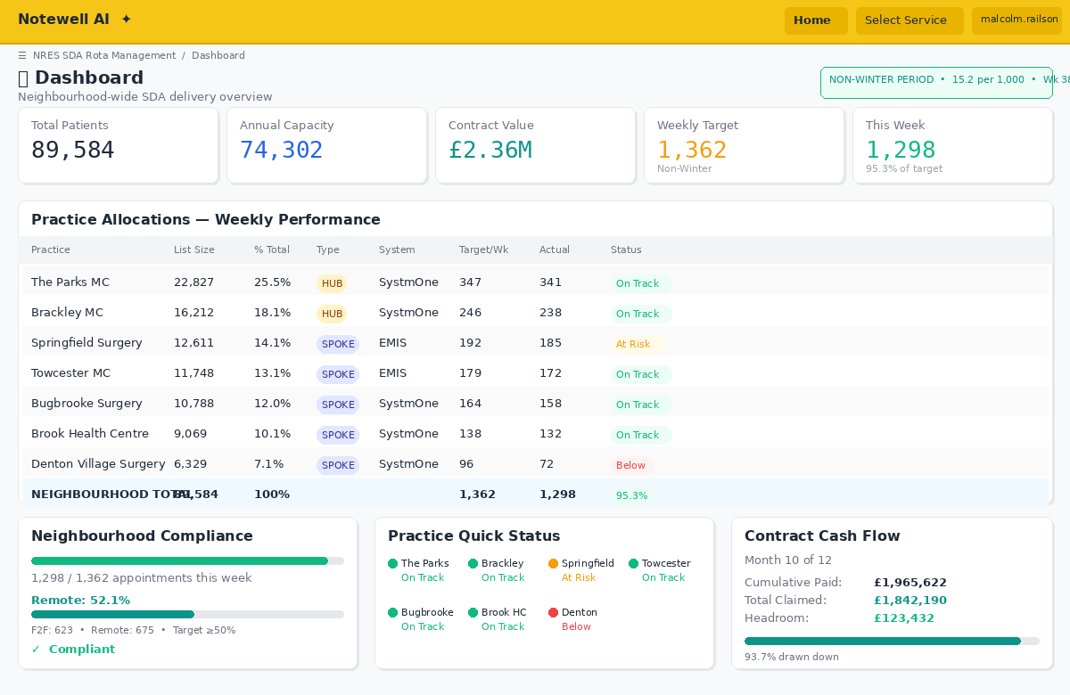
Figure 1: Dashboard — Neighbourhood-wide SDA delivery overview
- Key metrics cards at top: Total Patients (89,584), Annual Capacity (74,302), Contract Value (£2.36M), Current Weekly Target (auto-switch between 1,362 non-winter / 1,631 winter based on date)
- Contract cash flow summary card: Current month, cumulative paid to date (max claimable), cumulative claimed, remaining headroom — neighbourhood-wide with drill-down per practice
- Period indicator: Prominent display of whether we’re in Non-Winter (39 wks) or Winter (13 wks) period, with the applicable rate (15.2 or 18.2 per 1,000)
- Practice allocation table showing all 7 practices with: list size, % of total, hub/spoke status, clinical system, weekly appointment target (for current period), F2F/Remote split
- Neighbourhood-wide compliance gauge — total appointments scheduled this week vs required target
- Quick status tiles per practice: On Track (green), At Risk (amber), Below Target (red)
- On-site vs Remote split — visual showing current balance against the 50% remote requirement

2. Rota Management Page
This is the core operational page — the primary tool for managing day-to-day SDA delivery. It supports both Weekly and Monthly views, switchable with a single toggle.

View Toggle: Weekly | Monthly
Practice Managers are accustomed to working with both views. The toggle sits prominently at the top of the page alongside the practice filter.

Practice Filter & PM Experience
- Practice filter — view all practices (neighbourhood-wide) or drill into a single practice
- When a Practice Manager logs in, the view defaults to their own practice with the option to switch to neighbourhood-wide
- The filtered view is consistent across both weekly and monthly — selecting “Brackley MC” shows only Brackley’s rota, staff, compliance, and capacity in whichever view is active

Weekly View (default)
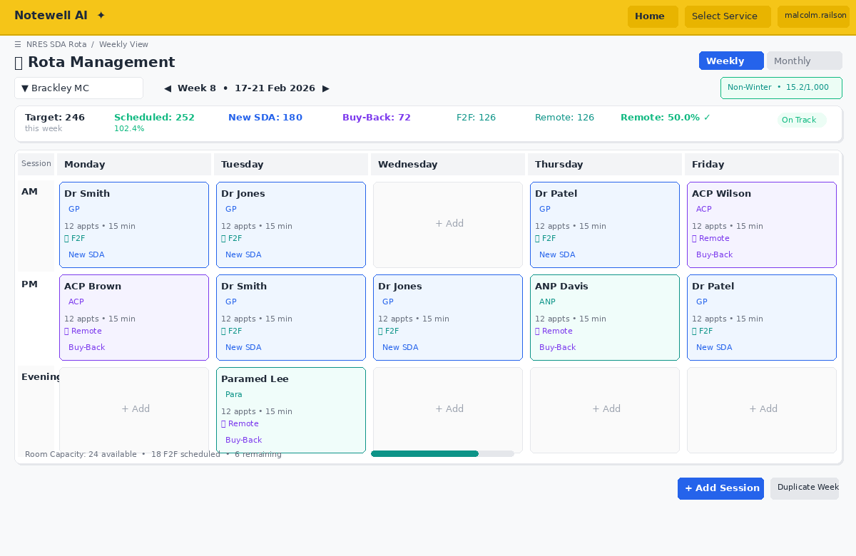
Figure 2: Rota Management — Weekly view with session assignments
- Week selector with forward/back navigation and week number display
- Auto-detect Non-Winter vs Winter period and display appropriate targets
- Rota grid showing Day × Session with staff assignments per practice
- Room capacity overlay — show available room slots from the capacity grid, flag when F2F bookings exceed room availability
- Add Session form with fields:
  - Practice (dropdown of 7)
  - Day (Mon–Sat)
  - Session (AM/PM/Evening)
  - Staff Name (text input or select from workforce directory)
  - Staff Type (GP/ACP/ANP/Paramedic/etc.)
  - Provision Type: “New SDA” or “Buy-Back” (critical distinction — visually differentiated)
  - Number of appointment slots (auto-populated based on staff type — e.g. GP default 12, ACP default 12; editable override if needed)
  - Delivery mode: Face-to-Face (Hub), Face-to-Face (Spoke), Remote (Telephone), Remote (Video)
  - Location (if F2F — which practice site; for The Parks show 4 sub-sites: Roade, Blisworth, Grange Park, Hanslope)
  - Notes field

Absence Tracking: Annual Leave, Sickness & PLT
The rota must account for staff unavailability. This is critical for realistic capacity planning — without it, the system would show full delivery every week when in reality staff take leave, get sick, and attend training.
- Absence types (selectable per staff member per session):
  - Annual Leave — planned, pre-approved
  - Sickness — unplanned, logged after the fact
  - PLT (Protected Learning Time) — practice-wide or individual training sessions, typically half-day closures
  - Study Leave — individual CPD/courses
  - Other — free text (e.g. jury service, compassionate leave)
- How absences appear on the rota:
  - Absent sessions are shown on the rota grid with a distinct visual style (e.g. greyed out with strikethrough, or hatched pattern) so it’s immediately obvious where gaps exist
  - Absent sessions do not count toward the weekly appointment target — the compliance tracker must subtract these from the expected delivery
  - In the monthly calendar view, days with absences show an absence count/indicator alongside the scheduled sessions
- Absence impact on targets:
  - Weekly compliance: adjusted_target_achieved = actual_delivered / (target - appointments_lost_to_absence) — OR simply track the raw shortfall and flag it
  - The system should show both: “Target: 347 | Scheduled: 300 | Lost to absence: 60 | Net capacity: 240 | Shortfall: 107”
  - Dashboard and practice views should display a weekly “absence impact” metric
- Absence planning features:
  - Staff can have leave pre-booked on the rota for future weeks (visible in monthly view)
  - Leave calendar overlay — toggle to see which staff are absent in any given week
  - Alert when too many staff are absent in the same week (configurable threshold, e.g. >30% of sessions unfilled)
  - PLT dates can be bulk-entered for all staff at a practice (since PLT usually affects the whole practice)
- Absence summary reporting (feeds into Compliance & Reports):
  - Sessions lost to annual leave, sickness, PLT per practice per month
  - Absence rate: sessions lost / sessions planned (%)
  - Trend over time — is sickness increasing? Are certain practices losing more capacity to leave?
- Database: session_absences (id, rota_session_id, staff_id, absence_date, session_slot, absence_type [annual_leave|sickness|plt|study_leave|other], notes, reported_by_user_id, created_at, updated_at)
- Per-practice compliance summary above the grid:
  - Appointments scheduled vs target for the week
  - Split by New SDA / Buy-Back
  - % remote (must be ≥50%)
  - Room utilisation vs capacity
- Colour coding: New SDA sessions in blue/teal, Buy-Back sessions in purple/amber
- Duplicate week button — copy entire rota to next week as a template
- Edit and delete existing sessions inline
- Warnings/alerts: Room capacity exceeded, remote ratio below 50%, practice below 80% of target

Monthly View
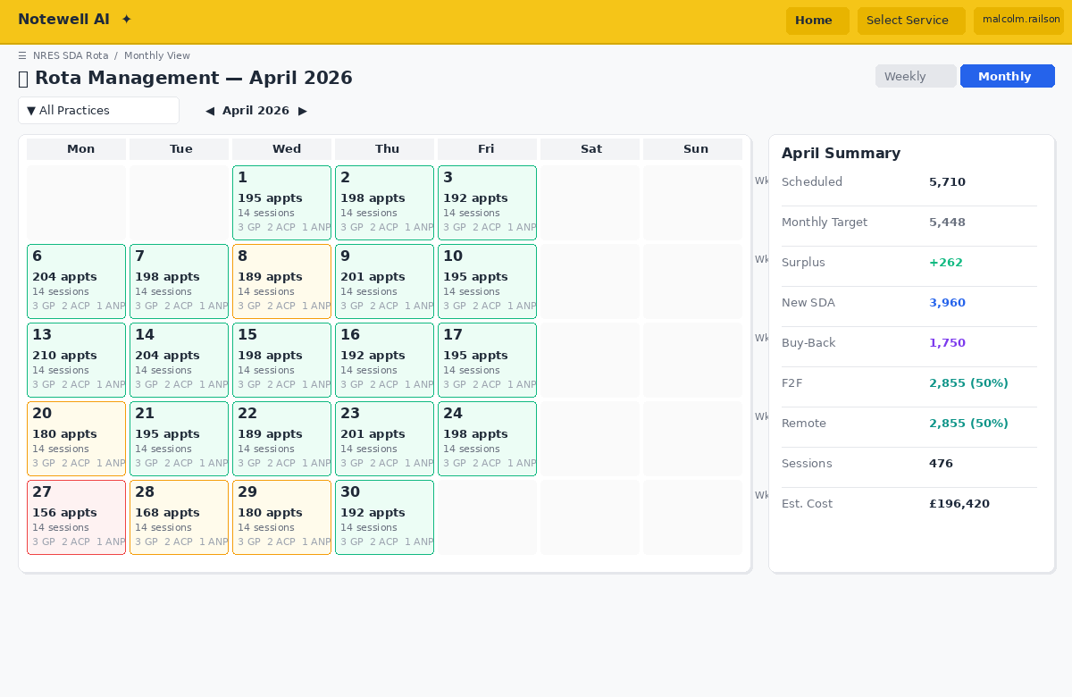
Figure 3: Rota Management — Monthly calendar overview
A calendar-style overview showing the full month at a glance. Designed for Practice Managers who need to plan staffing and spot gaps across 4–5 weeks.
- Month selector with forward/back navigation (e.g. “April 2026”)
- Calendar grid layout: Each day is a cell showing a summary of scheduled sessions
- Per-day cell contents (condensed):
  - Number of sessions scheduled
  - Total appointments for the day
  - Staff initials or count (e.g. “2 GPs, 1 ACP”)
  - Colour-coded: green (fully staffed to target), amber (partial), red (no sessions / below target), grey (weekend/non-working)
  - New SDA vs Buy-Back indicator (small colour dot or badge)
- Weekly row totals: Each week row shows the cumulative appointments for that week vs the weekly target, with compliance status (On Track / At Risk / Below Target)
- Monthly summary panel alongside the calendar:
  - Total appointments scheduled for the month
  - Expected target for the month (weekly target × number of working weeks in the month)
  - Shortfall or surplus
  - New SDA vs Buy-Back split for the month
  - Remote vs F2F ratio for the month
  - Staff utilisation: who is working how many sessions this month
  - Budget impact: estimated cost of all scheduled sessions for the month
- Click any day to expand into that day’s full session detail (staff, times, delivery mode, appointment count) — or jump to the weekly view for that week
- Drag to select multiple days for bulk session creation (e.g. “add GP AM session every Monday this month”)
- Month-to-month comparison: Toggle to show previous month alongside current for trend spotting
- Print/export monthly view — formatted for practice notice boards or team meetings
- Duplicate month button — copy the entire month’s rota pattern to the next month as a template

Shared Features (Both Views)
The following features are available in both weekly and monthly views: - Add Session form (same fields in both views — in monthly view, opens as a modal for the selected day) - Per-practice compliance summary: appointments vs target, New SDA/Buy-Back split, remote ratio, room utilisation - Colour coding: New SDA sessions in blue/teal, Buy-Back sessions in purple/amber - Edit and delete sessions inline - On behalf of indicator: When a Super User adds or edits a session for a practice, a small badge shows “Added by [Super User name] on behalf of [Practice]” — visible in the rota grid and in the audit trail - Warnings/alerts: Room capacity exceeded, remote ratio below 50%, practice below 80% of target - Quick filter bar: Filter by staff type, provision type (New SDA / Buy-Back), delivery mode (F2F / Remote) - Export/print the current view (PDF formatted for the selected practice)

3. Buy-Back Management Page
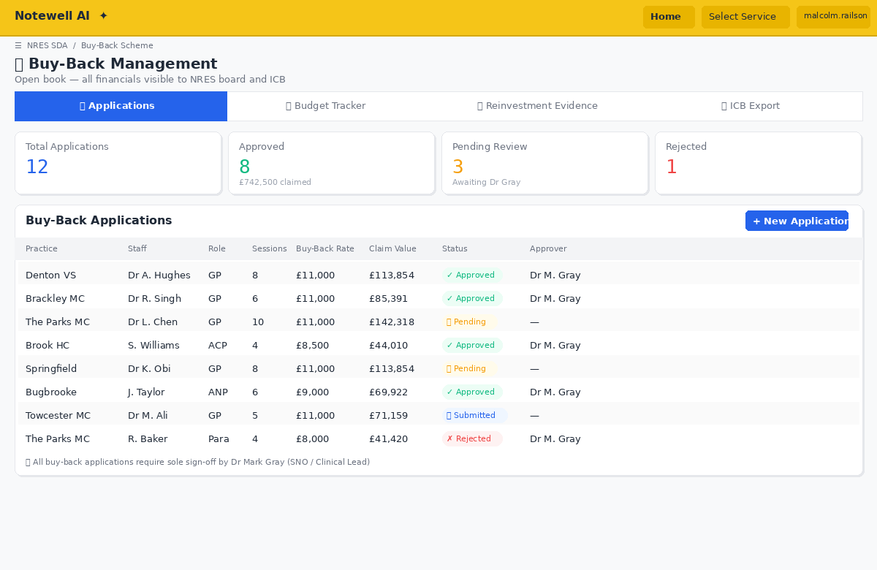
Figure 4: Buy-Back Management — Applications and approval workflow
- Buy-Back Applications list with status: Draft → Submitted → Board Review → Approved / Rejected
- New Application form:
  - Practice name (dropdown)
  - Staff member name and role
  - Current employment: sessions per week
  - Buy-back rate per session: Auto-populated from standard rates (GP = £11,000/session; other roles configurable in Settings)
  - On-costs percentage (default 29.38%)
  - Total buy-back cost (auto-calculated: rate × sessions × on-costs)
  - Percentage of time on same-day reactive work
  - Calculated buy-back claim value (auto: total cost × same-day %)
  - SDA appointments this staff currently delivers per week
  - Proposed reinvestment plan (free text — what new proactive care will the freed money fund, including proposed new hire role, sessions, and salary?)
  - Supporting evidence / notes
  - Flag checkbox: “GP Partner — no salary cost attributable (pending agreement)”
- Board sign-off panel: Single approver — Dr Mark Gray (SNO / Clinical Lead):
  - Decision: Approved / Rejected / Pending
  - Date stamp of decision
  - Rejection reason (mandatory if rejected)
  - Digital signature or confirmation checkbox
- Open book financial view: All buy-back applications and their financials are visible to all NRES board members — full transparency across all 7 practices
- Buy-back budget tracker per practice: total allocation, amount claimed via buy-back, amount spent on new recruitment, remaining balance — visible to all practices (open book)
- Reinvestment evidence tracking: What was the buy-back money actually spent on? Link to new hires / new services. Evidence documents must be uploaded.
- Neighbourhood summary: Total buy-back claimed across all practices, equity comparison showing each practice’s claims relative to their allocation
- ICB export: One-click export of all buy-back data for ICB audit (open book compliance)

Monthly Contract Cash Flow & Max Claimable Value
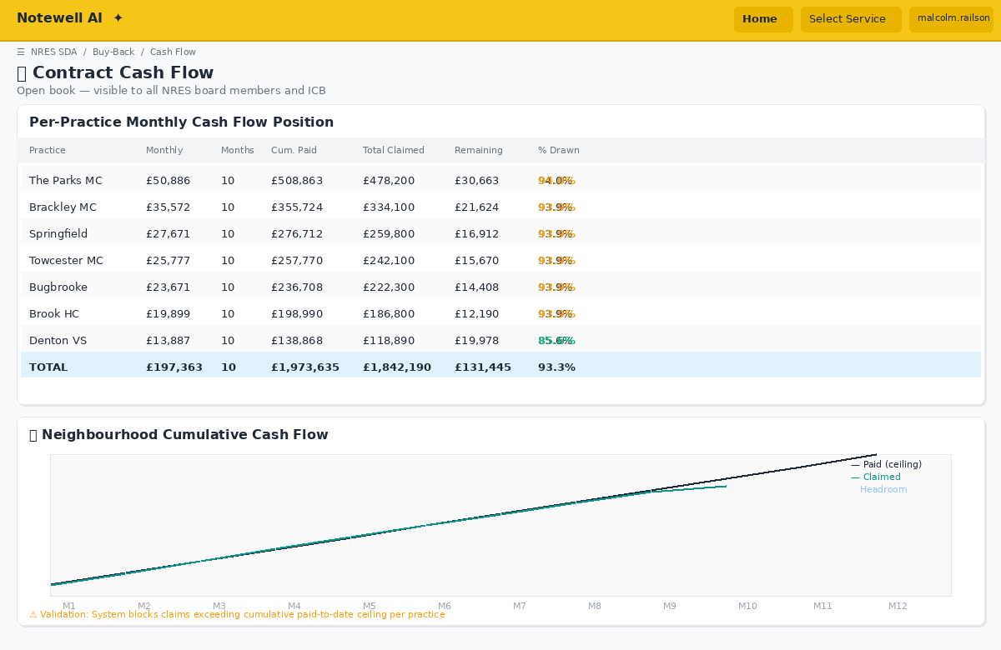
Figure 8: Contract Cash Flow — Per-practice position and cumulative chart
The contract pays each practice £26.33 per patient per year, disbursed in 12 equal monthly instalments. This means practices cannot claim more than has actually been paid into the scheme at any point. The system must track:
- Monthly instalment per practice: (list_size × £26.33) / 12
- Cumulative paid to date: Number of months elapsed since contract start × monthly instalment
- Max claimable value: The total amount that has been paid to date — this is the ceiling for all claims (new SDA spend + buy-back claims combined)
- Total claimed to date: Sum of all new SDA recruitment costs + all approved buy-back values drawn down so far
- Remaining claimable: Max claimable − total claimed (cannot go negative)
- Projected future: Forward view showing monthly instalments for remaining months, with projected claims overlaid
Display this as a dedicated “Contract Cash Flow” panel on both the Buy-Back page and the Dashboard, showing per practice:
Practice | Monthly Instalment | Months Paid | Cumulative Paid (Max Claimable) | Total Claimed | Remaining Claimable | % Drawn Down
Auto-calculated from list sizes
Also show a neighbourhood-wide cash flow chart: - X-axis: Months 1–12 of the contract year - Y-axis: £ value - Line 1: Cumulative contract payments (stepping up monthly — the max claimable ceiling) - Line 2: Cumulative claims (new SDA + buy-back) — must always stay below Line 1 - Shaded area between the two lines = remaining headroom - Visual warning if claims are approaching or exceeding the paid-to-date ceiling
Validation rule: The system must block or warn if a new buy-back approval or new SDA recruitment cost would push total claims above the cumulative amount paid to date for that practice. You cannot spend money that hasn’t been received yet.
Per-practice monthly breakdown view: - Month-by-month table showing: instalment received, new SDA costs incurred that month, buy-back claims drawn that month, running cumulative balance - Highlight any month where outgoings exceeded income - Running surplus/deficit indicator

4. Capacity Planning Page
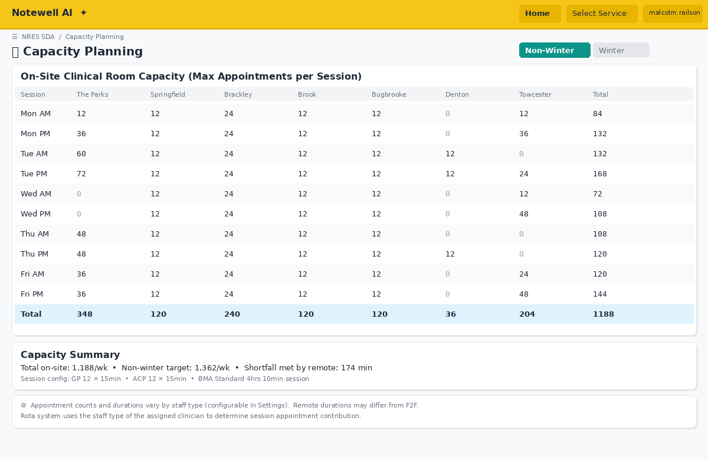
Figure 5: Capacity Planning — Room availability grid
Mirrors the existing Notewell capacity planning view but adds rota overlay: - Toggle between Sessions and Appointments view - Toggle between Non-Winter and Winter periods - Show rate, appointments/week required, F2F required, remote required, duration - Practice breakdown table: list size, % of total, appts/week, F2F (50%), Remote (50%) - Room availability grid (the Day × Session × Practice matrix from the screenshots) - Overlay: scheduled sessions vs available capacity, highlighting gaps and overflows - Note display: “Session appointment counts and durations vary by staff type (configurable in Settings). Defaults: GP = 12 × 15 mins, ACP = 12 × 15 mins. The board may adjust these independently. Remote appointment durations may differ from F2F.”

5. Practice Detail Page (per practice)
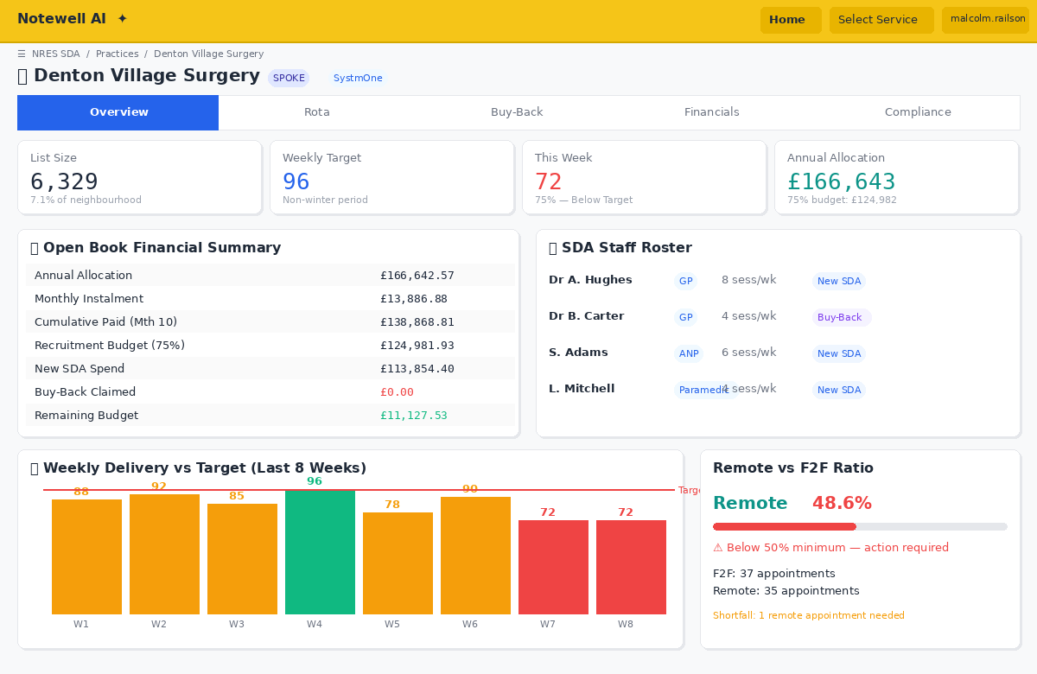
Figure 6: Practice Detail — Denton Village Surgery
- Individual practice dashboard with practice-specific metrics
- Hub or Spoke designation prominently displayed
- Clinical system (SystmOne / EMIS) shown
- Weekly appointment delivery history (line chart: actual vs target over time, with non-winter/winter periods shaded differently)
- Staff roster — who is assigned to SDA work at this practice
- Split view: New SDA staff vs Buy-Back staff
- Open book financial summary (visible to all board members, not just this practice):
  - Allocation (list size × per-patient rate)
  - Monthly instalment (allocation ÷ 12)
  - Cumulative paid to date (max claimable)
  - 75% recruitment budget
  - Spent on new SDA recruitment (itemised)
  - Claimed via buy-back (itemised with evidence)
  - Total claimed vs max claimable gauge
  - Remaining claimable headroom
  - Reinvestment spend and evidence
  - Month-by-month cash flow table: instalment in, costs out, running balance
- Remote vs F2F delivery ratio gauge (must maintain ≥50% remote)
- Room capacity utilisation by session
- For The Parks MC: show breakdown across 4 sub-sites (Roade, Blisworth, Grange Park, Hanslope)
- Email contacts: List of registered contacts for this practice with their report subscriptions. Quick-send ad hoc report button.

6. Compliance & Reporting Page
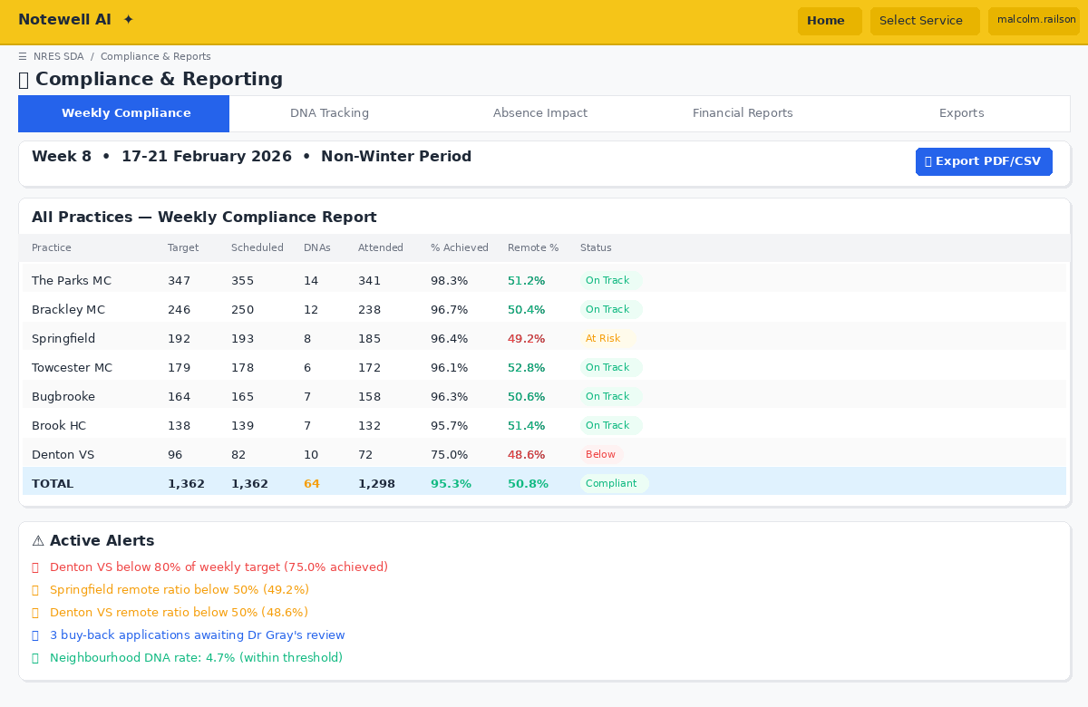
Figure 7: Compliance & Reporting — Weekly traffic light status
- Weekly compliance report — all 7 practices, traffic light status against targets
- Neighbourhood aggregate — total appointments delivered vs total target (1,362 or 1,631)
- Remote consultation % — neighbourhood-wide and per practice (target ≥50%)
- Buy-back vs New SDA split — stacked bar chart per practice
- Trend charts: Weekly delivery over time, with winter period highlighted

DNA (Did Not Attend) Tracking
DNAs directly impact delivery performance and must be monitored and reported: - DNA recording: Each practice enters weekly DNA counts (or they are imported from clinical system data). DNAs are tracked per practice, per week, split by delivery mode (F2F vs Remote) and appointment type (GP, ACP, etc.) - DNA rate calculation: dna_rate = dna_count / (attended + dna_count) × 100 - DNA impact on compliance: The system should show BOTH: - Gross appointments offered (scheduled) - Net appointments attended (scheduled minus DNAs) - The weekly compliance report should display: “Scheduled: 347 | DNAs: 22 | Attended: 325 | Target: 347 | Net achievement: 93.7%” - DNA dashboard metrics: - DNA rate per practice (weekly and rolling 4-week average) - DNA rate by delivery mode (F2F vs Remote — remote typically has lower DNA rates) - DNA rate trend over time per practice - Neighbourhood-wide DNA rate - Practices with DNA rates above configurable threshold (e.g. >5%) flagged amber, above 10% flagged red - DNA reporting: DNA figures included in weekly practice reports, monthly compliance reports, and board summaries - DNA cost impact: Estimated wasted cost per DNA (configurable: e.g. £30/DNA for GP, £20/DNA for ACP) — gives board visibility of financial impact of non-attendance - Database: weekly_dna_data (id, practice_id, week_number, year, delivery_mode, staff_type, dna_count, appointments_offered, created_by_user_id, created_at)

Absence Impact Reporting
- Sessions lost per practice per week/month — split by annual leave, sickness, PLT, study leave, other
- Absence rate: sessions lost / sessions planned (%) per practice and neighbourhood
- Capacity impact: appointments lost to absence vs target shortfall — helps distinguish between “not enough staff recruited” and “staff recruited but absent”
- Absence trend charts: Monthly view showing absence patterns — useful for identifying seasonal peaks or practices with high sickness rates
- Room utilisation report: % of available capacity used per practice per session
- Open book financial report: Neighbourhood-wide view of all 7 practices’ financials side-by-side — allocations, new SDA spend, buy-back claims, reinvestment evidence, remaining budgets. Designed for board meetings and ICB review.
- Monthly cash flow report: Per-practice and neighbourhood-wide view of cumulative contract payments vs cumulative claims, with max claimable headroom. Exportable for ICB financial reconciliation.
- Exportable reports for ICB submission (PDF/CSV) — must include full open book financial breakdown and cash flow position
- Email distribution: Any report can be sent on-demand to selected practice contacts or all subscribed recipients. One-click “Send to all practices” for board meeting preparation.
- Alerts dashboard: Practices below 80% of target, remote ratio below 50%, room capacity exceeded, buy-back applications pending Dr Mark Gray’s review, uneven buy-back distribution across practices, missing reinvestment evidence, claims approaching or exceeding max claimable value for any practice (cash flow ceiling breach), DNA rates above threshold, high absence rates. All alerts are also emailed to subscribed practice contacts in real time.

7. Workforce Directory
- All SDA staff across the neighbourhood
- Which practice(s) they work at (shared workforce model — staff can work across the neighbourhood, not just their home practice)
- Role, sessions per week, contract type (New SDA hire vs Buy-Back)
- Cost per session and total annual cost (including on-costs)
- Hub, Spoke, or Remote assignment
- Available days/sessions

8. Settings Page
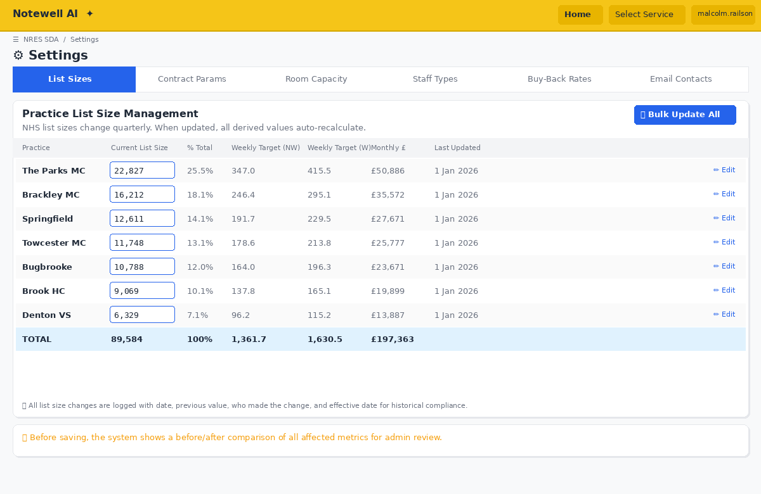
Figure 9: Settings — Practice List Size Management
This is a critical admin page. NHS practice list sizes change over time and directly affect every calculation in the system.

Practice List Size Management
- Editable list size field for each practice — admin can update any practice’s list size at any time
- When a list size is changed, the system must immediately auto-recalculate all derived values across the entire system:
  - % of total neighbourhood population
  - Weekly appointment targets (Non-Winter and Winter)
  - F2F / Remote appointment splits (50/50)
  - Financial allocation (list size × per-patient rate)
  - Recruitment budget (75% of allocation)
  - Compliance thresholds
  - Total neighbourhood figures (sum of all practices)
- List size history log: Every change is recorded with date, previous value, new value, and who made the change. This creates an audit trail for ICB reporting.
- Effective date: Each list size update has an effective date (e.g. “from 1 April 2026”). The system should apply the correct list size for any given week when calculating historical compliance. This means Week 1–52 reports use the list size that was active during that week, not the current list size.
- Bulk update: Option to update all 7 practice list sizes at once (e.g. when quarterly NHS Digital figures are published)
- Preview before saving: When list sizes are changed, show a before/after comparison of all affected metrics so the admin can review the impact before confirming

Practice Configuration
- Edit practice name, hub/spoke designation, clinical system, sub-sites
- Add or remove practices (future-proofing if the neighbourhood changes)
- Practice email contacts: Add one or multiple email addresses per practice, each with:
  - Contact name
  - Email address
  - Role (Practice Manager, GP Partner, Admin, Finance, Other)
  - Primary contact flag
  - Report subscription toggles: Weekly Report, Monthly Report, Alerts
  - Ability to add, edit, and remove contacts per practice

Contract Parameters (all editable)
- Contract start date (default April 2026 — determines month 1 for cash flow calculations)
- Per patient rate (default £26.33)
- Payment schedule: 12 equal monthly instalments (i.e. 1/12th of annual allocation paid per month)
- Overhead/buffer percentage (default 25%)
- Non-Winter rate per 1,000 patients (default 15.2)
- Winter rate per 1,000 patients (default 18.2)
- Non-Winter duration in weeks (default 39)
- Winter duration in weeks (default 13)
- Winter start week number (configurable)
- Remote consultation minimum % (default 50%)
- On-costs default percentage (default 29.38%)

Staff Type Session Configuration
Configurable per staff type — controls how many appointments each session contributes to weekly targets. F2F and Remote can be configured independently (e.g. remote appointments may be shorter, allowing more per session).
BMA standard session = 4 hours 10 minutes (250 minutes). This is the total session block including clinical time plus admin/handover. The appointment count and duration determine the clinical contact time within each session.
For each staff type (GP, ACP, ANP, Paramedic, Clinical Pharmacist, Physician Associate, First Contact Physio, Mental Health Practitioner): - BMA session duration in minutes — default 250 (4hrs 10mins) - Appointments per session (F2F) — default 12 - Appointment duration in minutes (F2F) — default 15 - Appointments per session (Remote) — default 12 (may increase if board reduces remote duration) - Appointment duration in minutes (Remote) — default 15 (board may change to 10) - Effective date for changes (so historical reporting uses the config that was active at the time)
Display: “Clinical contact: [appts × duration] mins | Admin/handover: [BMA session − clinical contact] mins | Total session: [BMA session] mins”
When any of these values change, recalculate: session appointment counts on the rota, weekly appointment totals per practice, compliance status, and room capacity utilisation.

Standard Buy-Back Session Rates
Configurable per staff type. These are the fixed rates used to calculate buy-back claim values — separate from what practices choose to pay new recruits. - GP buy-back rate per session (default £11,000) - ACP buy-back rate per session (configurable) - ANP buy-back rate per session (configurable) - Paramedic buy-back rate per session (configurable) - Other roles (add as needed)

Room Capacity Management
- Editable room capacity grid (Day × Session × Practice)
- Ability to update room availability as estate changes
- Temporary overrides (e.g. room unavailable due to maintenance)

User Management
- Role-based access with granular per-user permission overrides, managed exclusively by Malcolm Railson and Amanda Palin (Permission Administrators):

Role Templates (Default Starting Permissions)
Roles provide a baseline set of permissions. Individual users can then have permissions overridden at the user level — so you can grant or restrict access for specific people without changing the whole role.
- Admin: Full system access to all areas
- Super User (e.g. Malcolm Railson, Amanda Palin): Full edit access across all practices on behalf of any practice. All actions audit-logged. Also serves as Permission Administrator — only Super Users can manage user accounts and permission settings.
- SNO/Approver (Dr Mark Gray): Sole authority to approve/reject buy-back applications. Default view access to all open book data.
- Board Member: Default view access to all open book data, neighbourhood-wide reports, compliance dashboards.
- Practice Manager: Default edit access to own practice rota and buy-back applications. Default view access to open book financials and neighbourhood data. No access to other practices’ editable data.
- Read-only: Default view access to dashboards and reports only.

Granular Permission Matrix
Every page/feature in the system has three permission states per user:
Permission Level | Description
Edit | Can view, create, update, and delete data in this area
View | Can see data but cannot make any changes
No Access | Cannot see this area at all — hidden from navigation and inaccessible via direct URL
Permissions are set against the following system areas:
System Area | Admin | Super User | SNO/Approver | Board Member | Practice Manager | Read-only
Dashboard | Edit | Edit | View | View | View | View
Rota — Own Practice | Edit | Edit | View | View | Edit | View
Rota — Other Practices | Edit | Edit | View | View | View | No Access
Rota — Neighbourhood View | Edit | Edit | View | View | View | View
Buy-Back — Own Practice | Edit | Edit | Edit (approve/reject only) | View | Edit (submit only) | View
Buy-Back — Other Practices | Edit | Edit | Edit (approve/reject only) | View | View | No Access
Buy-Back — Approve/Reject | No Access | No Access | Edit | No Access | No Access | No Access
Capacity Planning | Edit | Edit | View | View | View | View
Practice Detail — Own | Edit | Edit | View | View | View | View
Practice Detail — Other | Edit | Edit | View | View | View | No Access
Compliance & Reports | Edit | Edit | View | View | View | View
Workforce Directory | Edit | Edit | View | View | View (own practice) | No Access
Cash Flow / Financials | Edit | Edit | View | View | View | No Access
Settings — List Sizes | Edit | Edit | No Access | No Access | No Access | No Access
Settings — Contract Params | Edit | Edit | No Access | No Access | No Access | No Access
Settings — Room Capacity | Edit | Edit | No Access | No Access | No Access | No Access
Settings — Email Contacts | Edit | Edit | No Access | No Access | View (own practice) | No Access
Settings — Scheduled Reports | Edit | Edit | No Access | No Access | No Access | No Access
Settings — Users & Permissions | Edit | Edit | No Access | No Access | No Access | No Access
Audit Trail | View | View | No Access | View | View (own practice) | No Access
These are defaults. Malcolm and Amanda can override any cell for any individual user.

Per-User Permission Overrides
- On the User Management screen, each user has their role displayed plus an “Override Permissions” button
- Clicking it opens a permission matrix showing all system areas with the role default pre-filled
- Malcolm or Amanda can change any individual cell to Edit, View, or No Access for that specific user
- Overrides are highlighted (e.g. amber badge) so it’s clear where a user differs from their role default
- Override reason field (optional) — for audit purposes, e.g. “Temporary edit access for CQC prep”
- Overrides can have an expiry date — automatically reverts to role default after the set date (useful for temporary access)

User Management Screen (Super Users Only — Malcolm & Amanda)
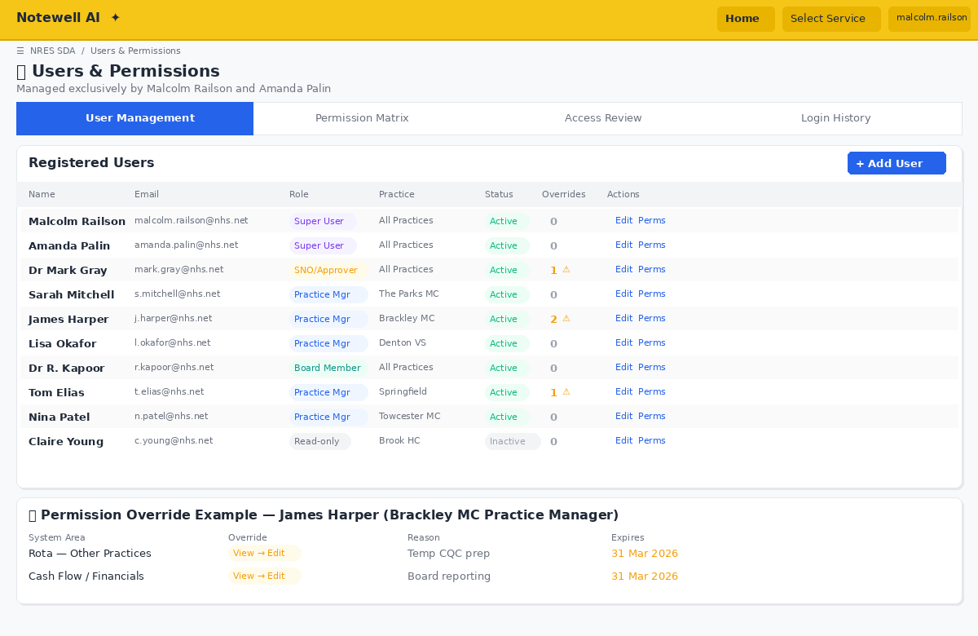
Figure 10: Users & Permissions — Role management with granular overrides
- User list: All registered users with name, email, role, assigned practice, active/inactive status, and count of permission overrides
- Add user: Name, email, assign role, assign practice (if applicable), set initial permissions
- Edit user: Change role, practice assignment, active status
- Permission overrides: Per-user granular permission matrix (as above)
- Bulk actions: Activate/deactivate multiple users, change role for multiple users
- Access review: Summary view showing “who can access what” — filterable by system area or by user, exportable for IG governance
- Login history: Last login date/time per user for security monitoring
- Only Malcolm Railson and Amanda Palin can access this screen (enforced — not configurable)

Audit Trail
Every data change across the system is logged for accountability and ICB governance. The audit trail records: - Who: Username and role of the person making the change (critically: if a Super User edits on behalf of a practice, both the Super User’s identity and the target practice are recorded) - What: Which record was changed (rota session, buy-back application, staff record, financial entry, setting, permission, user account, etc.) - When: Timestamp of the change - Before/After: Previous value and new value for every field changed - Action type: Created, Updated, Deleted, Approved, Rejected, Submitted, Permission Changed, User Added, User Deactivated - On behalf of: If a Super User or Admin acted on behalf of a practice, the practice name is recorded
The audit trail is: - Immutable — entries cannot be edited or deleted by any user - Searchable and filterable by user, practice, record type, date range, and action type - Exportable for ICB governance and IG reviews - Visible to Admins and Super Users (full trail), Board Members (full trail read-only) - Practice Managers can view the audit trail for their own practice only (unless overridden) - All permission changes are logged — including who changed whose access, from what to what, and why - All financial data visible to all authenticated users (open book principle)

Automated Scheduled Reports
The system sends automated email reports to practice contacts based on their subscription preferences. Each practice receives a tailored report covering only their own data alongside neighbourhood-wide aggregates for context.
Weekly Practice Report (sent every Monday morning, covering the previous week): - SDA appointments delivered vs target (with compliance status: On Track / At Risk / Below Target) - Split by New SDA vs Buy-Back provision - Remote vs F2F ratio (flagging if below 50%) - Room utilisation summary - Staff sessions delivered (who worked which days) - Comparison to other practices (anonymised or named — configurable) - Any shortfall highlighted with number of appointments behind target
Monthly Financial Report (sent 1st of each month, covering the previous month): - Contract instalment received that month - Cumulative paid to date (max claimable ceiling) - New SDA recruitment spend this month and cumulative - Buy-back claims drawn this month and cumulative - Remaining claimable headroom - Reinvestment evidence status (submitted / outstanding) - Budget burn rate and projected year-end position - Open book summary: all 7 practices’ financial positions side-by-side
Alert Emails (sent immediately when triggered): - Practice drops below 80% of weekly target - Remote ratio falls below 50% - Room capacity exceeded for a scheduled session - Buy-back application status change (submitted, approved, rejected) - Claims approaching max claimable ceiling (>90% drawn down) - List size update affecting the practice’s targets
Neighbourhood Board Summary (sent to all board members weekly): - Aggregate neighbourhood performance vs targets - All 7 practices at a glance with traffic light status - Buy-back applications pending Dr Mark Gray’s review - Cash flow summary across the neighbourhood - Any critical alerts from the past week
Report configuration in Settings: - Enable/disable each report type - Set schedule (day of week for weekly, date for monthly) - Choose which contacts at each practice receive which reports - Add additional recipients (e.g. ICB contacts, board members) for neighbourhood-wide reports - Preview any report before enabling automated sending - Send test email function - Report delivery log showing sent/failed/bounced status

UI/UX Requirements

Design System
- Use a professional NHS-aligned colour palette: Primary blues and teals, amber for warnings, red for alerts, green for on-track
- Match the existing Notewell AI branding style visible in the screenshots: yellow/gold header bar (#F5C518 or similar), clean white card layouts with subtle borders, blue/green/red status indicators
- Light content area with clean card-based layout (matching the Notewell dashboard aesthetic)
- Use Shadcn/UI components throughout for consistency
- Responsive layout (desktop-first but mobile-friendly for board members checking on phones)
- Data-dense tables with clear typography and good use of colour coding
- Monospace font for numbers/financial figures for easy scanning

Navigation Structure
Sidebar or top-nav with: - 🏠 Dashboard - 📅 Rota (Weekly & Monthly views) - 🔄 Buy-Back Scheme - 📊 Capacity Planning - 🏥 Practices (expandable to show all 7) - 📈 Compliance & Reports - 👥 Workforce - ⚙️ Settings (List Sizes, Contract Parameters, Room Capacity, Email Contacts, Scheduled Reports) - 👤 Users & Permissions (Super User only — Malcolm & Amanda) - 📝 Audit Trail (Super User & Admin only — searchable log of all changes)

Key Interactions
- Inline editing of appointment counts in the rota grid
- Quick filters everywhere (by practice, by staff type, by provision type, by delivery mode)
- Toast notifications for successful saves
- Confirmation dialogs for deletions
- Print-friendly views for board meeting papers
- Prominent visual distinction between New SDA and Buy-Back sessions throughout

Data Persistence
- Use Supabase for backend database
- Tables needed:
  - practices (id, name, current_list_size, pct_of_total, hub_or_spoke, clinical_system, sub_sites, created_at, updated_at)
  - practice_contacts (id, practice_id, email, contact_name, role [practice_manager|gp_partner|admin|finance|other], is_primary, receives_weekly_report, receives_monthly_report, receives_alerts, created_at, updated_at) — multiple email contacts per practice for automated report distribution
  - practice_list_size_history (id, practice_id, list_size, effective_date, previous_list_size, changed_by, change_reason, created_at) — audit trail for all list size changes; used to calculate correct targets for historical weeks
  - staff (id, name, role, home_practice_id, contract_type [new_sda|buy_back], cost_per_session, sessions_per_week, on_costs_pct, is_partner_buy_back, created_at)
  - rota_sessions (id, week_number, year, day, session_slot, practice_id, site_name, staff_id, staff_type, provision_type [new_sda|buy_back], appointment_count, delivery_mode [f2f_hub|f2f_spoke|remote_telephone|remote_video], notes, created_by_user_id, on_behalf_of_practice_id, last_updated_by_user_id, created_at, updated_at)
  - buy_back_applications (id, practice_id, staff_name, staff_role, sessions_per_week, standard_rate_per_session, on_costs_pct, total_cost_inc_oncosts, same_day_pct, calculated_buy_back_value, sda_appts_per_week, reinvestment_plan, reinvestment_new_hire_role, reinvestment_new_hire_salary, is_partner_no_salary, status [draft|submitted|under_review|approved|rejected], approver_decision, approver_decision_date, rejection_reason, evidence_document_url, notes, created_by_user_id, on_behalf_of_practice_id, last_updated_by_user_id, created_at, updated_at) — approved solely by Dr Mark Gray (SNO); standard_rate_per_session auto-populated from Settings based on staff role; tracks who created/edited including Super User on-behalf-of
  - room_capacity (id, practice_id, day, session_slot, available_appointments, notes, updated_at)
  - staff_type_session_config (id, staff_type, bma_session_duration_mins, appts_per_session_f2f, appt_duration_mins_f2f, appts_per_session_remote, appt_duration_mins_remote, effective_date, updated_by, created_at) — per-role appointment counts and durations, separate for F2F and Remote; BMA standard 250 mins; used to auto-calculate session contributions to weekly targets
  - session_absences (id, staff_id, practice_id, absence_date, session_slot [am|pm|evening], absence_type [annual_leave|sickness|plt|study_leave|other], rota_session_id, appointments_lost, notes, reported_by_user_id, created_at, updated_at) — tracks all staff absences; subtracts from weekly capacity; feeds absence reporting
  - weekly_dna_data (id, practice_id, week_number, year, delivery_mode [f2f|remote], staff_type, dna_count, appointments_offered, created_by_user_id, created_at) — DNA tracking per practice per week; used for DNA rate calculations and compliance reporting
  - buy_back_standard_rates (id, staff_role, rate_per_session, effective_date, updated_by, created_at) — configurable standard rates per role, e.g. GP = £11,000/session; auto-populates buy-back application forms
  - contract_parameters (id, key, value, updated_by, updated_at — configurable: per_patient_rate, overhead_pct, non_winter_rate, winter_rate, non_winter_weeks, winter_weeks, winter_start_week, remote_min_pct, default_on_costs_pct, bma_session_duration_mins [default 250], dna_amber_threshold_pct [default 5], dna_red_threshold_pct [default 10], dna_cost_gp [default 30], dna_cost_acp [default 20], absence_alert_threshold_pct [default 30], contract_start_date, payment_frequency_months [default 12 equal instalments])
  - monthly_cash_flow (id, practice_id, month_number, year, instalment_amount, new_sda_spend_this_month, buy_back_drawn_this_month, cumulative_paid, cumulative_claimed, notes, created_at, updated_at) — tracks monthly contract payments vs claims per practice for max claimable value calculations
  - reinvestment_records (id, buy_back_application_id, description, amount_spent, evidence_notes, created_at)
  - scheduled_reports (id, report_type [weekly_practice|monthly_financial|board_summary], schedule_day, schedule_time, is_enabled, include_anonymised_comparison, additional_recipients_json, created_at, updated_at)
  - report_delivery_log (id, report_type, practice_id, recipient_email, sent_at, status [sent|failed|bounced], error_message, created_at)
  - audit_log (id, user_id, user_name, user_role, action_type [created|updated|deleted|approved|rejected|submitted|permission_changed|user_added|user_deactivated], record_type [rota_session|buy_back|staff|practice|setting|list_size|room_capacity|contact|user_account|permission_override], record_id, practice_id, on_behalf_of_practice_id, field_changed, old_value, new_value, notes, created_at) — immutable audit trail; cannot be edited or deleted; records Super User actions on behalf of practices and all permission changes
  - users (id, name, email, role [admin|super_user|sno_approver|board_member|practice_manager|read_only], practice_id [null for neighbourhood-wide roles], is_active, last_login_at, created_by_user_id, created_at, updated_at)
  - role_default_permissions (id, role, system_area, permission_level [edit|view|no_access], created_at) — default permission matrix per role as defined above; seeded on setup
  - user_permission_overrides (id, user_id, system_area, permission_level [edit|view|no_access], override_reason, expires_at, set_by_user_id, created_at, updated_at) — per-user overrides of role defaults; set by Malcolm or Amanda only; expiry date optional for temporary access

Business Logic

Weekly Target Calculation (Dynamic — Driven by List Sizes)
All targets are dynamically calculated from practice list sizes, never hardcoded. When list sizes change in Settings, every metric recalculates automatically.
practice_weekly_target_non_winter = (current_list_size / 1000) × non_winter_rate
practice_weekly_target_winter = (current_list_size / 1000) × winter_rate
neighbourhood_total = sum of all practice targets
// For historical weeks, use the list size that was active on that date:
historical_target = (list_size_as_of_week_start / 1000) × applicable_rate

Financial Allocation (Dynamic — Driven by List Sizes)
practice_allocation = current_list_size × per_patient_rate
recruit_budget = practice_allocation × (1 - overhead_pct)
neighbourhood_contract_value = sum of all practice allocations
// These recalculate instantly when list sizes are updated in Settings

Period Detection
- Winter: 13 weeks (approximately November to February — exact week numbers configurable in settings)
- Non-Winter: 39 weeks (remainder of the year)
- System auto-detects based on current date and highlights prominently

Compliance Status per Practice
if actual >= target: GREEN "On Track"
if actual >= target × 0.8: AMBER "At Risk"
if actual < target × 0.8: RED "Below Target"

Room Capacity Validation
for each practice, day, session:
if scheduled_f2f_appointments > room_capacity[practice][day][session]:
FLAG: "Room capacity exceeded — {x} appointments scheduled but only {y} rooms available"

Remote Ratio Check
remote_pct = (remote_appointments / total_appointments) × 100
if remote_pct < 50: FLAG WARNING "Remote ratio below 50% mandatory minimum"

Permission Resolution
When determining what a user can access, the system checks in order:
1. Look up user's role → get role_default_permissions for the requested system_area
2. Check user_permission_overrides for this user + system_area
3. If override exists AND has not expired → use override permission_level
4. If override exists AND has expired → ignore it (revert to role default), flag for cleanup
5. If no override → use role default
6. If permission_level = 'no_access' → hide from navigation, block direct URL access, return 403
7. If permission_level = 'view' → render page read-only, disable all edit/create/delete controls
8. If permission_level = 'edit' → full interactive access
// Practice-scoped areas (rota, buy-back, practice detail):
// For Practice Managers, "Own Practice" vs "Other Practices" is determined by user.practice_id
// Super Users are not practice-scoped — they have edit access across all practices by default

Buy-Back Value Calculation
Uses the standard buy-back rate for the staff type (e.g. GP = £11,000/session), not the practice’s actual salary cost.
annual_buy_back_cost = standard_rate_per_session × sessions_per_week × 52
// e.g. GP: £11,000 × 8 sessions × 52 = £4,576,000? No — rate is per session per YEAR
// Correct: annual cost = rate_per_session × sessions_per_week (i.e. £11,000 × 8 = £88,000)
annual_buy_back_cost = standard_rate_per_session × sessions_per_week
on_costs = annual_buy_back_cost × (on_costs_pct / 100) // default 29.38%
total_cost = annual_buy_back_cost + on_costs
buy_back_claim_value = total_cost × (same_day_pct / 100)
Note: “per session” here means the annual rate for one session per week (industry standard GP session pricing). E.g. a GP doing 8 sessions/week at £11K/session = £88,000 annual salary.

Practice Financial Tracking (Dynamic)
allocation = current_list_size × per_patient_rate // recalculates when list size changes
recruit_budget = allocation × (1 - overhead_pct)
total_new_sda_spend = sum of new hire costs for this practice
total_buy_back_claimed = sum of approved buy-back values for this practice
remaining_budget = recruit_budget - total_new_sda_spend
// Note: buy-back money is reimbursed TO the practice but must be reinvested

Monthly Cash Flow & Max Claimable Value
The contract is paid in 12 equal monthly instalments. Claims cannot exceed what has been paid.
monthly_instalment = (current_list_size × per_patient_rate) / 12
months_elapsed = number of complete months since contract_start_date
cumulative_paid = monthly_instalment × months_elapsed // this is the MAX CLAIMABLE ceiling
cumulative_claimed = sum of all new SDA costs + all approved buy-back draw-downs to date
remaining_claimable = cumulative_paid - cumulative_claimed
headroom_pct = (remaining_claimable / cumulative_paid) × 100
// Validation: BLOCK or WARN if a new claim would breach the ceiling
if (cumulative_claimed + proposed_new_claim) > cumulative_paid:
BLOCK: "This claim of £X would exceed the max claimable value.
Cumulative paid to date: £Y. Already claimed: £Z.
Available: £(Y-Z). Wait until next monthly instalment or reduce claim."
Note: When list sizes change, the monthly instalment recalculates. However, past monthly payments already received should use the list size that was in effect when they were paid (use practice_list_size_history effective dates). Future projected instalments use the current list size.

Seed Data
Pre-populate: 1. All 7 practices with initial list sizes (Feb 2026) as shown in the practice table above, plus hub/spoke status, clinical systems, and sub-sites. Also create an initial entry in practice_list_size_history for each practice with effective_date = service start date. 2. Room capacity grid (the full Day × Session × Practice matrix as shown above) 3. All contract parameters as configurable settings with their default values 4. Denton Village Surgery’s proposal as a sample: buy-back application using the standard GP rate of £11K/session, plus a separate new recruitment proposal for an 8-session GP at £11K–£12K DOE with 29.38% on-costs

Priority Build Order
✦ GOLD STANDARD OPTION — FOR PROGRAMME BOARD CONSIDERATION POST GO-LIVE IF NEEDED. The sections below (Priority Build Order, Build Effort Estimate, Phased Launch Plan, and Milestone Schedule) describe the optional web-based system build. The Excel Workbook V3.1 is the primary operations tool and is fully sufficient to run the NRES programme. The system build described below is not a requirement, not currently budgeted, and would only proceed if the Programme Board considers it beneficial post go-live.
- Dashboard with practice allocations, targets, and period detection
- Rota page with weekly and monthly views, session management — New SDA + Buy-Back tracking + room capacity validation
- Capacity Planning page — mirroring existing Notewell view with rota overlay
- Buy-Back application workflow with board sign-off
- Practice detail pages
- Compliance reporting with export and email automation
- Workforce directory
- Users & Permissions with granular overrides
- Audit trail
Focus on getting the rota management, room capacity checking, and buy-back tracking working first — these are the core operational needs for the April 2026 service launch.

Build Effort Estimate

Summary
Phase | Hours (Low) | Hours (High) | Notes
1. Initial UI Build (Lovable) | 55 | 80 | Lovable scaffolds fast but needs iteration
2. Supabase Backend & Schema | 22 | 35 | 15+ tables, RLS policies are complex
3. Business Logic & Refinement | 35 | 50 | Dynamic calcs, permissions, workflows
4. Email Automation | 20 | 30 | Edge functions, 4 report templates
5. Testing & UAT | 40 | 60 | 6 roles × 20 system areas = many scenarios
6. Go-Live & First Month Support | 25 | 40 | Training, fixes, practice onboarding
TOTAL | 197 | 295
Realistic estimate: 200–300 hours Equivalent to roughly 5–8 weeks full-time or 3–4 months part-time alongside other NRES/PCN responsibilities.

Phase 1: Initial UI Build with Lovable (55–80 hrs)
Lovable will accelerate the frontend scaffolding significantly, but expect multiple rounds of prompting and refinement per page.
Component | Hours | Complexity
Dashboard (metrics, practice table, cash flow card) | 4–6 | Medium
Rota — Weekly view (grid, add session, compliance) | 8–12 | High
Rota — Monthly view (calendar, summaries, click-through) | 6–8 | High
Buy-Back management (applications, approval panel, tracker) | 6–8 | High
Capacity Planning (mirroring Notewell, overlay) | 4–6 | Medium
Practice Detail pages (×7, templated) | 4–6 | Medium
Compliance & Reporting (charts, exports, email send) | 6–8 | Medium
Workforce Directory | 3–4 | Low
Settings (list sizes, params, room capacity, rates, contacts) | 6–8 | Medium
Users & Permissions (matrix, overrides, user management) | 8–12 | High
Audit Trail (searchable, filterable log) | 4–6 | Medium
Risk factor: Lovable sometimes needs 3–5 iterations to get complex interactive components right (especially the rota grid and permission matrix). Budget for rework.

Phase 2: Supabase Backend & Schema (22–35 hrs)
Component | Hours | Notes
Database schema creation (15+ tables) | 4–6 | Straightforward from the spec
Row-Level Security policies | 8–12 | Hardest part — 6 roles, practice scoping, permission overrides, Super User on-behalf-of
Seed data (7 practices, room capacity, params) | 2–3
API integration & debugging | 8–14 | Connecting Lovable frontend to Supabase, handling edge cases
Warning: The granular permission system with per-user overrides and practice-scoped access is the most technically challenging piece. Supabase RLS is powerful but modelling “check user override → fall back to role default → scope by practice” requires careful policy design.

Phase 3: Business Logic & Refinement (35–50 hrs)
Component | Hours | Notes
Dynamic target calculations (list size → targets) | 4–6 | Cascading recalculation when list sizes change
Monthly cash flow & max claimable | 4–6 | Instalment tracking, ceiling validation
Buy-back approval workflow | 4–6 | Status transitions, Dr Mark Gray sign-off
Room capacity validation | 3–4 | F2F bookings vs room grid
Permission resolution engine | 6–8 | Override → role default → practice scoping
Staff type session config (per-role appt counts) | 3–4 | Auto-populating rota from config
Historical list size lookups | 3–4 | Using correct list size for past weeks
UI refinement iterations | 8–12 | Styling, layout, responsiveness, PM feedback

Phase 4: Email Automation (20–30 hrs)
Component | Hours | Notes
Email service setup (Supabase Edge Functions or Resend/SendGrid) | 4–6 | Need a transactional email provider
Weekly Practice Report template | 4–6 | Practice-specific data, charts, compliance
Monthly Financial Report template | 4–6 | Cash flow, open book summary
Board Summary template | 3–4 | Neighbourhood aggregate
Alert email triggers | 3–4 | Real-time on threshold breach
Scheduling engine (cron jobs) | 2–4 | Supabase pg_cron or Edge Function scheduler
Note: HTML email formatting is notoriously fiddly. Budget extra time if polished, branded emails are required rather than plain text.

Phase 5: Testing & UAT (40–60 hrs)
Component | Hours | Notes
Functional testing — all pages/features | 10–15 | Systematic walk-through of every feature
Role-based access testing | 8–12 | 6 roles × 20 system areas × 3 permission levels — extensive matrix
Permission override testing | 4–6 | Expiry, revert, edge cases
UAT with Practice Managers (2–3 practices) | 10–15 | Real users, real scenarios, real feedback
Bug fixes from testing | 8–12 | Always more than expected
Recommendation: Get 2–3 friendly PMs (Denton/Brackley) to test early. Don’t wait until everything is built — test in phases.

Phase 6: Go-Live & First Month Support (25–40 hrs)
Component | Hours | Notes
User setup (accounts, roles, permissions for all 7 practices) | 3–4
Training sessions (board + PMs) | 6–10 | Probably 2 sessions: one board, one PM group
User guide / documentation | 4–6 | Even basic “how to” saves support time
First month bug fixes & refinements | 8–12 | Things always surface in real use
PM feedback incorporation | 4–8 | “Can we also…” requests

Recommended Phased Launch Plan

Milestone Schedule
Milestone | Target Date | What’s Live | Estimated Hours
Alpha | Late March 2026 | Dashboard, Weekly Rota, basic Buy-Back, role-based access. Service go-live April 2026 uses Excel rota for initial weeks | ~80 hrs
Beta | May 2026 | + Monthly Rota, Capacity Planning, Practice Detail, permission overrides | ~60 hrs
Go-Live | July 2026 | Full system live: Email automation, Compliance Reports, Workforce Directory, audit trail. Replaces Excel-based tracking | ~60 hrs
Refinement | August–September 2026 | UAT feedback, polish, training, documentation | ~40 hrs
The NRES service launches in April 2026 using the Excel Workbook V3.1 as the primary operations tool, managed centrally by Malcolm Railson and Amanda Palin. No additional funding or resources are required for service launch. Should the Programme Board decide post go-live that a live web-based system would add value, the phased build described above could proceed: Alpha (late March) providing Dashboard, Weekly Rota, and basic Buy-Back; Beta (May) adding Monthly Rota, Capacity Planning, and Practice Detail; full Go-Live (July) replacing Excel entirely. This would be a board decision based on perceived value, not a project dependency. The Excel workbook remains the audit baseline and fallback throughout.

Recommendations to Reduce Risk & Time
Launch with role-based permissions only — deliver the granular per-user overrides in v2 post-launch. The role defaults cover 90% of access needs. This saves ~20–25 hours from the critical path.
Start with plain-text email reports — get the automation and scheduling working first, invest in polished HTML templates after launch. Saves ~10–15 hours.
Test with 2 practices early — Denton and Brackley are already engaged with buy-back proposals. Get their PMs using the Alpha from late March rather than waiting for a polished product.
Phase the Lovable prompts — feed the prompt to Lovable in sections following the priority build order rather than all at once. Start with Dashboard + Rota, get those working, then add Buy-Back, then Settings/Permissions.
Biggest risk areas: - Supabase Row-Level Security policies for the permission system (technically complex) - The rota grid interactions in Lovable (may need several iterations or manual code) - Email automation reliability (cron scheduling, failure handling) - Scope creep from PM feedback during UAT (“can we also…” requests)

Ongoing Support (Post Go-Live)
Budget approximately 4–8 hours per month ongoing for: - Quarterly list size updates (NHS Digital publications) - Contract parameter changes - New user setup and permission changes - Bug fixes and minor enhancements - Report template adjustments - Winter/non-winter period transitions - Annual contract renewal adjustments

