NRES New Models SDA Pilot
Comprehensive Reporting Plan
Rural East & South Neighbourhood Access Service
89,584 Patients | 7 GP Practices | £2.36M Contract
Document Owner: | NRES Programme Board
Version: | 1.6
Date: | February 2026
Status: | For ICB/Programme Board Approval
Classification: | Official – Sensitive
Data Source: | Excel Workbook V3.1 (primary) + Clinical System Extracts
ICB Alignment: | Cross-referenced to ICB Enhanced Service Specification v7

1. Executive Summary
This Reporting Plan establishes the framework for monitoring, evaluating and reporting on the NRES New Models Same Day Access (SDA) pilot serving 89,584 patients across 7 GP practices in the Rural East & South neighbourhood. The plan meets Northamptonshire ICB’s requirements for oversight, assurance and value-for-money assessment of the £2.36M annual investment. Version 1.6 has been cross-referenced against the ICB Enhanced Service Specification to ensure full alignment with all mandatory reporting requirements.
The reporting framework covers two distinct provision types:
Part A — Reactive SDA (15 min): New staff/sessions funded directly by the contract, delivered as same-day 15-minute appointments using slot types NRES SDA Face 2 Face and NRES SDA Virtual.
Part B — Continuity & Proactive Care (30 min): Longer 30-minute appointments across four national tracked categories (Long-Term Conditions, Mental Health, Frailty/Complex, Cancer/Palliative) using SDA-prefixed slot types. Part B activity provides the reinvestment evidence required for buy-back claims.
The primary operational tool is the NRES SDA Rota Management Workbook V3.1 (Excel), managed centrally by Malcolm Railson and Amanda Palin. No additional funding or systems are required.
v1.6 ICB Alignment: This version adds mandatory reporting areas identified in the ICB specification including complaints, safeguarding, health inequalities/Core20PLUS5, onward referrals and diagnostics, unmet demand, repeat attendances, prescribing/medicines management, equity of utilisation, EMAS referrals, staff satisfaction, Part B appointment duration monitoring, and named practice reporting leads.
TOTAL TARGET/WK  1,362  Non-Winter (39 wks) | WINTER TARGET/WK  1,631  Winter (13 wks) | ANNUAL TARGET  74,302  52-week total | CONTRACT VALUE  £2.36M  12-month LES | RECRUIT BUDGET  £1.77M  75% of contract

2. Scope & Objectives

2.1 Reporting Objectives
1. Demonstrate compliance with contractual obligations and NHS standards, including weekly appointment targets per practice calculated from list sizes (15.2/1,000 non-winter, 18.2/1,000 winter).
2. Provide ICB with transparent oversight of service performance, financial expenditure, and open book accounting across all 7 practices.
3. Enable evidence-based decision making for service optimisation, including Part B continuity evidence and buy-back scheme monitoring.
4. Support pilot evaluation and business case development for Year 2 commissioning.
5. Identify variation across practices to share best practice and address underperformance.
6. Meet all ICB mandatory monthly data submission requirements as set out in ICB ES Section 2.2.1, including quality domains (complaints, safeguarding, IPC, effectiveness), access equity, and narrative performance explanation.

2.2 The 7 NRES Practices
Practice | List Size | % of Total | Hub/Spoke | System | Target/Wk (NW) | Target/Wk (W)
The Parks MC | 22,827 | 25.5% | HUB | SystmOne | 347 | 416
Brackley MC | 16,212 | 18.1% | HUB | SystmOne | 246 | 295
Springfield Surgery | 12,611 | 14.1% | SPOKE | EMIS | 192 | 230
Towcester MC | 11,748 | 13.1% | SPOKE | EMIS | 179 | 214
Bugbrooke Surgery | 10,788 | 12.0% | SPOKE | SystmOne | 164 | 196
Brook Health Centre | 9,069 | 10.1% | SPOKE | SystmOne | 138 | 165
Denton Village Surgery | 6,329 | 7.1% | SPOKE | SystmOne | 96 | 115
TOTAL | 89,584 | 100% |  |  | 1,362 | 1,631

2.3 Named Practice Reporting Leads (ICB Requirement)
Per ICB Section 2.2.1, each GP Practice must nominate a named reporting lead responsible for timely and accurate data submission. These leads will work with the central NRES management team (Malcolm Railson and Amanda Palin) to ensure all monthly data is submitted within the agreed timeframe.
Practice | Named Reporting Lead | Role | Confirmed
The Parks MC | TBC | Practice Manager | Pending
Brackley MC | Amanda Palin | PCN Development Mgr | Confirmed
Springfield Surgery | TBC | Practice Manager | Pending
Towcester MC | TBC | Practice Manager | Pending
Bugbrooke Surgery | TBC | Practice Manager | Pending
Brook Health Centre | TBC | Practice Manager | Pending
Denton Village Surgery | TBC | Practice Manager | Pending

2.4 Risk Stratification & Continuity of Care
RED Flag Patients: High-risk patients automatically filtered to Continuity of Care with their named GP. AMBER Flag Patients: Moderate-risk, may access SDA for acute presentations. GREEN Flag Patients: Lower-risk, appropriate for standard SDA routing.

2.5 Part B Continuity Scheme & Slot Types
Category | Slot Type | Duration | Description
Long-Term Conditions | SDA-LTC-REVIEW | 30 min | Structured LTC reviews, medication optimisation
Mental Health & Wellbeing | SDA-MH-WELLBEING | 30 min | Psychological support, SMI checks
Frailty / Complex Elderly | SDA-FRAILTY-COMPLEX | 30 min | Falls risk, polypharmacy, care planning
Cancer / Palliative Care | SDA-CANCER-PALL | 30 min | Holistic reviews, symptom management

2.6 Buy-Back Scheme
Budget: 75% of each practice’s allocation designated as recruit budget (£1.77M total). Approval: Dr Mark Gray sole approver via 6-step workflow. Evidence: At submission, within 3 months, and ongoing quarterly including Part B clinical CSV data.

2.7 Clinical System Interoperability
SystmOne Direct (5 practices): Full record visibility, real-time slots. GP Connect (2 EMIS practices): Springfield and Towcester cross-system booking. Target: ≥98% success rate.

3. Key Performance Indicator Framework
The following KPIs are aligned with NHS England’s Primary Care Access standards, ICB commissioning requirements, and the ICB Enhanced Service Specification. KPIs marked with ★ are new in v1.6, added to close gaps identified against the ICB specification.

3.1 Access & Utilisation Metrics
KPI | Definition | Target | Freq
Slot Utilisation Rate | Booked ÷ Available × 100 | ≥85% | Weekly
DNA Rate | Did Not Attend ÷ Total Booked | <5% | Weekly
Same Day Access Rate | Same-day booked & attended ÷ Total | ≥70% | Weekly
Mode Split (F2F:Remote) | 50:50 target per contract | 50:50 ±10% | Weekly
Time to Appointment | Mean hours from request to appointment | <4 hours | Weekly
Weekly Compliance | Actual vs target per practice | ≥95% | Weekly
Part B % of Total | 30-min continuity as % of all appointments | ≥20% | Monthly
★ Unmet Demand | Patients unable to book due to lack of availability | Monitor | Weekly
★ Repeat Attendances | Patients attending NAS 2+ times in 4 weeks | Monitor | Monthly
★ Equity of Utilisation | NAS usage per practice vs list size proportion | ±2.5% | Monthly
★ Under-5 F2F Compliance | Under-5s seen face-to-face (ICB requirement) | 100% | Monthly
★ EMAS Referrals | Ambulance service bookings into NAS | Monitor | Monthly

3.2 Clinical System Connectivity Metrics
KPI | Definition | Target | Freq
SystmOne Booking Rate | % bookings via SystmOne direct (5 practices) | Monitor | Weekly
GP Connect Booking Rate | % bookings via GP Connect (2 EMIS) | Monitor | Weekly
GP Connect Success Rate | Successful transactions ÷ Attempts | ≥98% | Weekly

3.3 Risk Stratification & Continuity Metrics
KPI | Definition | Target | Freq
RED Flag Continuity Rate | % RED flag patients seen by named GP | ≥80% | Monthly
RED Flag SDA Diversion | RED patients incorrectly routed to SDA | <10% | Weekly
Risk Flag Currency | % patients with up-to-date stratification | ≥95% | Monthly

3.4 Workforce & Capacity Metrics
KPI | Definition | Target | Freq
GP Sessions Delivered | GP sessions completed vs planned | ≥95% | Weekly
ANP Sessions Delivered | ANP sessions completed vs planned | ≥95% | Weekly
ACP/Paramedic/Pharmacist | Allied health professional sessions | ≥90% | Weekly
Unfilled Sessions | Planned sessions with no clinician | <5% | Weekly
★ Staff Satisfaction Score | Quarterly staff survey result | ≥4.0/5.0 | Quarterly
★ Staff Retention Rate | 12-month rolling retention | ≥90% | Quarterly
★ Vacancies / Recruitment | Active vacancies and pipeline status | Monitor | Monthly

3.5 Quality & Safety Metrics
KPI | Definition | Target | Freq
Patient Satisfaction (FFT) | Positive response rate | ≥90% | Monthly
Consultation Outcome Rate | Resolved at NAS vs follow-up required | ≥75% | Monthly
Safety Events | Incidents linked to NAS | 0 | Immediate
★ Complaints | Volume, themes, resolution, learning actions | Monitor | Monthly
★ Safeguarding Referrals | Safeguarding concerns raised from NAS | Monitor | Monthly
★ IPC Compliance | Infection prevention & control at hub sites | 100% | Quarterly
★ Clinical Effectiveness | Appropriate referral rates, coding quality | Monitor | Quarterly

3.6 Financial Metrics
KPI | Definition | Target | Freq
Cost per Appointment | Total expenditure ÷ Completed appointments | Monitor | Monthly
Budget Variance | Actual spend vs profiled budget | ±5% | Monthly
Activity vs Contract | Delivered vs contracted volumes | ≥95% | Monthly
Buy-Back Drawdown | Claims vs recruit budget allocated | Monitor | Monthly
★ Prescribing Cost | NAS prescribing budget spend | Monitor | Monthly
★ Formulary Compliance | % prescriptions on local formulary | ≥95% | Monthly

3.7 Referrals & Diagnostics Metrics ★ NEW
Per ICB Section 2.2.1, onward referrals and diagnostics are fixed monthly reporting items for both Part A and Part B.
KPI | Definition | Target | Freq
Onward Referral Volume | Total referrals from NAS by destination | Monitor | Monthly
Onward Referral Rate | Referrals as % of attended appointments | Monitor | Monthly
Direct Referral % | Referrals made directly by NAS clinician (not passed to host practice) | ≥90% | Monthly
Diagnostics Ordered | Pathology, imaging, ECG from NAS | Monitor | Monthly
2WW Urgent Referrals | Two-week-wait cancer pathway referrals | Monitor | Monthly

3.8 Health Inequalities & Core20PLUS5 Metrics ★ NEW
ICB Specification Pending: Detailed reporting expectations for health inequalities metrics have not yet been provided by the ICB as at 20 February 2026. The framework below shows our proposed approach, ready to align with ICB requirements once confirmed. We have requested this information from the ICB and will update this section accordingly.
KPI | Definition | Target | Freq
Core20 NAS Utilisation | NAS usage by patients in 20% most deprived | Proportional | Quarterly
Deprivation Gap | Difference in NAS access by IMD quintile | <2.5% | Quarterly
Core20PLUS5 Cohort Rates | Appointment rates for 5 priority cohorts | Monitor | Quarterly
Interpreter Service Usage | Language support provided at NAS | Monitor | Monthly
Reasonable Adjustments | Adjustments requested and delivered | Monitor | Monthly
At-Risk Group Access | Access rates for locally defined vulnerable groups | Monitor | Quarterly

3.9 Prescribing & Medicines Management Metrics ★ NEW
Per ICB Medicines Optimisation section, the NAS prescribing budget forms part of the primary care prescribing budget. The Prescribing Achievement Framework will be monitored in consultation with the ICB.
KPI | Definition | Target | Freq
NAS Prescribing Volume | Items prescribed from NAS consultations | Monitor | Monthly
NAS Prescribing Cost | Cost of prescriptions from NAS | Monitor | Monthly
Formulary Compliance | % adherence to local formulary | ≥95% | Monthly
Antibiotic Prescribing Rate | Antibiotics as % of NAS consultations | Monitor | Monthly
PAF Score | Prescribing Achievement Framework | Monitor | Quarterly

3.10 Part B Appointment Duration ★ NEW
Per ICB Part B specification, proactive care appointments are variable length and must be tracked. This confirms that longer consultations are being delivered as intended.
KPI | Definition | Target | Freq
Part B Avg Duration | Mean appointment length across Part B slots | ≥28 min | Monthly
Duration by Category | Avg length per SDA-prefixed slot type | Monitor | Monthly
Duration Compliance | % of Part B appts meeting planned length | ≥90% | Monthly
Specific Clinic Types | Named clinics running (COPD, diabetes, frailty, etc.) | Monitor | Quarterly

4. Reporting Schedule & Governance

4.1 Report Types & Frequency
Report | Audience | Frequency | Owner
Operational Dashboard | Practice Managers, PCN Team | Real-time / Daily | NRES Development Manager
Weekly Activity Report | Programme Board, Practices | Weekly (Monday) | NRES Development Manager
Monthly Performance Report | ICB, Programme Board | Monthly (by 10th) | Programme Board Chair
Buy-Back Status Report | Programme Board, ICB Finance | Monthly | Malcolm Railson
★ Quality & Safety Report | ICB, Programme Board | Monthly | Clinical Governance Lead
★ Prescribing Report | ICB Medicines Team | Monthly | NAS Clinical Lead
Part B Continuity Report | Programme Board, ICB | Quarterly | NRES Development Manager
★ Health Inequalities Report | ICB, Programme Board | Quarterly | NRES Development Manager
★ Benefits Realisation Report | ICB Board | Quarterly | Programme Board
Quarterly Evaluation | ICB Board, NHS England | Quarterly | Programme Board
Annual Review & Business Case | ICB, NHS England | Annually | Programme Board

4.2 Mandatory Narrative Requirements (ICB Section 2.2.1)
Per ICB requirement, all monthly and quarterly reports must include mandatory narrative sections covering: (1) performance variances explained, (2) actions taken to address underperformance, (3) evidence of implementation of patient and staff feedback, and (4) learning from incidents. Reports without complete narrative will not be accepted.

4.3 Escalation Thresholds
GREEN | All KPIs on track. Utilisation ≥85%, satisfaction ≥4.0/5.0, compliance ≥95%, no unresolved incidents or complaints.

AMBER | One or more KPIs below target ≥4 weeks. Corrective action plan within 10 days. Practice notified. ICB informed.

RED | KPIs persistently below target >4 weeks, patient safety concern, safeguarding failure, financial discrepancy, or buy-back evidence overdue >30 days. Immediate ICB escalation.

Additional triggers (v1.6):
• RED: Unmet demand >5% of weekly capacity for 2 consecutive weeks
• RED: Safeguarding referral not raised where indicated
• AMBER: Complaint unresolved >20 working days
• AMBER: Practice not submitting data by agreed deadline
• AMBER: Prescribing formulary compliance <90%
• AMBER: Equity index <0.85 for any practice

5. Detailed Report Specifications

5.1 Weekly Activity Report
Data sourced from Excel Compliance Tracker. Content: Total appointments by slot type (Part A 15-min + Part B 30-min); rota type and staff type; booking source; utilisation per practice; DNA rates; same-day booking rate; unfilled slots; unmet demand count; EMAS bookings; week-on-week trend; risk stratification routing; exception report and actions.

5.2 Monthly Performance Report
Content: Executive summary with RAG; KPI dashboard with targets vs actuals; practice-level breakdown; Part A/B split; mode analysis; workforce by staff type; risk stratification; financial summary (open book, buy-back drawdown); patient feedback; complaints and safeguarding summary; prescribing summary; repeat attendance analysis; demand patterns; risk register update; recommendations. Must include mandatory narrative section.

5.3 Quality & Safety Report ★ NEW
Content: Complaints tracker (volume, themes, practice, resolution status, days open, learning actions); safeguarding referrals raised from NAS (by type and practice); IPC compliance for hub sites; clinical effectiveness indicators; safety events; training compliance; mandatory narrative on learning from incidents and implementation of patient feedback.

5.4 Prescribing & Medicines Report ★ NEW
Content: NAS prescribing volume and cost; prescribing by category; formulary compliance %; antibiotic prescribing rates; Prescribing Achievement Framework scores; practice-level breakdown; polypharmacy review status for Part B patients.

5.5 Health Inequalities Report ★ NEW
This report specification will be finalised once the ICB provides detailed expectations for health inequalities reporting metrics. As at 20 February 2026, this information has not yet been provided. The proposed framework below is ready for alignment.
Proposed content: Core20PLUS5 cohort tracking; IMD deprivation quintile analysis; NAS utilisation equity across practices; at-risk group access monitoring (GRT communities, rough sleepers, asylum seekers, LD register, digitally excluded); interpreter service usage; reasonable adjustments; demographic breakdown.

5.6 Referrals & Diagnostics Report ★ NEW
Content: Onward referral volumes by destination (secondary care, community, MH, MSK, social prescribing); referral rate per practice; direct-from-NAS compliance (not passed back to host practice); diagnostics ordered (pathology, imaging, ECG); 2WW urgent cancer referrals; practice-level breakdown.

5.7 Quarterly Evaluation Report
Content: Cumulative KPIs; Part B continuity outcomes across 4 categories; Part B appointment duration analysis; specific clinic types operational; health inequalities quarterly analysis; benefits realisation update (financial and non-financial); trend analysis; hub vs spoke comparison; value for money; winter/non-winter comparison; lessons learned; recommendations.

5.8 Benefits Realisation Report ★ NEW
Per ICB Section 2.2, a formal Benefits Realisation Programme covering:
Financial benefits: Cashable savings (cost savings), non-cashable savings (cost avoidance, productivity). Measured against baseline trajectories.
Non-financial benefits: Service effectiveness (patient outcomes, safety, experience, satisfaction); workforce (morale, retention, recruitment); strategic goals; risk mitigation; reputation. System savings in excess of investment, measured against baseline trajectories.

6. Alignment with Operations Tool
The Excel Workbook V3.1 is the primary data source for all reports. The 20 tabs map directly to the reporting components described in this plan.
Excel Tab | Reporting Component | Report Type
Assumptions | Contract parameters, list sizes, period dates | All reports (baseline)
Practice Allocations | % of total, weekly targets, financial allocations | Weekly, Monthly
Weekly Rota | Sessions planned vs delivered by staff type | Weekly Activity
Monthly Rota | Calendar view, cumulative compliance | Monthly Performance
Buy-Back Tracker | Applications, approvals, evidence status | Buy-Back Status
Cash Flow | Monthly instalments, cumulative spend, ceiling | Financial Reconciliation
Compliance Tracker | 52-week compliance by practice, RAG | All reports
DNA Tracking | DNA rates by practice, mode, trend | Weekly, Monthly
Absence Tracker | Staff absence impacting session delivery | Workforce metrics
Practice Dashboards (×7) | Individual practice performance view | Practice-level reporting
Audit Log | All changes tracked for accountability | Quarterly, Annual

7. Dashboard & Report Mockup Screens
The following 16 screens illustrate the key reporting views in the Notewell design system. Screens 1–10 cover operational reporting; Screens 11–16 (marked ★ NEW) address the ICB specification requirements identified in the alignment review.

7.1 KPI Dashboard Overview
Primary dashboard: weekly KPIs, mode split, compliance trend, RAG summary, Part A/B split
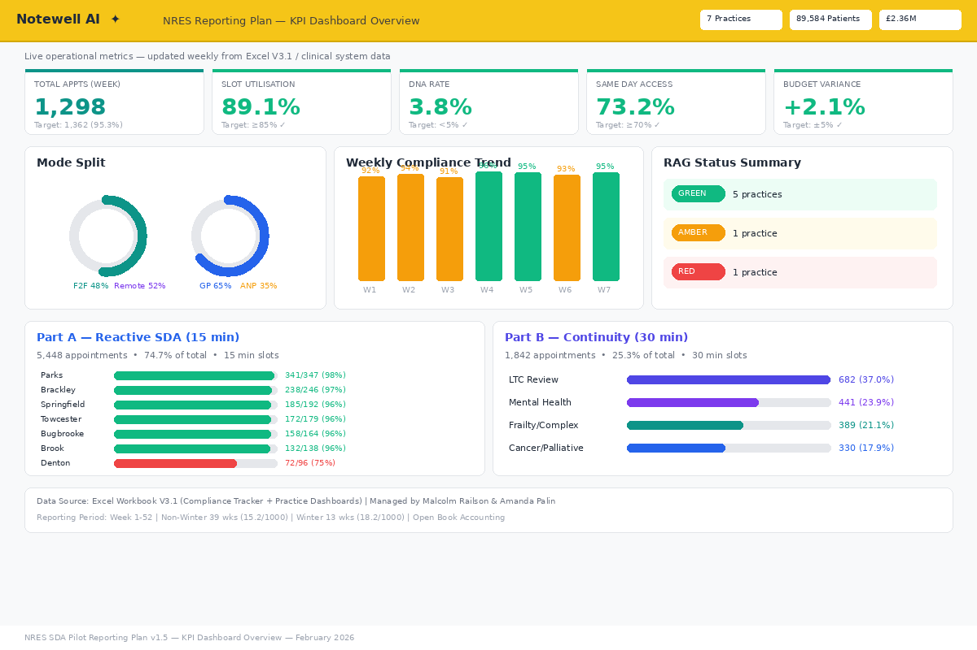
7.1 KPI Dashboard Overview — Notewell AI reporting view

7.2 Weekly Activity Report
Slot type analysis including Part B, rota performance by staff role, week-on-week trend
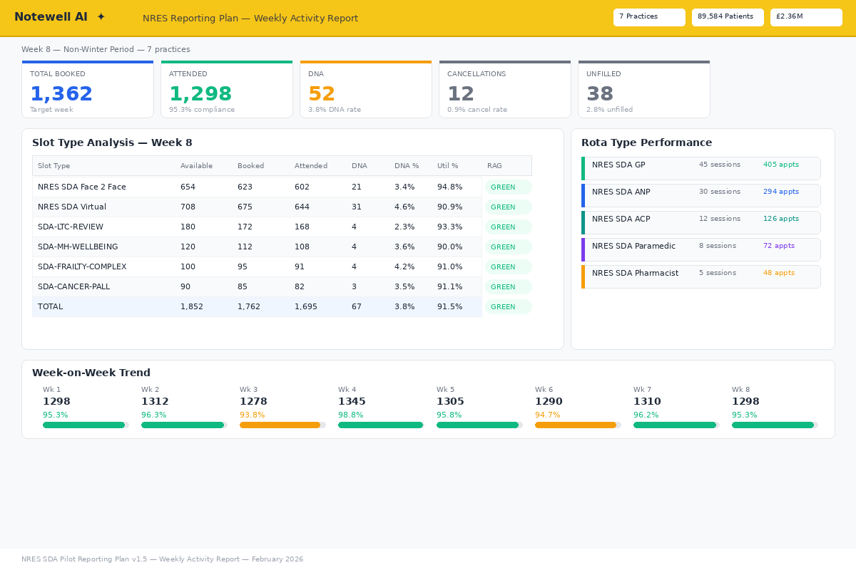
7.2 Weekly Activity Report — Notewell AI reporting view

7.3 Practice Comparison
All 7 practices: actual vs target, hub/spoke, list size allocation, financial allocation
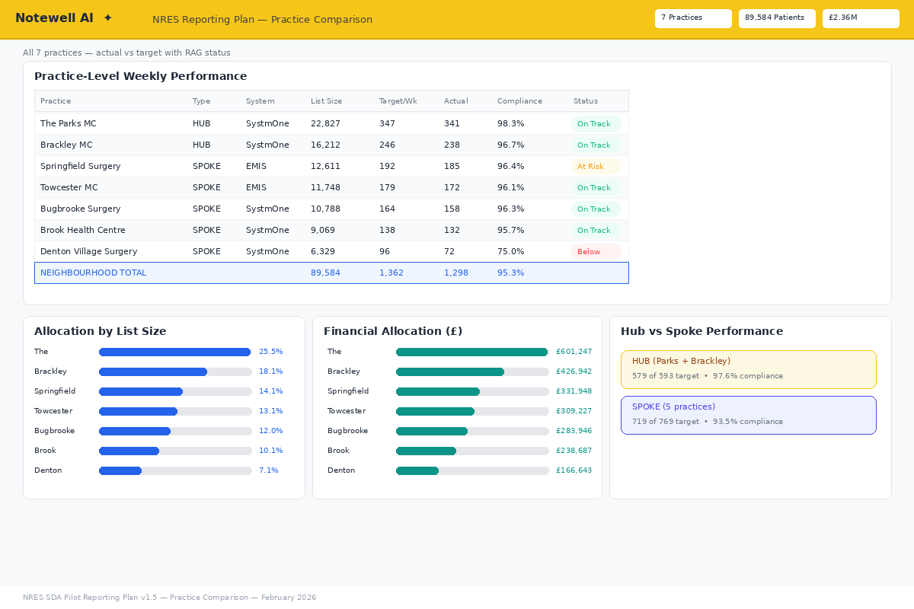
7.3 Practice Comparison — Notewell AI reporting view

7.4 Part B Continuity Evidence
Four national categories, SDA-prefixed slots, clinical system CSV import methodology
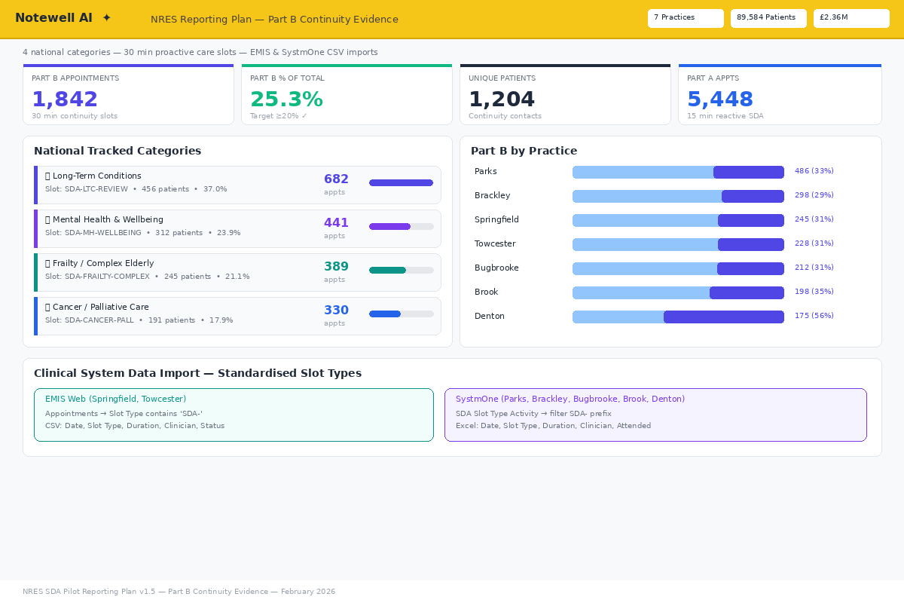
7.4 Part B Continuity Evidence — Notewell AI reporting view

7.5 Buy-Back Financial Tracking
Open book: recruit budget, new SDA vs buy-back per practice, evidence status, 6-step workflow
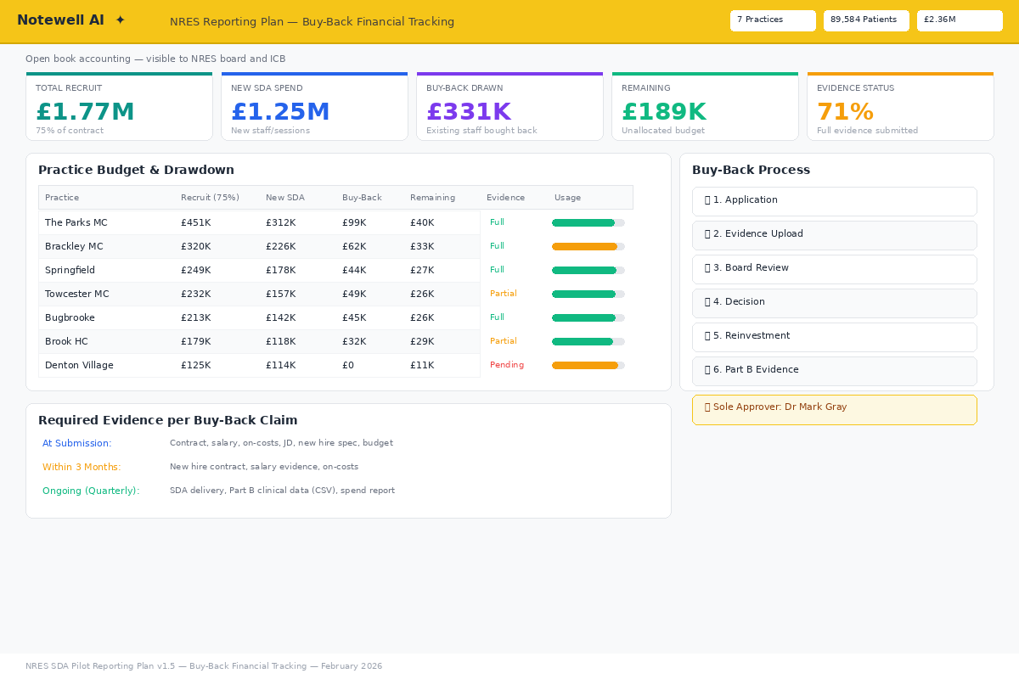
7.5 Buy-Back Financial Tracking — Notewell AI reporting view

7.6 Risk Stratification & Routing
RED/AMBER/GREEN patient routing, continuity rates, weekly RED flag monitoring
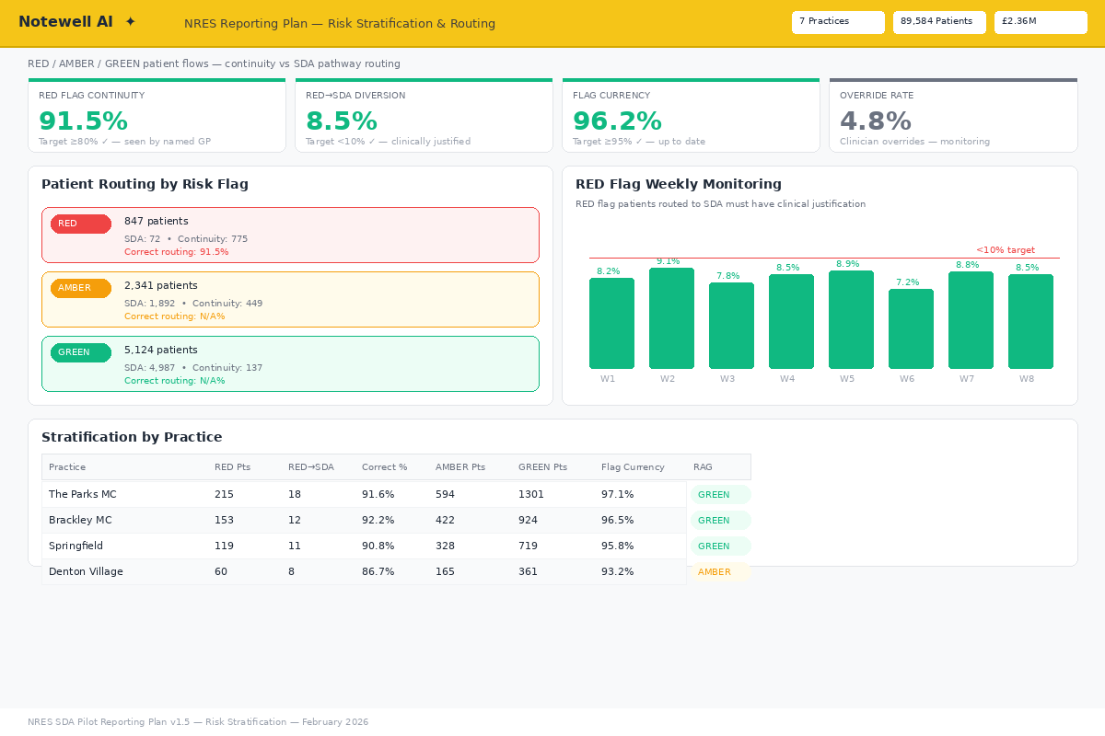
7.6 Risk Stratification & Routing — Notewell AI reporting view

7.7 Clinical System Connectivity
SystmOne vs GP Connect performance, booking sources, system distribution
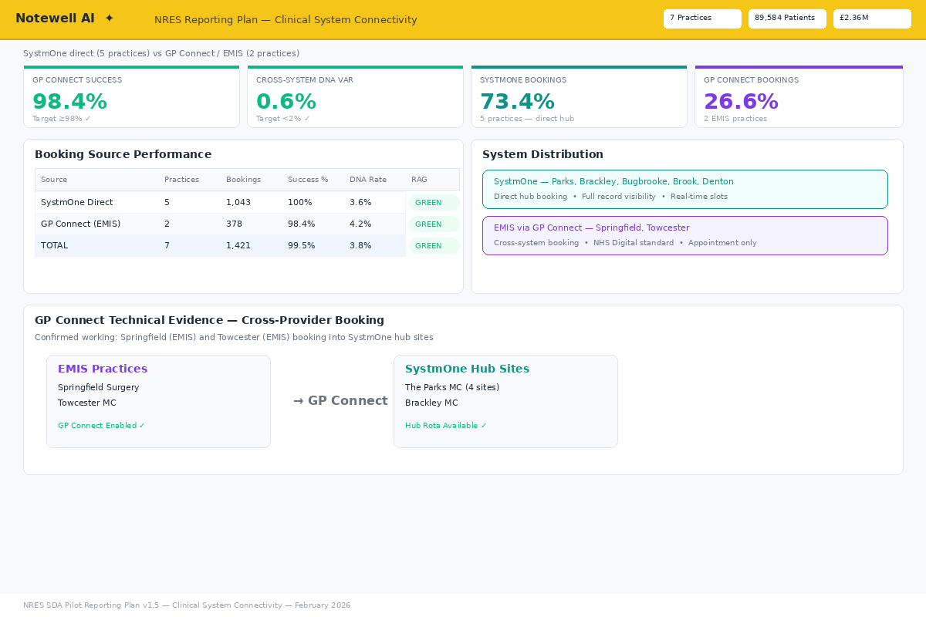
7.7 Clinical System Connectivity — Notewell AI reporting view

7.8 Financial Reconciliation
Monthly cash flow, spend breakdown, cost per appointment by mode and staff type
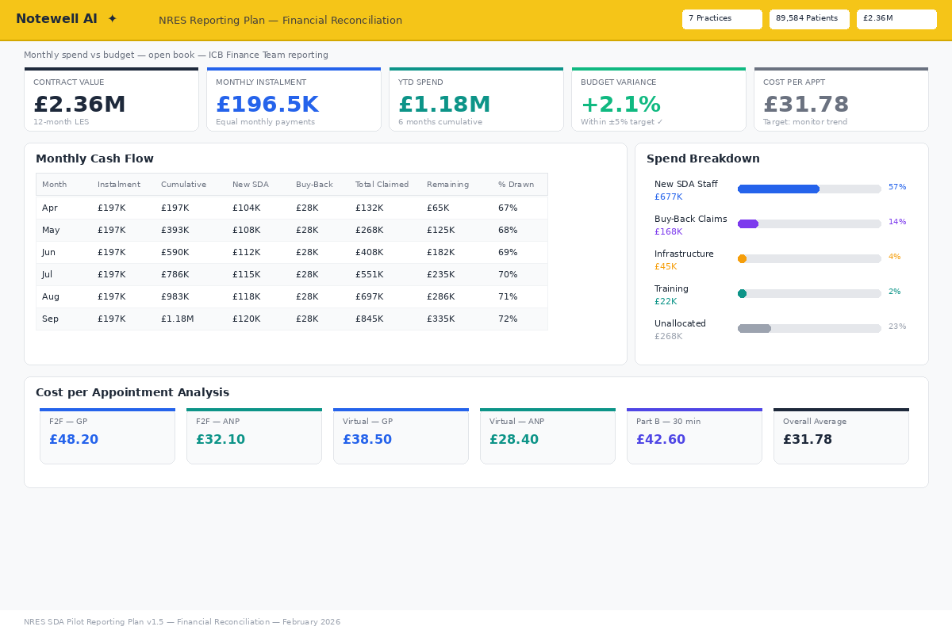
7.8 Financial Reconciliation — Notewell AI reporting view

7.9 Escalation & RAG Monitor
Escalation thresholds, trigger monitoring, practice-level RAG with compliance bars
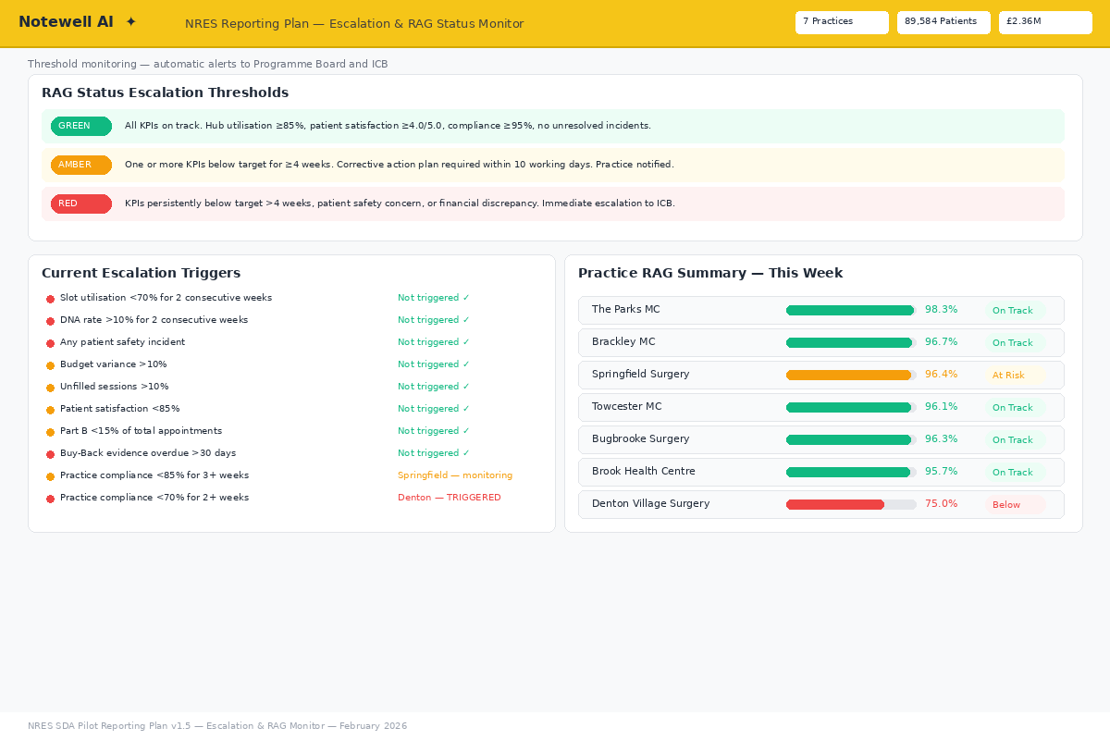
7.9 Escalation & RAG Monitor — Notewell AI reporting view

7.10 Quarterly Evaluation
Cumulative KPIs, value for money assessment, quarterly recommendations
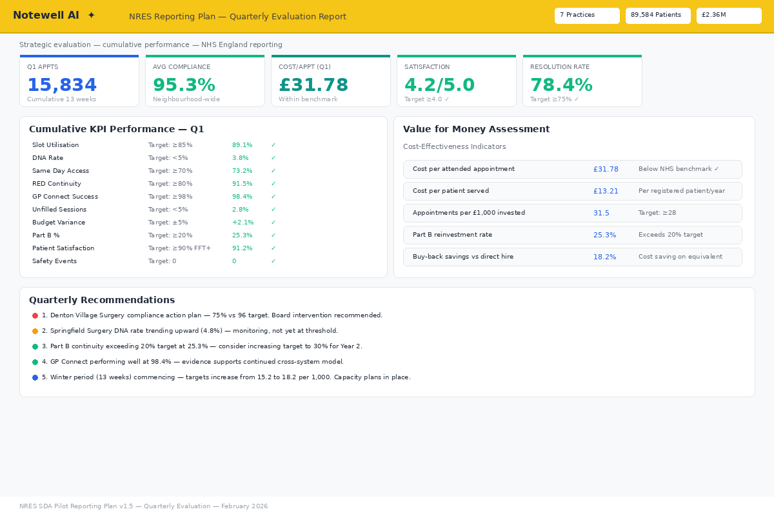
7.10 Quarterly Evaluation — Notewell AI reporting view

7.11 Quality & Safety Dashboard ★ NEW
ICB mandatory: complaints tracker, safeguarding referrals, IPC compliance, mandatory narrative section (ICB 2.2.1)
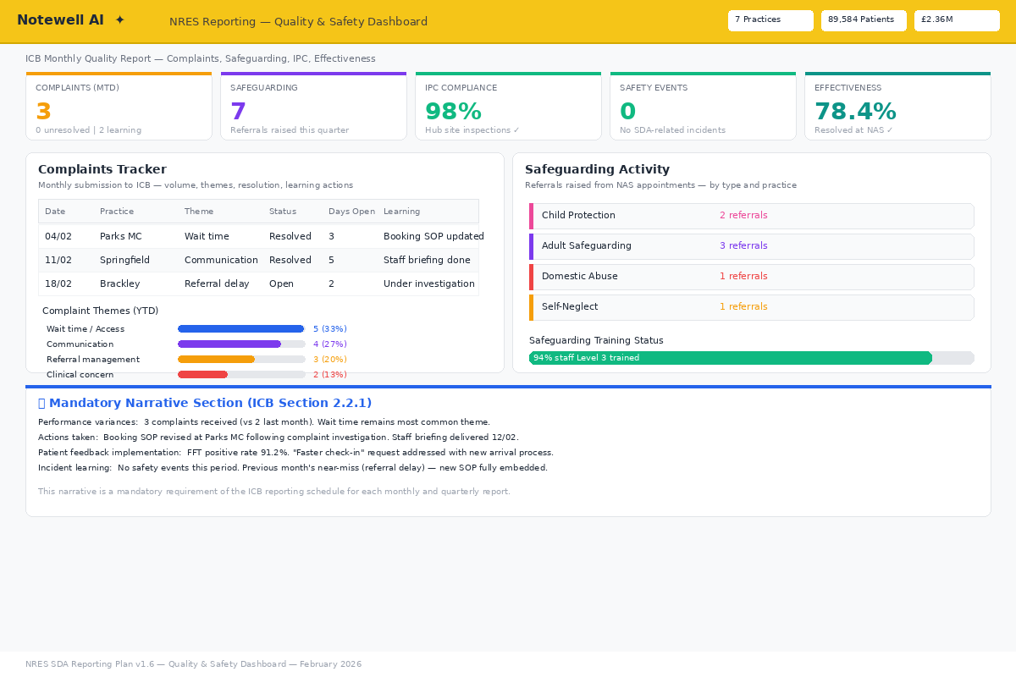
7.11 Quality & Safety Dashboard ★ NEW — Notewell AI reporting view

7.12 Health Inequalities & Core20PLUS5 ★ NEW
ICB strategic priority: deprivation quintile analysis, Core20PLUS5 cohort tracking, at-risk groups, proposed metrics (pending ICB confirmation)
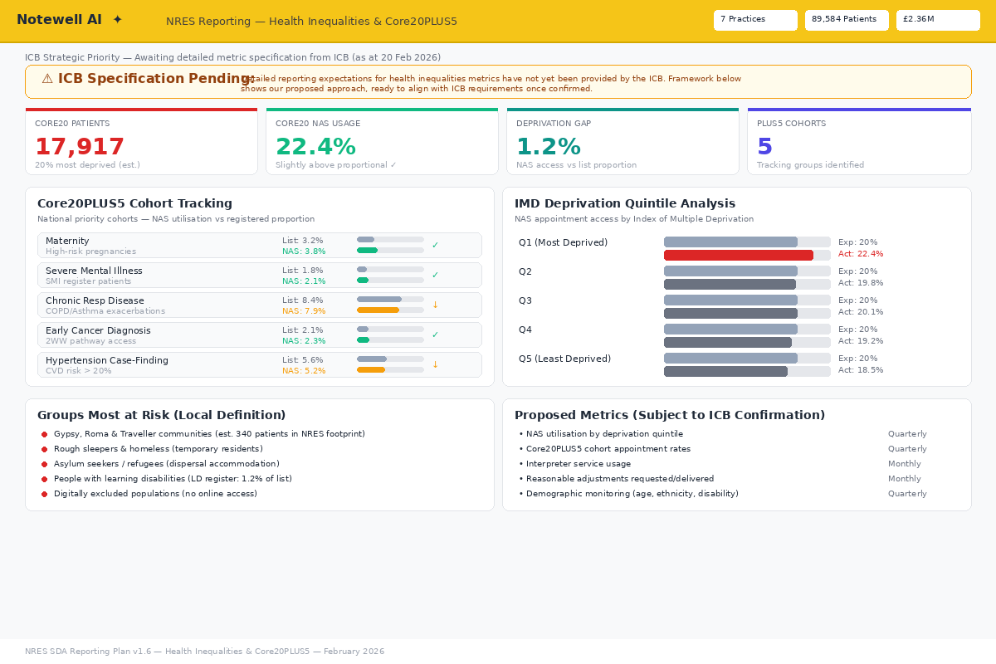
7.12 Health Inequalities & Core20PLUS5 ★ NEW — Notewell AI reporting view

7.13 Referrals & Diagnostics ★ NEW
ICB fixed monthly item: onward referral destinations, diagnostics ordered, 2WW referrals, direct-from-NAS compliance
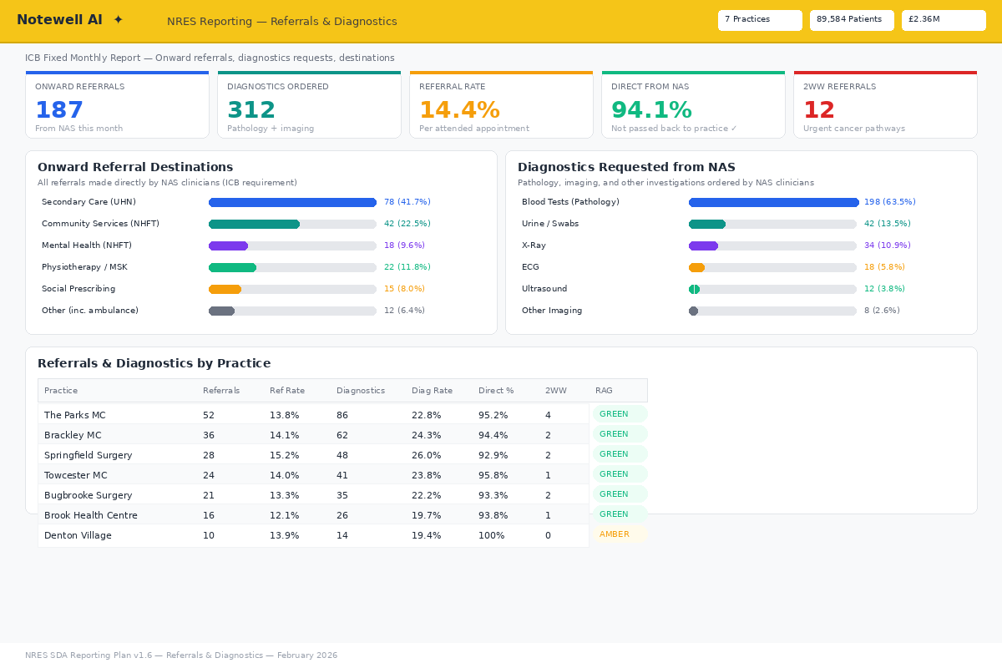
7.13 Referrals & Diagnostics ★ NEW — Notewell AI reporting view

7.14 Access Equity & Demand ★ NEW
ICB fixed monthly item: unmet demand tracking, repeat attendance analysis, equity of utilisation, EMAS bookings, named reporting leads
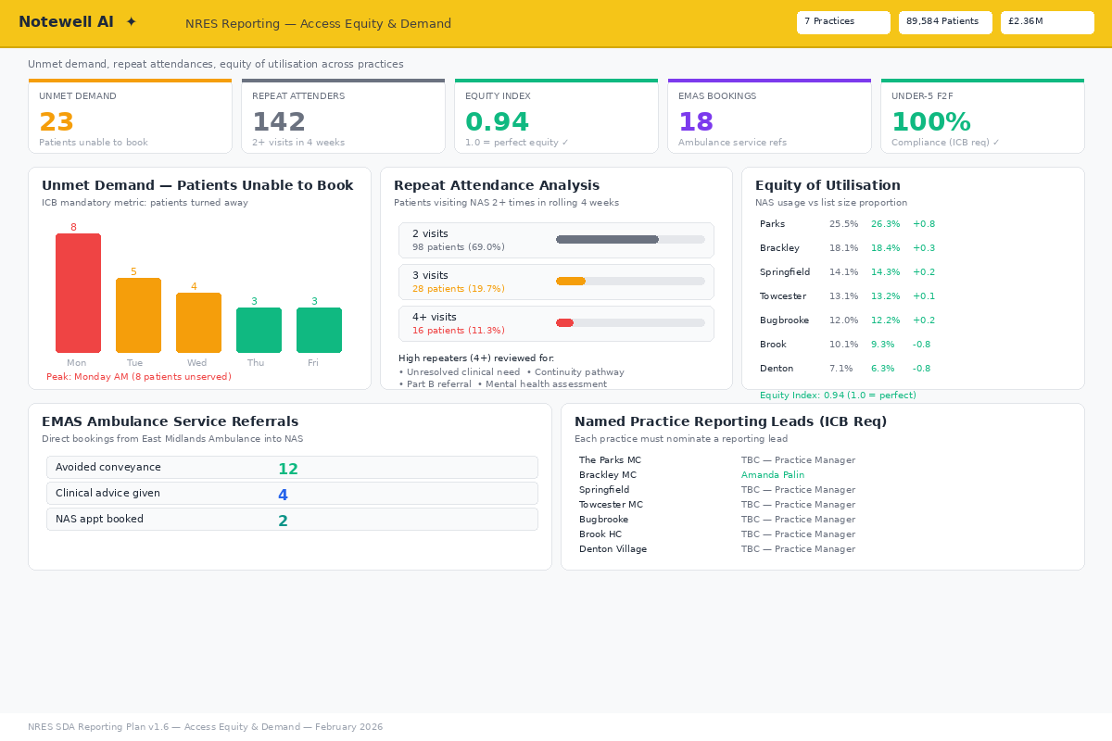
7.14 Access Equity & Demand ★ NEW — Notewell AI reporting view

7.15 Prescribing & Medicines ★ NEW
ICB Medicines Optimisation: prescribing by category, formulary compliance, PAF scores, antibiotic rates, practice breakdown
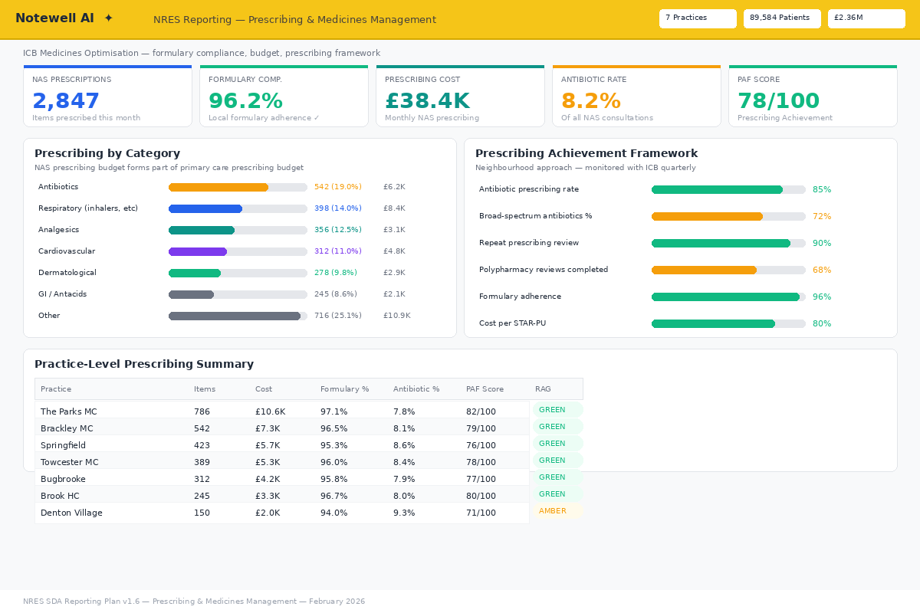
7.15 Prescribing & Medicines ★ NEW — Notewell AI reporting view

7.16 Workforce & Part B Duration ★ NEW
ICB outcomes: staff satisfaction survey, recruitment/retention, Part B appointment length monitoring, training placements
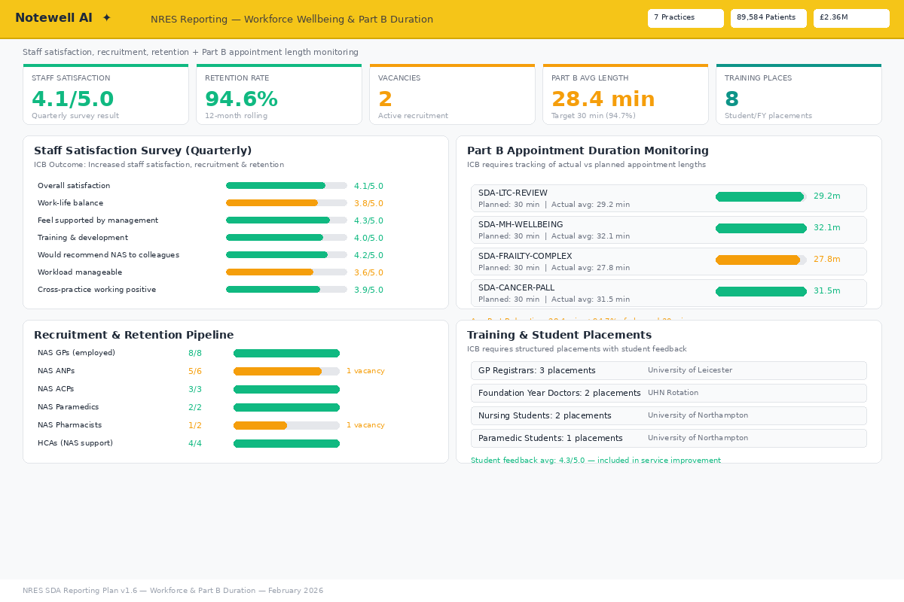
7.16 Workforce & Part B Duration ★ NEW — Notewell AI reporting view

8. Data Governance & Quality
All appointments coded with correct slot type at point of booking. Rota allocation must match clinician type. Outcome codes within 24 hours. Weekly data quality audits. Monthly validation against source systems. Buy-back evidence validated against financial records and Part B clinical data. Complaints and safeguarding data quality checked monthly.
Information governance: NHS DSPT compliance; patient data pseudonymised or aggregated; secure NHS network storage; data sharing agreements between practices and PCN; open book financial data visible only to NRES board and ICB finance.

9. ICB Specification Cross-Reference
The following table maps each ICB reporting requirement to the corresponding section in this Reporting Plan, confirming full alignment.
ICB Requirement | ICB Section Ref | Reporting Plan Section | Status
Utilisation rates (practice breakdown) | 2.2.1 | 3.1, 7.3 | Covered
Outcomes | 2.2.1 | 3.5 | Covered
Onward referrals | 2.2.1 | 3.7, 7.13 | NEW v1.6
Diagnostics | 2.2.1 | 3.7, 7.13 | NEW v1.6
Access times | 2.2.1 | 3.1 | Covered
Repeat attendances | 2.2.1 | 3.1, 7.14 | NEW v1.6
Patients unable to book | 2.2.1 | 3.1, 7.14 | NEW v1.6
Appointment lengths (Part B) | 2.2.1 | 3.10, 7.16 | NEW v1.6
Specific clinics for cohorts | 2.2.1 | 3.10 | NEW v1.6
Complaints | 2.2.1 Quality | 3.5, 5.3, 7.11 | NEW v1.6
Safeguarding | 2.2.1 Quality | 3.5, 5.3, 7.11 | NEW v1.6
IPC | 2.2.1 Quality | 3.5 | NEW v1.6
Patient experience | 2.2.1 Quality | 3.5 | Covered
Effectiveness | 2.2.1 Quality | 3.5 | NEW v1.6
Training/workforce | 2.2.1 Quality | 3.4, 7.16 | NEW v1.6
Narrative explanation | 2.2.1 | 4.2 | NEW v1.6
Named reporting leads | 2.2.1 | 2.3 | NEW v1.6
Open Book accounting | Governance | 3.6, 6 | Covered
Quarterly practice reports | Governance | 4.1 | Covered
Benefits realisation | 2.2 | 5.8 | NEW v1.6
Health inequalities | Part A | 3.8, 5.5, 7.12 | NEW v1.6*
Core20PLUS5 | Part A | 3.8, 7.12 | NEW v1.6*
Equity of utilisation | Exceptions | 3.1, 7.14 | NEW v1.6
EMAS referrals | Part A | 3.1, 7.14 | NEW v1.6
Prescribing/medicines | Medicines Opt. | 3.9, 5.4, 7.15 | NEW v1.6
Staff satisfaction | Outcomes 2.2 | 3.4, 7.16 | NEW v1.6
50:50 GP/ANP skill mix | Activity Model | 3.1 | Covered
Risk stratification | Part A | 3.3 | Covered
* Health Inequalities / Core20PLUS5 marked amber as ICB detailed metric expectations not yet provided (as at 20 Feb 2026). Framework in place ready for alignment.

10. Document Approval
Role | Name | Date | Signature
NRES Development Manager
Programme Board Chair
ICB Representative
Clinical Lead
Finance Lead

Document Control: Version 1.6 adds mandatory ICB reporting areas identified through cross-referencing against the ICB Enhanced Service Specification: complaints, safeguarding, health inequalities/Core20PLUS5, onward referrals & diagnostics, unmet demand, repeat attendances, prescribing/medicines management, equity of utilisation, EMAS referrals, staff satisfaction, Part B appointment duration, named reporting leads, mandatory narrative sections, and benefits realisation. 6 new dashboard mockups added (total 16). Reviewed quarterly.

