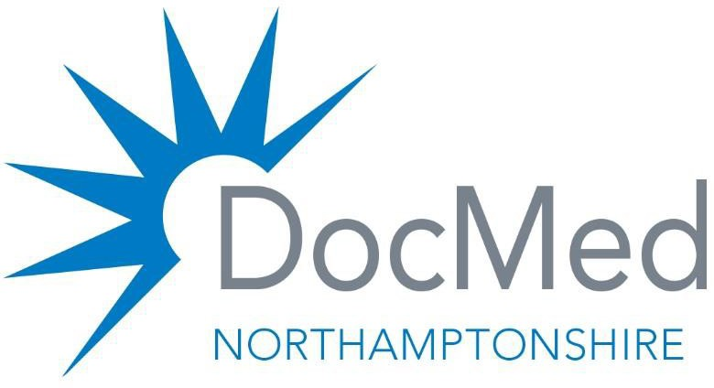

Same Day Access Innovator – Rural South and East Programme Board
Terms of Reference (ToR)
Background
As part of the Northamptonshire ICB New Models of Care programme, which aims to help patients stay well for longer by improving health and care services in local communities, across neighbourhoods, Rural South and East Neighbourhood have been successful in being selected as one of the neighbourhoods for West Northamptonshire.
Neighbourhood Access Service and Complex Care and Long-Term Condition Services are due to commence from April 2026. Over the next few months, we will work together across the Neighbourhood, with one voice and in collaboration, in order to develop these services together to ensure they are the best fit for our local populations and align to the service specification, to support positive patient outcomes and ensure sufficient evaluation data for onward funding commitment and expansion into other Neighbourhoods.
These ToR’s for the Programme Board will outline its purpose, scope, membership, responsibilities, and governance structure, ensuring effective oversight and delivery of projects.
Purpose and Scope
PML, as the Single Nominated Organisation, have formed the Programme Board to establish and to oversee the delivery of the Neighbourhood Access Service and the Complex Care and Long-Term services specific to this neighbourhood ensuring alignment with Northamptonshire ICB strategic objectives.
This Programme Board is responsible for:
- Providing Assurance: Ensuring that leadership, management, and governance arrangements are robust and effectively implemented to deliver the desired outcomes and benefits for positive patient experience and outcomes.

- Oversight of Workstreams: Monitoring the progress of various workstreams that will be required and ensuring that they align with the overall programme objectives.

- Decision-Making: Acting as an approving body of the workstreams required and to ensure transparent and timely feedback to the ICB. This will give assurance of the delivery and preparedness for the start of this innovation.

Membership
The membership of the Programme Board will consist of voting and non-voting members:
There are 8 Voting members:
- One GP and One Practice Manager from each of the seven Practices within the Rural South and East Neighbourhood. Each Practice will have One Vote. (One GP to be the named Clinical Lead on the Programme Board.)

- PML Senior Responsible Officer (and will have the deciding vote in the event of a tie)
Non-voting members
- PML Programme Director

- ICB representative to ensure that the SDA initiative remains true to the service specification and ensure a positive return on investment.

- Digital and Estates lead who will support the Digital and Estate solutions and set up of hardware to ensure delivery and training across the neighbourhood.

- Managerial Lead supporting the Programme Director and the Digital and Estates Lead to fulfil the SDA specification and tasks.

- A Deputy from each practice must be identified and may attend if the nominated representative is unable to attend.

- VCSE representative (s) will be co-opted onto the Programme Board as appropriate to ensure that the innovator has the support of Third Sector. VCSE will also be part of the appropriate task and finish groups alongside our PPG.

- Patient representative (s) will be co-opted onto the Programme Board as appropriate, however, these representatives will be engaged in appropriate task and finish groups, and communication will be circulated to them as a newsletter and distributed to the PPG groups within the seven practices.
Membership may change as the delivery of work progresses and therefore the membership must be reviewed monthly to ensure that we have fair representation and the right skills engaged for the implementation and success of this innovation.
PML will ensure that the Programme Board is provided with secretarial support to ensure agendas, papers and meetings are minuted and circulated in a timely manner. This will include the PML Project Manager who will support the project timeline and framework ensuring that actions and targets are written and transparent to all stakeholders.

Key Roles and Responsibilities overview
(1) Senior Responsible Officer (SRO):
The SRO is responsible for the overall delivery of the programme and will Chair the Programme Board. The SRO will be Dr Mark Gray as the Medical Director of PML as the Single Nominated Organisation.

(2) Programme Director
A Programme Director oversees the development, implementation, and management of the SDA initiative ensuring alignment with strategic goals and effective execution. They are the liaison point between the membership and aligned tasks, clinical and financial governance and for the organisation of the Programme Board meetings, ensuring all information is available. This will include finance reports, performance reports, risk register ownership.
The Programme Director will be Maureen Green, Director of Community Services as PML is the nominated Single Nominated Organisation. This role will be accountable for the execution of the programme and in the absence of the SRO will chair the Programme Board meetings.

(3) Clinical Lead
A Clinical Lead is one of the key General Practitioners who will be responsible for advising and overseeing on the new initiatives. This will include overseeing recruitment and practices, ensuring high-quality patient care, and leading clinical teams within healthcare settings and developing and agreeing the patient pathways and standard operating procedures.
The Clinical Lead will be Dr Simon Ellis supporting will be Dr Muhammed Chisti

4) Managerial Lead
The Managerial Lead will take on specific identified responsibilities as advised by the Programme Director. This is a vital supporting role for the success of the initiative. This will also include support to the Estates and Digital solutions.
The Managerial lead is Amanda Taylor and supporting this will be Lucy Hibberd

(5) Digital and Estates Lead
The Digital and Estates Lead will support the Digital and Estates solutions and set up of hardware to ensure delivery and training across the neighbourhood. This role will work closely with the Managerial Lead reporting into the Programme Director to ensure that reporting and actions are responsive for the delivery of the initiative.
The Digital and Estates Lead will be Malcom Railson supporting this will be Alex Whitehead.

Responsibilities and actions of the Programme Board
The Programme Board has several key responsibilities, alongside operational resources including:
- It is a decision-making Board in collaboration with all the membership.

- Reviewing and Approving actions and tasks that may be delegated to individual operational or working teams to ensure that the innovation will be fit and ready for purpose.

- Scrutinizing update reports and directing any actions that need to be taken to ensure the project remains on time.

- Producing regular performance reports to be submitted to the ICB

- Escalation of Issues: Identifying and escalating critical issues that may affect programme progress or reputation.

- Ensure financial governance that the innovation remains within the financial envelope.

- To agree External and Internal communication plans to ensure that patients, MPs, Councillors, third Sector and ICB are aware of progress.

- To agree the Key Performance Indicators (KPIs) that are to be measurable positive outcomes.

- To agree the recruitment strategy in order to deliver on the outcomes.

- To agree the hub and spoke model of care.

- To agree the Part B of the innovation to ensure measurable outcomes and focussed health needs are agreed and deployed across the neighbourhood.

- To ensure that Standard Operating Procedures and Policies cover all elements of the patient pathway and in line with regulatory and governance requirements.

- To ensure that a training plan is agreed as we begin to roll out the innovation as we scope training and skills gaps.

- To agree a Risk Register for the innovation and that this is scoped and agreed and reviewed at every meeting and shared at PML Board and individual Practice Partnership meetings monthly.

The Programme Board will meet every two weeks in the first instance as we scope out the tasks and actions that will be nominated to individuals within the Programme Board membership.
One of the meetings will always be held in person at the end of the monthly DocMed meetings.
The other meeting can be a virtual meeting to reduce the amount of travel and time away from each of our work areas.
Meeting rooms have been made available in between the Programme Board meetings for each member of the task and finish group and nominated accountable person to be able to use to meet with others as actions and pathways are agreed and developed.
For Quoracy in the Programme Board– There must be One representative from each of the Practices.
For any voting within the Programme Board – there must be a winning number of votes. In the instance of a tied vote then the SRO will have the last vote and say on the action being voted on.

