Referensi

<https://how2electronics.com/iot-ac-energy-meter-with-pzem-004t-esp32-webserver/#google_vignette>

wiring

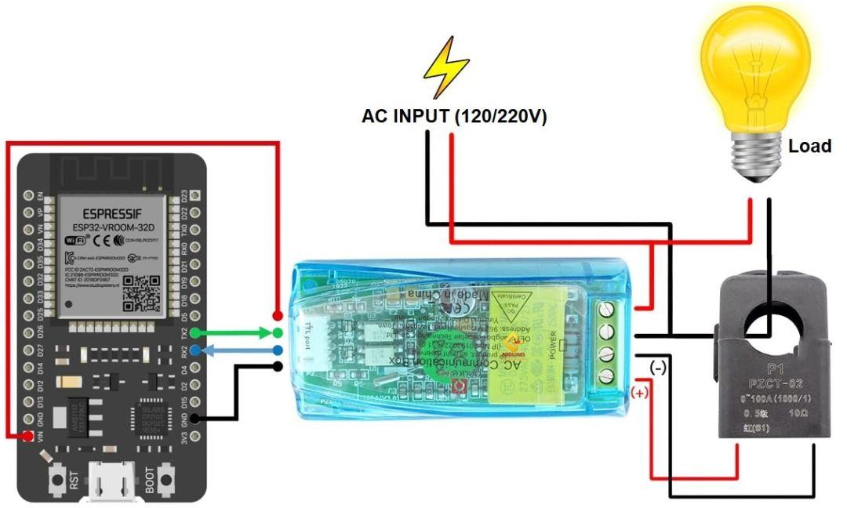

<https://randomnerdtutorials.com/esp32-ds18b20-temperature-arduino-ide/>

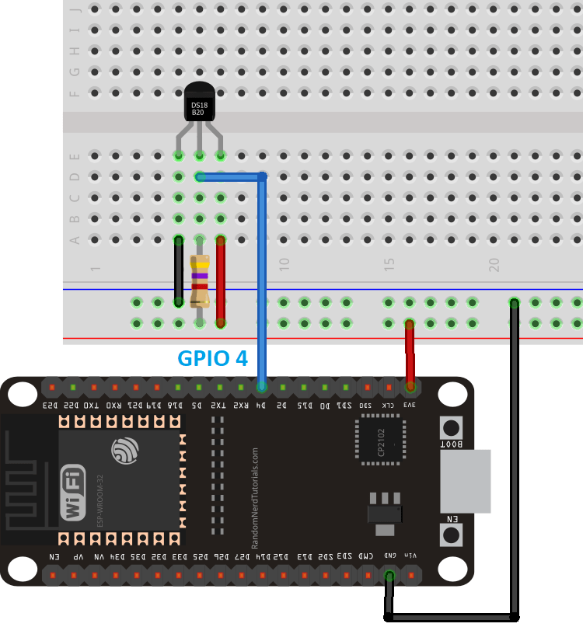

<https://esp32io.com/tutorials/esp32-keypad-1x4>

