**Estimating access to rabies post-exposure prophylaxis in Madagascar**

*Malavika Rajeev*

*July 18th, 2018*

**Background**

* An estimated 60,000 people per year die from canine rabies globally.
* These deaths are preventable if people receive prompt post-exposure prophylaxis (PEP.
* In countries where rabies is endemic, there are significant barriers to accessing PEP (i.e. socioeconomics, availability)
* In Madagascar, PEP is provided at no cost to the patient, however there are only 31 clinics, or CTAR (centre de traitment antirabique) in the country where PEP is available (Figure 1 inset in A) and no mass dog vaccination.

**Data**

* 16 months of data on clinically diagnosed and laboratory confirmed animal rabies cases and corresponding human exposures from the Moramanga District (Figure 1).
* 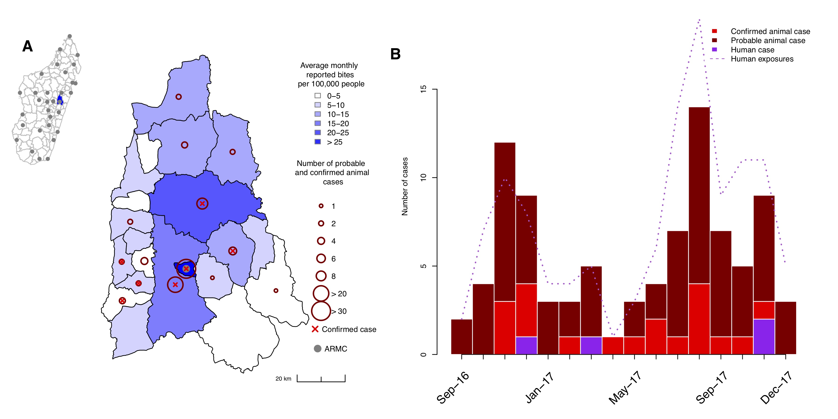Institut Pasteur Madagascar also has 4 years of data on **reported animal bites** from 20(?) of the 31 CTAR.

***Figure 1. Rabies in the Moramanga District.*** *A) Average monthly reported bite incidence (blue shading) per commune and total numbers of probable or confirmed cases (dark red circles). A red x indicates if at least one animal case was confirmed in the commune. All coordinates are the commune centroid, and the inset shows the district (in blue) in relation to the other districts (polygons) and ARMC (grey points) in Madagascar. B) Time series of probable and confirmed animal cases and human cases (bars), as well as total confirmed/probable rabies exposures (dashed line) from September 2016 to December 2017.*

***How do we estimate the burden of human rabies in Madagascar with the available data?***

**The standard decision tree approach**

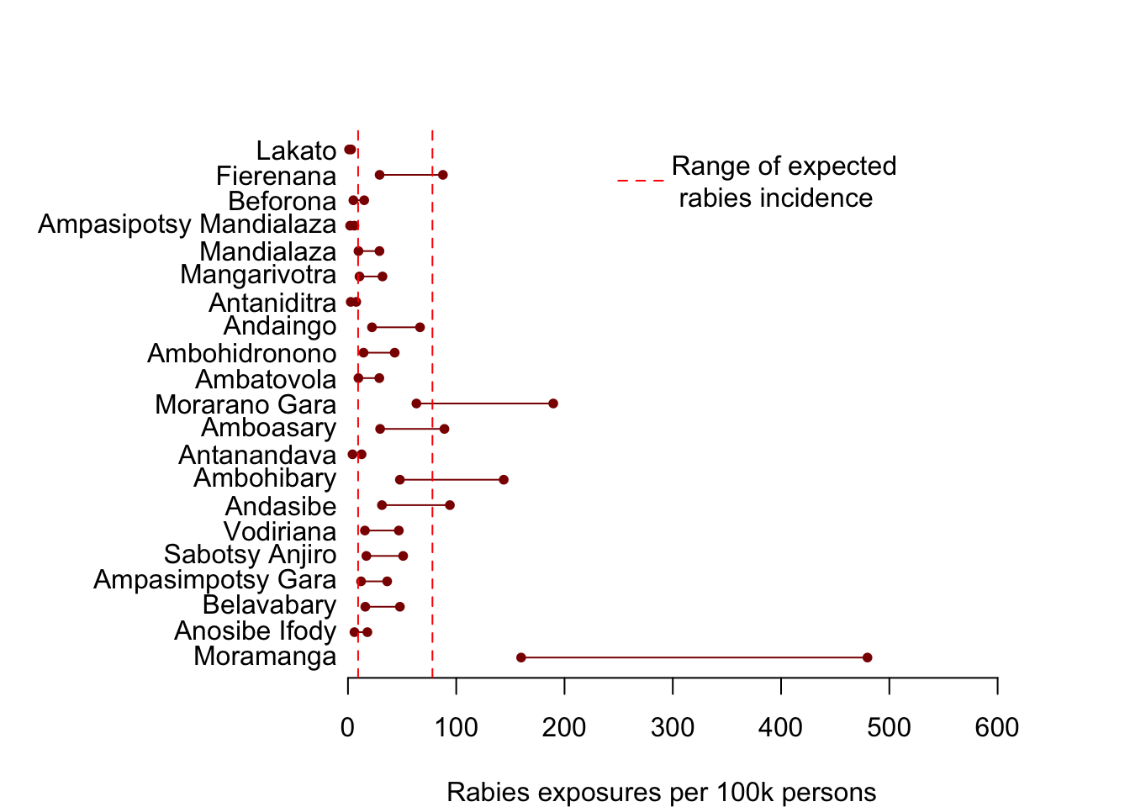 $R=\frac{B×p_{rabid}}{ρ}$ $R=\frac{B×p_{rabid}}{ρ}$

* $R$ $R$ is the estimated rabies exposure incidence
* $B$ $B$ is the total reported bites
* $p_{rabid}$ is the probability that a reported animal bite is a genuine rabies exposure
* $ρ$ $ρ$ is the probability that a rabies exposure is reported
* Using district level estimates of $p_{rabid}$ = 0.2 -0.4 and $ρ$ = 0.85 from data aggregated to district level from the Moramanga District as shown in Figure 1.

$$R=\frac{B×p_{rabid}}{ρ}$$

***This assumes that reported animal bites are proportional to rabies exposure incidence.***

***Figure 2****. Estimates of rabies exposure incidence at the commune level for the Moramanga District using standard decision tree.*

***Instead, we’re going to assume that rabies exposure incidence is the same everywhere and bites primarily reflect differences in reporting.***

**Model of reporting by travel time[1] to clinic**

$ρ=\frac{B×p_{rabid}}{R}$

We estimate the potential relationship between travel time and reporting ( $B_{tt}$ and $B_{0}$) given high and low estimates of incidence 2 and high, mid, and low proportion rabid ( $x$ $x$ = 0.25, 0.5, or 0.75).

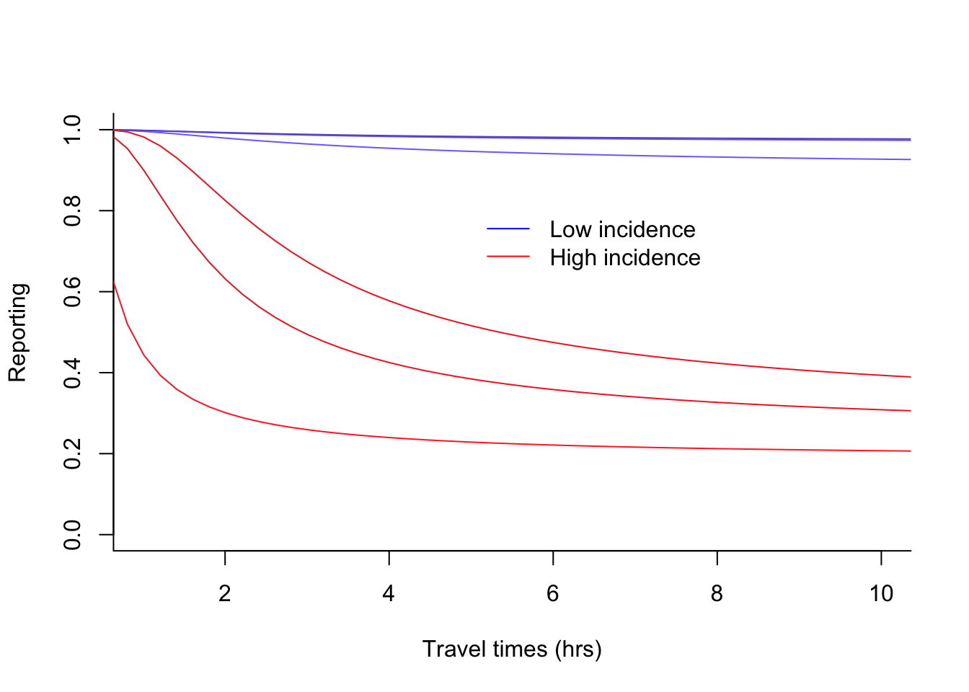 $B∼Poisson(\frac{ρR}{p_{rabid}})$

$ρ=logistic(B_{tt}T+B_{0})$ $p_{rabid}=\left\{\begin{matrix}x, & if \frac{R}{B}>x \\ \frac{R}{B}, & otherwise\end{matrix}\right.$ $ρ=\frac{B×p_{rabid}}{R}$

$p_{rabid}=\left\{\begin{matrix}x, & if \frac{R}{B}>x \\ \frac{R}{B}, & otherwise\end{matrix}\right.$

***Why/is this a (more) reasonable assumption to make?***

1. Travel times to closest CTAR generated from friction surfaces from Malaria Atlas Project <https://map.ox.ac.uk/research-project/accessibility_to_cities/>.

   2 Range of estimated rabies incidence from recent modeling study which estimated human rabies exposure incidence in a fully susceptible dog population (i.e. no dog vaccination).