Supplementary Materials

## S1. Estimating travel times to the nearest ARMC

We used two raster inputs: 1) the travel time estimates generated using the friction surface from the Malaria Atlas Project (Weiss et al. 2018) at an ~1 km^2 scale and the locations of existing ARMC and 2) the population estimates which we resampled from the World Pop raster of population originally at an N resolution. We then extracted the mean of travel times weighted by the population in that grid cell for each district or commune to get administrative level estimates of travel times to the nearest ARMC. Figure S1 shows the raster inputs as well as the resulting estimates of travel times at the admin level.

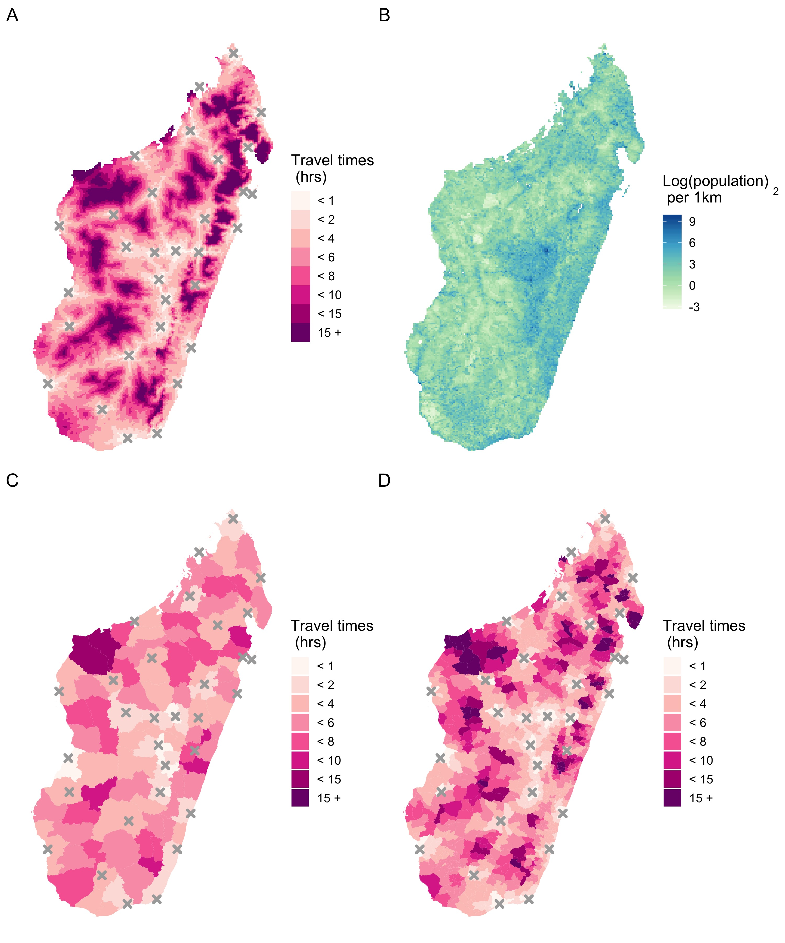 ***Figure S1.1. A)*** *Travel time estimates at an approximately 1x1 km scale* ***B)*** *Population per 1x1 km grid cell. Mean travel times weighted by population size extracted for each* ***C)*** *District and* ***D)*** *Commune.*

## S2. Correcting data for underreporting and excluding Category I exposures

### Underreporting of forms

Figure S1.1 correcting

Figure S1.2 vial ests

### Cat I exposures

Figure S1.3 contacts

Figure S1.4 ttime differences

## S3. Candidate models of bite incidence

## S4. Sensitivity of these models to reporting/contact cut_offs

## S5. Incrementally adding clinics (where they were added, shifts in ttimes + catchment pops, shifts in burden/reporting etc. –answer q here: why are there still abt 100 deaths)

## S6. Sensitivity of burden estimates to parameter assumptions (baseline + incremental)

## References

Weiss, D. J., A. Nelson, H. S. Gibson, W. Temperley, S. Peedell, A. Lieber, M. Hancher, et al. 2018. “A Global Map of Travel Time to Cities to Assess Inequalities in Accessibility in 2015.” *Nature* 553 (7688): 333–36. <https://doi.org/10.1038/nature25181>.