Estimating Access to Rabies Post-Exposure Prophylaxis in Madagascar

## INTRODUCTION

Inequities in access to care are a major driver of disease burden globally. Often, the populations at greatest risk of a given disease are the most underserved. Delivering interventions to these groups is challenging due to financial and infrastructural limitations, and requires careful consideration of how best to optimize the allocation of limited resources.

Canine mediated rabies is estimated to cause approximately 60,000 human deaths anually. These deaths can be prevented through prompt administration of post-exposure prophylaxis. However, access to this intervention is highly limited in areas where the disease is endemic (*cite GAVI paper or Nandini’s paper of geographic availability of PEP*). Data on true rabies exposures in humans and incidence in animals is also lacking in most of these countries, with the most commonly available data being numbers of bite victims reporting to health facilities. The majority of rabies burden studies thus far have integrated these data on reported bites into a probability decision tree framework to estimate rabies burden, often with the key assumption that overall reported bite incidence (i.e. both bites due to non-rabid and rabid animals) are proportional to rabies incidence (i.e. the more bites reported in a location, the higher the incidence of *rabies* exposures there) and that reporting is uniform across space. At the sub-national level where access to PEP is highly heterogenous, these assumptions likely underestimate rabies deaths in places with low reporting and overestimate rabies deaths in places with high reporting of bites.

In Madagascar, Institut Pasteur de Madagascar (IPM) provides PEP at no-cost to patients at 31 clinics, or anti-rabies medical centers (ARMC) across the country. PEP is not available at any other public clinics or through the private sector. In addition, there is limited control in dog populations and the disease is endemic throughout the country. Due to the spatially restricted nature of PEP, geographic access is likely to be a major driver of disease burden within the country. To get spatial estimates of disease burden in this context, we use data on reported bite incidence at the sub-national level (district) and assume that bite incidence reflects access to PEP rather than than differences in rabies incidence. We fit the data to travel times to the closest ARMC, a metric of geographic access. Then using a range of rabies incidence given endemic transmission with no mass dog vaccination (*GAVI paper*), we generate sub-national estimates of rabies burden in an adapted decision tree framework.

In 2018, Gavi added PEP to their vaccine investment portfolio, and by 2020, Gavi-eligible countries will be able to apply for funding to expand access to PEP, which has the potential to drastically reduce burden of rabies. We explore the impact of this potential intervention using this same model pipeline, we explore the impacts of geographically expanding access to PEP in Madagascar on reducing the burden of human rabies deaths.

## METHODS

### GIS Data

We used the global friction surface for 2015 generated by the Malaria Atlas Project ( <https://map.ox.ac.uk/research-project/accessibility_to_cities/>, Weiss et al. 2015,) and GPS points of clinics to estimate the travel time to the nearest ARMC for the country of Madagascar at a 1 x 1 km scale. We then calculated a weighted average of travel times by human population to the commune level, using administrative shapefiles available trhough the UN Office for the Coordination of Humanitarian Affairs. Human population estimates were taken from the 2015 UN adjusted population projections from World Pop (www.worldpop.org, Linaird et al. 2012) and also aggreagated to the commune level.

## OGR data source with driver: ESRI Shapefile   
## Source: "/Users/mrajeev/Documents/Projects/MadaAccess/data/MadaGIS/MadaPops.shp", layer: "MadaPops"  
## with 114 features  
## It has 25 fields

## OGR data source with driver: ESRI Shapefile   
## Source: "/Users/mrajeev/Documents/Projects/MadaAccess/output/communes/communes_extracted.shp", layer: "communes_extracted"  
## with 1578 features  
## It has 12 fields  
## Integer64 fields read as strings: id_0

### Bite patient data

We used a database of bite patient forms submitted to IPM from ARMC across the country between 2014 - 2017. These were individual patient data forms that were submitted as frequently as monthly to annually by clinics. Of the 31 existing ARMC, 10 submitted fewer than 10 forms over the four years. Two clinics, the IPM ARMC and the Fianarantsoa ARMC had separate databases which were not available at the time of analysis. Overall, we had data from 19 clinics across the country (Fig 1A). These data include details of the administrative district of the bite patient’s address and the date of reporting. We also had 27 months of data from the Moramanga District that were resolved to the commune level (the administrative level below the district).

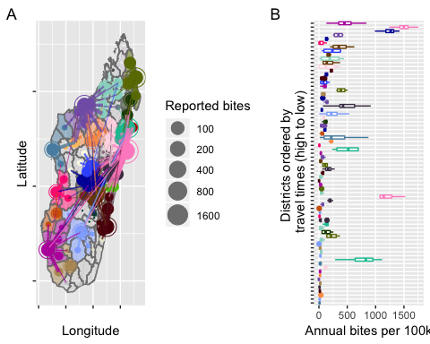

For most districts, the majority of bites were reported to the closest clinic as estimated by our travel time metric (Fig 1A). Therefore, we defined the catchment area for each clinic as all districts for which the clinic was the closest ARMC. We excluded any catchment areas for which the clinic did not submit any forms (catchments = 12, districts = 42, in grey in Fig 1A).

As even for clinics which submitted data, there was substantial undersubmission of forms, we estimated clinic level reporting as the proportion of days on which forms were submitted, excluding any periods for which there were no forms submitted for 15 consecutive days (Figure S2.1A). Our estimate of reporting did vary based on our assumption of the threshold number of consecutive days (Figure S2.1B), so in subsequent analyses we looked at the sensitivity of model parameter estimates to changing this threshold. To estimate the average annual bites reported for each district, we further excluded data from any years for which there was less than 25% reporting at the clinic level.

Previous work in the Moramanga District showed that low risk contacts, i.e. touching or feeding a suspected animal or human rabies case, make up approximately 20% of patients reporting to ARMC (Rajeev et al. 2018). These low risk exposures do not contribute to burden and therefore we attempted to exclude them from our analysis. Generally, contacts present as clustered cases, so we excluded patients reporting on any dates that had greater than 3 standard deviations above the mean number of patients reporting per day (Figure S2.1A). We validated this method using the Moramanga ARMC data for which we had details on the type of exposure, and found that setting the threshold to 3 standard deviations (SDs) resulted in approximately 50% of known contacts excluded, with only 2% of non-contacts excluded (Figure S2.1B). For the national data for which a subset of patient forms were explicitly noted to be contacts, we found that our exclusion criteria of 3 SDs identified 68.28 of known contacts. We further excluded these known contacts which were not identified based on the daily distribution of patients, resulting in the exclusion of approximately 7.18 % of patient records from the national data.

After excluding contacts and correcting for undersubmission of forms, our final dataset consisted of estimates of average bite incidence for 72 districts from 19 catchments (Figure 4).

### Model of reported bites as a function of travel time

We modeled incidence of bites as a function of travel times in hours as follows:

where is the expected number of bites given travel times and the human population size for a given location. We then estimate the likelihood of observing our data where observed bites are a poisson distribution around the mean , given , the effect of travel times of reported bites and , the model intercept.

We fit this to our available data in three ways: 1) Average annual reported bites at the commune level estimated from 27 months of data from the Moramanga District 2) Average annual reported bites at the district level (calculated as above from the national database) 3) Average annual reported bites at the district level, but with commune level travel times () so that:

We also looked at how well distance from the closest ARMC (rather than travel times) predicted bites as an alternative proxy for access, replacing travel times in hours () with distance from the nearest ARMC in km (). Distance to the nearest ARMC was taken as the minimum distance from the centroid of the commune or district to any ARMC. As travel times are correlated with human population size (Figure S3.1A), we also compared how well bites were predicted by human population size alone and in combination with our metrics of access. For the models with population size, we used a model framework with either population size alone or population size and a access metric (either travel times or distance) as predictors of bites (for example, for a model with population size and distance as covariates: ).

### Estimation of burden and reporting

We used our model to predict average annual bite incidence for all 114 districts in Madagascar. We estimate average reporting of rabid exposures and deaths due to rabies given this and assumptions about rabies exposures.

We calculated the expected reporting of rabid exposures () given bite incidence as predicted by our model() as:

or the fraction of incidence due to rabid exposures () divided by the total rabies exposure incidence () for a range of estimated rabies incidence and . We look at the range of reported in Rajeev et al. 2018 for data from the Moramanga District (0.2 - 0.6). where the proportion of reported bites that are rabies exposures () are defined as:

such that rabid reported bites (i.e. ) cannot exceed the expected number of human exposures given maximum reporting (i.e. ). is taken from the Moramanga ARMC data for Moramanga Ville, the commune with the ARMC (i.e. the area with the minimum travel time in the district, on average 3.12 minutes).

To generate , the rabies incidence in dogs in the absence of any vaccination, , is multiplied by the estimated dog population in the commune () and the exposure rate per rabid dogs ( = 0.39 persons exposed per rabid dog)(Hampson et al. 2018). We use a human:dog ratio (HDR) of 5 to generate our maximum expected incidence and an HDR of 25 for our minimum expected incidence, which gives a range of approximately 15.6 - 78 exposures per 100,000 persons. As there is little data on dog populations in Madagascar, this range encompasses both a wide range of observed HDRs and exposure rates across Africa (*cite*).

We compare the estimates of reporting generated from the commune model vs. the district model by summing the commune level reporting estimates weighted by the proportion of the district population they are applied to such that:

To estimate the average number of deaths for each administrative unit, we extended the above framework into a stochastic framework as follows:

where is drawn from a uniform distribution between the minimum and maximum expected number of human exposures for each location and , the number of reported bites, is drawn from a poisson distribution with the mean predicted number of bites from the travel time model. We draw from a uniform distribution between 0.2 - 0.6, while constraining it as per Equation 4. We assume that all rabies exposed patients who report to an ARMC receive and complete PEP, and PEP is completely effective at preventing death due to rabies. The probability of death in the absence of PEP is taken from Changalucha et al. 2018 (*cite*).

### Strategically expanding PEP access

Given limited resources and capacity of clinics to provision PEP, we developed a framework to look at the incremental benefit of expanding PEP provisioning to additional clinics. Starting with the current locations, we added one clinic at a time, calculating the proportion of people living < 3 hours away from any clinic for the country. We added the clinic which minimized this metric, and then repeated the process iteratively, ranking clinics and adding the top clinic sequentially. We calculate burden for the given clinic locations and look at the incremental reduction in burden as each clinic is added.

We also look at how expansion to additional clinics may impact vaccine demand. Specifically, we use our model predicted estimates of annual bites for each administrative unit and then aggregate these to the clinic catchment (assuming that all patients report to their closest clinic). For each catchment, we simulate throughput by randomly assigning patient presentation dates, and then assuming perfect compliance (i.e. all patients reporting subsequently on day 3 and day 7 for their second and third doses) generate dates of subsequent doses. We use these dates to estimate vial usage given routine vial sharing practices in Madagascar (i.e. each vial is split between two patients, and vials are discarded at the end of each day) and the new abridged TRC regime (2 injection sites on day 0, 3, and 7). We take the mean of 100 simulations of throughput for each catchment and scenario.

### Sensitivity analyses for burden estimates

We estimate burden deterministically across a range of parameter values to test the effects of our model assumptions on estimates of rabies burden. Specifically, we fix rabies incidence at the minimum and maximum of our estimated range, look at the range of values of p_rabid between 0.2 - 0.6 (as per Moramanga), and the range of values of rho_max (0.85 - 0.99) to get at maximum and minimum estimates of burden. We also examine the impact of systematic variation in rabies incidence with human population (a potential proxy for changes in the dog population, see section S5) by looking at how estimates of burden change if rabies incidence were to scale positively or negatively with human population size.

## RESULTS

### Models of bites as a function of travel times

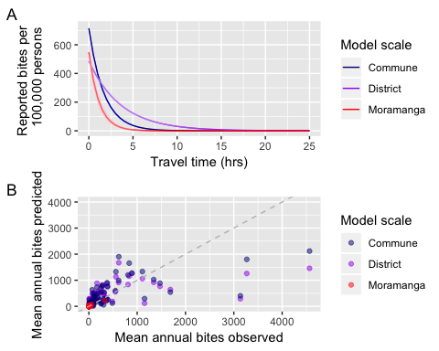

|  |  |  |  |  |  |  |  |
| --- | --- | --- | --- | --- | --- | --- | --- |
| beta | intercept | beta_upper | beta_lower | intercept_lower | intercept_upper | likelihood | model |
| -0.2755049 | -5.322564 | -0.2695505 | -0.2816521 | -5.340647 | -5.303961 | -16380.2483 | Mada flatPop ttimes_district |
| -0.5905733 | -4.933737 | -0.5794975 | -0.6017320 | -4.951395 | -4.916157 | -12600.1466 | Mada flatPop ttimes_commune |
| -0.8713064 | -5.201150 | -0.8001008 | -0.9458253 | -5.311230 | -5.093651 | -278.2458 | Mora flatPop ttimes_mora |

We estimated similar parameter values from our commune-level data from the Moramanga ARMC and the district level data from 19 clinics across the country (Table 1, Figure 2A), with reported bite incidence decreasing with travel times to the ARMC. The model of bites as a function of travel times at the commune level summed to the district level resulted in a fit closer to the model fit to the Moramanga data at the commune level than the district model. All of the models produced reasonable fits to the data (Figure 5B), however, there was some variation in bite incidence that was not captured by the models, generally underestimating bite incidence in some districts.

### Estimation of burden and reporting

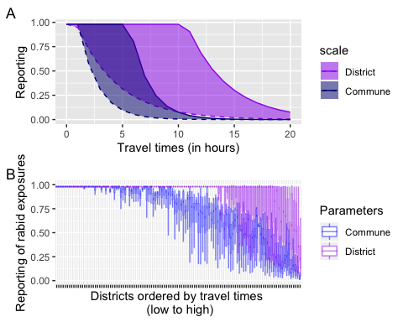

Generally, estimated reporting of rabies exposures decayed with travel times given model predicted bite incidence and a range of rabies incidence and (Figure 3). Given our model assumptions, reporting was estimated at the maximum of 0.98 for travel times under 1 hour given the maximum estimated rabies exposure incidence and the minimum estimate of (the lower range of reporting probabilities), and travel times under 5 - 10 hours given the minimum estimated rabies exposure incidence and the maximum estimate of (the upper range of reporting probabilities). We found that the commune model estimated a lower range of reporting probabilities than the district model (Figure 3, see section S6), so we compared estimates of burden given these two models in subsequent analyses.

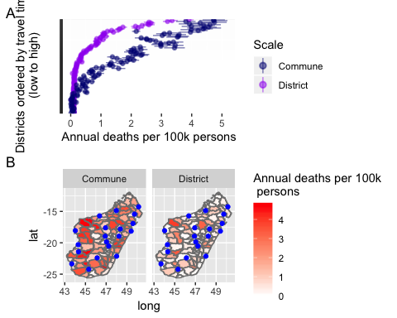

|  |  |  |
| --- | --- | --- |
| model | averted | deaths |
| Commune | 929.127 | 287.046 |
| District | 1120.332 | 96.849 |

Overall, we estimate average annual deaths between 97 - 287 and deaths_averted between 929 - 1120. In general, incidence of rabies deaths increases with travel times, but this effect is more pronounced for the district model compared to the commune model. Our sensitivity analyses show, that while there is considerable uncertainty in the number of deaths estimated, the pattern of deaths increasing with travel times is robust for both models (see figure S5.2). Comparing the two models is, the district model generally predicts lower reported bite incidence overall and less steep declines in reporting with higher travel times.

### Expanding access to PEP

We find that expanding access to PEP reduces burden of rabies death, but this effect decays as ARMC are added, saturating after about approximately 200 clinics (or 2 ARMC per district). This effect is more pronouned for the commune level model than for the district model. Vaccine demand also increases, and more vials are needed per averted death as PEP is expanded, with vials needed outpacing the increase in deaths averted. These patterns are also generally robust to our model assumptions (see figure S5.3 and S5.4).

## user system elapsed   
## 0.309 0.004 260.760

## user system elapsed   
## 0.290 0.002 233.840

## DISCUSSION

Main findings - [ ] Travel times are a good predictor of bites, suggesting that this could shape burden significantly - [ ] We develop a framework to look at the potential impact of this access on burden, to get more realistic sub-national and national estimates - [ ] Scenario analysis shows that expanding access could significantly reduce burden - [ ] However due to broad remoteness, expanding access alone will not eliminate human rabies deaths

Limitations - [ ] Not thinking about clinic functioning - [ ] Reporting issues and what it means (i.e. we’re assuming that clinics are not reporting, but they may not be provisioning at all, etc.) - [ ] Not accounting for other factors which drive access/reporting (i.e. socioeconomics and awareness although these are likely correlated and that has implications for the scenario analysis) - [ ] Just another set of assumptions and a set that needs validation–what data could do this? - [ ] Contacts issue and what it means for the results - [ ] Approach only works in endemic setting, and where reporting = receiving (i.e. in a free setting), although for GAVI countries this is likely the case

Discussion: broader context - [ ] Compare to previous estimates of burden (Moramanga, GAVI paper, etc.) for Mada - [ ] Compare range of estimates of human rabies exposure incidence and deaths to estimates from other endemic settings - [ ] P_rabid estimates compared to other endemic settings (look at Moramanga data in Supplementary materials?) Differences in reporting of rabid vs. non-rabid bites? - [ ] Availability of PEP in other countries is also similarly or even more limited - [ ] Other studies that have looked at access and mortality/vacc

Discussion: conclusions - [ ] Access likely shapes burden in a big way in Mada - [ ] Expanding access will therefore likely decrease burden in a big way, but there are limitations due to infrastructure, etc. - [ ] Spatial differences in reporting also has implications for surveillance (and could parallel dog vaccination heterogeneity) and this needs to be explored *hint*hint* - [ ] Our results depend on strong assumptions, so key data on dog pops, rabies, reporting, etc. are needed to validate this, surveillance @ clinic level! - [ ] Regardless expanding access alone will likely not prevent all deaths, you need dog vacc!

## Acknowledgements

## Supplementary Materials

### S1. Estimates of reporting

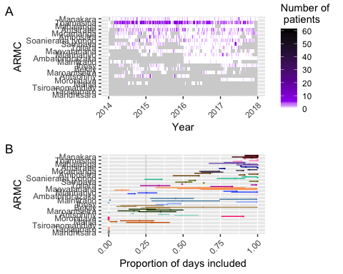

### S2. Accounting for low-risk contacts reporting to clinics

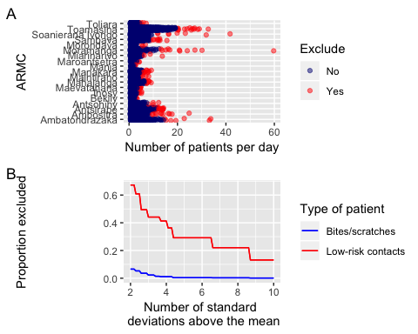

### S3. Comparing models of reported bites

## dAICc df weight  
## Mada flatPop distance_commune 0.0 2 1   
## Mada flatPop distance_district 1907.1 2 <0.001  
## Mada flatPop ttimes_commune 2557.1 2 <0.001  
## Mada addPop distance_commune 3501.4 3 <0.001  
## Mada addPop distance_district 3651.2 3 <0.001  
## Mada addPop ttimes_commune 5988.7 3 <0.001  
## Mada flatPop ttimes_district 10117.3 2 <0.001  
## Mada addPop ttimes_district 11704.9 3 <0.001  
## Mada onlyPop pop_commune 16773.9 2 <0.001  
## Mada onlyPop pop_district 19617.5 2 <0.001

## dAICc df weight  
## Mora addPop distance_mora 0.0 3 1   
## Mora addPop ttimes_mora 23.3 3 <0.001  
## Mora flatPop distance_mora 60.3 2 <0.001  
## Mora flatPop ttimes_mora 172.8 2 <0.001  
## Mora onlyPop pop_commune 192.1 2 <0.001

|  |  |  |  |  |  |  |  |  |  |  |
| --- | --- | --- | --- | --- | --- | --- | --- | --- | --- | --- |
| beta | intercept | beta_upper | beta_lower | intercept_lower | intercept_upper | likelihood | model | beta_pop | beta_pop_upper | beta_pop_lower |
| -0.0266421 | -5.0979546 | -0.0261764 | -0.0270728 | -5.1155148 | -5.0817179 | -12275.1100 | Mada flatPop distance_district | NA | NA | NA |
| -0.0343062 | -4.8855589 | -0.0337119 | -0.0348607 | -4.9040024 | -4.8681439 | -11321.5748 | Mada flatPop distance_commune | NA | NA | NA |
| -0.2755049 | -5.3225643 | -0.2695505 | -0.2816521 | -5.3406471 | -5.3039615 | -16380.2483 | Mada flatPop ttimes_district | NA | NA | NA |
| -0.5905733 | -4.9337370 | -0.5794975 | -0.6017320 | -4.9513954 | -4.9161569 | -12600.1466 | Mada flatPop ttimes_commune | NA | NA | NA |
| 0.7488911 | 4.3103086 | 0.7602605 | 0.7375343 | 4.2777953 | 4.3426727 | -21130.3395 | Mada onlyPop pop_district | NA | NA | NA |
| 4.0674984 | 2.5759042 | 4.0973611 | 4.0374428 | 2.5600007 | 2.5917510 | -19708.5107 | Mada onlyPop pop_commune | NA | NA | NA |
| -0.0656446 | -5.0428714 | -0.0610556 | -0.0704027 | -5.1492160 | -4.9396924 | -222.0311 | Mora flatPop distance_mora | NA | NA | NA |
| -0.8713064 | -5.2011505 | -0.8001008 | -0.9458253 | -5.3112301 | -5.0936514 | -278.2458 | Mora flatPop ttimes_mora | NA | NA | NA |
| 14.7924477 | -0.5785633 | 15.3931033 | 14.2026191 | -0.7899901 | -0.3759637 | -287.9105 | Mora onlyPop pop_commune | NA | NA | NA |
| -0.0271682 | 6.1530622 | -0.0266928 | -0.0276321 | 6.1117287 | 6.1933409 | -13146.1050 | Mada addPop distance_district | 0.4425714 | 0.4551374 | 0.4303510 |
| -0.0337870 | 4.2475634 | -0.0330706 | -0.0344224 | 4.2162854 | 4.2750980 | -13071.1617 | Mada addPop distance_commune | 2.5906225 | 2.6323997 | 2.5521878 |
| -0.2733171 | 5.7678128 | -0.2669129 | -0.2797342 | 5.7245787 | 5.8108443 | -17172.9334 | Mada addPop ttimes_district | 0.4965106 | 0.5090935 | 0.4839466 |
| -0.5816994 | 4.2298707 | -0.5685681 | -0.5949374 | 4.2001548 | 4.2594791 | -14314.8233 | Mada addPop ttimes_commune | 2.5409214 | 2.5818457 | 2.4997962 |
| -0.0411482 | 2.1525100 | -0.0348245 | -0.0476486 | 1.7543947 | 2.5355948 | -190.7551 | Mora addPop distance_mora | 8.5895949 | 9.5621936 | 7.6478618 |
| -0.4485915 | 1.6314070 | -0.3704940 | -0.5310784 | 1.2720790 | 1.9802803 | -202.4141 | Mora addPop ttimes_mora | 9.7322420 | 10.6224711 | 8.8629352 |

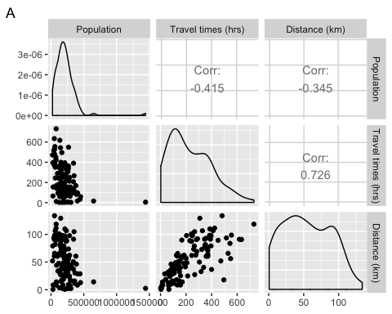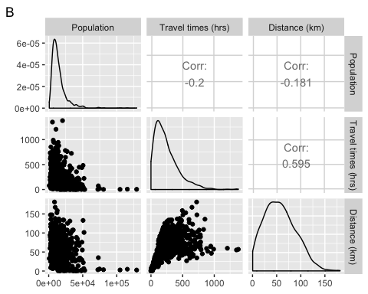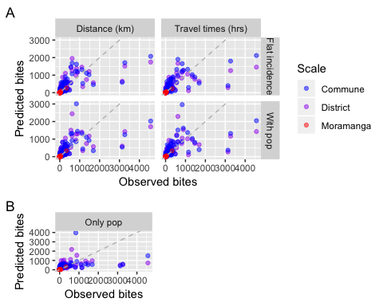

### S4. Sensitivity of parameter estimation to different reporting estimates and exclusion of contacts

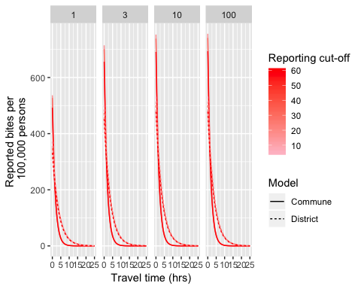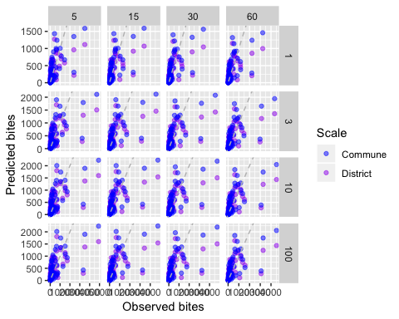

### S5. Sensitity analyses for burden estimates

## user system elapsed   
## 5.385 1.769 7.350

## user system elapsed   
## 0.674 0.012 0.711

## user system elapsed   
## 60.962 29.194 98.095

## user system elapsed   
## 2.440 0.175 2.656

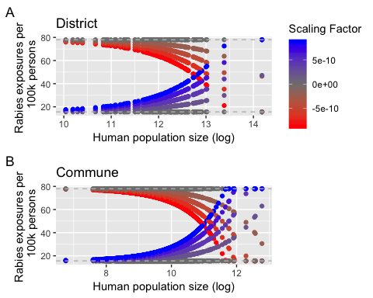

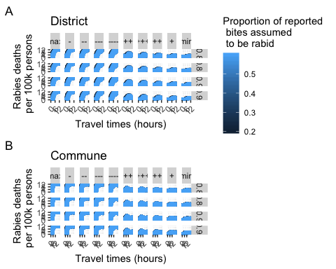

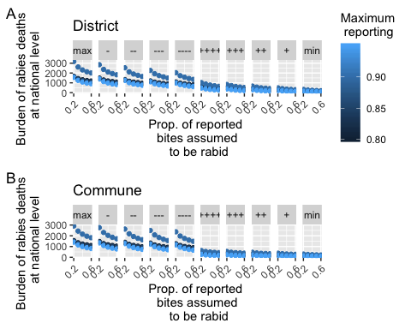

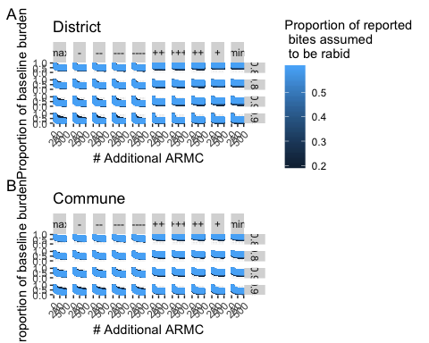

### S6: Difference between reporting estimates for each model

