Estimating Access to Rabies Post-Exposure Prophylaxis in Madagascar

## INTRODUCTION

Deaths due to canine mediated rabies, estimated to cause approximately 60,000 human deaths anually, can be prevented through prompt administration of post-exposure prophylaxis. However, access to this intervention is highly limited in areas where the disease is endemic (*cite GAVI paper or Nandini’s paper of geographic availability of PEP*). Data on true rabies exposures in humans and incidence in animals is also lacking in most of these countries, with the most commonly available data being numbers of bite victims reporting to health facilities.

The majority of rabies burden studies use these data to estimate burden from probability decision tree frameworks, often with the key assumption that overall reported bite incidence (i.e. both bites due to non-rabid and rabid animals) are proportional to rabies incidence (i.e. the more bites reported in a location, the higher the incidence of *rabies* exposures there) and that reporting is uniform across space. While at the national level these estimates may be accurate, at the sub-national level, this framework will likely underestimate rabies deaths in places with low reporting and overestimate rabies deaths in places with high reporting of bites.

Here–discuss geographic variation in access to vaccination and care–how this shapes mortality for other diseases.

In Madagascar, Institut Pasteur de Madagascar (IPM) provides PEP at no-cost to patients at 31 clinics across the country. PEP is not available at any other public clinics or through the private sector. In addition, there is limited control in dog populations and the disease is endemic throughout the country. Due to the spatially restricted nature of PEP, geographic access is likely to be a major driver of disease burden within the country. To get spatial estimates of disease burden in this context, we flip the standard decision tree and make the assumption that reported bite incidence reflects access to PEP rather than differences in rabies incidence, using travel times to clinics as a predictor of reported bites. Then using a range of rabies incidence given endemic transmission with no mass dog vaccination (*GAVI paper*), we generate sub-national estimates of rabies burden in an adapted decision tree framework. Finally, using this same model pipeline, we explore the impacts of geographically expanding access to PEP in Madagascar on reducing human rabies deaths.

## METHODS

### GIS Data

We used the global friction surface for 2015 generated by the Malaria Atlas Project ( <https://map.ox.ac.uk/research-project/accessibility_to_cities/>, Weiss et al. 2015,) and GPS points of clinics to estimate the travel time to the nearest ARMC for the country of Madagascar at a 1 x 1 km scale. We then calculated a weighted average of travel times by human population to the commune level, using administrative shapefiles available trhough the UN Office for the Coordination of Humanitarian Affairs. Human population estimates were taken from the 2015 UN adjusted population projections from World Pop (www.worldpop.org, Linaird et al. 2012) and also aggreagated to the commune level.

### Bite patient data

We used a database of bite patient forms submitted to IPM from ARMC across the country between 2014 - 2017. These were individual patient data forms that were submitted as frequently as monthly to annually by clinics. Of the 31 existing ARMC, 10 clinics submitted fewer than 10 forms over the four years. Two clinics, the IPM ARMC and the Fianarantsoa ARMC had separate electronic databases which were not available at the time of analysis. Overall, we had data from 19 clinics across the country (Fig 1A). These data include the administrative district of the bite patient’s address and the date of reporting. We also had 27 months of bite patient data from the Moramanga District that were resolved to the commune level (the administrative level below district).

For most districts, the majority of bites were reported to the closest clinic as estimated by our travel time metric (Fig 1A, Fig S1). Therefore, we defined the catchment area for each clinic as all districts for which the clinic was the closest ARMC. We excluded any districts from catchments for which the clinic did not submit any forms (n = 12, districts in grey in Fig 1A).

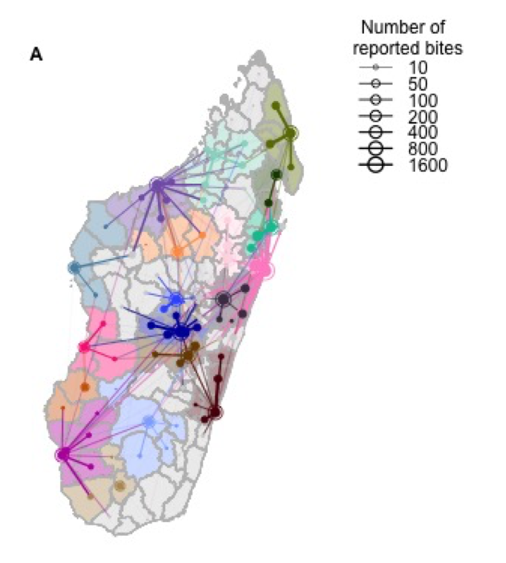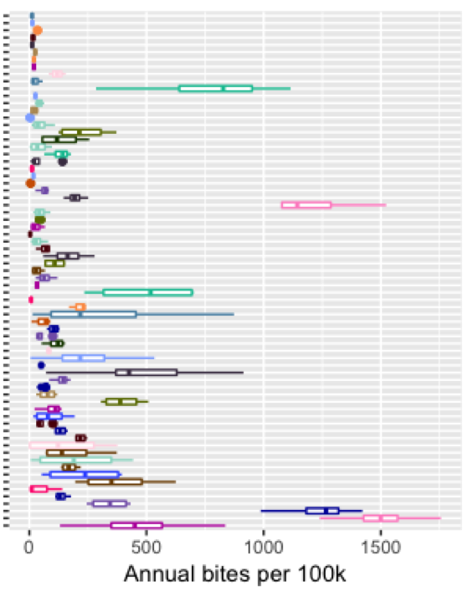

**B**

**A**

**Figure 1. A)** The network of patient visits: the open circles represent the total number of patients reporting to each clinic location for which we have data. The color corresponds to the clinic catchment.each filled circle is the total number of bites reported for that district, and the lines show which ARMC those patients reported to with the line width proportional to number of patients. Districts in catchments exlcuded due to lack of forms submitted by the clinic are colored in grey. **B)** The estimated annual bite incidence for each district with colors corresponding to the catchment and the y-axis ordered by district level travel times.

As even for clinics which submitted data there was substantial undersubmission of forms, we estimated clinic level reporting as the proportion of days on which forms were submitted, excluding any periods for which there were no forms submitted for 15 consecutive days (Figure 2A shows the time series of form submission for each clinic and periods of time excluded by the 15 day threshold). Estimates of reporting did vary based on our assumption of the threshold number of consecutive days (Figure 2B), but 15 days seemed to be a conservative threshold in most cases. To estimate the average annual bites reported for each district, we further excluded data from any years for which there was less than 25% reporting at the clinic level.

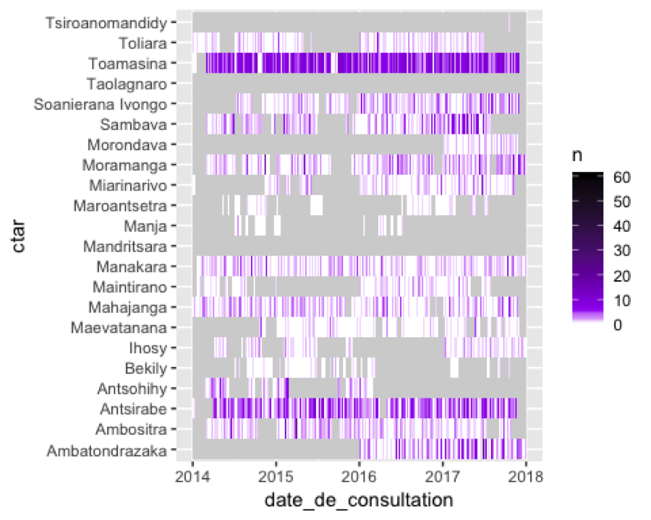

**A**

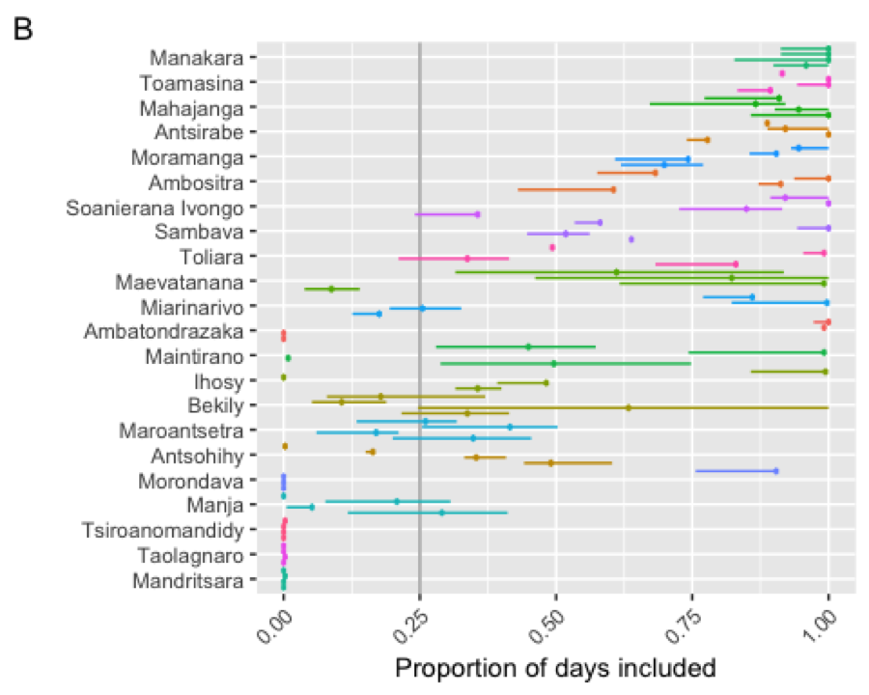

**B**

***Figure 2 A)*** *The daily time series of the number of forms submitted by each clinic, with periods of time where no forms were submitted for >= 15 days excluded in grey.* ***B)*** *The proportion of days included (our estimate of reporting) for each clinic for each year for a range of consecutive day thresholds (line range showing the estimate for between 5 – 30 consecutive days of no form submission, point is the estimate at the 15 day cut-off).*

Previous work in the Moramanga District showed that low risk contacts with probable or confirmed rabies cases make up approximately 20% of patients reporting to ARMC (Rajeev et al. 2018). Generally, contacts present as clustered cases, so we excluded patients reporting on any dates that had greater than 3 standard deviations above the mean number of patients reporting per day (Figure 3A). We validated this method using the Moramanga ARMC data for which we had details on the type of exposure, and found that setting the threshold to 3 standard deviations (SDs) resulted in approximately 50% of known contacts excluded, with only 2% of non-contacts excluded (Figure 3B). For the national data for which a subset of patient forms were explicitly noted to be contacts, we found that our exclusion criteria of 3 SDs identified 68.28 of known contacts. We further excluded these known contacts which were not identified based on the daily distribution of patients, resulting in the exclusion of approximately 7.18% of patient records from the national data. We also compared this method to assuming that 20% of total bites at the district level were contacts.

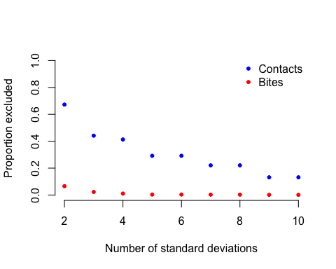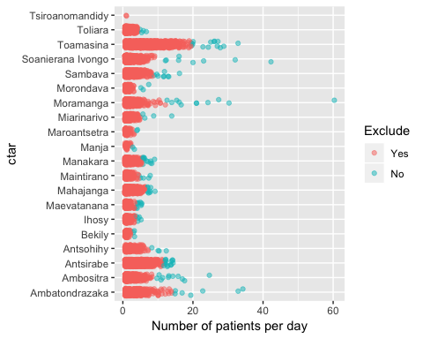

**A**

**B**

***Figure 3. A)*** *Distribution of daily clinic throughput, with days colored in blue excluded as the number of patients reporting that day was greater than two standard deviations above the mean number of patients reporting per day.* ***B)*** *The proportion of known contacts (blue) vs. bites (red) excluded for each cut-off level (i.e. if we excluded patients reporting on days with greater than n standard deviations above the mean clinic throughput).*

After excluding contacts and correcting for undersubmission of forms, our final dataset consisted of estimates of average bite incidence for 71 districts from 19 catchments (Figure 2B).

### 

### Model of reported bites as a function of travel time

While the national bite patient data is available at the district level, travel times and therefore reporting, likely vary significantly at the sub-district level. In order to translate the impacts of differences in access at sub-district scales to the magnitude of reported bites at the district scale, we modeled bites at the district level as the sum of incidence at the commune level. Incidence at the commune level is then a function of travel times to the closest ARMC. Specifically, we modeled bites as follows:

where is the mean number of bites in district, which is the sum of bites at the commune level given **commune level travel times**, . We then estimate the likelihood of observing the bites at the district level where bites are a poisson distribution around the mean , given , the effect of travel times of reported bites and , the model intercept.

As we had data available on reported bites at the commune level from the Moramanga ARMC (from Rajeev et al. 2018), we modeled observed commune bites in the same framework, but un-aggregated, where:

where = the mean number of bites in commune and the observed bites at the commune level follow a poisson distribution around the mean . We only included communes which were designated to be within the catchment for the clinic. We compared our estimates of (i.e. the impact of travel time on incidence) and (the intercept) for our district data at the national level and the commune level data from the Moramanga ARMC.

Finally, we compared these models to a model of bites at the district level as the function of travel times averaged to the district level:

where , , and are respectively human population size, weighted travel times, and mean number of bites in district . As travel times are correlated with human population size (Figure Z), we also compared how well bites were predicted by human population size alone for these different models, as a test of whether the observed patterns could be predicted by bite incidence scaling with population size. We also looked at how well distance from the closest ARMC (rather than travel times) predicted bites as an alternative proxy for access (TO DO).

### Estimating burden and reporting

We used our model to predict average annual bite incidence for all 114 districts in Madagascar, and estimated average reporting of rabid exposures and deaths due to rabies given this and assumptions about rabies exposures.

We calculated the expected reporting of rabid exposures () given bite incidence as predicted by our model() as:

or the fraction of incidence due to rabid exposures () divided by the total rabies exposure incidence () for a range of estimated rabies incidence and . We look at the range of reported in Rajeev et al. 2018 for data from the Moramanga District (0.2 - 0.6). where the proportion of reported bites that are rabies exposures () are defined as:

such that rabid reported bites (i.e. ) cannot exceed the expected number of human exposures given maximum reporting (i.e. ). is taken from the Moramanga ARMC data for Moramanga Ville, the commune with the ARMC (i.e. the area with the minimum travel time in the district, on average *xx* minutes).

To generate , the rabies incidence in dogs in the absence of any vaccination, , is multiplied by the estimated dog population in the commune () and the exposure rate per rabid dogs ( = 0.39 persons exposed per rabid dog)(Hampson et al. 2018). We use a human:dog ratio (HDR) of 5 to generate our maximum expected incidence and an HDR of 25 for our minimum expected incidence. As there is little data on dog populations in Madagascar, this range of HDRs encompasses a wide range observed across Africa (cite!).

To estimate the average number of deaths for each commune, we extended the above framework into a stochastic framework as follows:

where is drawn from a uniform distribution between the minimum and maximum expected number of human exposures for each location and , the number of reported bites, is drawn from a poisson distribution with the mean predicted number of bites from the travel time model. We constrain as in Equation N, and we assume that all rabies exposures reported to an ARMC receive and complete PEP, and PEP is completely effective at preventing death due to rabies. The probability of death in the absence of PEP is taken from cite GAVI/Joel paper.

### Estimating the impact of expanding PEP Access (TO DO)

We use this framework to compare three scenarios of PEP provisioning in Madagascar:

1. The baseline with the current clinic locations (n = 31)
2. Expansion of ARMC to one clinic per district (n = 114)
3. Expansion of ARMC to two clinics per district, choosing the clinic which minimizes the proportion of people living greater than 3 hours away from a clinic.

We use data on the location of clinics provided by IPM to regenerate travel times to the nearest ARMC given expansion as per scenario 2 and 3. We then predict the expected bite incidence from the model given these new travel times and compare the relative decreases in burden for the three scenarios.

### Strategically expanding PEP access (TO DO)

Given limited resources and capacity of clinics to provision PEP, we developed a framework to look at the incremental benefit of additional ARMC. Starting with the current locations (Scenario 1), we added one clinic and recalculated the proportion of people living < 3 hours away from a clinic for the country. We added the clinic which minimized this metric, and then repeated the process iteratively, ranking clinics and adding the top clinic in each interation sequentially. We calculate burden for the given clinic locations and look at the incremental reduction in burden as each clinic is added.

### Sensitivity analyses for burden estimates and scenario analyses (TO DO)

## RESULTS

### Models of bites as a function of travel times

We estimated similar parameter values from our commune-level data from the Moramanga ARMC and the district level data from 19 clinics across the country (Table 1, Figure 4A), with reported bite incidence decreasing with travel times to the ARMC. All of the models produced reasonable fits to the data (Figure 4B), however, there was some variation in bite incidence that was not captured by the model.

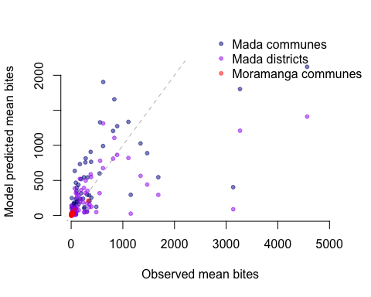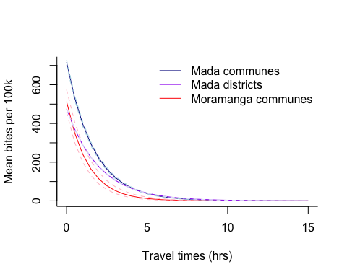

**A**

**B**

**Figure 4.** Travel times as a predictor of bites **A)** the estimated relationship between travel times and mean annual bite incidence per 100,000 persons and **B)** Observed vs. predicted mean annual bites for the three different models (Mada communes: travel time effect at the commune level summed to the district level; Mada districts: travel time effect at the district level; Moramanga communes: travel time effect at the commune level for Moramanga data).

**Table 1: Summary of parameter estimates from different models of bites**

|  |  |  |
| --- | --- | --- |
| Parameter | Model | Estimate (95 % CI) |
| (travel time predictor) | Mada communes | -0.0098 (-0.0096 — -0.0010) |
| Moramanga communes | -0.0125(-0.0113424 — -0.0137) |
| Mada districts | -0.0083 (-0.0081 — -0.0084) |
| (intercept) | Mada communes | -4.939 (-4.922 — -4.957) |
| Moramanga communes | -5.273 (-5.160- — -5.387) |
| Mada districts | -5.348 (-5.347 — -5.349) |

#### *Model validation*

### Estimation of reporting and burden

Generally, estimated reporting of rabies exposures decayed with travel times given model predicted bite incidence and a range of rabies incidence and (Figure 5). Given our model assumptions, reporting was estimated at the maximum of 0.98 for travel times under 1 hour at the the lower range of reporting probabilities (given the maximum estimated rabies exposure incidence and the minimum estimate of the proportion of reported bites which are rabies exposures), and travel times under 5.5 hours at the upper range of reporting probabilities (given the minimum estimated rabies exposure incidence and the maximum estimate ofthe proportion of reported bites which are rabies exposures).

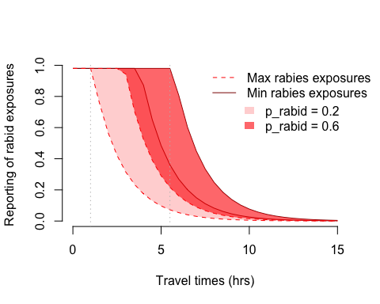

***Figure 5.*** *Estimated impact of travel time on reporting of rabid exposures for a range of rabid exposure incidence and the proportion of reported bites that are rabid.*

When we estimate burden of deaths stochastically within this range of incidence and given our high and low estimates of proportion of reported bites that are rabid, we see that burden of deaths also decreases with travel times (Figure 7, results presented aggregated at the district level). Overall, we estimate average annual deaths between 383 - 707. **Also estimate deaths averted here!**.

When we compare our burden estimates at the district vs. the commune level (summed to district), we see that while overall, the estimates are very similar (Fig 6), calculating burden at the district level results in an assumption of maximum reporting for the whole district, which assumes very low burden for districts with low travel times in certain scenarios, even though within these districts there may be communes which have signficantly higher travel times and thus burden (Figure 8). I think that this may have an even bigger impact in the scenario analysis, as we’ll push more areas into the low travel time region.

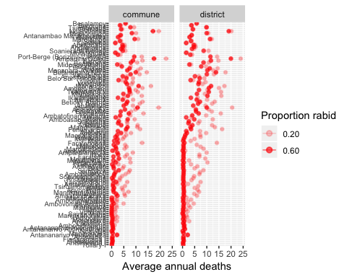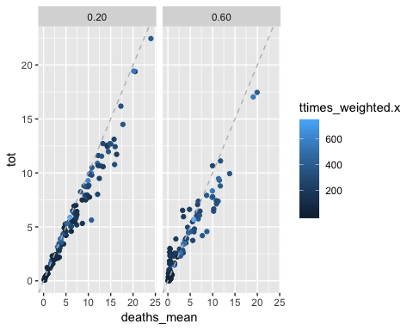

**A**

**B**

***Figure 6. A)*** *Estimates of burden when calculated at the commune level (and then summed to district) vs. the district level. Y-axis is ordered by travel times at the district level.* ***B)*** *Correlation between the two estimates for the two different levels of p_rabid. Points are colored by travel times at the district level.*

***Figure 7.*** *Estimates of burden at the* ***A)*** *commune level from the commune model and* ***B)*** *district level from the district model*.

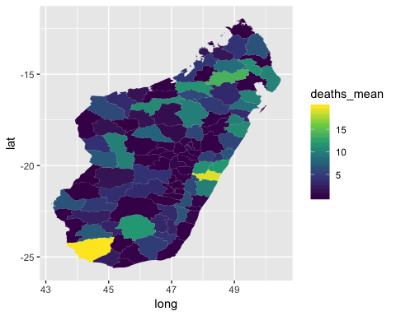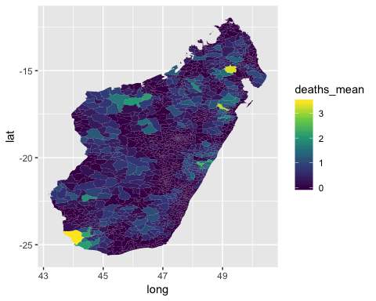

**A**

**B**

### Expanding access to PEP

### Sensitivity analyses

## DISCUSSION