Lessons learned and paths forward for rabies dog vaccination in Madagascar: a case study of pilot vaccination campaigns in Moramanga District

Caitlynn Filla*, Malavika Rajeev*,2,✉, Zoavina Randriana3, Chantal Hanitriniana4, Radoniaina R. Rafaliarison3, Glenn Edosoa5, Mamitiana Andriamananjara6, Nivohanitra Perle Razafindraibe6, José Nely7, Angelique Ferreira, Annie Yang2,11, Fenomanana Daniel3, Tara A. Clarke3, Zachary Farris3,9, Terry Stone8, Jochem Lastdrager8, Tsiky Rajaonarivelo3, Katie Hampson10, C. Jessica E. Metcalf2, and Kim Valenta3,1

* Joint first authors.

1 University of Florida, Department of Anthropology, Gainesville, Florida, USA  
2 Department of Ecology and Evolutionary Biology, Princeton University, Princeton, United States  
3 The Mad Dog Initiative, Akanin’ny Veterinera Akaikiniarivo, Ambatobe, Antananarivo 101, Madagascar  
4 Mention Zoologie et Biodiversité Animale, Faculté des Sciences, Université d’Antananarivo, Antananarivo, Madagascar  
5 Chargé des Maladies Tropicales Négligées, Organisation mondiale de la Santé Madagascar, Antananarivo, Madagascar  
6 Direction des Services Vétérinaires, Ministère chargé de l’Agriculture et de l’Élevage, Antananarivo, Madagascar  
7 Service contre les Maladies Endémo-épidémiques et Tropicales Négligées, Ministère de la Santé Publique, Antananarivo, Madagascar  
8 Travelling Animal Doctors, 919 Crossan Rd, Newark, Delaware, USA  
9 Appalachian State University, Department of Health and Exercise Science, Boone, North Carolina, USA  
10 Boyd Orr Centre for Population and Ecosystem Health, Institute of Biodiversity, Animal Health and Comparative Medicine, University of Glasgow, Glasgow, UK  
11 Deceased.

✉ Correspondence: [Malavika Rajeev <[mrajeev@princeton.edu](mailto:mrajeev@princeton.edu)>](mailto:mrajeev@princeton.edu)

## Abstract

Canine rabies causes an estimated 60,000 human deaths per year, but these deaths are preventable through post-exposure prophylaxis of people and vaccination of domestic dogs. Dog vaccination campaigns targeting coverage of 70% at the population level are effective at interrupting transmission and eventually can lead to elimination of the disease. Given this evidence, the WHO and it’s partners have set a global goal to eliminate deaths due to canine rabies by the year 2030. Here, we report on initial lessons learned during pilot dog vaccination campaigns in the Moramanga District of Madagascar, a country with a high estimated burden of rabies and limited control in the dog population. We compare two different vaccination strategies: a larger volunteer driven effort to vaccinate dogs in two communes using static point vaccination, and continuous vaccination as part of routine veterinary services in the district by the District Veterinarian. We compared costs, time, personnel, and coverage achieved by each of the campaigns. We also use dog age data from the campaigns to estimate key demographic parameters, and use these estimates to simulate different vaccination strategies. Overall we found that dog vaccination was feasible and that most dogs were accessible to vaccination. We find that there are tradeoffs between the vaccination strategies, with the first campaign achieving higher coverage, but with more resources and with more limited geographic scope compared to the second campaign with continuous delivery. Our modeling results suggest that targeting puppies through community based vaccination efforts could help achieve coverage levels sufficient to interrupt transmission. Moving forward, our results show that mass dog vaccination is feasible and can achieve high coverage in Madagascar, however innovative strategies and an investment in dog vaccination as a public good will be required to maintain the sustained levels of coverage needed for disease elimination.

## Introduction

Canine rabies results in an estimated 60,000 human deaths per year globally (Hampson et al. 2015). These deaths are entirely preventable: prompt post-exposure prophylaxis of humans exposed to rabies is highly effective at preventing death and mass dog vaccination can interrupt transmission in domestic dogs and eventually lead to disease elimination (Fooks et al. 2014). The WHO and its partners have set a goal to eliminate human deaths due to canine rabies by the year 2030 (‘ZeroBy30’)(Abela-Ridder et al. 2016). Annual dog vaccination campaigns achieving at least 70% coverage are the recommended target for controlling rabies in the domestic dog population (World Health Organization 2013). However, achieving this coverage target in low and middle income countries where the burden of human rabies is concentrated can be challenging due to economic, ecological, sociocultural, and political reasons (Fahrion et al. 2017).

In sub-Saharan African countries, parenteral vaccination implemented through static point vaccination campaigns have been shown to be cost-effective and feasible (Borse et al. 2018). While most dogs in these settings are considered free-roaming, they are mostly owned and are accessible for vaccination through these campaigns Jibat, Hogeveen, and Mourits (2015). However, reaching high coverage and maintaining vaccination campaigns at scale requires sustained investment and coordination, and the challenges in implementation largely reflect financial and logistical constraints more than feasibility of vaccination itself (Fahrion et al. 2017). Developing clear and context-specific strategies and lowering costs and resources needed could help spur implementation and scaling up of campaigns in these countries.

In Madagascar, canine rabies has been endemic for over a century and over almost the same time period, the Institut Pasteur de Madagascar has provided post-exposure prophylaxis free-of-charge to bite patients in the country (Reynes et al. 2011). Currently, there are only 31 clinics where these human vaccines are available, and there is minimal dog vaccination due to high costs to owners and lack of availability of the vaccine (Rajeev et al. 2019). Recent studies have estimated a high burden of human deaths, masked by weak surveillance across the country (Rajeev et al. 2020, 2019).

The veterinary sector is largely private, with some veterinarians employed in hybrid private/public employment as designated district veterinarians [comment: Njara/Nivo]. While dog vaccination is rare, livestock officers and veterinarians work together to implement cattle vaccination campaigns for anthrax on an annual basis as mandated by the government (owners are charged a fee per animal for these vaccines which vary by location) (Organization Mondiale de la Sante 2017). No routine mass dog vaccinations have been conducted on the island, although a few pilot programs have begun in recent years, largely implemented by NGO-government partnerships.

Here, we summarize lessons learned through implementation of pilot vaccination programs in the Moramanga District of Madagascar, where previous work has shown high incidence of dog rabies cases and human rabies exposures. In 2018 and 2019, we deployed two different vaccination strategies. In 2018, we led a larger scale volunteer-led pilot vaccination campaign in two Communes (sub-district level) using a central point strategy. In 2019/2020, we provided vaccines, all necessary supplies for vaccine administration, and a per-vaccine fee to the District Veterinarian to vaccinate animals as part of routine services. We compare time, human resources, costs, and coverage estimates between these campaigns, and using a demographic and vaccination model we further explore different vaccination strategies based on what we learned during implementation.

## Methods

### Study Area

The Moramanga District is located midway between the central highlands and the east coast of Madagascar, at an average altitude of 936 m. It comprises 21 communes, covering approximately 7150 km2 with an approximate human population of 3.044^{5}. Previous work in the district has established a high burden of rabies exposures and deaths despite the availability of post-exposure prophylaxis at the district hospital (Rajeev et al. 2019). While Moramanga is relatively close to the capital city of Antananarivo (~ 3 hrs by bus), within the district, travel times between locations are highly variable, with much of the population living in more rural areas with limited access to roads and transportation (Rajeev et al. 2020). Before 2018, there were limited animal rabies vaccination services, with most animal vaccines available in the urban commune of Moramanga Ville and owners charged > 15,000 Ariary (~ 4.28 USD) per vaccine administered.

### 2018 Campaign

In 2018, a pilot vaccination campaign was organized through a collaboration with two NGOs (the Mad Dog Initiative and Traveling Animal Doctors), the Department of Veterinary Services, and the Ministry of Public Health in the District of Moramanga. This campaign focused on two communes in Moramanga, Moramanga Ville (the district center) and Andasibe (a rural commune surrounding Andasibe National Park), where previously high incidence of probable rabies exposures (Moramanga Ville) and a high burden of deaths (Andasibe) had been recorded (Rajeev et al. 2019).

The campaign was planned as a series of central point vaccination stations covering 1 - 3 sub-communes (or fokontany) per day. A week before the campaign dates, the vaccination team advertised the date with the chief of the fokontany and provided posters advertising the date of the vaccine and that it would be available at no cost to owners. During the campaign, we used Rabisin (10 mL vials with 1 mL per dose, Boehringer Ingelheim) to vaccinate both dogs and cats presented that were at least 1 month old. As part of the campaign, owners were surveyed by vaccinators about how many dogs and cats they owned in total (split by > 1 yr vs. < 1 yr in order to avoid language ambiguities that might result in excluding pups and kittens), as well as if their dogs were free roaming (no restrictions on movement by the owner/‘mireny,’ tied/‘mifatora,’ or fenced/‘fefy’). Vaccinations were delivered at no cost to owners, but as animal vaccination is generally thought of as a paid service in Madagascar, owners were asked how much in Ariary they would be willing to pay to have one animal vaccinated against rabies. For each animal vaccinated, we recorded the species (cat or dog), sex, approximate age in years, and whether the animal had been previously vaccinated.

To assess coverage, post-vaccination coverage surveys were conducted according to previously established methodology(Sambo et al. 2017; Gibson et al. 2015). All animals vaccinated were concurrently marked with a colored, non-toxic, livestock crayon [comment: ask Jochem for brand] along the top or back of the head. Between 4 - 6 PM when dogs are most active (Sambo et al. 2017) and on the same day as the campaign, in each vaccination location two transect surveys were done. Each team (two people per team) walked a transect for 1 hour starting in opposite directions and accompanied by a local guide to ensure that walking paths did not overlap. Teams recorded any marked and unmarked dogs observed, their roaming status (whether roaming, inside a fence, or tied), and their approximate age (greater or less than 1 yr of age).

### 2019 Campaign

For the 2019 campaign, instead of a central point campaign strategy, vaccine vials(Rabisin) and the supplies needed to administer them (needle, syringe, vaccination card for owners) were distributed to the District Veterinarian, who then delivered the vaccination at no cost to owners, but was directly compensated 1,5000 Ar (~ 0.40 USD) per rabies vaccine administered. The campaign lasted from September 6, 2019 to June 19, 2020, One week prior to her visiting each location, the District Veterinarian advertised the vaccines by calling ahead to the fokontany leaders and other officials who then advertised to their communities, largely through word-of-mouth. For each animal vaccinated, the District Veterinarian collected the age, sex, and also asked owners to approximate the distance they travelled to receive the vaccination in meters. Researchers communicated with the District Veterinarian about progress periodically throughout the campaign, primarily through telephone calls. No other compensation or instructions were provided, and we asked the District Veterinarian to administer as many (or as few vaccines) as feasible or wanted. As the vaccinations were delivered continuously, we were unable to do comparable post-vaccination surveys.

### Analyses

#### Campaign resource and cost comparisons

We documented the overall costs and resources required for the two vaccination efforts. We tracked the number of vaccination points, the number of days over which these vaccinations occurred, and the number of person days required overall (i.e. the number of working people per day over the campaign (Mazeri et al. 2021)), in addition to monetary costs. As costs were incurred in both USD and Ariary, and the exchange rate declined rapidly between 2018 and 2019, we used the midpoint between the two years (3314 Ar to 1 USD) for the cost comparisons.

For the 2018 campaign, we broke costs down into the following categories: direct vaccine costs (cost for vaccine, syringes, needles, vaccination cards), supplies (livestock crayons, muzzles, gloves, alcohol, swabs), food and lodging for NGO personnel and other vaccinators during the campaign, personnel costs (per diems for DSV veterinarian, livestock field officers, local guides, and NGO employees), and advertisement (posters and banners for advertising the campaign). Foreign NGO volunteer expenses for travel to Madagascar were not included in these costs. Vehicles and drivers are also not included in these costs, as the drivers’ time and vehicle use were donated to the campaign by volunteers involved in the campaign [comment: re Katie, transects were really cheap because people vaccinating did them, like ~ 100 bucks for crayons & guides, so will keep it the costs but mention that they are cheap in the discussion]. In 2019, costs were split into two categories, direct vaccine costs (for same items as in 2018), and personnel costs (per vaccine fee paid to the district veterinarian), and supplies (a generator and fuel for the veterinarian to maintain the vaccine under cold chain during power outages). Transportation costs were also not included as the District Veterinarian used her own vehicle and vaccinated a part of their routine veterinary service provisioning.

We used the data on owners’ reported willingness to pay for vaccines to estimate the proportional reduction in animals vaccinated as fees are increased. We also estimated how this would impact cost per animal vaccinated by approximating the costs for implementation (i.e. those costs that remain fixed) from costs incurred per animal vaccinated (i.e. vaccine, syringe, vaccination card, and per vaccination fee to District Veterinarian in 2019), and calculating the balance between the returns from owner payments (i.e. increases in cost recovery per animal vaccinated) vs. decreasing numbers of animals vaccinated overall. [comment maybe add campaign photos (without identifiable people) per Tara]? #### Coverage estimates

For the 2018 campaign, we used the transect data to estimate coverage as the proportion of dogs sighted that were marked using a binomial confidence interval at the commune level. For the 2019 campaign, we estimated vaccination coverage using human-to-dog ratios and human population estimates (CLEAVELAND 2003; Athingo et al. 2020). We used a range of 8 - 25, based on previous data from Madagascar (Ratsitorahina et al. 2009) and based on recent estimates from household surveys in the Moramanga District (Leblanc 2019). We set the point estimate using an HDR of 19.5, the midpoint between the HDRs estimated for two communities in the District by LeBlanc et al. 2019. We used human population estimates from WorldPop (Linard et al. 2012) in each commune where the vaccinations were delivered. Coverage was estimated as the number of dogs vaccinated in total in that commune divided by the estimated dog population. We used this same method for the 2018 campaign, as well, to compare coverage estimated by the post-vaccination transects vs. HDRs.

#### Dog Demography

Using the age data on vaccinated animals collected during both vaccination campaigns, we estimated the proportion of the population in four age classes: pups under the age of 1 year, juveniles 1 - 2 yrs, adults aged 2 - 6 years, and older dogs age 6+ years based on . With the assumption that these estimates represent the population at a stable age distribution, we use a Leslie matrix model to estimate annual adult survival probability and fertility using maximum likelihood estimation (Fujiwara and Diaz-Lopez 2017). Specifically, we assume that the number of individuals in each age class follows a Poisson distribution with the mean predicted by the stable age distribution from the model (the proportion of individuals in each age class at equilibrium, equal to the eigenvector associated with the dominant eigenvalue of the matrix $ν$) multiplied by the total number of individuals in the population ($N_{t}$):

$$N_{a}∼Pois(νN_{t})$$

We assume that all individuals older than 1 year of age reproduce, and we do not estimate declines in fertility given the small proportion of dogs older than age six years in the population. To get bootstrapped estimates, we used 100 sub-sampled data sets of 1000 observations each from the observed age data to fit the parameters, and also varied initial values used in the optimization (N = 100 initial values sets) for 10,000 parameter estimates total.

#### Modeling vaccination campaign strategies

We used the parameter estimates from the demographic model to simulate different vaccination strategies in a hypothetical commune with 1000 dogs. We used a discrete time age-structured model with a monthly time step to compare three strategies:

1. Annual vaccination campaigns occuring within the same month each year targeting dogs of all ages
2. Continuous vaccination of new puppies throughout the year targeting puppies that reach the age of 3 months
3. A combined approach with annual campaigns (as 1) and routine puppy vaccination (as 2)

We split the dog population into pups (< 1 year old) and adults based on the stable age distribution estimated from the demographic model. To estimate pup survival in year one, we took the fertility estimates (number of new pups per reproducing dog in the pup age class per year) and divided by an estimate of newborn pups per reproducing dog each year based on average litter size, average number of litters per female per year (Hampson et al. 2009; Morters et al. 2014; Czupryna et al. 2016), and the proportion of the adult population that is female (estimated from our data). We assumed that for the annual campaign strategy, surviving vaccinated adult dogs were revaccinated in subsequent years (Del Rio Vilas et al. 2017), but that if a pup had been vaccinated within 9 months of the campaign, it was not revaccinated. We also assumed that vaccine immunity lasted for a discrete period of 3 years (with revaccination resetting this period of waning)[comment for KH abt clarification here]. A subset of parameter estimates resulted in estimates of population decline, but based on the shape of the age pyramid and to simulate reasonable campaign scenarios, we filtered to parameter estimates which corresponded to positive population growth.

#### Data and ethics statement

All data were analysed in R version 4.0.2 (2020-06-22) (R Core Team 2020), largely using the tidyverse package suite (Wickham et al. 2019). Geospatial data were mapped using the sf (Pebesma 2018) package. All data and code are available at <https://github.com/mrajeev08/mora_vax>. The vaccinations were part of a public health campaign and routine veterinary service provisioning carried out by the local veterinary officials, the NGOs involved, and in partnership with the Ministry of Public Health and the Department of Veterinary Services at the national level. The Madagascar Dog Initiative also maintains institutional approvals (IACUC # at Institution X)[comment: Kim to fill in] and national research permits (MICET permit #130-19/MEDD/SG/DGEF/DGRNE) for its research and volunteer programs .

## Results

### Summary of 2018 and 2019 campaigns

During the 2018 campaign, a total of 3137 animals were vaccinated (2057 dogs and 1080 cats) in the Moramanga (urban) and Andasibe (rural) communes over 13 days during the month of April (Table 1). We vaccinated at 7 points in Andasibe and 14 points in Moramanga Ville. During the 2019 campaign, between September 2019 - June 2020, the District Veterinarian vaccinated a total of 2385animals (1898 dogs and 486) over 48 days in 7 communes in the Moramanga District. While more animals were vaccinated per vaccination point and per vaccination day in 2018 compared to 2019, the number of animals vaccinated per person-day was much higher for the 2019 campaign. More animals were vaccinated in 2018 vs. 2019, but this was largely a result of vaccinating more cats during the 2018 campaign (Table 1).

In 2018, 15% of dogs had a previous history of vaccination (largely in the urban commune of Moramanga Ville) with only 7% of dogs vaccinated within the last year. This remained largely the same in 2019 (~ 13%), as the District Veterinarian focused their efforts in other communes. The District Veterinarian did vaccinate 771 dogs in Moramanga Ville in 2019, and of those 24.9% had been vaccinated in the previous year’s campaign, whereas only 24.9% of dogs vaccinated in all other communes had any history of previous vaccination. In addition, in 2019, 2.1% of animals had been spayed or neutered, reflecting efforts by the Mad Dog Initiative to implement free spay and neuter clinics in the district.

In 2018, 19% of owners reported their animals were free-roaming, but this varied by location (Table 1). In addition, while less than 19% of owners in Moramanga Ville reported that their animals were free roaming, the majority of animals observed during the transects (77%) were observed outside of fences and not tied, and thus the majority of animals could be classified as semi-confined in the more urban township of Moramanga Ville, and free-roaming in the rural setting of Andasibe (approximately 67% of owners reported their dogs as free-roaming, Table 1). In 2019, the District Veterinarian also asked owners to approximate how far they travelled in meters to get their animals vaccinated, and 94% of people reportedly travelled less than 1 km to reach the vaccination point.

#### Table 1. Summary of 2018 and 2019 campaigns: breakdown of of animals vaccinated, prior vaccination history, dog demography, dog ownership, daily and per vaccination rates by year and location (for 2018).

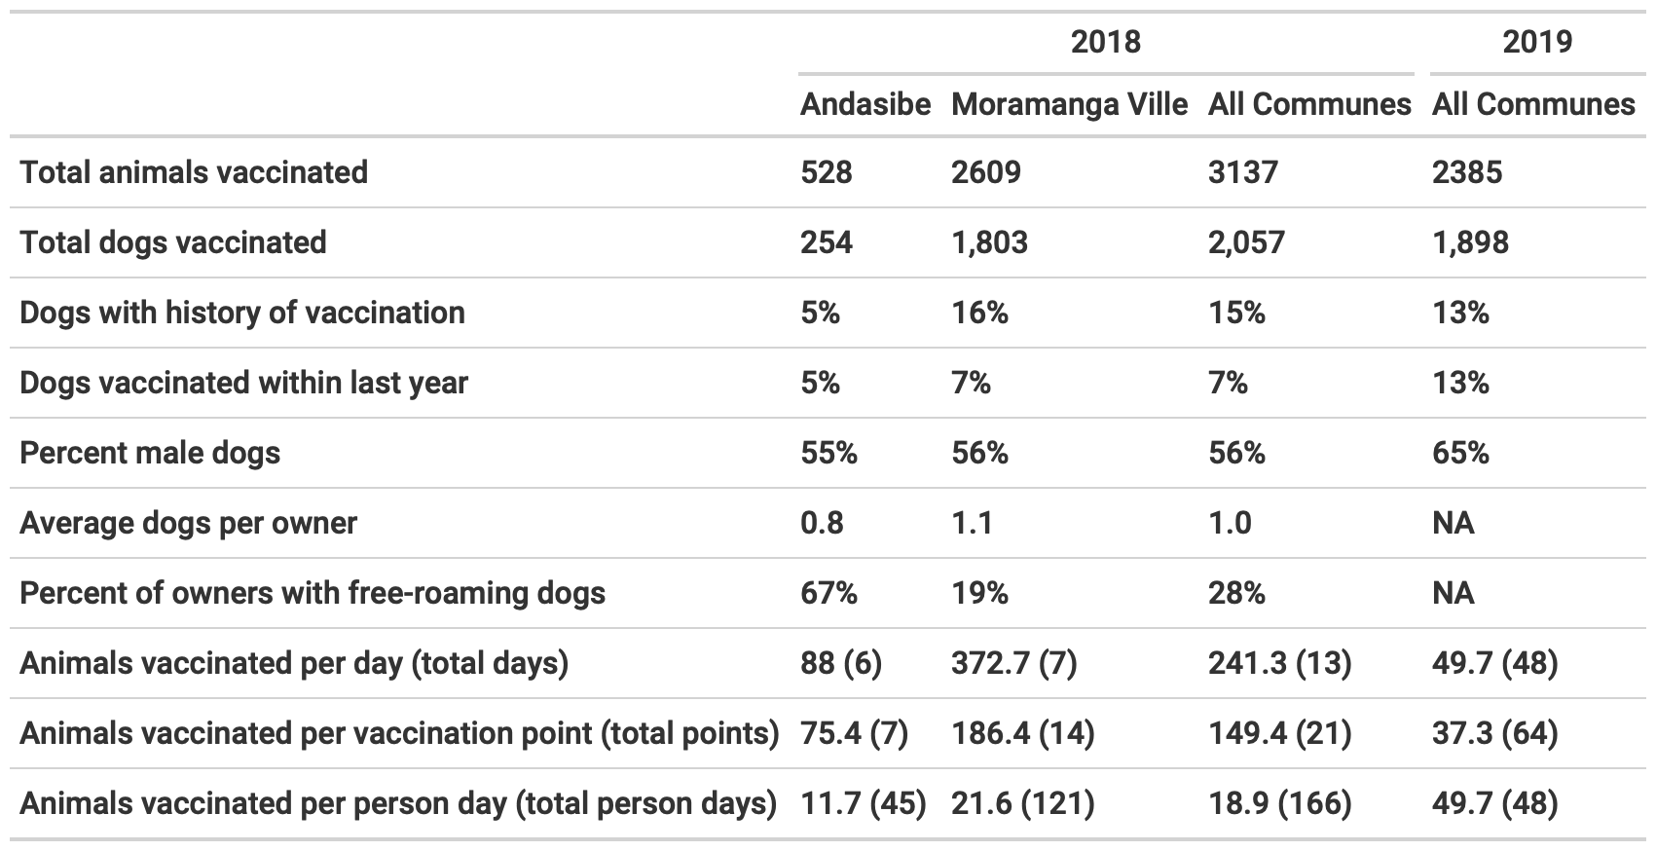

### Cost comparison and willingness to pay

The 2018 campaign cost more overall and per animal vaccinated than the 2019 campaign, largely due to increased personnel costs (Fig 1A & B, Table 1). Reflecting the extra personnel necessary to run the central point campaign, the 2018 campaign also took substantially more person-days per animal vaccinated (Table 1). We found that charging owners for vaccination would result in minimal cost recovery (Fig 1C) and beyond a minimal cost would actually result in increased costs per vaccinated individual than free-of-charge campaigns. Cost recovery would be more likely given a 2019 style strategy where the majority of the costs are incurred on a per animal basis, compared to the 2018 campaigns where the costs are largely due to setting up the central point vaccination stations (Fig 3A) [comment for KH abt clarification here]. More importantly, in all cases, even a nominal fee would significantly reduce numbers of dogs vaccinated and thus vaccination coverage, particularly in the rural commune of Andasibe (Fig 1D).

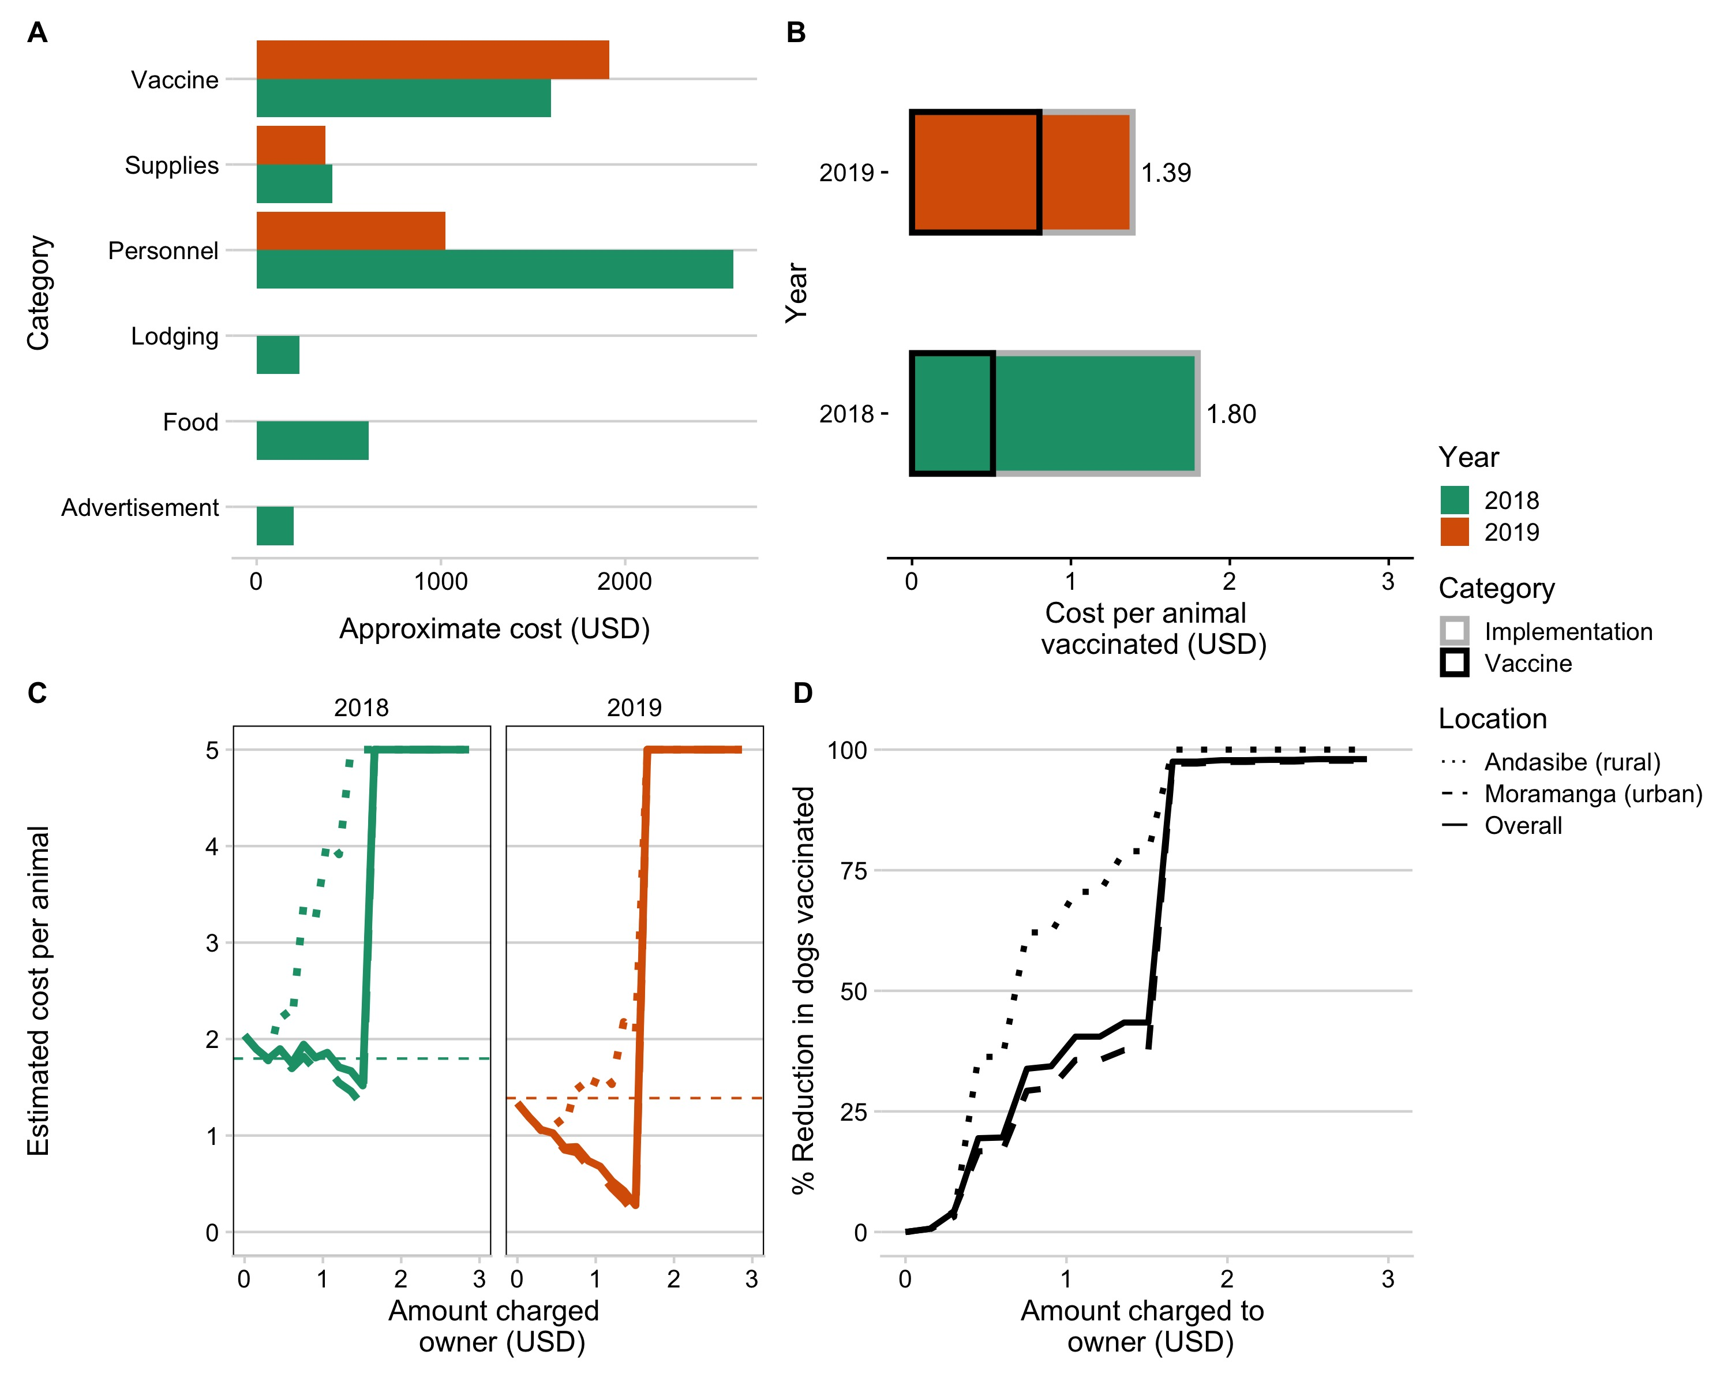 #### Figure 1. Comparing campaign costs and willingness to pay *A) Vaccine costs broken down by category and by year (colors). B) Overall cost per animal vaccinated for the two campaign years, split by direct costs of vaccination per animal (i.e. vaccine, vaccination card, syringes) and baseline implementation costs (i.e. personnel, supplies, subsistence costs for vaccinators during the campaign). C) Estimated cost per animal vaccinated under a willingness to pay model for two campaigns examining increasing costs charged to the owner, with estimated costs declining due to cost recovery through owner payments and then peaking once owners report to be no longer willing to pay for the vaccine. D) The percent reduction in number of animals vaccinated given owners willingness to pay. The curves in C and D are shown based on the overall responses on willingness to pay (solid line) from both Moramanga and Andasibe, and the responses split by Commune (dashed and dotted lines).*

### Comparing campaign coverage estimates

The 2018 campaign covered two communes and was estimated to have achieved approximately 60% coverage (Figure 2A). The 2019 campaign covered 7 communes, but was estimated to have achieved lower coverage levels (Figure 2, ranging from 5 - 60%). In the 2018 campaign, we used post-vaccination coverage transects to estimate vaccination coverage, but we were unable to do this in 2019 given the continuous delivery strategy. In addition, in Andasibe in 2018, coverage estimates were based on a single transect resulting in more uncertainty. However, coverage estimated from the transects in 2018 were consistent with the HDR based estimates (for both Andasibe and Moramanga, transect-based estimates fell within the range of the HDR estimates). We also back-calculated HDRs given our vaccination coverage estimates, and these were similar to the HDRs calculated from the household survey (18.8 - 39.1 for Andasibe compared to 21.7 in a rural community and 13.4 - 15.9 for Moramanga Ville compared to 17.2 in an urban community).

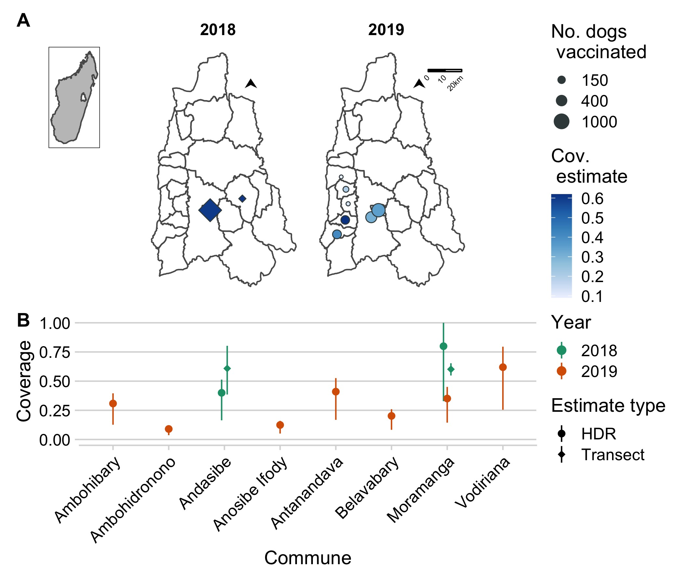 #### Figure 2. Estimates of coverage achieved by the 2018 and 2019 campaigns. *A) The commune level numbers of dogs vaccinated (size of points) and the associated coverage estimates (color of points) for the year 2018 (estimated using post-vaccination transects) and 2019 (estimated using a human-to-dog ratio (HDR) of 19.5, based on a recent household survey in the Moramanga District). The inset shows the location of the Moramanga District in Madagascar. B) A comparison of coverage estimates by location and by method of estimation (post-vaccination transects vs. HDR based estimates); for the transect based estimates, the line range shows the 95% exact binomial confidence interval while for the HDR based estimates, the line range shows the range of coverage estimates assuming an HDR range of 8 - 25 according to estimates from the literature.*

### Dog demography and simulating vaccination strategies

Demographic data from vaccinated dogs shows a population pyramid with a large base, indicative of a fast-growing population, and with a male bias (approximately 60% male, Figure 3A). We fit these data to an age-structured model, and were able to generate parameter estimates which resulted in stable age distributions consistent with the data (Figure 3B). We filter to parameter estimates that are consistent with a growing population resulting in mean adult annual survival probability of 0.77 (95% quantile: 0.59 - 0.97). We use estimates of fertility (on average 1.09, 95% quantile: 0.82 - 1.41) to back-calculate pup survival, which ranges from 0.26 - 0.44. We find that given these demographic parameters, annual campaigns that target dogs of all ages result in rapid decline in vaccination coverage in between campaigns, largely due to rapid turnover of the dog population (compared to the impact of waning immunity assuming a discrete 3 year period of vaccine immunity, evident in the additional dip at year 3, Fig 3D). Continuously targeting 70% of the puppy population for vaccination, while unable to achieve the peak coverage, consistently reaches coverage of about 50% of the dog population. A combined strategy maintains the highest and most temporally stable levels of coverage close to the target of 70%.

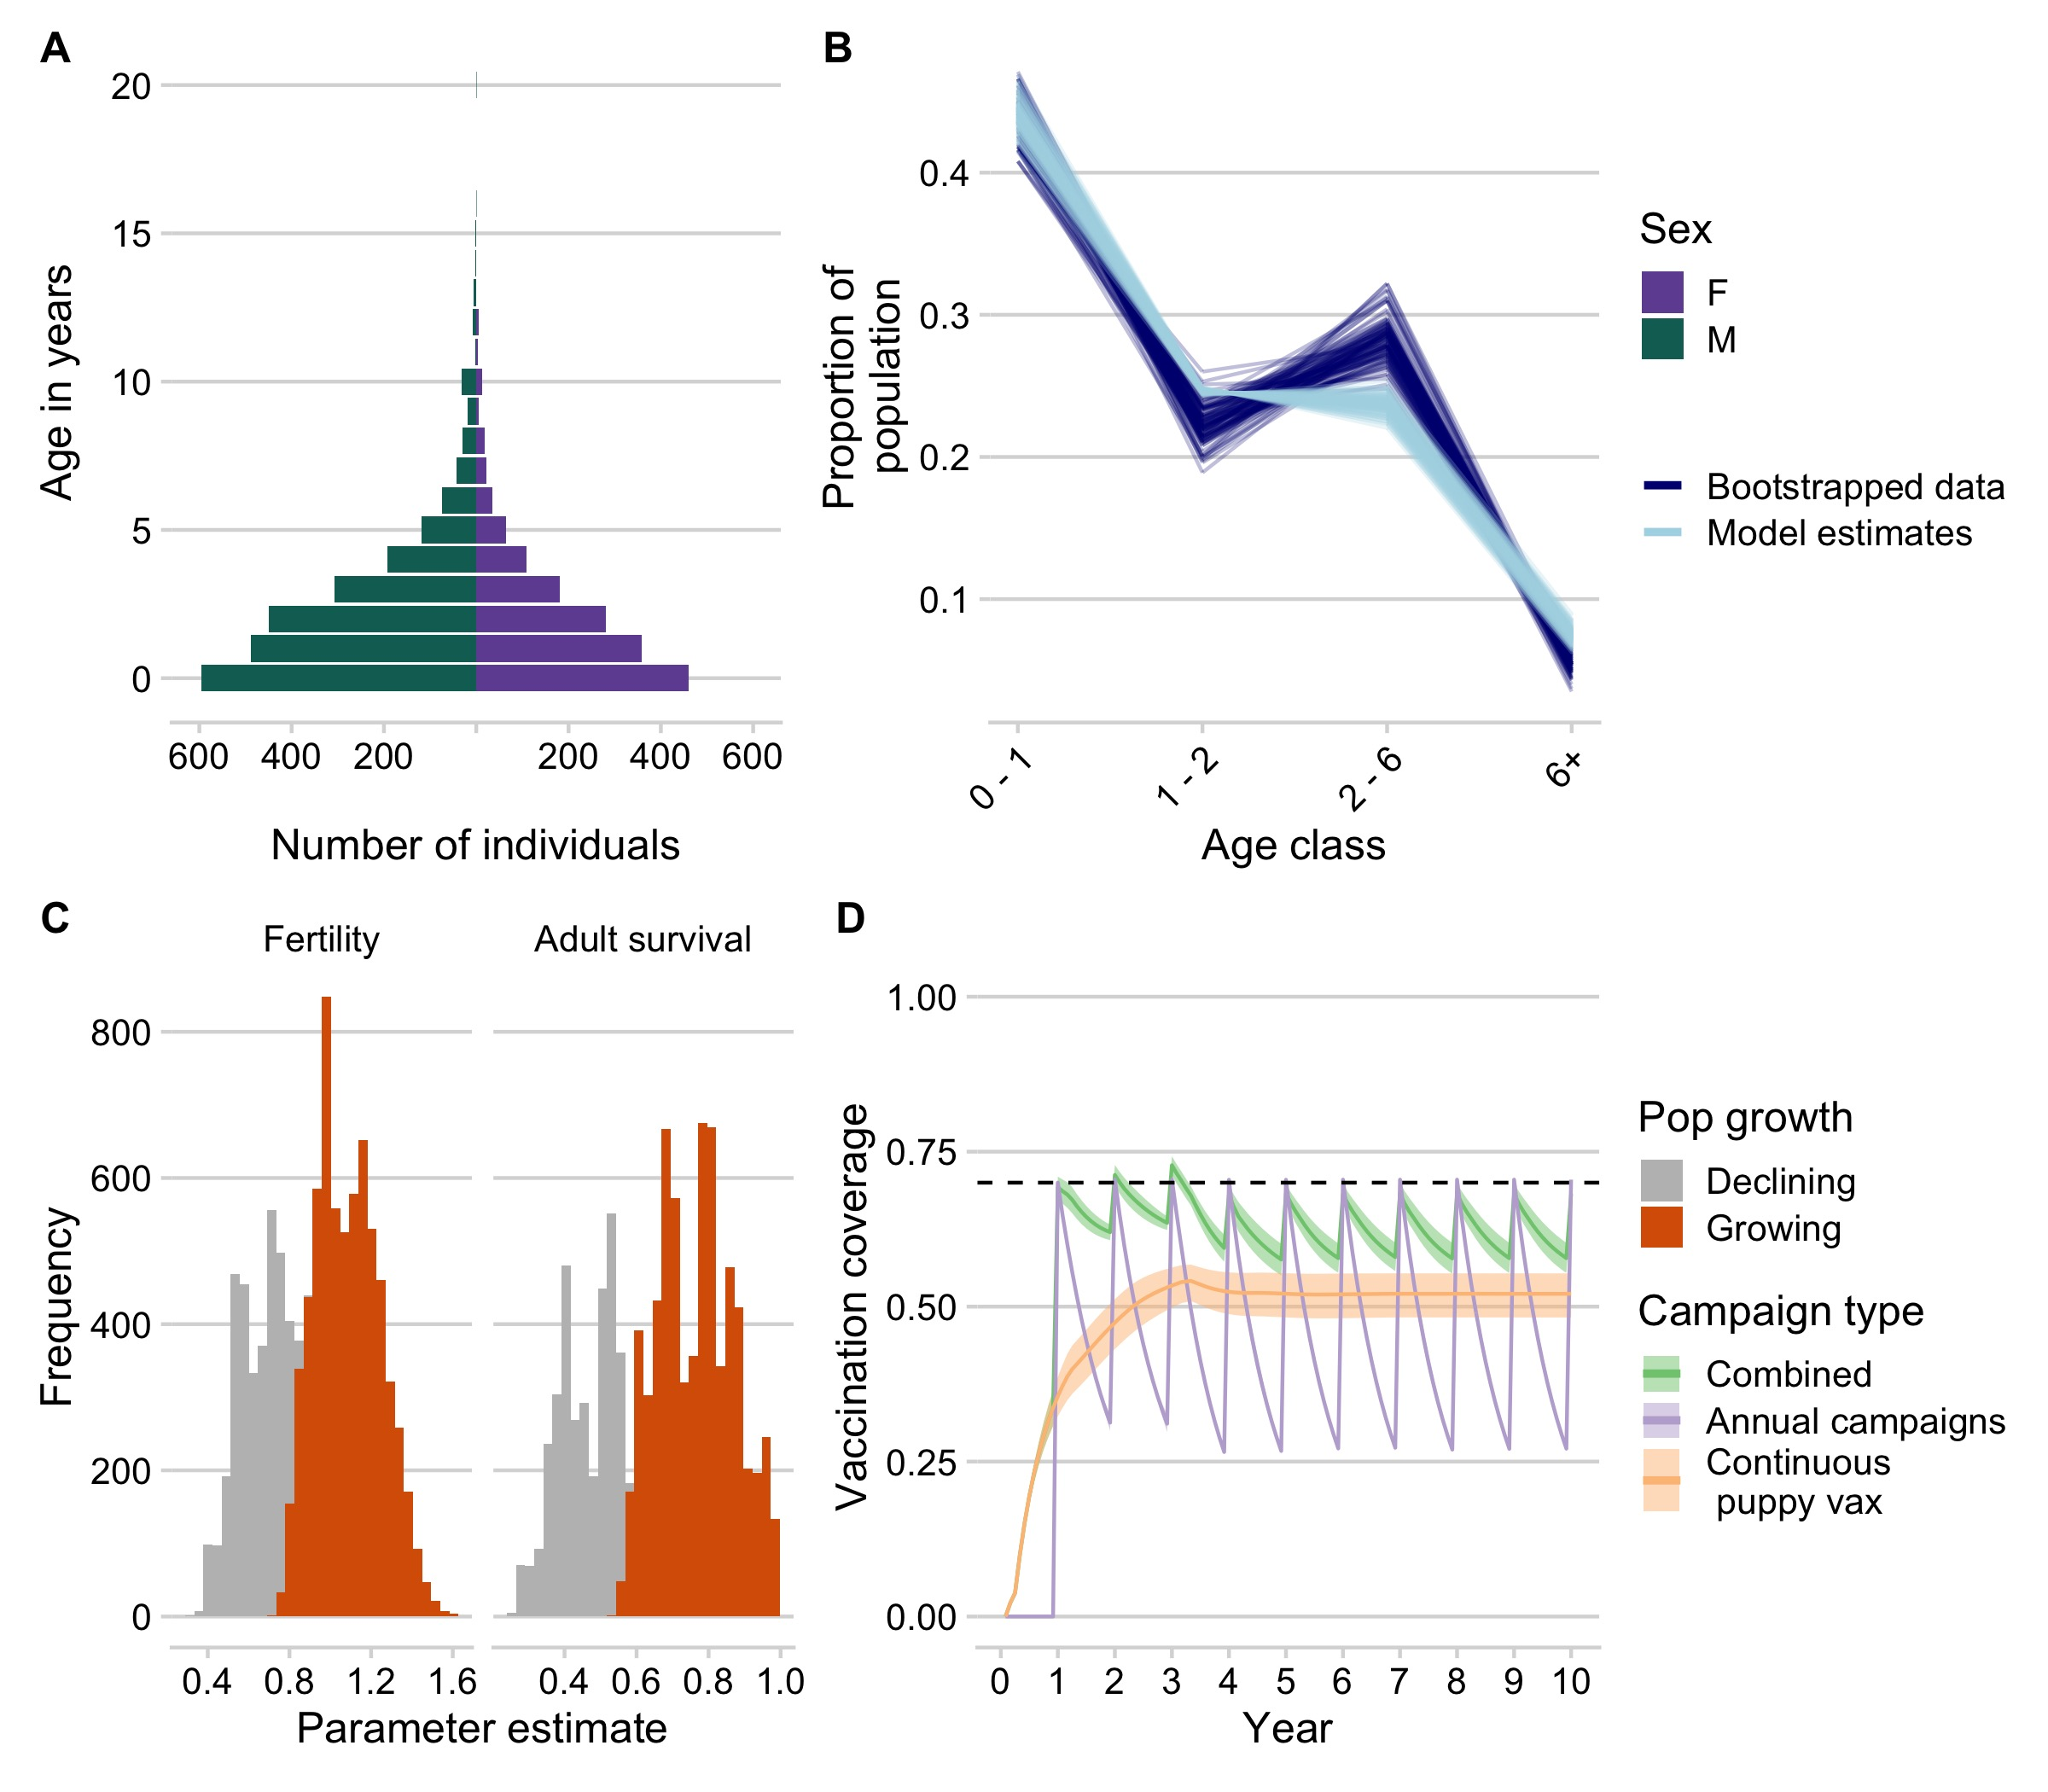 #### Figure 3. Dog demography and implications for campaign strategies *A) The age pyramid for vaccinated dogs by sex. B) Bootstrapped estimates of the proportion of the population in each age class from the age data (dark blue) compared to estimates from the demographic models fit to these data (light blue). C) Parameter estimates for annual fertility rates and adult survival probability, with estimates highlighted in orange showing the parameter estimates which result in positive population growth. B) Simulated vaccination coverage (N = 1000) using the demographic parameters from (C) in a hypothetical commune with 1000 dogs for three different campaign strategies: 1) annual vaccination campaigns targeting dogs of all ages (purple), 2) routine vaccination of puppies at 3 months of age, and 3) a combined strategy with campaigns annually and continuous puppy vaccination in between campaigns.*

## Discussion

Through vaccination campaigns implemented in Moramanga District of Madagascar, we saw high demand for vaccination from dog owners and found that dogs were accessible and able to be handled efficiently for parenteral vaccination at a reasonable cost (between 1.3 - 1.8 USD per animal vaccinated). We find that providing the vaccine at no direct cost to dog owners will be critical to achieving sufficient coverage, as even with nominal fees, a significant proportion of owners indicated they would no longer vaccinate their animals. A central point vaccination strategy achieved higher coverage over a shorter time period in 2018 compared to dog vaccinations conducted by the District Veterinarian as part of routine veterinary service provision in 2019. However, it came at a higher cost per animal vaccinated, was more limited in geographic scope, and required more resources in terms of personnel. In addition, in the rural setting of Andasibe, the central point campaign strategy achieved lower coverage, reflecting less accessible, hard-to-reach human communities in this location. Based on the lessons learned through these campaigns, in particular the observation that puppies were relatively easy to handle for vaccinators and owners, we find that continuous vaccination targeting puppies in particular may be an effective way to maintain vaccination coverage levels given high turnover in dog populations.

There were several limitations to our analyses. Owner reports of willingness to pay, age of animals, and distance travelled to the vaccination point likely all suffer from recall bias and uncertainty, whilst willingness to pay studies are often overestimates of observed practice (Birhane et al. 2016). In addition, age of animals brought to vaccination points may not be representative of the age structure of the underlying population, and other work has shown that in general puppies (individuals < 1 year) tend to have lower vaccination coverage than adults (Arief et al. 2016; Sanchez-Soriano et al. 2020; Mazeri et al. 2019; Minyoo et al. 2015). We also did not vaccinate animals less than 1 month of age, which may explain why we sometimes estimated declining populations (as part of the age class of 0-1 years was not captured by the data). However, our analyses based on these data are consistent with previous findings from SSA that demonstrate male-biased populations, skewed towards puppies, and with high mortality in the first year of life (Czupryna et al. 2016; Taylor et al. 2017). Studies have also shown that charging fees for vaccines can greatly reduce the efficacy of campaigns and are a significant barrier to vaccination for owners (Schildecker et al. 2016; Yoak et al. 2021; Barbosa Costa et al. 2020). Similarly, distance to campaign points has been identified as a barrier to vaccination, and in most cases owners eport traveling less than 1km to reach a vaccination point (Mazeri et al. 2018; Mazeri et al. 2019). We used HDRs, which can be sensitive to underlying estimates of the human population and the spatial scale of estimation (Sambo et al. 2018, 2017). However, we used HDR estimates from a recent household survey study in the district, and found these to give coverage estimates consistent with those from post-vaccination transects. Finally, in our vaccination model, we make several simplifying assumptions: we assume that immunity wanes after three years (simulating vaccination with a long-lasting vaccine such as Nobivac, compared to the manufacturer stated one year efficacy for Rabisin [comment for KH BI states this on their vials]); we assume that vaccinated dogs that survive to the following year are revaccinated in subsequent campaigns; and in our age-structured models we do not account for population carrying capacity, but rather simulate over a short time frame over which population growth remains reasonable.

Our estimates of costs per animal vaccinated are in line with recent estimates from other settings (Undurraga et al. 2020), although we likely underestimate costs given the donation of time and resources by the organizations and individuals involved (i.e. costs associated with international volunteers including airfare and visa costs as well as costs of transportation donated to the campaign). We also did not include costs of pre-exposure prophylaxis as all of our volunteers and vaccinators had been vaccinated prior to the campaigns. Both pre- and post-exposure vaccines should however always be readily available for vaccinators and be included in vaccination program budgets. While the volunteer-led effort resulted in significant financial and personnel resources being devoted to the campaign, costs were higher per animal vaccinated and overall. In addition, NGO and volunteer based campaigns may be difficult to sustain given unpredictable funding, time commitments, and turnover in staff (Ferguson et al. 2020). Dog vaccination delivered through the District Veterinarian was less costly, with the majority of the costs directly related to vaccination.

One key aspect we do not consider is potential feedback loops between vaccination and demography. Estimates of the effects of vaccination on dog demography are mixed (Czupryna et al. 2016), but vaccination may increase dog survival (Conan et al. 2015). If dog population growth is driven by survival, then this could mean that increased vaccination results in increased population growth. However, if growth is driven more by demand from human communities, then vaccination could stabilize the population and reduce turnover of the population. Improving dog population management, encouraging responsible pet ownership practices, and increasing veterinary services could all complement vaccination efforts, but have not been demonstrated to result in meaningful rabies control without parallel dog vaccination (Taylor et al. 2017).

In settings with high dog ownership, moving towards community-based vaccination strategies could be an effective way to achieve sufficient and consistent coverage, particulary in hard-to-reach communities. During our campaign, we found that puppies at approximately 3 months old were easy to handle for both vaccinators and owners. Puppy vaccination could be carried out by local officials embedded in communities (along the lines of community health workers), particularly given recent findings on thermotolerance of rabies vaccines and locally manufactured methods for maintaining temperatures required for sustained vaccine storage (up to 3 months) (Lugelo et al. 2020). Incentivizing vaccinators appropriately will be a key challenge, as currently providing no-cost rabies vaccination is not seen as part of routine duties for district veterinarians or for livestock officers. Implementing dog vaccination alongside government mandated livestock vaccination campaigns may also be a strategy to scale up vaccination efforts at relatively low-cost. Expanding veterinary services across the country and relieving financial pressures on veterinarians and animal health workers through appropriate compensation could greatly improve veterinary services across Madagascar (Organization Mondiale de la Sante 2017). For volunteer based efforts, focusing on local volunteers (i.e. veterinary students) may be a more cost-effective strategy. However similar to international volunteers, volunteers require subsistence during vaccination campaigns when not based in the communities where they study or live.

Overall, our results suggest that dog vaccination is a feasible and effective strategy for controlling canine rabies in Madagascar. However, rabies vaccination must be recognized as a public good, and strategies to remove barriers for dog owners and to incentivize veterinarians and other animal health workers to implement vaccination will be key to campaign success. Borrowing strategies from human vaccination efforts, i.e. use of community health workers, could be a way to deliver vaccinations and reduce costs in the hardest-to-reach communities. In addition, refining vaccination strategies to local contexts and using improved tools and systems, such as mobile phone based data collection, could improve efficacy and lower costs of campaigns (Mazeri et al. 2021; Gibson et al. 2016). To monitor the success of these campaigns, it will be critical to develop efficient and effective methods to estimate vaccination coverage and to measure their impact on reducing rabies incidence through robust surveillance (Lushasi et al. 2020; Ferguson et al. 2020). Given it’s island context, Madagascar could be a model for rabies elimination, with limited chances for reintroduction from outside the island, and strategies that tackle the context specific challenges could be a path forward for the country to reach ZeroBy30.

## Acknowledgements

We thank all the veterinarians, livestock officers, local officials and leaders, NGO staff, and volunteers involved in each of the campaigns. We are grateful to staff and officials at the Department of Veterinary Services, the Ministry of Public Health, and the Institut Pasteur de Madagascar for their support and technical assistance. In particular, we thank Carmen Barba Claassens, Jean Hyacinthe Randrianarisoa, Ranaivoarimanana, Fierenantsoa Randriamahatana, Esther Noiarisaona, Cara Brook, and Christian Ranaivoson, Rila Ratovoson, and Claire LeBlanc. The campaign costs were supported by donations from Lush Cosmetics Charity Pot. Parts of this work were funded by grants from the Center for Health and Wellbeing and the Department of Ecology and Evolutionary Biology at Princeton University to MR. MR was supported by an NSF Graduate Research Fellowship and a Princeton Institute for Regional and International Studies Graduate Fellowship. KH is supported by the Wellcome Trust (207569/Z/17/Z).

We want to particularly acknowledge the contributions to this work by Annie Yang, an undergraduate researcher and volunteer with Princeton University and the Madagascar Dog Initiative who tragically passed away in a car accident before this research was published.

## References

Abela-Ridder, B, L Knopf, S Martin, L Taylor, Gregorio Torres, and Katinka de Balogh. 2016. “2016: The Beginning of the End of Rabies?” *The Lancet Global Health*.

Arief, Riana A, Katie Hampson, Andri Jatikusumah, Maria D W Widyastuti, Sunandar, Chaerul Basri, Anak A G Putra, et al. 2016. “Determinants of Vaccination Coverage and Consequences for Rabies Control in Bali, Indonesia.” *Frontiers in Veterinary Science*.

Athingo, Rauna, Tenzin Tenzin, Andre Coetzer, Emmanuel H. Hikufe, Josephat Peter, Laina Hango, Tangeni Haimbodi, et al. 2020. “Application of the GARC Data Loggera Custom-Developed Data Collection Deviceto Capture and Monitor Mass Dog Vaccination Campaigns in Namibia.” Edited by Monique Lechenne. *PLOS Neglected Tropical Diseases* 14 (12): e0008948. <https://doi.org/10.1371/journal.pntd.0008948>.

Barbosa Costa, Galileu, Fleurinord Ludder, Benjamin Monroe, Pierre Dilius, Kelly Crowdis, Jesse D. Blanton, Emily G. Pieracci, Jennifer R. Head, Andrew D. Gibson, and Ryan M. Wallace. 2020. “Barriers to Attendance of Canine Rabies Vaccination Campaigns in Haiti, 2017.” *Transboundary and Emerging Diseases* 67 (6): 2679–91. <https://doi.org/10.1111/tbed.13622>.

Birhane, Meseret G., Mary Elizabeth G. Miranda, Jessie L. Dyer, Jesse D. Blanton, and Sergio Recuenco. 2016. “Willingness to Pay for Dog Rabies Vaccine and Registration in Ilocos Norte, Philippines (2012).” Edited by Jakob Zinsstag. *PLOS Neglected Tropical Diseases* 10 (3): e0004486. <https://doi.org/10.1371/journal.pntd.0004486>.

Borse, Rebekah H, Charisma Y Atkins, Manoj Gambhir, Eduardo A Undurraga, Jesse D Blanton, Emily B Kahn, Jessie L Dyer, Charles E Rupprecht, and Martin I Meltzer. 2018. “Cost-Effectiveness of Dog Rabies Vaccination Programs in East Africa.” *PLoS Neglected Tropical Diseases*.

CLEAVELAND, S. 2003. “A Dog Rabies Vaccination Campaign in Rural Africa: Impact on the Incidence of Dog Rabies and Human Dog-Bite Injuries.” *Vaccine* 21 (17-18): 1965–73. <https://doi.org/10.1016/s0264-410x(02)00778-8>.

Conan, Anne, Oluyemisi Akerele, Greg Simpson, Bjorn Reininghaus, Jacques van Rooyen, and Darryn Knobel. 2015. “Population Dynamics of Owned, Free-Roaming Dogs: Implications for Rabies Control.” Edited by Charles E Rupprecht. *PLOS Neglected Tropical Diseases* 9 (11): e0004177. <https://doi.org/10.1371/journal.pntd.0004177>.

Czupryna, Anna M, Joel S Brown, Machunde A Bigambo, Christopher J Whelan, Supriya D Mehta, Rachel M Santymire, Felix J Lankester, and Lisa J Faust. 2016. “Ecology and Demography of Free-Roaming Domestic Dogs in Rural Villages Near Serengeti National Park in Tanzania.” *PLoS ONE*.

Del Rio Vilas, Victor J., Mary J. Freire de Carvalho, Marco A. N. Vigilato, Felipe Rocha, Alexandra Vokaty, Julio A. Pompei, Baldomero Molina Flores, Natael Fenelon, and Ottorino Cosivi. 2017. “Tribulations of the Last Mile: Sides from a Regional Program.” *Frontiers in Veterinary Science* 4 (January). <https://doi.org/10.3389/fvets.2017.00004>.

Fahrion, Anna S., Louise H. Taylor, Gregorio Torres, Thomas Müller, Salome Dürr, Lea Knopf, Katinka de Balogh, Louis H. Nel, Mary Joy Gordoncillo, and Bernadette Abela-Ridder. 2017. “The Road to Dog Rabies Control and Eliminationwhat Keeps Us from Moving Faster?” *Frontiers in Public Health* 5 (May). <https://doi.org/10.3389/fpubh.2017.00103>.

Ferguson, Adam W., Dishon Muloi, Dedan K. Ngatia, Wangechi Kiongo, Duncan M. Kimuyu, Paul W. Webala, Moses O. Olum, et al. 2020. “Volunteer Based Approach to Dog Vaccination Campaigns to Eliminate Human Rabies: Lessons from Laikipia County, Kenya.” Edited by Abdallah M. Samy. *PLOS Neglected Tropical Diseases* 14 (7): e0008260. <https://doi.org/10.1371/journal.pntd.0008260>.

Fooks, Anthony R, Ashley C Banyard, Daniel L Horton, Nicholas Johnson, Lorraine M McElhinney, and Alan C Jackson. 2014. “Current Status of Rabies and Prospects for Elimination.” *The Lancet*.

Fujiwara, Masami, and Jasmin Diaz-Lopez. 2017. “Constructing Stage-Structured Matrix Population Models from Life Tables: Comparison of Methods.” *PeerJ* 5 (October): e3971. <https://doi.org/10.7717/peerj.3971>.

Gibson, Andrew D, Ian G Handel, Kate Shervell, Tarryn Roux, Dagmar Mayer, Stanford Muyila, Golden B Maruwo, et al. 2016. “The Vaccination of 35,000 Dogs in 20 Working Days Using Combined Static Point and Door-to-Door Methods in Blantyre, Malawi.” Edited by Charles E Rupprecht. *PLOS Neglected Tropical Diseases* 10 (7): e0004824. <https://doi.org/10.1371/journal.pntd.0004824>.

Gibson, Andrew D, Praveen Ohal, Kate Shervell, Ian G Handel, Barend M Bronsvoort, Richard J Mellanby, and Luke Gamble. 2015. “Vaccinate-Assess-Move Method of Mass Canine Rabies Vaccination Utilising Mobile Technology Data Collection in Ranchi, India.” *BMC Infectious Diseases*.

Hampson, Katie, Laurent Coudeville, Tiziana Lembo, Maganga Sambo, Alexia Kieffer, Michaël Attlan, Jacques Barrat, et al. 2015. “Estimating the Global Burden of Endemic Canine Rabies.” Edited by Marilia Sá Carvalho. *PLOS Neglected Tropical Diseases* 9 (4): e0003709. <https://doi.org/10.1371/journal.pntd.0003709>.

Hampson, Katie, Jonathan Dushoff, Sarah Cleaveland, Daniel T Haydon, Magai Kaare, Craig Packer, and Andy Dobson. 2009. “Transmission Dynamics and Prospects for the Elimination of Canine Rabies.” *PLOS Biol*.

Jibat, Tariku, Henk Hogeveen, and Monique C M Mourits. 2015. “Review on Dog Rabies Vaccination Coverage in Africa: A Question of Dog Accessibility or Cost Recovery?” *PLoS Neglected Tropical Diseases*.

Leblanc, Claire. 2019. “Rabies in Madagascar: A Three-Pronged Survey of Knowledge and Practices Among Health Care Providers from Anti-Rabies Treatment Centers, Veterinarians and the Community of Moramanga.” PhD thesis, Cnam de Sante Publique.

Linard, Catherine, Marius Gilbert, Robert W Snow, Abdisalan M Noor, and Andrew J Tatem. 2012. “Population distribution, settlement patterns and accessibility across Africa in 2010.” *PloS one* 7 (2): e31743–43. <https://doi.org/10.1371/journal.pone.0031743>.

Lugelo, Ahmed, Katie Hampson, Machunde Bigambo, Rudovick Kazwala, and Felix Lankester. 2020. “Controlling Human Rabies: The Development of an Effective, Inexpensive and Locally Made Passive Cooling Device for Storing Thermotolerant Animal Rabies Vaccines.” *Tropical Medicine and Infectious Disease* 5 (3): 130. <https://doi.org/10.3390/tropicalmed5030130>.

Lushasi, Kennedy, Rachel Steenson, Jubilate Bernard, Joel Jackson Changalucha, Nicodem James Govella, Daniel T. Haydon, Husna Hoffu, et al. 2020. “One Health in Practice: Using Integrated Bite Case Management to Increase Detection of Rabid Animals in Tanzania.” *Frontiers in Public Health* 8 (February). <https://doi.org/10.3389/fpubh.2020.00013>.

Mazeri, Stella, Jordana L. Burdon Bailey, Dagmar Mayer, Patrick Chikungwa, Julius Chulu, Paul Orion Grossman, Frederic Lohr, et al. 2021. “Using Data-Driven Approaches to Improve Delivery of Animal Health Care Interventions for Public Health.” *Proceedings of the National Academy of Sciences* 118 (5): e2003722118. <https://doi.org/10.1073/pnas.2003722118>.

Mazeri, Stella, Andrew D. Gibson, Natascha Meunier, Barend M.deC Bronsvoort, Ian G. Handel, Richard J. Mellanby, and Luke Gamble. 2018. “Barriers of Attendance to Dog Rabies Static Point Vaccination Clinics in Blantyre, Malawi.” *PLOS Neglected Tropical Diseases* 12 (1): 1–17. <https://doi.org/10.1371/journal.pntd.0006159>.

Mazeri, Stella, Andrew D Gibson, Barend Mark de Clare Bronsvoort, Ian G Handel, Fred Lohr, Jordana Burdon Bailey, Dagmar Mayer, Luke Gamble, and Richard J Mellanby. 2019. “Sociodemographic Factors Which Predict Low Private Rabies Vaccination Coverage in Dogs in Blantyre, Malawi.” *Veterinary Record* 184 (9): 281–81. <https://doi.org/10.1136/vr.105000>.

Minyoo, Abel B., Melissa Steinmetz, Anna Czupryna, Machunde Bigambo, Imam Mzimbiri, George Powell, Paul Gwakisa, and Felix Lankester. 2015. “Incentives Increase Participation in Mass Dog Rabies Vaccination Clinics and Methods of Coverage Estimation Are Assessed to Be Accurate.” Edited by Charles E Rupprecht. *PLOS Neglected Tropical Diseases* 9 (12): e0004221. <https://doi.org/10.1371/journal.pntd.0004221>.

Morters, Michelle K, Trevelyan J McKinley, Olivier Restif, Andrew J K Conlan, Sarah Cleaveland, Katie Hampson, Helen R Whay, I Made Damriyasa, and James L N Wood. 2014. “The Demography of Free-Roaming Dog Populations and Applications to Disease and Population Control.” *Journal of Applied Ecology*.

Organization Mondiale de la Sante. 2017. “Evaluation Externe Conjointe Des Principales Capacites RSI de La Republique de Madagascar: Resume de Mission, 10 Au 14 Juillet 2017.” Organisation mondiale de la Sante.

Pebesma, Edzer. 2018. “Simple Features for R: Standardized Support for Spatial Vector Data.” *The R Journal* 10 (1): 439–46. <https://doi.org/10.32614/RJ-2018-009>.

R Core Team. 2020. *R: A Language and Environment for Statistical Computing*. Vienna, Austria: R Foundation for Statistical Computing. <https://www.R-project.org/>.

Rajeev, Malavika, Glenn Edosoa, Chantal Hanitriniaina, Soa Fy Andriamandimby, Helene Guis, Ravo Ramiandrasoa, Rila Ratovoson, et al. 2019. “Healthcare Utilization, Provisioning of Post-Exposure Prophylaxis, and Estimation of Human Rabies Burden in Madagascar.” *Vaccine*.

Rajeev, Malavika, Hélène Guis, Glenn Edosoa, Chantal Hanitriniaina, Anjasoa Randrianarijaona, Reziky Tiandraza Mangahasimbola, Fleur Hierink, et al. 2020. “How Geographic Access to Care Shapes Disease Burden: The Current Impact of Post-Exposure Prophylaxis and Potential for Expanded Access to Prevent Human Rabies Deaths in Madagascar.” <https://doi.org/10.1101/2020.10.02.20205948>.

Ratsitorahina, Maherisoa, Jhon H Rasambainarivo, Soloherilala Raharimanana, Hary Rakotonandrasana, Marie-Perle Andriamiarisoa, Fidilalao A Rakalomanana, and Vincent Richard. 2009. “Dog Ecology and Demography in Antananarivo, 2007.” *BMC Veterinary Research*.

Reynes, Jean-Marc, Soa Fy Andriamandimby, Girard Marcelin Razafitrimo, Josette Razainirina, Elisabeth Marie Jeanmaire, Hervé Bourhy, and Jean-Michel Heraud. 2011. “Laboratory Surveillance of Rabies in Humans, Domestic Animals, and Bats in Madagascar from 2005 to 2010.” *Advances in Preventive Medicine*.

Sambo, Maganga, Katie Hampson, Joel Changalucha, Sarah Cleaveland, Tiziana Lembo, Kennedy Lushasi, Eberhard Mbunda, Zacharia Mtema, Lwitiko Sikana, and Paul Johnson. 2018. “Estimating the Size of Dog Populations in Tanzania to Inform Rabies Control.” *Veterinary Sciences* 5 (3): 77.

Sambo, Maganga, Paul C D Johnson, Karen Hotopp, Joel Changalucha, Sarah Cleaveland, Rudovick Kazwala, Tiziana Lembo, et al. 2017. “Comparing Methods of Assessing Dog Rabies Vaccination Coverage in Rural and Urban Communities in Tanzania.” *Frontiers in Veterinary Science*.

Sanchez-Soriano, Carlos, Andrew D. Gibson, Luke Gamble, Jordana L. Burdon Bailey, Dagmar Mayer, Frederic Lohr, Patrick Chikungwa, et al. 2020. “Implementation of a Mass Canine Rabies Vaccination Campaign in Both Rural and Urban Regions in Southern Malawi.” Edited by Sergio Recuenco. *PLOS Neglected Tropical Diseases* 14 (1): e0008004. <https://doi.org/10.1371/journal.pntd.0008004>.

Schildecker, S., M. Millien, J. D. Blanton, J. Boone, A. Emery, F. Ludder, N. Fenelon, et al. 2016. “Dog Ecology and Barriers to Canine Rabies Control in the Republic of Haiti, 2014-2015.” *Transboundary and Emerging Diseases* 64 (5): 1433–42. <https://doi.org/10.1111/tbed.12531>.

Taylor, Louise H., Ryan M. Wallace, Deepashree Balaram, Joann M. Lindenmayer, Douglas C. Eckery, Beryl Mutonono-Watkiss, Ellie Parravani, and Louis H. Nel. 2017. “The Role of Dog Population Management in Rabies Eliminationa Review of Current Approaches and Future Opportunities.” *Frontiers in Veterinary Science* 4 (July). <https://doi.org/10.3389/fvets.2017.00109>.

Undurraga, Eduardo A., Max F. Millien, Kasim Allel, Melissa D. Etheart, Julie Cleaton, Yasmeen Ross, Ryan M. Wallace, et al. 2020. “Costs and Effectiveness of Alternative Dog Vaccination Strategies to Improve Dog Population Coverage in Rural and Urban Settings During a Rabies Outbreak.” *Vaccine* 38 (39): 6162–73. <https://doi.org/10.1016/j.vaccine.2020.06.006>.

Wickham, Hadley, Mara Averick, Jennifer Bryan, Winston Chang, Lucy McGowan, Romain François, Garrett Grolemund, et al. 2019. “Welcome to the Tidyverse.” *Journal of Open Source Software* 4 (43): 1686. <https://doi.org/10.21105/joss.01686>.

World Health Organization. 2013. “WHO Expert Consultation on Rabies. Second Report.” *World Health Organization Technical Report Series*.

Yoak, Andrew J., Abraham Haile, Jeanette O’Quin, Maria Belu, Meseret Birhane, Meseret Bekele, Sylvia Murphy, et al. 2021. “Barriers and Opportunities for Canine Rabies Vaccination Campaigns in Addis Ababa, Ethiopia.” *Preventive Veterinary Medicine* 187 (February): 105256. <https://doi.org/10.1016/j.prevetmed.2020.105256>.