1. **Introduction**

A data set (regression_1.csv – Refer Annexure) is provided on the Resales of Homes data. The data set consists of resale home price transactions with 8 variables having the details like Price, Sq Ft., Age, Feats, NE, CUST, COR and Tax.

**The requirement is to fit a Multiple Regression Model for finding the determinants of the reselling price of a house given a set of predictors.**

1. **Approach**

Given the data set, a multiple regression model needs to be fitted with resale price of homes as the dependent variable and all other variables as predictors. In addition to the fitting a multiple regression model, the heteroscedasticity, multicollinearity and the violation of normality assumption in the fitted model is also checked and the necessary remedies has been suggested so as to achieve an optimum fitted model

**C. Method: Multiple Regression**

**Step 1: Data Preparation by transforming the values of the Feats variable with dummy variables (binary).**

**Reason: The numbers provided in the Feats variable are categorical in nature and hence transformed by dummy variable (binary)**

***Reference R Code:***

***setwd("C:\\Software\\xlri\\Regression\\Assignment")***

***library(car)***

***library(lmtest)***

***library(tseries)***

***library(sandwich)***

***library(stats)***

***library(MASS)***

***library(faraway)***

***realestateprice<-read.csv("regression_1.csv",header=TRUE, na.strings=c("*",'NA'))***

***str(realestateprice)***

***head(realestateprice)***

***for(level in unique(realestateprice$Feats)-1){***

***realestateprice[paste("Feats", gsub("-","_", gsub(" ","_",level, fixed=TRUE), fixed=TRUE), sep = "_")] <- ifelse(realestateprice$Feats == level, 1, 0)***

***}***

***realestateprice$Feats__1<-NULL***

***realestateprice$Feats<-NULL***

**Step 2: Data Preparation by Imputing missing values for the variables Age and Tax**

**Reason: The missing values needed to be imputed for the variables Age and Tax. The following process has been applied for imputation:**

1. **The imputation in case of Age variable is done by taking the mean of the available values in the variable.**
2. **The imputation in case of Tax is done by Regressing the Tax variable on the other predictor variables and generating a model to achieve the value to be imputed in Tax variable.**

***Reference R Code:***

***The R Code for Imputation of Age variable***

***cor(realestateprice,use="complete.obs")***

***realestateprice$Age[is.na(realestateprice$Age)]=round(mean(realestateprice$Age[!is.na(realestateprice$Age)],na.rm=FALSE),0)***

***The R Code for Imputation of Tax variable***

***lmtax<-lm(TAX~ SQ.FT+Age+NE+CUST+COR+Feats_7+Feats_6+Feats_5+Feats_3+Feats_4+Feats_2***

***+Feats_****1+Feats_0 ,data=realestateprice )*

*lmtax*

***Output of the above model***

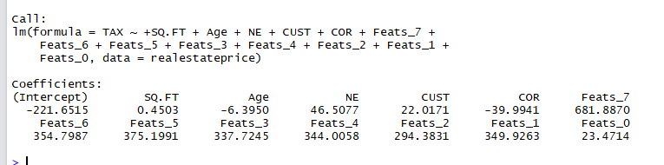

***#Imputing the coefficients from the model to generate the missing values for the TAX variable***

***realestateprice$k<-0***

***for(i in 1:nrow(realestateprice))***

***{***

***if(is.na(realestateprice$TAX[i])==TRUE)***

***{***

***realestateprice$k[i]=realestateprice$k[i]+1***

***}***

***}***

***#***

***for (i in 1:nrow(realestateprice))***

***{***

***if(realestateprice$k[i]==1)***

***{***

***realestateprice$TAX[i]= (-221.6515***

***+ 0.4503 *realestateprice$SQ.FT[i]***

***-6.3950*realestateprice$Age[i]***

***+46.5077*realestateprice$NE[i]***

***+22.0171*realestateprice$CUST[i]***

***-39.9941*realestateprice$COR[i]***

***+681.8870*realestateprice$Feats_7[i]***

***+ 354.7987*realestateprice$Feats_6[i]***

***+375.1991*realestateprice$Feats_5[i]***

***+344.0058 *realestateprice$Feats_4[i]***

***+337.7245*realestateprice$Feats_3[i]***

***+294.3831 *realestateprice$Feats_2[i]***

***+349.9263* realestateprice$Feats_1[i]***

***+23.4714* realestateprice$Feats_0[i]***

***)***

***}***

***}***

***realestateprice$TAX<-round(realestateprice$TAX,0)***

***realestateprice$k<-NULL***

**Step 3: Writing back the data set to the working directory.**

**Reason: The data set once transformed with dummy variables for the variable Feats and imputed with values for the variables Age and TAX has been written back to the working directory for further process.**

**The file Imputed Data_1.csv is attached in the Annexure for reference**

***Reference R Code:***

***write.csv(realestateprice,"Imputed Data_1.csv")***

**Step 4: Building the multiple regression model on the basis of the imputed data**

***Reference R Code:***

***lmprice<-lm(Price~SQ.FT+Age+NE+CUST+COR+TAX+Feats_7+Feats_6+Feats_5+Feats_3+Feats_4+Feats_2***

***+Feats_1+Feats_0 ,data=realestateprice )***

***summary(lmprice)***

***Output of the above summary () command***

Call:

lm(formula = Price ~ SQ.FT + Age + NE + CUST + COR + TAX + Feats_7 +

Feats_6 + Feats_5 + Feats_3 + Feats_4 + Feats_2 + Feats_1 +

Feats_0, data = realestateprice)

Residuals:

Min 1Q Median 3Q Max

-539.51 -86.94 -3.26 68.56 545.06

Coefficients:

Estimate Std. Error t value Pr(>|t|)

(Intercept) 212.54857 190.94112 1.113 0.26825

SQ.FT 0.21564 0.07218 2.988 0.00352 **

Age -0.14455 1.99665 -0.072 0.94243

NE 7.44853 36.81947 0.202 0.84009

CUST 125.74816 47.50376 2.647 0.00941 **

COR -54.31730 43.12211 -1.260 0.21068

TAX 0.68517 0.13470 5.087 1.66e-06 ***

Feats_7 11.69593 262.37956 0.045 0.96453

Feats_6 -0.15777 191.58367 -0.001 0.99934

Feats_5 -84.75506 189.47235 -0.447 0.65559

Feats_3 -64.40592 185.05882 -0.348 0.72854

Feats_4 -78.15470 185.14314 -0.422 0.67382

Feats_2 -94.95114 185.95695 -0.511 0.61073

Feats_1 -70.08806 194.34225 -0.361 0.71911

Feats_0 -11.95310 218.36154 -0.055 0.95645

---

Signif. codes: 0 ‘***’ 0.001 ‘**’ 0.01 ‘*’ 0.05 ‘.’ 0.1 ‘ ’ 1

Residual standard error: 172.5 on 102 degrees of freedom

Multiple R-squared: 0.8192, Adjusted R-squared: 0.7944

F-statistic: 33.01 on 14 and 102 DF, p-value: < 2.2e-16

**Note :**

1. **The transformation of the Feats variable and imputation of the variables Age and TAX and building the regression model is also executed in excel. (Refer : Section D -Conclusion)**
2. **All the predictors variables in the above model seemed to be significant from the business perspective and hence retained in the model. However we will check specific issues like Multicollinearity, Heteroscedasticity and violation of normality in the subsequent steps and address them.**

**Step 5: Checking Multicollinearity in the Model**

**Reason: To check the multicollinearity in the model. i.e. to check if any of the predictor variables are themselves linearly correlated**

***Reference R Code:***

***vif(lmprice)***

***Output of the above vif () command***

SQ.FT Age NE CUST COR TAX Feats_7 Feats_6 Feats_5

5.569805 1.440567 1.184372 1.574839 1.116144 6.373824 2.293464 9.191943 12.021651

Feats_3 Feats_4 Feats_2 Feats_1 Feats_0

24.509898 31.324873 16.048708 8.352165 3.149590

***#### Building the Linear Model after removing Multicollinearity***

***lmpricefit <- lm(Price~.***

***-Feats_5***

***-Feats_4***

***-Feats_3***

***-Feats_2***

***,data=realestateprice)***

***summary(lmpricefit)***

Call:

lm(formula = Price ~ . - Feats_5 - Feats_4 - Feats_3 - Feats_2,

data = realestateprice)

Residuals:

Min 1Q Median 3Q Max

-546.86 -85.12 0.00 71.66 556.80

Coefficients:

Estimate Std. Error t value Pr(>|t|)

(Intercept) 134.29288 66.27669 2.026 0.04525 *

SQ.FT 0.22074 0.06939 3.181 0.00193 **

Age -0.12160 1.93825 -0.063 0.95010

NE 7.48749 35.63280 0.210 0.83397

CUST 127.54513 43.97647 2.900 0.00453 **

COR -57.15128 41.60907 -1.374 0.17249

TAX 0.67603 0.12669 5.336 5.43e-07 ***

Feats_6 75.63566 64.49272 1.173 0.24351

Feats_7 89.28993 180.11490 0.496 0.62111

Feats_1 6.67923 69.89685 0.096 0.92405

Feats_0 62.14127 130.47624 0.476 0.63487

---

Signif. codes: 0 ‘***’ 0.001 ‘**’ 0.01 ‘*’ 0.05 ‘.’ 0.1 ‘ ’ 1

Residual standard error: 169.7 on 106 degrees of freedom

Multiple R-squared: 0.8182, Adjusted R-squared: 0.8011

F-statistic: 47.72 on 10 and 106 DF, p-value: < 2.2e-16

***vif(lmpricefit)***

***Output of the vif () command on the new model***

|  |  |  |  |  |
| --- | --- | --- | --- | --- |
| |  | | --- | |  | |  | | |  | | --- | |  | | |
|  |
| |  | | --- | |  | |

**Outcome/ Inference:**

**On running vif, it is found that the vif of the transformed variables like Feats_5,Feats_4,Feats_3, Feats_2 have vif more than 10 and hence dropped from the model.**

**(Ref : VIF Standard more than 10 implies multicollinearity of that variable)**

**On dropping the variables, the *lmpricefit* is the new model and again vif is checked for the new model. It is observed that there is no further multicollinearity in the new model**

**Step 6: Checking Heteroscedasticity in the Model by Breusche Pegan Test**

**Reason : To check the heteroscedasticity in the model , the following hypothesis testing is done :**

**H0 : The error variances of the model is similar for all observations**

**H1 : The error variances of the model varies**

***Reference R Code:***

***bptest(lmpricefit)***

**Outcome/ Inference:**

**The below is the result of** **Breusche Pegan Test. The p-value of the test statistics which is less than 0.05 signifies heteroscedasticity in the model**

***Output of the Breusche Pegan Test***

studentized Breusch-Pagan test

data: lmpricefit

**BP = 43.119, df = 10, p-value = 4.735e-06**

**Step 7: Checking Violation of Normality assumption in the Model by Shapiro Wilk Test**

**Reason: To check the violation of Normality assumption in the model, the following hypothesis testing is done**

**H0: The sample of observations taken from a normally distributed population**

**H1: The sample of observations has not come from a normally distributed population**

***Reference R Code:***

***shapiro.test(resid(lmpricefit))***

**Outcome/ Inference:**

**The below is the result of Shapiro Wilk Test. The p-value which is significantly less than 0.05 signifies violation of normality assumption in the model**

***Output of the Shapiro Wilk Test***

Shapiro-Wilk normality test

data: resid(lmpricefit)

**W = 0.95037, p-value = 0.0002801**

**Step 8: Remedy/Rectification of Heteroscedasticity and Violation of Normality assumption by Box Cox Transformation and building the multiple regression model once again**

**Reason: Since both Heteroscedasticity and Violation of Normality Assumption are observed in the model, Box Cox transformation is applied as a remedy for both**

***Reference R Code:***

***lamdabx<-boxcox(lmpricefit)***

***trans_df = as.data.frame(lamdabx)***

***optimal_lambda = round(trans_df[which.max(lamdabx$y),1],4)***

***optimal_lambda***

**Solution Proposed: The Box-Cox transformation is defined as:**

**T(Y)= $(Y^{λ}$-1)/ $λ$**

**where Y is the response variable and λ (lambda)is the transformation parameter.**

**Box-Cox transformation defined above is helpful to define a measure of the normality of the resulting transformation. One measure is to compute the correlation coefficient of a normal probability plot. The correlation is computed between the vertical and horizontal axis variables of the probability plot and is a convenient measure of the linearity of the probability plot (the more linear the probability plot, the better a normal distribution fits the data).**

**The Box-Cox normality plot is a plot of these correlation coefficients for various values of the λ parameter. The value of $λ$ (lambda) corresponding to the maximum correlation on the plot is then the optimal choice for $λ$**

**The optimal $λ$ (lambda) computed as per the above code = -0.101**

**The $λ$ (lambda) thus calculated is incorporated on the dependent variable (price) to achieve a new model which is**

***lmprice_model_cox <- lm((((Price ^ optimal_lambda) - 1) / optimal_lambda) ~ SQ.FT +Ag +NE+CUST +COR+TAX***

***+Feats_7+Feats_6 +Feats_1 +Feats_0 ,data = realestateprice)***

***summary(lmprice_model_cox)***

*Output of the above summary () command for the new model that incorporates the optimal lambda*

|  |  |  |  |  |
| --- | --- | --- | --- | --- |
| |  | | --- | | Call:  lm(formula = (((Price^optimal_lambda) - 1)/optimal_lambda) ~  SQ.FT + Age + NE + CUST + COR + TAX + Feats_7 + Feats_6 +  Feats_1 + Feats_0, data = realestateprice)  Residuals:  Min 1Q Median 3Q Max  -0.221990 -0.039522 0.004661 0.045042 0.167806  Coefficients:  Estimate Std. Error t value Pr(>|t|)  (Intercept) 4.582e+00 2.811e-02 163.040 < 2e-16 ***  SQ.FT 1.100e-04 2.943e-05 3.737 0.000302 ***  Age -1.272e-04 8.219e-04 -0.155 0.877354  NE 4.949e-03 1.511e-02 0.327 0.743940  CUST 3.743e-02 1.865e-02 2.007 0.047257 *  COR -1.876e-02 1.764e-02 -1.063 0.289991  TAX 2.587e-04 5.372e-05 4.816 4.9e-06 ***  Feats_7 -2.093e-02 7.638e-02 -0.274 0.784566  Feats_6 1.891e-03 2.735e-02 0.069 0.944999  Feats_1 -5.911e-03 2.964e-02 -0.199 0.842303  Feats_0 -5.579e-02 5.533e-02 -1.008 0.315636  ---  Signif. codes: 0 ‘***’ 0.001 ‘**’ 0.01 ‘*’ 0.05 ‘.’ 0.1 ‘ ’ 1  Residual standard error: 0.07195 on 106 degrees of freedom  Multiple R-squared: 0.8094, Adjusted R-squared: 0.7914  F-statistic: 45.01 on 10 and 106 DF, p-value: < 2.2e-16 | |  | | |  | | --- | |  | | |
|  |
| |  | | --- | |  | |

**The above model is again tested for Breusche Pegan Test and Shapiro Wilk test respectively. The results are as follows:**

***bptest(lmprice_model_cox)***

studentized Breusch-Pagan test

data: lmprice_model_cox

**BP = 33.742, df = 10, p-value = 0.0002042**

*shapiro.test(resid(lmprice_model_cox))*

Shapiro-Wilk normality test

data: resid(lmprice_model_cox)

**W = 0.98458, p-value = 0.2019**

**Both the tests after Box Cox transformation reflect substantial improvement of p value. Breusche Pegan test after Box Cox transformation shows significant reduction in heteroscedasticity in the model.(p- value before 4.735e-06**,

**p-value after 0.0002042**)

**Shapiro Wilk test after Box Cox transformation shows that the violation of normality assumption is rectified in the model as the p-value after transformation is 0.2019, which is higher than 0.05**

**The plots generated as per the Box Cox transformation are as follows:**

***plot(lmprice_model_cox)***

**Plot 1: Displays the normal distribution post box cox transformation deriving lambda**

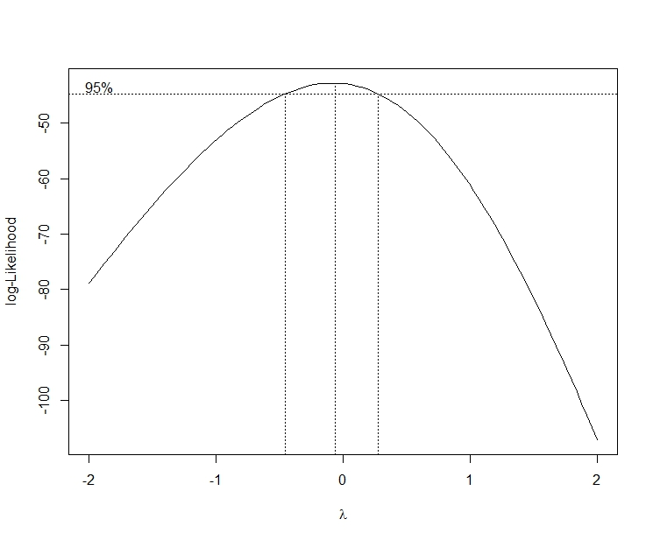

**Figure 1: Normal Distribution plot deriving lambda**

**Plot 2: Displays the relatively uniform distribution of residuals post box cox transformation implying reduction in heteroscedasticity**

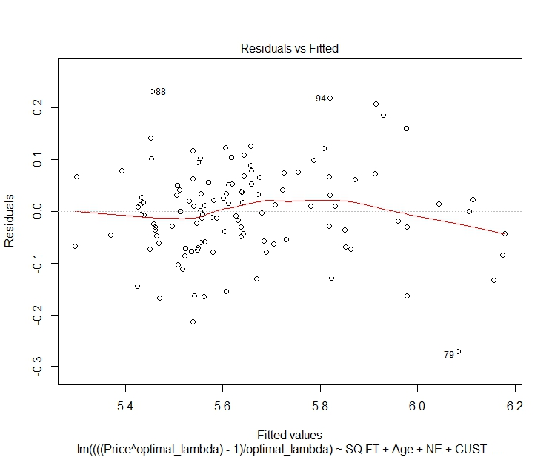

**Figure 2: Residual VS. Fitted Values post Box Cox transformation**

**Plot 3: Displays the improvement in the model as far as the heteroscedasticity is concerned as there is little discernible pattern in the plot and inclination to normal distribution**

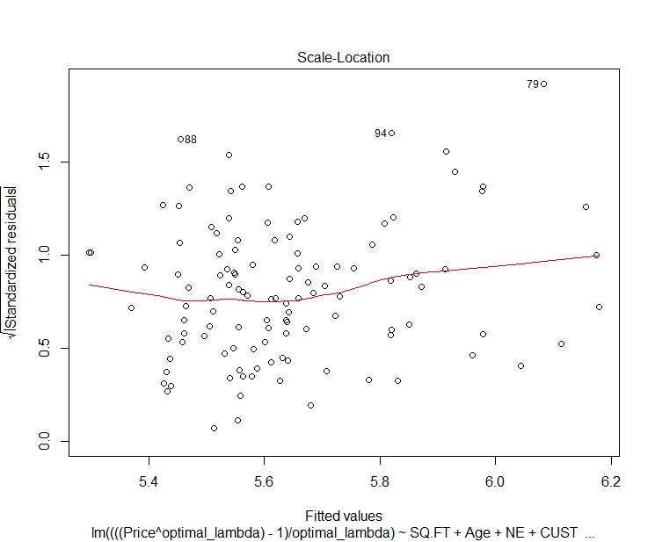

**Figure 3: Standardized residual VS Fitted Values**

**Plot 4: Displays very few observations lying in the range of Cook’s distance implying very few outliers in the model.**

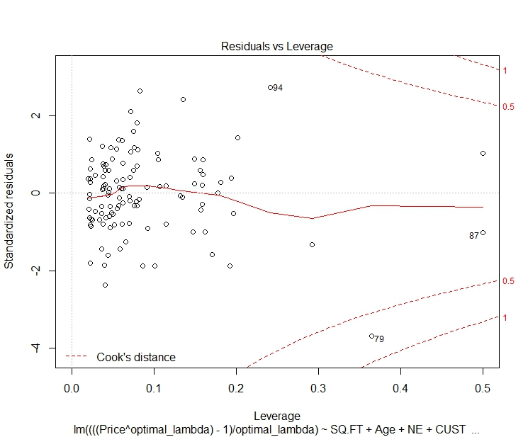

**Figure 4: Leverage VS. Standardized residuals post Box Cox transformation**

**D. Conclusion**

**We conclude that SQ.FT, Tax and CUST are significant predictors of the Price of the house.**

**The final equation as per the model is as follows( using R)**

***Price^(optimal_lambda) - 1/optimal_lambda***

***=4.582***

***+0.00011*SQ.FT***

***-0.0001272*Age***

***+ 0.004949*NE***

***+0.03743*CUST***

***-0.01876*COR***

***+0.0002587*TAX***

***-0.02093*Feats_7***

***+0.001891*Feats_6***

***-0.005911* Feats_1***

***-0.05579* Feats_0***

**The final computation and model (using excel)**



**ANNEXURE**

1. **Working Data Set**



1. **Imputed Data Set**



1. **R code**

