**Name:** Rajib Mandal(SID: TA17002)

**Data Set Information**

The data is related with direct marketing campaigns of a Portuguese banking institution. The marketing campaigns were based on phone calls. The goal is to build models which predict if the client will subscribe a term deposit(y)

**Data Cleaning and preparation**

The following tasks are performed during this phase

1. Check if there is missing value in any of the given fields in the data set

bankdata<-read.csv("bankdata1.csv",header=TRUE)

naColumns <- function(df)

{

colnames(df)[unlist(lapply(df, function(x) any(is.na(x))))]

}

naColumns(bankdata)

1. Calculate mode in the job field and replace unknown value with mode

job_mode<-names(table(bankdata$job))[table(bankdata$job)==max(table(bankdata$job))]

bankdata$job[bankdata$job == "unknown"] <- job_mode

1. Remove month data from the data set
2. Transform all the categorical fields with numerical value 0 &1
3. Create dummy variable for job

bankdata$job_status<-ifelse(bankdata$job!='unemployed',1,0)

bankdata$job<-NULL

1. Create dummy variable marital

bankdata$sing_status<-ifelse(bankdata$marital=="single",1,0)

bankdata$mar_status<-ifelse(bankdata$marital=="married",1,0)

bankdata$marital<-NULL;

1. create dummy variable for education

bankdata$education_primary<-ifelse(bankdata$education=='primary',1,0)

bankdata$education_secondary<-ifelse(bankdata$education=='secondary',1,0)

bankdata$education_tertiary<-ifelse(bankdata$education=='tertiary',1,0)

bankdata$education<-NULL

1. create dummy variables for default

bankdata$default_yes<-ifelse(bankdata$default=='yes',1,0)

bankdata$default<-NULL

1. create dummy variable for housing

bankdata$housing_loan<-ifelse(bankdata$housing=='yes',1,0)

bankdata$housing<-NULL

1. create dummy variable for loan

bankdata$loan_approval<-ifelse(bankdata$loan=='yes',1,0)

bankdata$loan<-NULL

1. create dummy variable for contact

bankdata$contact_cellular<-ifelse(bankdata$contact=='cellular',1,0)

bankdata$contact_telephone<-ifelse(bankdata$contact=='telephone',1,0)

bankdata$contact<-NULL

1. create dummy variable for outcome

bankdata$p_outcome_fail<-ifelse(bankdata$poutcome=='failure',1,0)

bankdata$p_outcome_success<-ifelse(bankdata$poutcome=='success',1,0)

bankdata$p_outcome_other<-ifelse(bankdata$poutcome=='other',1,0)

1. create dummy variable for y

bankdata$churn_y_deposit<-ifelse(bankdata$y=='yes',1,0)

bankdata$y<-NULL

1. Check for multicollinearity

res <-glm(churn_y_deposit~age+balance+day+duration+campaign+pdays+

p_outcome_fail+ p_outcome_success+p_outcome_other+mar_status+sing_status+ education_primary+education_tertiary+education_secondary+default_yes+loan_approval+housing_loan+contact_cellular+contact_telephone+job_status

,data=bankdata,family = "binomial")

vif(res)

Since the values all the variables are less than 10, we can conclude there is no relation between explanatory variables.

|  |  |
| --- | --- |
| Variable Name | Values |
| age | 1.519295 |
| balance | 1.034195 |
| day | 1.019289 |
| duration | 1.173969 |
| campaign | 1.043238 |
| pdays | 3.37609 |
| p_outcome_fail | 2.800721 |
| p_outcome_success | 1.304001 |
| p_outcome_other | 1.750624 |
| mar_status | 2.577838 |
| sing_status | 3.069774 |
| education_primary | 3.276973 |
| education_tertiary | 5.674969 |
| education_secondary | 6.051041 |
| default_yes | 1.013234 |
| loan_approval | 1.034935 |
| housing_loan | 1.188188 |
| contact_cellular | 1.629395 |
| contact_telephone | 1.563408 |
| job_status | 1.008203 |

**Model Building**

1. Creation of testing and training dataset from the given data set with 70:30 ratio

spl<-sample.split(bankdata,SplitRatio = 0.7)

bankdata_training<-subset(bankdata,spl==TRUE)

bankdata_testing<-subset(bankdata,spl==FALSE)

1. Building best fitted model on training data

**Model:1**

Consider all explanatory variables in the model

churn_logistic<-glm(churn_y_deposit~age+balance+day+duration+campaign+pdays+

p_outcome_fail+ p_outcome_success+p_outcome_other+mar_status+sing_status+

education_primary+education_tertiary+education_secondary+ default_yes+loan_approval+housing_loan+contact_cellular+contact_telephone+job_status,data = bankdata_training,family = "binomial")

summary(churn_logistic)

|  |  |  |
| --- | --- | --- |
| Summary | | Degree of Freedom |
| Null deviance | 10651.6 | 7705 |
| Residual deviance | 6467 | 7685 |
| AIC | 6509 |  |

**Model:2**

Remove day field from the model

churn_logistic<-glm(churn_y_deposit~age+balance+duration+campaign+pdays+

p_outcome_fail+ p_outcome_success+p_outcome_other+mar_status+sing_status+

education_primary+education_tertiary+education_secondary+

default_yes+housing_loan+contact_cellular+contact_telephone+job_status,data = bankdata_training,family = "binomial")

summary(churn_logistic)

|  |  |  |
| --- | --- | --- |
| Summary | | Degree of Freedom |
| Null deviance | 10651.6 | 7705 |
| Residual deviance | 6472.4 | 7686 |
| AIC | 6512.4 |  |

**Model:3**

Remove day field & loan approval from the model

churn_logistic<-glm(churn_y_deposit~age+balance+duration+campaign+pdays+

p_outcome_fail+ p_outcome_success+p_outcome_other+mar_status+sing_status+

education_primary+education_tertiary+education_secondary+

default_yes+housing_loan+contact_cellular+contact_telephone+job_status,data = bankdata_training,family = "binomial")

summary(churn_logistic)

|  |  |  |
| --- | --- | --- |
| Summary | | Degree of Freedom |
| Null deviance | 10651.6 | 7705 |
| Residual deviance | 6525.6 | 7687 |
| AIC | 6563.6 |  |

Since AIC for Model1 is less than Model2 & Model3 , we choose Model1 as a best fitted model

1. Apply Logistic regression on test data

prediction_data<-predict(churn_logistic,bankdata_testing,type="response")

predicted_outcome<-ifelse(prediction_data>0.5,1,0)

churn<-data.frame(bankdata_testing,prediction_data,predicted_outcome)

write.csv(churn,"TEST_Assignnment_TA17002.csv")

tb<-table(predicted_outcome,bankdata_testing$churn_y_deposit)

acc<-sum(diag(tb))/sum(tb)

acc

miss_class<-1-acc

Here we find the accuracy of the logistic model is 80.63%

1. The performance of the model is 88.72%

roc_pred<-predict(churn_logistic,bankdata_testing,type="response")

roc_obj<-prediction(roc_pred,bankdata_testing$churn_y_deposit)

roc_performance<-performance(roc_obj,"tpr","fpr")

plot(roc_performance)

abline(a=0,b=1)

accuracy<-performance(roc_obj,"auc")

accuracy

1. Evaluating TPR, FPR

For the threshold value **0.5** ,we get **TPR= 0.7426 FPR= 0.1505**

Thus, we can conclude 74% customer who will churn properly classified with Churn label, and 15% of the customers who will remain as customers are improperly labelled as ***Churn***

Here is the sample code

tpr<-round(as.numeric(unlist(roc_performance@y.values)),4)

fpr<-round(as.numeric(unlist(roc_performance@x.values)),4)

alpha<-round(as.numeric(unlist(roc_performance@alpha.values)),4)

i<-which(round(alpha,2)==0.5)

paste("Threshold=",(alpha[i]),"TPR=",tpr[i],"FPR=",fpr[i])

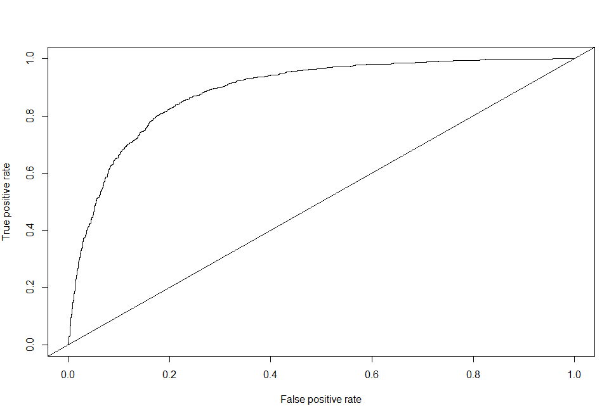

ROC Curve generated from Excel(Refer : TEST_Assignnment_TA17002.xlsx)

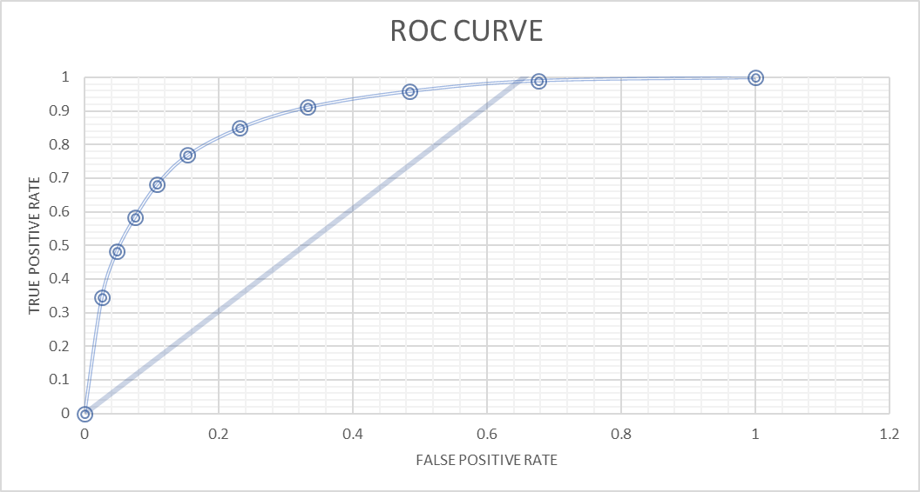

**Appendix**

Refer attached two files for detail analysis

1. Dataminig_Assignnment_TA17002.R
2. TEST_Assignnment_TA17002.XLSX