1. **Difference Between Selenium IDE,Selenium Webdriver And Selenium Grid**

**Selenium WebDriver**

- Has a API Library

- More complex framework setup and more file and dependency involvement

- Can be used in any browser and treats the browser as an object

- Requires knowledge of at least one major coding language

- iPhone/Android applications Support

**Selenium IDE**

- It’s a standalone Java (jar) application that runs HTML test suites in the browser

- Simple installation and quick-start capabilities

- Records and plays back test data

- No coding skill required

- Can be used in FireFox, Chrome and Microsoft Edge

- No iPhone/Android applications Support

**Selenium Grid**

- It’s a Smart proxy Browser that makes it easy to run tests in parallel machines

- It supports distributed test execution

- Test cases can be run in parallel in multiple machines on Selenium Grid

- The machine which triggers the test case is known as Hub

- Hub is a central point or a local machine that receives all the test requests and distributes them to the right nodes

**2. Simple Script**

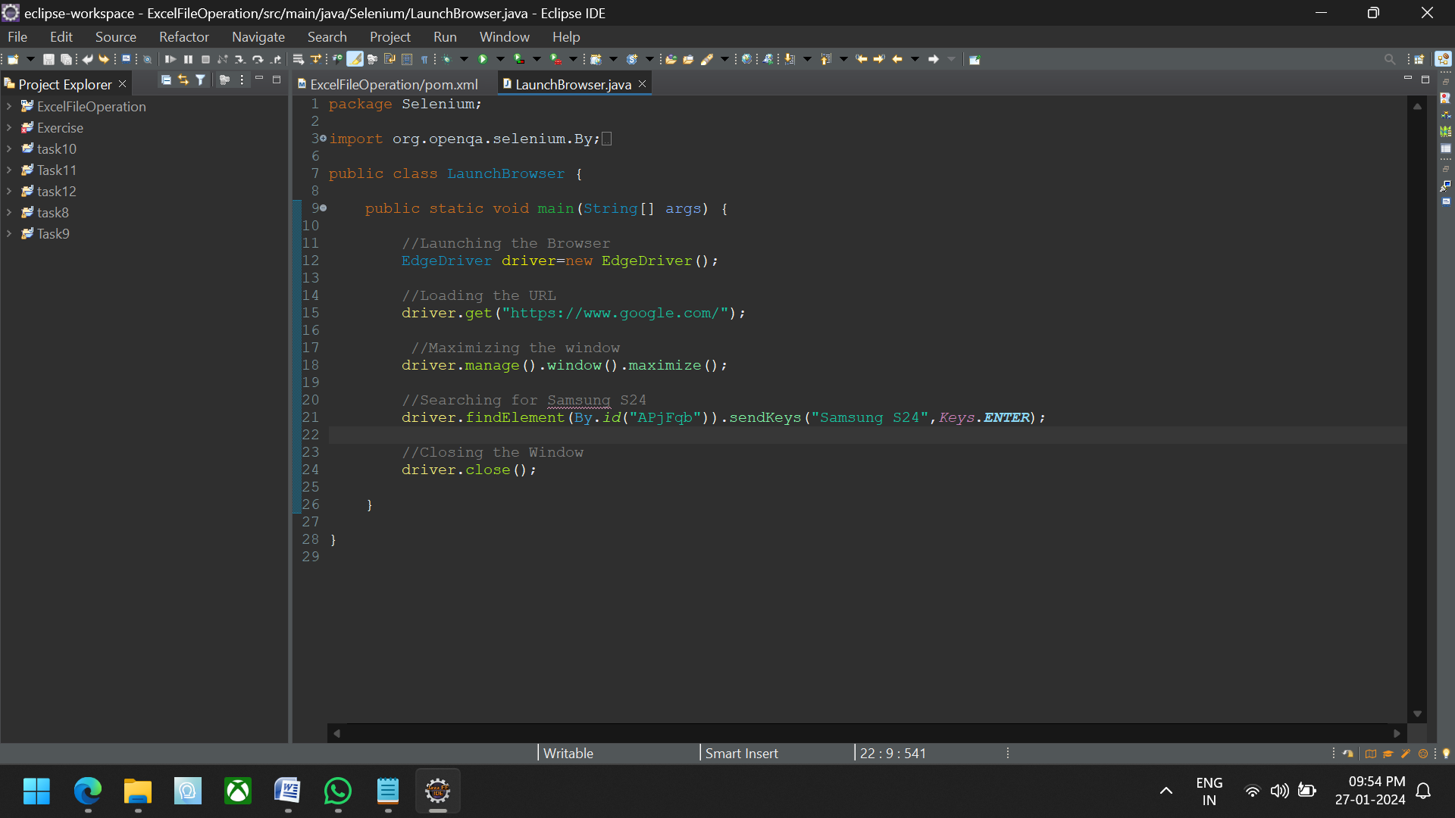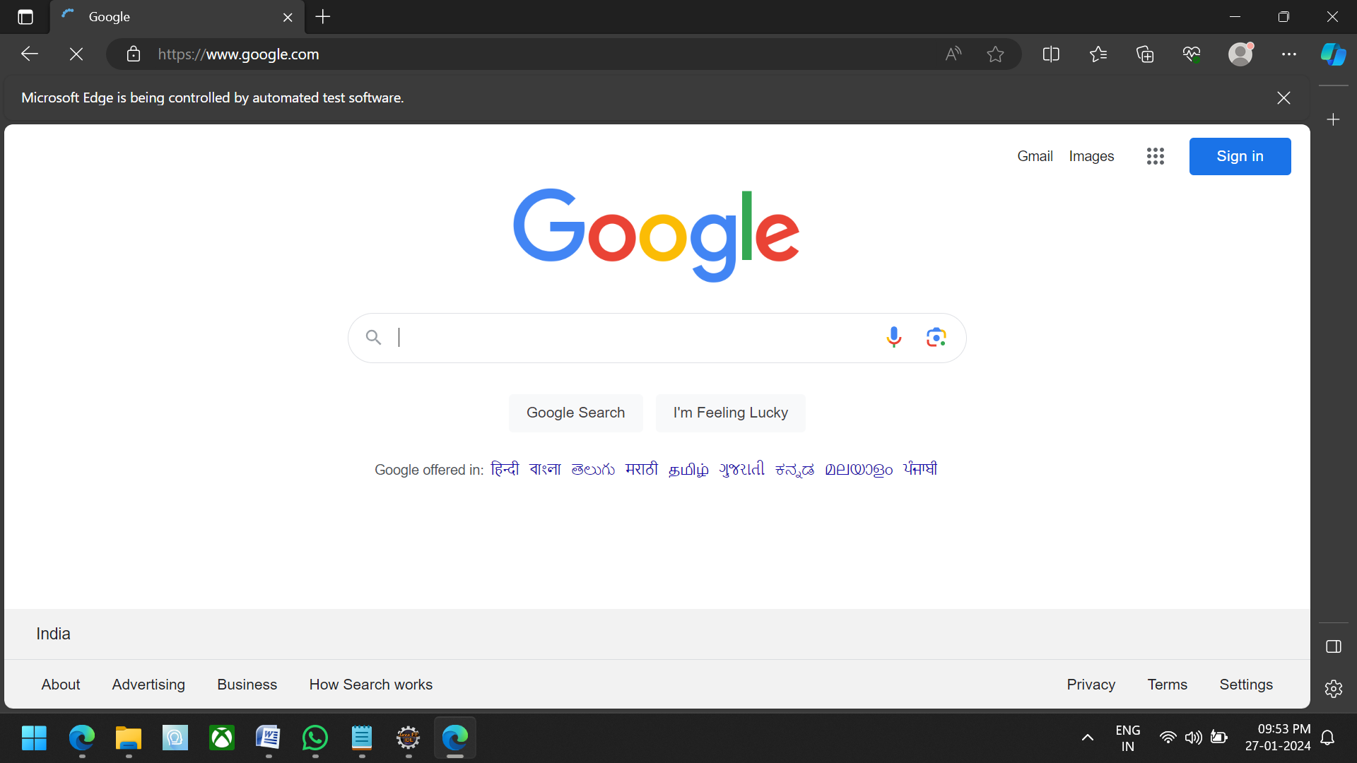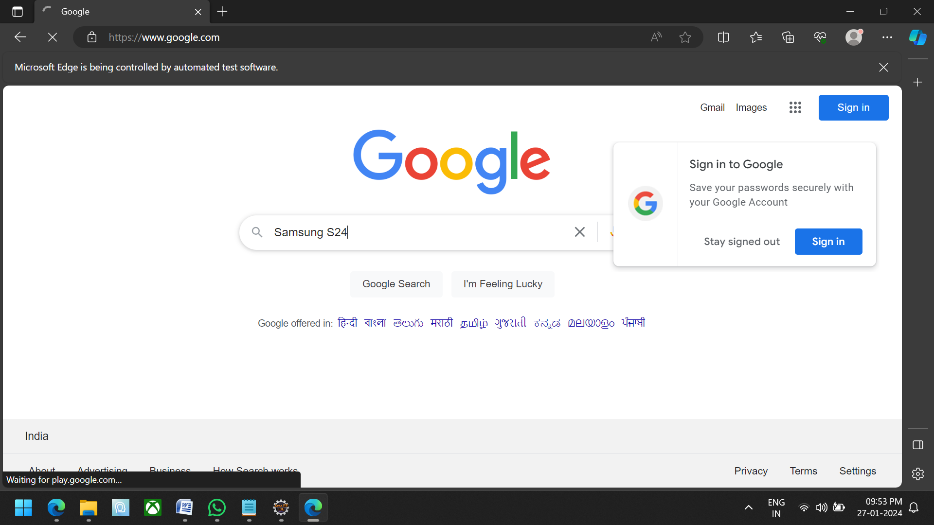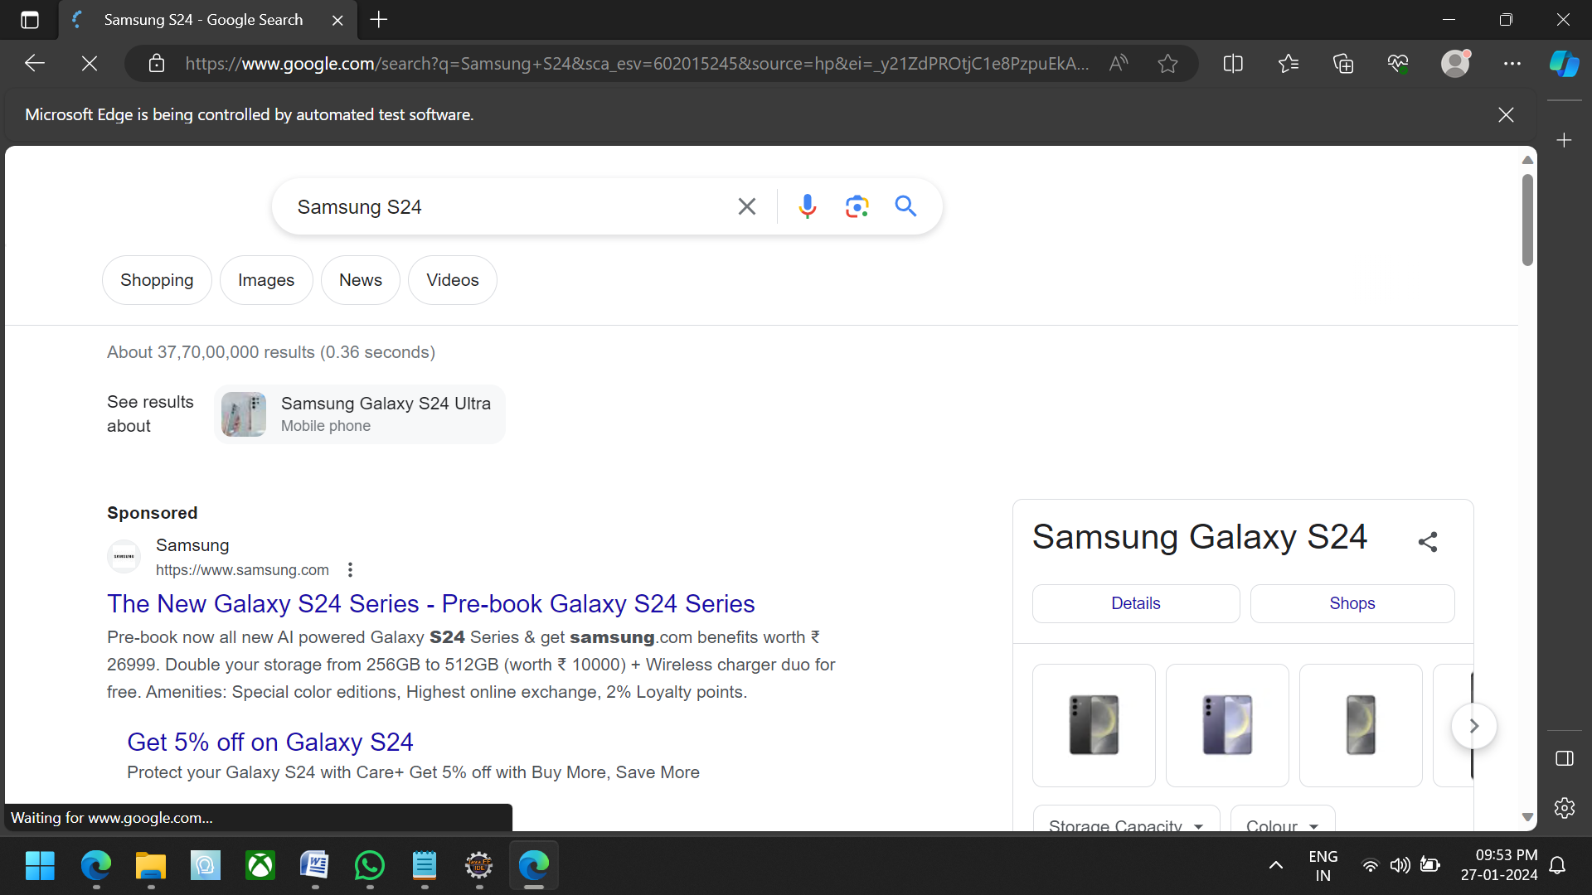

3. **Selenium**

Selenium Automation allows tests to be executed quickly and accurately, reducing the likelihood of human mistakes and ensuring consistent test results.

- Selenium is one of the most widely used open source Web UI (User Interface) automation testing suite

- Developed by Jason Huggins in 2004

- Selenium supports automation across different browsers, platforms and programming languages

**Advantages**

- Open Source Availability

- Multi-Browser Support

- Language and Framework Support

- Ease Of Implementation

- Flexibility

- Less Hardware Usage

- Easy to Learn and Use

- Advanced browser interactions

- Support Across Various Operating Systems

- Supports mobile testing

- Parallel Testing

- Documentation and Reporting

**4. Browser Drivers Used In Selenium**

- ChromeDriver

- FirefoxDriver

- SafariDriver

- OperaDriver

- EdgeDriver

- InternetExplorerDriver

- EventFiringWebDriver

- RemoteWebDrive

**5. Creating a Simple Web Driver Script**

EdgeDriver driver=new EdgeDriver();

driver.get("https://www.google.com/");

driver.manage().window().maximize();

driver.findElement(By.id("APjFqb")).sendKeys("Samsung S24",Keys.ENTER);

driver.close();

**To create a New Maven Project**

* Open your IDE and create a new Java project

* Create a package inside your java project

* Create a class

* For Launching Microsoft Edge,create the driver code EdgeDriver driver=new EdgeDriver();

* Using get method and give URL

* For maximizing the window,we use code for the driver reference and respective classes

* To inspect the web elements, give the code for find elements

* Using send key method to search the input

* Using hit method for enter key command

* Closing the driver method