PERSONAL INFORMATION | Muhammad Ajmal
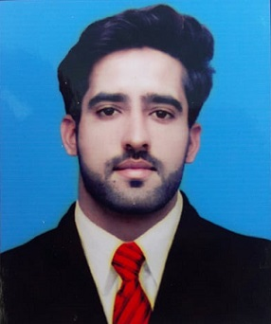 |   43/3-A Street No.18, Model Town Ugoki Sialkot, Pakistan

03044300620

ajmalg08@gmail.com
 | Sex Male | Date of birth 21/02/1996 | Nationality Pakistani

EDUCATION AND TRAINING

(2015 – ... )  (2013 - 2015)  (2011 - 2013)  (2009- 2011) | Bachelor Of Science Software Engineering (BSSE)  University Of Gujrat Sialkot Sub Campus, Sialkot, Pakistan.  Bachelor Of Science (B.Sc Double Math Physics)
(2015 – ... )  (2013 - 2015)  (2011 - 2013)  (2009- 2011) | University of Gujrat, Pakistan.  Higher Secondary School Certificate (Pre-Engineering)  Superior College For Boys, Kashmir Road, Sialkot, Pakistan.  Secondary School Certificate (Science)  Govt. Islamia High School Dudhu Chak, Pakistan.
Skill Set | Good Communication, Confident, Task-Oriented, Leadership Skills, Decision Making & Adaptability.
Worked with Sap Management Software & Holds Certification In Search Engine Optimization (SEO).
Social & Co-curricular Activities | - Member of UOG Blood Donor Society.  - Certified Donor Of Pakistan Red Crescent Society.  - Member of Pakistan Boy Scouts.  - Member of Ma’maar Foundation Working for Blood Donation and Helping the Needy Students.
Experiences
- Winner Health Care Gujranwala: as an HR officer ( 23rd April 2018 to Present )
- Interwood Mobel: as Sales officer ( 2 Months)
- Web Development
- Html + Css
- Word Press Web Development
- SEO Diplomatic

Projects & Seminars
- Participated in Programming Simulation Workshop held at UOG Sialkot Campus.
- Presented Documentary On Entrepreneurship.
- Presented the Determinants of Pakistan’s Foreign Affairs.
- Presented “The Marketing Plan and Strategy of Honda City Aspire”.
- Participated in University Department open forum discussion on “Political Reality of International Trade”.

Interests & Hobbies
- Computer and Internet skills
- Web Development
- Programming
- Movies
- Book reading

Language
- Urdu
- English
- Punjabi

