**PREPARATION OF PAPERS FOR REPORTS ON GEODESY AND GEOINFORMATICS**

**John SMITH(1), Jerry WHITE(2)**

Please insert the author affiliation, Institution, City, Country (1)

Department of Geodesy and Cartography, Warsaw University of Technology

Warsaw, Poland (2)

**Abstract**

*These paper give you template for preparing article for “Reports on Geodesy and Geoinformatics”. The authors are requested to prepare the paper according to the scheme given below. The length of the abstract should be not larger than 200-250 words.*

**Keywords:** insert 3 – 4 keywords or phrases

1. **Introduction**

To prepare the paper for “Reports on Geodesy and Geoinformatics” use editor MS Word for Windows. Use font Arial for the whole text. For the title and subtitles use type size 12 with Arial bold font. For the text use the font size of 12 points. Capitalize the first word and all other principal words of the titles and subtitles. The titles should be centered, the subtitles initial caps left, numbering of subsections by decimal system, e.g. 1.1, 1.2, 1.3 etc.

The paper should be prepared using A4 paper format with the following margins: upper, left and right and bottom margins to be set at 2.5 cm.

1. **Figures, equations and tables**

The figures and subscriptions should be numbered below the figures and centred, e.g. >"Fig. 1. Text"< (align to the left of figure, use the font size of 11 points).

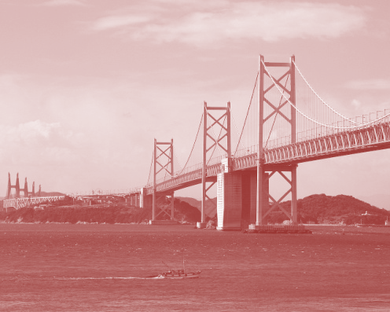

**Fig. 1.** Title of figure

For equations it is recommended to use standard equation editor existing in Word editor. We accept insertion of the equations into tables. Insert the equation number on the right side. See example:

|  |  |
| --- | --- |
|  | (1) |

The tables should be numbered on the top of the table and centred, e.g. >"Table 1. Text< (align to the left of table, use the font size of 11 points).

**Table 1.** Title of table

|  |  |  |  |  |  |  |  |  |
| --- | --- | --- | --- | --- | --- | --- | --- | --- |
|  |  | |  | | |  | | |
|  |  | |  |  | |  |  |
|  |  |  | |  |  | |  |  |
|  |  |  | |  |  | |  |  |
|  |  |  | |  |  | |  |  |

1. **Conclusions**

These paper presents example for preparing article for “Reports on Geodesy and Geoinformatics”. We require **APA Citation Style. You can find more informations about APA Citation Style in internet pages:** [www.rog.gik.pw.edu.pl](http://www.rog.gik.pw.edu.pl/)**.**

**Acknowledgement**

Please insert acknowledgementusing type Arial size 11 points.

**References**

Neitzel, F. (2010). Generalization of total least-squares on example of unweighted and weighted 2D similarity transformation. Journal of Geodesy, 84(12), 751-762. doi:10.1007/s00190-010-0408-0

Teunissen, P. J. G., & de Bakker, P. F. (2013). Single-receiver single-channel multi-frequency GNSS integrity: outliers, slips, and ionospheric disturbances. Journal of Geodesy, 87(2), 161-177. doi:10.1007/s00190-012-0588-x

Knight, N. L., Wang, J., & Rizos, C. (2010). Generalised measures of reliability for multiple outliers. Journal of Geodesy, 84(10), 625-635. doi:10.1007/s00190-010-0392-4

**Authors:** Short information about authors: name with title, address of the institution, email address.