**How to make project ReadOnly in CVS**

Testing with ZZZTestProject project

Step 1: I was able to commit the code after making changes in the project.

***

cvs ci -m "Adding this comment line before changing permission of project in cvs" -l "/ZZZTestProject/src/CreateTableUtility.java"

/usr/webdev/cvsroot/ZZZTestProject/src/CreateTableUtility.java,v <-- src/CreateTableUtility.java

new revision: 1.2; previous revision: 1.1

ok (took 0:00.079)

Step 2:

Created a file under CVSROOT



Permissions on this file are:



Step 3: copied [this](https://blog.christopherschultz.net/index.php/2012/06/15/read-only-cvs-access-for-only-certain-projects/) into read-only-project.sh file.

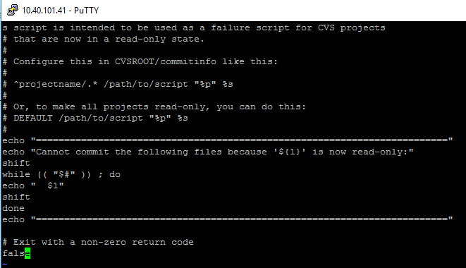

Step 4: Add this line in commitinfo file, explained in [this](https://osric.com/chris/accidental-developer/2018/03/make-a-cvs-project-read-only/) document.

This line uses regex given in references below of this page.

^reponame\(/\|$\) read-only-project.sh "%p" %s

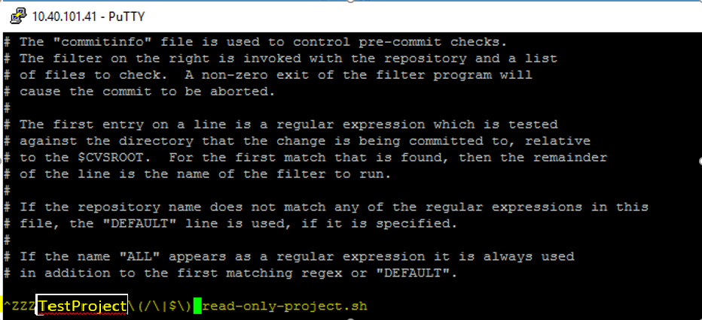

Step 5: We are done, and on further commit in cvs will result in this message.

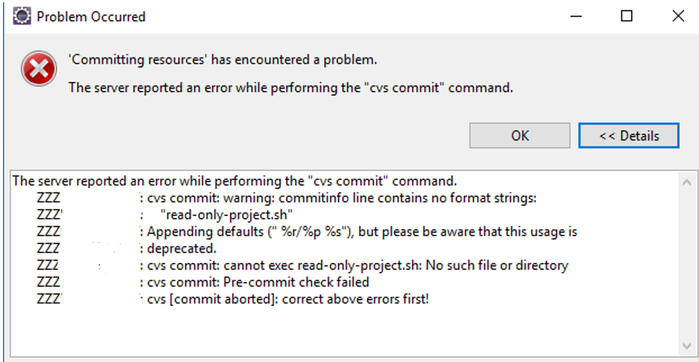

***

cvs ci -m "Adding this another comment line to first test after changing permission of project in cvs" -l "/ZZZTestProject/src/CreateTableUtility.java"

cvs commit: warning: commitinfo line contains no format strings:

"read-only-project.sh"

Appending defaults (" %r/%p %s"), but please be aware that this usage is

deprecated.

cvs commit: cannot exec read-only-project.sh: No such file or directory

cvs commit: Pre-commit check failed

cvs [commit aborted]: correct above errors first!

The server reported an error while performing the "cvs commit" command. (took 0:00.074)

Error: ZZZTestProject: cvs commit: warning: commitinfo line contains no format strings:

Error: ZZZTestProject: "read-only-project.sh"

Error: ZZZTestProject: Appending defaults (" %r/%p %s"), but please be aware that this usage is

Error: ZZZTestProject: deprecated.

Error: ZZZTestProject: cvs commit: cannot exec read-only-project.sh: No such file or directory

Error: ZZZTestProject: cvs commit: Pre-commit check failed

Error: ZZZTestProject: cvs [commit aborted]: correct above errors first!

***

References: <http://cvsman.com/cvs-1.12.12/cvs_185.php#SEC185>

<http://cvsman.com/cvs-1.12.12/cvs_189.php>

**Just in case we decide to Rollback to ReadOnly access of Projects in cvs**

Rollback: Make 1 project writeable

Solution: Remove the particular project line, done in Step 4, from commitinfo file.

Rollback: Make All Projects writeable and remove ReadOnly access thing in CVS

Solution:

* Empty commitinfo file at /usr/webdev/cvsroot/CVSROOT/ Do not delete commitinfo file.
* Delete read-only-project.sh at /usr/webdev/cvsroot/CVSROOT/