A Guide to

Connecting to Jump Server

and Managing Docker Services

Connect to the Jump Server

**For Example:**

Jump server details**:**

* IP: 54.156.121.86
* Username: Administrator
* Password: I0?)YQSAPz69nd0;@m0VQ7sUGuBc2fBX

To access the EC2 instance where the AIQ application resides, follow these steps:

1. **Open Remote Desktop Connection:**

* On your local machine, search for "Remote Desktop Connection" in the Start menu.
* Click on the application when it appears.

1. **Enter Server Details:**

* In the Remote Desktop Connection window, enter the IP address: **54.156.121.86**
* Click "Connect."

1. **Authenticate:**

* Enter the provided username: **Administrator**
* Enter the provided password: **I0?)YQSAPz69nd0;@m0VQ7sUGuBc2fBX**
* Click "OK" to log in.

* Open the new putty session in the demo sever

After logging in, you will see two saved PuTTY sessions:  
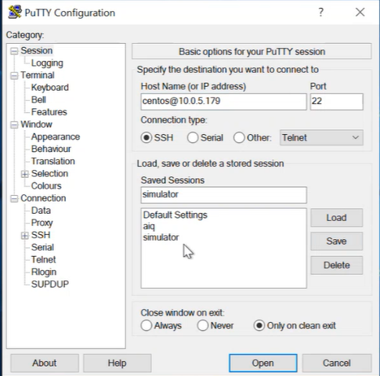

**\* AIQ**: This session is configured to connect to the AIQ server.

* **Simulator**: This session is configured to connect to the Simulator server.

**4. Accessing AIQ Reports:**

To access the AIQ reports, follow these steps:

1. Click the AIQ instance from the PuTTY session.

2. This will log in with the username `centos`.

3. Give **`sudo su -`** to get into the root folder.

4. Once you get into the root folder, then go to   
**cd /opt/aiq-reports/**  
 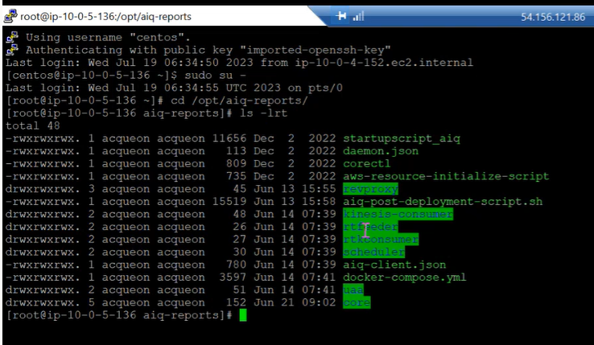

Managing Docker and Logs:

**To control the AIQ application services, utilize the following commands:**

* You can use the following command to check the process:

**docker ps**

This command will list all the running containers on the system. The output of the command will include the following information for each container:

* The container ID
* The container name`
* The image name
* The status of the container (running, stopped, etc.)
* The ports that the container is exposed

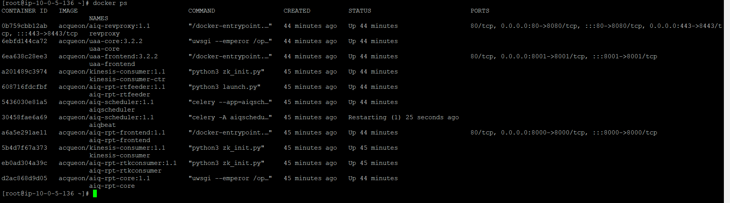

* The following command will list all of the Docker images that are installed on the current system:

**docker image ls**

The output of the command will include the following information for each image:

* The image ID
* The image name
* The image tag
* The size of the image
* The creation date of the image

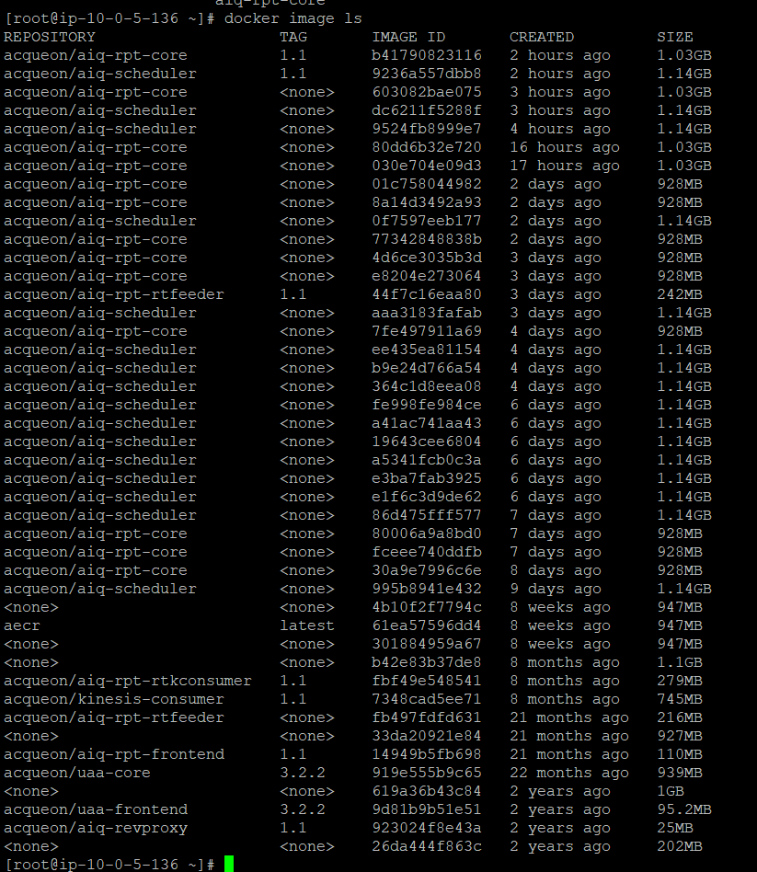

* To know all the container status, use:

**sudo /opt/aiq-reports/corectl status** or

**./corectl status**

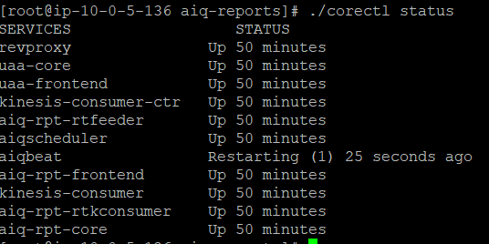

* To stop the running services, use:

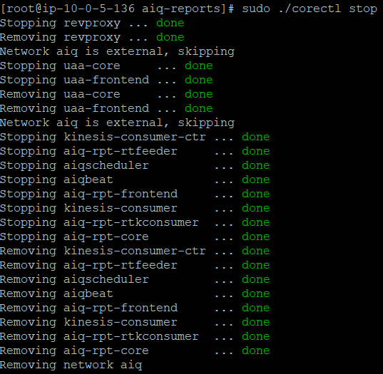

**sudo /opt/aiq-reports/corectl stop** or

**sudo ./corectl stop**

* To pull the latest AIQ application image, use this command:

**sudo /opt/aiq-reports/corectl pull** or **sudo ./corectl pull**

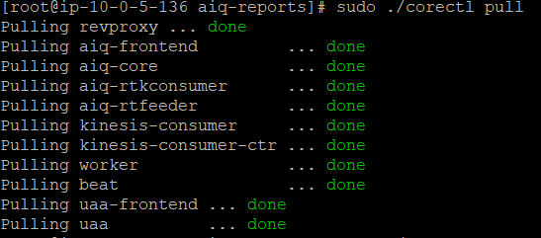

* To start the AIQ application services, use the following command:

**sudo /opt/aiq-reports/corectl start** or **sudo ./corectl start**

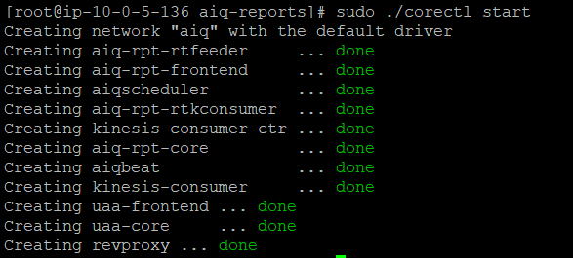

* to enter into a running container in interactive mode

**docker exec -it container_name bash**

replace container_name with the name of the container that you want to enter  
  
To exit from a running container, you can use the following commands:

* **exit**: This command will exit from the container and stop the container.

🡪sudo systemctl restart docker 🡪command to restart docker   
  
Logs

**1. Viewing Logs:**

* All logs are available in the **core/var/logs** directory.
* To list the logs in chronological order, use the command:  
  **ls -lrt core/var/logs**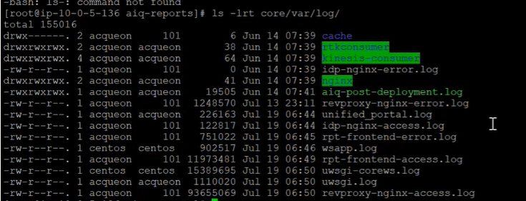

**2. Check Container Logs:**

To view real-time logs of a Docker container, use:  
**docker logs -f container_name**

*Replace* ***container_name*** *with the actual name of the container.*

For Example, To view the real time logs of a Docker container kinesis-consumer-ctr  
  
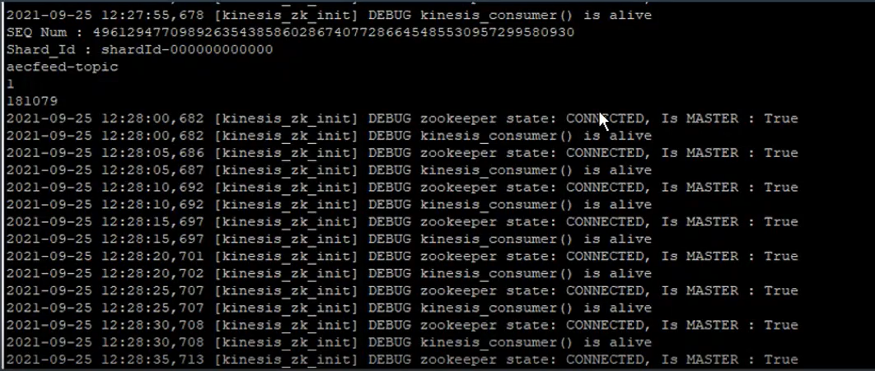  
You should see something like this. Check if you see any errors in these logs.

**Accessing Redis and Retrieving Data**

To interact with the Redis instance, follow these steps:

1. Access the Redis Directory:

Open a terminal and navigate to the Redis directory within the AIQ Reports directory:  
**cd /opt/aiq-reports/core/redis-stable**

2. Execute Redis Client:

Run the Redis client using the following command:  
**./src/redis-cli -h master.redis-aiq-dev-env.g89k7k.use1.cache.amazonaws.com --tls**

This command connects to the Redis server using its host address and enables TLS encryption.  


3. Retrieve Data:

Once connected to the Redis client, you can retrieve data using various Redis commands.

For example, to retrieve all key-value pairs of a specific key, use:  
 **hgetall keyname**

Replace *keyname* with the actual name of the key you want to retrieve data from.

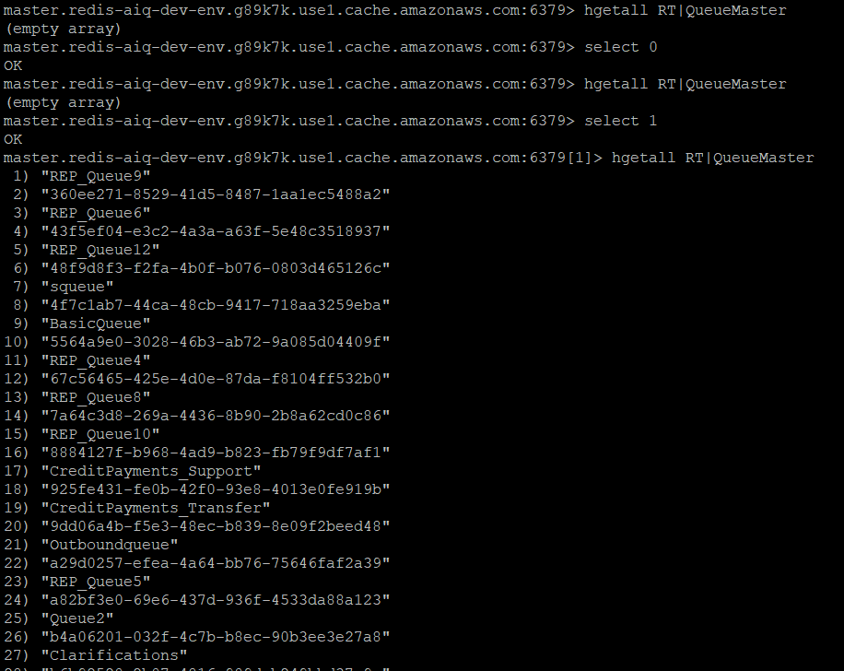

AIQ-SIMULATOR

Simulator, which allows the collection of data related to agent logins, call counts, and queue abandonment. The simulator is executed on a separate Linux server instance within an EC2 environment. Here's how you can manage the simulator using specific commands:

Simulator Commands:

1. **Accessing the Simulator Directory:**

To access the Simulator, follow these steps:

1. Click the simulator from the PuTTY session.
2. This will log in with the username `centos`.
3. Give **`sudo su -`** to get into the root folder.
4. Navigate to the simulator directory using the command:

**cd /root/aiq/mssql-simulator/  
  
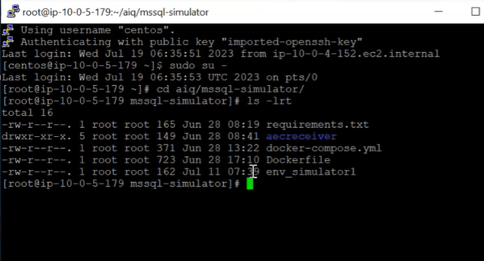**

1. **Managing the Docker Container:**

* If changes are made to a container, restart it using the following command:
* To stop and remove the container, use:

**docker-compose down**

* To run the container in the background (detached mode), execute:

**docker-compose up -d**

**Editing Agent Details for Load Testing:**

* Enter the following command to open the "env-simulator1" file in the vi text editor:

**vi env-simulator1**

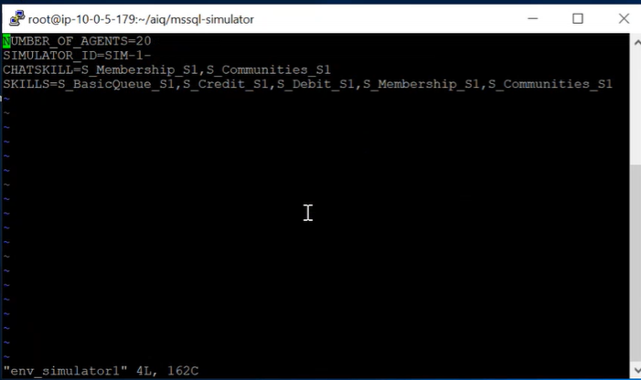

Before increasing the number of agents in the simulator, ensure you've created the corresponding agents in Amazon Connect. After that, follow these steps to adjust agent details in the "env-simulator1" file:

Edit Agent Details:

* Once in the vi editor, press i to enter "insert" mode. This allows you to modify the content.
* Locate the section related to agent details. This is where you can adjust the number of agents, their properties, or any other load-testing parameters.

Save and Exit:

* After making the necessary changes, press Esc to exit "insert" mode.
* To save your changes and exit the vi editor, type :wq and press Enter.

Note: Always ensure a consistent number of agents between Amazon Connect and the simulator for accurate load testing.