SlNo | Name of Experiments
HTML-FORMS
1 | Design and create a webpage user login-form
2 | Design and create a webpage user Registration-form
3 | Design and create a webpage user Application-form
4 | Design and create webpage sign-up forms.
5 | Design and create webpage feedback-forms.
HTML-WITH -CSS
6. | Design and create webpage using HTMLwith CSS
7 | Design and create webpage Table with heading and data using HTML with CSS
HTML With JAVA VALIDATION FORMS
8 | Design and create a web-page is login-form with validation.
9 | Design and create a web-page is form with validation
10 | Design and create a web-page is registration form with validation
FSD LAB-PROGRAMMING

1. Design and create a webpage user login-form.
Program name : Login.html
<html>
<head>
<title> Login Form</title>
</head>
<body bgcolor=”blue”>
<form>
<h13><center> LOGIN FORM </center></h1>
<hr><br><br><center>
USERNAME :
<input type="text" placeholder="Enter your email id"/> <br><br>
PASSWORD :
<input type="password" placeholder="Enter your password"/><br><br>
<input type="submit" value="Login" onClick="submit_form()"/>
<input type="button" value="SignUp" onClick="create()"/>
</center>
</form>
</body>
</html>
Output:
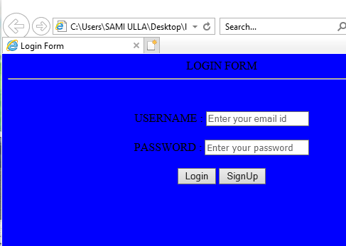
2. Design and create a webpage user Registration-form.
Program Name : Registration.html
<html>
<head>
<title>Registration</title>
</head>
<body bgcolor=lightblue>
<form>
<h1 align=center><u>Registration Form</u></h1>
<br><br><center>
<hr color="blue"><br><br>
First Name : <input type=text value=" " name="txt1"><br><br>
Last Name : <input type=text value=" " name="txt2"><br><br>
E-mail : <input type=text value="" name="txt3"><br><br>
Password : <input type=password value="" name="pwd1"><br><br>
Confirm Password : <input type=password value="" name="pwd2"><br><br>
Address :
<textarea rows=3 cols=60></textarea><br><br>
Date of Birth :<br>
dd <select name="sel1">
<option>--</option>
<option>01</option>
<option>02</option>
<option>03</option>
<option>04</option>
<option>05</option>
<option>27</option>
<option>28</option>
<option>29</option>
<option>30</option>
<option>31</option>
</select><br>
mm <select name="sel2">
<option>--</option>
<option>01</option>
<option>02</option>
<option>03</option>
<option>04</option>
<option>05</option>
<option>06</option>
<option>07</option>
<option>08</option>
<option>09</option>
<option>10</option>
<option>11</option>
<option>12</option>
</select><br>
yyyy <select name="sel3">
<option>----</option>
<option>1987</option>
<option>1988</option>
<option>1989</option>
<option>1990</option>
<option>1991</option>
<option>1992</option>
<option>1993</option>
<option>1994</option>
<option>1995</option>
<option>1996</option>
<option>1997</option>
<option>1998</option>
<option>1999</option>
<option>2000</option>
<option>2001</option>
<option>2002</option>
<option>2003</option>
<option>2004</option>
<option>2005</option>
<option>2006</option>
<option>2007</option>
<option>2008</option>
<option>2009</option>
<option>2010</option>
</select><br><br>
Sex :
<input name="rb1" type="radio" value="radiobutton">Male
<input name="rb1" type="radio" value="radiobutton">Female
<br><br>
Martial Status :
<input name="rb2" type="radio" value="radiobutton">Single
<input name="rb2" type="radio" value="radiobutton">Married
<br><br>
Mobile Number : <input type=text name="txt4"><br><br>
Branch :
<input name="rb3" type="radio" value="radiobutton">CSE
<input name="rb3" type="radio" value="radiobutton">IT<br><br>
<input name="rb3" type="radio" value="radiobutton">ECE
<input name="rb3" type="radio" value="radiobutton">EEE<br><br>
<input name="rb3" type="radio" value="radiobutton">MECH
<br><br>
Languages Known &nbsp
<input name="cb1" type="checkbox" value="checkbox">English
<input name="cb1" type="checkbox" value="checkbox">Telugu<br><br>
<input name="cb1" type="checkbox" value="checkbox">Hindi
<input name="cb1" type="checkbox" value="checkbox">Kannada<br><br>
<input name="cb1" type="checkbox" value="checkbox">Tamil
<br><br>
<input type=submit value="SUBMIT" name="btn1"><br><br>
<input type=reset value="RESET" name="btn1">
</center>
</form>
</body>
</html>

Ouput:

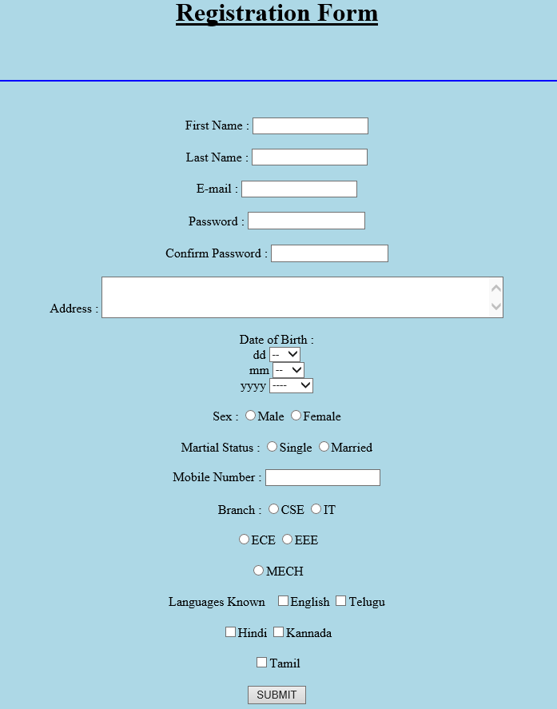
3. Design and create a webpage user Application-form
Program Name :Application.html
<html>
<head>
<title> Application</title>
</head>
<body bgcolor="lightgreen">

<form>
<h1> APPLICATION FORM</h1>

User id :
<input type="text" name="userid" size="12" /><br><br>

Password :
<input type="password" name="passid" size="12" /><br><br>

Name :
<input type="text" name="username" size="50" /><br><br>

Address :
<input type="text" name="address" size="50" /><br><br>

ZIP Code :
<input type="text" name="zip" /><br><br>

Email :
<input type="text" name="email" size="50" /><br><br>

Sex :
<input type="radio" name="msex" value="Male" /> Male
<input type="radio" name="fsex" value="Female" /> Female<br><br>

Language preference :
<input type="checkbox" name="en" value="en" checked />English
<input type="checkbox" name="nonen" value="noen" />Non English <br><br>

Write about yourself : <br>
(optional)
<textarea name="desc" rows="4" cols="40"></textarea><br><br>
<input type="submit" name="submit" value="Submit" />
</form>

</body> </html>

Output:

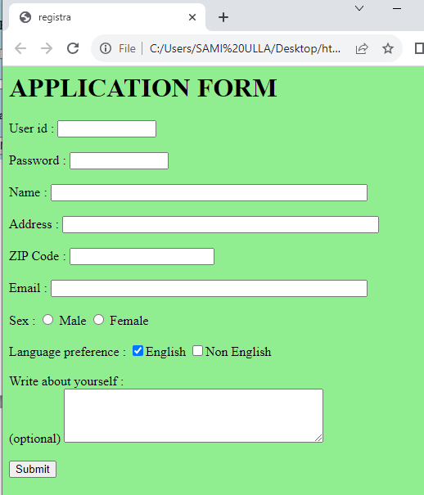

4. Design and create webpage sign-up forms.
Program Name: Sign-up.html
<html>
<head>
<title> SignUp Page</title>
</head>
<body align="center" >
<h1> CREATE YOUR ACCOUNT</h1>
<hr>
<font color="pink">
Name :
<input type="text" placeholder="Enter your name" id="n1"><br><br>
Email :
<input type="text" placeholder="Enter your email id" id="e1"><br><br>
Set Password :
<input type="password" placeholder="Set a password" id="p1"><br><br>
Confirm Password :
<input type="password" placeholder="Confirm your password" id="p2"><br><br>
Name :
<input type="text" placeholder="Enter your name" id="n1"><br><br>
Date of Birth :<br>
dd <select name="sel1">
<option>--</option>
<option>01</option>
<option>02</option>
<option>03</option>

<option>29</option>
<option>30</option>
<option>31</option>
</select><br>
mm <select name="sel2">
<option>--</option>
<option>01</option>
<option>02</option>
<option>11</option>
<option>12</option>
</select><br>
yyyy <select name="sel3">
<option>----</option>
<option>1987</option>
<option>1988</option>
<option>2022</option>
<option>2023</option>
</select><br><br>
Sex :
<input type="radio" name="msex" value="Male" /> Male
<input type="radio" name="fsex" value="Female" /> Female<br><br>
Language preference :
<input type="checkbox" name="en" value="en" checked />English
<input type="checkbox" name="nonen" value="noen" />Non English <br><br>
<input type="submit" value="Create" onClick="create_account()"/>
</body>
</html>

output:

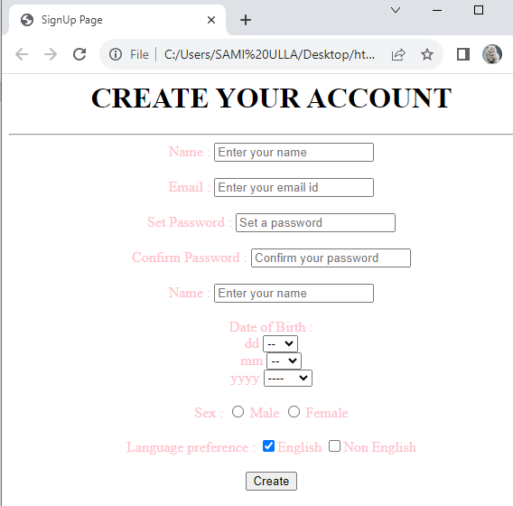

5. Design and create a webpage feedback-forms.
Program Name : Feedback.html
<html>
<head>
<title> feedback form</title>
</head>
<body>
<h2>FEED BACK FORM</h2>
<form>
First Name:
<input type="text" name="firstname" placeholder="Your name.."><br><br>
Last Name:
<input type="text" name="lastname" placeholder="Your last name.."><br><br>
E-Mail Id :
<input type="email" name="mailid" placeholder="Your mail id.."><br><br>

Country :
<select name="country">
<option>Select Country</option>
<option>Australia</option>
<option>Canada</option>
<option>USA</option>
<option>Russia</option>
<option>Japan</option>
<option>India</option>
<option>China</option>
</select><br><br>

Feed Back :
<textarea row=”5” cols=”50” placeholder="Write something.." "></textarea><br><br>

<input type="submit" value="Submit">
</form>
</body>
</html>

Output:
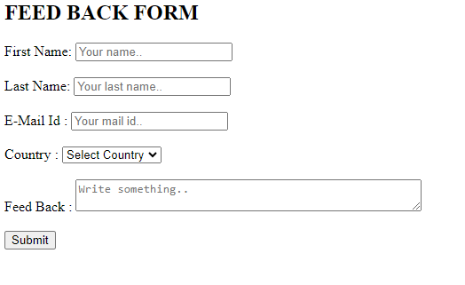

6. Design and create webpage using HTML with CSS
Program Name : progcss.html
<html>
<head>
<title> CSS border-radius </title>
<style>
div {
padding: 50px;
margin: 20px;
border: 6px ridge red;
width: 300px;
float: left;
height: 150px;
}
p{
font-size: 25px;
}
#one {
border-radius: 90px;
background: lightgreen;
}
#two {
border-radius: 25% 10%;
background: orange;
}
#three {
border-radius: 35px 10em 10%;
background: cyan;
}
#four {
border-radius: 50px 50% 50cm 50em;
background: lightblue;
}
</style>
</head>
<body>
<div id = "one">
<h2> Welcome to the java </h2>
<p> border-radius: 90px; </p>
</div>
<div id = "two">
<h2> Welcome to the H.M.S </h2>
<p> border-radius: 25% 10%; </p>
</div>
<div id = "three">
<h2> Welcome to the h.m.s polytechnic </h2>
<p> border-radius: 35px 10em 10%; </p>
</div>
<div id = "four">
<h2>Welcome to the Tumkur</h2>
<p>border-radius: 50px 50% 50cm 50em;</p>
</div>
</body>
</html>

Output:

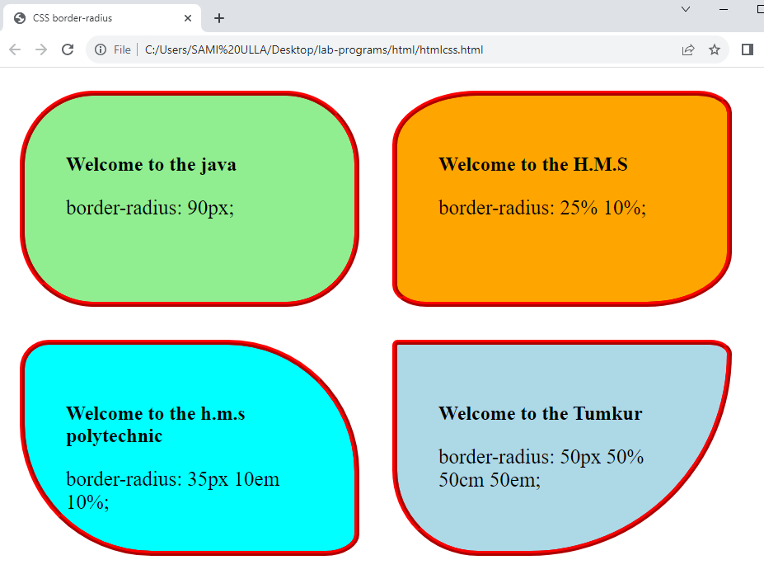

7. Design and create webpage Table with heading and data using HTML with CSS
Program Name: progcss2.html
<html>
<head>
<title> border-collapse property </title>
<style>
table{
border: 2px solid blue;
text-align: center;
font-size: 20px;
width: 80%;
height: 50%;
}
th{
border: 5px solid red;
background-color: yellow;
}
td{
border: 5px solid violet;
background-color: cyan;
}
#t1 {
border-collapse: separate;
}
</style>
</head>
<body>

<h1> The border-collapse Property </h1>
<h2> border-collapse: separate; </h2>
<table id = "t1">
<tr>
<th> First_Name </th>
<th> Last_Name </th>
<th> Subject </th>
<th> Marks </th>
</tr>
<tr>
<td> James </td>
<td> Gosling </td>
<td> Maths </td>
<td> 92 </td>
</tr>
<tr>
<td> Alan </td>
<td> Rickman </td>
<td> Maths </td>
<td> 89 </td>
</tr>
<tr>
<td> Sam </td>
<td> Mendes </td>
<td> Maths </td>
<td> 82 </td>
</tr>
</table>
</body>
</html>
Output:

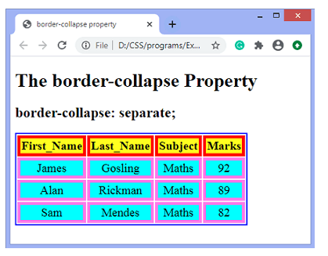

8.Design and create a web-page is login-form with validation.
Program Name:logjas.html
<html>
<head>
<title>Welcome To Login Form</title>
<script>
function login() {
var uname = document.getElementById("email").value;
var pwd = document.getElementById("pwd1").value;
var filter = /^([a-zA-Z0-9_\.\-])+\@(([a-zA-Z0-9\-])+\.)+([a-zA-Z0-9]{2,4})+$/;
if(uname =='')
{
alert("please enter user name.");
}
else if(pwd=='')
{
alert("enter the password");
}
else if(!filter.test(uname))
{
alert("Enter valid email id.");
}
else if(pwd.length < 6 || pwd.length > 6)
{
alert("Password min and max length is 6.");
}
else
{
alert('Thank You for Login ');
}
}
//Reset Inputfield code.
function clearFunc()
{
document.getElementById("email").value="";
document.getElementById("pwd1").value="";
}
</script>
</head>
<body>
<!-- Main div code -->
<div id="main">
<div class="h-tag">
<h2><center>Welcome To My Account Login</center></h2>
</div>
<!-- Login box -->
<div class="login">
<table cellspacing="2" align="center" cellpadding="8" border="0">
<tr>
<td>Enter User Name :</td>
<td><input type="text" placeholder="Enter user name here" id="email" class="tb" /></td>
</tr>
<tr>
<td>Enter Password :</td>
<td><input type="password" placeholder="Enter Password here"
id="pwd1" class="tb" /></td>
</tr>
<tr>
<td></td>
<td>
<input type="submit" value="Reset" onclick="clearFunc()" class="btn" />
<input type="submit" value="Login" class="btn" onClick="login()" /></td>
</tr>
</table>
</div>
<!-- login box div ending here.. -->
</div>
<!-- Main div ending here... -->
</body>
</html>
Output:
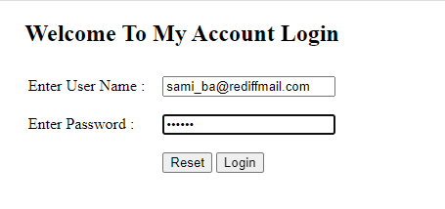

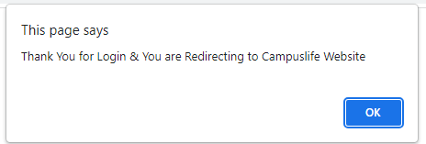

9. Design and create a web-page is form with validation
File name: form1.html
<html>
<head>
<title>Form Validation</title>
<script type = "text/javascript" src="form1.js">
</script>
</head>
<body>
<form name = "myForm" onsubmit = "return(validate());">
<table cellspacing = "2" cellpadding = "2" border = "1">
<tr>
<td align = "right">Name</td>
<td><input type = "text" name = "Name" /></td>
</tr>
<tr>
<td align = "right">EMail</td>
<td><input type = "text" name = "EMail" /></td>
</tr>
<tr>
<td align = "right">Zip Code</td>
<td><input type = "text" name = "Zip" /></td>
</tr>
<tr>
<td align = "right">Country</td>
<td>
<select name = "Country">
<option value = "-1" selected>[choose yours]</option>
<option value = "1">USA</option>
<option value = "2">UK</option>
<option value = "3">INDIA</option>
</select>
</td>
</tr>
<tr>
<td align = "right"></td>
<td><input type = "submit" value = "Submit" /></td>
</tr>
</table>
</form>
</body>
</html>
File name: form1.js
// Form validation code will come here.
function validate() {
if( document.myForm.Name.value == "" ) {
alert( "Please provide your name!" );
document.myForm.Name.focus() ;
return false;
}
if( document.myForm.EMail.value == "" ) {
alert( "Please provide your Email!" );
document.myForm.EMail.focus() ;
return false;
}
if( document.myForm.Zip.value == "" || isNaN( document.myForm.Zip.value ) ||
document.myForm.Zip.value.length != 5 ) {
alert( "Please provide a zip in the format #####." );
document.myForm.Zip.focus() ;
return false;
}
if( document.myForm.Country.value == "-1" ) {
alert( "Please provide your country!" );
return false;
}
return( true );
}

Output:

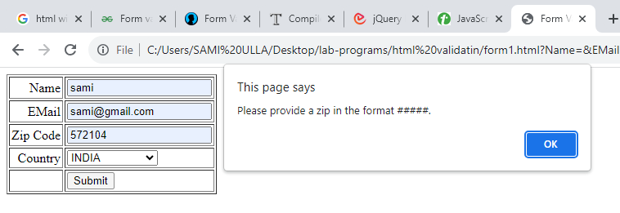

10.Design and create a web-page is registration form with validation
File name: reg.html
<html>
<head>
<title>JavaScript Form Validation using a sample registration form</title>
<script src="reg.js"></script>
</head>
<body bgcolor="pink" onload="document.registration.userid.focus();">
<h1><center>Registration Form</center></h1><br><br>
<hr color="red"><center>
<font size="15" color="blue">Use tab keys to move from one input field to the next.</font><br><br>
<form name='registration' onSubmit="return formValidation();">
<label for="userid">User id:</label>
<input type="text" name="userid" size="12" /><br><br>
<label for="passid">Password:</label>
<input type="password" name="passid" size="12" /><br><br>
<label for="username">Name:</label>
<input type="text" name="username" size="50" /><br><br>
<label for="address">Address:</label>
<input type="text" name="address" size="50" /><br><br>
<label for="country">Country:</label>
<select name="country">
<option selected="" value="Default">(Please select a country)</option>
<option value="AF">Australia</option>
<option value="AL">Canada</option>
<option value="DZ">India</option>
<option value="AS">Russia</option>
<option value="AD">USA</option>
</select><br><br>
<label for="zip">ZIP Code:</label>
<input type="text" name="zip" /><br><br>
<label for="email">Email:</label>
<input type="text" name="email" size="50" /><br><br>
<label id="gender">Sex:</label>
<input type="radio" name="msex" value="Male" /><span>Male</span><br><br>
<input type="radio" name="fsex" value="Female" /><span>Female</span><br><br>
<label>Language:</label>
<input type="checkbox" name="en" value="en" /><span>English</span><br><br>
<input type="checkbox" name="nonen" value="noen" /><span>Non English</span><br><br>
<label for="desc">About:</label>
<textarea name="desc" id="desc"></textarea><br><br>
<input type="submit" name="submit" value="Submit" /></center>
</form>
</body>
</html>
File name: reg.js
function formValidation()
{
var uid = document.registration.userid;
var passid = document.registration.passid;
var uname = document.registration.username;
var uadd = document.registration.address;
var ucountry = document.registration.country;
var uzip = document.registration.zip;
var uemail = document.registration.email;
var umsex = document.registration.msex;
var ufsex = document.registration.fsex; if(userid_validation(uid,5,12))
{
if(passid_validation(passid,7,12))
{
if(allLetter(uname))
{
if(alphanumeric(uadd))
{
if(countryselect(ucountry))
{
if(allnumeric(uzip))
{
if(ValidateEmail(uemail))
{
if(validsex(umsex,ufsex))
{
} }
} }
} }
} }
return false;
}
function userid_validation(uid,mx,my)
{
var uid_len = uid.value.length;
if (uid_len == 0 || uid_len >= my || uid_len < mx)
{
alert("User Id should not be empty / length be between "+mx+" to "+my);
uid.focus();
return false;
}
return true;
}
function passid_validation(passid,mx,my)
{
var passid_len = passid.value.length;
if (passid_len == 0 ||passid_len >= my || passid_len < mx)
{
alert("Password should not be empty / length be between "+mx+" to "+my);
passid.focus();
return false;
}
return true;
}
function allLetter(uname)
{
var letters = /^[A-Za-z]+$/;
if(uname.value.match(letters))
{
return true;
}
else
{
alert('Username must have alphabet characters only');
uname.focus();
return false;
} }
function alphanumeric(uadd)
{
var letters = /^[0-9a-zA-Z]+$/;
if(uadd.value.match(letters))
{
return true;
}
else
{
alert('User address must have alphanumeric characters only');
uadd.focus();
return false;
} }
function countryselect(ucountry)
{
if(ucountry.value == "Default")
{
alert('Select your country from the list');
ucountry.focus();
return false;
}
else
{
return true;
} }
function allnumeric(uzip)
{
var numbers = /^[0-9]+$/;
if(uzip.value.match(numbers))
{
return true;
}
else
{
alert('ZIP code must have numeric characters only');
uzip.focus();
return false;
} }
function ValidateEmail(uemail)
{
var mailformat = /^\w+([\.-]?\w+)*@\w+([\.-]?\w+)*(\.\w{2,3})+$/;
if(uemail.value.match(mailformat))
{
return true;
}
else
{
alert("You have entered an invalid email address!");
uemail.focus();
return false;
}
} function validsex(umsex,ufsex)
{
x=0;
if(umsex.checked)
{
x++;
} if(ufsex.checked)
{
x++;
}
if(x==0)
{
alert('Select Male/Female');
umsex.focus();
return false;
}
else
{
alert('Form Succesfully Submitted');
window.location.reload()
return true;
} }
Output:

