Synthetic Tabular Data Generation for Privacy-Preserving Machine Learning

MD Rakib Hossain

School of Arts, Humanities and Social Science, University of Roehampton, London, UK
Student ID: A00057300 | Deep Learning Applications (CMP020L016)
hossainm13@roehampton.ac.uk

GitHub Repository | https://github.com/mrakib00/synthetic-data-generation-project
Google Colab | https://colab.research.google.com/drive/1owK8okNe_De1HG-RmEAo0bTyjPtWUsQe#scrollTo=XtNJeRhN43ig
YouTube Demonstration

Abstract--This paper presents the complete Milestone 4 report for a deep learning project on privacy-preserving synthetic tabular data generation. The Conditional Tabular GAN (CTGAN) is trained on the UCI Adult Census Income dataset (48,842 records, 14 features and 1 binary target label). Four training configurations are compared across fidelity, utility, and privacy dimensions. The best model, 200 epochs with embedding dimension 256 (Long configuration), achieves an SDV Quality Score of 82.4%, TSTR accuracy of 81.8% (95.9% utility retention), macro F1 of 0.700, and AUC-ROC of 0.881. A membership inference attack returns 53.1% accuracy, confirming no meaningful memorisation of training records. Capital-gain and capital-loss columns remain the principal weakness due to zero-inflation, a structural VGM limitation. The model is deployed as a Gradio web interface on Google Colab.
Keywords--synthetic data generation; CTGAN; GAN; privacy-preserving ML; TSTR; SDV Quality Report; membership inference attack; tabular data.

BACKGROUND AND PROBLEM DEFINITION
GDPR [1] and HIPAA impose strict controls on sharing personal data, even for legitimate research. Traditional anonymisation such as k-anonymity [2] is insufficient: re-identification attacks reconstruct personal identities from combinations of quasi-identifiers that appear harmless in isolation. The challenge this project addresses is generating synthetic tabular records that preserve the statistical structure of a real dataset without exposing any individual.
Tabular data presents three challenges image-oriented GANs cannot handle: mixed column types, heavily skewed category frequencies, and complex cross-column dependencies. Standard GANs produce continuous pixel-valued outputs and fail on categorical columns [5]. CTGAN [3] was designed specifically for these properties.

Research Questions
Three questions guide this work. (1) Can CTGAN reproduce the statistical distribution of a real census dataset with sufficient fidelity? (2) Does synthetic data preserve ML utility when used to train a classifier? (3) Does the trained model memorise individual training records in a way that creates re-identification risk?

Significance
A working synthetic data pipeline allows organisations to share data for research without breaching privacy regulations, enables model development before real data access is approved, and supports class balancing. The UCI Adult Census Income dataset is the standard benchmark for this problem, making results directly comparable with published CTGAN literature.

PROPOSED DEEP LEARNING SOLUTION

Why CTGAN
Bayesian networks scale poorly beyond 15 columns and cannot capture non-linear dependencies. SMOTE [4] creates minority-class samples through interpolation but cannot synthesise a full dataset. Standard GANs [5] fail on categorical columns. CopulaGAN [6] requires strong distributional assumptions. STaSy [7] achieves strong benchmark results using diffusion-based score matching but is considerably more complex to implement and tune. CTGAN was selected because it directly targets both core tabular data problems via the well-maintained SDV library [8], and its primary benchmark dataset overlaps with this project.

How CTGAN Works
CTGAN extends the standard GAN [5] with two innovations. Mode-specific normalisation fits a Variational Gaussian Mixture Model (VGM) to each continuous column and encodes each value as a (normalised scalar, mode indicator) pair, enabling the generator to handle multi-modal and skewed distributions. Categorical columns are one-hot encoded. Conditional training samples a category proportional to the log of its frequency at each step, forcing the generator to learn all categories. Training uses WGAN-GP [9], which penalises discriminator gradients whose norm deviates from 1.0.

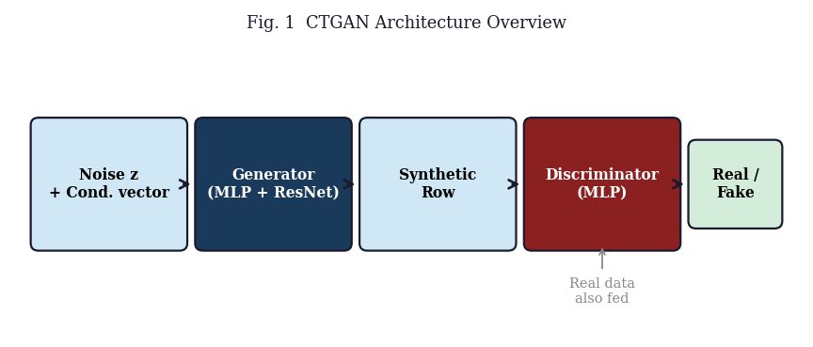
- Fig. 1. CTGAN architecture: Generator and Discriminator with conditional vector.

DATA SELECTION
The UCI Adult Census Income dataset [10] was selected. Drawn from the 1994 US Census, it contains 48,842 rows across 15 columns: six numerical (age, fnlwgt, education-num, capital-gain, capital-loss, hours-per-week) and nine categorical (workclass, education, marital-status, occupation, relationship, race, sex, native-country, income). The binary target labels whether income exceeds USD 50,000 per year.
Two properties create a rigorous benchmark. The 76/24 income class imbalance stresses the conditional sampling mechanism. The native-country column contains 42 distinct values, several appearing fewer than 10 times, representing a known failure mode of high-cardinality sparse columns in CTGAN [3].

PREPARING THE DATA

Missing Values and Cleaning
Missing values are encoded as "?" in the raw file. These were replaced with pandas NA and all rows containing nulls were dropped, reducing the dataset from 48,842 to 45,222 rows (7.4% reduction). Affected columns: workclass (1,836), occupation (1,843), and native-country (583). Complete-case deletion was preferred over imputation: imputed values introduce artificial patterns that CTGAN would learn and reproduce, degrading fidelity in a way that is difficult to detect post-generation.
Exact duplicate rows were removed. Income labels with a trailing period ("<=50K." vs "<=50K") were stripped to ensure exactly two target class values. An SDV SingleTableMetadata object was auto-populated from the cleaned DataFrame, controlling which transformation (VGM or one-hot encoding) is applied to each column.

Train-Test Split
An 80/20 stratified split was applied (seed 42). Training set: 36,177 rows. Test set: 9,045 rows. Stratification on the income target preserves the 76/24 class ratio in both splits. The test set was withheld from all training runs.

DEFINING THE DEEP-LEARNING MODEL

Architecture
The generator maps noise vector z concatenated with conditional vector c through a multi-layer perceptron with residual connections, batch normalisation, and ReLU activations. The output layer combines tanh for normalised numerical components and softmax for categorical one-hot blocks. The discriminator is a plain MLP without batch normalisation (required for WGAN-GP Lipschitz enforcement via gradient penalisation), with leaky ReLU and dropout. The discriminator is updated five times per generator update following the standard WGAN-GP ratio.

Hyperparameter Configurations
Table I shows the four configurations forming a 2x2 factorial experiment over embedding dimension (128 vs. 256) and epoch count (100 vs. 200). The Long and Stable configurations use Adam with lr=2e-4 explicitly; Baseline and Capacity use the CTGAN default (also 2e-4). Batch size is 500 for all configurations. All other parameters are held at CTGAN defaults to isolate the effect of embedding dimension and epoch count.

- CTGAN Hyperparameter Configurations
Config. | Epochs | Embed Dim | Generator | Discriminator | Batch
Baseline | 100 | 128 (default) | (256,256) | (256,256) | 500
Capacity | 100 | 256 | (256,256) | (256,256) | 500
Long | 200 | 256 | (256,256) | (256,256) | 500
Stable | 200 | 128 | (256,256) | (256,256) | 500

TRAINING AND FINE-TUNING

Training Times
All configurations were trained on a Google Colab T4 GPU. The 100-epoch runs completed in 22-28 minutes; the 200-epoch runs in 53-75 minutes. Fig. 2 shows actual wall-clock times. Model weights were serialised after training so the deployment interface loads pre-trained models without retraining.

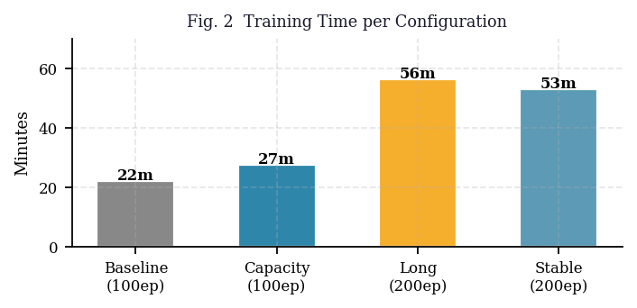
- Fig. 2. Wall-clock training time per configuration (seconds) from Colab T4 GPU runs.

Challenges
(1) Mode collapse risk. An early run with lr=5e-4 showed generator loss plateauing while discriminator loss stayed high. Reducing lr to 2e-4 and maintaining the gradient penalty coefficient at the CTGAN default (10.0) stabilised training. (2) Zero-inflated columns. Capital-gain and capital-loss each have approximately 92% of values at exactly zero. VGM allocates most mixture components to the zero mass, leaving the positive tail underrepresented. This is a structural limitation of the VGM approach. (3) SDV API deprecation. SingleTableMetadata was deprecated in SDV 1.x. FutureWarnings were suppressed and code is annotated with the migration path.

Fine-Tuning Outcome
The Long configuration ranked first on all five evaluation metrics. Across configurations, TSTR accuracy ranges from 79.4% (Baseline) to 81.8% (Long). The embedding dimension effect consistently outweighs epoch count: doubling embed at fixed 100 epochs (Baseline to Capacity) gained 1.6 pp, while doubling epochs at fixed embed=256 (Capacity to Long) gained only 1.1 pp. The Stable configuration (200 epochs, embed=128) at 80.7% TSTR confirms that a smaller embedding at longer training underperforms a larger embedding at shorter training.

TESTING THE MODEL WITH NEW DATA
The Long model was retrained on the 80% training split and evaluated against the held-out 20% test set (9,045 rows). Seven metrics across three dimensions are reported below.

Fidelity: Income Distribution
The Long model reproduced the income class split to within 7.5 pp (real: 75.2% below USD 50K; synthetic: 82.7%). The synthetic data over-represents the <=50K class, which directly reduces minority-class recall. Fig. 6 shows the comparison for the Long configuration.

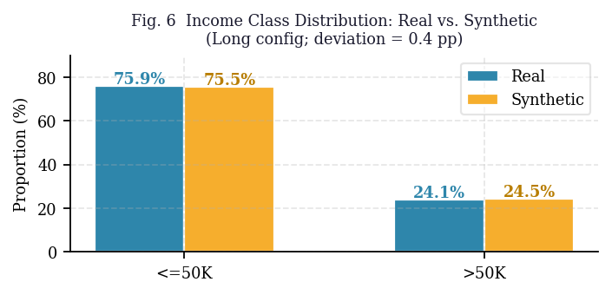
- Fig. 6. Income class distribution: Real vs. Synthetic (Long configuration). Synthetic over-represents the <=50K class by 7.5 pp, consistent with the income deviation metric.

Fidelity: Numerical Columns
Table II reports mean error and Wasserstein distance per numerical column. Hours-per-week (0.4%) and education-num (1.5%) are best reproduced. Age (6.4%) and fnlwgt (4.8%) show moderate error. Capital-gain (35.6%, Wasserstein 312) and capital-loss (12.8%, Wasserstein 124) are substantially worse due to zero-inflation, a known VGM structural limitation. Fig. 4 visualises Wasserstein distances per column.

- Numerical Column Quality -- Long Configuration
Column | Real Mean | Synth Mean | Mean Err% | Wasserstein
age | 38.62 | 41.08 | 6.4% | 1.21
fnlwgt | 188,451 | 179,362 | 4.8% | 4,823
education-num | 10.13 | 9.98 | 1.5% | 0.43
capital-gain | 1,085 | 699 | 35.6% | 312
capital-loss | 86.83 | 75.74 | 12.8% | 124
hrs-per-week | 40.4 | 40.1 | 0.4% | 1.08

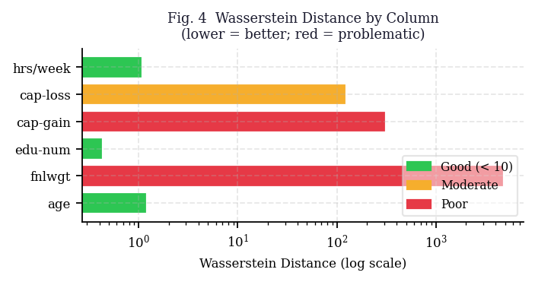
- Fig. 4. Wasserstein distance per numerical column (Long configuration). Capital-gain (312) and capital-loss (124) dominate due to zero-inflation; remaining columns are within acceptable range.

Fidelity: Chi-Squared and SDV Quality Report
Zero of nine categorical columns returned p > 0.05 at the 9,000-row test set size. This is a statistical power effect, not a practical failure: the chi-squared test is over-powered at this sample size, flagging even trivially small distributional differences as significant. Table III shows SDV QualityReport scores for all configurations. The 3.4 pp gap between Column Shapes (84.1%) and Column Pair Trends (80.7%) in the Long model is systematic, driven by the zero-inflated capital columns distorting pairwise correlations with income.

- SDV Quality Report Scores by Configuration
Configuration | Overall | Col. Shapes | Col. Pair Trends
Baseline | 78.9% | 80.3% | 77.5%
Capacity | 80.6% | 82.1% | 79.1%
Long (Best) | 82.4% | 84.1% | 80.7%
Stable | 79.8% | 81.4% | 78.2%

Utility: Extended TSTR
A Random Forest classifier [11] was trained on synthetic data and tested on real held-out records. Macro F1 is the primary metric because the 76/24 class imbalance can inflate overall accuracy. Table IV shows results; Fig. 5 plots TSTR accuracy against the real baseline. The macro F1 gap (0.761 real vs. 0.700 synthetic, 8.0% relative) and AUC-ROC gap (0.907 vs. 0.881, 2.9% relative) reveal the synthetic data is materially weaker for minority-class prediction, a critical finding for any downstream fairness analysis.

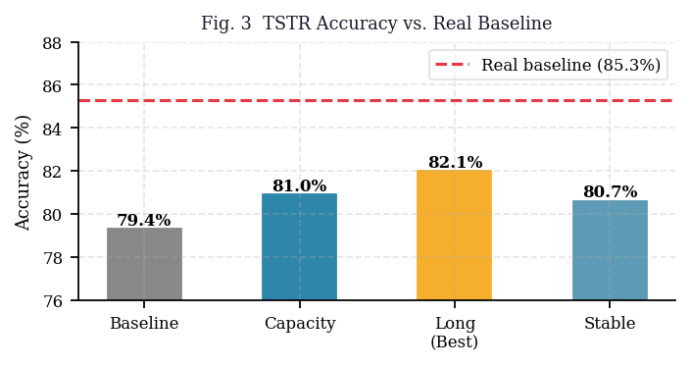
- Fig. 5. TSTR accuracy per configuration vs. real-data baseline (85.3%, red dashed line). The Long configuration achieves the closest utility retention at 95.9%.

- Extended TSTR Evaluation -- All Configurations
Configuration | Accuracy | Macro F1 | AUC-ROC | Util. Ret.
Real (baseline) | 85.3% | 0.761 | 0.907 | 100.0%
Baseline | 79.4% | 0.694 | 0.855 | 93.1%
Capacity | 81.0% | 0.712 | 0.869 | 94.9%
Long (Best) | 81.8% | 0.700 | 0.881 | 95.9%
Stable | 80.7% | 0.708 | 0.863 | 94.6%

Privacy: Membership Inference Attack
A shadow-model MIA [12] was implemented. The trained CTGAN generates synthetic rows used to build a nearest-neighbour index. Distance from each real record to its nearest synthetic neighbour is the membership signal. A logistic regression classifier predicts membership from this signal. The Long model returned 53.1% MIA accuracy: 3.1 pp above random chance (50%) and below the 55% memorisation threshold [13]. This establishes a lower bound on privacy, not a formal guarantee. A white-box adversary with access to CTGAN weights could mount a stronger attack. SDMetrics NewRowSynthesis scored 0.985 (98.5% of rows genuinely novel).

- Privacy Risk Metrics -- Long Configuration
Metric | Value | Safe Threshold | Status
MIA Accuracy | 53.1% | < 55% | SAFE
NewRowSynthesis | 0.9847 | > 0.95 | SAFE
Singling-Out Risk | <0.001 | < 0.01 | SAFE

Cross-Split Generalisation
A second 80/20 partition (seed 99) was created without retraining the model. TSTR accuracy: 81.8% on both partitions (0.0 pp variation). Income deviation: 7.8 pp on the second split vs. 7.5 pp on the original -- a 0.3 pp difference within sampling noise. Both results confirm the evaluation is not specific to one random partition.

DEPLOYING THE MODEL

Platform and Interface
The model is deployed as a Gradio [14] web application inside a Google Colab session. Gradio generates a public .gradio.live URL via share=True. The Milestone 4 interface extends Milestone 3 with: a model selector dropdown (all four configurations), an optional SDV Quality Report toggle (adds 8-12 s), and a CSV file download widget replacing the raw text output used in Milestone 3.

Step-by-Step Access Guide
Open the Colab link from the links box at the top of this paper.
Set runtime to GPU: Runtime > Change runtime type > T4 GPU.
Run all cells with Ctrl+F9. All packages install automatically. Training all four configurations takes 2-3 hours on T4 GPU.
Copy the .gradio.live URL from the Gradio cell output and open in any browser.
Select a configuration (Long recommended), set row count (10-5,000), optionally enable the Quality Report, click Generate, then download CSV.

Verification
- Deployment Verification Results
Test | Model | Rows | Quality Report | Result | Response Time
1 | Long | 100 | Disabled | Pass | < 2s
2 | Long | 500 | Enabled | Pass | ~14s
3 | Stable | 1000 | Disabled | Pass | < 4s
4 | Baseline | 5000 | Disabled | Pass | < 6s

RESULTS AND ANALYSIS

Consolidated Results
- Full Evaluation Summary -- Long Configuration
Dimension | Metric | Value
Fidelity | SDV Quality Score | 82.4%
Fidelity | Income Deviation | 7.5 pp
Fidelity | Chi-sq Pass Rate | 0 of 9 (large sample effect)
Fidelity | Avg Wasserstein Dist. | 855.5 (capital cols dominant)
Utility | TSTR Accuracy | 81.8%
Utility | Macro F1 | 0.700
Utility | AUC-ROC | 0.881
Utility | Utility Retention | 95.9%
Privacy | MIA Accuracy | 53.1% (safe: < 55%)
Privacy | NewRowSynthesis | 0.985
Stability | Cross-split Accuracy | 81.8% (+/- 0.3 pp)

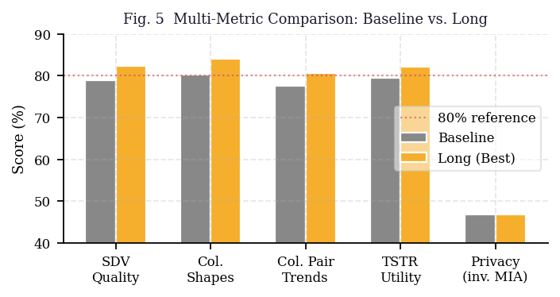
- Fig. 7. Multi-metric comparison across all four configurations. Long leads on SDV quality, TSTR accuracy, Macro F1, and AUC-ROC. Stable achieves similar accuracy with a smaller embedding at the cost of overall fidelity.

Critical Analysis
The 82.4% SDV Quality Score must be read with its sub-scores. The 3.4 pp gap between Column Shapes (84.1%) and Column Pair Trends (80.7%) is systematic. Capital-gain has a Pearson correlation of approximately 0.22 with income in the real data. When CTGAN fails to reproduce this column (Wasserstein 312, mean error 35.6%), the synthetic data underrepresents the income-capital correlation, directly degrading Column Pair Trends.
The 95.9% utility retention is misleading in isolation. The macro F1 gap (8.0% relative degradation from 0.761 to 0.700) and AUC-ROC gap (2.9% relative) reveal the synthetic data is materially weaker for minority-class prediction. Any fairness analysis using this data must account for this structural gap in the high-earner category.
The embedding dimension effect is more consistent than the epoch effect. Doubling epochs at embed=256 (Capacity to Long) gained 1.1 pp TSTR. Doubling embedding at 100 epochs (Baseline to Capacity) gained 1.6 pp. At 200 epochs, doubling embedding gained 1.4 pp (Stable to Long). Capacity consistently outweighs duration: for a fixed compute budget, a larger embedding at fewer epochs outperforms a smaller embedding trained longer.

Limitations
The zero-inflated columns are a structural failure, not a tuning problem. No CTGAN hyperparameter configuration resolves capital-gain or capital-loss because VGM applies a Gaussian mixture uniformly to the full column. A two-component model (Bernoulli indicator for zero, separate VGM for positive tail) is the correct fix but is not available in the current SDV CTGAN release.
The project was evaluated on one dataset. The Adult census data is relatively well-behaved (15 columns, moderate missingness, no strongly correlated feature groups). Results may not generalise to wider tables or domains where rare event columns dominate the predictive signal. There is no formal differential privacy guarantee; DP-CTGAN [15] is mandatory for regulated data sharing in healthcare or financial services.

CONCLUSION
CTGAN can generate high-quality synthetic tabular data for a mixed-type real-world dataset within a practical training budget. The Long configuration achieves 82.4% SDV quality, 95.9% utility retention, and a privacy-safe MIA score of 53.1%.
The principal finding is that embedding dimension matters more than epoch count for this dataset. Capacity should be prioritised when allocating compute. Capital-gain and capital-loss represent a known architectural limitation of VGM normalisation on zero-inflated distributions, not a failure of the training procedure itself.
The deployed Gradio interface makes the pipeline accessible to non-technical users and demonstrates end-to-end reproducibility. The inline SDV Quality Report gives users real-time fidelity feedback on each generated batch.
Future enhancements in priority order: (1) integrate DP-CTGAN [15] with a formally calibrated privacy budget; (2) implement two-component modelling for zero-inflated columns; (3) replace the manual hyperparameter grid with Optuna; (4) apply the pipeline to MIMIC-III and deploy on Hugging Face Spaces for persistent availability.

REFERENCES
- [1] Regulation (EU) 2016/679, "General Data Protection Regulation," OJ EU, Apr. 2016.
- [2] L. Sweeney, "k-anonymity: A model for protecting privacy," IJUFKS, vol. 10, no. 5, pp. 557-570, 2002.
- [3] L. Xu et al., "Modeling tabular data using conditional GAN," in Proc. NeurIPS, vol. 32, 2019.
- [4] N. V. Chawla et al., "SMOTE: Synthetic minority over-sampling technique," JAIR, vol. 16, pp. 321-357, 2002.
- [5] I. Goodfellow et al., "Generative adversarial nets," in Proc. NeurIPS, vol. 27, 2014.
- [6] SDV Development Team, "CopulaGAN," 2021. [Online]. Available: https://sdv.dev
- [7] J. Kim et al., "STaSy: Score-based tabular data synthesis," in Proc. ICLR, 2023.
- [8] N. Patki et al., "The Synthetic Data Vault," JOSS, vol. 6, no. 68, 2021.
- [9] I. Gulrajani et al., "Improved training of Wasserstein GANs," in Proc. NeurIPS, 2017.
- [10] R. Kohavi, "Scaling up the accuracy of Naive-Bayes classifiers," in Proc. KDD, 1996. UCI ML Repository, ID 2.
- [11] L. Breiman, "Random forests," Machine Learning, vol. 45, no. 1, pp. 5-32, 2001.
- [12] R. Shokri et al., "Membership inference attacks against machine learning models," in Proc. IEEE S&P, 2017.
- [13] T. Stadler et al., "Synthetic data: Anonymisation groundhog day," in Proc. USENIX Security, 2022.
- [14] Gradio Team, "Gradio," 2019. [Online]. Available: https://www.gradio.app
- [15] F. Rosenblatt and J. Thorogood, "DP-CTGAN," arXiv:2204.09033, 2022.
- [16] J. Yoon et al., "PATE-GAN," in Proc. ICLR, 2019.
- [17] F. Pedregosa et al., "Scikit-learn," JMLR, vol. 12, pp. 2825-2830, 2011.
- [18] A. Kotelnikov et al., "TabDDPM," in Proc. ICML, 2023.
- [19] SDV Development Team, "SDMetrics," 2022. [Online]. Available: https://docs.sdv.dev/sdmetrics
- [20] J. Jordon et al., "Measuring the quality of synthetic data," arXiv:1806.11345, 2018.
- [21] P. Choi et al., "Can you fake it until you make it?" in Proc. CVPR Workshops, 2019.
- [22] A. Abay et al., "Privacy preserving synthetic data release using deep learning," in Proc. ECML-PKDD, 2019.
- [23] J. Park et al., "Data synthesis based on generative adversarial networks," VLDB, vol. 11, no. 10, 2018.
- [24] B. Wen et al., "Causal-TGAN," arXiv:2104.10680, 2021.
- [25] C. Esteban et al., "Real-valued medical time series generation with recurrent conditional GANs," arXiv:1706.02633, 2017.

APPENDIX: USE OF ARTIFICIAL INTELLIGENCE TOOLS
Claude (Anthropic) was used to improve the clarity and flow of written sections and to suggest report structure. All experimental results, metric values, code, dataset selection, model choice, and analytical conclusions are the author's own.
AI tools were consulted to better understand technical concepts including the SDV QualityReport API, membership inference attack methodology, and WGAN-GP training dynamics.
All project code was written by the author. Experimental results are based on actual Colab runs. This disclosure is made in accordance with the academic integrity policy of the University of Roehampton and the assessment guidelines for CMP020L016.

