Sokoban Test Plan

# Non-Gameplay Related

## Test 1

Test: Create a setup object

Description: Create a setup object by calling “new Setup()”;

Result: A setup class was created without error

Evidence:

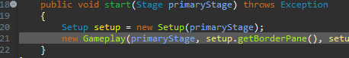

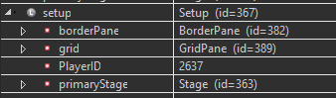

## Test 2

Test: Check Levels are present

Description: Check the folder containing the levels to ensure it contains correct level file types.

Result: Does not pass correctly

Evidence: Without Level Files

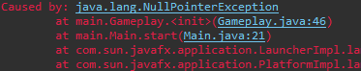

With Level Files



Solution: By putting the code that checks the content of the folder into a separate method, and adding a try-catch it would be possible to catch this error and handle it properly

## Test 3

Test: Generate Buttons for each level

Description: Generate a separate button for each level file present in the folder

Result: Buttons are generated correctly for the number of files present

Evidence: 4 Level Files present:

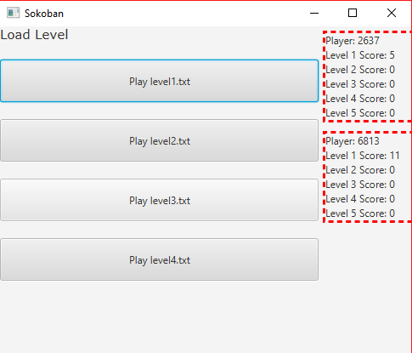

5 Level Files Present:

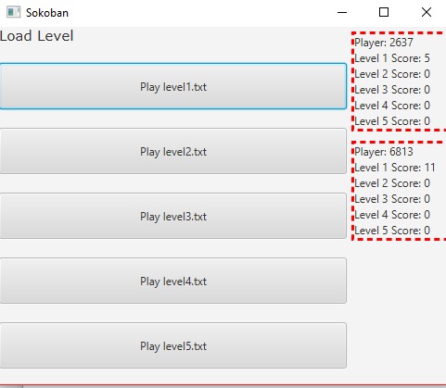

## Test 4

Test: Check the API loads up the scoreboard for menu

Description: Check the API can call the scoreboard and present it on the main menu

Result: Successful, the scoreboard is presented with correct data

Evidence:

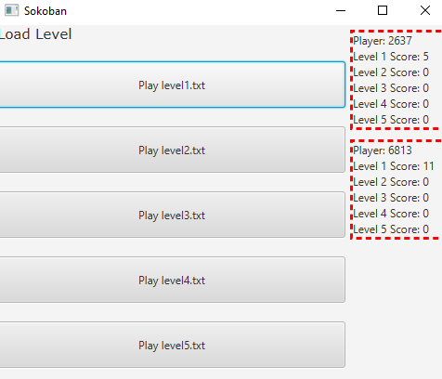

# Gameplay Related

## Test 1

Test: Can the player move

Description: When the keyboard buttons are pressed, does the player move if normal gameplay allows it

Result: Successful

Evidence: Before Button Press

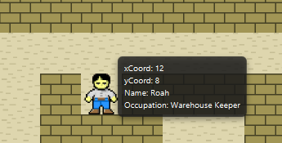

After Button “w” is pressed

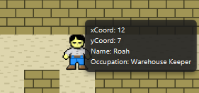

## Test 2

Test: does the player NOT walk into walls

Description: If the player attempts to walk into the wall, does the program prevent this

Result: Successful, the player cannot walk onto the same tile as walls

Evidence: Before Button Press

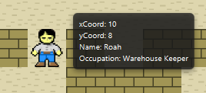

After Button “a” is pressed

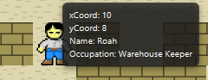

## Test 3

Test: Can the player push a crate

Description: Can the player push a crate when they attempt to move onto the same tile space as the crate

Result: Successful, the player can move crates

Evidence: Before button press

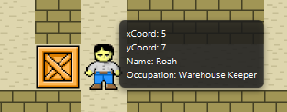

After Button “a” is pressed

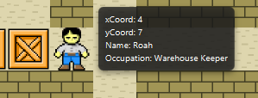

## Test 4

Test: Can the player move crates onto other crates

Description: If the player attempts to push a crate tile onto another crate tile, will the program prevent this.

Result: Successful, the program will prevent the player from moving crates

Evidence: Before button press

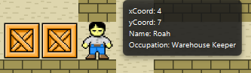

After Button “a” is pressed

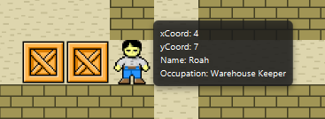

## Test 5

Test: Can the player move crates into walls

Description: If the player attempts to move a crate tile into a wall, does the program prevent this

Result: Successful, the player is prevented from moving a crate tile into a wall tile

Evidence: Before button press

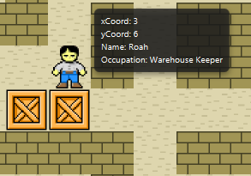

After button “s” is pressed

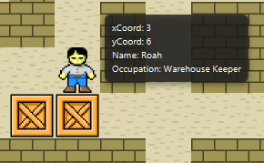

## Test 6

Test: Is winning possible

Description: When all crates are present on the diamond tiles, does this trigger a win condition

Result: Successful, the program detects a win and triggers the correct response

Evidence: Before crate is moved onto diamond

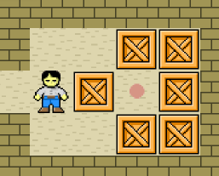

After crate is moved onto diamond tile

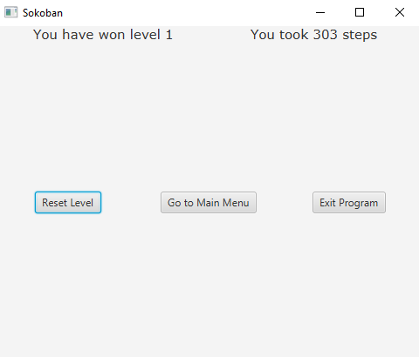

## Test 7

Test: Can the level be reset

Description: When the “Reset Level” button is pressed during gameplay

Result: Successful, the game is reset

Evidence: Before button is clicked

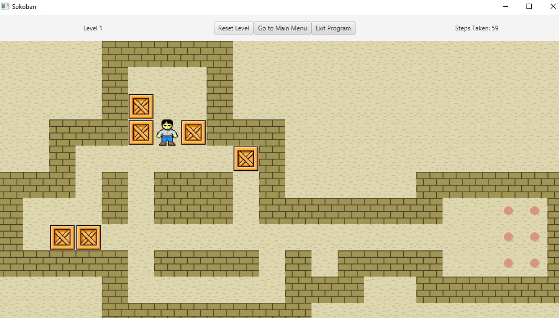

After button is clicked

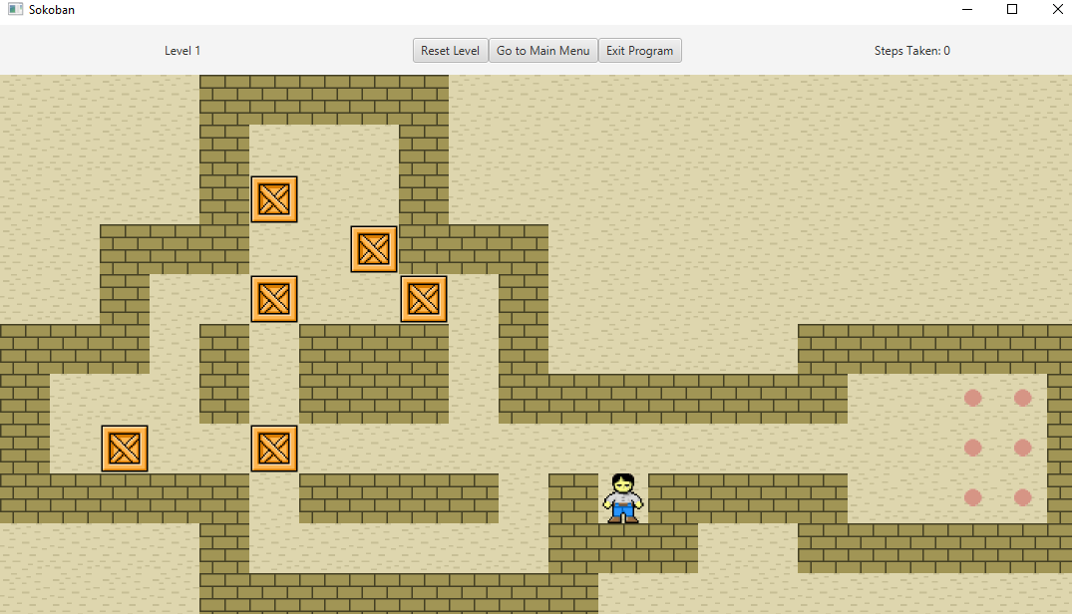

## Test 8

Test: Can the player quit to main menu

Description: IF the player pressed the “Main Menu” button during gameplay, does the program quit the level and return to the main menu

Result: Successful, the level is unloaded and the player is returned to the main menu

Evidence: Before Button is clicked

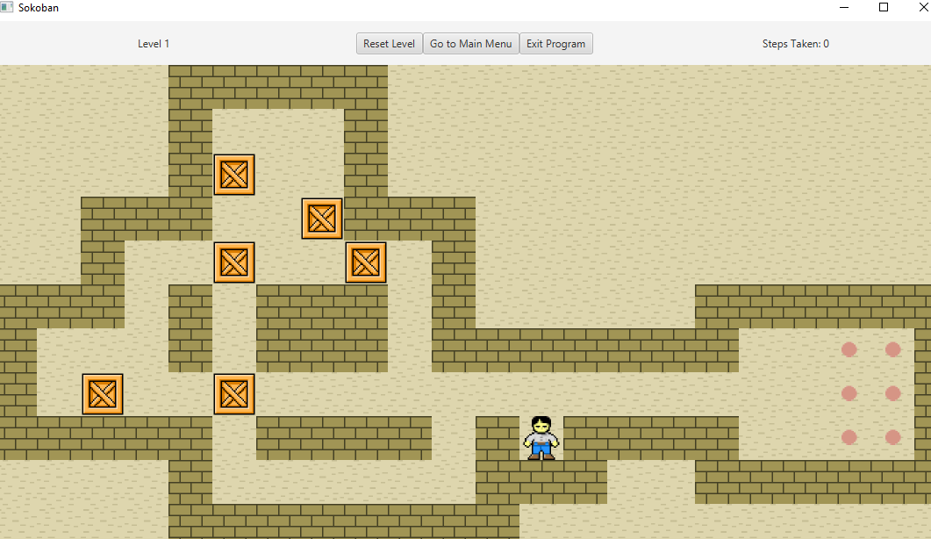

After Button is clicked

