**Setup-and-Configure-Azure-Site-Recovery-(ASR)-for-On-Premises-Hyper-V-Host**

**Introduction**

This document will provide a step by step walk-through on how to go about setting up and configuring ASR (Azure Site Recovery) and backing up your On-Premises Virtual Machines (VMs) with Azure Resource Manager (ARM). Azure’s Recovery Service Vault is a unified vault/resource that allows you to manage your backup and data disaster recovery needs within Azure. For example, if you are hosting your VMs on-premises you can create a link between your on-prem site and Azure to allow your VMs to be backed-up into Azure, regardless of your hypervisor, it can be either ESX or Hyper-V, either will work. This documen will provide steps for Hyper-v host

**Configuring Azure**

1. Create a Recovery Services Vault. Within Azure Resource Manager (ARM), if we select New, within the Marketplace, select Monitoring + management, then select Backup and Site Recovery (OMS) within the featured apps. Of course if this is no longer present, just search for it within the marketplace.
2. Create the vault - Give it a meaningful name, and you can either create a new Resource Group, or use an existing.
3. Choose your Protection Goal(s) - Click Settings > Site Recovery (Under Getting Stated) > Step 1: Prepare Infrastructure > Protection Goal > And specify the following > Click OK:

* Replicating to: Azure
* Machines Virtualized: Yes, with Hyper-V
* Using SCVMM (Virtual Machine Manager): No

**Setup the Source Environment**

1. Prepare the source, give Hyper-V site a name, “hyper-v-xyz” or whatever is appropriate
2. download the ASR Provider Installer, along with the Vault Registration Key.
3. Install and Configure the ASR Provider on Hyper-V Host

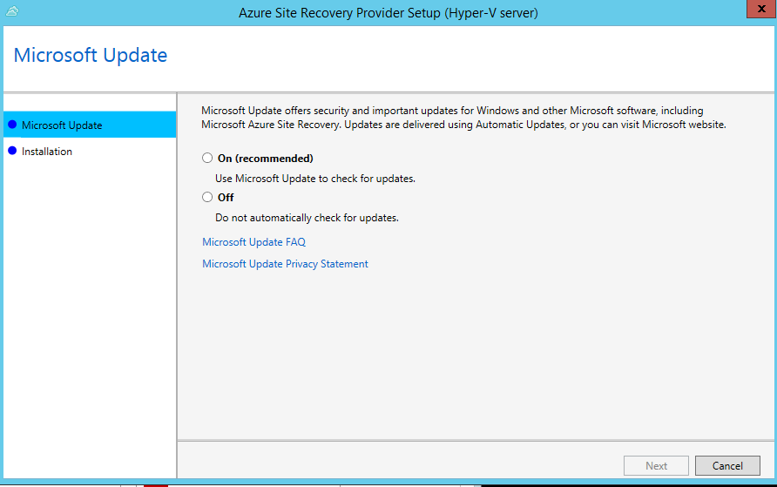

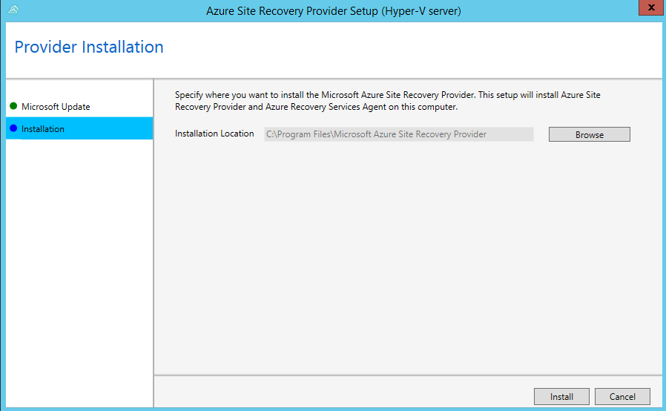

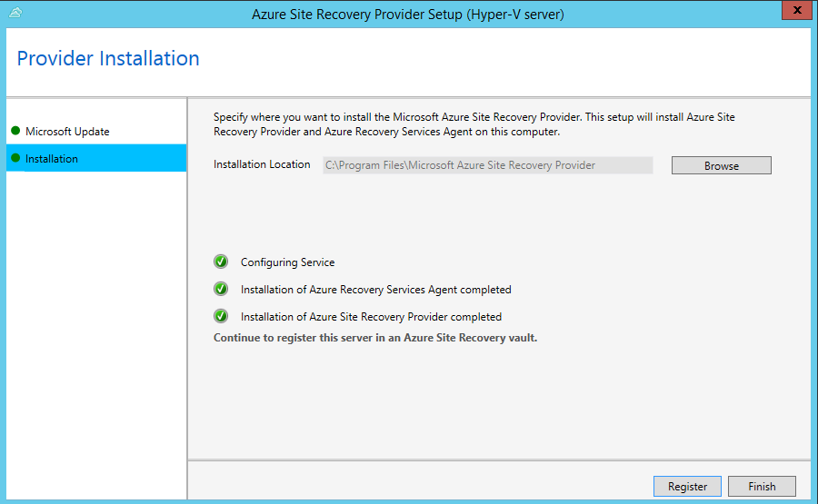

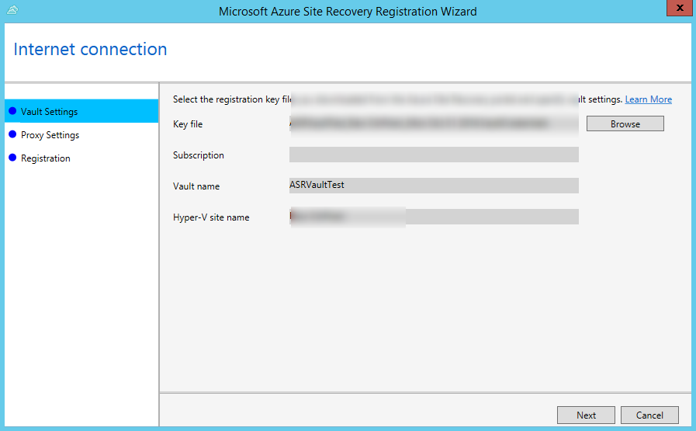

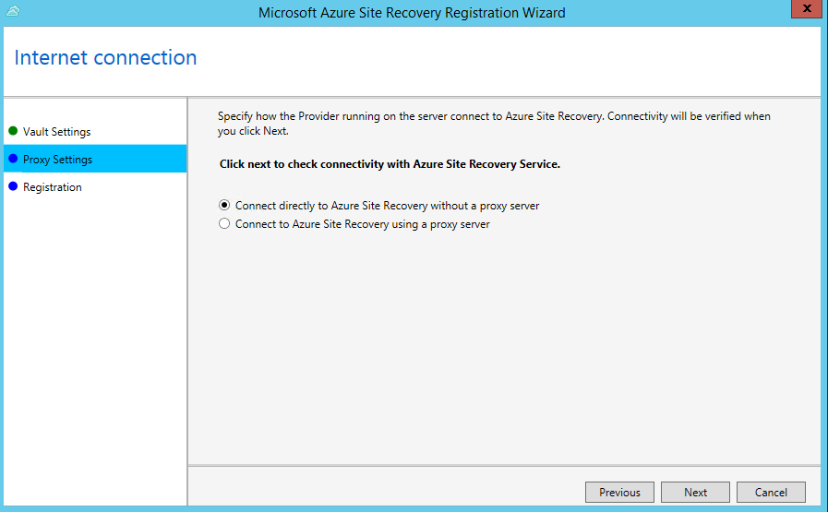

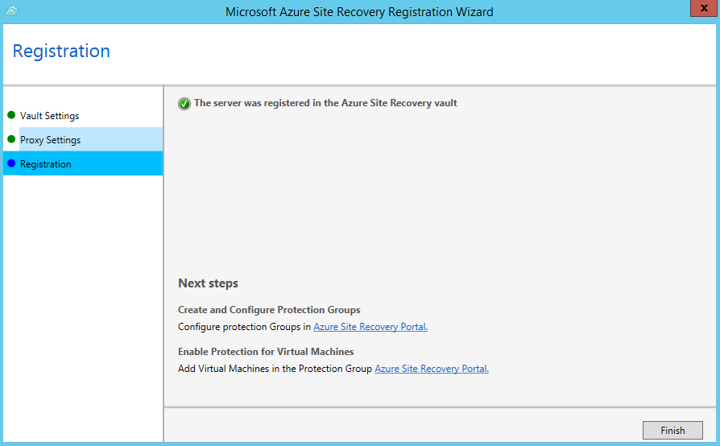

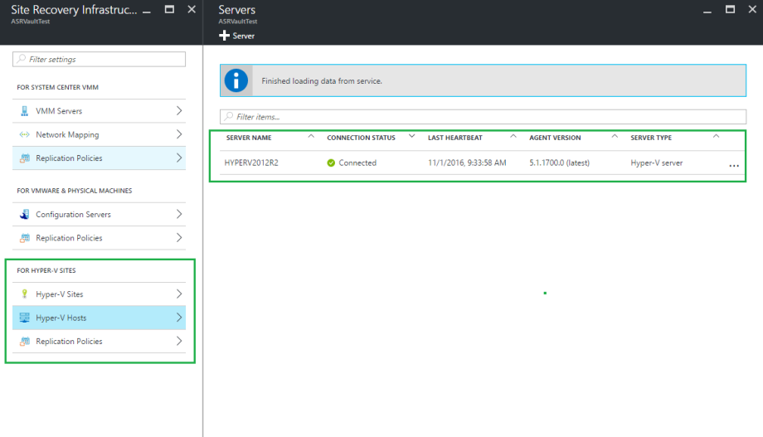

1. Create a Replication Policy

* Within our Vault properties > Settings > Manage: Site Recovery Infrastructure > For Hyper-V Sites: Replication Policies > +Replication Policies

1. Associate Hyper-V Site(s)

* Associate the Hyper-V site to vault

1. Create a Storage Account + Virtual Network

* Within the Replication, we have a few options here. Pick whatever is appropriate

1. Create a Target Virtual Network:
2. Setup Replication Settings

* Since we create the Replication Policy beforehand, this auto-filled.
* Do some Capacity Planning.

1. Now Azure should have connected with our Hyper-V host, we can now see our VMs within our Hyper-V host. Here we now need to select which machines we will want to include within ASR.
2. Configure the VMs properties:
3. Once you're good to go, go ahead and apply the Replication Policy to the VMs.
4. Go ahead and hit “Enable Replication“.
5. Go back to our Hyper-V host, and configure the Network/Throttling bandwidth. launch Microsoft Azure Backup. Change the network throttling settings to your needs. Like less during on ours and increase during off hours

**Creating The Recovery Plan:**

1. Last step is to Create a Recovery Plan

