Continuous Integration with Cruise Control
Installation and Perforce Binding

Author: Parameswaran Ganesan
Date Written: 15 Oct 2009

Declaration: I/We hereby declare that this document is based on my/our personal experiences and/or experiences of my/our project members. To the best of my/our knowledge, this document does not contain any material that infringes the copyrights of any other individual or organization including the customers of Infosys.

Name of the Author : Parameswaran Ganesan

Project Details:

Project Involved : TRZENGS
H/W Platform : Microsoft Windows Server 2003/2008.
S/W Environment : Microsoft .Net Framework
Application Type : Web Application
Project Type : Maintenance

Target Readers : Developers to setup CruiseControl.NET® for Continuous Integration.

Keywords : CruiseControl.NET®, Continuous Integration, Nant, FxCop, NUNIT

Table of Contents

Overview 3
Pre-Requisite 3
Installation 3
Procedure for Cruise Control Configuration 3
Detecting Changes in Perforce: 3
Build Solution: 6
Build Report via Email: 8
Using FxCop: 9
Using NUNIT: 11
References: 15

Overview

CruiseControl.NET® is an Automated Continuous Integration server, implemented using the Microsoft.NET Framework.
Why Cruise Control:
CruiseControl.NET® (CCNet) consists of a suite of applications, but at its core is the CruiseControl.NET Server which is an automated integration server.
The CruiseControl.NET® Server automates the integration process by monitoring the project's source control repository directly. On each occasion a developer commits modifications, the server will automatically trigger an integration build to validate changes. Also, the developer can be notified whether the changes that they committed integrated successfully or not.
Overall, integration is as easy as checking in the code. It also guarantees that an integration build will happen. The risks of not validating the changes are not felt.

Pre-Requisite
- Windows Server 2003
- Microsoft Visual Studio 2003 or Microsoft Visual Studio 2005
- .Net Framework 1.1 or .Net Framework 2.0

Installation

These are the steps to be followed for execution of the installation in the same order:

Installable

CruiseControl.Net - http://sourceforge.net/projects/ccnet/files/CruiseControl.NET%20Releases/

Nant - http://nantcontrib.sourceforge.net/nightly/

NUnit - http://nunit.org/download.html

FxCop - http://www.microsoft.com/downloads/details.aspx?FamilyID=3389f7e4-0e55-4a4d-bc74-
4aeabb17997b&DisplayLang=en

Procedure for Cruise Control Configuration

Detecting Changes in Perforce:

The configuration file (ccnet.config) present in this path “C:\Program Files\Cruisecontrol.Net\Server” needs to be configured to enable continuous integration.
The ccnet.config file is configured by adding tags to it just like HTML tags.
A sample structure of ccnet.config file to configure Cruisecontrol.Net to work with Perforce is given below.

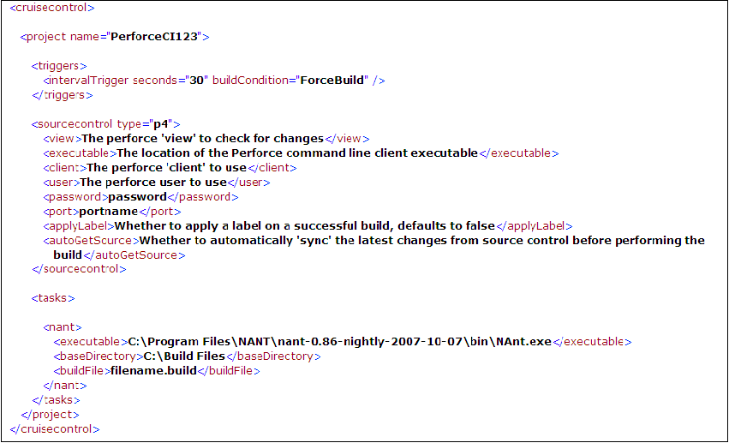

The above tags will create a project with the name mentioned in the <Project> tag.
Open Internet Explorer and then specify the URL http://localhost/ccnet/ViewFarmReport.aspx. This will open the Cruisecontrol.Net dashboard where all the projects configured in the config file will be listed.

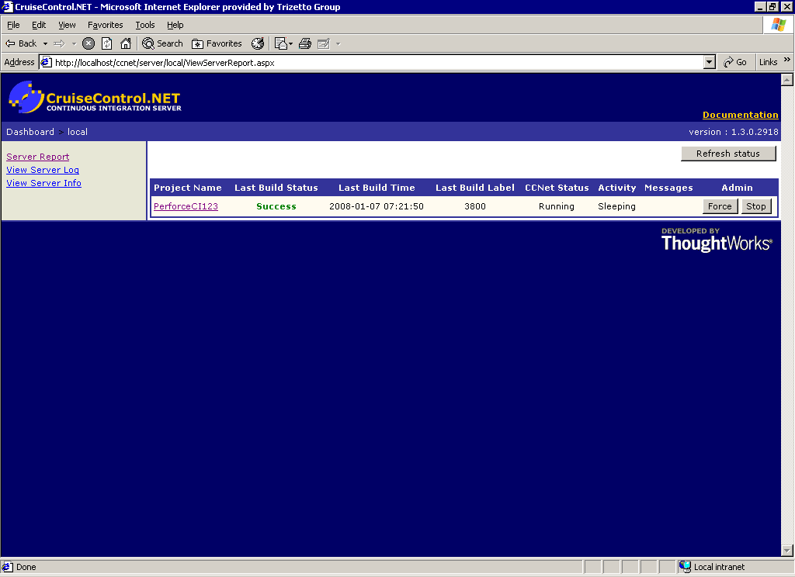

Click on the project name to view its results.

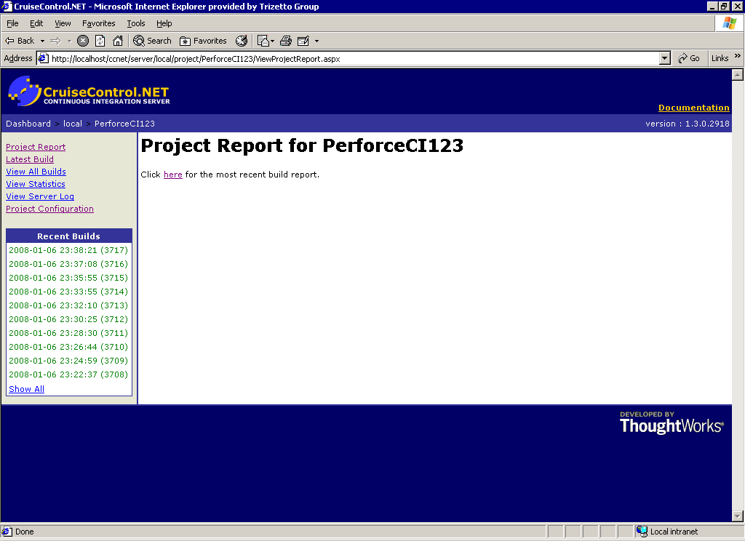

Cruisecontrol.Net will look for changes in the “View” mentioned in the <view> tag.

<view>The perforce 'view' to check for changes</view>

It is the path in Perforce where Cruisecontrol.Net will look for file changes. In order to mention the time interval to look for changes, <triggers> tag is added. Here in the “Seconds” attribute, we specify the number of seconds after an integration cycle completes, before triggering the next integration cycle. In “buildcondition” attribute of this tag the condition that should be used to launch the integration. It can be IfModificationExists or ForceBuild. By default the value for seconds tag is 60 and IfModificationExists for buildcondition attribute.

Build Solution:

If there are any modifications made to the files in the view specified, Cruisecontrol.Net will initiate Nant to build the solution file. To configure Nant the <tasks> tag needs to be added inside <project> tag after <sourcecontrol> tag as shown in the sample above.

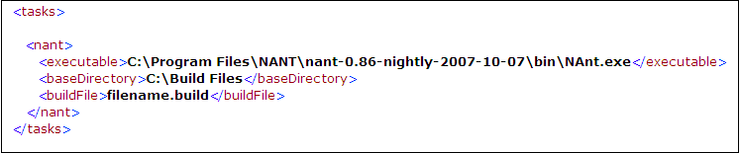
In this <tasks> tag the path of the Nant executable is specified. A build file needs to be created to mention the path of the solution that is to be built. The path of this build file is specified in < baseDirectory > tag (<baseDirectory>C:\Build Files<baseDirectory>) and the name of the file is mentioned in <buildFile> tag (<buildFile>filename.build<buildFile>).

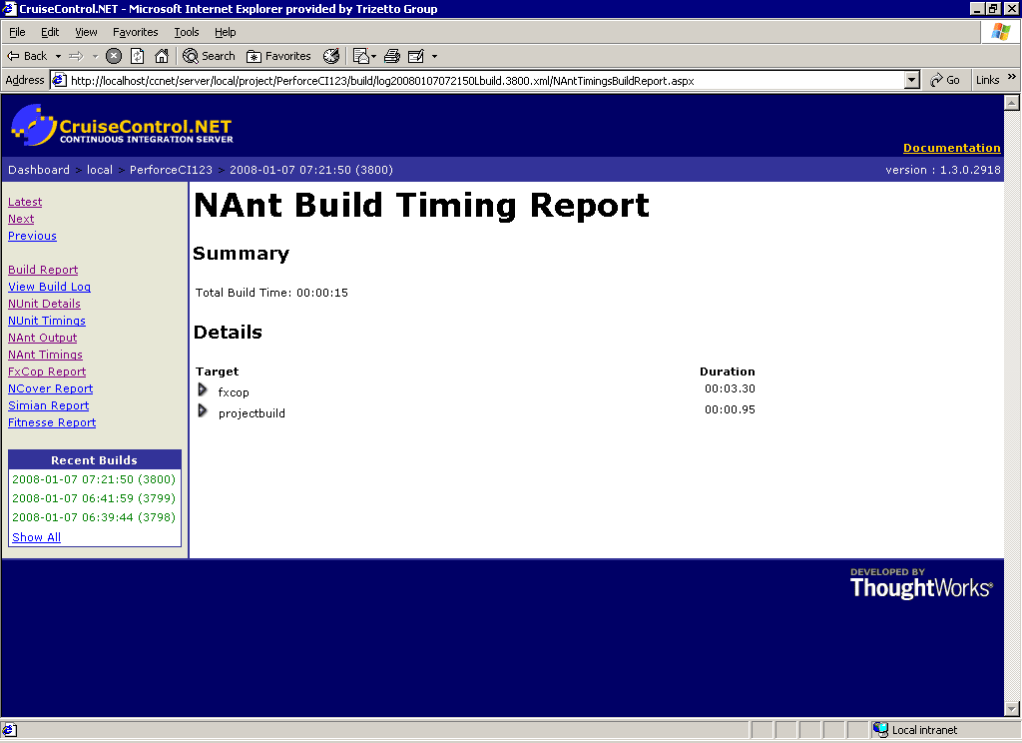

A sample of the build file is shown below.

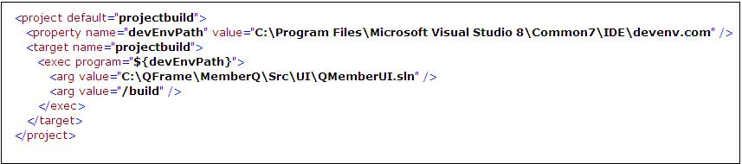
In the property tag the path of the executable that builds the solution is mentioned and is used in <exec program> tag.

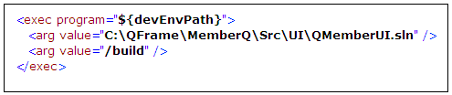

In the <arg> tag (<arg value="C:\QFrame\MemberQ\Src\UI\QMemberUI.sln" />), the path of the solution that needs to be built is specified.

Build Report via Email:

Cruisecontrol.Net can be configured to send a build report via e-mail. The tag that is used is shown below.

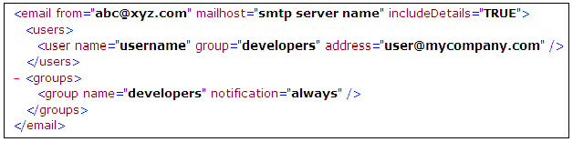

In <email> tag, “from” attribute is used to specify the email address that email will be marked as coming from. “Mailhost” used to specify the SMTP server that CruiseControl.NET will connect to send email.
Any number of users can be added using the <users> tag. Here the group attribute is used to specify a group to which the user belongs. This should match with the name mentioned in the <groups> tag.

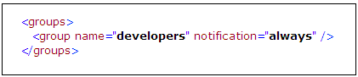
The notification attribute determines when to send email to this group. Possible values to this attribute can be "always" - used to send email when any build occurs and "change" - used to send email when the status of the build changes (e.g. from 'passed' to 'failed').

Using FxCop:

FxCop is a free static code analysis tool from Microsoft that checks .NET managed code assemblies for conformance to Microsoft's .NET Framework Design Guidelines. FxCop includes both GUI and command line versions of the tool. Microsoft Visual Studio 2005 includes a "Code Analysis" feature based on FxCop.
FxCop provides a tool to help developers to follow their company's coding standards. FxCop does code analysis to check whether the new code is compliant with the coding standards, naming conventions followed by the company. FxCop will ensure that the specified rules are used in the coding or not.

Steps to create an fxcop project:
- Install FxCop 1.35 in the system
- Open fxcop
- Add a target by selecting Project->Add Targets from menu option
- Add a rules by selecting Project->Add Rules from menu option
- Any number of targets and rules can be added
- Select rules tab and select all the rules that have to be applied by using the checkboxes in the nodes
- Now click ‘Analyze’
- The right pane would indicate non conformance
- Double click the error message to view the full details
- Now save the project as ‘projectname.fxcop’

Steps to configure fxcop with CruiseControl.NET:
- The following code snippet is used to configure the fxcop with CruiseControl.NET. This code should be placed in ccnet.config outside <tasks> tags.

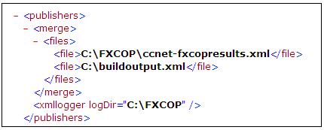

- The output will be logged in fxcopresults.xml.
- The result will be seen in CruiseControl.NET dash board.

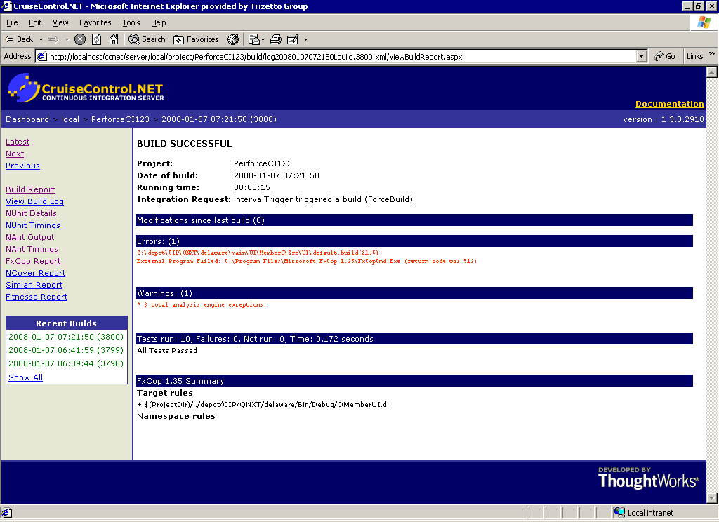

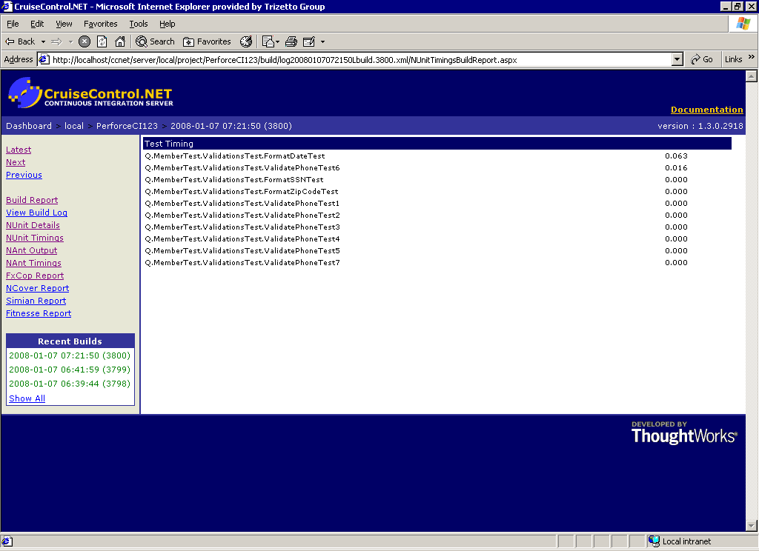

Using NUNIT:

NUnit is a unit-testing framework for all .Net languages. It is written entirely in C# and has been completely redesigned to take advantage of many .NET language features, for example custom attributes and other reflection related capabilities.

Example of a Nunit test fixture:

using System;
using System.Collections.Generic;
using System.Text;
using NUnit.Framework;
using Q.Global;
using Q.Global.Exceptions;
using System.Data;
using Q.EligibilityLDL;
using Q.Global.DomainManagement;
using Q.Global.ServiceDefinitions;

namespace Q.EligibilityLDLTest
{
[TestFixture()]
public class EligibilityLDLTest
{
#region Class Variables
public IQcsiSession objSession;
public static Q.Global.DomainManagement.AppDomainManager mAppDom;
private EligibilityData EligService = null;

#endregion

#region TestFixtureSetUP
[SetUp()]
public void TestFixtureSetUp()
{

mAppDom = new Q.Global.DomainManagement.AppDomainManager(false, MasterLocation.UNKNOWN);
EligService = new EligibilityData();
Console.WriteLine("TestFixtureSetUp");

}

#endregion

#region Method Tests

[Test]
public void FindMemberbyLastNameTest()
{
Console.WriteLine("Start");
System.DateTime methodStartTime = System.DateTime.Now;
DataSet ds = new DataSet();
DataTable dt = new DataTable();
ds = null; dt = null;

string m_envId = "";
objSession = null;
objSession = Globals.CreateSession();
try
{

objSession.Login("", "");
Console.WriteLine(objSession.NTUserName);
Console.WriteLine(objSession.Password);
Console.WriteLine(objSession.UserName);
//objSession.Login();
//objSession.NTUserName = "Connect@QCSICORP";
}
catch (Exception ex)
{
throw new ApplicationException("Login failed for user ", ex);
}

m_envId = objSession.SessionData.EnvironmentList.Environment[0].EnvID;
objSession.SelectEnv("82", "plandata");
try
{
dt = EligService.FindMemberbyLastName(objSession, "smith");
}
catch (Exception ex)
{
string str = ex.ToString();
}
//Console.WriteLine("assert");
Console.WriteLine("Number of Rows returned:" + dt.Rows.Count);
Assert.IsFalse(dt.Rows.Count < 0);
//Assert.IsNotNull(dt.Rows.Count);
//Console.WriteLine(dt.Rows.Count.ToString());
Console.WriteLine("end");
System.TimeSpan methodDuration = System.DateTime.Now.Subtract(methodStartTime);
System.Console.WriteLine(String.Format("Q.Member.Validations.FormatSSN Time Elapsed: {0}", methodDuration.ToString()));

}

#endregion

#region TestFixtureTearDown
[TearDown()]
public void TestFixtureTearDown()
{
//mAppDom.Dispose();
//EligService.Dispose();
Console.WriteLine("TestFixtureTearDown");
}
#endregion

}
}

Steps to use Nunit:
- Install Nunit in the system
- Write the test case logic in .cs file and place that file in the same solution where the class file is located
- To write a test case, project needs to have Nunit.framework .dll as reference
- Now build the solution and create a dll for the solution
- The dll created should be given as the input for the Nunit
- File ->open project and give the path where the dll is placed
- Now click ‘Run’ button
- The Green dot indicates success and red dot failure. Shown below is the Nunit UI
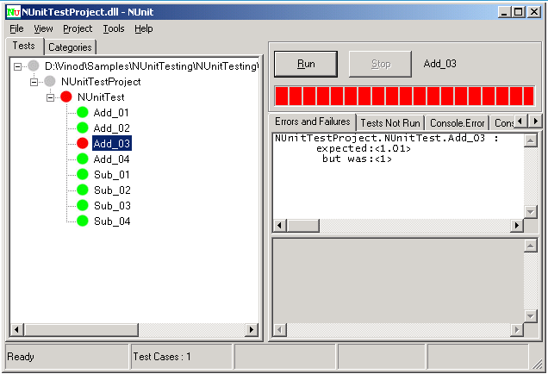

Steps to configure the Nunit with CruiseControl.NET®:
- The following code snippet should be added in ccnet.config file to configure Nunit with CruiseControl.NET®

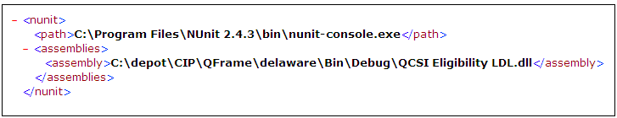

- The output will be displayed in the CruiseControl.NET® dash board.

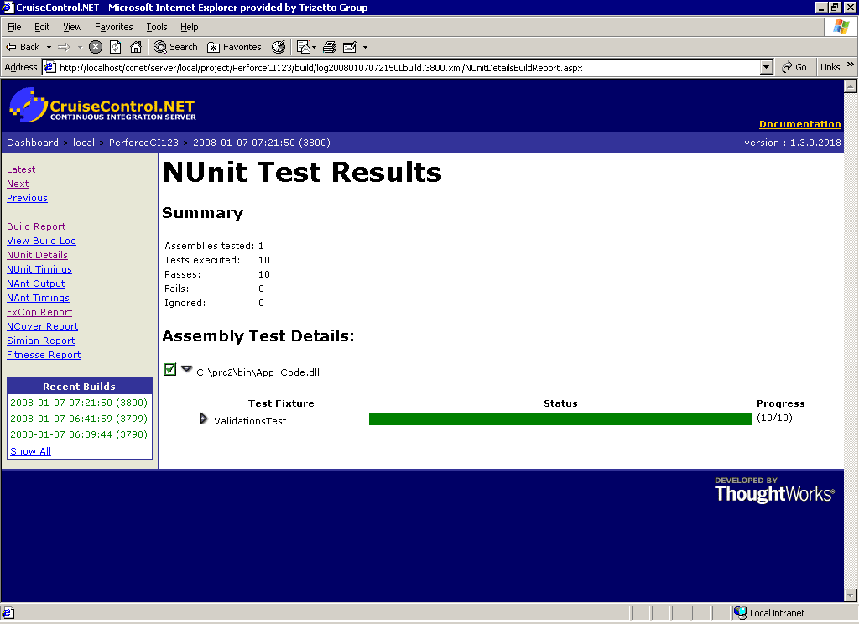

References:
- Perforce Source Control Block -http://confluence.public.thoughtworks.org/display/CCNET/Perforce+Source+Control+Block

- E-Mail Publisher –
http://confluence.public.thoughtworks.org/display/CCNET/Email+Publisher

- Trigger Blocks –
http://confluence.public.thoughtworks.org/display/CCNET/Trigger+Blocks

