Infosys
JIRA OVERVIEW
Basic functionality in JIRA

Contents

Overview 3
Creating a new project in JIRA 3
Creating a new Issue 5
Finding the issues that you have created 8
Closing / Resolving an issue 9
Reopening a closed issue 11

Overview

JIRA is the defect tracking tool developed by Atlassian. We use this tool to log Defects, issues, new features and improvements. This tool helps us to keep track of the Defect history and status.
The Administrator creates the nodes for the project in the tool and users can access the same with the respective permissions. Users are added to the tool by the administrator. The administrator has complete access to all the projects and issues logged in JIRA. Project wise or Role wise permissions are given by the administrator and the user access is restricted to the permissions given to him.
Below are the major functionalities in JIRA with snapshots
- Creating a new project
- Creating a new issue
- Finding the issues created
- Closing / resolving the issue.
- Reopening the issue.

Creating a new project in JIRA

1. Go to the Administration tab in your JIRA application.

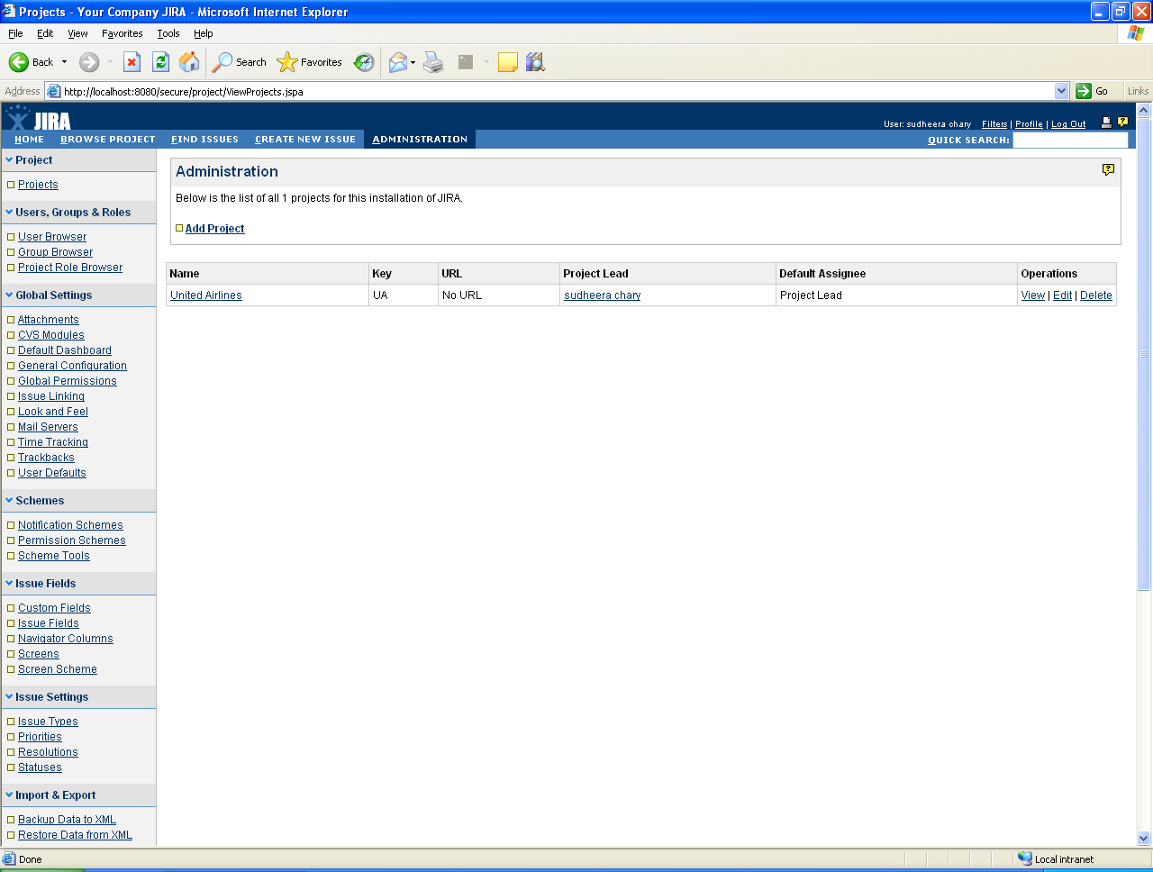

2. Click on Add project.
3. Enter the mandatory fields (marked by an asterix) and click on ADD.

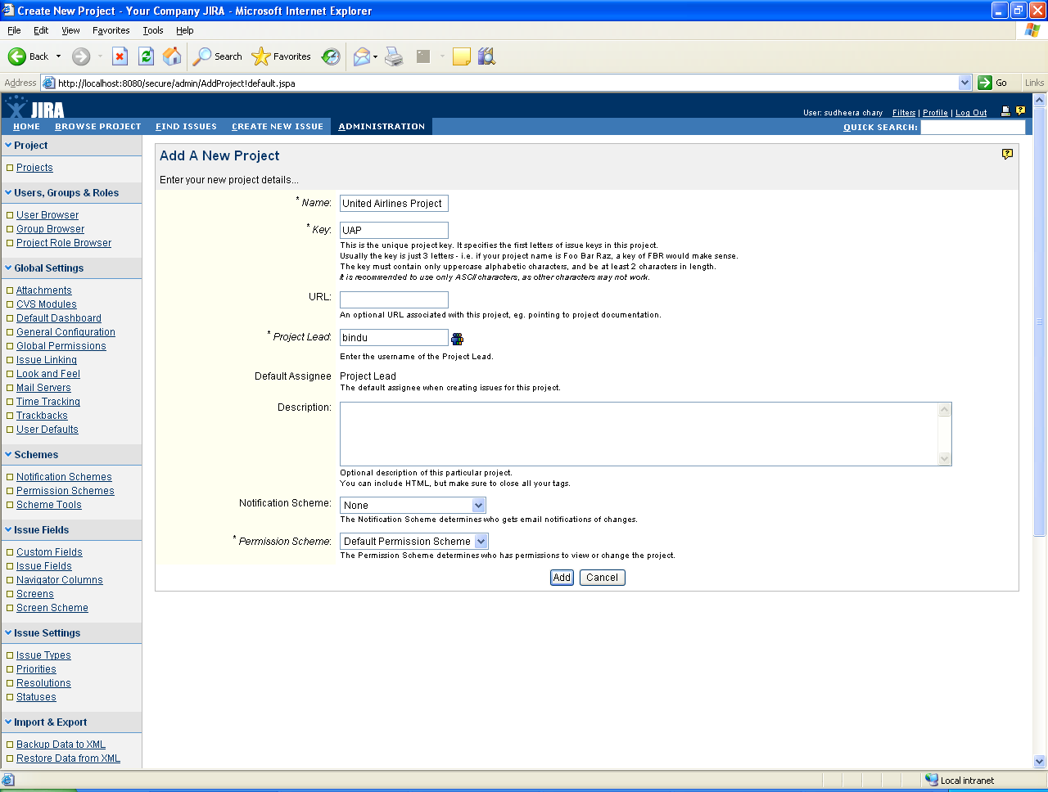

4. The new project is added.

Creating a new Issue

- Go to Create new issue tab in the menu
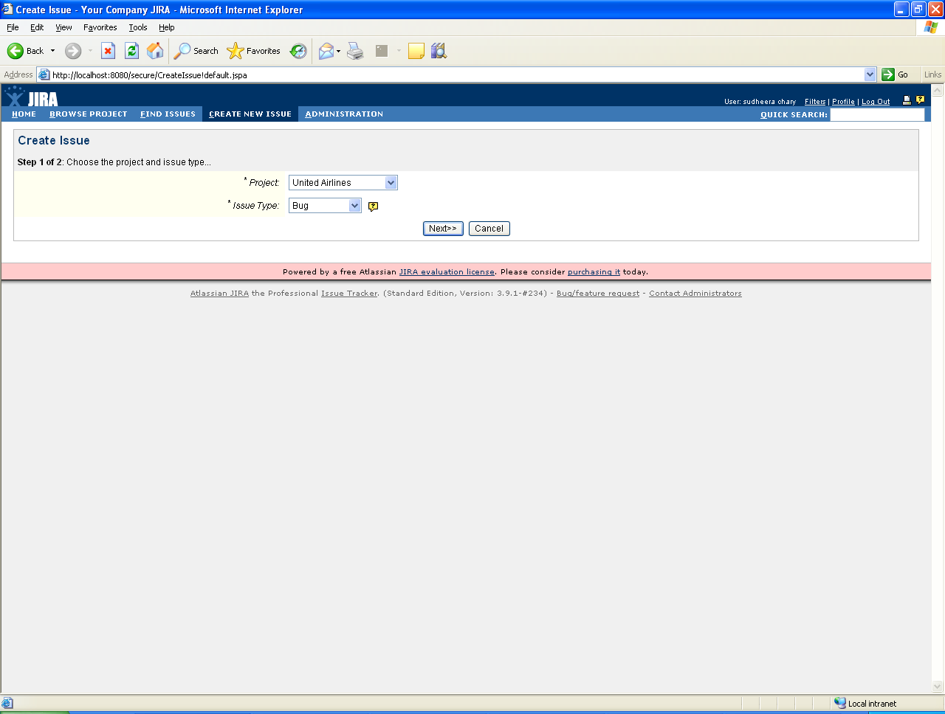

- Select the issue type.
- The following are the issue types.
- Defect
- New feature
- Task
- Improvement

- For adding a Defect select the project name for which you want to create a Defect
- Click on Next
- Provide the summary of the Defect ( The title of the Defect comes here)
- Set the priority and the due date for the Defect
- Assignee is the person to whom we are assigning the Defect to be fixed or confirmed.
- Provide the environment in which the Defect was found.
- Provide the description of the Defect.
- The Description of the Defect may contain the following
  - Repro steps.
  - Expected Result
  - Actual Result

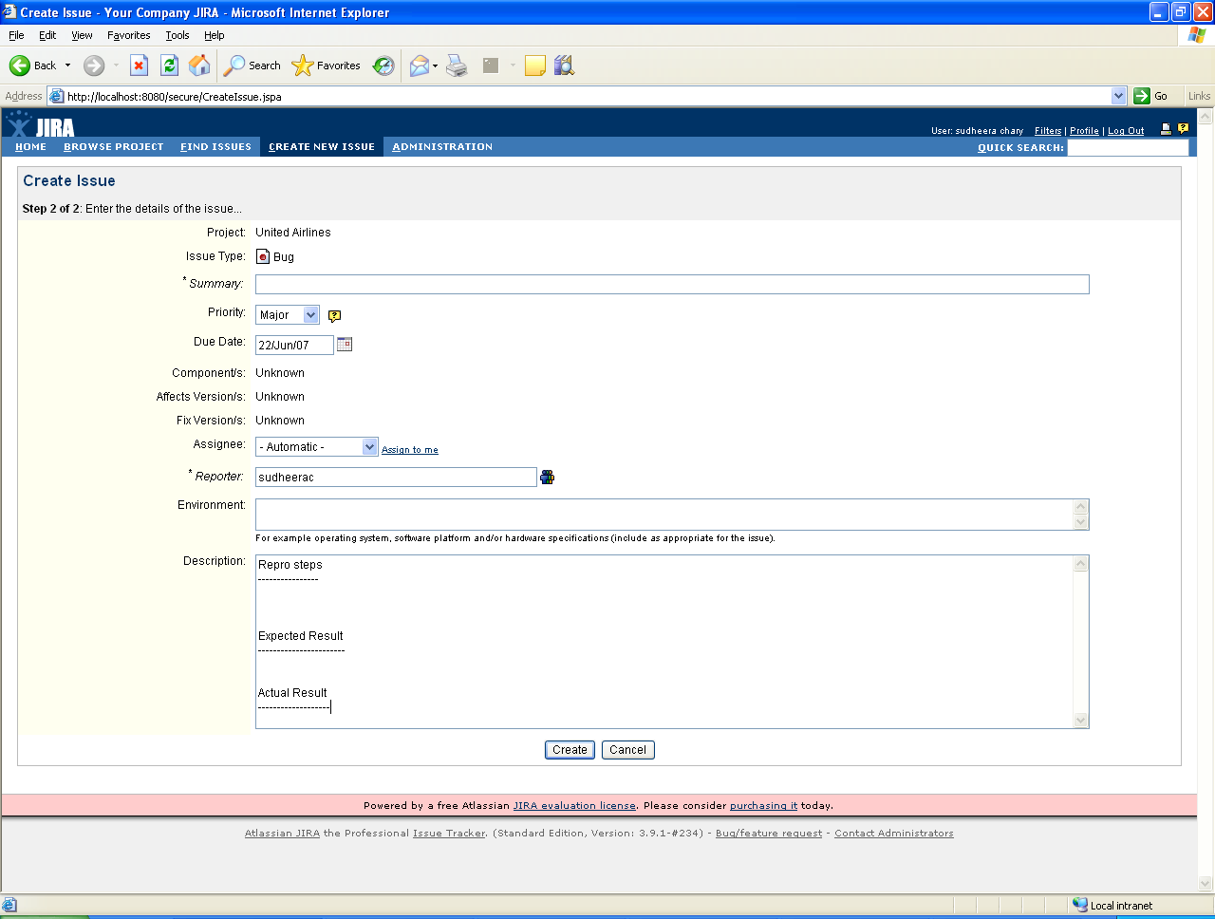

- After the issue is created we can attach a file or error screenshot with the issue. We can also copy, comment, edit, move and delete the issue with the options provided in the left hand panel of the issue.
- The issue can be tracked or monitored so that the creator of the issue may get a mail when the issue is modified, resolved or closed.
- For attachments the admin has to enable the attachments by providing an attachment path the first time he configures JIRA.

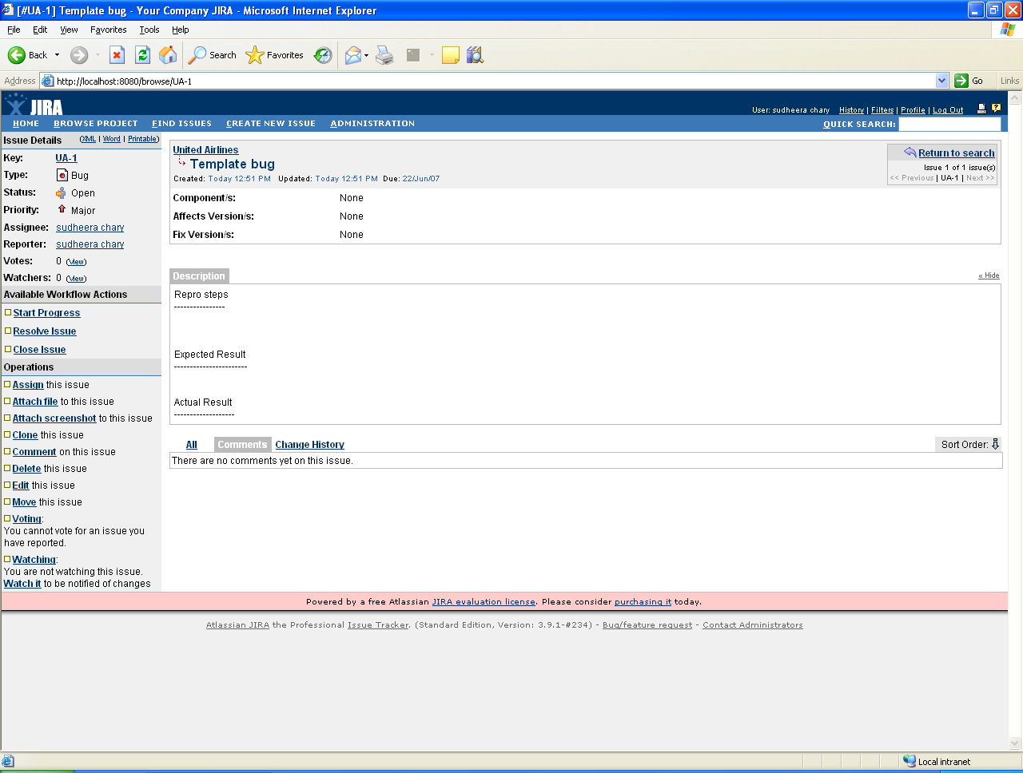

Finding the issues that you have created

- Go to the Find issue option in the menu of the application

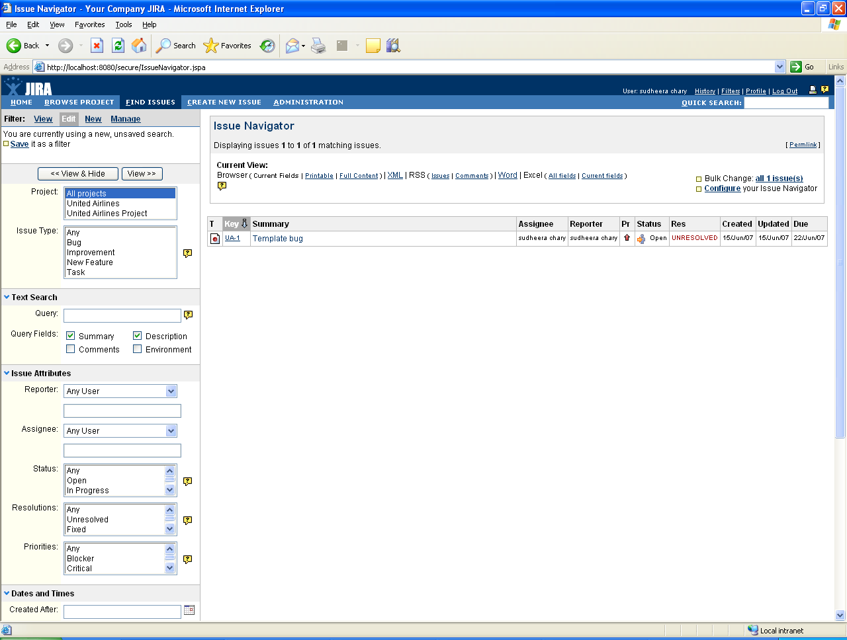

- Provide the search criteria. (ie if you wantto see the list of Defects in the created project – Select the project name and the issue type as Defect ) .
- Click on View button.
- The Defects created for the project will be listed out.

Closing / Resolving an issue

- Click on Close Issue.

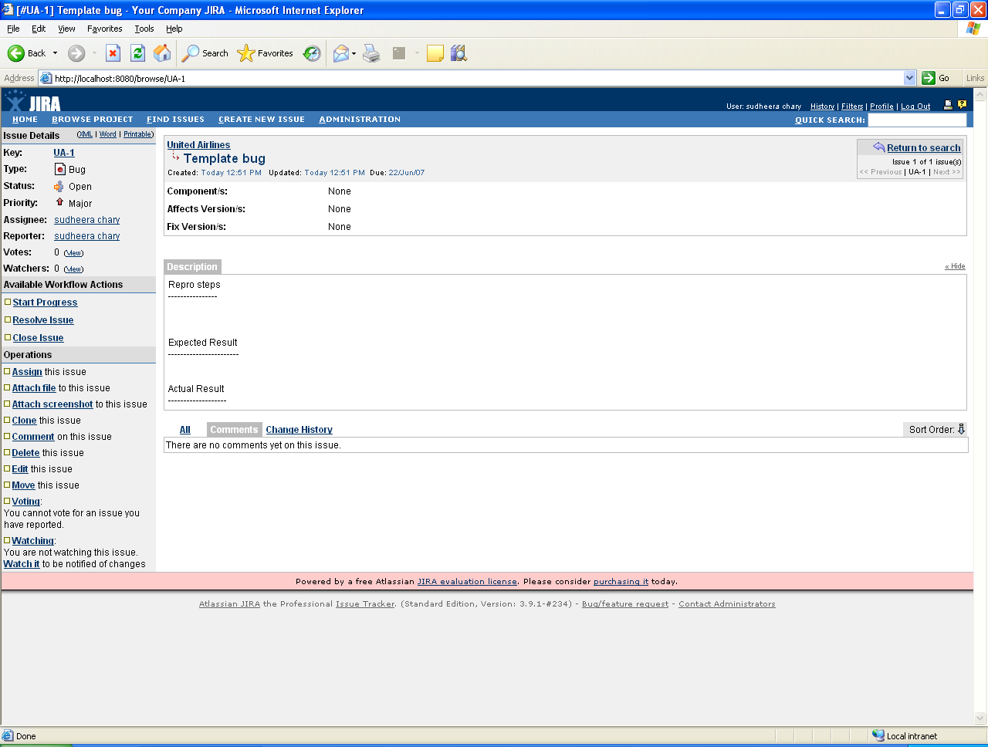

- Enter all the fields for closing the Defect
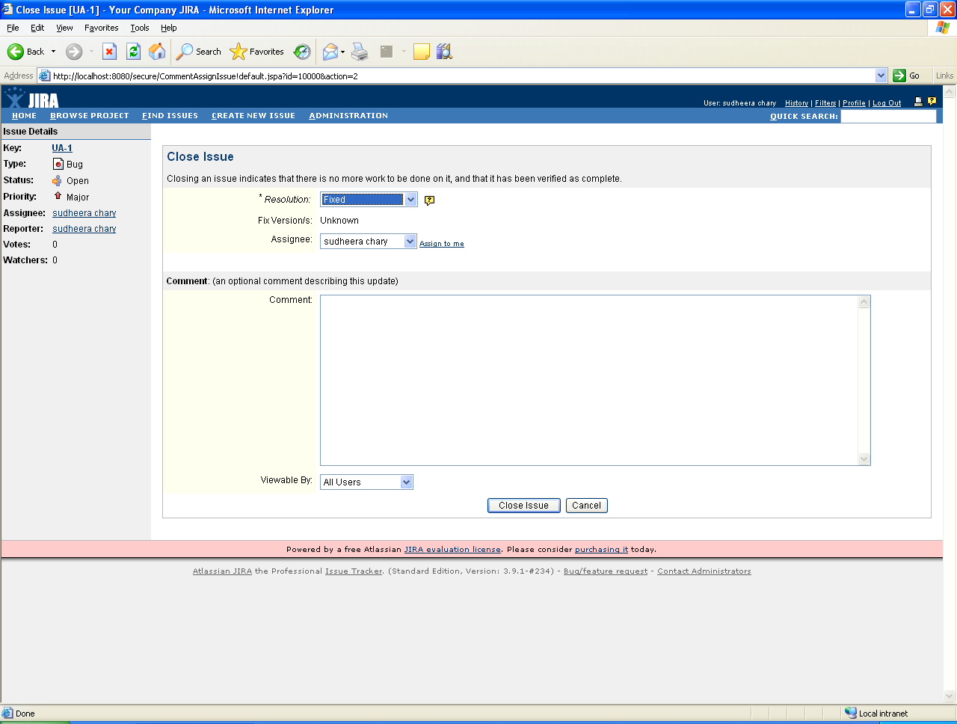

- Click on Close issue.

Reopening a closed issue

- Click on Reopen Issue

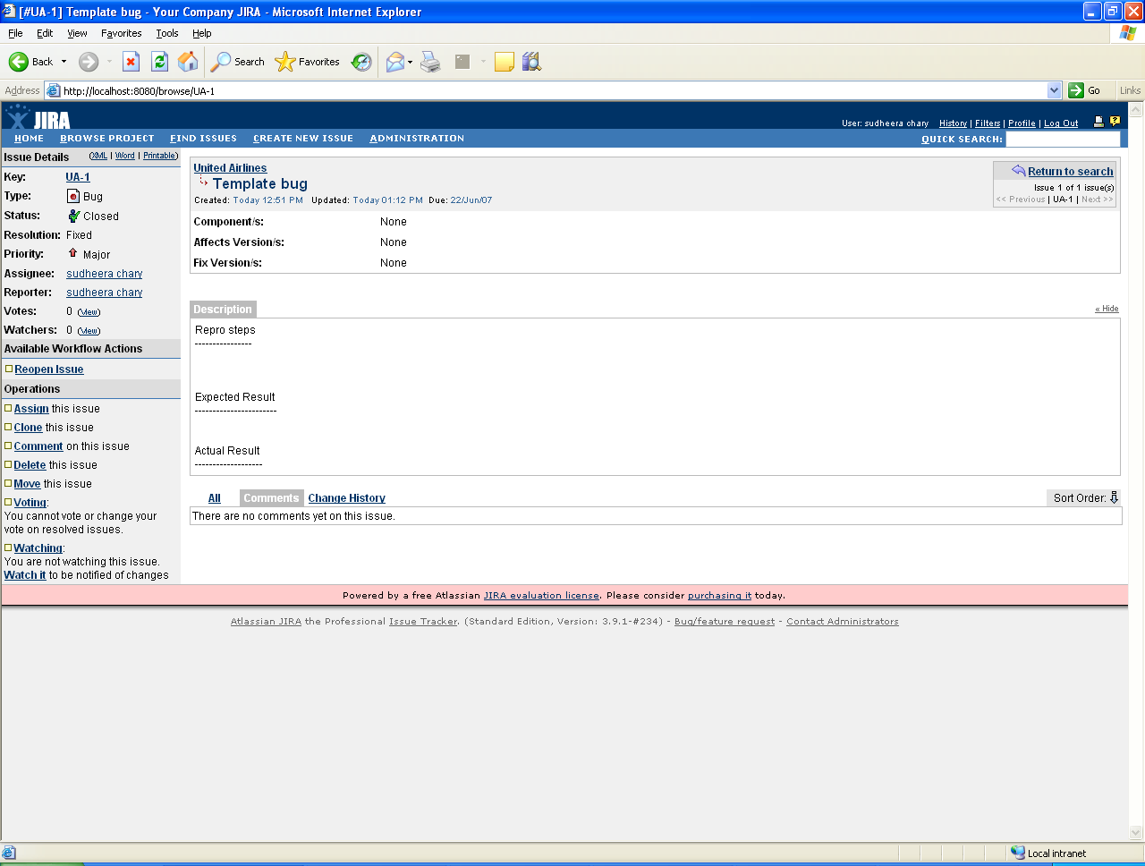

- Enter the comments and click on Reopen issue

