Working with Subversion Commands

Author(s): (1) Ch Jayaram Reddy

Written On: 5th Sep 2009

Declaration

I/We hereby declare that this document is based on our personal experiences and / or experiences of my/our project members. To the best of our knowledge, this document does not contain any material that infringes the copyrights of any other individual or organization including the customers of Infosys.

Target readers: Developers

Keywords:

Subversion, Unix, Version Control systems

Introduction:
Subversion is configuration management system used to manage working copy of files and to perform various configuration management operations like versioning of files, tracking changes and maintains log records on all changes made to the files. Subversion follows the famous “COPY-MODIFY-MERGE” model which is useful mechanism in multiple developer environments. In this, multiple developers can have their own working copy of project files, modify the files as per need and finally can merge the changes with centralized repository.
COPY
MERGE
MODIFY

COPY-MODIFY-MERGE MODEL
The important list of commands available with subversion are:
add | diff (di) | merge | resolved
blame (praise, annotate, ann) | export | mkdir | revert
cat | help (?, h) | move (mv, rename, ren) | status (stat, st)
checkout (co) | import | propdel (pdel, pd) | switch (sw)
cleanup | info | propedit (pedit, pe) | unlock
commit (ci) | list (ls) | propget (pget, pg) | update (up)
copy (cp) | lock | proplist (plist, pl) | resolved
delete (del, remove, rm) | log | propset (pset, ps) | revert

The subversion process life cycle is depicted in below diagram.

svn admin create repository- path
Repository created

svn add file1.c
File1.c scheduled for deletion(next commit)
svn svn delete file1.c
File1.c present in repository

svn checkout file1.c
File1.c checked out for editing

vi file1.c
File1.c modified- ready for check in

svn status file1.c svn status file1.c
File1.c modified locally
File1.c modified at repository needs an update

svn update file1.c
File1.c modified with local and repository changes
svn commit file1.c

edit file/
svn resolved file1.c
File1.c is ready for check in

svn commit file1.c

Example below helps to understand various svn commands useful during the version controlling process.
- To start with, create a new directory SVNRES.
- Use svnadmin command with create option to set this directory as central repository as shown in
Fig1.0.
- Now, list the contents of the SVNRES, you can find multiple svn administrative files and directories created in the repository
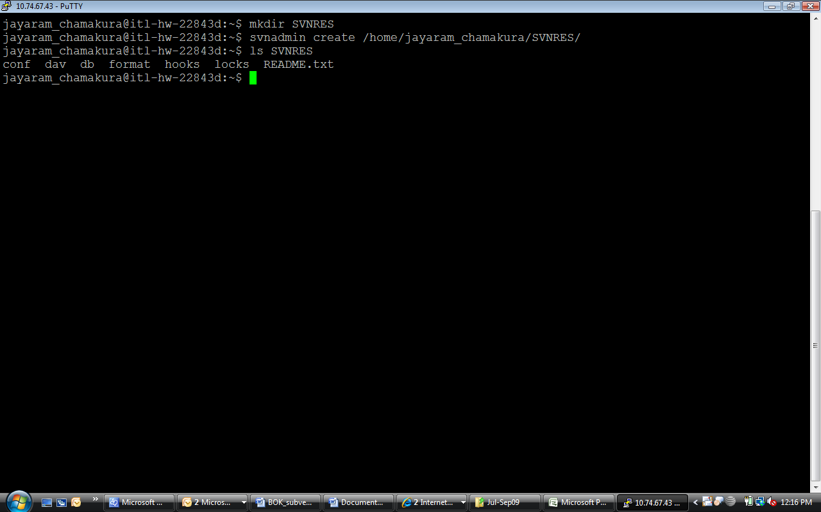
Fig 1.1
- As your repository is ready, use svn import command to add project/files to repository as shown in Fig1.1
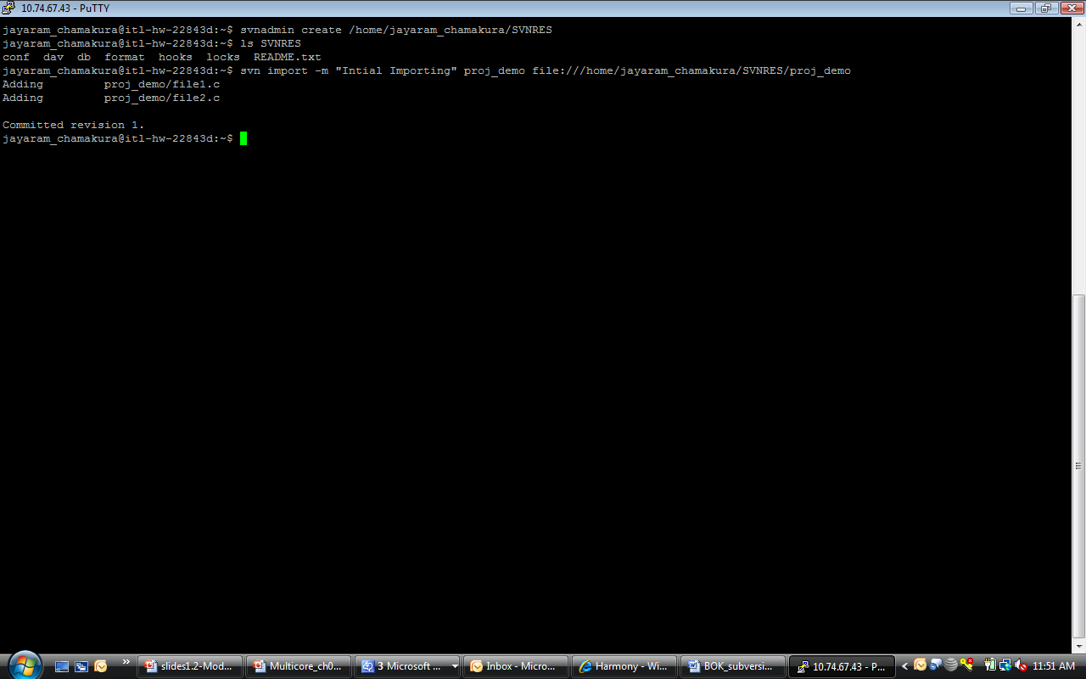Fig 1.2
- Notice that, first argument is source directory of project and second argument is destination/repository location.
- Use svn list command with svn path option to list the files in project at central repository.
- To have a local working copy, create a new directory “svncopy1”, Use svn checkout command as shown in Fig 1.3 to checkout files to svncopy1 directory. Notice “A” for each file added to local working copy.
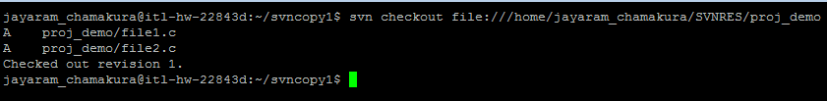
Fig 1.3

- Now operations like adding, deleting, copying, editing can be done to this working copy.
- To add a file,
  - Create a sample file add.txt using editor as shown in svncopy1 directory.
  - Use svn add command to schedule it for adding as shown.
  - Use svn commit command to add it this file to repository as shown.
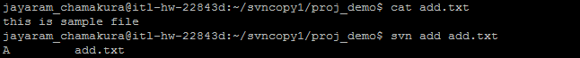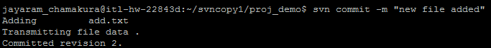Fig1.4
- To delete a file from repository,
  - Use svn delete command to delete add.txt from repository.
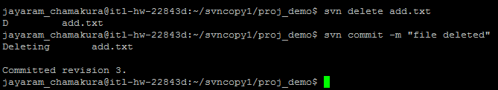
Fig1.5
- To learn commands for examining changes, Open file2.c and add a line of data.
- Run svn status command to see status of the files with respect to repository.
- Notice symbol “M” with file2.c, specifying file is modified locally.
- Now to know modifications done locally, run svn diff command as shown.
- Notice the output given, lines starting with ‘+’ are from working copy and lines starting with ‘-‘ are from repository copy.
- These changes can be undone, to undo changes to file2.c use svn revert command.
- Now run svn status command again to know status of file2.c. You can notice no output shown, as file2.c is already reverted
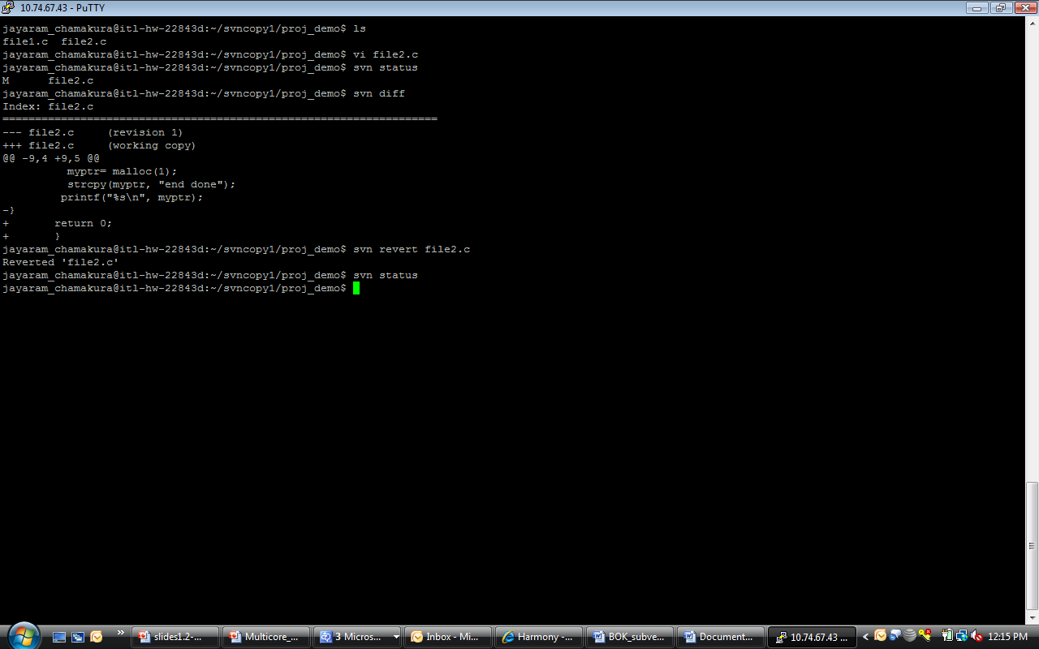Fig1.6
- To understand, svn’s conflict resolution commands, move out of the svncopy1 directory.
  - Create a new working copy by checking out the repository.
  - Open the files file1.c and file2.c and make changes as shown in Fig1.7.
  - Commit this change to repository using the svn commit command.

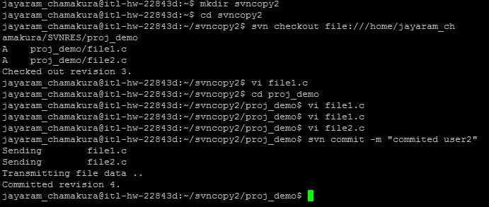
Fig1.7

- Now switch back to working copy in svncopy1 directory, change file1.c.
- Now there is latest copy at repository and different copy of file in svncopy1.
- Now run svn update to update your local working copy. Notice symbols with these 2 files. Symbol “C” means a conflict is there.
- To resolve it, open the file file1.c, edit the file and save it.
- Run svn resolved command to make file1.c ready for commit.
- Use svn commit command to commit these changes.
- Finally, use svn log command to list all log messages of successful commit operations.
This Bok helps as a starting point to understand the working of SUBVERSION on Unix. To understand/know much on each and every command discussed, you can use svn command-name –help in unix .

References:
http://subversion.tigris.org/
svn manuals in unix-like Operating system

