Navigating the Path to Academic Success

In this project as per your instructions we have designed application to display dataset values and then train various machine learning algorithms like SVM, Random Forest, XGBOOST, KNN, Logistic Regression and Gradient Boosting. Each algorithm performance is evaluated in terms of user accuracy, precision, recall and FSCORE.

All algorithm manages to give an accuracy of over 90 to 99% and among all algorithms XGBOOST stand winner with an accuracy of over 98%.

If student performance poor then system will display alert message to Focus and work hard.

To implement this project we have designed following modules

1. User Login: user can login to system using username and password as ‘admin and admin’.
2. Load & Process Dataset: user can load dataset and then display and process dataset values
3. Train ML algorithms: this module will train all algorithms and then display training result in table and graph format
4. Predict Performance: user will input his academic details and then ML algorithm will predict his performance
5. Graph Analysis: will plot PIE chart of all student performance

SCREEN SHOTS

To run project double click on run.bat file to start python server and get below page

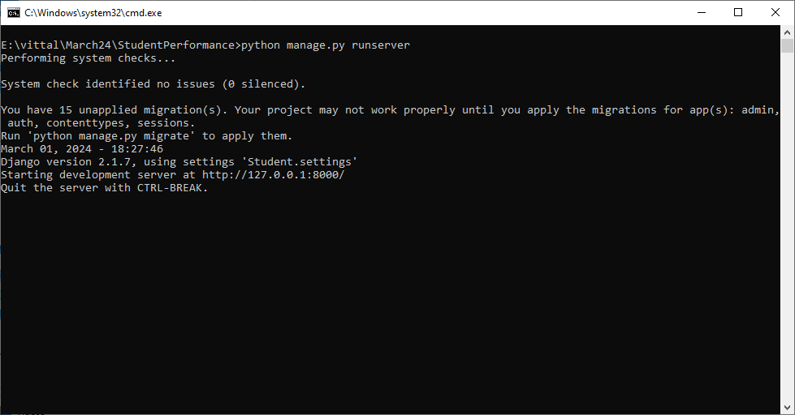

In above screen python server started and now open browser and enter URL as <http://127.0.0.1:8000/index.html> and press enter key to get below page



In above screen click on ‘User Login’ link to get below page

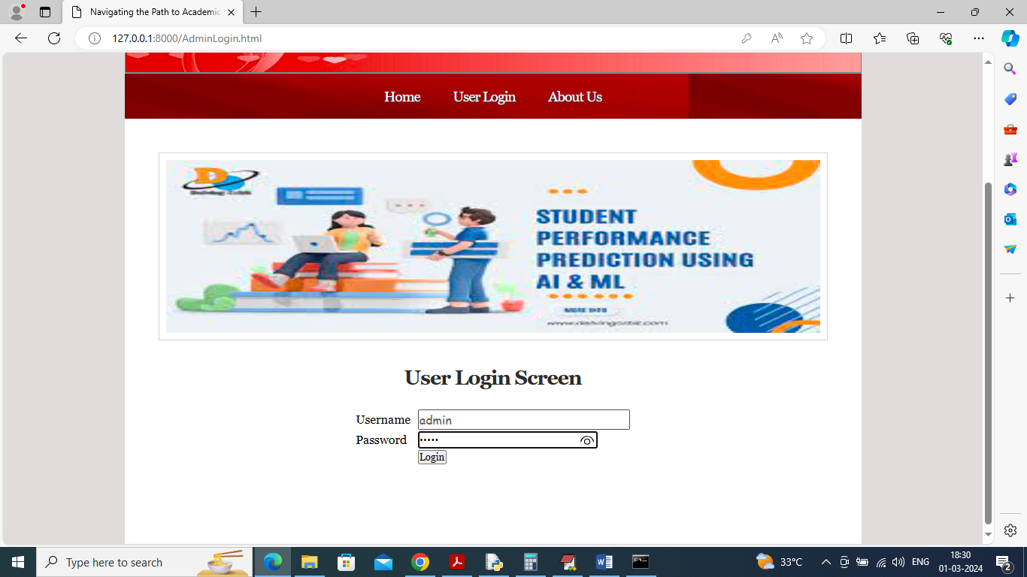

In above screen user is login and after login will get below page

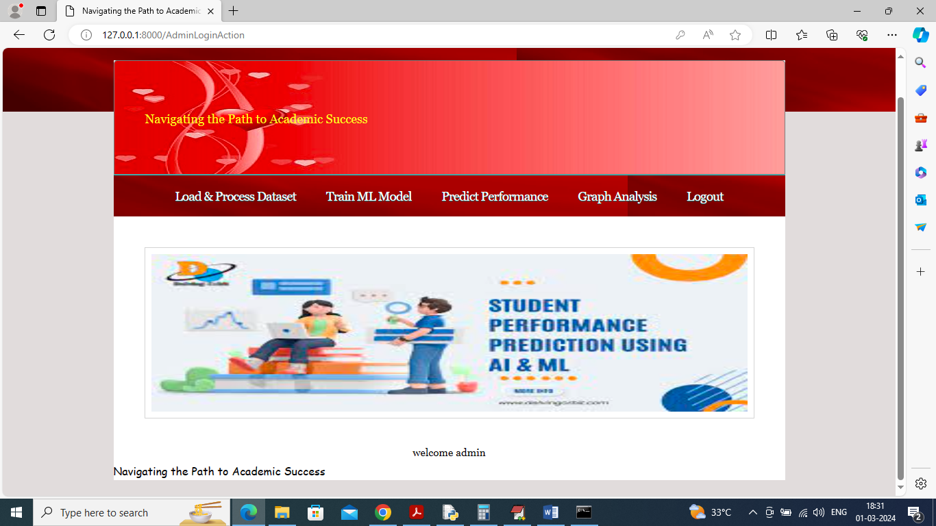

In above screen user can click on ‘Load & Process Dataset’ link to get below page

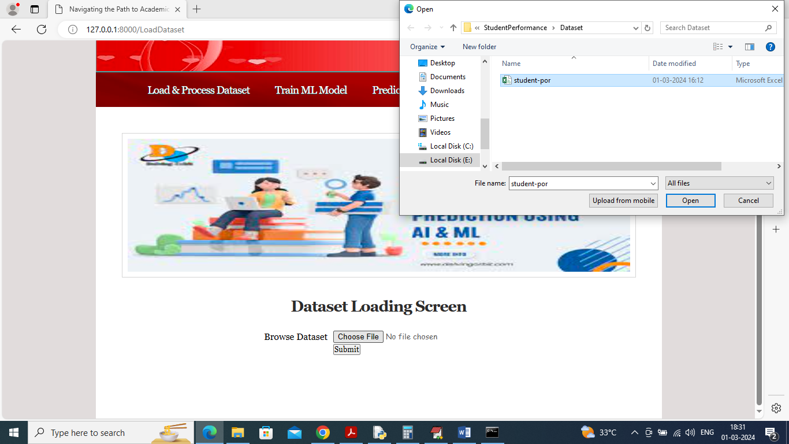

In above screen select and load dataset file and this dataset file available inside ‘Dataset’ folder and then click on ‘Open’ and ‘Submit’ button to get below page

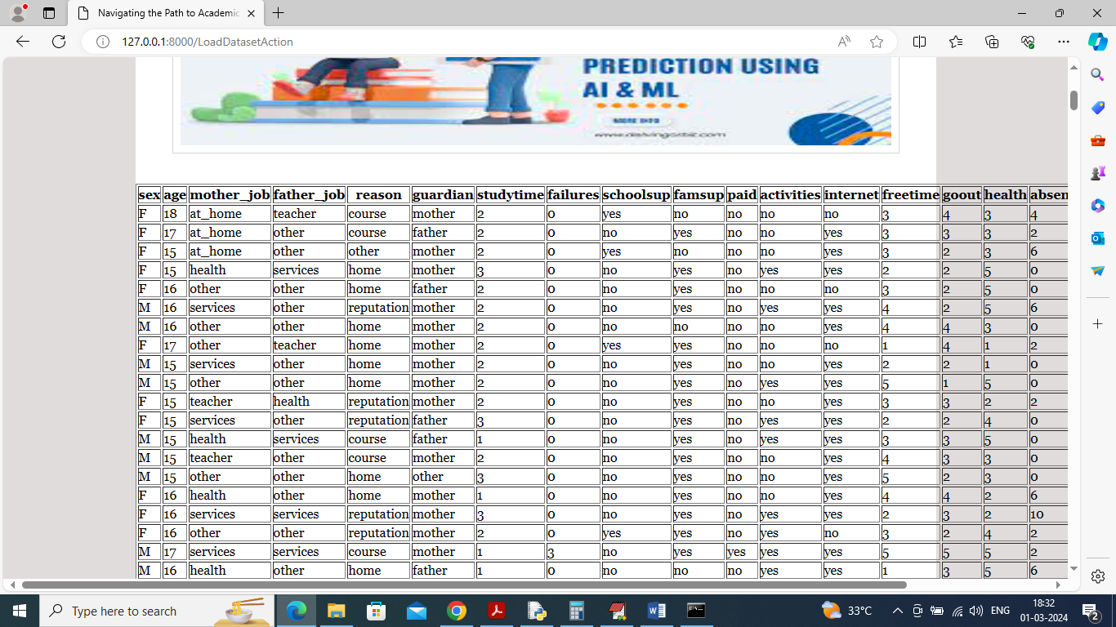

In above screen dataset loaded and can see all columns and its values and now click on ‘Train ML Algorithm’ link to train all algorithms and get below page

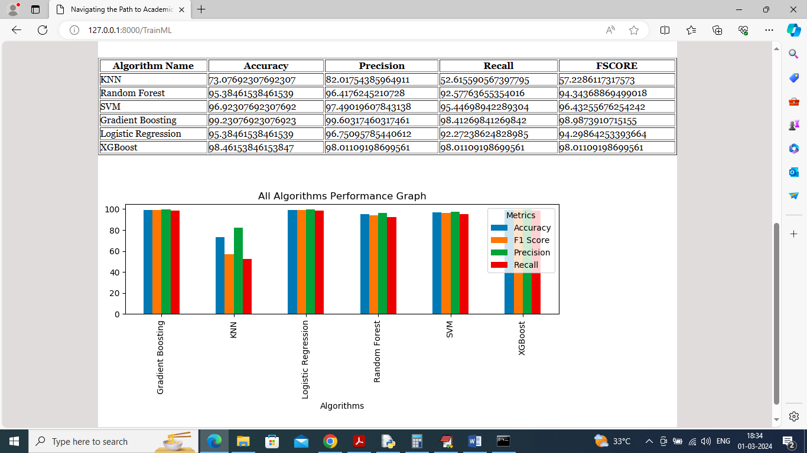

In above screen can see each algorithm performance in tabular format and in graph format. In graph x-axis represents algorithm names and y-axis represents accuracy and other metrics in different colour bars and in all algorithms Gradient boosting and XGBOOST got high accuracy and now click on ‘Predict Performance’ link to get below page

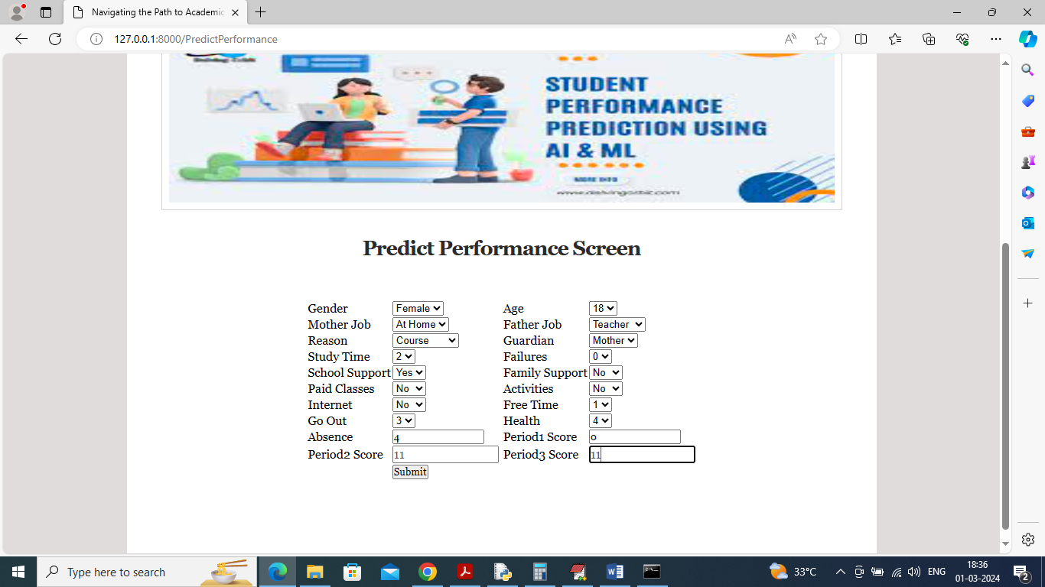

In above screen user will enter and select academic details and then click on ‘Submit’ button to get below output

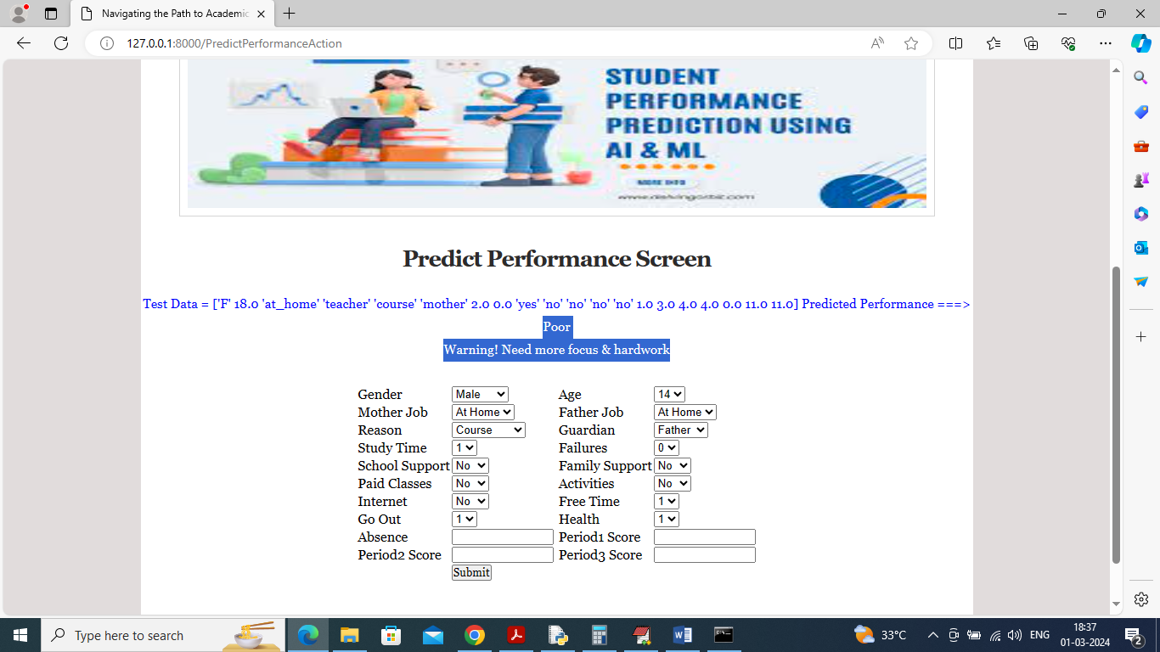

In above screen in blue colour can see user academic data and then can predicted performance as ‘Poor’ with alert message to improve. Similarly you can input any details and get performance predicted. Below is another output

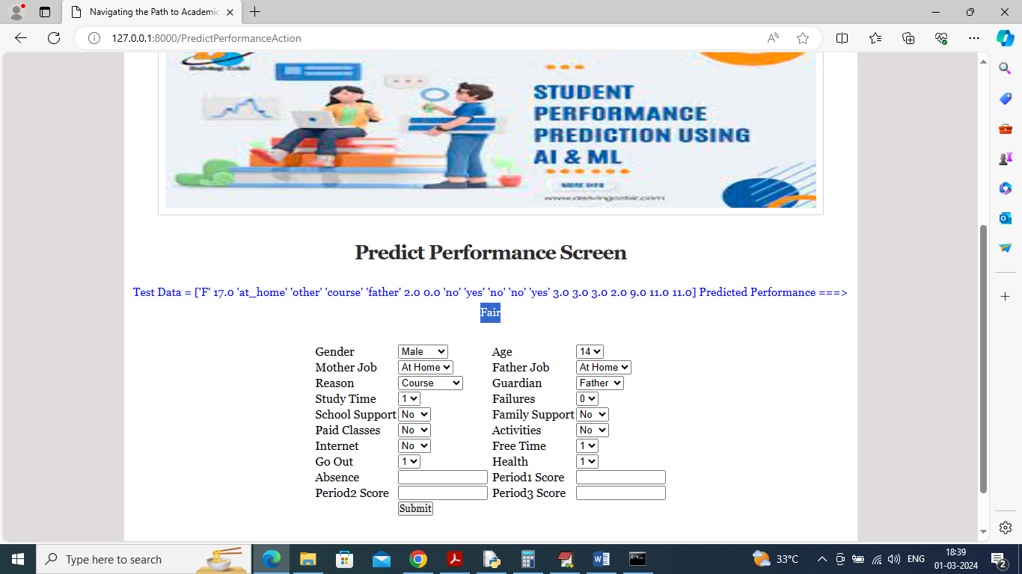

In above screen predicted performance is ‘Fair’.

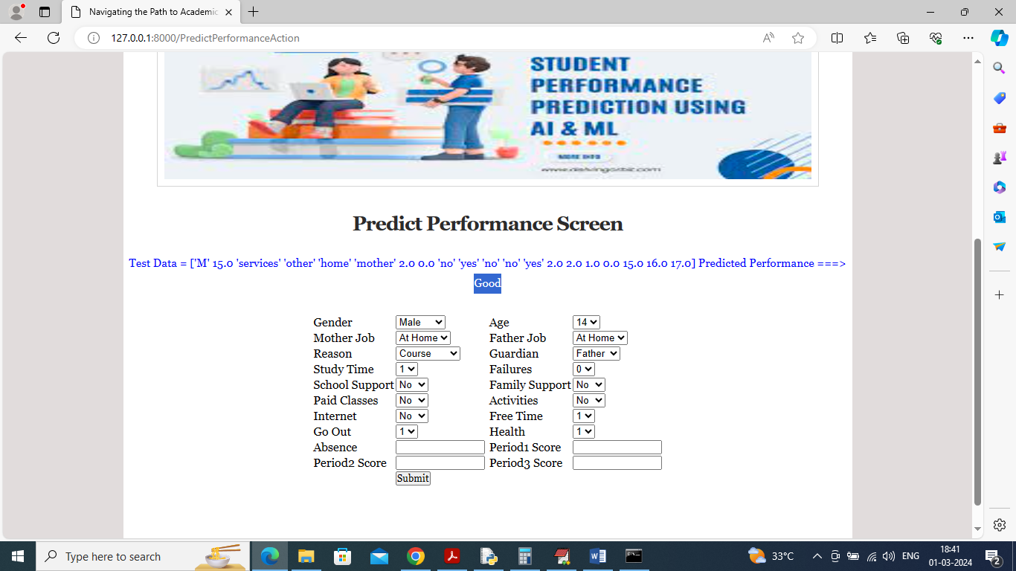

In above screen predicted performance is ‘Good’.

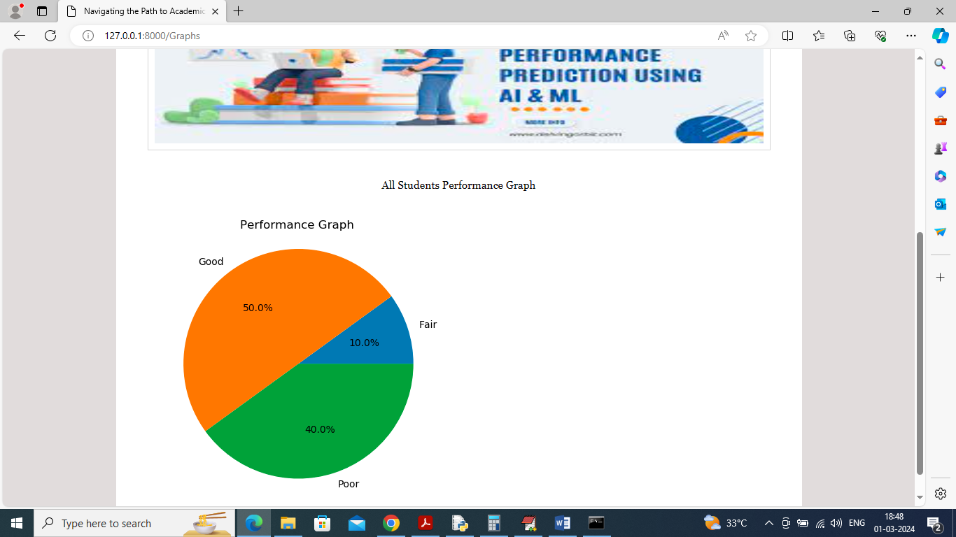

In above pie chart graph can see overall performance of all students