Mitchell Ramirez
CS-320
Professor Lopez
February 20 2026
Project 2: Reflection
Throughout creating the model, service classes, and the sequential testing modules via JUnit, I developed two different personalities for this class: that of a software developer, and the other is a determined malignant plotter to prove that the developer does not know what they are doing. I used the JUnit tests to try and bend the boundaries of the specifications. Such as, the specifications of the task that says that the full name cannot be null, is greater than 10 characters, and making it mandatory.
if (firstName == null || firstName.length() > 10) {
return false;
} return true;

I tested the valid version of the name, the null string, a very long string, and finally the empty string. The two samples are as follows:
Assertions.assertThrows(IllegalArgumentException.class, () -> {
testContact.setFirstName("ThisisWaytolongforaname");
Assertions.assertThrows(IllegalArgumentException.class, () -> {
new Contact(longID, "Ned", "Flanders", validPhone, "744 Evergreen Terrace");

I did not try to get 100% on any of the classes because that is not feasible possible. So to the best of my ability, I set up more than 3 constructor parameters, and I did not think it was worth the time to test every good and bad constructors for each of the parameters. Although, I did try to target 100% of both the getters and setters; and only a good constructor and a single invalid constructor.
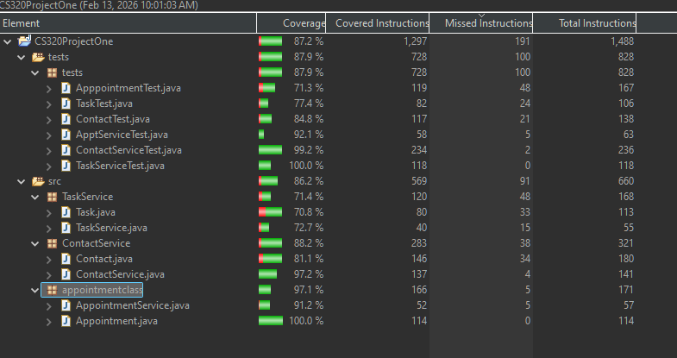
To make sure that the software is sound technically, I tried the “spirit of the code”. For example, in the ContactService, there was a method that deleted an ID that the user created. This can be tested in a few ways: adding three objects to the collection, deleting, and then confirming that the collection is now the size of two. Lastly, looking through the entire collection to confirm that it is gone.
An issue with only doing one of these tests is that it leaves room for abnormal behavior. If only the collection size is checked, then the wrong item could be deleted and thus the test passes. On the other hand, if the item is searched for as the only technique, the test could pass if all of the items were to be accidentally deleted. I tested as such:
@DisplayName("Test deleteContact")
@Test
void testDeleteContact() {

service.addContact("Homer", "Simpson", "1234567890", "Address 1"); // ID 0
service.addContact("Marge", "Simpson", "1234567890", "Address 2"); // ID 1
service.addContact("Bart", "Simpson", "1234567890", "Address 3"); // ID 2

assertEquals(3, service.contactList.size());

service.deleteContact("1");

assertEquals(2, service.contactList.size());

boolean found = false;
for(int i = 0; i < service.contactList.size(); i++) {
if(service.contactList.get(i).getContactID().equals("1")) {
found = true;
}
}
assertFalse(found);
}

As mentioned previously, it is not enough to just check the size of the collection after deleting it, checking that it is deleted fully is important as well. A further step could be to ensure that the remaining objects are still intact and as expected, which I did not test in my code.
For the three modules needed in this application, I included both unit and static testing: both are a form of whitebox testing. Static testing is studying the code and comparing it to the specifications in an attempt to find any bugs within the code. I used this to find and fix any offending code after one of JUnit tests failed.
When I wrote the class methods, I attempted to design the logic to match the specifications that were outlined in the document. During the unit testing creation, I reread the specifications and tried to find the ways to private that I made errors during the coding process. One of the JUnit tests failed, and I had to inspect the code to figure out why. For example, I used the wrong attribute that was within the logic branch – which of course caused the test to fail.
I also deduced that merely making sure that an exception is thrown when expected was not enough. By catching the correct and expected an exception is also important. In another case, I was asserting that a constructor would decline due to a bad input. An error was thrown, but the one that I had expected. So, in other subsequent code, I evaluated the exception type to make sure it was the exception that I was hoping for, and it would not create any false positives.
Creating the service classes did have very little to do with the testing of the system and it had no integration tests. Each of the specifications created a model and service class that the drives and then interacts with the model classes. Theoretically, we can test the model class through the service class and treat it as the system. I did a little of this in later developed code: missing testing should be treated as technical indebtedness.
Integration testing would be testing the entire application and bringing all the systems together. In such case, both the system and integration tests would stay the same. I could, on paper, validate each of the TaskService, ApplicationService, and the other classes that would work together at the integration level. I did no automated testing, which means I manually ran the JUnit tests. For bigger applications, automated testing should be practiced for continuous delivery, and this could be done at the building stage, pre-deployment, and even after deploying the software (by testing for bugs).
I did not run a security scan which means that the libraries and components needed to be scanned for vulnerabilities at the bigger company. We know that testing is important, especially when data is involved. Now, there are no databases or user input for the system, so protecting against attacks: SQL injections or MITM, would be moot. Unless it is being deployed at a company-wide software.
For the logic tests, I had an example for length, and if I passed the argument is null. But with the ideologically, the requirement suggests that there must be a description. So as it stands, the reason for the description must not be an empty string; the validation proceeds:
void testInvalidDesc() {
assertThrows(IllegalArgumentException.class, () -> {
new Appointment(validID, goodDate, null);
});
assertThrows(IllegalArgumentException.class, () -> {
new Appointment(validID, goodDate, "");
});
Avoiding technical debt is a skill that needs to be built throughout life as a developer, which is not something that anyone can learn in a short amount of time. Security issues come up every day and exploits can be attempted in very little time. Moreso, technical debt is not always a bug, it could be just a missed use case that was oversighted. Continuing to measure user satisfaction, such as forums or concerns; or fixing issues that were found in the static and dynamic scanning tools that are built into the pipeline.
Beyond the unmistakable benefits of JUnit tests, they can also serve as the indicator of code quality. Often, mature software will have higher code coverage which can lead to better sustainability. Low code coverage should be treated as a technical debt. Within this application, JUnit tests provided a second set of eyes, and having caught improper usage of copying and pasting. To get the most of the using JUnit tests, it is mandatory that the coder puts away their pride, and set out to prove what it may occur with no side effects.

