CS 255 System Design Document Template

This template lays out all the different sections that you need to complete for Project Two. Each section has guidance to prompt your thinking. You will need to continually reference the interview transcript as you work to make sure that you are addressing your client’s needs. There is no required length for the final document. Instead the goal is to complete each section based on what your client’s needs are. Remove this note when you are finished, and replace all bracketed text with the relevant information.

UML Diagrams

UML Use Case Diagram
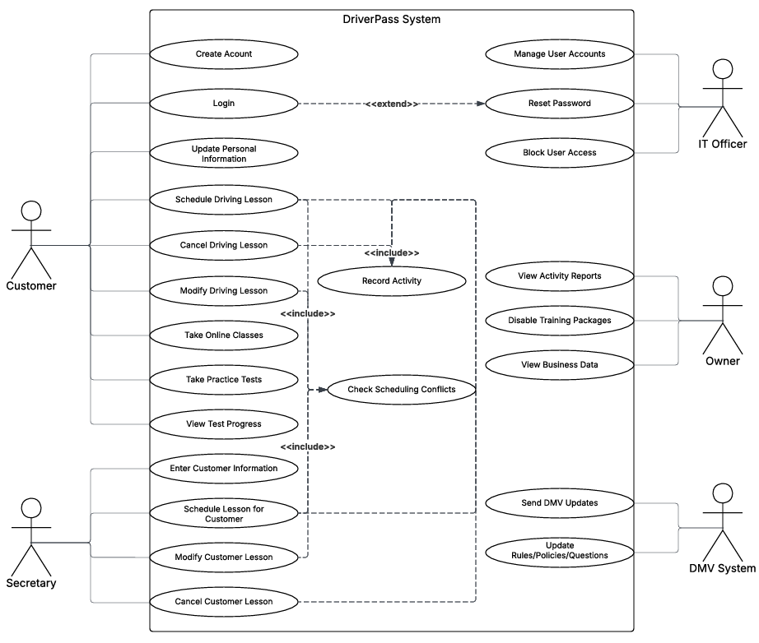

UML Activity Diagrams
Use Case #1: Scheduling Driving Lesson (Customer)
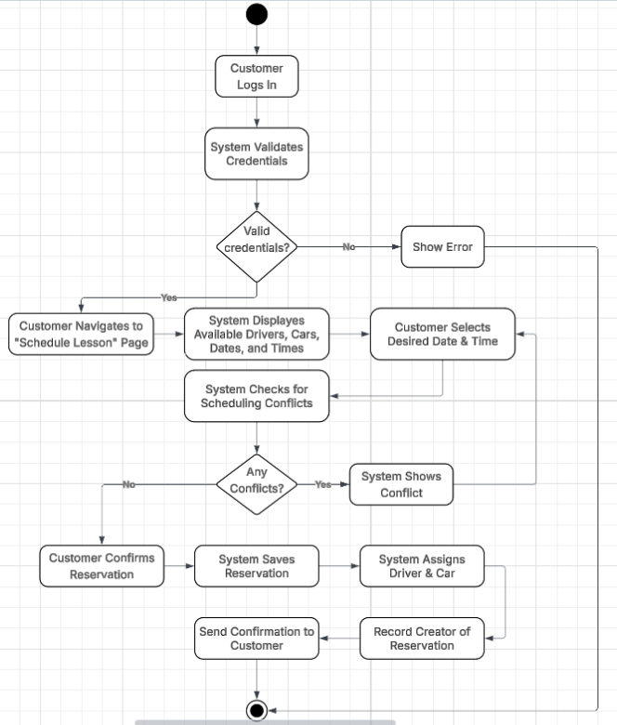

Use Case #2: Reset Password (extends Login)
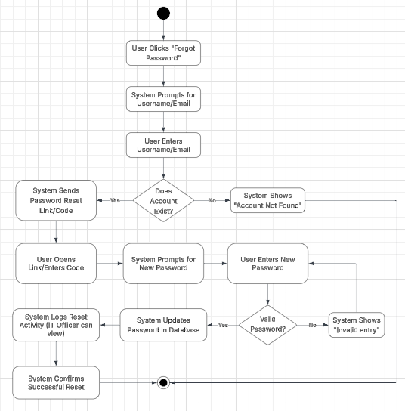

UML Sequence Diagram
UML Sequence Diagram for Use Case #1, Schedule Driving Lesson
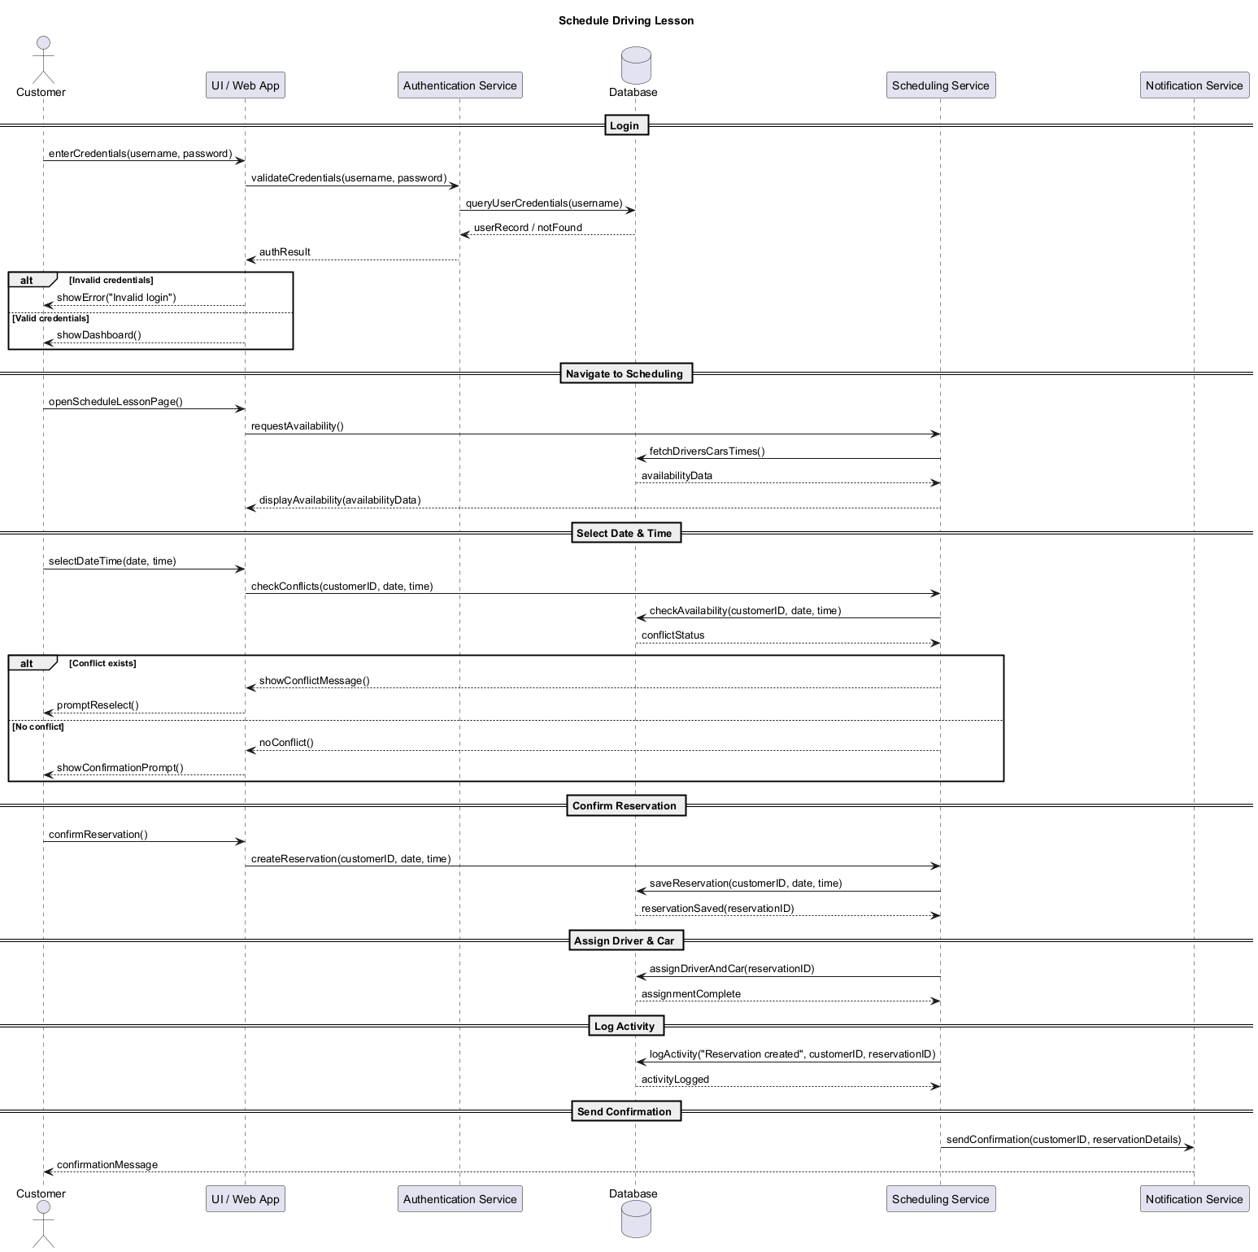

UML Class Diagram
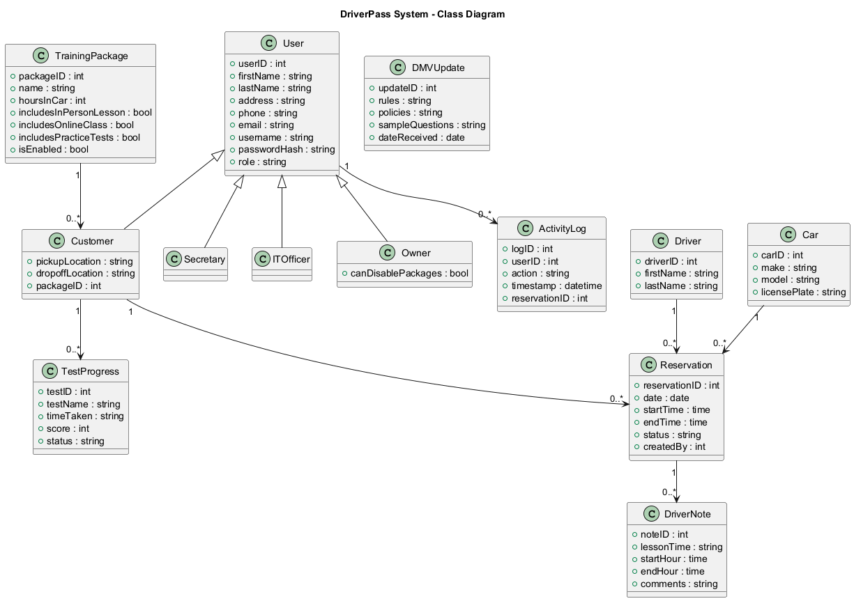

Technical Requirements

The DriverPass system requires a modern, scalable, secure technical environment capable of supporting web‑based access, scheduling operations, user management, DMV updates, and activity tracking. Based on the system’s UML diagrams and functional workflows, the following hardware, software, tools, and infrastructure components are required.

- Hardware Requirements
  - Server-Side Hardware (Cloud-Hosted)
    - Cloud-based virtual servers capable of running a multi-tier web application
    - Minimum 4 vCPUs and 8–16 GB RAM for the application server
    - Separate database instance with SSD storage for fast read/write operations
    - Redundant storage for backups and disaster recovery
  - Client-Side Hardware
    - Any modern computer, tablet, or smartphone
    - Minimum requirements:
      - • 2 GB RAM
      - Modern web browser
      - Stable internet connection
- Software Requirements
  - Server-Side Software
    - Web Application Framework:
      - Node.js, Java Spring Boot, .Net Core, or similar
    - Database Management System:
      - MySQL, PostgreSQL, or SQL Server
      - Supports relational tables for Users, Reservations, Drivers, Cars, Packages, TestProgress, ActivityLog, etc.
    - Authentication & Security Libraries:
      - • Password hashing (bcrypt, Argon2)
      - Role-based access control
    - API Layer:
      - RESTful endpoints for scheduling, account management, DMV updates, and reporting
  - Client-Side Software
    - Modern web browser (Chrome, Firefox, Safari, Edge)
    - Responsive UI framework (Bootstrap, React, Angular, Vue)
  - Development Tools
    - UML modeling tool (LucidChart, PlantUML)
    - Version Control (GitHub)
    - IDE (VS Code, IntelliJ, Visual Studio)
- Infrastructure Requirements
  - Cloud Hosting
    - A cloud provider such as AWS, Azure, or Google Cloud
    - Services required:
      - Virtual machines or container hosting
      - Managed SQL database
      - Load balancer for high availability
      - Secure storage for logs and DMV update file
  - Networking & Security
    - • HTTPS encryption for all data transmission
    - Firewall rules restricting access to internal services
    - Automatic account lockout after repeated failed login attempts
    - Secure password reset workflow (email verification or tokenized link)
  - Scalability
    - Ability to scale horizontally to support simultaneous customers, secretary operations, and DMV updates
    - Auto-scaling for peak scheduling periods
  - Logging & Monitoring
    - Centralized logging for:
      - Reservation creation
      - Modifications
      - Cancellations
      - Password resets
    - Monitoring tools for uptime, performance, and error tracking
- Integration Requirements
  - DMV Update Integration
    - Secure API endpoint or file-based import for receiving DMV rules, policies, and sample questions
    - Automated processing of updates
    - Notification system to alert staff when new updates arrive
  - Email/Notification Service
    - SMTP server or cloud email service (SendGrid, AWS SES, etc.)
    - Used for:
      - Password reset links
      - Reservation confirmations
      - System notification
- Data Requirements
  - Database Schema
    - Must support all entities shown in the class diagram:
      - User (with role inheritance)
      - Customer
      - Reservation
      - Driver
      - Car
      - DriverNote
      - TrainingPackage
      - TestProgress
      - DMVUpdate
      - ActivityLog
  - Data Integrity Rules
    - Prevent scheduling conflicts (driver, car, customer)
    - Enforce foreign key relationships
    - Ensure secure storage of password hashes
    - Maintain audit logs for all reservation-related actions
- Tools Required for System Operation
  - Web server: Nginx or Apache
  - Application runtime: Node.js, Java, or .NET
  - Database tools: phpMyAdmin, pgAdmin, or Azure Data Studio
  - Backup tools: Automated daily snapshots
  - Reporting tools: Export to CSV/Excel for offline analysis

These technical requirements ensure the DriverPass system can support all functional workflows shown in your UML diagrams — from login and scheduling to password resets, DMV updates, and activity logging — while remaining secure, scalable, and accessible from any device.

