README
CRUD Python Module and Dashboard for the Grazioso Salvare Project
Matthew Randall
Southern New Hampshire University | CS 340: Client/Server Development

About the Project
Global Rain, a custom software design and development company, has been contracted to build a full stack application for Grazioso Salvare, an international rescue-animal training company. Grazioso Salvare identifies dogs that are good candidates for search-and-rescue training, and has reached an agreement with a nonprofit agency operating five animal shelters in the region around Austin, Texas to receive that agency’s outcome data. The completed application will let users at Grazioso Salvare work with the shelter data to identify and categorize available dogs.
The first phase of that development is a portable, object-oriented CRUD Python module that gives programmatic access to the Austin Animal Center (AAC) outcomes data stored in MongoDB. The AnimalShelter class connects to the "aac" database and "animals" collection and implements all four CRUD operations - Create, Read, Update, and Delete. Grazioso Salvare requested that the code be open source and available on GitHub so that similar organizations can use and adapt it.
The second phase, delivered in Project Two, is the client-facing web dashboard built on top of that module. The dashboard reads the same data through the AnimalShelter class, filters it down to the dogs matching a given rescue profile, and presents the results as an interactive data table, a breed distribution chart, and a geolocation chart. No part of the interface queries MongoDB directly.

Motivation
The module exists to be the data-access layer between a client dashboard and MongoDB. Grazioso Salvare looks for specific profiles when selecting dogs to train: search-and-rescue training is generally more effective on dogs no more than two years old, and different breeds are proficient at different rescue specialties such as water rescue, mountain or wilderness rescue, disaster recovery, and tracking a specific person by scent. Each of those is a query against breed and age, so the application needs one dependable way to ask the database questions rather than ad hoc queries scattered through the interface.
Centralizing all database interaction in one importable module keeps the code easier to read, test, and maintain, and means the same module can power the Project Two dashboard without modification. Because the user interface never talks to MongoDB directly, either layer can change independently of the other.
That separation is what made the dashboard straightforward to build. Each rescue profile became a query document handed to the same read() method the test script already exercised, and the interface only had to render whatever came back. Identifying a candidate dog by hand means scanning roughly ten thousand shelter records for a narrow combination of breed, sex, and age; the dashboard turns that search into a single click.

Dashboard Functionality
The dashboard implements every widget listed in the Dashboard Specifications Document:
- Branding: the Grazioso Salvare logo, wrapped in an anchor tag linking to www.snhu.edu, and a unique identifier crediting the developer by name.
- Interactive filter options: a radio-button group offering Water Rescue, Mountain or Wilderness Rescue, Disaster or Individual Tracking, and Reset. Each option runs its own query against MongoDB through the CRUD module rather than filtering a cached copy of the data in Python.
- Interactive data table: paginated ten rows at a time, sortable and filterable on every column, with single-row selection. The table rebuilds itself from the query results each time the filter changes.
- Geolocation chart: a Leaflet map centered on Austin that drops a marker on the selected animal, with the breed on the tooltip and the animal name in the popup.
- Second chart: a pie chart of the breeds present in the current table view. The ten most common breeds are labelled individually and the remainder are grouped into a single "Other breeds" slice so the legend stays readable in the unfiltered state.
A line beneath the filter options reports the rescue type selected and the number of records the query returned, so the count is visible at a glance rather than inferred from the pagination control.
The filter criteria come from the Rescue Type and Preferred Dog Breeds table in the specifications document:
Rescue Type | Preferred Breeds | Preferred Sex | Training Age
Water | Labrador Retriever Mix, Chesapeake Bay Retriever, Newfoundland | Intact Female | 26 to 156 weeks
Mountain or Wilderness | German Shepherd, Alaskan Malamute, Old English Sheepdog, Siberian Husky, Rottweiler | Intact Male | 26 to 156 weeks
Disaster or Individual Tracking | Doberman Pinscher, German Shepherd, Golden Retriever, Bloodhound, Rottweiler | Intact Male | 20 to 300 weeks

Each rescue type is stored as a MongoDB query document filtering on animal_type, breed, sex_upon_outcome, and age_upon_outcome_in_weeks. Breed is matched with an anchored, case-insensitive regular expression rather than an exact string, because the shelter records most dogs as mixes and crosses. An anchored pattern such as ^(German Shepherd|Rottweiler) matches "German Shepherd Mix" and "German Shepherd/Labrador Retriever" while still excluding unrelated breeds such as "Australian Shepherd Mix". The data set also spells one breed "Doberman Pinsch" rather than "Doberman Pinscher", so the disaster query uses the shorter form to catch those records.

Getting Started
Using the module requires the AAC data loaded into MongoDB and an authenticated user account, both established in the Module Three milestone.
Database and user authentication. The aac_shelter_outcomes.csv data set was imported with the mongoimport tool, creating the "aac" database and "animals" collection with 10,000 documents. The "aacuser" account was then created in the admin authentication database with the readWrite role on "aac". Both the module and the dashboard authenticate with this account.

Reproducing the Setup
The following steps reproduce the environment from a fresh Codio workspace:
- Open a terminal in the Codio workspace and confirm the data set is present in the datasets folder:
ls datasets/
- Import the data set with mongoimport, specifying CSV type, a header row, and the target database and collection:
mongoimport --type=csv --headerline --db=aac \
--collection=animals ./datasets/aac_shelter_outcomes.csv
- Confirm the output reports: 10000 document(s) imported successfully. 0 document(s) failed to import.
- Open the mongo shell and switch to the admin authentication database:
mongosh
use admin
- Create the application account, granting it read and write access to the aac database only. Using passwordPrompt() rather than a literal keeps the password out of the shell history:
db.createUser(
{ user: "aacuser",
pwd: passwordPrompt(),
roles: [{ role: "readWrite", db: "aac" }]
})
- Exit the shell, then log back in as the new account to verify it:
exit
mongosh --username "aacuser" --authenticationDatabase admin
- Confirm the account is authenticated and holds the expected role. The output reports authenticatedUsers as aacuser on admin, and authenticatedUserRoles as readWrite on aac:
db.runCommand({connectionStatus: 1})
- Place CRUD_Python_Module.py in the same directory as the script or notebook that will use it.
- Import the class and instantiate it with the aacuser credentials, as shown under Usage below.
- Install the packages the dashboard imports:
pip install dash jupyter-dash dash-leaflet plotly pandas
- Place ProjectTwoDashboard.ipynb and the Grazioso Salvare logo PNG in that same directory, alongside CRUD_Python_Module.py.
- Open ProjectTwoDashboard.ipynb in JupyterLab and set the username and password variables in the model section to the aacuser credentials created in step 5.
- Select Kernel, then Restart Kernel and Run All Cells.
- Open the proxied URL printed by app.run_server(). If port 8050 is already in use, pass an alternate port, for example app.run_server(port=8051).
- Select each rescue type in turn to confirm the data table, the pie chart, and the geolocation chart all update together.

Development Notes
Authentication. The main challenge was authentication. The aacuser account is defined in the admin database but holds its permissions on aac, so my connections failed until I added authSource=admin to the connection URI. Authentication runs against the database that owns the user, not the database being queried. Running db.getUsers() in the shell is what showed me where the account actually lived.
Lazy connections. MongoClient does not contact the server until the first operation, so instantiating the class cleanly did not prove my credentials were valid. I have the test notebook run a trivial query right after instantiating, which forces the connection and confirms authentication before the CRUD tests start.
Cursors. find() returns a lazily evaluated cursor rather than documents, so I wrap it in list() to walk the cursor once and hand the caller a normal Python list.
Update semantics. I return modified_count rather than matched_count. A document that already holds the value being written gets matched but not changed, so modified_count is the accurate count of what actually changed.
Credential handling. The module takes the username and password as arguments, so no credentials live in CRUD_Python_Module.py and any account can use it without editing the source. The aacuser credentials do appear in the test notebook and in the dashboard notebook, since the specification requires demonstrating authenticated access and the screenshots have to show the class being instantiated. In a deployed system I would read those from environment variables instead, and the account is scoped to readWrite on aac only, so it grants nothing beyond this project’s data.
Breed matching excluded mixes. Matching the breed field against the exact strings in the specifications table returned almost nothing, because the shelter records the majority of dogs as mixes and crosses. An anchored regular expression solved it: the pattern matches any breed value beginning with one of the preferred breed names, which captures "German Shepherd Mix" and "German Shepherd/Labrador Retriever" without pulling in unrelated breeds that merely contain a matching word. Reviewing the distinct breed values also revealed that Doberman Pinscher is stored as "Doberman Pinsch", which I corrected in the disaster query.
Stale row selection after filtering. Switching from the unfiltered view to a filter returning fewer rows caused the map callback to fail, because the previously selected row index no longer existed in the smaller result set. The filter callback now resets selected_rows and page_current alongside the table data, and the map callback falls back to the first row when the index is out of range. Clearing filter_query and sort_by in the same callback is what makes Reset return every widget to its original state, including any sort or in-table filter the user applied by hand.
Position-based column access. The starter code addressed the latitude, longitude, breed, and name fields by numeric column position. That works only as long as MongoDB returns the fields in the expected order, and it broke as soon as I normalized the column order for the data table. Looking values up by column name instead removed the dependency entirely.
Unreadable pie chart. Charting every breed in the full data set produced a legend of several hundred entries. Limiting the chart to the ten most frequent breeds and grouping the remainder into an "Other breeds" slice keeps it informative at every filter level.
ObjectID in the data table. The Dash data table cannot serialize the BSON ObjectID that MongoDB returns in the _id field, and the table failed to render until that column was dropped from the DataFrame. The drop is applied to every query result, not just the initial load.
Map width collapse. The map rendered as an empty region until I gave its container an explicit width. Sizing the map to 100% inside a flex child that had no width of its own resolved to zero, so both chart containers are now set to half the row.

Installation
The following tools are required, each chosen for a specific reason:
MongoDB (Community Server) - the NoSQL document database storing the AAC data. Each animal outcome is a JSON-like document that maps directly onto MongoDB’s data model, with no schema translation needed.
PyMongo - the official MongoDB driver for Python, maintained by MongoDB itself. It was chosen over third-party drivers because it is the reference implementation, is documented alongside the database, and exposes the MongoClient, insert_one(), find(), update_many(), and delete_many() APIs this module is built on. Its result objects also report the acknowledgement flag and the modified and deleted counts that the CRUD methods return.
Python 3 - the implementation language, chosen for readability and its strong data-handling ecosystem.
JupyterLab / Jupyter Notebook - runs the test script and the dashboard notebook interactively so each operation’s output is visible for demonstration.
Dash - the web application framework providing both the view and the controller layers of the dashboard. It was chosen because the entire interface can be declared in Python, so the project needs no separate JavaScript front end.
JupyterDash - serves a Dash application from inside a Jupyter notebook, which is what allows the dashboard to run in the Codio workspace rather than requiring a standalone web server.
Dash Leaflet - renders the geolocation chart. It wraps the Leaflet mapping library as Dash components, so the map, its tile layer, and its markers are declared in the same Python layout tree as every other widget.
Plotly Express - generates the breed pie chart in a single call from a dataframe, and returns a figure that dcc.Graph renders directly.
pandas - structures the list of documents returned by read() into a dataframe, which is the form both the Dash data table and Plotly Express expect.
Codio workspace - the course cloud environment, where MongoDB and the tools above are preinstalled.
pip install pymongo
pip install dash jupyter-dash dash-leaflet plotly pandas

The MVC Split
The application follows the Model-View-Controller pattern, and each layer maps onto one of the tools above.
Model - MongoDB holds the data, accessed only through the AnimalShelter class. Three qualities made it the right choice here. Its document structure matches the source data, so the CSV loads with a single mongoimport command and needs no schema definition, table normalization, or join logic. Its Python interface is close to frictionless: PyMongo expresses both documents and queries as ordinary Python dictionaries, so a query is composed with normal data structures rather than assembled SQL strings, and results return as dictionaries that pandas consumes directly. And because the collection is schemaless, each rescue filter combines an exact match, a regular expression, and a numeric range in one find() call, so adding a new rescue profile later means adding a query document rather than altering a table.
View - the Dash layout is a tree of Python objects. html components provide the structure, dash_table.DataTable renders the interactive table, dcc.Graph renders the pie chart, and dash_leaflet renders the map. Dash serves that tree to the browser as a React application.
Controller - the @app.callback decorator wires component properties together. An Input declares what a callback listens to and an Output declares what it updates, so selecting a radio item triggers the database query and the redraw of every dependent widget without any event-handling code or manual refresh. The callbacks are the only place the interface and the data layer meet, and they meet through the CRUD module.

Usage
The module is imported, instantiated with valid credentials, and then its four methods are called. The class is instantiated once and reused, so the connection is opened a single time rather than per operation.

Attributes
client - the authenticated MongoClient connection to the MongoDB server, built from the username and password passed to the constructor.
database - a cached handle to the "aac" database.
collection - a cached handle to the "animals" collection. Every CRUD method operates on this handle, so neither the database nor the collection name is repeated inside the methods.

CRUD Operations
create(data) - inserts a single document into the collection using insert_one(). Accepts a dictionary of key/value pairs. Returns True when MongoDB acknowledges the write and False if a database error occurs. Raises ValueError if data is None, because that is a caller error rather than a database failure and should be visible rather than hidden behind a return value.
read(query) - queries the collection using find() rather than find_one(), so that all matching documents are returned rather than only the first. Accepts a dictionary lookup pair; an empty dictionary matches every document. The returned cursor is iterated into a list, so the caller receives a concrete result. Returns an empty list if a database error occurs, and raises ValueError if query is None.
update(query, update_data) - changes existing documents using update_many(), so that every document matching the lookup is updated rather than only the first. The first argument is the lookup pair; the second is the change to apply. Either form is accepted: the change can be written with a MongoDB update operator, such as {"$set": {"outcome_type": "Transfer"}}, or as plain key/value pairs such as {"outcome_type": "Transfer"}, which the method wraps in $set. Accepting the operator form means $inc, $unset, and the rest of the operator set work as well. Returns the number of documents modified, or 0 if a database error occurs. Raises ValueError if either argument is None.
delete(query) - removes documents using delete_many(), so that every document matching the lookup is removed. Accepts a dictionary lookup pair and returns the number of documents removed, or 0 if a database error occurs. Raises ValueError if query is None. That guard matters more here than anywhere else in the class, because treating a missing filter as "match everything" would empty the collection and a delete cannot be undone.
close() - closes the underlying MongoDB connection. Included because a class that opens a resource should also provide a way to release it.

Code Example
from CRUD_Python_Module import AnimalShelter

# Instantiate with the aacuser credentials
shelter = AnimalShelter("aacuser", "<password>")

# CREATE - returns True on an acknowledged insert
shelter.create({"name": "TestPup", "animal_type": "Dog",
"breed": "Labrador Retriever Mix"})

# READ - returns a list of matching documents
dogs = shelter.read({"animal_type": "Dog"})
print(len(dogs), "documents found")

# UPDATE - returns the number of documents modified
modified = shelter.update({"name": "TestPup"},
{"$set": {"outcome_type": "Transfer"}})

# DELETE - returns the number of documents removed
removed = shelter.delete({"name": "TestPup"})

Dashboard Queries
The dashboard calls only read(), passing a different query document for each rescue type. The water rescue filter is representative of all three:
{
"animal_type": "Dog",
"breed": {"$regex": "^(Labrador Retriever|Chesapeake Bay Retriever|Newfoundland)",
"$options": "i"},
"sex_upon_outcome": "Intact Female",
"age_upon_outcome_in_weeks": {"$gte": 26.0, "$lte": 156.0}
}
MongoDB performs the filtering. The dashboard never narrows the result set in Python; it hands the query document to read() and renders whatever comes back, so the table, the pie chart, and the map are always drawn from the same server-side result.

Tests
The ProjectOneTestScript.ipynb notebook imports the module and exercises all four CRUD operations in sequence. Open it in JupyterLab, restart the kernel, and run all cells in order.
Every document the script inserts carries a test_record marker field, and the update and delete cells filter on that marker. Since update() and delete() act on every match, that marker is what guarantees the tests cannot touch the imported Austin Animal Center data. The delete cell removes the test documents, so the collection is left exactly as it was.
I insert two documents rather than one so the counts coming back from update() and delete() show both methods acting on all matches instead of only the first. A further cell passes None to each method to confirm the guard clauses raise ValueError, and the last cell calls close() to release the connection.
The dashboard was tested by selecting each rescue type in turn and confirming that all three widgets responded. Water Rescue returns 23 records, Mountain or Wilderness Rescue returns 18, Disaster or Individual Tracking returns 30, and Reset returns the full 10,000. Those counts match what the same criteria produce when checked directly against the data set, which confirms the queries are correct rather than merely plausible.

Steps Taken to Complete the Project
- Built and tested the AnimalShelter CRUD module against the imported aac database, then reused it unchanged as the dashboard’s only data-access layer.
- Built the unfiltered data table first, populating it with a retrieve-all read of the collection and dropping the ObjectID _id field before handing the records to pandas.
- Translated the Rescue Type and Preferred Dog Breeds table into three MongoDB query documents, each filtering on animal type, breed, sex, and age in weeks.
- Added the radio-button filter control and the callback that re-queries the database and rebuilds the table data and columns whenever the selection changes.
- Added the pie chart and the geolocation chart, both driven by the table’s derived_virtual_data property so they follow the filter and the current table view automatically.
- Added the branding: the logo linked to www.snhu.edu and the developer credit in the header.
- Tested each filter option in turn, verified the record counts against the data set, captured the screenshots below, and documented the project in this README.

Screenshots

Importing the Data Set
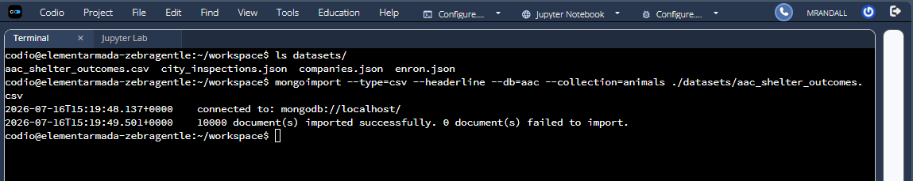Figure 1. The mongoimport command executed in the Codio terminal, importing aac_shelter_outcomes.csv into the "aac" database and "animals" collection. All 10,000 documents imported successfully with 0 failures.

User Authentication
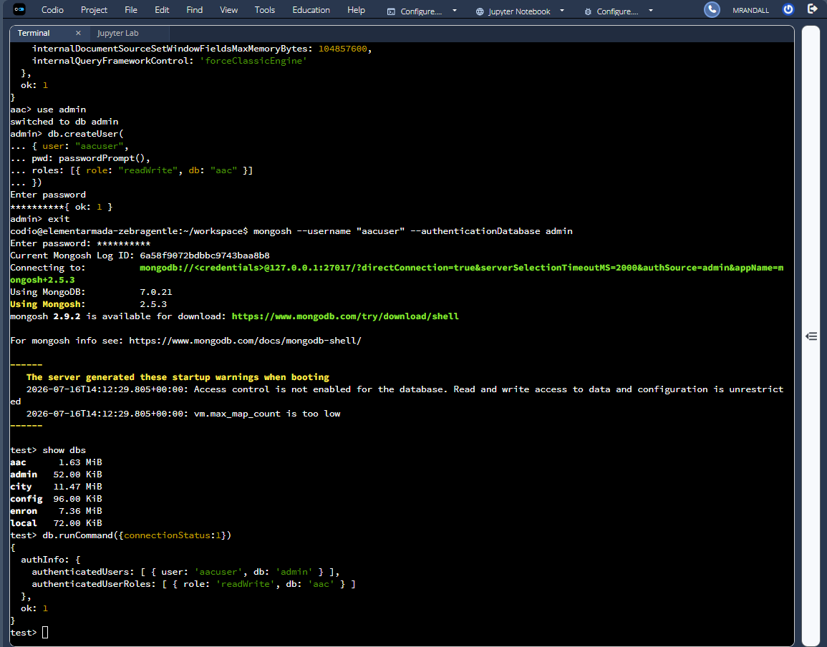Figure 2. Creation of the "aacuser" account in the admin authentication database with the readWrite role on "aac", followed by login as aacuser, listing the databases, and the db.runCommand({connectionStatus:1}) output showing the authenticated user and role.

CRUD Functionality Test Execution
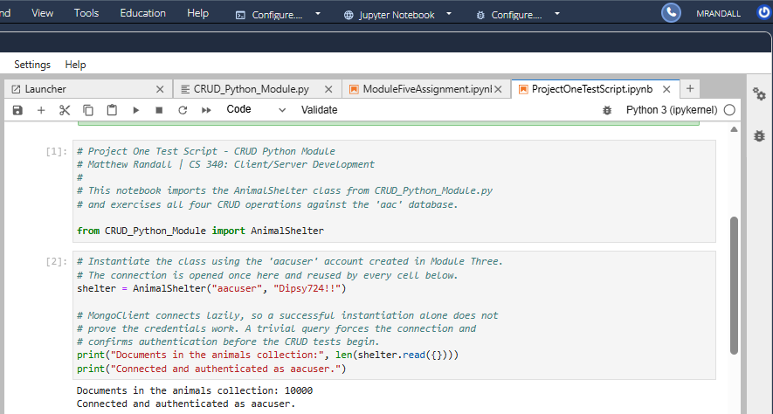Figure 3. The test notebook imports the AnimalShelter class from CRUD_Python_Module.py and instantiates it with the aacuser credentials. The immediate query returns 10,000 documents, confirming both the connection and successful authentication.
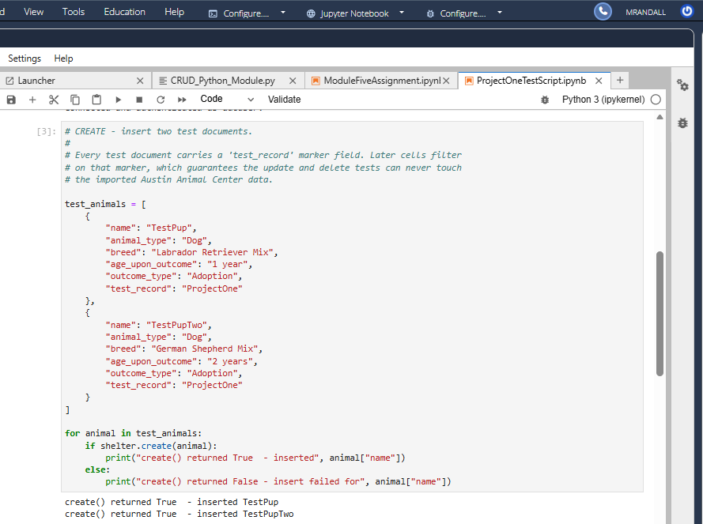Figure 4. The create() method inserting two test documents. Each returns True, confirming MongoDB acknowledged the writes. Both documents carry the test_record marker used by the update and delete tests.
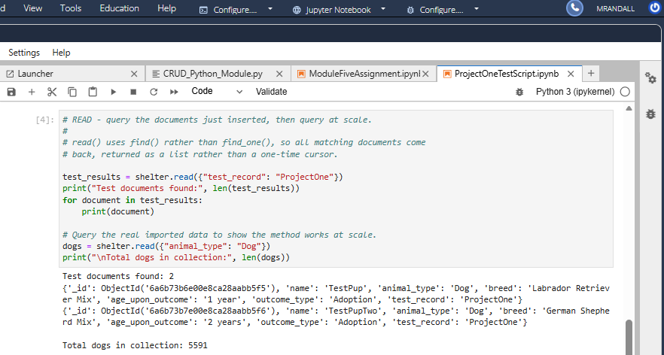Figure 5. The read() method returning both test documents as a list, then querying the imported data at scale and returning 5,591 documents with animal_type "Dog".
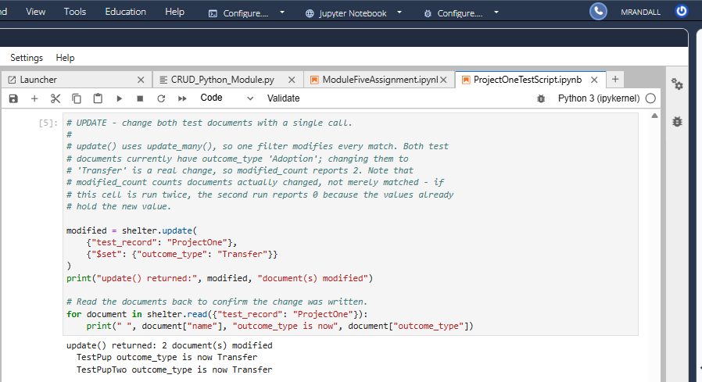Figure 6. The update() method changing outcome_type on both test documents with a single call. The method returns 2, the number of documents modified, and reading the documents back confirms the new value was written.
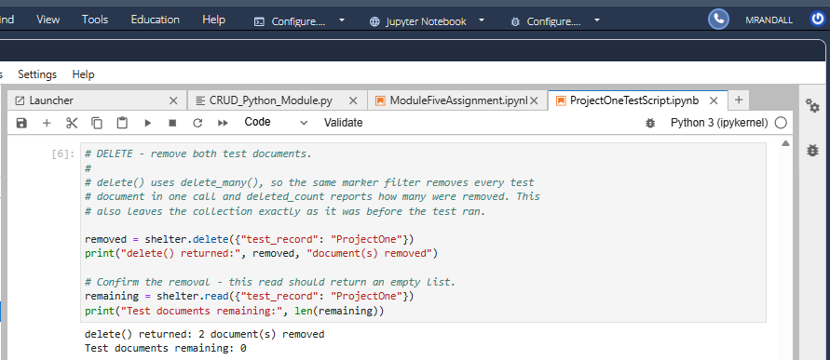Figure 7. The delete() method removing both test documents with a single call. The method returns 2, the number of documents removed, and a follow-up read confirms none remain.
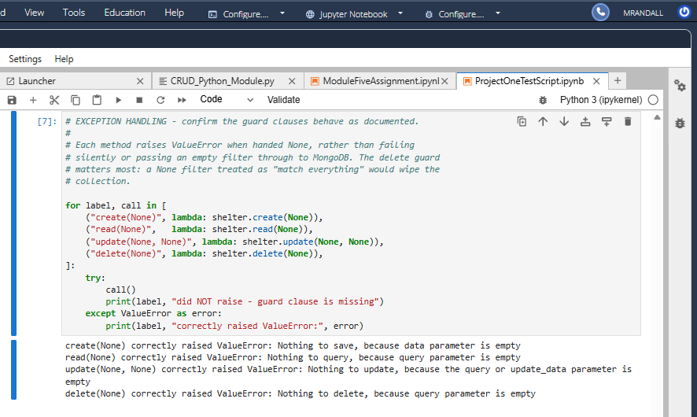Figure 8. Each method raising ValueError when passed None, confirming the guard clauses prevent a missing argument from reaching MongoDB.

Dashboard Functionality
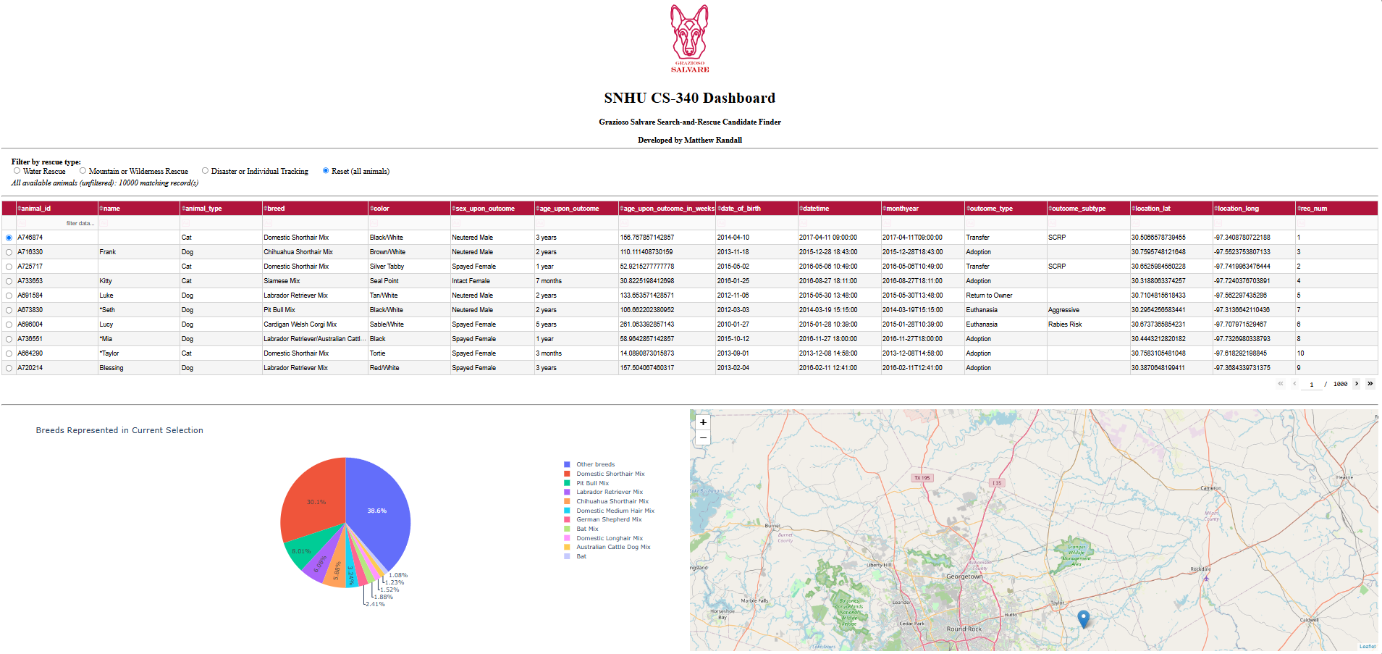Figure 9. The dashboard in its starting, unfiltered state, showing the Grazioso Salvare logo, the unique identifier, the radio-button filter options, the interactive data table, the breed pie chart, and the geolocation chart. The record count reports all 10,000 documents.
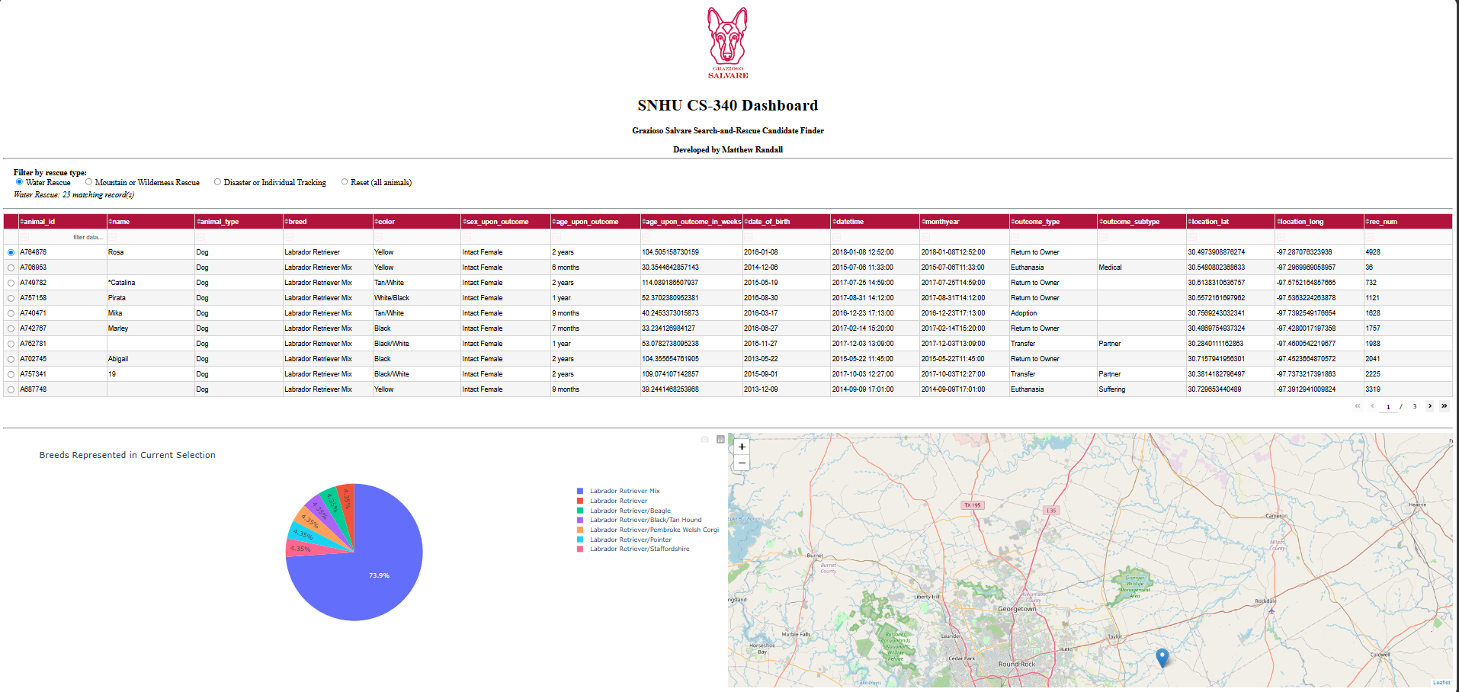Figure 10. The Water Rescue filter applied. The count drops to 23 records, every row is an intact female between 26 and 156 weeks old, and the table, pie chart, and map all update together. The pie legend narrows to Labrador Retriever variants.
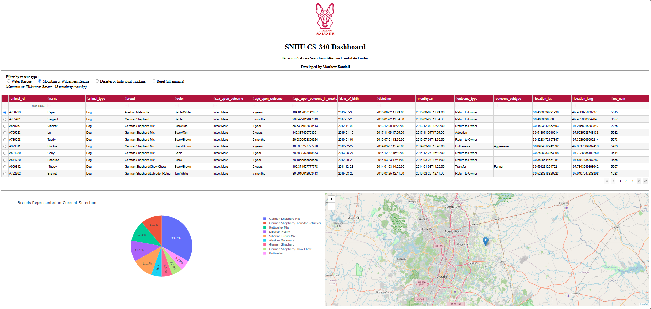Figure 11. The Mountain or Wilderness Rescue filter applied, returning 18 intact males. The legend shows the anchored breed pattern matching German Shepherd, German Shepherd Mix, and German Shepherd/Labrador Retriever alongside Alaskan Malamute, Siberian Husky, and Rottweiler.
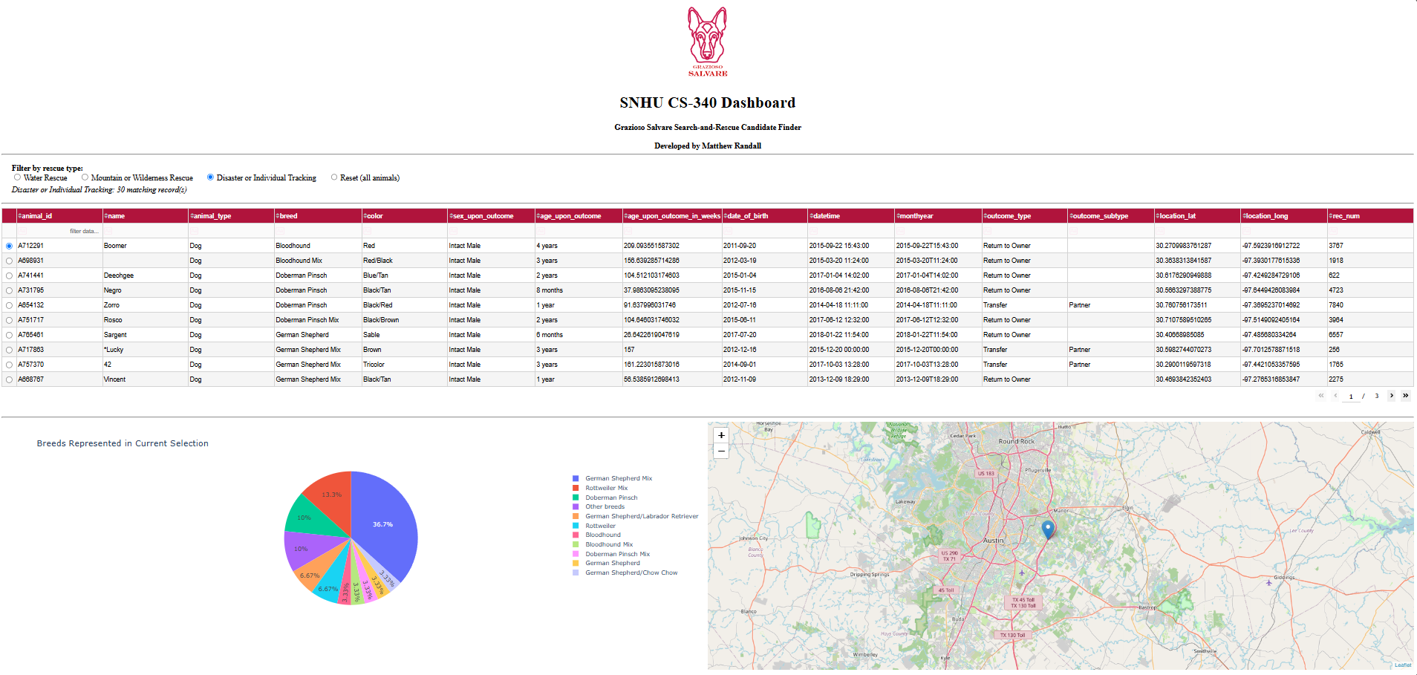Figure 12. The Disaster or Individual Tracking filter applied, returning 30 records. This filter accepts the widest age range at 20 to 300 weeks, and Bloodhound and Doberman Pinsch appear here and under no other filter.
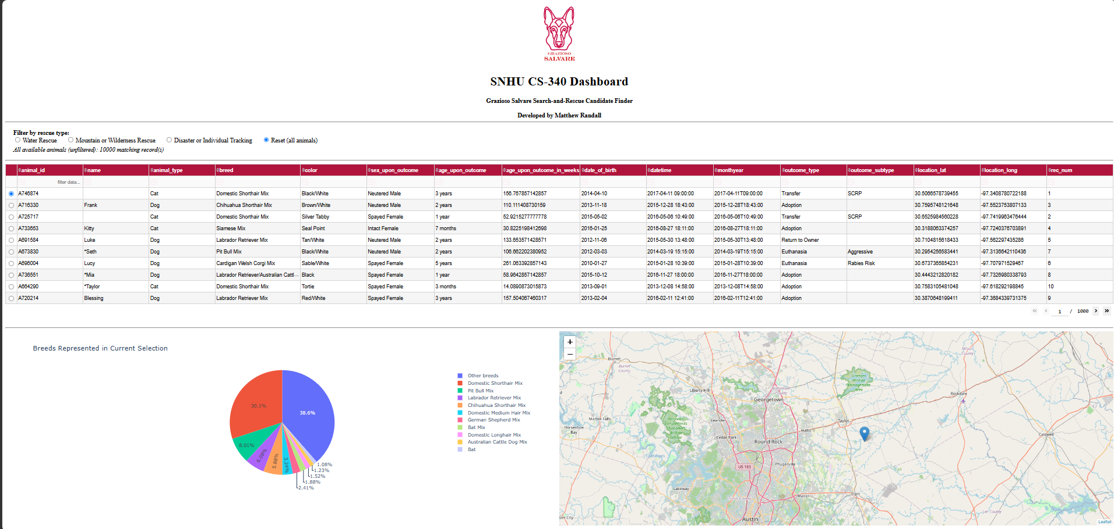Figure 13. Reset selected from a filtered state. All widgets return to their original, unfiltered condition and the count returns to 10,000.

Resources
- MongoDB documentation — https://www.mongodb.com/docs/
- PyMongo documentation — https://pymongo.readthedocs.io/en/stable/
- Dash documentation — https://dash.plotly.com/
- Dash Core Components — https://dash.plotly.com/dash-core-components
- Dash DataTable reference — https://dash.plotly.com/datatable
- Dash Leaflet documentation — https://www.dash-leaflet.com/
- Plotly Express documentation — https://plotly.com/python/plotly-express/
- pandas documentation — https://pandas.pydata.org/docs/
- Project Jupyter — https://jupyter.org/
- Python — https://www.python.org/
- Codio — https://www.codio.com/
- Austin Animal Center Outcomes data set — https://doi.org/10.26000/025.000001

Contact
Matthew Randall
Southern New Hampshire University | CS 340: Client/Server Development

