 Make Linux Mint Xfce Your Own
Personalize the look and feel of your Linux Mint Xfce desktop. You will change the wallpaper, theme, and panel, then show your finished design.
Technology Commons | Port Credit Secondary School

LEVEL 4+: MAKE THE INSTRUCTIONS BETTER
If anything here is unclear, incomplete, or could be explained better, improve it in your own copy. Use Suggesting mode if it is available. Otherwise, add a clearly labelled “Suggested improvement” with your revised wording. Include one sentence explaining why your version is clearer or more useful. Do not remove required work. Mr. A will review your change and may update the course website and future assignment documents if he agrees it helps. Improving a real instruction accurately is one way to demonstrate Level 4+ thinking.
Related course lesson: Explore Linux, Part 2: Make Linux feel like your computer

What to submit
Submit ONE Google Doc with a BEFORE screenshot, an AFTER screenshot, the configuration detective response, and your short answers below. No additional files are needed.

1. Save your BEFORE screenshot
REFERENCE EXAMPLE (not your submission): A typical Linux Mint Xfce desktop. Your BEFORE screenshot should show your own wallpaper and the full bottom panel. (Image: Linuxiac)
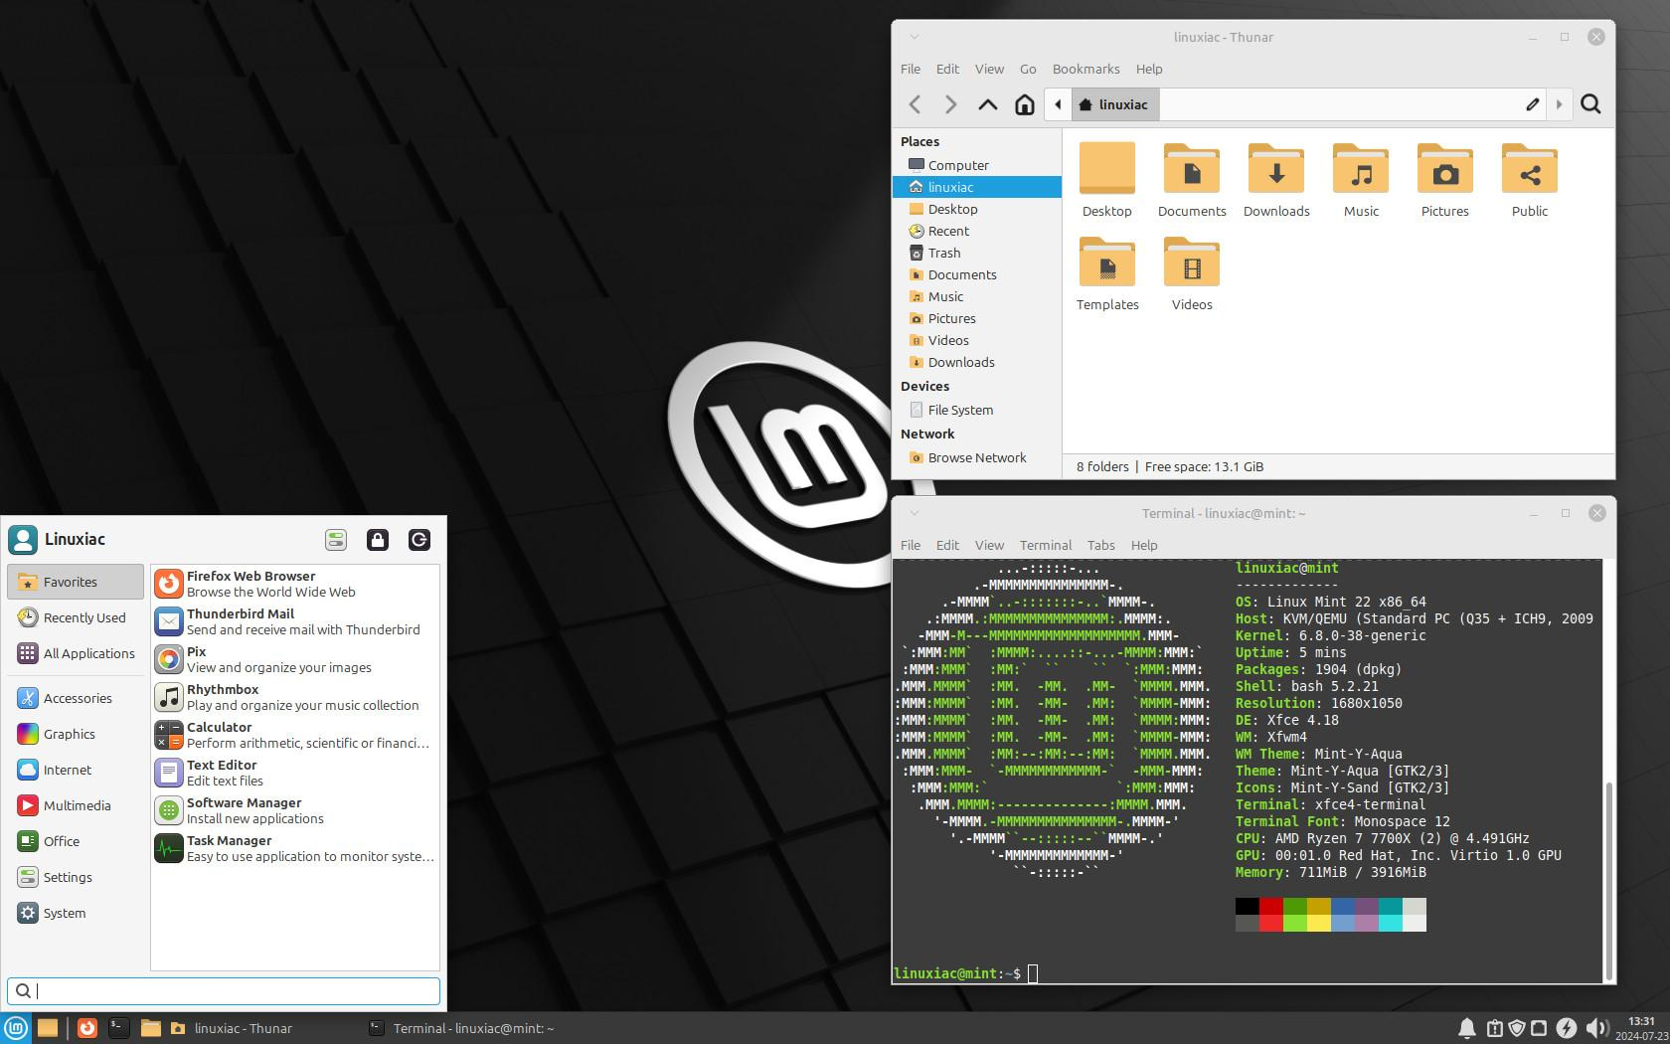
Do this FIRST, before changing any settings. Sign in to your own Linux account and show the full desktop with its wallpaper and bottom panel visible.
Press Print Screen (PrtSc) on the keyboard. If nothing happens, try Fn + PrtSc or open Menu and search for Screenshot. Save the picture in your Pictures folder.
In this Google Doc, click the space below and choose Insert > Image > Upload from computer. Select the screenshot you just saved.
BEFORE screenshot: [Insert your original desktop screenshot here.]

2. Get inspiration from these videos
These videos show what Xfce can look like. Watch what interests you, then use the simple built-in settings in Step 3. You do NOT need to copy the exact video design or install anything.
Video A: Customize Your Linux Mint XFCE: A Simple Guide (Specter). See an example of a complete desktop makeover.
Video B: Making XFCE Look Better (NH Soft). Skip to 3:33 for wallpaper, 7:32 for applying themes, and 12:49 for changing the panel. Skip downloads, terminal commands, and the later Compiz effects.

3. Make your desktop look better
Do these THREE changes in order. A desktop environment is the graphical part of Linux: its wallpaper, windows, icons, menus, and panel (the bar containing the app menu and clock).

Change A: Wallpaper
EXAMPLE: In Desktop Settings > Background, choose a wallpaper thumbnail. Your screen may look slightly different. (Image: It's FOSS)
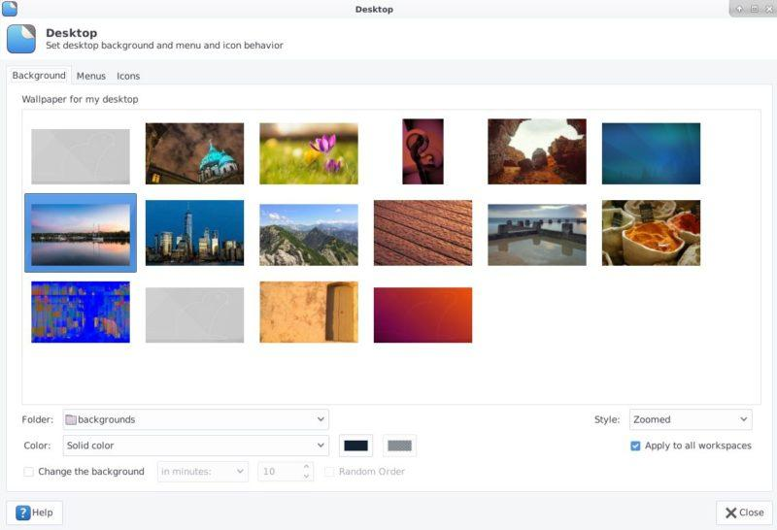
1. Right-click an empty part of the desktop.
2. Select Desktop Settings, then Background.
3. Choose a different built-in picture. Close the window to see the new desktop.

Change B: Theme or icons
EXAMPLE: Appearance > Style. Click one of the built-in themes in the list. Your theme names may differ. (Image: Xfce Project)
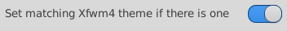
1. Open Menu > Settings > Appearance. If you cannot find it, type Appearance into the menu search box.
2. Open the Style tab and try a different built-in style. This changes how menus and application windows look.
3. Optional: Open the Icons tab and choose a different built-in icon set. Keep something readable.

Change C: Panel (taskbar)
EXAMPLE: Panel Preferences > Display. Find the Row size (pixels) control to resize your panel. (Image: It's FOSS)
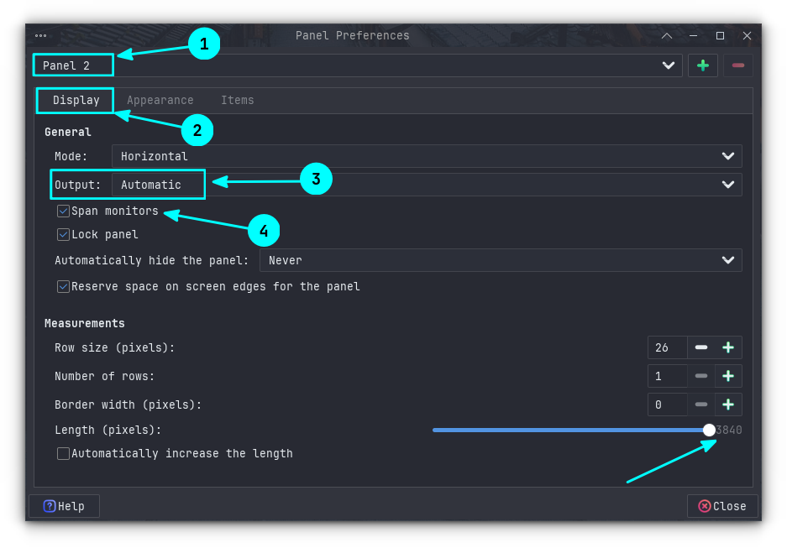
1. Right-click the bottom panel, the bar with the menu and clock.
2. Choose Panel > Panel Preferences (or search for Panel in the menu).
3. Adjust the panel's row size, position, or appearance. Start with a slightly larger or smaller panel. Do NOT delete the panel or remove the menu.
4. Close Panel Preferences. You should now have a desktop that looks different in at least three ways.
If a setting looks wrong, open the same settings window and change it back. Ask for help before deleting panel items or changing anything you do not recognize.

Configuration detective: predict, test, and solve
Use the configuration detective instructions on the course website. Inspect the current values, predict one safe change, test it, and use the terminal output or built-in help to solve any problem. Do not use sudo or remove panel controls.
Goal and prediction: What will you change, and what do you expect to happen?
Type here:
Test result: What changed? What stayed the same?
Type here:
Problem-solving evidence: If the first attempt did not work, what message, setting, manual page, or help output helped you decide what to try next?
Type here:

4. Save your AFTER screenshot
Make sure your updated wallpaper and panel are visible. To show your theme, you may leave a File Manager window open.
Take another screenshot using PrtSc (or the Screenshot app), save it, and insert it below through Insert > Image > Upload from computer.
AFTER screenshot: [Insert your redesigned desktop screenshot here.]

5. Tell me what you changed
Fill in the spaces below AFTER you have finished the changes. Short answers are fine. Name the settings you used so someone else could repeat your work.
A. What wallpaper did you choose? Where did you change it?
Type here:
B. What theme or icon change did you make? Which menu or setting did you use?
Type here:
C. What did you change about the panel? How did you do it?
Type here:
D. Which change made your desktop look better or easier to use? Why?
Type here:
E. What did you predict, test, and learn from your configuration change? If something went wrong, what evidence helped you fix it?
Type here:

Optional extra: Make it even more yours
Want to go further? Try changing fonts or pointer size through Settings, adding a favourite application shortcut, or arranging your desktop icons. You can also explore the appearance options in the videos, but do not download themes or install desktop effects without permission.
What extra change did you try?
Type here, or write 'I completed the required work.'

6. Submit in Google Classroom

Submit only this completed Google Doc in Google Classroom. The BEFORE and AFTER screenshots should be inserted into the document, not attached as separate files.
Do not include passwords, student numbers, or other private information in your screenshots or answers.

Before you turn it in
☐ My BEFORE screenshot is near the start of the document.
☐ I changed the wallpaper, theme or icons, and panel.
☐ My AFTER screenshot shows my redesigned desktop.
☐ I completed the configuration detective and answered the five required questions.
☐ I checked for private information and clicked Turn in.

SHARING + LICENCE
CC BY-SA 4.0 · Created by Andrew Andrade · andrewandrade.ca · Source: github.com/mrandrewandrade
Please share, modify and redistribute. If you change this file, do not remove:
CC BY-SA 4.0. Original Source: andrewandrade.ca and add your own name + links. Sharing is caring!

