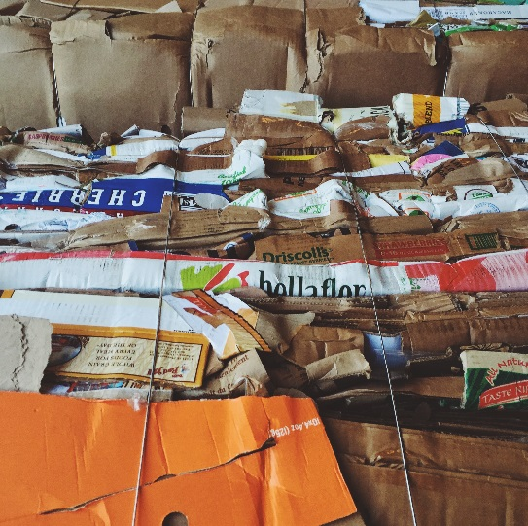

ABOUT US:

Rainier Waste Solutions is aPacific Northwest company based in Seattle, WA. We offer a wide range of services that support and contribute to the evolving waste industry.

Our company started in 2009 delivering garbage carts and containers to residents and businesses throughout the City of Seattle and has expanded ever since. Chris Bridges, Owner and President, has extensive knowledge of the waste industry and has been working with major waste companies such as Waste Management, Republic Services, Waste Connections and Recology CleanScapes for over 15 years. Today Rainier Waste Solutions areas of focus are hauling in and around the Seattle area. Additionally, we believe education is vital in the fast-pace and ever-changing world of waste. Therefore we offer waste audits along with educational programming for our customers so they can stay on top of bettering the environment by disposing of waste appropriately and responsibly.

***"Rainier Waste Solutions is a highly motivated company that is committed to offering the best service in order to help our customers achieve their goals effectively and efficiently."***

[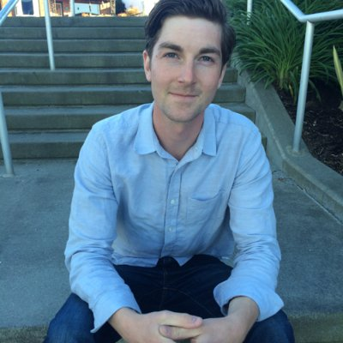](javascript:void(0))

MAIN SERVICES:

Roll Off Container Hauling –

We service a variety of containers in and around the Seattle area. We deliver and collect the container when you call and let us know you need it removed. We will take your debris to a recycling facility for responsible disposal.

Do you have a large (or even a small) demolition project? Do you have a construction project? We offer various size containers and services for your project needs. Do you have a compactor? We can haul those. Do you have an upcoming special event? We can help with those too. Contact us for a quote.

Below are the types of materials we collect:

* Construction, demolition, land-clearing debris
* Asphalt, brick, concrete, rock, masonry, dirt
* Cardboard, paper
* Metals, plastics
* Wood materials
* Gypsum wall board scraps
* Roofing materials and siding
* Clean stryrofoam
* Insulation
* Carpet

Bale Hauling –

We specialize in collecting bales at distribution centers, grocery stores packing companies, but are always willing to collect at other types of businesses. Do you have a tons of baled cardboard? We can pick those bales up for you for free. Do you have loose cardboard? We can help you purchase a baler in order for the loose cardboard to be collected at a lower cost with a potential rebate. Contact us to find out how.

Waste Audits -

Have you always been confused about recycling and, now, composting/food waste? Do you have a program in place at your business, but it’s just not working? We can help you expand your recycling program to best fit your needs and possibly lower your waste utility bill at the same time. By performing a simple audit of your waste stream is the best way to identify opportunities to cut costs and increase recycling.

Are you a trying to obtain a LEED-EB certification or stay qualified as a LEED building? We conduct waste audits and provide the required documentation needed for certification. Contact us to see how we may help.

OTHER SERVICES:

* Container Management Services (organize, wash, repair, paint, inventory, etc…)

If you are a manufacturer of carts and containers we have extensive experience with assembly, delivery and removal programs. Contact us to see how we can assist you with your project.

*Insert quote from Larry.*

* Cart Delivery and/or Removal   
  If you are a manufacturer of carts and containers we have extensive experience with assembly, delivery and removal programs. Contact us to see how we can assist you with your project.

*Insert quotes from Leon and Katie/Don.*

* Container Labeling  
  Municipalities are beginning to cut costs by not purchasing new containers and just re-labeling them. We can help with large-scale relabeling projects. Contact us for a quote.

*Insert quote from Jim (Bothell).*

* Route Auditing and Sequencing  
   *Insert quote from Allan?*
* Litter Mitigation and Refuse Management  
  Let us help you with your refuse needs at your next large (or even small-scale event) such as street festivals, races, and outdoor concerts. We deliver carts and litter stations for all waste streams to your event location. We also service those carts throughout the event to prevent overflow and litter. At the end of the event, we will ensure carts are removed and the event area properly cleaned. Contact us for a quote and availability.