Prompt Version Control Portal
UI Screen Mockups (MVP)
Document date: 18 July 2026
Status: Visual wireframes for review — not final production UI
Purpose
This document shows how the main screens of the self-hosted Prompt Portal are intended to look and work. Screens are desktop-first (approx. 1280×800). Images are annotated with the product rules already locked in requirements.
Key product rules shown in the UI
- Every image belongs to the prompt that created it (1 prompt → many images).
- Prompt text is versioned (1, 2, 3…). Media is not versioned.
- No separate Commit button — Save creates a new text version when text changes.
- Draft save is allowed.
- Images only: max 2 MB each, 50 MB total quota, warning at 90%.
- No video file upload (video is a tag only). No public share links.
- Sign-in: Google or Facebook only (single allowlisted user).

Screens in this document
- Login
- 2. Prompt library
- 3. Create / Edit prompt
- 4. Prompt detail
- 5. Compare versions
- 6. Settings

1. Login
What this screen is for
- Google and Facebook OAuth buttons only.
- Private self-hosted app; only allowlisted accounts can sign in.
- No guest browsing and no public share entry point.

Mockup
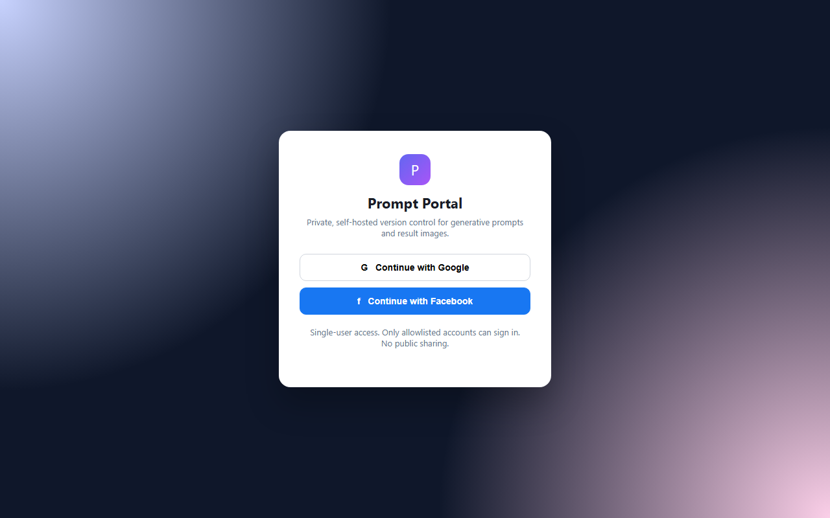

2. Prompt library
What this screen is for
- Grid of prompts with optional thumbnail from owned result images.
- Search and filters: status, media type focus (including video tag), has-media.
- Storage quota meter (36/50 MB example) always visible.
- Text-only prompts show a 'No media / Text only' placeholder.
- Primary action: New prompt.

Mockup
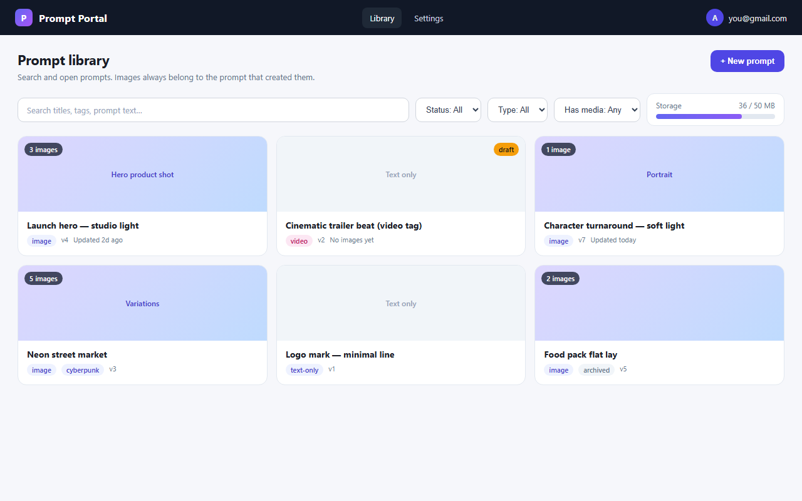

3. Create / Edit prompt
What this screen is for
- Left: title, status, media type focus, tags, prompt body, negative prompt, parameters.
- Right: result image upload — only in prompt context (images must have a parent prompt).
- Multiple images allowed per prompt; dropzone + thumbnails.
- Actions: Save as draft, Save (no Commit button).
- Helper text explains automatic text versioning on Save.

Mockup
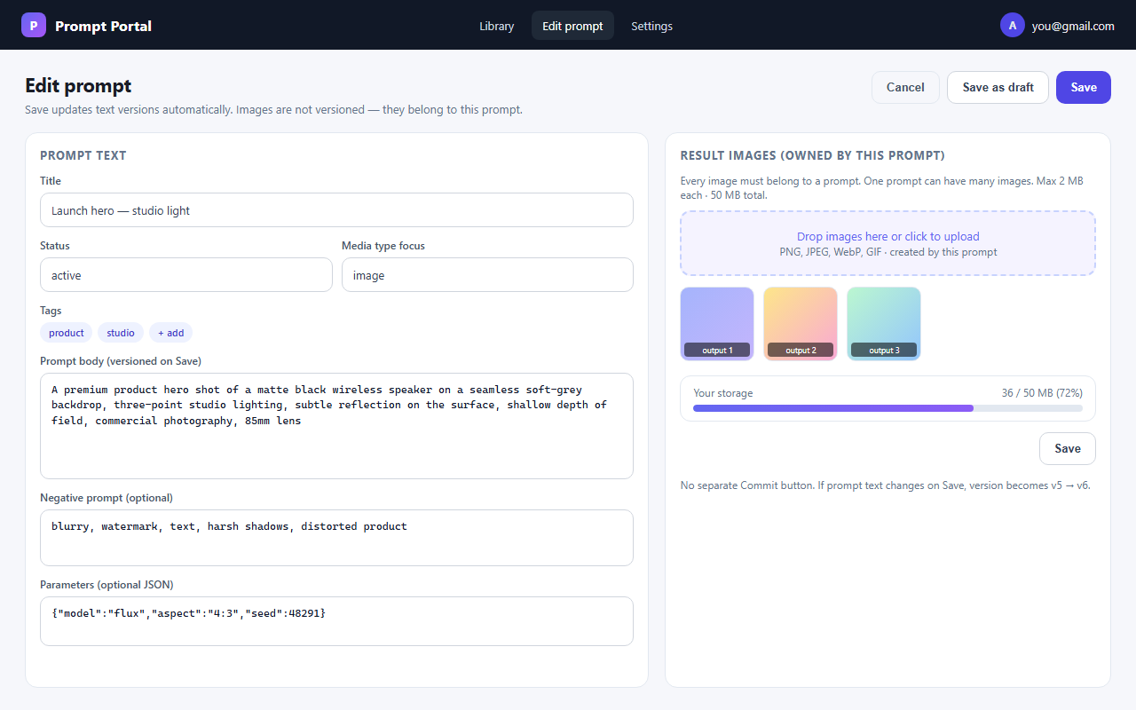

4. Prompt detail
What this screen is for
- Current prompt text with one-click Copy prompt.
- Gallery of result images owned by this prompt.
- Version history for text only (v1…v4) with Diff and Restore.
- Restore creates a new version; images stay on the current gallery.
- Edit / Archive actions.

Mockup
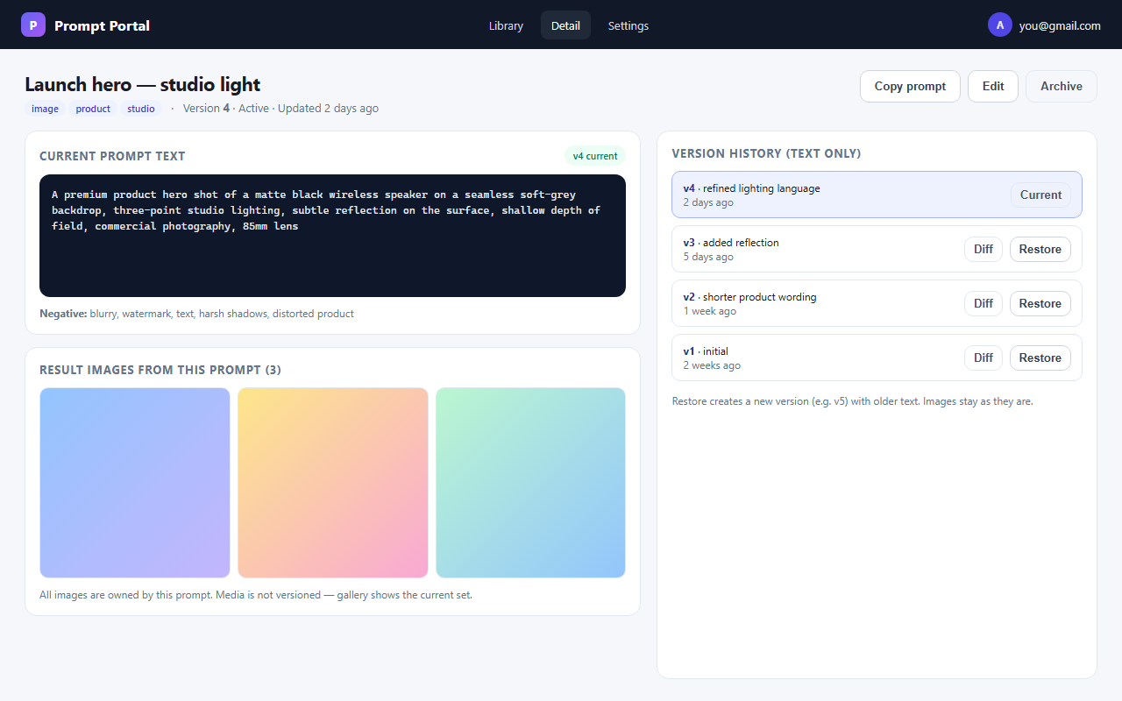

5. Compare versions
What this screen is for
- Side-by-side text comparison between two integer versions.
- Highlight removals (red) and additions (green).
- Option to restore the left version as a new version.
- Caption reminds users that images are not versioned.

Mockup
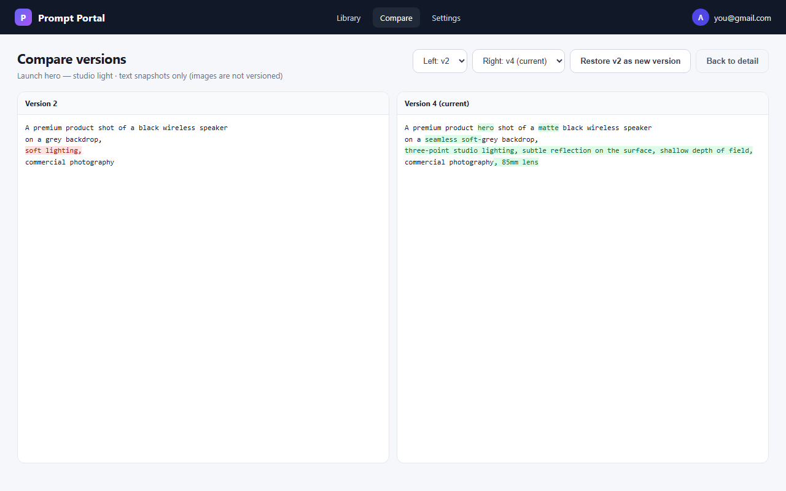

6. Settings
What this screen is for
- Account identity (Google/Facebook allowlisted user).
- Quota detail: used vs 50 MB, 2 MB per file, 90% warning note.
- Retention: unmodified data may be deleted after 2 years.
- User responsibility notice.
- Short product rules summary for operators.

Mockup
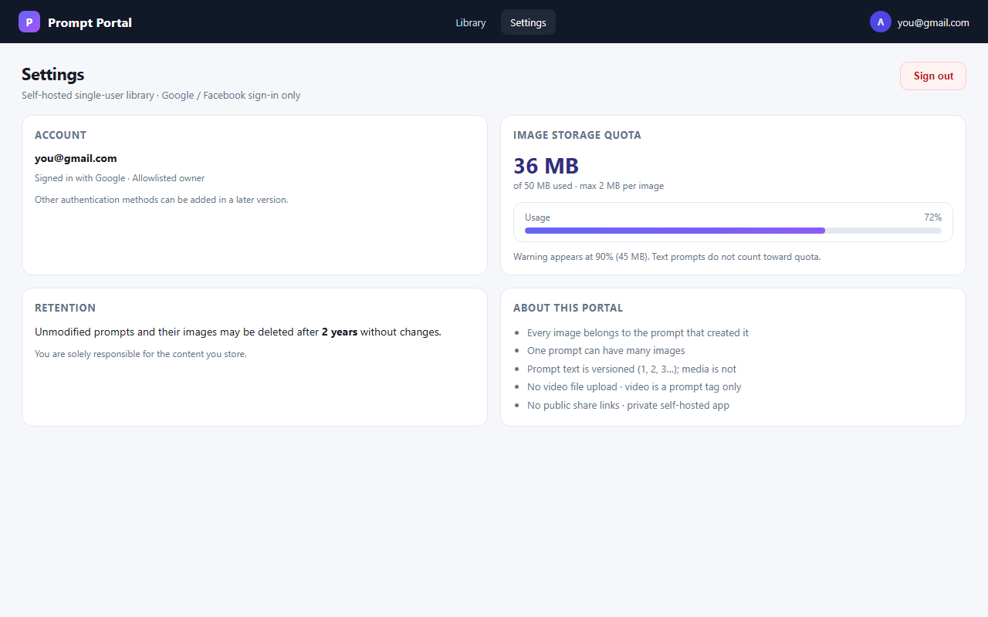

7. Typical user flows (mapped to screens)
A. Create a text-only prompt
- Library → New prompt → fill text → Save → Detail (v1, no images).
B. Create a prompt with result images
- Library → New prompt → enter text → upload one or more images on that prompt → Save → Detail shows gallery (all images owned by this prompt).
C. Iterate text
- Detail → Edit → change body → Save → new version number (e.g. v4→v5) → history updates.
D. Replace / add images only
- Detail → Edit → add or replace images → Save → version number unchanged (media not versioned).
E. Recover old wording
- Detail → Compare / Restore → new version with older text; current images unchanged.

Notes for reviewers
- These are concept mockups to agree layout and behaviour before implementation.
- Final colours, fonts, and spacing may change; information architecture should stay the same.
- Source HTML for the mockups lives in Documents/prompt-portal/mockups/.
- Requirements: REQUIREMENTS.md · Technical design: TECHNICAL_DESIGN.md

