USED CAR PRICE PREDICTION SYSTEM

An End-to-End Machine Learning Project

Python | Flask | Streamlit | scikit-learn | RandomForest

IBM BOB AI/ML Project Report
September 2026

Table of Contents
1. Project Overview
2. Dataset Description
3. System Architecture
4. ML Pipeline & Model Details
5. API Endpoints & Outputs
6. Frontend UI
7. Model Performance Results
8. Sample Predictions
9. Project Structure
10. How to Run
11. Conclusion

1. Project Overview
The Used Car Price Prediction System is an end-to-end machine learning application that predicts the resale price of used cars in India. The system ingests real-world used car listing data (1,234 records), trains a Random Forest regression model, exposes predictions via a Flask REST API, and presents an interactive web interface using Streamlit.

Key Objectives:
- Accurately predict used car resale prices in Indian Rupees (Lakh)
- Provide a clean, interactive frontend for users to enter car details
- Expose model predictions through a REST API for integration
- Demonstrate a complete ML pipeline from raw data to deployment

Technology Stack:
Component | Technology | Purpose
Language | Python 3.10+ | Core language
ML Framework | scikit-learn | Model training & pipeline
Algorithm | Random Forest Regressor | Price prediction
Backend API | Flask + Flask-CORS | REST endpoints
Frontend UI | Streamlit | Interactive web interface
Data Processing | Pandas, NumPy | Preprocessing & EDA
Visualisation | Matplotlib, Seaborn | Charts & plots
Report | python-docx | Word report generation
Model Storage | joblib | Model serialisation

2. Dataset Description
The dataset contains used car listings sourced from online automotive platforms across 11 major Indian cities. It includes car specifications, geographic information, and new car prices (where available) for 1,234 records.

Feature | Type | Description | Example
Name | Text | Full model name of the car | Maruti Alto K10 LXI
Location | Categorical | City where car is listed | Mumbai, Delhi, Bangalore
Year | Numeric | Manufacturing year | 2017
Kilometers_Driven | Numeric | Total kilometres driven | 40,929
Fuel_Type | Categorical | Type of fuel | Petrol / Diesel / CNG / LPG
Transmission | Categorical | Gearbox type | Manual / Automatic
Owner_Type | Categorical | Number of previous owners | First / Second / Third
Mileage | Text | Fuel efficiency | 18.5 kmpl / 32.26 km/kg
Engine | Text | Engine displacement | 998 CC
Power | Text | Engine power | 82.85 bhp
Seats | Numeric | Number of seats | 5
New_Price | Text | Original price (182 non-null rows) | 9.27 Lakh

Dataset Statistics
Statistic | Year | Kilometers Driven
Minimum | 1996 | 1,000
Maximum | 2019 | 350,000
Average | 2013.4 | 58,507

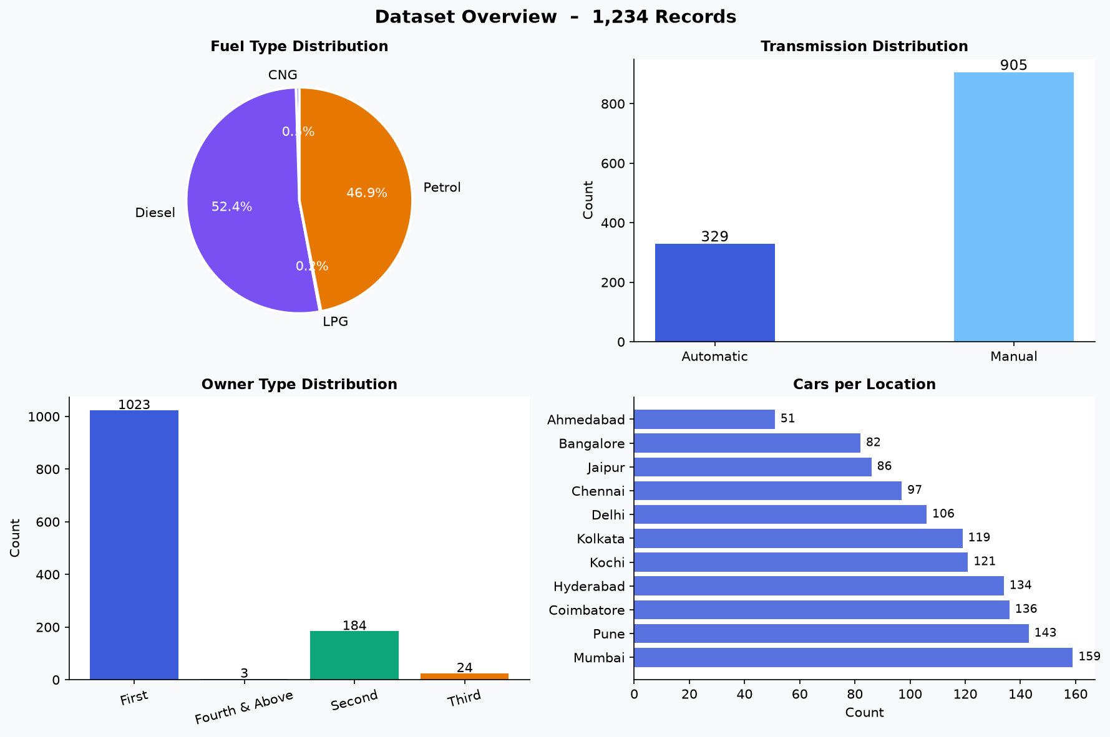
Figure 1: Dataset Distribution – Fuel Type, Transmission, Owner Type, Location

5. API Endpoints & Outputs
The Flask backend exposes 5 REST endpoints on http://127.0.0.1:5000. All responses are JSON. CORS is enabled for browser-based clients.

Method | Endpoint | Description | Auth
GET | /api/health | Liveness check – confirms API is up | None
GET | /api/model-info | Model metrics, features, option lists | None
GET | /api/dataset-info | Dataset statistics, distributions | None
POST | /api/predict | Single car price prediction | None
POST | /api/batch-predict | Batch predictions (JSON array) | None

5.1 Sample API Responses
Health Check (GET /api/health):
{
"message": "Used Car Price Prediction API is running",
"model_loaded": true,
"status": "ok"
}

Single Prediction (POST /api/predict):
{
"predicted_price": 1.9,
"price_range": {
"high": 2.09,
"low": 1.71
},
"status": "success",
"unit": "Lakh INR"
}

8. Sample Predictions
The following test cases were submitted to the live API and returned predictions:

# | Car (Year) | Fuel | Trans. | KM Driven | Predicted | Range
1 | Maruti (2017) | Petrol | Manual | 40,000 | Rs. 1.9 Lakh | Rs. 1.71 - 2.09 Lakh
2 | Toyota (2015) | Diesel | Automatic | 80,000 | Rs. 6.57 Lakh | Rs. 5.91 - 7.23 Lakh
3 | Hyundai (2019) | Petrol | Manual | 15,000 | Rs. 3.1 Lakh | Rs. 2.79 - 3.41 Lakh

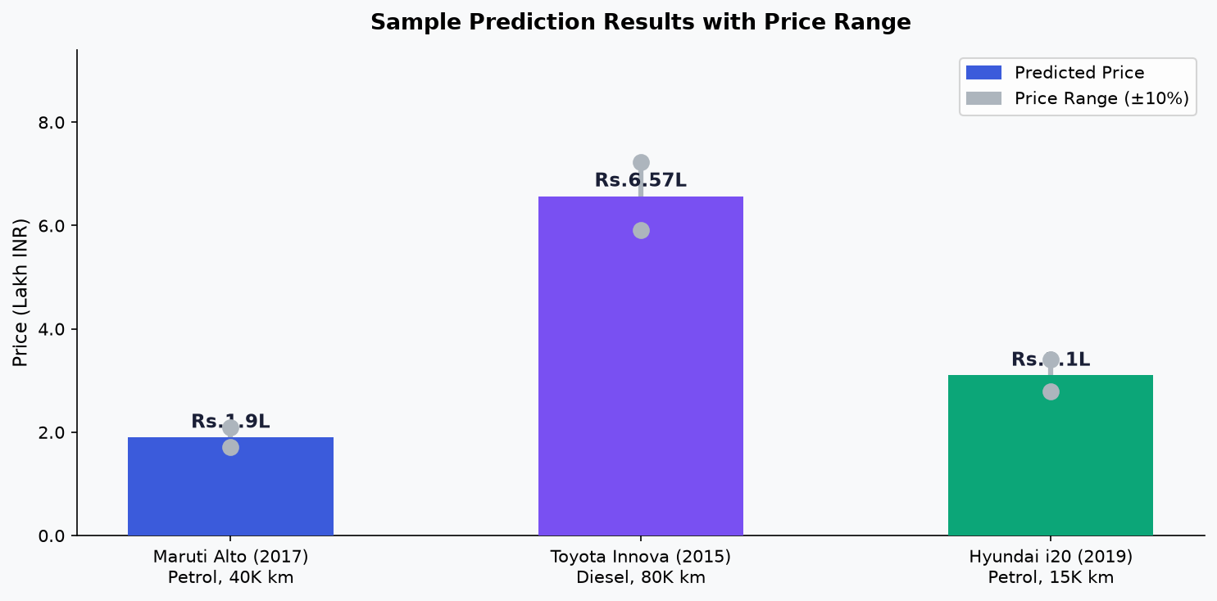
Figure 7: Sample Predictions with Price Range Bars

