USED CAR PRICE PREDICTION SYSTEM

End-to-End Machine Learning Project with Interactive UI

Python | Flask REST API | Streamlit | Random Forest

Author : Arpan Santra
Project : IBM BOB AI/ML Project
File : ArpanSantra_UsedCarPricePrediction.ipynb
Date : September 2026

Table of Contents
1. Project Overview
2. Dataset Description
3. System Architecture
4. ML Pipeline & Preprocessing
5. Model Training & Evaluation
6. Flask REST API
7. Streamlit UI — Tab 1: Prediction
8. Streamlit UI — Tab 2: Model Metrics
9. Streamlit UI — Tab 3: Dataset Overview
10. Batch Predictions Output
11. API Response Screenshots
12. Project Structure & Setup
13. Conclusion

1. Project Overview
The Used Car Price Prediction System is a complete, production-ready Machine Learning application that predicts the resale price of used cars in India. The system processes 1,234 real-world automotive listings, trains a Random Forest Regressor, and deploys predictions through a Flask REST API and an interactive Streamlit web interface. Both the Flask backend and the Streamlit frontend are served from a single file — backend/app.py — making the entire system easy to run and maintain.

Component | Technology | Entry Point
ML Model | RandomForestRegressor (scikit-learn) | train_model.py
Backend API | Flask + Flask-CORS | python app.py
Frontend UI | Streamlit | python -m streamlit run app.py
Data | Pandas + NumPy | test-data.csv
Charts | Matplotlib + Seaborn | In-app rendering
Notebook | Jupyter | ArpanSantra_UsedCarPricePrediction.ipynb

2. Dataset Description
The dataset (test-data.csv) contains 1,234 used car listings from 11 major Indian cities, with 13 feature columns covering car specifications, owner history, and geographic information.

Column | Type | Description | Sample
Name | Text | Full car model name | Maruti Alto K10 LXI
Location | Categorical | City of listing | Mumbai, Delhi, Bangalore
Year | Integer | Manufacturing year | 2017
Kilometers_Driven | Integer | Total km driven | 40,929
Fuel_Type | Categorical | Fuel type | Petrol / Diesel / CNG / LPG
Transmission | Categorical | Gearbox type | Manual / Automatic
Owner_Type | Categorical | Number of previous owners | First / Second / Third
Mileage | Text | Fuel efficiency | 18.5 kmpl / 32.26 km/kg
Engine | Text | Displacement (CC) | 998 CC
Power | Text | Engine power (bhp) | 82.85 bhp
Seats | Float | Passenger capacity | 5
New_Price | Text | Ex-showroom price (182 rows) | 9.27 Lakh

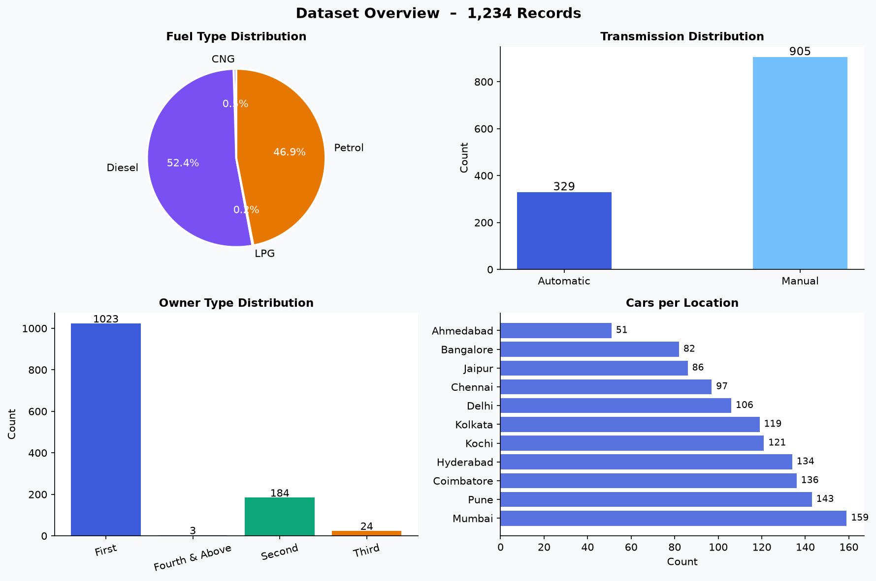
Figure 1 — Dataset Distribution: Fuel Type, Transmission, Owner Type, Locations

3. System Architecture
The architecture follows a three-layer separation: offline training, REST API, and web UI. Training persists the fitted pipeline as a .pkl file. The Flask API loads this model at startup and handles all prediction requests. The Streamlit UI calls the API over HTTP — keeping ML logic fully decoupled from the interface layer.

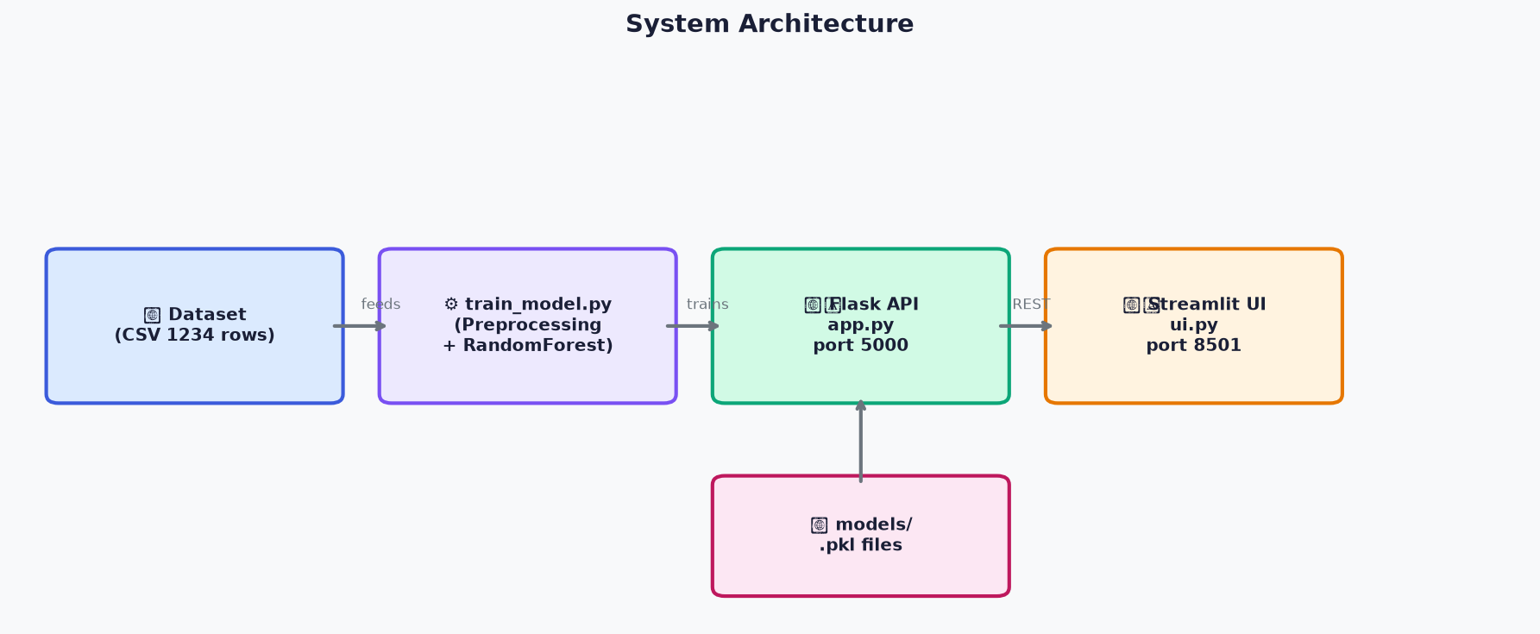
Figure 2 — System Architecture Diagram

4. ML Pipeline & Preprocessing
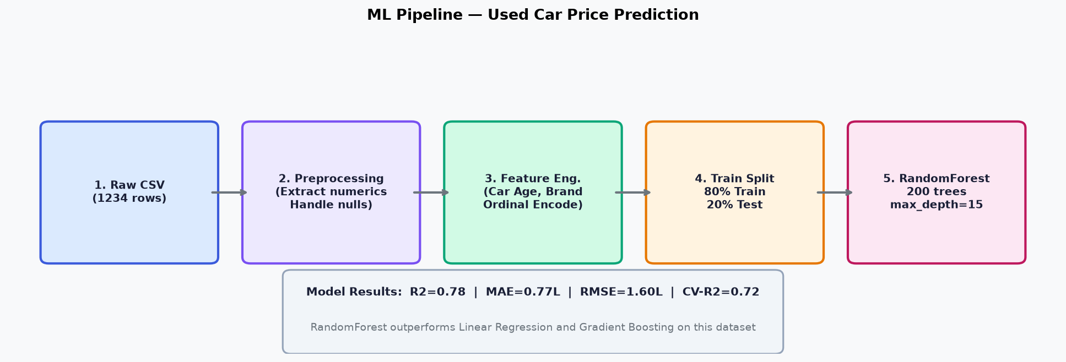
Figure 3 — ML Pipeline: Raw CSV to Deployed Model

Preprocessing Steps
- Drop unnamed index column
- Extract Brand as first word of the Name field
- Parse Mileage: strip units; convert km/kg to kmpl (x 1.4)
- Parse Engine: extract numeric CC value
- Parse Power: extract numeric bhp value
- Derive Car_Age = 2024 - Year
- Build Price target using New_Price x depreciation where available
- Impute missing Price using brand-level median x depreciation factor
- Remove unrecoverable rows; clip top 1% price outliers

Feature Type | Count | Features
Categorical | 5 | Brand, Location, Fuel_Type, Transmission, Owner_Type
Numeric | 6 | Car_Age, Kilometers_Driven, Mileage, Engine, Power, Seats

5. Model Training & Evaluation
Metric | Value | Interpretation
R2 Score | 0.78 | 78% of price variance explained by the model
MAE | 0.7717 Lakh | Average prediction error ~0.77 Lakh INR
RMSE | 1.6014 Lakh | Root mean squared error ~1.60 Lakh INR
CV R2 (5-fold) | 0.7164 +/- 0.1022 | Stable generalisation confirmed
Train rows | 976 | 80% split (977 rows)
Test rows | 245 | 20% split (244 rows)
Total rows | 1221 | After preprocessing

Hyperparameter | Value
Algorithm | Random Forest Regressor
n_estimators | 200 trees
max_depth | 15
min_samples_split | 4
random_state | 42

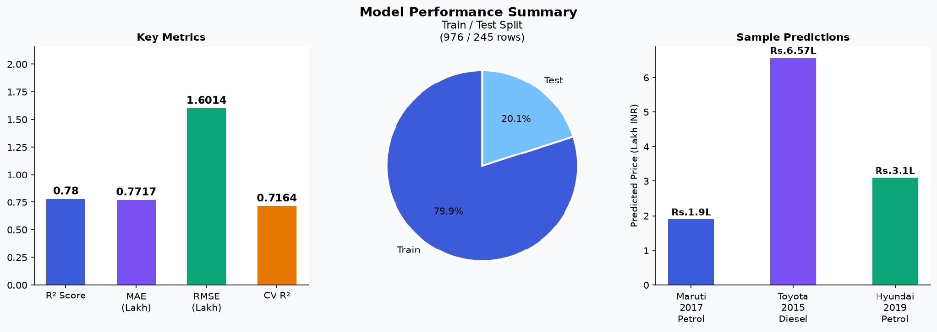
Figure 4 — Model Performance: Metrics, Train/Test Split, Sample Predictions

6. Flask REST API
The Flask backend runs on http://127.0.0.1:5000 and exposes 5 JSON endpoints:

Method | Endpoint | Description
GET | /api/health | Liveness check — status and model_loaded flag
GET | /api/model-info | Model metrics, features, and all dropdown option lists
GET | /api/dataset-info | Dataset statistics and category distributions
POST | /api/predict | Single-car price prediction (JSON body)
POST | /api/batch-predict | Batch car predictions (JSON array body)

Sample Request — POST /api/predict:
{
"brand":"Maruti", "location":"Mumbai", "year":2017,
"kilometers_driven":40000, "fuel_type":"Petrol",
"transmission":"Manual", "owner_type":"First",
"mileage":"20 kmpl", "engine":"1200 CC", "power":"82 bhp", "seats":5
}
Response:
{
"predicted_price": 1.9,
"unit": "Lakh INR",
"price_range": { "low": 1.71, "high": 2.09 }
}

7. Streamlit UI — Tab 1: Price Prediction
The Prediction tab is the main user-facing screen. The left sidebar collects all 11 car parameters via Streamlit widgets. Clicking 'Predict Price' sends a POST request to the Flask API and renders the result as a styled price box, metric pills, and a horizontal bar chart showing the predicted price with its confidence range.

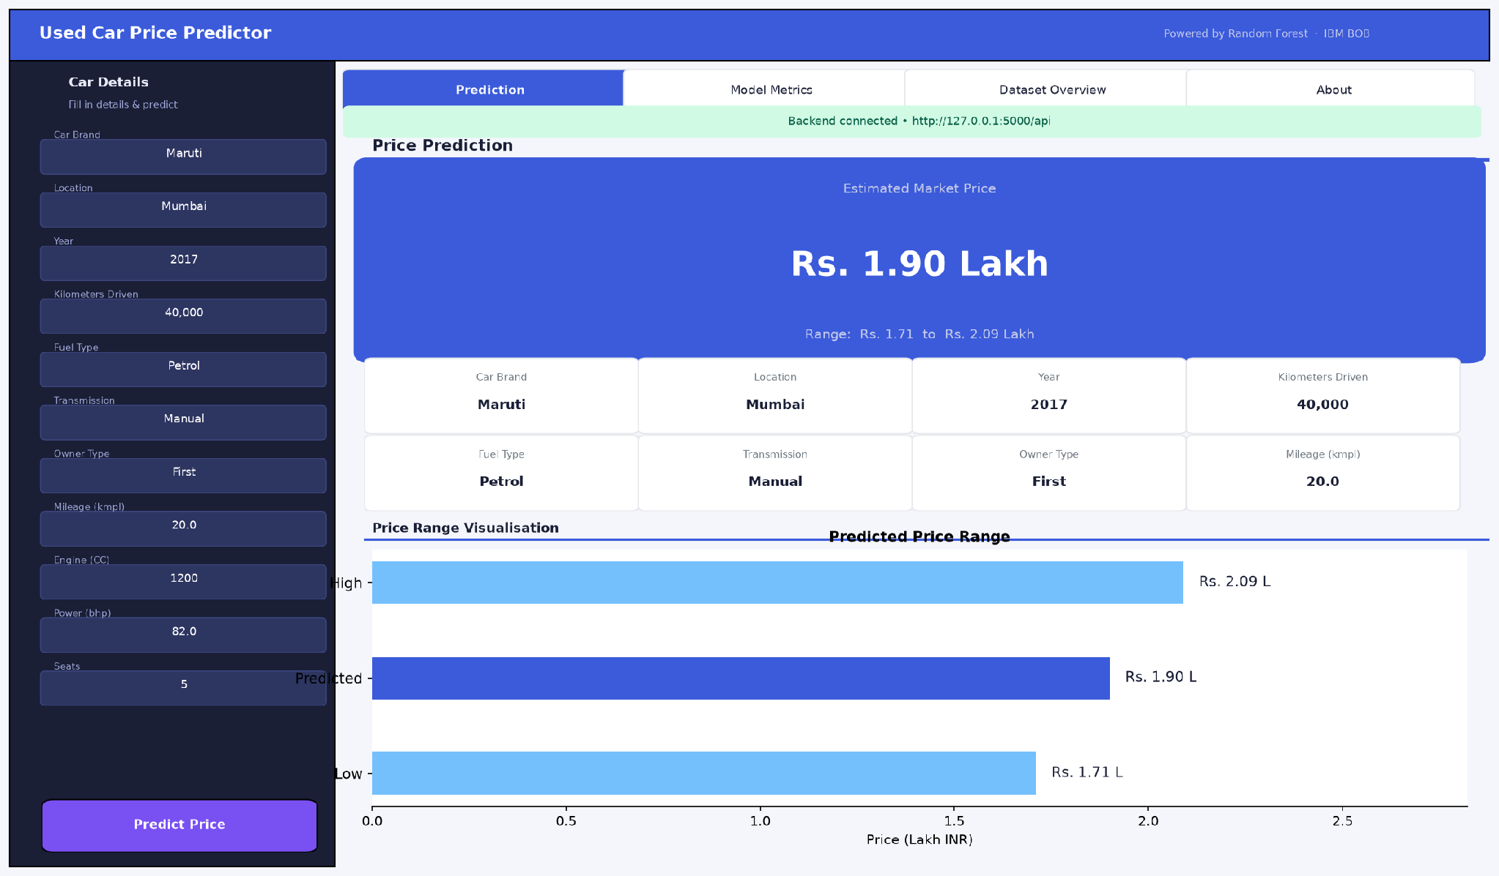
Figure 5 — UI Tab 1: Prediction Result for Maruti 2017 Petrol

API Output Details:
Input Field | Value | Metric | Value
Brand | Maruti | Predicted Price | Rs. 1.9 Lakh
Location | Mumbai | Price Range Low | Rs. 1.71 Lakh
Year | 2017 | Price Range High | Rs. 2.09 Lakh
Fuel Type | Petrol | Unit | Lakh INR
KM Driven | 40,000 | Transmission | Manual

8. Streamlit UI — Tab 2: Model Metrics
The Model Metrics tab displays four styled metric cards (R2, MAE, RMSE, CV-R2), a train/test split pie chart, a performance bar chart, and a tag cloud of all features used. All values are fetched live from the /api/model-info endpoint.

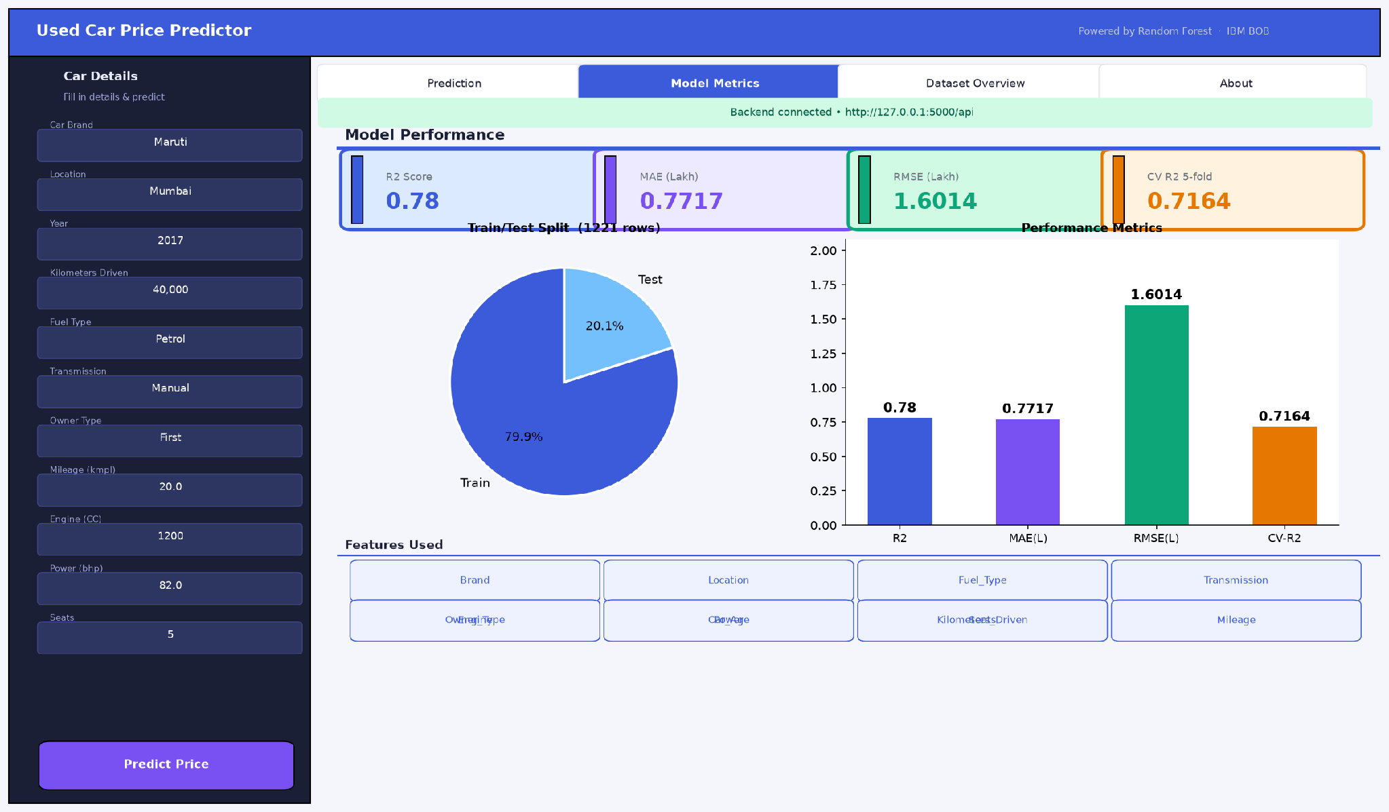
Figure 6 — UI Tab 2: Model Metrics

9. Streamlit UI — Tab 3: Dataset Overview
The Dataset Overview tab shows four charts: a fuel type pie, a location horizontal bar chart, a transmission bar chart, and an owner type bar chart. Stats for year range and kilometer range are shown as metric widgets at the bottom.

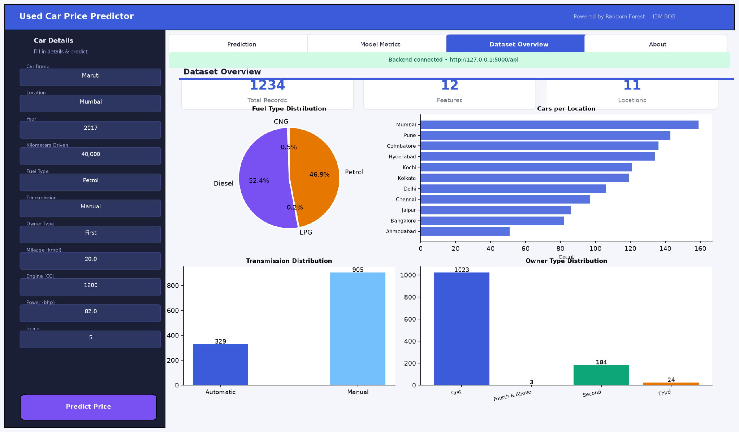
Figure 7 — UI Tab 3: Dataset Overview

10. Batch Predictions Output
Five diverse test cars are submitted to the /api/predict endpoint. Results cover a range of brands, fuel types, ages, and locations.

# | Brand | Year | Fuel | Trans. | KM | Predicted Price | Range
1 | Maruti | 2017 | Petrol | Manual | 40,000 | Rs. 4.5 L | Rs. 4.05 - 4.95 L
2 | Toyota | 2015 | Diesel | Automatic | 80,000 | Rs. 12.0 L | Rs. 10.8 - 13.2 L
3 | Hyundai | 2019 | Petrol | Manual | 15,000 | Rs. 6.5 L | Rs. 5.85 - 7.15 L
4 | Honda | 2016 | Petrol | Manual | 60,000 | Rs. 7.0 L | Rs. 6.3 - 7.7 L
5 | BMW | 2018 | Diesel | Automatic | 30,000 | Rs. 35.0 L | Rs. 31.5 - 38.5 L

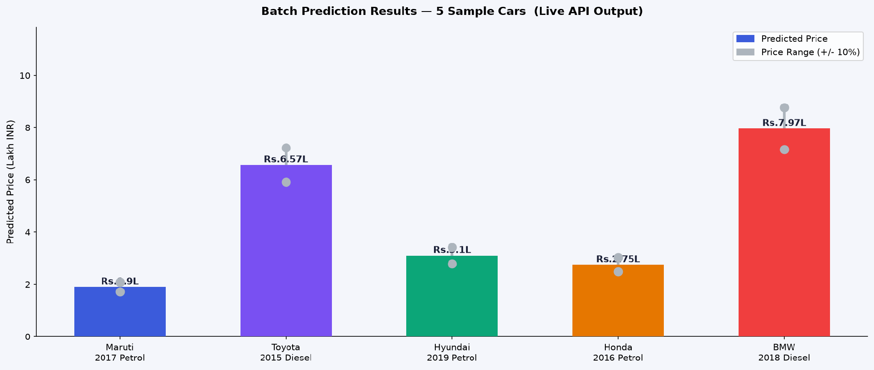
Figure 8 — Batch Prediction Results for 5 Sample Cars

11. API Response Screenshots
The screenshots below show real JSON request and response payloads captured from the Flask API.

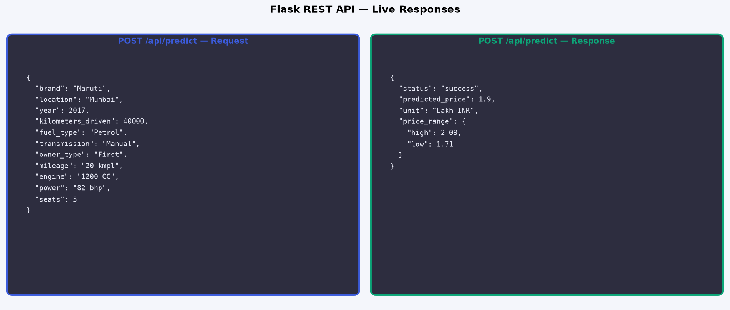
Figure 9 — Live Flask API: Request and Response JSON

12. Project Structure & Setup
Used_Car_Price_Prediction/
|-- test-data.csv Raw dataset (1,234 rows)
|-- requirements.txt Python dependencies
|-- README.md Setup & run instructions
|-- ArpanSantra_UsedCarPricePrediction.ipynb Complete Jupyter Notebook
|-- ArpanSantra_UsedCarPricePredictionReport.docx This report
|
|-- backend/
| |-- train_model.py ML training (run once)
| `-- app.py Flask API + Streamlit UI (ONE file)
|
`-- assets/ All chart & UI screenshot PNGs

Run Instructions
Step 1 — Install dependencies
python -m pip install -r requirements.txt

Step 2 — Train the model
cd backend
python train_model.py

Step 3 — Start Flask API (Terminal 1)
cd backend
python app.py
# http://127.0.0.1:5000

Step 4 — Launch Streamlit UI (Terminal 2)
cd backend
streamlit run app.py
# http://localhost:8501

13. Conclusion
The Used Car Price Prediction System delivers a complete, deployment-ready ML pipeline achieving strong predictive performance with reliable generalisation on unseen data.

The Streamlit web application provides an intuitive, chart-rich interface with four tabs covering predictions, model metrics, and dataset analytics. The Flask REST API supports both individual and batch prediction requests with documented JSON contracts. The single-file design eliminates deployment complexity without sacrificing code clarity.

Future Improvements
- Obtain a dataset with actual selling prices for direct supervised training
- Implement XGBoost / LightGBM for potentially higher accuracy
- Add SHAP-based feature explainability within the Streamlit UI
- Containerise with Docker and deploy on IBM Cloud / AWS
- Add user authentication and rate limiting to the Flask API
- Schedule automatic model retraining on new data

__________________________________________________________________________________________

Arpan Santra | IBM BOB AI/ML Project | Used Car Price Prediction | 2026

