PROJECT PROPOSAL
Smart University Service &
Information Management System
SUMIS
A Web-Based Management Information System for University Administrative Services

Project Name: | Smart University Service & Information Management System (SUMIS)
Student Names: | Usman Ahmed | Ali Mobin | Abdul Qadir
Team Leader: | Usman Ahmed
Advisor: | Engr. Abdur Rehman
University: | FAST National University of Computer & Emerging Sciences (NUCES), Karachi
Program: | BS Computer Science — 6th Semester
Submission Date: | February 16, 2025

Submitted in partial fulfillment of the requirements for the Software Engineering course
FAST-NUCES Karachi Campus · Karachi, Pakistan

Table of Contents

1. Overview
2. Project Detail
2.1 Problem or Challenge
2.2 Project Vision
2.3 Project Feasibility Study
2.3.1 Technical Feasibility
2.3.2 Operational Feasibility
2.3.3 Economic Feasibility
2.4 Project Goals
2.5 Project Abstract
2.6 Project Scope
2.7 Project Team
2.8 Existing & Related Work
2.9 Proposed Solution & Architecture
2.10 Use Case Model
2.11 Feature List
2.12 Software Development Methodology
2.13 Proposed Infrastructure Platform and Tools
2.14 Project Timeline
2.15 Mockups (Optional)
2.16 References

1. Overview
The Smart University Service & Information Management System (SUMIS) is a web-based MIS developed to digitize the administrative and service-delivery operations of FAST-NUCES Karachi. Students at FAST currently manage service requests, complaints, and faculty appointments through informal email chains or by visiting multiple offices in person. There is no centralized tracking, no automated routing, and no data available for management to gauge operational performance.

SUMIS addresses this by providing a unified digital platform for students, faculty, department staff, and administration. The system covers six domains: campus information management, service request lifecycle, complaint handling, academic coordination, institutional communication, and management reporting — implementing 20 core domain functional requirements in total.

This is a new application built from scratch over 16 weeks (one semester) by three 6th-semester BS Computer Science students at FAST-NUCES Karachi, under the supervision of Engr. Abdur Rehman. The project uses Agile Scrum methodology and a Python Flask-based three-tier web architecture.

Customer  FAST-NUCES admin & students | Type  New web application (MIS) | Duration  16 Weeks | Stack  Python Flask + PostgreSQL

2. Project Detail
2.1 Problem or Challenge
At FAST-NUCES Karachi, students dealing with routine administrative tasks — requesting transcripts, submitting course withdrawal forms, reporting IT or maintenance issues, or scheduling meetings with faculty — have no digital channel to do so. Everything is handled by walking to the relevant office, submitting a paper form, and then making repeated follow-up visits with no visibility into what is happening with their request. This results in wasted time for both students and administrative staff, frequent loss of request records, and frustration on all sides.

From a management perspective, department heads and university administration have no consolidated data on how many requests are pending, how long complaints take to resolve, or which services are most demanded. Decisions about staffing and resources are made on gut-feel rather than evidence. This is a solvable operational problem — the university already has the processes; what is missing is a digital system to manage and report on them.

2.2 Project Vision
Our vision is to make every administrative interaction at FAST-NUCES Karachi trackable, transparent, and fast. A student should be able to submit any service request from their laptop, receive a reference number, watch it move through the system, and get notified when it is done , without visiting a single office counter. A faculty member should be able to manage consultation availability digitally. A department should receive complaints in a structured queue with priorities already set.

For management, SUMIS will serve as a live operational dashboard — showing workload by department, complaint trends, and service demand patterns so that resource allocation can be evidence-based. The system's success will be measured by a visible reduction in complaint resolution times and a documented improvement in student satisfaction with administrative services at FAST-NUCES.

2.3 Project Feasibility Study

2.3.1 Technical Feasibility
SUMIS will be implemented as a web-based three-tier architecture using React for the frontend, Python Flask for the backend, and PostgreSQL as the relational database management system. The system is not a mobile application; it is a browser-based web platform accessible through standard web browsers over HTTP/HTTPS. React will be used to build a dynamic and responsive user interface, enabling modular component-based development and improved user interaction. The frontend will communicate with the Flask backend through RESTful APIs. Flask will handle business logic, workflow processing, and request routing, while PostgreSQL will ensure secure, structured, and reliable data storage with strong support for relational queries and reporting.
All technologies in the selected stack are open-source, mature, and widely adopted in modern web development. The team has prior exposure to Python programming and database systems through academic coursework, making the backend development manageable. Flask’s lightweight nature reduces backend complexity, while React’s structured component model simplifies frontend development. Deployment can be achieved using cloud platforms such as Render, which support Flask servers and PostgreSQL databases. Based on the availability of skills, tools, and infrastructure, the technical feasibility of the proposed web-based system is confirmed.
2.3.2 Operational Feasibility
SUMIS replaces manual and paper-based administrative workflows with a centralized web-based system without changing the core institutional processes. The existing workflow of submitting requests, routing them to relevant departments, reviewing, approving or rejecting them, and maintaining records remains the same, but is digitized for efficiency and transparency. Users such as students, administrative staff, and management will access the system through a standard web browser, requiring no additional software installation or specialized hardware.
Because the system is web-based, it can be accessed from any device with internet connectivity, including desktops and laptops commonly used within the university. The adoption of the system requires minimal training, as the processes are already familiar to users. By reducing paperwork, organizing requests into structured queues, and generating automated reports, the system improves operational efficiency without introducing complexity. Therefore, operational feasibility is confirmed.
2.3.3 Economic Feasibility
The proposed system is economically feasible because it relies entirely on free and open-source technologies. Development tools such as VS Code, Git, and GitHub are freely available. The runtime technologies—React, Python Flask, and PostgreSQL—are also open-source and do not require licensing fees. For academic deployment, hosting can be done using free-tier services such as Render, minimizing infrastructure costs.
As this is a web-based academic project, the total direct development cost is effectively zero. For future institutional deployment, the only recurring expense would be web hosting and optional domain registration. The selected technology stack ensures scalability while keeping operational costs low. Based on these considerations, the economic feasibility of the project is confirmed.

2.4 Project Goals
Functional Goals:
- Implement all 20 specified domain functional requirements across six operational areas.
- Deliver a complete service request lifecycle: submit, route, approve/reject, complete.
- Provide a complaint management system with categorization, priority, assignment, and resolution tracking.
- Enable faculty appointment scheduling, event registration, and attendance recording.
- Generate operational performance reports and service demand analytics for management.

Technological Goals:
- Build the web-based application using Python Flask (MVC via Blueprints), SQLAlchemy ORM, and PostgreSQL.
- Structure the application into six Flask Blueprints, one per functional domain, enabling modular and parallel development.
- Deploy the completed application to a cloud-hosted environment accessible via standard web browsers.

Quality Goals:
- Write PyTest unit tests for all service request and complaint business logic.
- Conduct at least one round of User Acceptance Testing with real FAST-NUCES students.
- All 20 FRs must be traceable from requirement to implementation to test case.

Organizational / Learning Goals:
- Apply Agile Scrum with 6 sprints, documented sprint reviews, and retrospectives.
- Produce SRS, architecture document, UML diagrams, and user manual.
- Build team competency in Python web development, database-driven MIS design, and structured testing.

Constraints:
- Must be completed within 16 weeks by three students alongside other coursework.
- All tools and platforms must be free or open-source.
- Scope is fixed to the 20 specified FRs; additional features are out of scope.

2.5 Project Abstract
FAST-NUCES Karachi, like many Pakistani universities, manages administrative operations through paper forms, email, and in-person queues. Students requesting documents, reporting issues, or scheduling meetings lack a centralized digital platform and cannot track request status. Administrative staff process requests manually, leading to delays and limited transparency, while management lacks consolidated insights into service volumes and resolution performance.
This project presents SUMIS — the Smart University Service & Information Management System — a web-based MIS that digitizes and centralizes these operations. SUMIS is structured around six functional domains: Information & Navigation Management (FR-01 to FR-04), Service Request Management (FR-05 to FR-09), Complaint & Issue Management (FR-10 to FR-13), Academic & Administrative Coordination (FR-14 to FR-16), Institutional Communication Management (FR-17 to FR-18), and Management Reporting & Decision Support (FR-19 to FR-20), totalling 20 core domain functional requirements.
The system serves six actor types: students, faculty, department staff, event coordinators, university administrators, and an automated routing engine. Students digitally submit and track requests, staff receive structured and prioritized task queues, and management accesses real-time reports and performance analytics.
SUMIS is implemented as a three-tier web application using React for the frontend interface, Python Flask for backend business logic and REST APIs, and PostgreSQL for relational data management. React provides a responsive, component-based user interface; Flask manages workflows and routing logic; and PostgreSQL ensures data integrity and analytical support. The project is developed by a three-member 6th-semester team using Agile Scrum and demonstrates core Software Engineering practices including requirements engineering, UML modelling, layered architecture, workflow design, and structured testing.

2.6 Project Scope
In Scope:
- All 20 functional requirements across the six defined domains.
- A web application accessible via browser on desktop and mobile without installation.
- Role-based access for students, faculty, department staff, event coordinators, and admins using Flask-Login.
- Automated request routing and complaint assignment based on defined rules.
- Management reports: operational performance (FR-19) and demand analytics (FR-20).
- Python Flask backend, SQL Alchemy ORM, PostgreSQL database, React for Frontend.
- Complete project documentation: SRS, architecture document, UML diagrams, test plan, and user manual.

Out of Scope:
- Fee payment, financial transactions, or accounting system integration.
- LMS features — grade management, attendance tracking, or assignment submission.
- Native iOS or Android mobile applications.
- External API integrations (HEC, NADRA, banking).
- Any feature beyond the 20 specified FRs.

2.7 Project Team
The team consists of three 6th-semester BS Computer Science students at FAST-NUCES Karachi. Each member leads a defined domain and contributes to shared integration and testing. Supervision is provided weekly by Engr. Abdur Rehman.

Name | Role | Availability | Assigned Functional Responsibilities
Usman Ahmed (Team Leader) | Team Lead & Backend | Full-time, 16 wks | FR-01–04 (Information & Navigation), FR-10–13 (Complaint Management), FR-19–20 (Reporting). Leads Flask application structure, Blueprint design, SRS documentation, and UML diagrams.
Ali Mobeen | Core Dev | Full-time, 16 wks | FR-05–09 (Service Request Management), FR-17–18 (Communication). Leads SQLAlchemy schema design, business rule implementation, and automated routing logic.
Abdul Qadir | Coord. & QA | Full-time, 16 wks | FR-14–16 (Academic Coordination). Leads Jinja2 template development, cross-module integration, PyTest-based testing, deployment to Render/PythonAnywhere, and user manual.
Engr. Abdur Rehman | Advisor / Supervisor | Weekly meetings | Project guidance, milestone review, sprint evaluations, and final grading.

2.8 Existing & Related Work
We researched existing university management tools and comparable systems to identify the gap SUMIS fills:

System | Strengths | Gaps / Limitations | SUMIS Advantage
SAP / Oracle ERP for Universities | Full enterprise integration — HR, finance, academic | Extremely expensive; no student-facing service portal; out of reach for most Pakistani universities | SUMIS is purpose-built, cost-free for academic use, focused on service and complaint management
COMSATS University CMS | Timetable, grades, course registration | No service request tracking, no complaint management, no operational analytics | SUMIS adds an end-to-end request and complaint lifecycle the CMS does not provide
HEC Learning Management System | Online academic content delivery | No administrative service functions whatsoever | SUMIS targets administrative MIS operations, a separate domain
Freshdesk / Zendesk Help-Desk | Ticket submission and tracking | General-purpose commercial tools; not tailored to university domain or academic coordination workflows | SUMIS is built for university-specific processes and actors from the ground up
Current Manual / Email Workflows | Zero cost, familiar to staff | No tracking, no routing logic, no reporting — highly error-prone and inefficient | SUMIS replaces all manual workflows with structured, auditable digital processes

Conclusion: No accessible, free, university-specific system simultaneously handles service request lifecycle, complaint management, academic coordination, and management analytics for a context like FAST-NUCES. SUMIS fills this gap.

2.9 Proposed Solution & Architecture
SUMIS follows a three-tier web architecture comprising a React Presentation Layer, a Flask Application Layer, and a PostgreSQL Data Layer. The system is fully web-based and accessed through standard browsers over HTTPS. React implements a component-based, single-page interface that communicates with the backend through RESTful APIs. This clear separation between frontend and backend enables modular development and improves maintainability. Flask serves as the backend framework, handling request routing, authentication, business logic, and workflow orchestration. The application is organized using Flask Blueprints, with each functional domain encapsulated in a separate module to ensure logical separation and support parallel development by the three-member team.

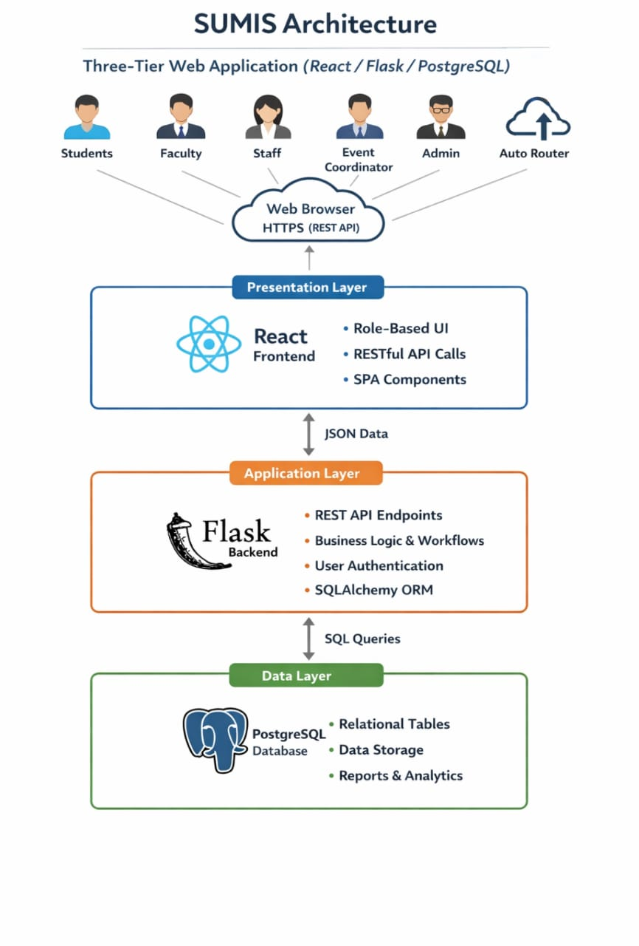

The Presentation Layer consists of React. Role-based rendering ensures that each actor type (student, faculty, department staff, event coordinator, administrator) accesses only authorized views. All client interactions—such as service requests, complaint submissions, and report retrieval—are handled asynchronously via secure API calls.
The Flask Application Layer exposes REST endpoints, enforces authentication and authorization, and implements the business logic for all 20 functional requirements, including automated routing and workflow state transitions. SQL Alchemy ORM is used to map Python models to relational tables, abstracting database operations and ensuring data consistency.
The Data Layer is a normalized PostgreSQL database with 20+ relational tables representing system entities and transactional records. PostgreSQL ensures ACID compliance, referential integrity, and efficient query performance for management reporting. Deployment is achievable on platforms such as Render, with GitHub used for version control and collaboration.

2.10 Use Case Model
The UML Use Case Diagram below identifies all six actors and maps each of the 20 functional requirements to its corresponding use cases within the SUMIS system boundary. The diagram was constructed following standard UML 2.5 notation.

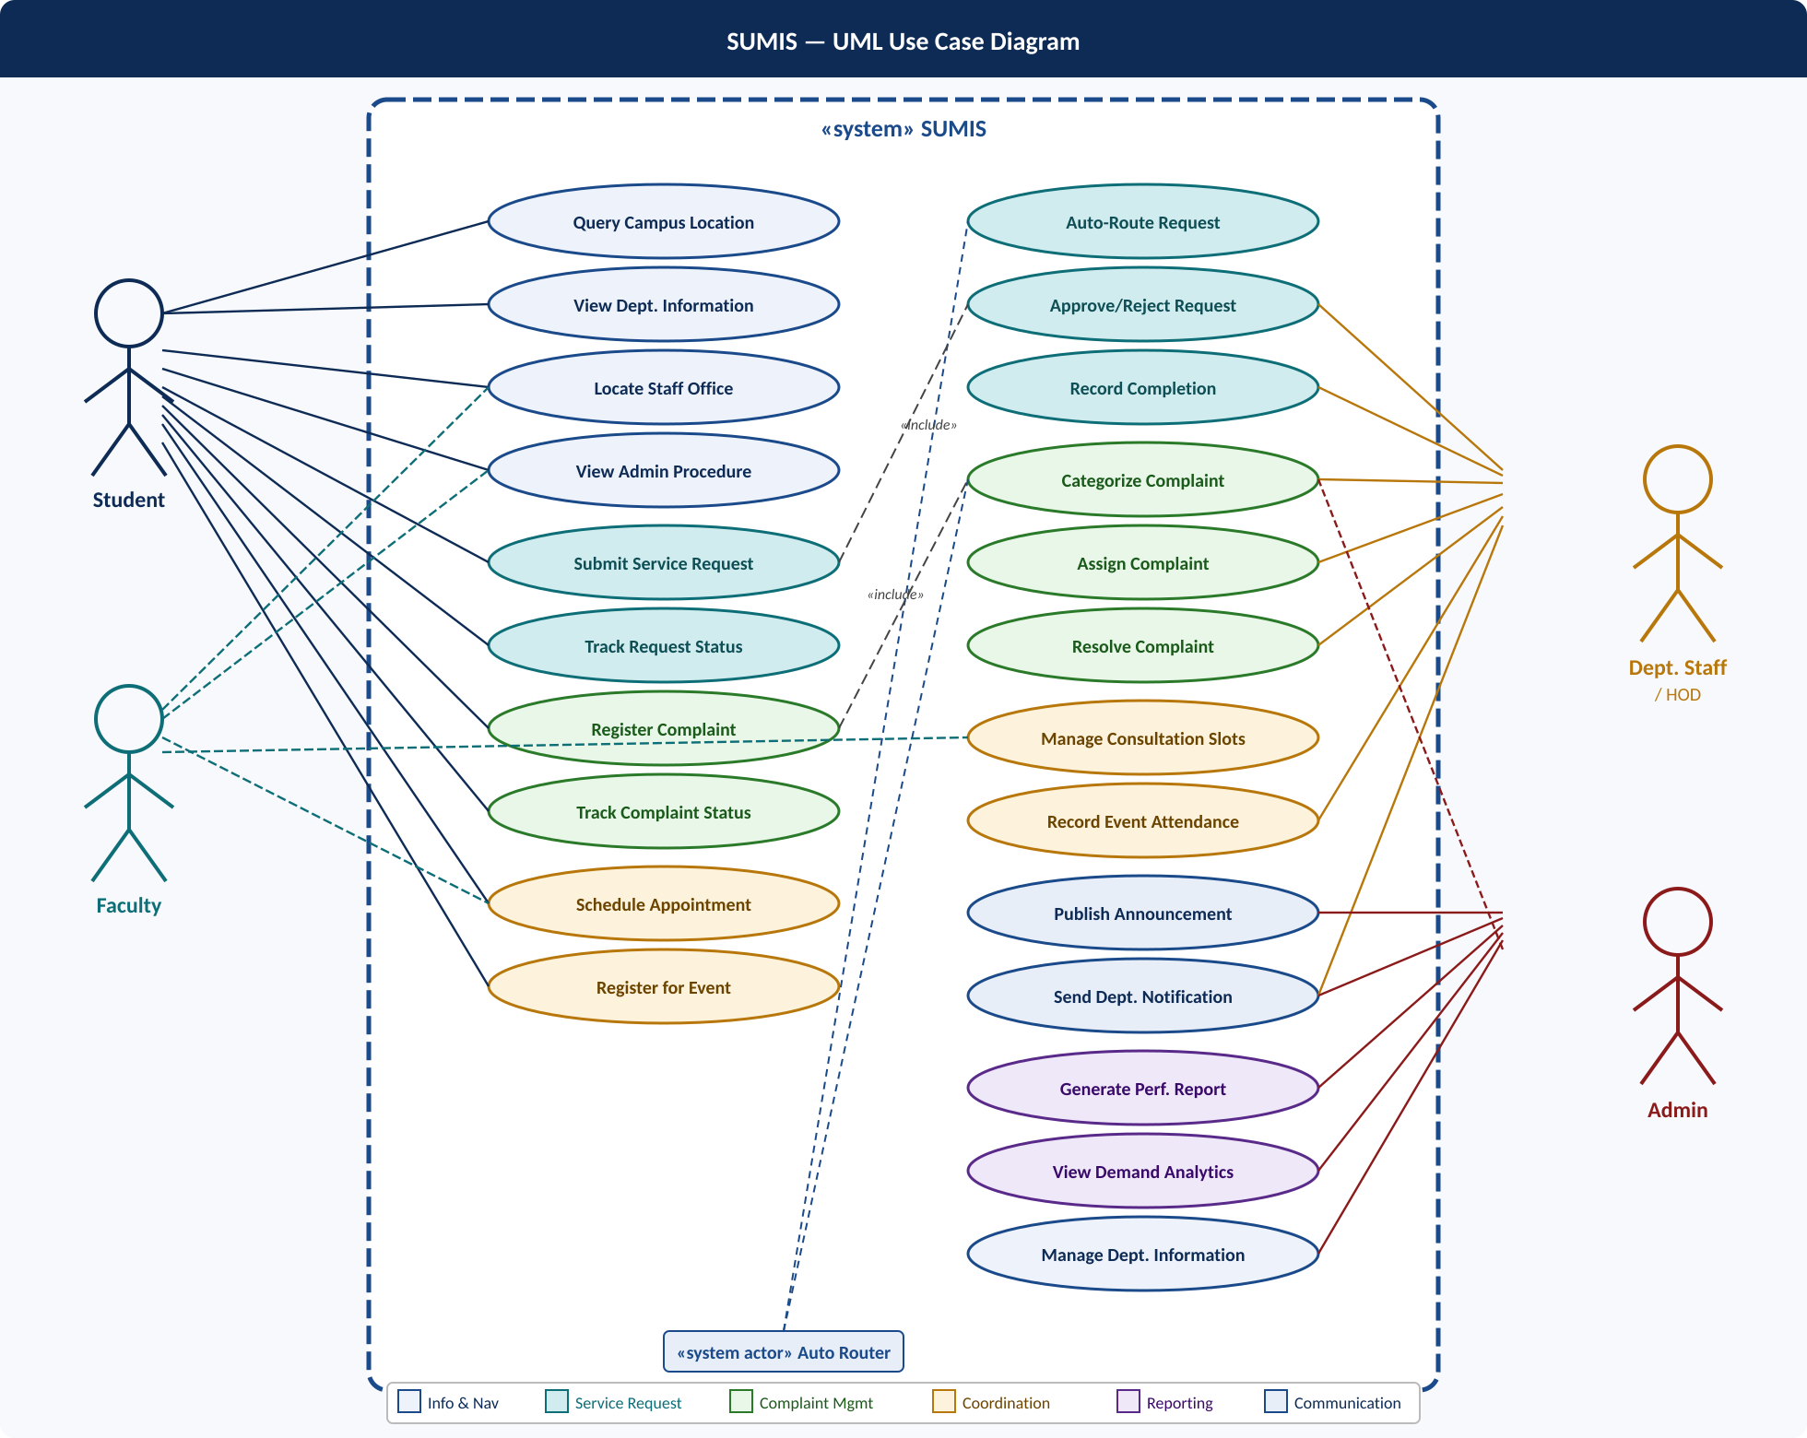
Figure 2: SUMIS UML Use Case Diagram — 6 Actors, 20 Functional Requirements
Actors and their primary interactions:

Actor | Type | Key Use Cases
Student | Primary — initiates most transactions | Query Location, View Dept Info, Submit Service Request, Track Request, Register Complaint, Schedule Appointment, Register for Event
Faculty | Primary — manages availability | Manage Consultation Slots, Approve/Reject Request, Receive Announcements
Department Staff | Primary — processes work | Route Request, Approve/Reject Request, Record Completion, Categorize & Assign Complaint, Resolve Complaint, Send Notification
Event Coordinator | Primary — manages events | Manage Event Registrations, Record Attendance, Publish Announcements
Admin | Primary — oversight & reports | Manage Department Info, Prioritize Complaints, Publish Announcements, Generate Reports, View Analytics
Auto Router | System Actor — executes rules | Auto-Route Service Requests, Auto-Categorize Complaints

2.11 Feature List
The 20-core domain functional requirements of SUMIS are listed below. These describe real university business processes only — non-functional requirements, UI design choices, and technology specifications are excluded.

# | ID | Feature Name | Description | Domain
1 | FR-01 | Campus Location Query Processing | Process user queries to return exact location of department offices, labs, and service counters on campus. | Info & Nav
2 | FR-02 | Department Information Management | Maintain and retrieve structured records for each university department including services and contact personnel. | Info & Nav
3 | FR-03 | Faculty & Staff Office Locator | Enable searchable access to faculty office assignments, room numbers, and published consultation schedules. | Info & Nav
4 | FR-04 | Administrative Procedure Guidance | Deliver step-by-step procedural instructions for common university processes such as transcript requests and course withdrawal. | Info & Nav
5 | FR-05 | Service Request Submission | Accept and record official student requests for university services — documents, certificates, and administrative approvals. | Service Req.
6 | FR-06 | Automated Request Routing | Automatically evaluate and assign each submitted request to the correct administrative unit based on request type. | Service Req.
7 | FR-07 | Service Request Status Tracking | Enable users to monitor the current processing stage of any submitted service request through its full lifecycle. | Service Req.
8 | FR-08 | Request Approval / Rejection Processing | Allow responsible departments to evaluate requests, record approval or rejection decisions, and attach official remarks. | Service Req.
9 | FR-09 | Service Completion Recording | Record the formal completion of a service request after delivery, closing the lifecycle and updating workload records. | Service Req.
10 | FR-10 | Complaint Registration | Accept and record formal complaints from users regarding campus facilities, IT services, or administrative issues. | Complaint
11 | FR-11 | Complaint Categorization & Prioritization | Classify each complaint by issue type (facility, IT, academic) and assign an urgency priority level. | Complaint
12 | FR-12 | Complaint Assignment to Responsible Unit | Forward classified complaints to the relevant operational department accountable for resolution. | Complaint
13 | FR-13 | Complaint Resolution Tracking | Record and monitor complaint lifecycle events from submission through investigation and final resolution. | Complaint
14 | FR-14 | Faculty Appointment Scheduling | Allow students to formally request and confirm meetings with faculty based on published consultation slots. | Coordination
15 | FR-15 | Event Registration Management | Manage student enrollment in university seminars, workshops, and official events with capacity controls. | Coordination
16 | FR-16 | Attendance Recording for Events | Record and store verified participation of registered attendees at university events for institutional records. | Coordination
17 | FR-17 | University Announcement Distribution | Publish and archive official university-wide notices, policy updates, and administrative communications. | Communication
18 | FR-18 | Department-Specific Notification Mgmt | Enable departments to issue targeted service updates or instructions to associated students and staff. | Communication
19 | FR-19 | Operational Performance Reporting | Generate structured reports on request volumes, complaint resolution rates, and departmental workload. | Reporting
20 | FR-20 | Service Demand Analytics | Analyze aggregated trends in service usage and complaint types to support administrative resource planning. | Reporting

2.12 Software Development Methodology
We are using Agile Scrum adapted for a three-person academic team over 6 sprints of 2–3 weeks each.

Why Agile Scrum?
SUMIS has 20 well-defined requirements across six distinct domains. Scrum lets us deliver one working domain per sprint, which is far better than a Waterfall approach where nothing is testable until week 14. Early sprints also allow us to catch integration issues between our three separate modules before they become problematic. The sprint structure maps naturally to the six Flask Blueprint domains and the 16-week semester timeline.

How We Adapt Scrum:
- Sprint Length: 2–3 weeks (6 sprints total).
- Sprint Planning: Start of each sprint — team selects and assigns FRs as sprint backlog items, and identifies the corresponding Flask Blueprint and SQLAlchemy models to implement.
- Standups: 3 times per week via WhatsApp — progress, blockers, next steps (5 minutes each).
- Sprint Review: End of sprint — each member demos their completed Blueprint module to the team and Engr. Abdur Rehman.
- Sprint Retrospective: Brief written log — what worked, what did not, action items for next sprint.
- Product Owner: Usman Ahmed (Team Leader) — maintains backlog and prioritizes features.
- Version Control: GitHub with feature branches — no direct pushes to main; all merges via pull requests reviewed by at least one other team member.

2.13 Proposed Infrastructure Platform and Tools

Category | Tools / Technologies
Frontend | React
Backend Framework | Python Flask (MVC-style structure using Blueprints)
ORM | SQL Alchemy
Database | PostgreSQL
Authentication | Flask-Login, Flask-Bcrypt
Testing | PyTest (Python unit testing)
Version Control | Git, GitHub
IDE | Visual Studio Code
Project Tracking | GitHub Projects
Diagramming | draw.io (ER diagram, architecture, DFD), draw.io / Papyrus (UML)
Deployment | Render or PythonAnywhere (Flask app + PostgreSQL)
Communication | WhatsApp (team), Microsoft Teams (advisor meetings)

2.14 Project Timeline
The project follows a 16-week Agile Scrum schedule divided into 6 sprints. The Gantt chart below shows task owners and sprint boundaries across the full 16-week timeline.

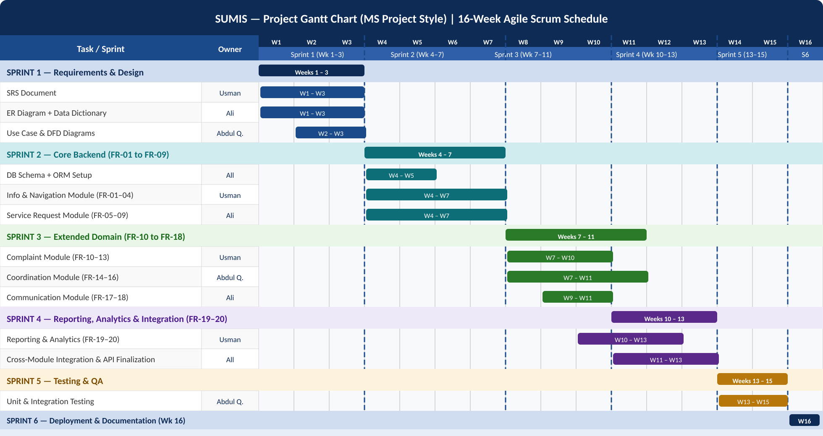
Figure 3: SUMIS Project Gantt Chart — 16-Week Agile Scrum Schedule

Sprint | Weeks | Focus Area | Key Deliverables
S1 | 1–3 | Requirements & Design | SRS, ER Diagram, Use Case Diagram, DFD, Wireframes, Data Dictionary, Flask project structure and Blueprint scaffold
S2 | 4–7 | Core Backend — FR-01 to FR-09 | PostgreSQL schema via SQL Alchemy, Flask-Login setup, Information & Navigation Blueprint (FR-01–04), Service Request Blueprint (FR-05–09)
S3 | 7–11 | Extended Domain — FR-10 to FR-18 | Complaint Blueprint (FR-10–13), Coordination Blueprint (FR-14–16), Communication Blueprint (FR-17–18), Jinja2 templates for all modules
S4 | 10–13 | Reporting, Analytics & Integration | FR-19–20 analytics queries, cross-Blueprint integration, automated routing engine testing, data consistency validation
S5 | 13–15 | Testing & QA | PyTest unit tests per Blueprint, integration tests, one round of UAT with real students, bug fix log
S6 | 16 | Deployment & Handover | Deployment to Render or PythonAnywhere, technical documentation, user manual, final presentation & demo

2.15 References
References are in IEEE citation format.

[1] R. S. Pressman and B. R. Maxim, Software Engineering: A Practitioner's Approach, 9th ed. New York, NY, USA: McGraw-Hill Education, 2020.
[2] I. Sommerville, Software Engineering, 10th ed. Harlow, UK: Pearson, 2015.
[3] K. Schwaber and J. Sutherland, "The Scrum Guide," Scrum.org, Nov. 2020. [Online]. Available: https://scrumguides.org/scrum-guide.html [Accessed: Feb. 2025].
[4] Object Management Group (OMG), "Unified Modelling Language (UML) Specification, v2.5.1," 2017. [Online]. Available: https://www.omg.org/spec/UML/ [Accessed: Feb. 2025].
[5] IEEE Computer Society, "IEEE Recommended Practice for Software Requirements Specifications," IEEE Std 830-1998, IEEE, 1998.

SUMIS — Smart University Service & Information Management System
Usman Ahmed · Ali Mobin · Abdul Qadir | Supervisor: Engr. Abdur Rehman
FAST-NUCES Karachi · Python Flask · BS Computer Science 6th Semester · February 2025

