**Database Engineering**

**CEP Lab Report**

**Phase # 2**



**Semester: Spring 2022**

**Lab Instructor: Mr. Umer Shahid**

**SUBMITTED BY:**

**Hassan Iftikhar (2018-EE-13)**

**Ashar Khan (2018-EE-18)**

**SECTION-A**

**Department of Electrical Engineering**

**University of Engineering and Technology, Lahore**

**Hospital Management System**

**Updated EER Diagram:**

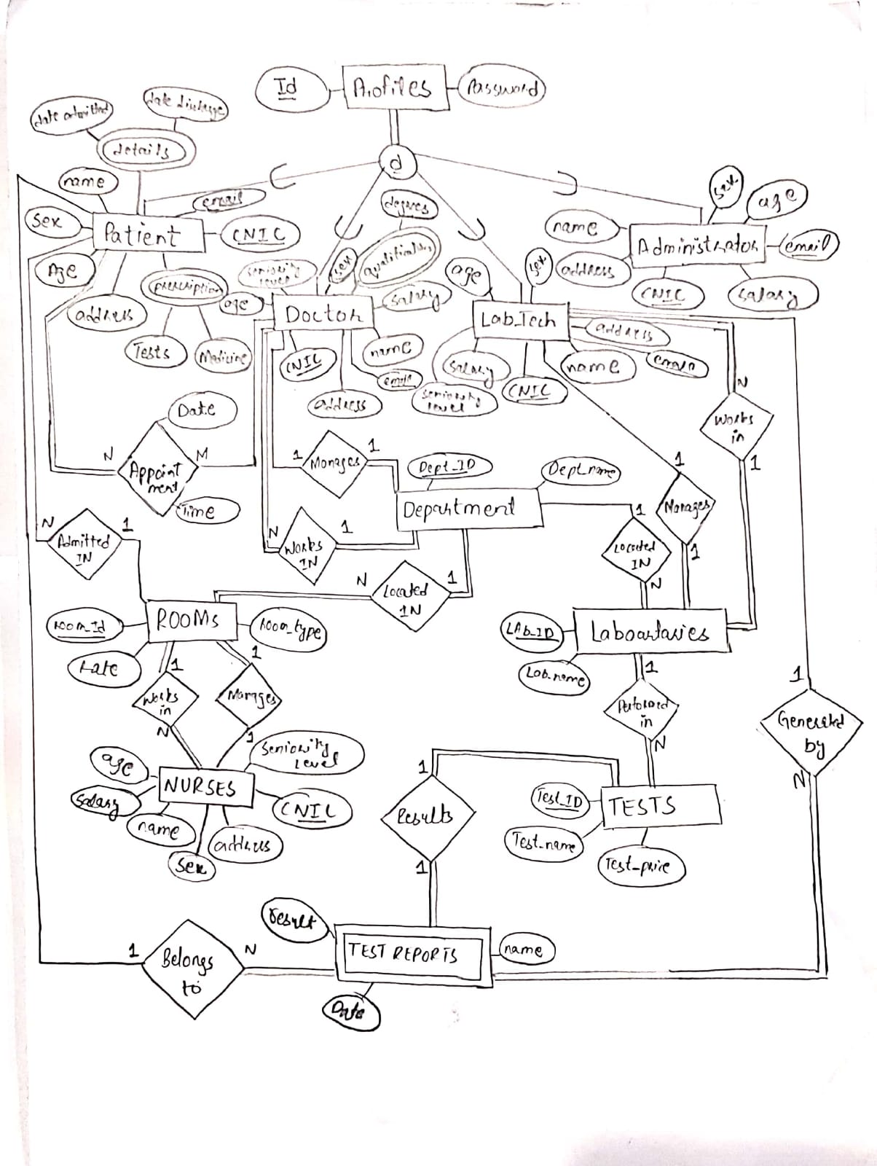

**Schema:**

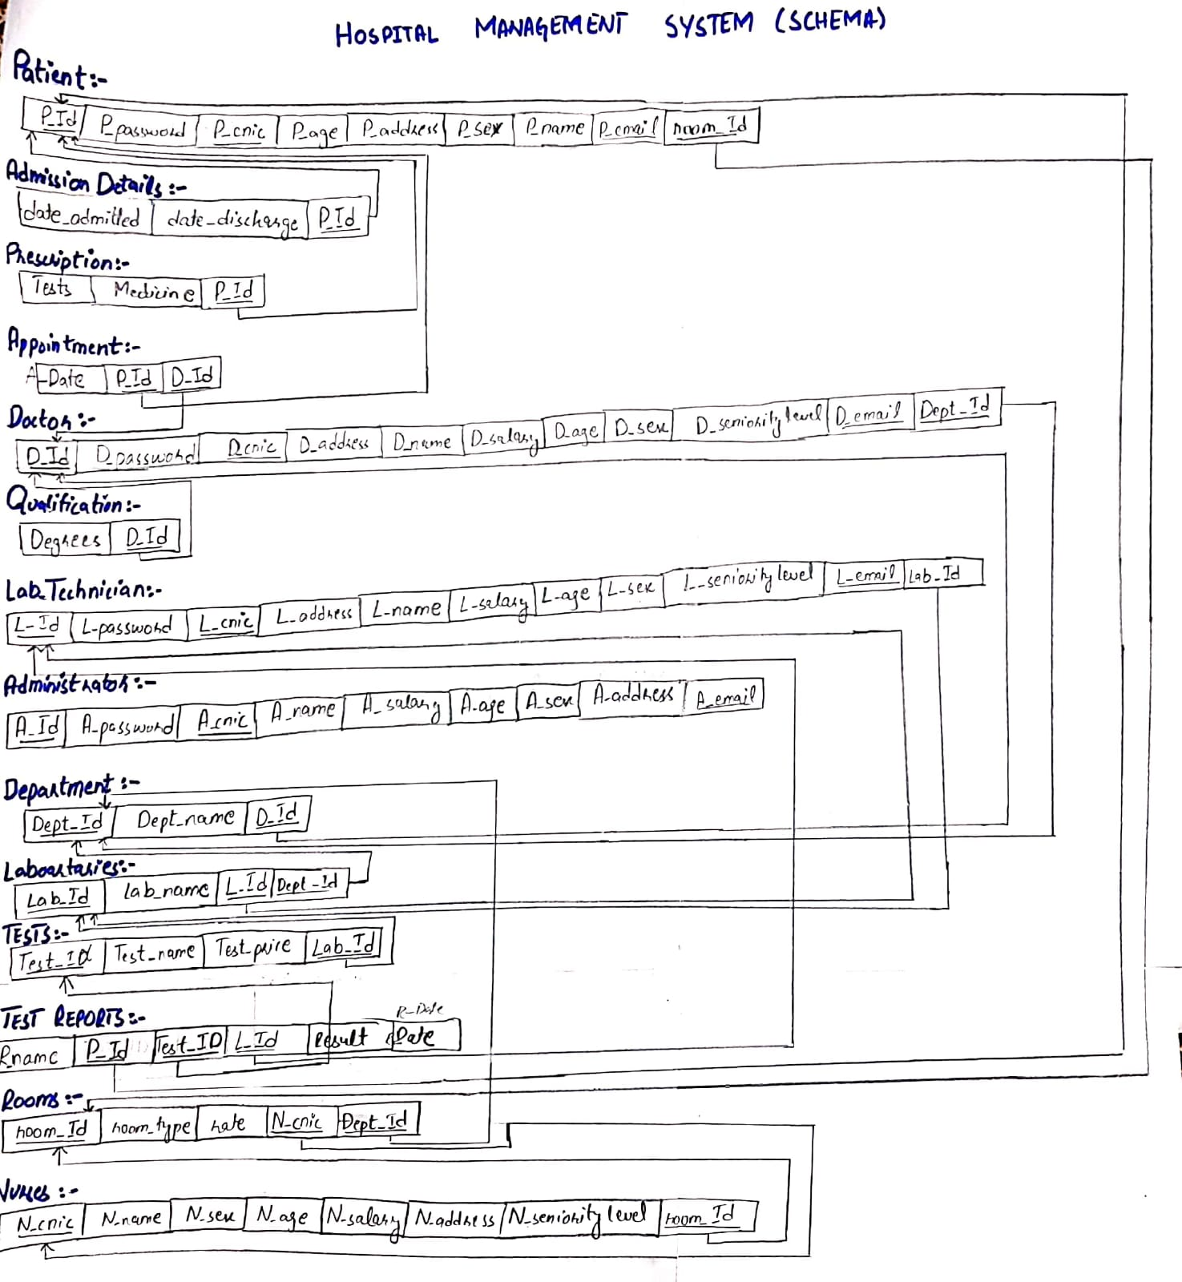

**Table Creation**:

CREATE SCHEMA IF NOT EXISTS `CEP` ;

USE `CEP`;

CREATE TABLE if not exists `cep`.`patient` (

`P_Id` INT NOT NULL,

`P_password` VARCHAR(45) NOT NULL,

`P_cnic` int NOT NULL,

`P_age` VARCHAR(45) NOT NULL,

`P_address` VARCHAR(45) NOT NULL,

`P_sex` VARCHAR(45) NOT NULL,

`P_name` VARCHAR(45) NOT NULL,

`P_email` VARCHAR(45) NOT NULL,

`room_Id` VARCHAR(45) NOT NULL,

PRIMARY KEY (`P_Id`)

-- constraint `patient` foreign key (`room_Id`) references `rooms`(`room_Id`)

);

create table if not exists Admission_Details(

data_admitted datetime not null,

date_discharge datetime not null,

P_Id int not null,

primary key(P_Id),

foreign key (P_Id) references patient(P_Id)

);

create table if not exists prescription(

tests varchar(100),

medicine varchar(45),

P_Id int not null,

foreign key (P_Id) references patient(P_Id)

);

create table appointment(

A_Date datetime,

P_Id int not null,

D_Id int not null

-- foreign key (D_Id) references doctor (D_Id),

-- foreign key (P_Id) references patient (P_Id)

);

create table doctor (

D_Id int not null,

D_password varchar(45) not null,

D_cnic int not null,

D_address varchar(45) not null,

D_name varchar(45) not null,

D_salary int not null,

D_age int not null,

D_sex varchar(5) not null,

D_senioritylevel varchar(10) not null,

D_email varchar(45) not null,

Dept_Id int not null,

primary key (D_Id)

-- foreign key (Dept_Id) references department (Dept_Id)

);

create table qualification(

degrees varchar(45),

D_Id int not null,

foreign key (D_Id) references doctor(D_Id)

);

create table lab_technician(

L_Id int not null,

L_password varchar(45) not null,

L_cnic int not null,

L_address varchar(100) not null,

L_name varchar(45) not null,

L_salary int not null,

L_age int not null,

L_sex varchar(10) not null,

L_senioritylevel varchar(45) not null,

L_email varchar(45) not null,

Lab_Id int not null,

primary key (L_Id)

-- foreign key (Lab_Id) references laboratories (Lab_Id)

);

create table administrator (

A_Id int not null,

A_password varchar(45) not null,

A_cnic int not null,

A_name varchar(45) not null,

A_salary int not null,

A_age int not null,

A_sex varchar(10) not null,

A_address varchar(45) not null,

A_email varchar(45) not null,

primary key (A_Id)

);

create table department (

Dept_Id int not null,

Dept_name varchar(45) not null,

D_Id int not null,

primary key (Dept_Id),

foreign key (D_Id) references doctor (D_Id)

);

create table laboratories(

Lab_Id int not null,

Lab_name varchar(45) not null,

L_Id int not null,

Dept_Id int not null,

primary key (Lab_Id),

foreign key (L_Id) references lab_technician (L_Id),

foreign key (Dept_Id) references department (Dept_Id)

);

create table if not exists tests(

Test_Id int not null,

Test_name varchar(45) not null,

Test_price int not null,

Lab_Id int not null,

primary key (Test_Id),

foreign key (Lab_Id) references laboratories(Lab_Id)

);

create table if not exists test_reports(

R_name varchar(45) not null,

P_Id int not null,

Test_Id int not null,

L_Id int not null,

Result varchar(45),

R_date datetime,

foreign key (P_Id) references patient(P_Id),

foreign key (L_Id) references lab_technician(L_Id),

foreign key (Test_Id) references tests(Test_Id)

);

create table if not exists rooms(

room_Id int not null,

room_type varchar(45),

rate int not null,

N_cnic int not null,

Dept_Id int not null,

primary key(room_Id),

foreign key (Dept_Id) references department (Dept_Id),

foreign key (N_cnic) references nurses(N_cnic)

);

create table nurses (

N_cnic int not null,

N_name varchar(45) not null,

N_sex varchar(10),

N_age int not null,

N_salary int not null,

N_address varchar(45),

N_senioritylevel varchar(45),

room_Id int not null,

primary key(N_cnic),

foreign key (room_Id) references rooms(room_Id)

);

**Frontend view screenshots:**

**View 1:**

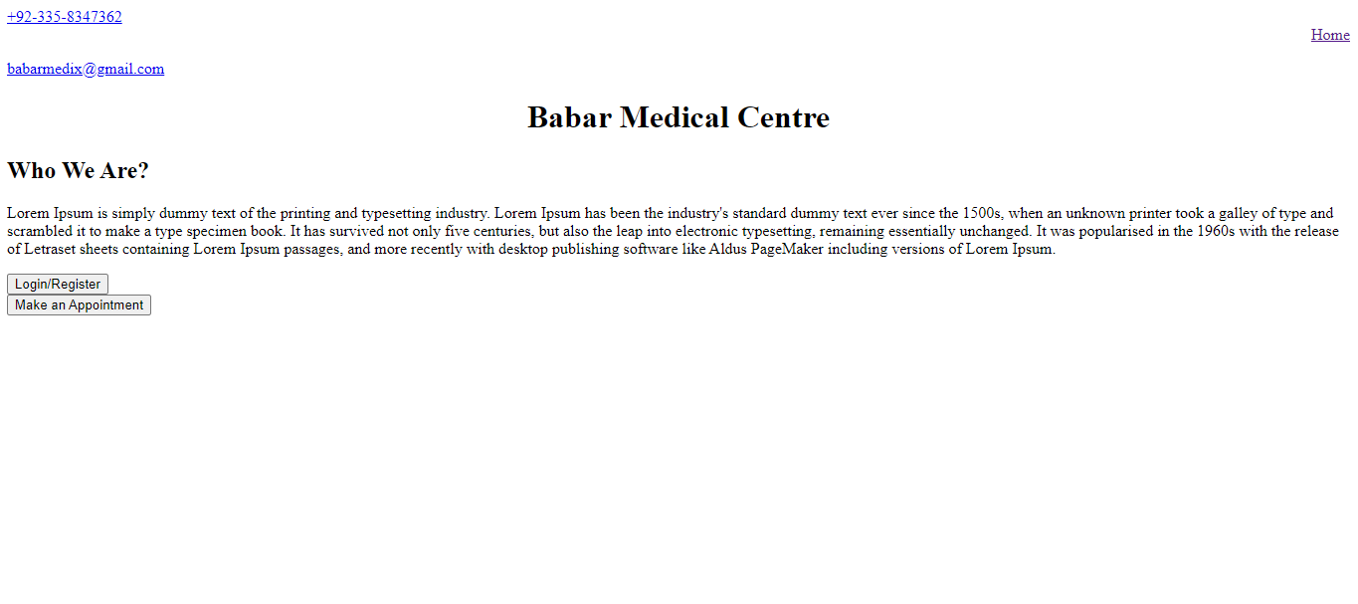

This the Homepage view that will appear when are website is opened.

**HTML Statements:**

<!DOCTYPE html>

<html lang="en" dir="ltr">

<head>

<style>

h1 {text-align: center;}

.home{text-align: right;}

</style>

<meta charset="utf-8">

<title>Babar Medical Centre</title>

</head>

<body>

<a href="#">+92-335-8347362</a>

<div class="home">

<a href="homepage.html">Home</a>

</div>

<p><a href="http://gmail.com">babarmedix@gmail.com</a></p>

<h1>Babar Medical Centre</h1>

<h2>Who We Are?</h2>

<p>Lorem Ipsum is simply dummy text of the printing and typesetting industry. Lorem Ipsum has been the industry's standard dummy text ever since the 1500s, when an unknown printer took a galley of type and scrambled it to make a type specimen book. It has survived not only five centuries, but also the leap into electronic typesetting, remaining essentially unchanged. It was popularised in the 1960s with the release of Letraset sheets containing Lorem Ipsum passages, and more recently with desktop publishing software like Aldus PageMaker including versions of Lorem Ipsum.</p>

<form class="" action="login.html" method="post">

<input type="submit" name="Login" value="Login/Register">

</form>

<form class="" action="login1.html" method="post">

<input type="submit" name="Login" value="Make an Appointment">

</form>

</body>

</html>

**View 2:**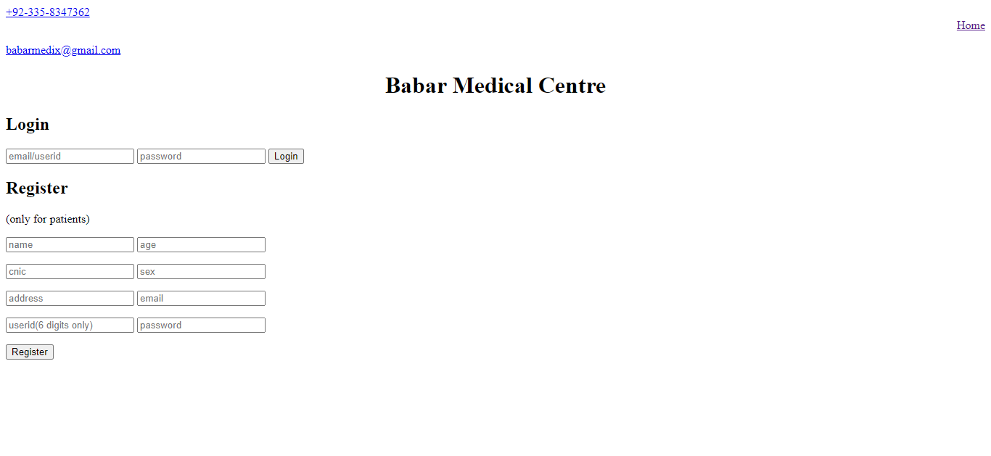

This is the login/register view, it will appear when Login/Register button is clicked on homepage.

**Html Statements:**

<!DOCTYPE html>

<html lang="en" dir="ltr">

<head>

<style>

h1 {text-align: center;}

.home{text-align: right;}

</style>

<meta charset="utf-8">

<title>Babar Medical Centre</title>

</head>

<body>

<a href="#">+92-335-8347362</a>

<div class="home">

<a href="homepage.html">Home</a>

</div>

<p><a href="http://gmail.com">babarmedix@gmail.com</a></p>

<h1>Babar Medical Centre</h1>

<h2>Login</h2>

<form class="" action="http://www.facebook.com" method="post">

<input type="email" name="Login ID" placeholder="email/userid">

<input type="text" name="Password" placeholder="password">

<input type="submit" name="Login" value="Login">

</form>

<h2>Register</h2> <p>(only for patients)</p>

<form class="" action="postregister.html" method="post">

<p><input type="text" name="name" placeholder="name">

<input type="text" name="age" placeholder="age"></p>

<p><input type="text" name="cnic" placeholder="cnic">

<input type="text" name="sex" placeholder="sex"></p>

<p><input type="text" name="address" placeholder="address">

<input type="text" name="email" placeholder="email"></p>

<p><input type="text" name="userid" placeholder="userid(6 digits only)">

<input type="text" name="password" placeholder="password"></p>

<input type="submit" name="Login" value="Register">

</form>

</body>

</html>

**View 3:**

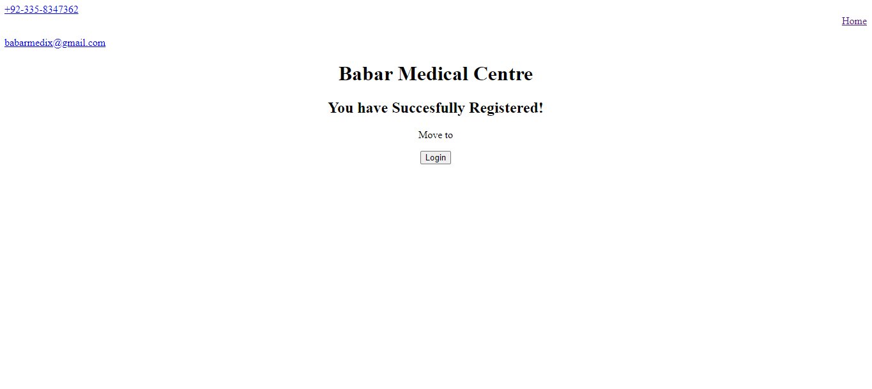

This is the post registration view, appear after registration of the user.

**Html Statements:**

<!DOCTYPE html>

<html lang="en" dir="ltr">

<head>

<style>

h1 {text-align: center;}

.home{text-align: right;}

.postreg{text-align:center;}

</style>

<meta charset="utf-8">

<title>Registered</title>

</head>

<body>

<a href="#">+92-335-8347362</a>

<div class="home">

<a href="homepage.html">Home</a>

</div>

<p><a href="http://gmail.com">babarmedix@gmail.com</a></p>

<h1>Babar Medical Centre</h1>

<div class="postreg">

<h2>You have Succesfully Registered!</h2>

<p>Move to</p> <form class="" action="login2.html" method="post">

<input type="submit" name="Login" value="Login">

</form>

</div>

</body>

</html>

**View 4:**

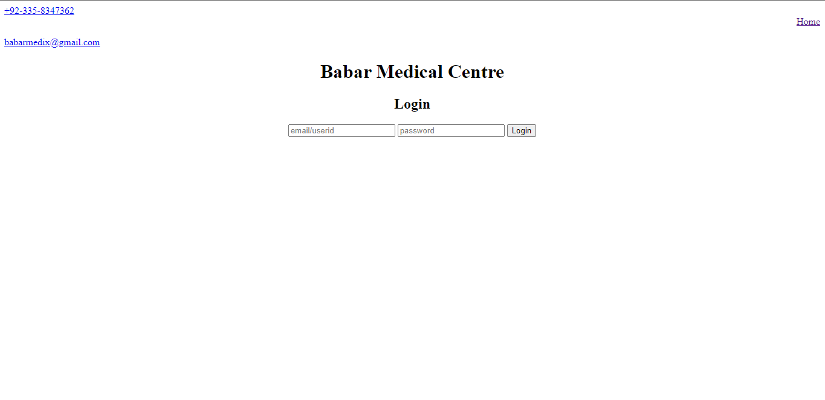

This page will appear when the login button on the post registration view is clicked.

**Html Statements:**

<!DOCTYPE html>

<html lang="en" dir="ltr">

<head>

<style>

h1 {text-align: center;}

.home{text-align: right;}

.login{text-align: center;}

</style>

<meta charset="utf-8">

<title>Login</title>

</head>

<body>

<a href="#">+92-335-8347362</a>

<div class="home">

<a href="homepage.html">Home</a>

</div>

<p><a href="http://gmail.com">babarmedix@gmail.com</a></p>

<h1>Babar Medical Centre</h1>

<div class="login">

<h2>Login</h2>

<form class="" action="http://www.facebook.com" method="post">

<input type="email" name="Login ID" placeholder="email/userid">

<input type="text" name="Password" placeholder="password">

<input type="submit" name="Login" value="Login">

</form>

</div>

</body>

</html>

**View 5:**

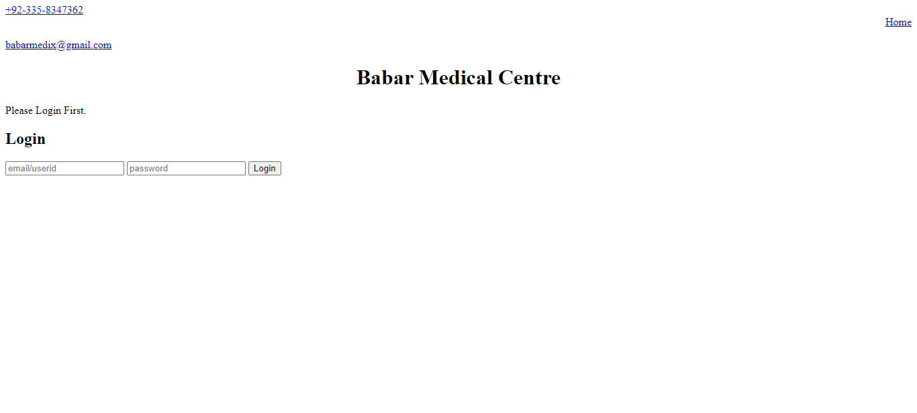

This will appear when the Make an appointment button is clicked on the homepage.

**Html Statements:**

<!DOCTYPE html>

<html lang="en" dir="ltr">

<head>

<style>

h1 {text-align: center;}

.home{text-align: right;}

</style>

<meta charset="utf-8">

<title>Babar Medical Centre</title>

</head>

<body>

<a href="#">+92-335-8347362</a>

<div class="home">

<a href="homepage.html">Home</a>

</div>

<p><a href="http://gmail.com">babarmedix@gmail.com</a></p>

<h1>Babar Medical Centre</h1>

<p>Please Login First.</p>

<h2>Login</h2>

<form class="" action="http://www.facebook.com" method="post">

<input type="email" name="Login ID" placeholder="email/userid">

<input type="text" name="Password" placeholder="password">

<input type="submit" name="Login" value="Login">

</form>

</body>

</html>

**View 6:**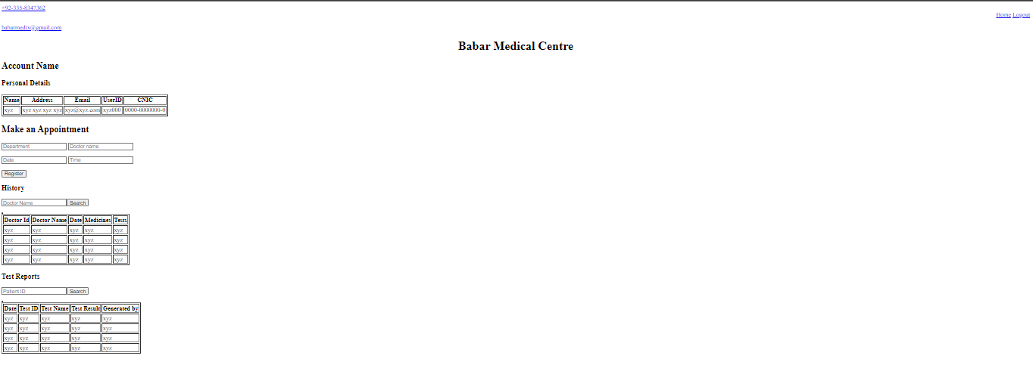

This view will appear when a patient will login in our website.

**Html Statements:**

!DOCTYPE html>

<html lang="en" dir="ltr">

<head>

<style>

h1 {text-align: center;}

.home{text-align: right;}

</style>

<meta charset="utf-8">

<title>Profile</title>

</head>

<body>

<a href="#">+92-335-8347362</a>

<div class="home">

<a href="homepage.html">Home</a>

<a href="login.html">Logout</a>

</div>

<p><a href="http://gmail.com">babarmedix@gmail.com</a></p>

<h1>Babar Medical Centre</h1>

<h2>Account Name</h2>

<h3>Personal Details</h3>

<table border="1">

<thead>

<th>Name</th>

<th>Address</th>

<th>Email</th>

<th>UserID</th>

<th>CNIC</th>

</thead>

<tr>

<td>xyz</td>

<td>xyz xyz xyz xyz</td>

<td>xyz@xyz.com</td>

<td>xyz000</td>

<td>0000-0000000-0</td>

</tr>

</table>

<h2>Make an Appointment</h2>

<form class="" action="" method="post">

<p><input type="text" name="dept" placeholder="Department">

<input type="text" name="name" placeholder="Doctor name"></p>

<p><input type="text" name="date" placeholder="Date">

<input type="text" name="time" placeholder="Time"></p>

<input type="submit" name="register" value="Register">

</form>

<h3>History</h3>

<form class="" action="" method="post">

<p><input type="text" name="search" placeholder="Doctor Name"><input type="submit" name="search" value="Search"></p>

</form>

<table>

<table border="1">

<table border="1">

<thead>

<th>Doctor Id</th>

<th>Doctor Name</th>

<th>Date</th>

<th>Medicines</th>

<th>Tests</th>

</thead>

<tr>

<td>xyz</td>

<td>xyz</td>

<td>xyz</td>

<td>xyz</td>

<td>xyz</td>

</tr>

<tr>

<td>xyz</td>

<td>xyz</td>

<td>xyz</td>

<td>xyz</td>

<td>xyz</td>

</tr>

<tr>

<td>xyz</td>

<td>xyz</td>

<td>xyz</td>

<td>xyz</td>

<td>xyz</td>

</tr>

<tr>

<td>xyz</td>

<td>xyz</td>

<td>xyz</td>

<td>xyz</td>

<td>xyz</td>

</tr>

</table>

<table>

<h3>Test Reports</h3>

<form class="" action="" method="post">

<p><input type="text" name="search" placeholder="Patient ID"><input type="submit" name="search" value="Search"></p>

</form>

<table border="1">

<table border="1">

<thead>

<th>Date</th>

<th>Test ID</th>

<th>Test Name</th>

<th>Test Result</th>

<th>Generated by</th>

</thead>

<tr>

<td>xyz</td>

<td>xyz</td>

<td>xyz</td>

<td>xyz</td>

<td>xyz</td>

</tr>

<tr>

<td>xyz</td>

<td>xyz</td>

<td>xyz</td>

<td>xyz</td>

<td>xyz</td>

</tr>

<tr>

<td>xyz</td>

<td>xyz</td>

<td>xyz</td>

<td>xyz</td>

<td>xyz</td>

</tr>

<tr>

<td>xyz</td>

<td>xyz</td>

<td>xyz</td>

<td>xyz</td>

<td>xyz</td>

</tr>

</table>

</body>

</html>

**View 7:**

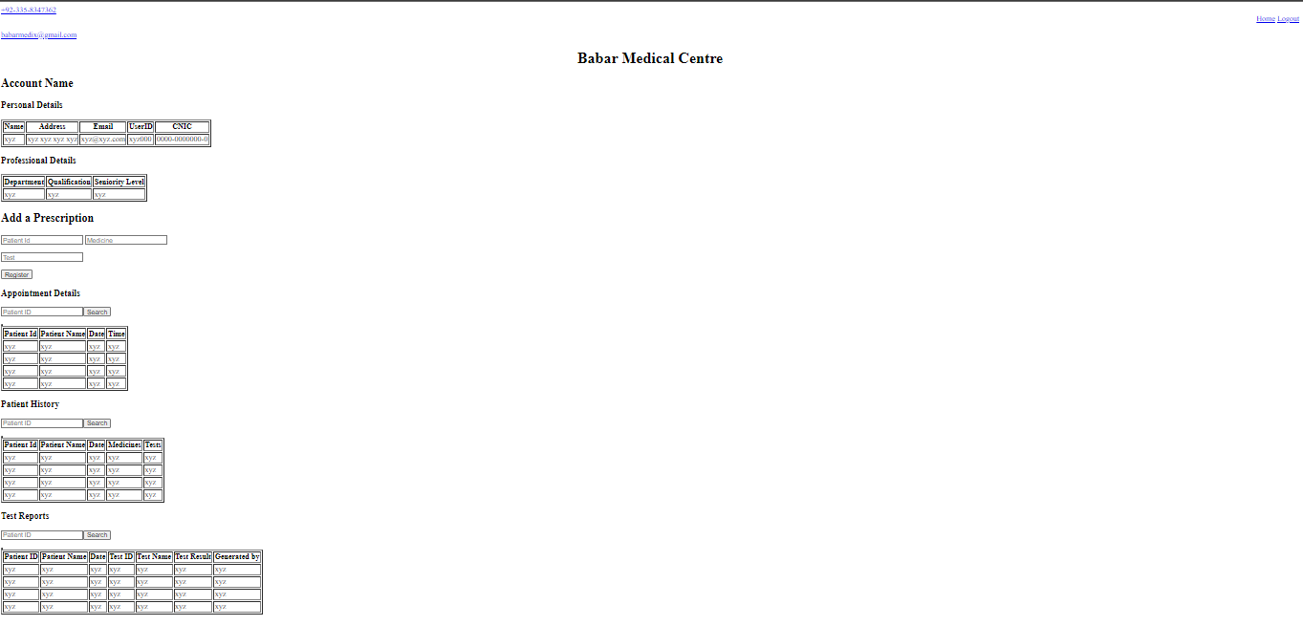

This view will appear when a doctor will login in our website.

**Html Statements:**

<!DOCTYPE html>

<html lang="en" dir="ltr">

<head>

<style>

h1 {text-align: center;}

.home{text-align: right;}

</style>

<meta charset="utf-8">

<title>Profile</title>

</head>

<body>

<a href="#">+92-335-8347362</a>

<div class="home">

<a href="homepage.html">Home</a>

<a href="login.html">Logout</a>

</div>

<p><a href="http://gmail.com">babarmedix@gmail.com</a></p>

<h1>Babar Medical Centre</h1>

<h2>Account Name</h2>

<h3>Personal Details</h3>

<table border="1">

<thead>

<th>Name</th>

<th>Address</th>

<th>Email</th>

<th>UserID</th>

<th>CNIC</th>

</thead>

<tr>

<td>xyz</td>

<td>xyz xyz xyz xyz</td>

<td>xyz@xyz.com</td>

<td>xyz000</td>

<td>0000-0000000-0</td>

</tr>

</table>

<h3>Professional Details</h3>

<table border="1">

<thead>

<th>Department</th>

<th>Qualification</th>

<th>Seniority Level</th>

</thead>

<tr>

<td>xyz</td>

<td>xyz</td>

<td>xyz</td>

</tr>

</table>

<h2>Add a Prescription</h2>

<form class="" action="" method="post">

<p><input type="text" name="Patient Id" placeholder="Patient Id">

<input type="text" name="medicine " placeholder="Medicine"></p>

<p><input type="text" name="Test " placeholder="Test"></p>

<input type="submit" name="register" value="Register">

</form>

<h3>Appointment Details</h3>

<form class="" action="" method="post">

<p><input type="text" name="search" placeholder="Patient ID"><input type="submit" name="search" value="Search"></p>

</form>

<table border="1">

<table border="1">

<thead>

<th>Patient Id</th>

<th>Patient Name</th>

<th>Date</th>

<th>Time</th>

</thead>

<tr>

<td>xyz</td>

<td>xyz</td>

<td>xyz</td>

<td>xyz</td>

</tr>

<tr>

<td>xyz</td>

<td>xyz</td>

<td>xyz</td>

<td>xyz</td>

</tr>

<tr>

<td>xyz</td>

<td>xyz</td>

<td>xyz</td>

<td>xyz</td>

</tr>

<tr>

<td>xyz</td>

<td>xyz</td>

<td>xyz</td>

<td>xyz</td>

</tr>

</table>

<h3>Patient History</h3>

<form class="" action="" method="post">

<p><input type="text" name="search" placeholder="Patient ID"><input type="submit" name="search" value="Search"></p>

</form>

<table border="1">

<table border="1">

<thead>

<th>Patient Id</th>

<th>Patient Name</th>

<th>Date</th>

<th>Medicines</th>

<th>Tests</th>

</thead>

<tr>

<td>xyz</td>

<td>xyz</td>

<td>xyz</td>

<td>xyz</td>

<td>xyz</td>

</tr>

<tr>

<td>xyz</td>

<td>xyz</td>

<td>xyz</td>

<td>xyz</td>

<td>xyz</td>

</tr>

<tr>

<td>xyz</td>

<td>xyz</td>

<td>xyz</td>

<td>xyz</td>

<td>xyz</td>

</tr>

<tr>

<td>xyz</td>

<td>xyz</td>

<td>xyz</td>

<td>xyz</td>

<td>xyz</td>

</tr>

</table>

<h3>Test Reports</h3>

<form class="" action="" method="post">

<p><input type="text" name="search" placeholder="Patient ID"><input type="submit" name="search" value="Search"></p>

</form>

<table border="1">

<table border="1">

<thead>

<th>Patient ID</th>

<th>Patient Name</th>

<th>Date</th>

<th>Test ID</th>

<th>Test Name</th>

<th>Test Result</th>

<th>Generated by</th>

</thead>

<tr>

<td>xyz</td>

<td>xyz</td>

<td>xyz</td>

<td>xyz</td>

<td>xyz</td>

<td>xyz</td>

<td>xyz</td>

</tr>

<tr>

<td>xyz</td>

<td>xyz</td>

<td>xyz</td>

<td>xyz</td>

<td>xyz</td>

<td>xyz</td>

<td>xyz</td>

</tr>

<tr>

<td>xyz</td>

<td>xyz</td>

<td>xyz</td>

<td>xyz</td>

<td>xyz</td>

<td>xyz</td>

<td>xyz</td>

</tr>

<tr>

<td>xyz</td>

<td>xyz</td>

<td>xyz</td>

<td>xyz</td>

<td>xyz</td>

<td>xyz</td>

<td>xyz</td>

</tr>

</body>

</html>

**View 8:**

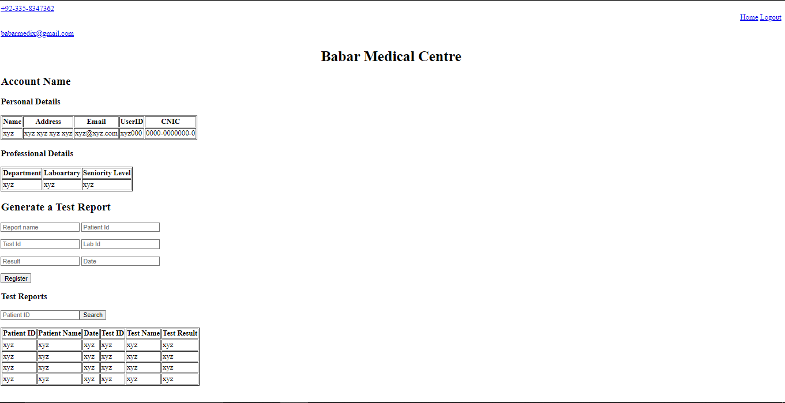This view will appear when a Lab Technician will login.

**Html Statements:**

<!DOCTYPE html>

<html lang="en" dir="ltr">

<head>

<style>

h1 {text-align: center;}

.home{text-align: right;}

</style>

<meta charset="utf-8">

<title>Profile</title>

</head>

<body>

<a href="#">+92-335-8347362</a>

<div class="home">

<a href="homepage.html">Home</a>

<a href="login.html">Logout</a>

</div>

<p><a href="http://gmail.com">babarmedix@gmail.com</a></p>

<h1>Babar Medical Centre</h1>

<h2>Account Name</h2>

<h3>Personal Details</h3>

<table border="1">

<thead>

<th>Name</th>

<th>Address</th>

<th>Email</th>

<th>UserID</th>

<th>CNIC</th>

</thead>

<tr>

<td>xyz</td>

<td>xyz xyz xyz xyz</td>

<td>xyz@xyz.com</td>

<td>xyz000</td>

<td>0000-0000000-0</td>

</tr>

</table>

<h3>Professional Details</h3>

<table border="1">

<thead>

<th>Department</th>

<th>Laboartary</th>

<th>Seniority Level</th>

</thead>

<tr>

<td>xyz</td>

<td>xyz</td>

<td>xyz</td>

</tr>

</table>

</form>

<h2>Generate a Test Report</h2>

<form class="" action="" method="post">

<p><input type="text" name="name" placeholder="Report name">

<input type="text" name="Patient Id" placeholder="Patient Id"></p>

<p><input type="text" name="Test Id" placeholder="Test Id">

<input type="text" name="Lab Id" placeholder="Lab Id"></p>

<p><input type="text" name="result" placeholder="Result">

<input type="text" name="Date" placeholder="Date"></p>

<input type="submit" name="register" value="Register">

</form>

<h3>Test Reports</h3>

<form class="" action="" method="post">

<p><input type="text" name="search" placeholder="Patient ID"><input type="submit" name="search" value="Search"></p>

</form>

<table border="1">

<thead>

<th>Patient ID</th>

<th>Patient Name</th>

<th>Date</th>

<th>Test ID</th>

<th>Test Name</th>

<th>Test Result</th>

</thead>

<tr>

<td>xyz</td>

<td>xyz</td>

<td>xyz</td>

<td>xyz</td>

<td>xyz</td>

<td>xyz</td>

</tr>

<tr>

<td>xyz</td>

<td>xyz</td>

<td>xyz</td>

<td>xyz</td>

<td>xyz</td>

<td>xyz</td>

</tr>

<tr>

<td>xyz</td>

<td>xyz</td>

<td>xyz</td>

<td>xyz</td>

<td>xyz</td>

<td>xyz</td>

</tr>

<tr>

<td>xyz</td>

<td>xyz</td>

<td>xyz</td>

<td>xyz</td>

<td>xyz</td>

<td>xyz</td>

</tr>

</body>

</html>

**View 9:**

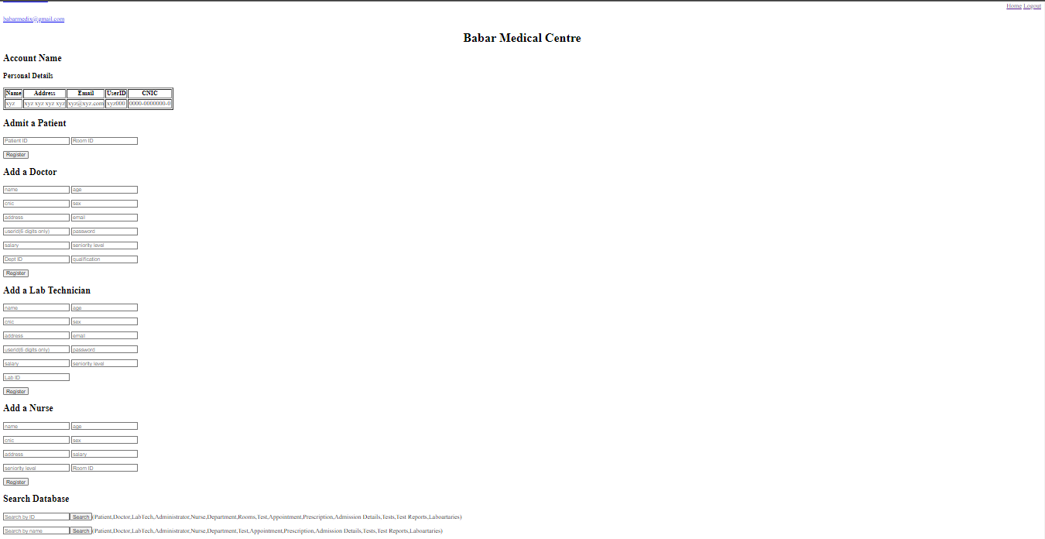

This is the administrator’s view.

**Html Statements:**

<!DOCTYPE html>

<html lang="en" dir="ltr">

<head>

<style>

h1 {text-align: center;}

.home{text-align: right;}

</style>

<meta charset="utf-8">

<title>Profile</title>

</head>

<body>

<a href="#">+92-335-8347362</a>

<div class="home">

<a href="homepage.html">Home</a>

<a href="login.html">Logout</a>

</div>

<p><a href="http://gmail.com">babarmedix@gmail.com</a></p>

<h1>Babar Medical Centre</h1>

<h2>Account Name</h2>

<h3>Personal Details</h3>

<table border="1">

<thead>

<th>Name</th>

<th>Address</th>

<th>Email</th>

<th>UserID</th>

<th>CNIC</th>

</thead>

<tr>

<td>xyz</td>

<td>xyz xyz xyz xyz</td>

<td>xyz@xyz.com</td>

<td>xyz000</td>

<td>0000-0000000-0</td>

</tr>

</table>

<h2>Admit a Patient</h2>

<form class="" action="" method="post">

<p><input type="text" name="patient id" placeholder="Patient ID">

<input type="text" name="room id" placeholder="Room ID"></p>

<input type="submit" name="register" value="Register">

</form>

<h2>Add a Doctor</h2>

<form class="" action="" method="post">

<p><input type="text" name="name" placeholder="name">

<input type="text" name="age" placeholder="age"></p>

<p><input type="text" name="cnic" placeholder="cnic">

<input type="text" name="sex" placeholder="sex"></p>

<p><input type="text" name="address" placeholder="address">

<input type="text" name="email" placeholder="email"></p>

<p><input type="text" name="userid" placeholder="userid(6 digits only)">

<input type="text" name="password" placeholder="password"></p>

<p><input type="text" name="salary" placeholder="salary">

<input type="text" name="seniority level" placeholder="seniority level"></p>

<p><input type="text" name="Dept" placeholder="Dept ID">

<input type="text" name="Degrees" placeholder="qualification"></p>

<input type="submit" name="register" value="Register">

</form>

<h2>Add a Lab Technician</h2>

<form class="" action="" method="post">

<p><input type="text" name="name" placeholder="name">

<input type="text" name="age" placeholder="age"></p>

<p><input type="text" name="cnic" placeholder="cnic">

<input type="text" name="sex" placeholder="sex"></p>

<p><input type="text" name="address" placeholder="address">

<input type="text" name="email" placeholder="email"></p>

<p><input type="text" name="userid" placeholder="userid(6 digits only)">

<input type="text" name="password" placeholder="password"></p>

<p><input type="text" name="salary" placeholder="salary">

<input type="text" name="seniority level" placeholder="seniority level"></p>

<p><input type="text" name="Lab" placeholder="Lab ID"></p>

<input type="submit" name="register" value="Register">

</form>

<h2>Add a Nurse</h2>

<form class="" action="" method="post">

<p><input type="text" name="name" placeholder="name">

<input type="text" name="age" placeholder="age"></p>

<p><input type="text" name="cnic" placeholder="cnic">

<input type="text" name="sex" placeholder="sex"></p>

<p><input type="text" name="address" placeholder="address">

<input type="text" name="salary" placeholder="salary"></p>

<p><input type="text" name="seniority level" placeholder="seniority level">

<input type="text" name="room" placeholder="Room ID"></p>

<input type="submit" name="register" value="Register">

</form>

<h2>Search Database</h2>

<form class="" action="" method="post">

<p><input type="text" name="ID" placeholder="Search by ID"><input type="submit" name="search" value="Search">(Patient,Doctor,LabTech,Administrator,Nurse,Department,Rooms,Test,Appointment,Prescription,Admission Details,Tests,Test Reports,Laboartaries)</p>

<p><input type="text" name="name" placeholder="Search by name"><input type="submit" name="search" value="Search">(Patient,Doctor,LabTech,Administrator,Nurse,Department,Test,Appointment,Prescription,Admission Details,Tests,Test Reports,Laboartaries)</p>

</form>

</body>

</html>

**Tasks Division:**

|  |  |
| --- | --- |
| **2018-EE-13** | **2018-EE-18** |
| The development of front-end using html only | |
| Tables creation on SQL | EER diagram to Schema Conversion |
| Documentation | |