**Home Page**

1. Will I be able to see the names and email addresses of all the users who download/click on ‘get it now’ the free cheat sheet in my Mailchimp account ?. Can you test this please because by clicking and downloading the cheat sheet, I will like to have all the email addresses of the readers who download the cheat sheet in my Mailchimp account ?
2. The pop up on the home page should be changed to the below so that readers know immediately what they are getting. Please use this one below as the pop up lead magnet

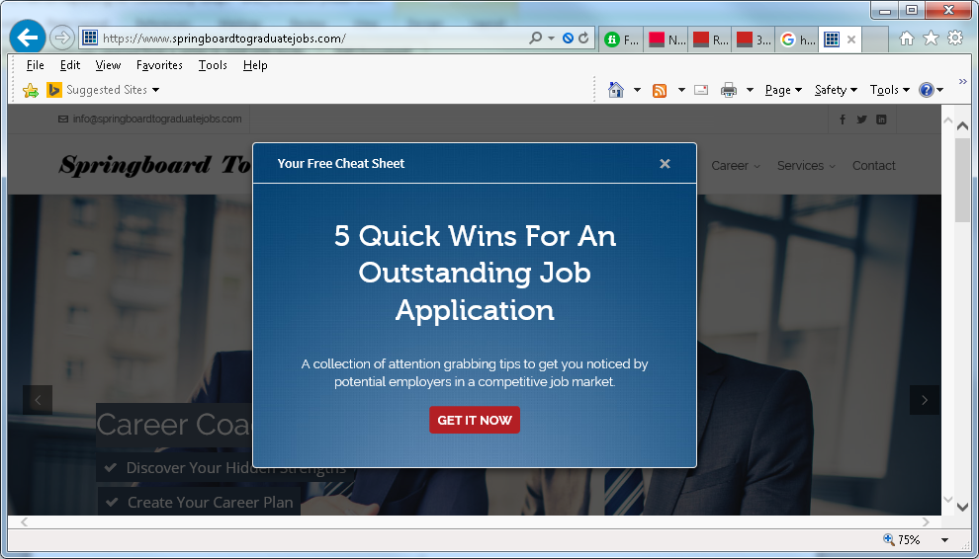

1. The subscription box below should be changed to the pop up in the picture above in number 2 above.

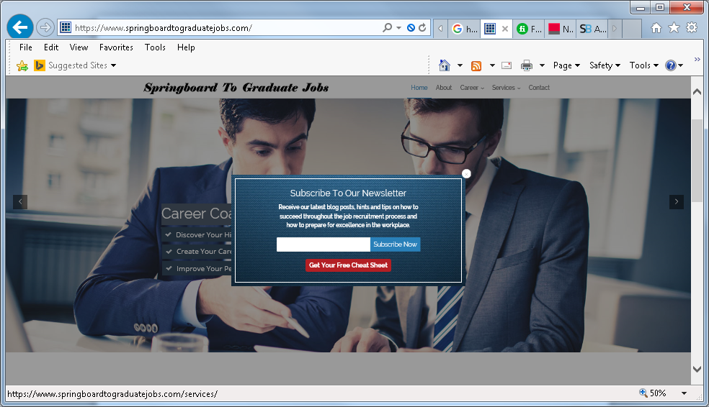

1. The text in the subscription box ….**Receive our latest blog posts, hints and tips on how to succeed throughout the job recruitment process and how to prepare for excellence in the workplace..** please use it to update the existing orange subscription boxes on the Website wherever it appears (home page, about page etc.. pls check the whole website).

**Receive our latest blog posts, hints and tips on how to succeed throughout the job recruitment process and how to prepare for excellence in the workplace**

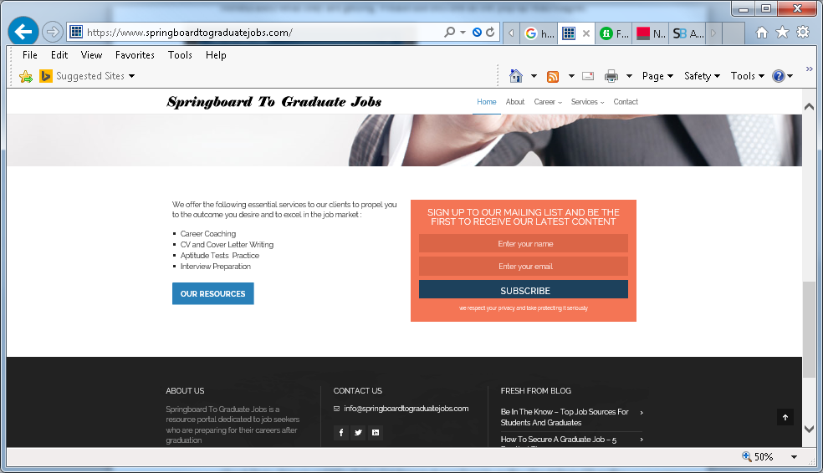

Or just use the subscription box below which you created if easier for you (i.e. to replace the orange box):



**About Page:**

1. The lead magnet is not very obvious. Users must be able to see this when they click on the About Page. Can you add the below lead magnet as a Pop Up on the About Page OR on the right hand side of the page (maybe above the subscription box on the right hand side of the About Page?) for readers to be able to see it well



1. The About Page click button says (download cheet sheet). The spelling is **CHEAT** not CHEET. Please change that blue click button text on the About Page to:

Yours Free: 5 Quick Wins For An Outstanding Job Application

Get It Now

**Contact Page:**

1. My Enquiry Relates To: Select All That Apply – The ‘M’y is not on the same line as My Enquiry Relates To: Select All That Apply. The ‘M’ - My needs to be on the same line as the other words