1. CV and Cover Letter Preparation (Accordion)

Add **bullet point** to last text/sentence. It is currently missing ..

* + Prepare a final draft CV and Cover letter (which will be sent to you via email)

1. Interview Preparation (Accordion)

Add **bullet point** to last text/sentence. It is currently missing ..

* + Gain practical advice on how to put away your nerves, improve your body language and non-verbal communication

1. Aptitude Tests Practice (Accordion)

Add **bullet point** to last text/sentence. It is currently missing ..

* Do not miss  out on our exclusive offers and reviews of the best  aptitude tests available in the market today

1. On the home page, indent/move the 4 bullet points that list our services **a little bit** to the right
2. On the home page, the text on the first slider picture says Coaching and Mentoring.. change this to Career Coaching.
3. On the Services page,
   * Where it shows Coaching and Mentoring, this text needs to change to OUR SERVICES. When you click on Learn More, it should take you to Our Services page i.e. the page with the accordion. Don’t forget to change the picture for the coaching, to show something that reflects all our services. You can use the same picture you use for Our Services page here also
   * Work With Us is ok as it is – no changes
4. The ‘Contact Page’ is not working properly. If you enter the details to test this you’ll see its not working. The subject line is showing [text-853]… This is incorrect and not showing what I selected in the tick box. See example below. You can test it yourself.

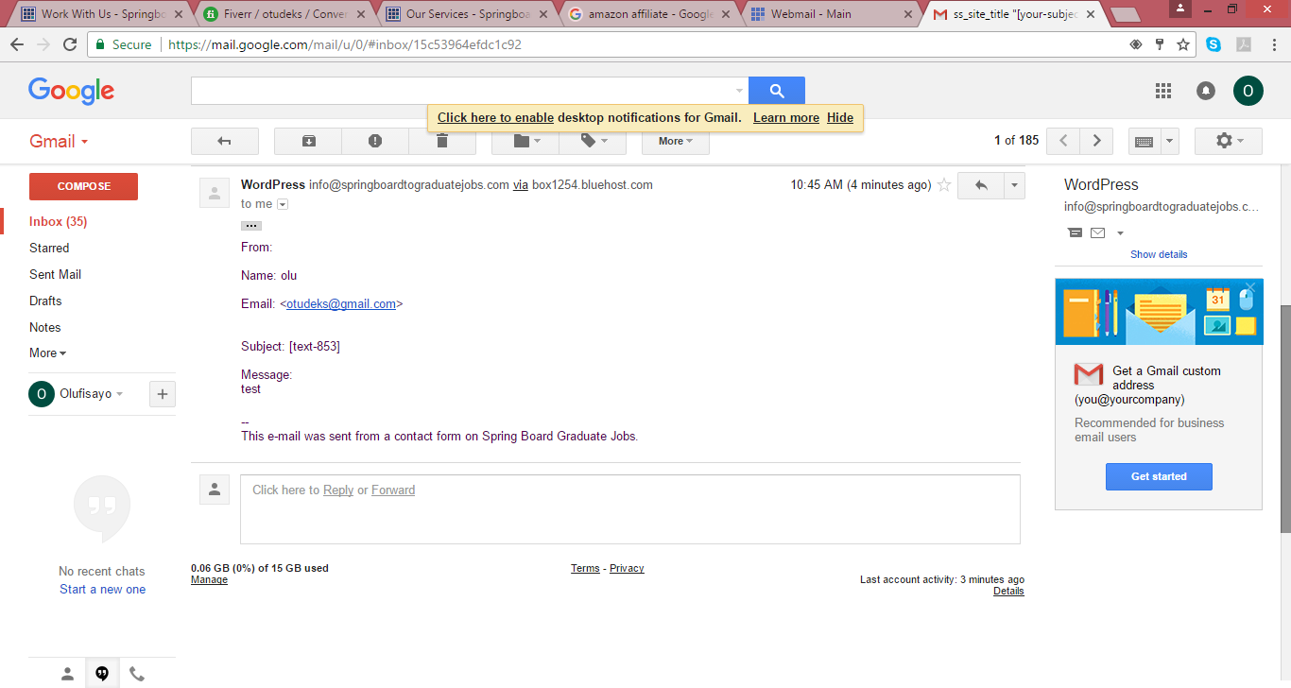

1. On the About Page. You’ve just copied the text I sent you into the page. You need to indent the 4 bullet point on the services a little bit to the right. Change the following also:
   * Remove this sentence: ‘‘…I’m Graduate Jobs Coach (often called GradJobsCoach) and’’
   * Remove heading: **Meet Graduate Jobs Coach**
   * Add some graphics and bullet points to make the About Page look better and more interactive.
2. The pop up subscription is not related to the niche.. it’s too generic.
   * Change the text to the below:

Subscribe To Our Newsletter

Receive our latest blog posts, hints and tips on how to succeed throughout the job recruitment process and how to prepare for excellence in the workplace.

* Leave the subscribe now button. Leave the secure and spam free text