BootcamP ASSIGNMENT – II

GIT

1. Create two separate branches from master.

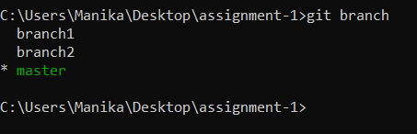

1. Make changes in the same function of the sources code in both the branches.

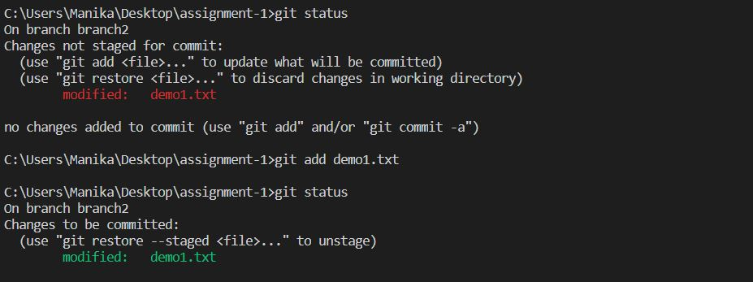

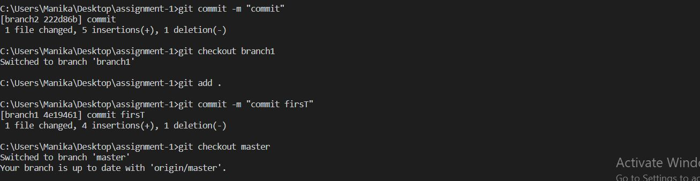

1. Merge branch1 into the master

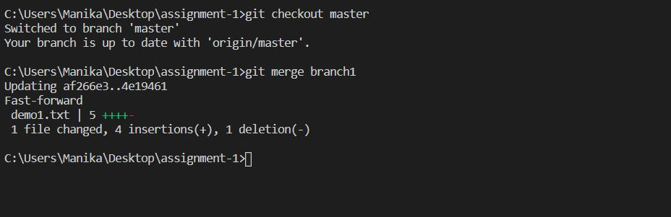

1. Try ang merge branch2 into the master (merge conflict should arise)

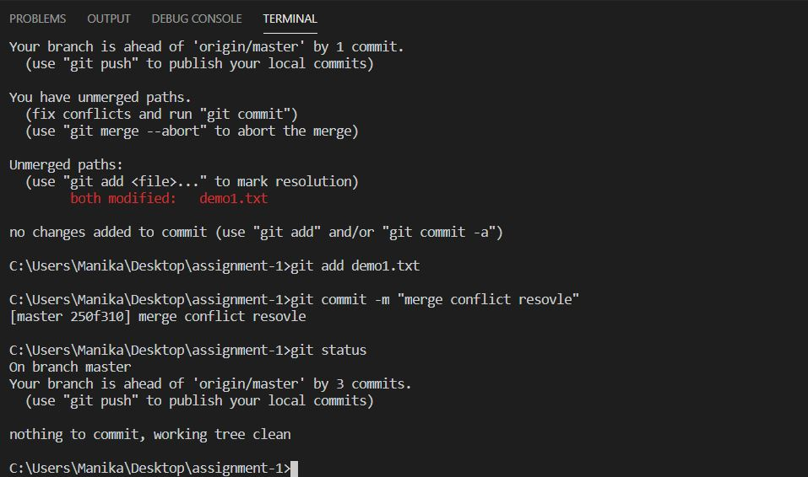

1. Install a merge tool of your choice and resolve the merge conflict using git merge tool command.

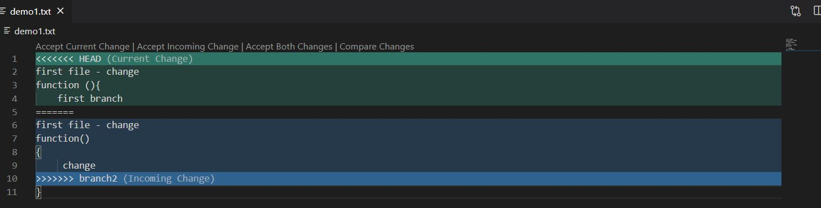

Jenkins

1. Create multiple freestyle project in Jenkins to checkout, build, test, package and deploy the web application in a tomcat9 server.
2. Build pipeline view with appropriate plugin installation.

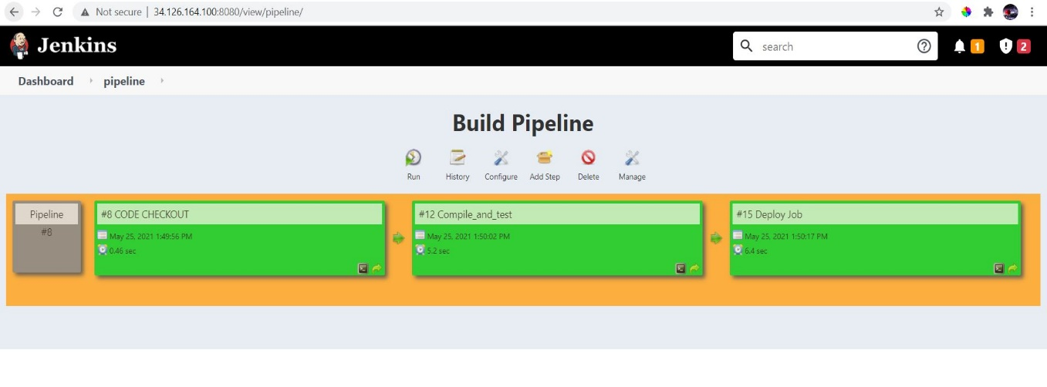

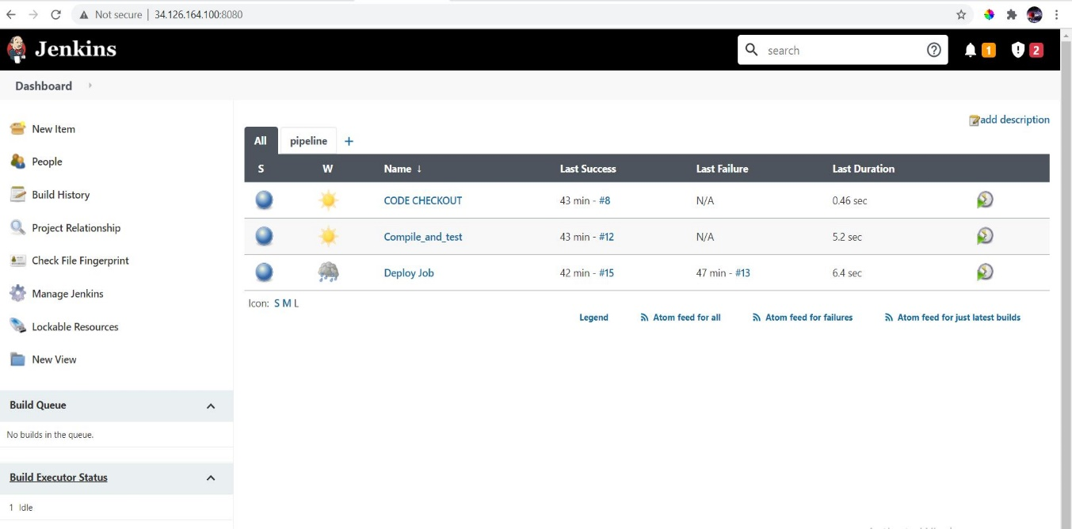

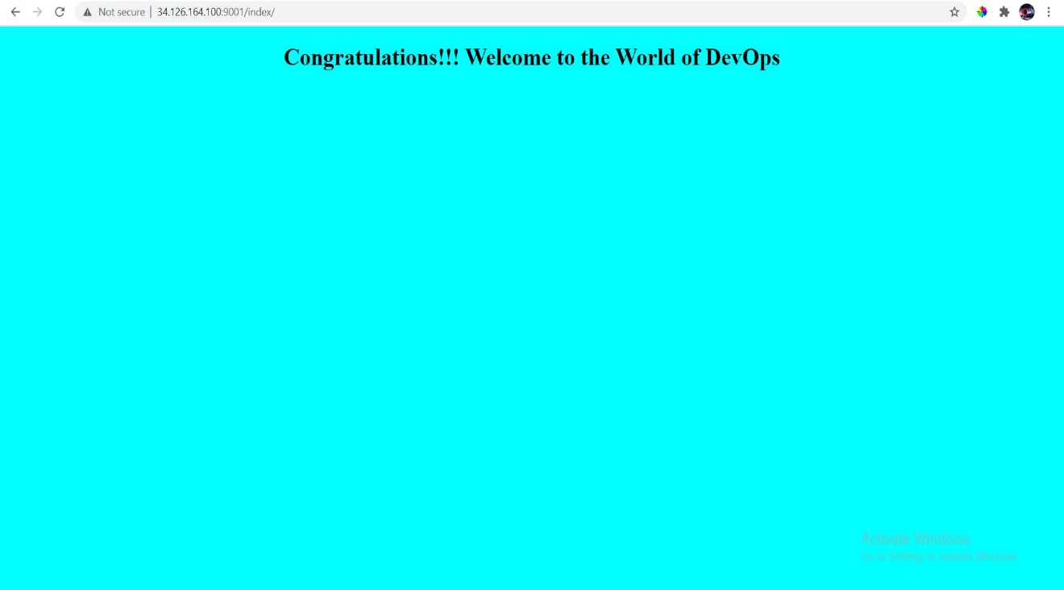

1. Configure maven as a tool in Jenkins’s environment.

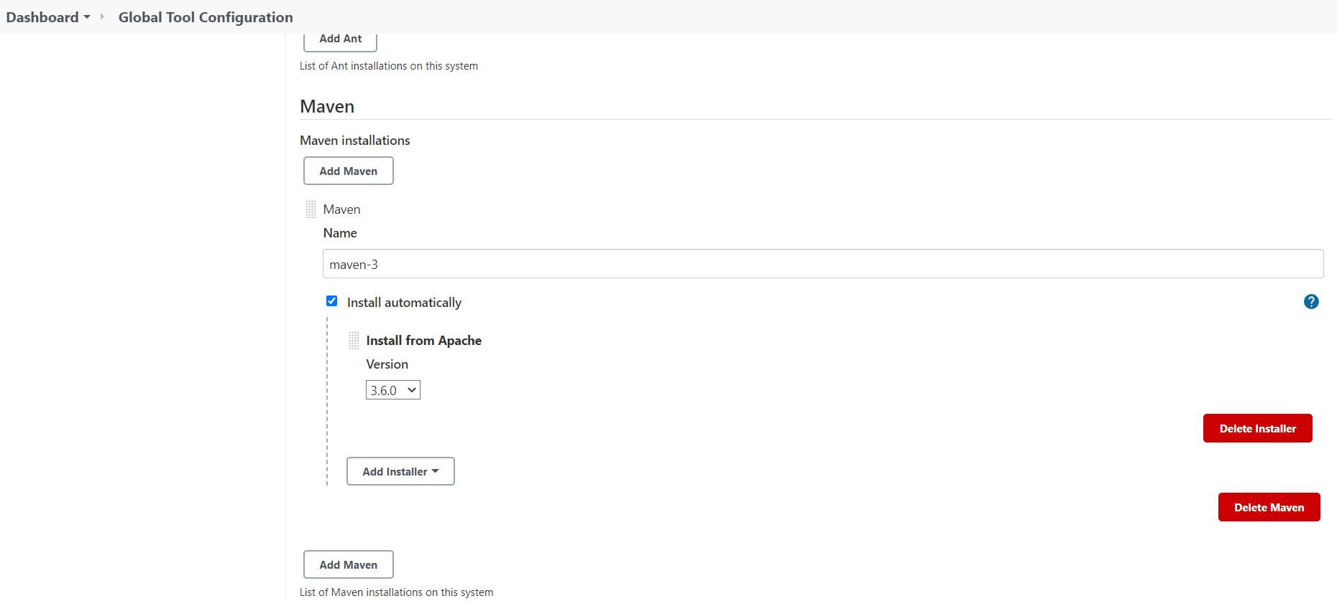

1. Console output of each successful execution of the job.

* Output Job1(CODE CHECKOUT)

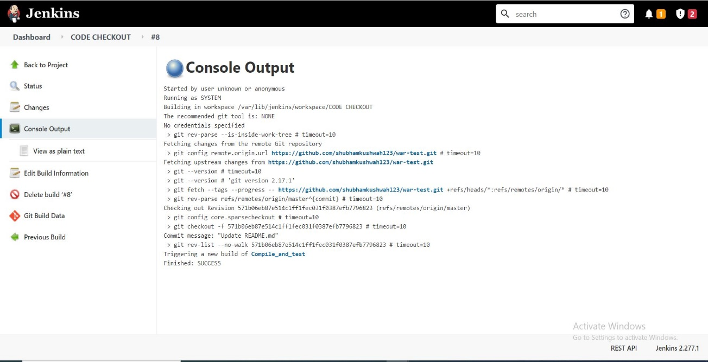

* Output Job2(Compile_and_test)

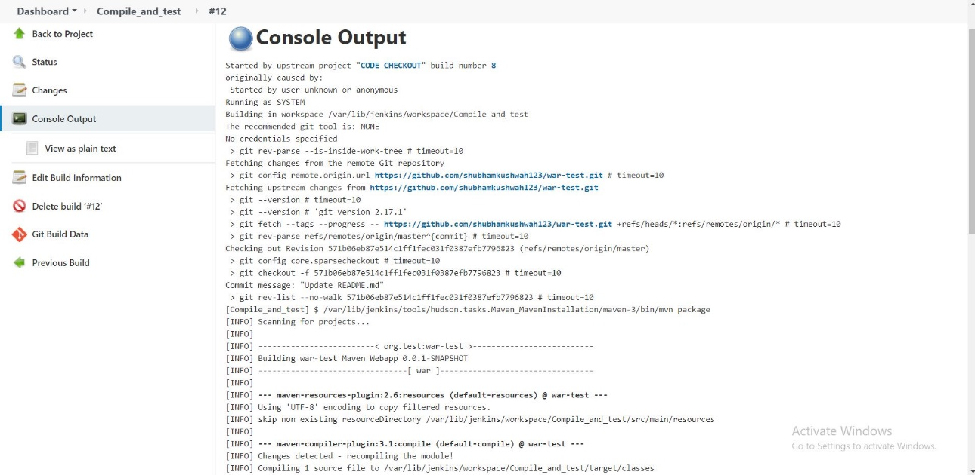

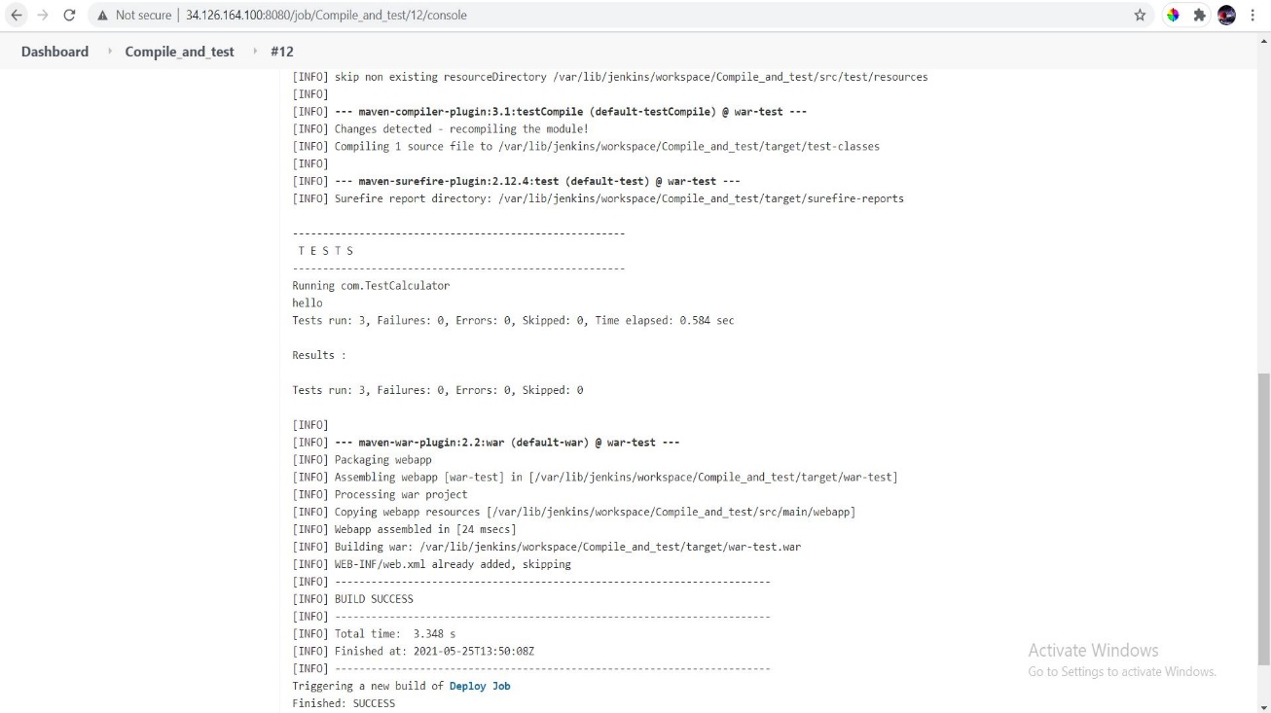

* Output Job3(Deploy Job)

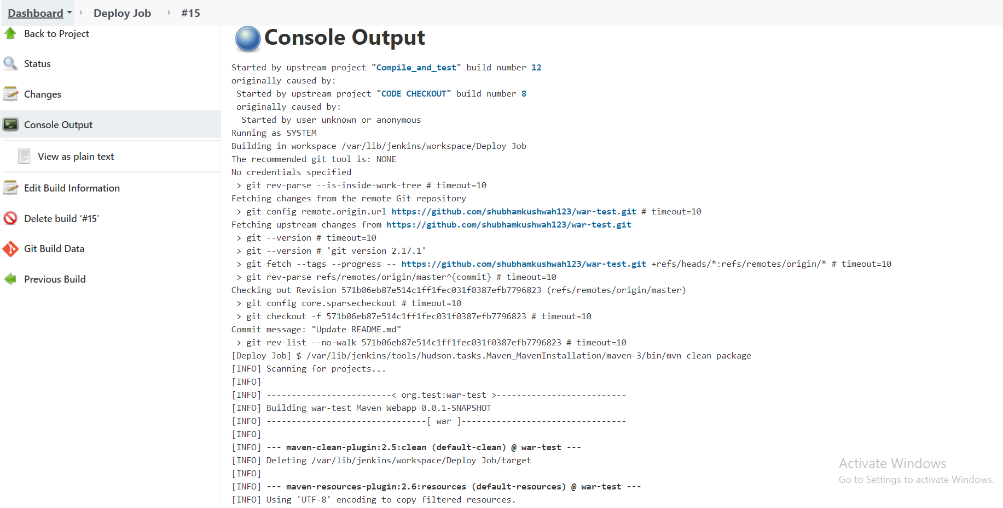

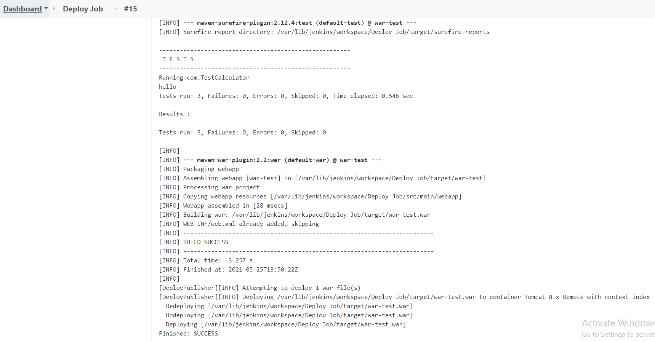

1. Create a pipeline job and write the script to achieve the same tasks. Pipeline must be triggered with a GitHub webhook upon every commit.

