BootcamP ASSIGNMENT – III

1. Docker file to create a docker image for this application using nginx as the base image.

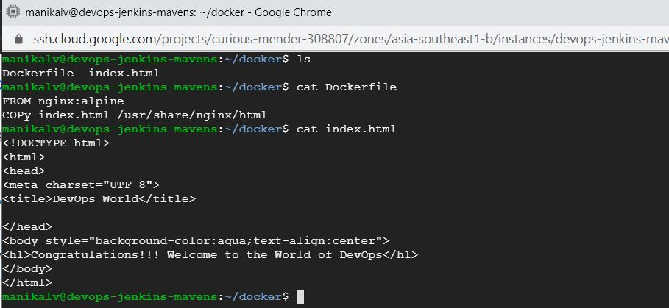

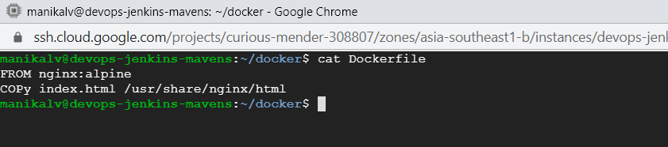

1. Push the docker image to the Docker Hub.

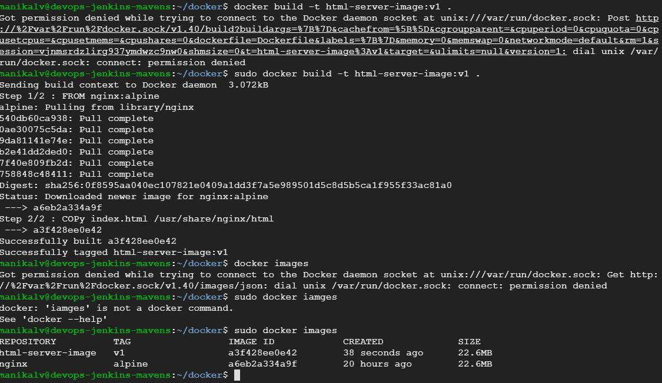

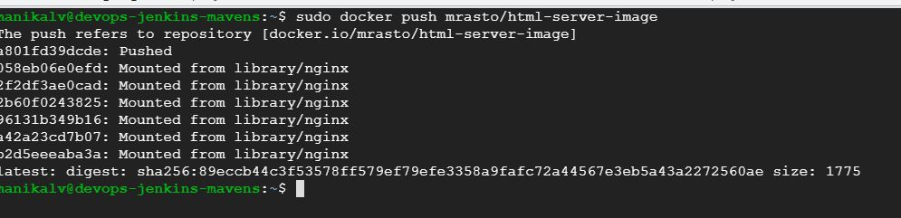

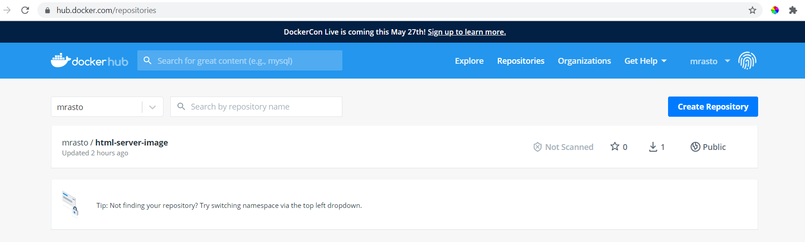

1. Pull and Run the docker containers on any remote instance.

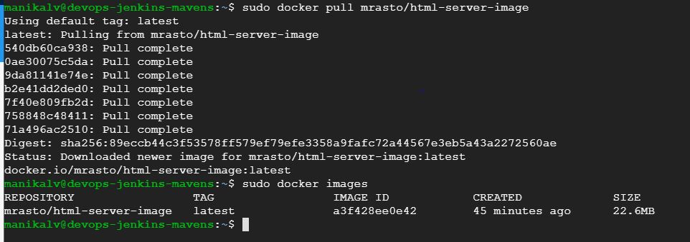

1. Access the application from the browser using appropriate url and port.

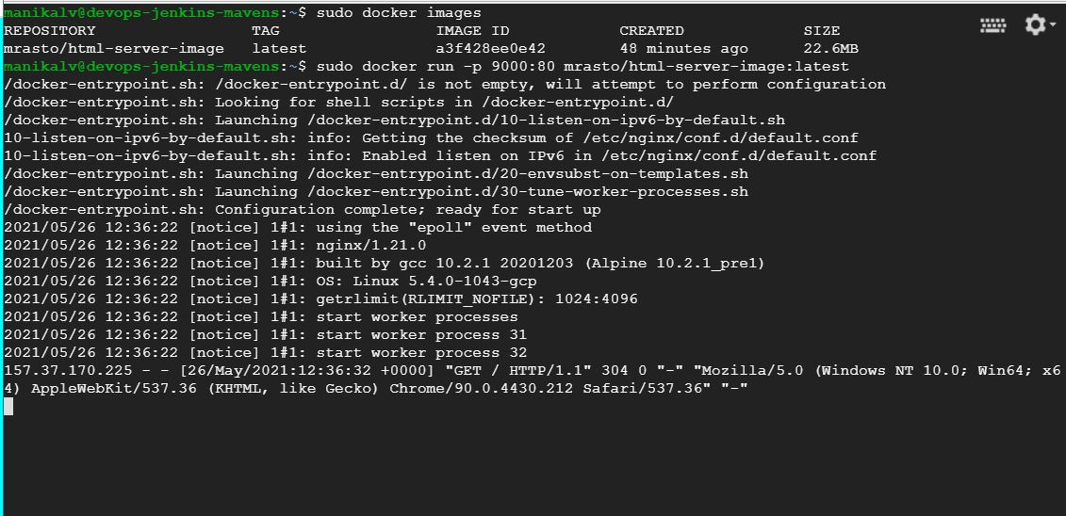

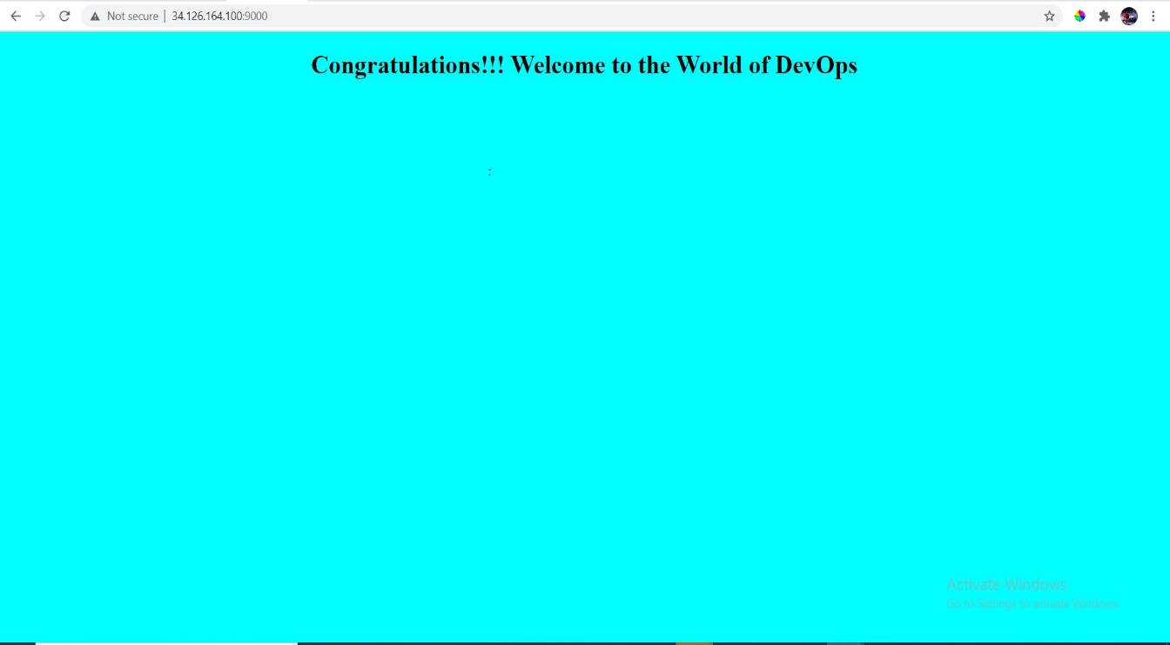

Docker-Compose

1. Docker-compose.yml file to run the above application container along with a mysql database container together.

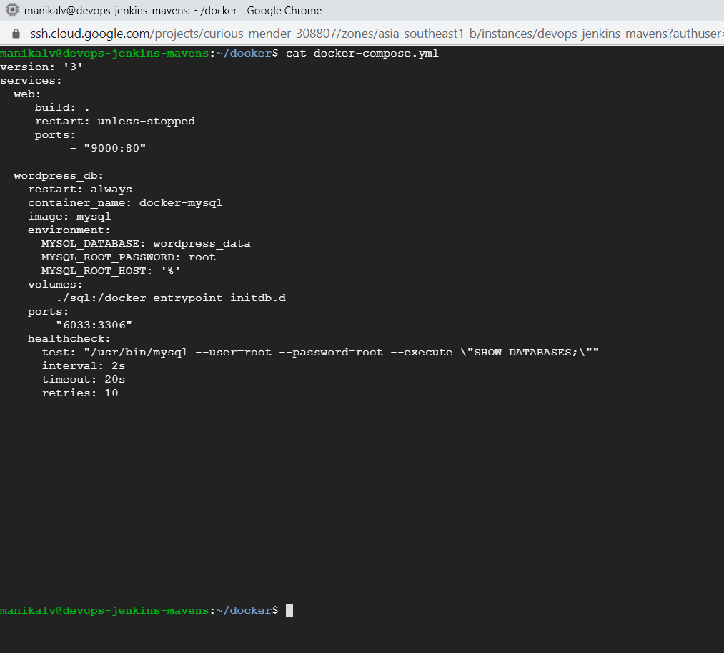

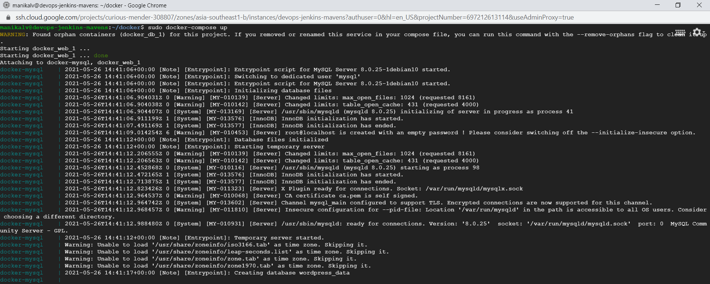

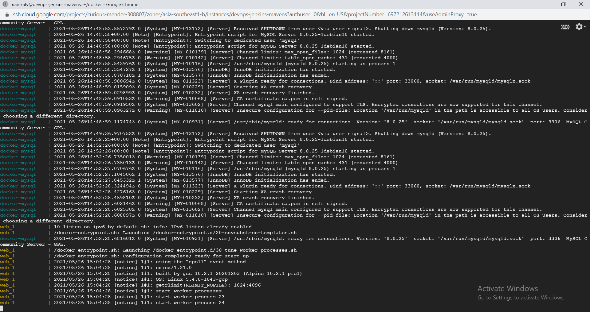

1. Connect to the mysql database container in the -it mode and create a table named test having id, name and age as attributes.

