BootcamP ASSIGNMENT – IV

1. Create 2 nodes, one is the master and another is Slave one.

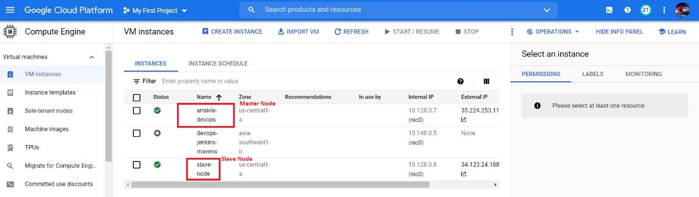

1. Configure the master node to enable password less authentication.

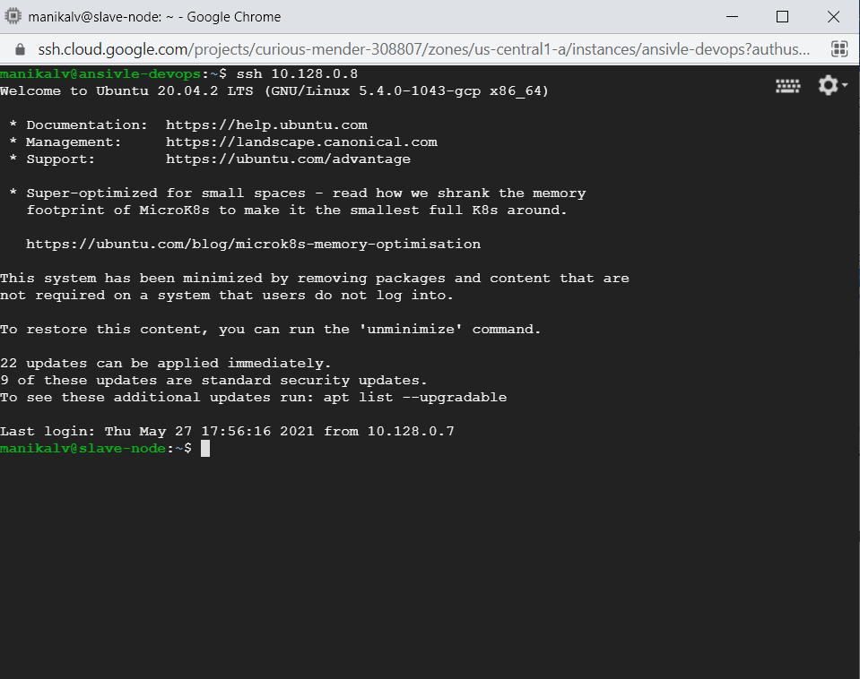

1. Install Ansible on Master node.

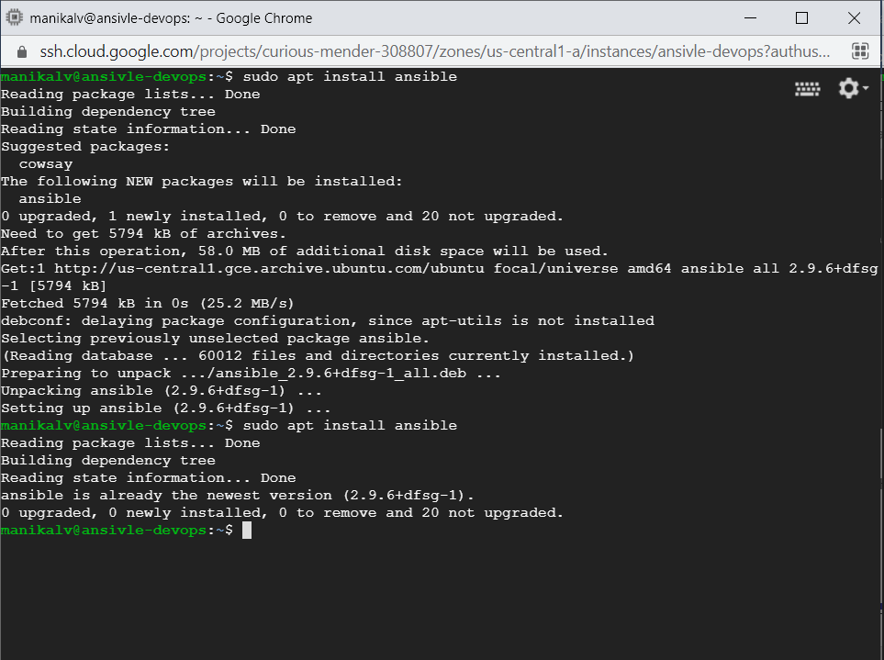

1. Playbook to install following Software in the Slave node:
2. Java
3. Maven
4. Nginx
5. Docker

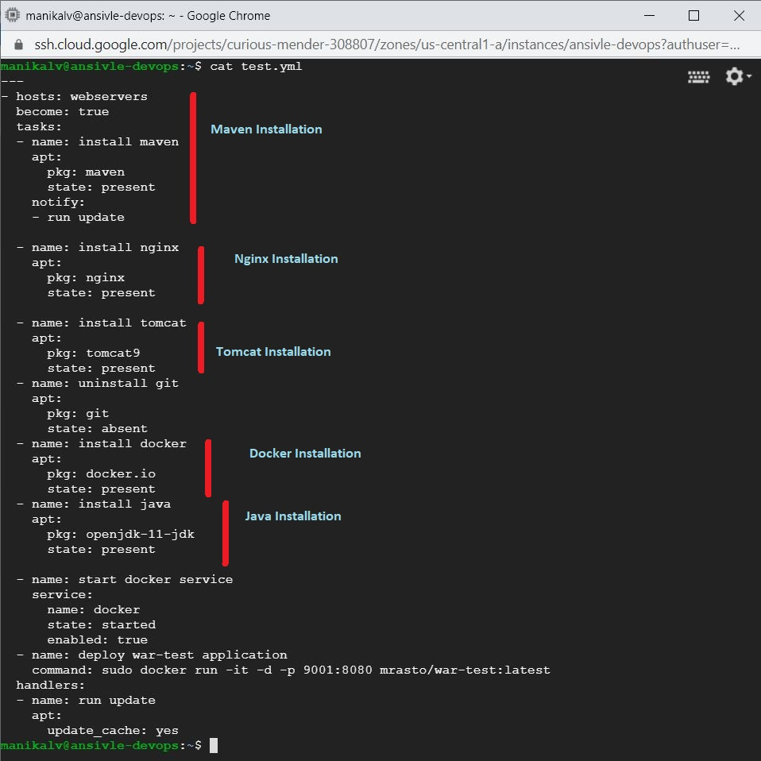

1. Configure playbook to deploy the application available in the below repository as docker container in the Slave node.

Repo: <https://github.com/shubhamkhushwah123/war-test.git>

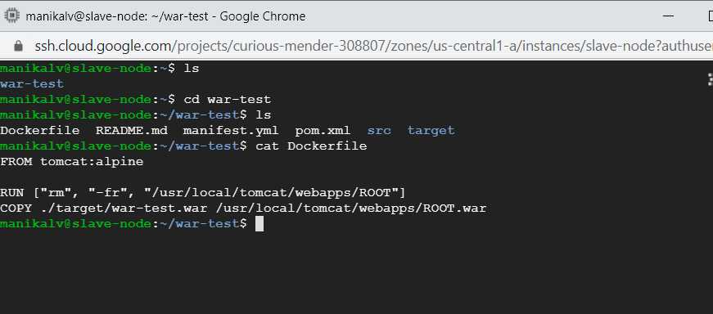

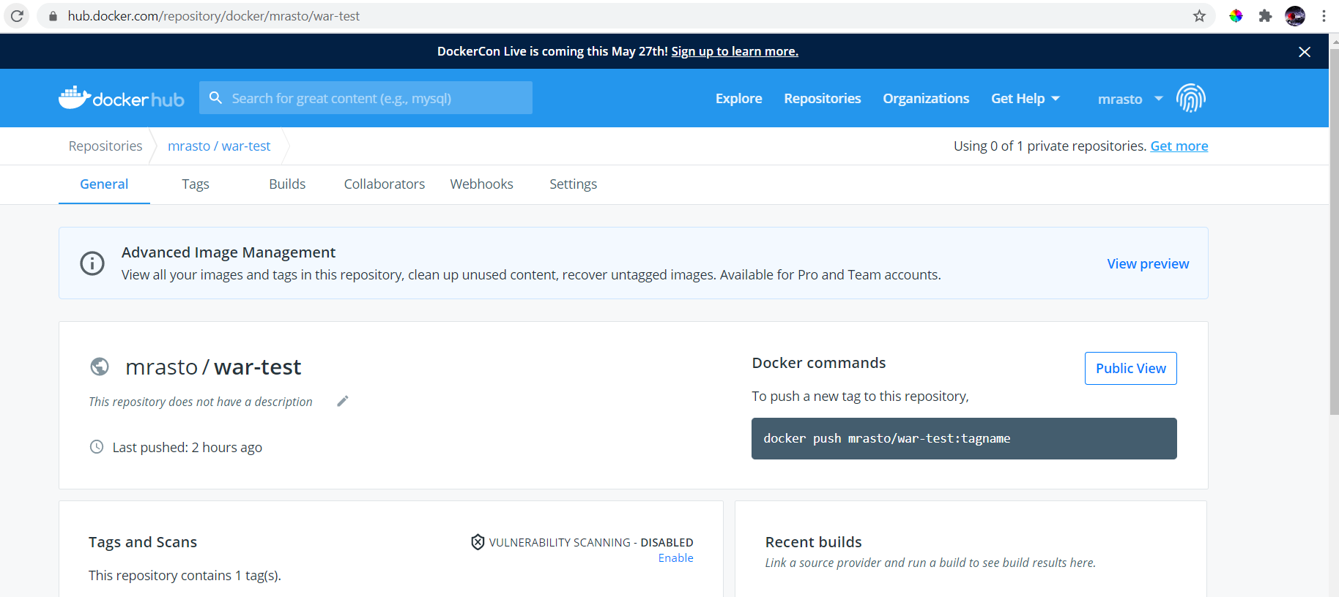

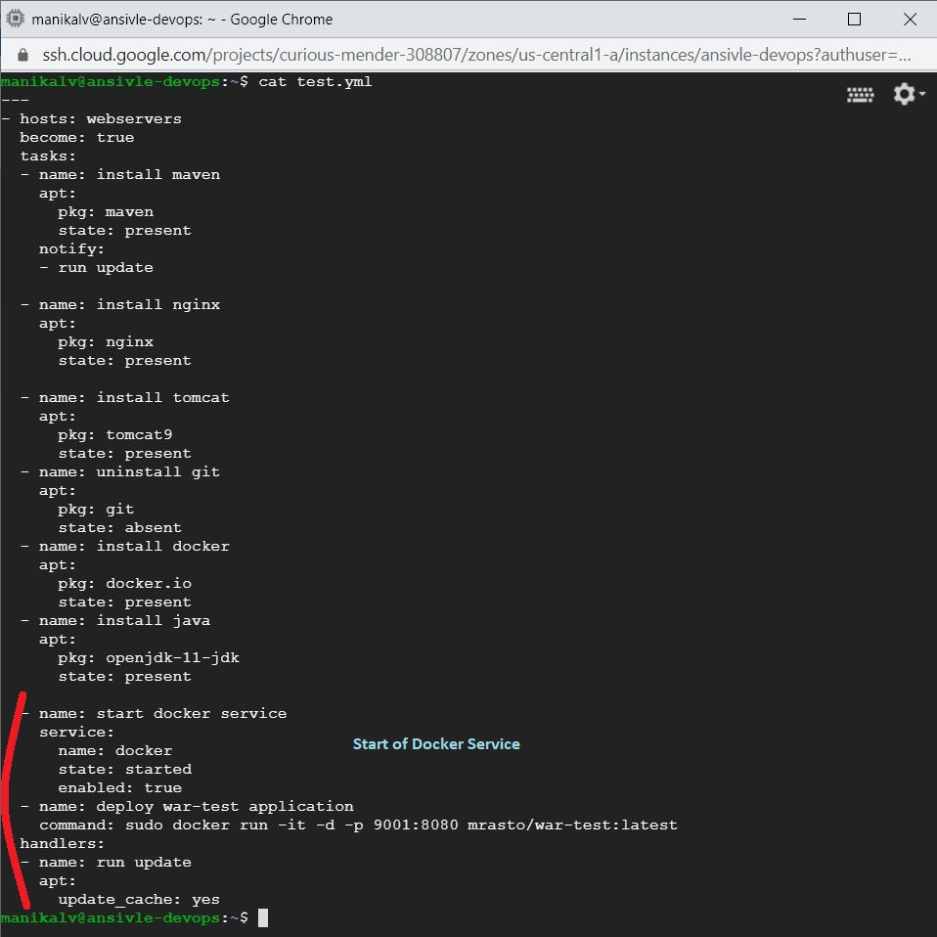

1. Run playbook and attach the screenshots of the playbook yml and output of the playbook execution.

