BootcamP ASSIGNMENT – I

1. Create a local GIT repo ‘developerA’ having 3 files

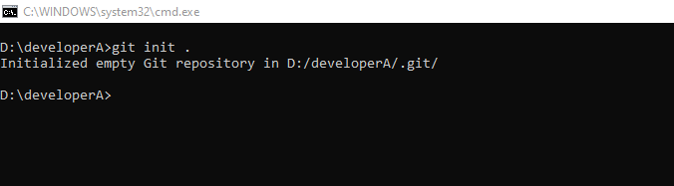

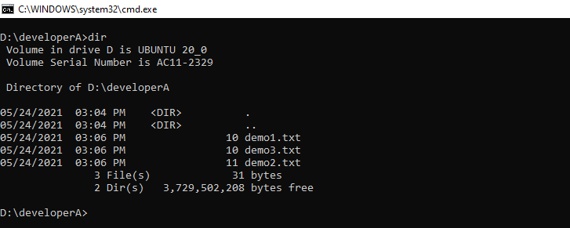

1. Add all 3 files into stagging area and commit them.

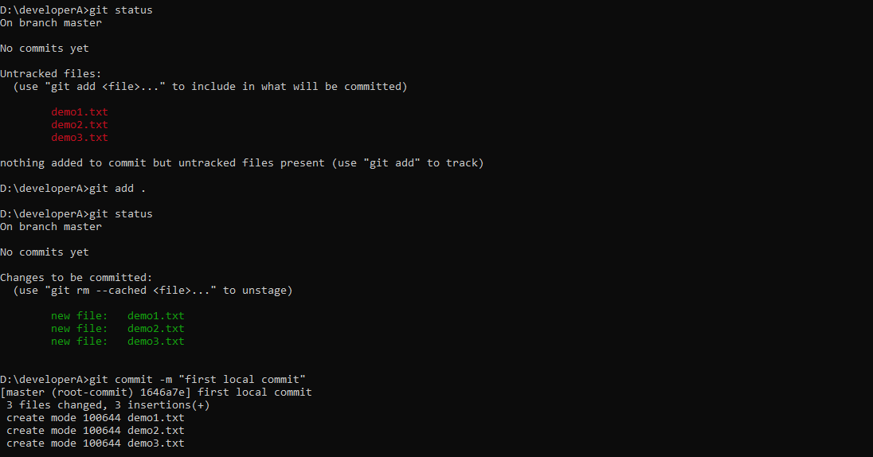

1. Create a ‘remote’ repo.

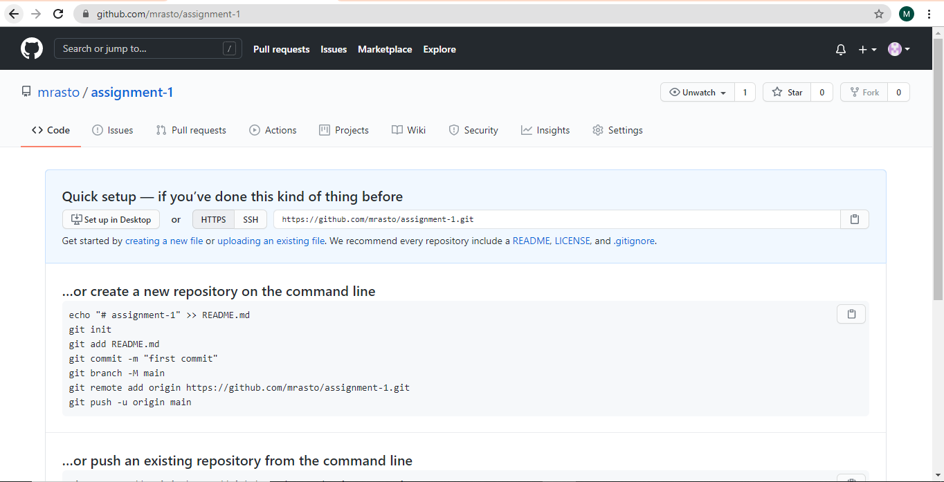

1. Add ‘remote’ to the ‘Local’ repo and push the code changes.

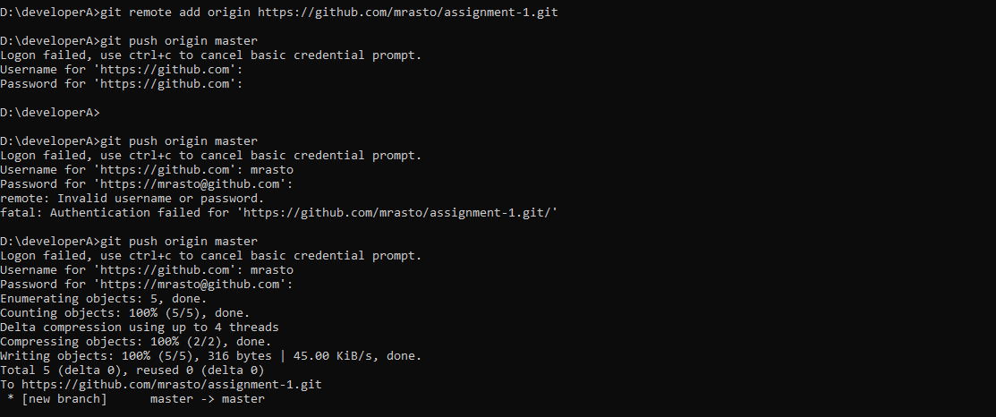

1. Clone the remote repo to another folder ‘developerB’

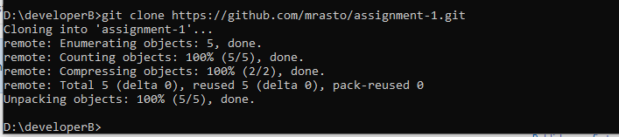

1. Make and commit the changes via ‘developerB’ and synchronize the changes in ‘developerA’.

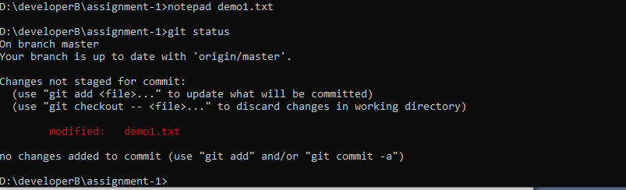

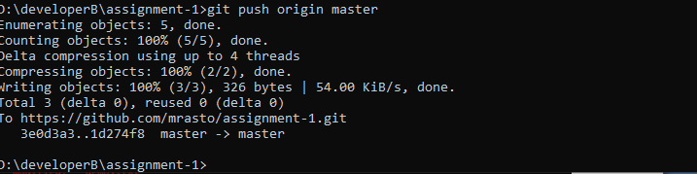

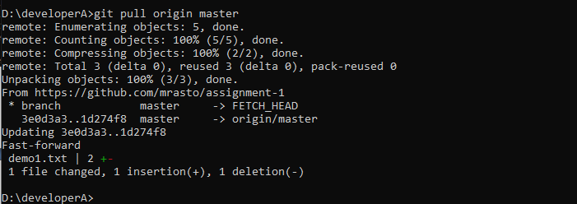

7. Create the new branch for a new branch for a new feature you want to add to the app(feature1) and changes the files.

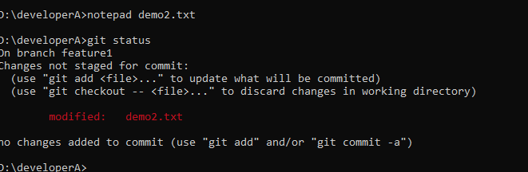

8. Merge back the created branch with the master branch.

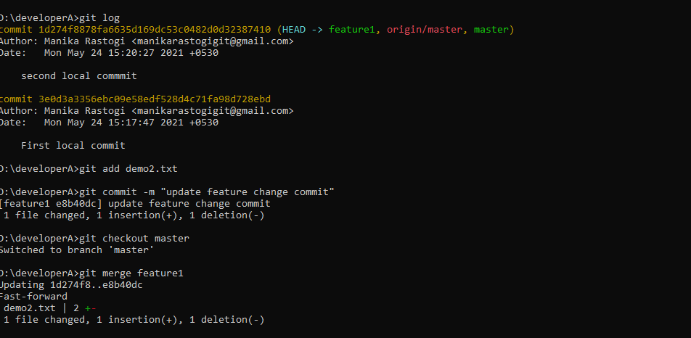

9. Delete the feature1 branch after merging.



