## DEVELOPMENT OF FACE MASK DETECTION TECHNIQUE USING MACHINE LEARNING

Project report submitted

in partial fulfillment of requirement for the degree

of

**Bachelor of Technology**

in

**Computer Science and Engineering**

**Name of the student(s) Name of the Supervisor**

**Ravi Mishra(1851110077) Mr. Sanjiv Agrawal**

**Vanshika Agrawal(1851110114) (Assistant Professor)**



#### Department of Computer Science and Engineering

**GL BAJAJ GROUP OF INSTITUTIONS, MATHURA**

Approved by AICTE, CoA & Affiliated to Dr APJ AKTU, Lucknow

NH#2, Mathura-Delhi Road, PO-Akbarpur, Mathura-281406 (UP)

Session: 2021-2022

**INDEX**

**Contents Page No.**

Certificate i

Declaration ii

Acknowledgement iii

Abstract iv

List of Figures & Tables v

Chapter 1.

Introduction 1-3

* 1. Objective & Scope of the Project
     1. Objective 4
     2. Scope 5

Chapter 2.

Literature Review 6

2.1 Dataset 7-9

Chapter 3

Design of Project Model

3.1 Packages Used

3.1.1 Computer Vision 10-11

3.1.2 OpenCV 12-13

3.1.3 Tensor Flow 14-15

3.1.4 Keras 16-17

3.1.5 Jupyter Notebook 18-19

Chapter 4.

Proposed Methodology 20

4.1 Data Processing 21

4.2 Training of Model 22-24

4.3 Implementing Face Mask Detector 25-26

4.4 Hardware and Software Used

4.4.1 Hardware Used 27

4.4.2 Software Used 27

Chapter 5.

Results & Conclusion

5.1 Result 28-32

5.2 Conclusion 33

5.3 Future Works 34

Appendix 35-37

References 38

**CERTIFICATE**

This is to certify that:

Mr Ravi Mishra S/o RajMurti Mishra Enrollment No. 0181CS060 Roll No. 1851110077 and Miss. Vanshika Agrawal D/o Naresh Agrawal Enrollment No. 0181CS020 Roll No. 1851110114 has worked on **“Development of Face Mask Detection Technique using Machine Learning”**. This project is part of a partial fulfillment of requirement for the degree of Bachelor in Technology in Computer Science Engineering.

To the best of my knowledge and belief, this is the original work and has not been submitted for any other degree elsewhere.

Date :24/04/2022

Place: Mathura **Signature**

##### (Mr.Sanjiv Agrawal)

CSE Department,Asst. Prof

##### Signature

**(Dr. Ramakant Baghel)**

CSE Department, HoD

### DECLARATION

I hereby certify that the work which is being presented in B. Tech. Project Report entitled **“Development of Face Mask Detection Technique using Machine Learning”**, as partial fulfillment of the requirement for the degree of Bachelor of Technology in Computer Science and Engineering, submitted to the Department of Computer Science and Engineering of GL BAJAJ Group of Institutions, NH#2- Mathura-Delhi Road, PO-Akbarpur, Mathura-281001 (UP), is an authentic record of my own work carried out during a period from September 2021 to April 2022 under the supervision of Mr. Sanjiv Agrawal, in the CSE Department.

The matter presented in this project report in full or part, has not been submitted by me for the award of any other degree elsewhere and is free from plagiarism.

Name of Candidate:

Ravi Mishra(1851110077) Vanshika Agrawal(1851110114)

### ACKNOWLEDGEMENTS

I would like to express my greatest appreciation to the all individuals who have helped and supported me throughout the project. I am thankful to my HoD and all Faculty members for his ongoing support during the project, from initial advice, and encouragement, which led to the final report of this project. I would also like to thank Mr. Sanjiv Agrawal who was always there for us.

I wish to thank my parents as well for their undivided support and interest who inspired me and encouraged me to go my own way, without whom I would be unable to complete my project.

At the end, I want to thank my friends and classmates who displayed appreciation to my work and motivated me to continue my work.

**Abstract**

COVID-19 is one of the most dangerous virus which caused pandemic in human life, not only in terms of direct casualties but also regarding socio-economic impact. The outbreak quickly spread around the world. The 1-year anniversary of the global corona virus pandemic get passed away in 2021, but still no way to tell how long the pandemic will continue. After analyzing report by WHO of covid-19, to minimize the rate of covid-19 transmission, our national government advised citizens to wear face masks. A model using deep learning and MobileNetV2 for face mask detection is presented. This method was trained and checked on the real time dataset . There are 3,833 images in the Medical Masks Dataset, including 1918 images of people wearing no mask and 1915 images of people wearing masks. We adopted OpenCV to detect faces in real time from a live stream captured with our webcam. With the aid of computer vision and deep learning, we hope to classify whether or not the person in the video stream is wearing a face mask . If the camera captures a face without mask an Email notification will be sent out to the administrator and system alarm will ring.

**Keywords : Corona virus, Tensor flow, Mask detector,**

**Opencv, Alarmsystem**

**List of figures**

|  |  |
| --- | --- |
| **Figure 1** | Depicts images of human wearing a mask |
| **Figure 2** | Depicts images of human not wearing a mask |
| **Figure 3** | Decision flow chart of the proposed approach |
| **Figure 4** | Snippet of face mask detector training code |
| **Figure 5** | Snippet of data preprocessing code |
| **Figure 6** | Snippet of Face mask detector Testing code |
| **Figure 7** | Accuracy Plot |
| **Figure 8** | Analyzing the result without face mask |
| **Figure 9** | Analyzing the result with face mask |
| **Figure 10** | Analyzing the results of test photograph with a probability of 100% when more than two faces are present. |

**Chapter 1**

**Introduction**

COVID-19, a pandemic disease caused by Severe Acute Respiratory Syndrome Coronavirus 2, is currently affecting the entire world (SARS-CoV- 2)[1] According to the world health organization ,COVID-19 is primarily transmitted from person to person by respiratory droplets. There is micrometer small covid-19 particles which always thrown out of our mouth while speaking singing, coughing, etc. We observed even after vaccination has started in India then too corona virus cases are increasing. According to the World Health Organization's Corona virus situation survey, over 124 million people are infected with the disease in 213 countries, killing over 2.73 million people worldwide as of March 23, 2021. India is now ranked third in the world for the number of cases of infected Corona virus. It has reported that it has 11.5 million infected people and 160 thousand killed people

Observing the global crisis, a new need for face mask identification has emerged. It is one of the technologies capable of detecting and checking the identity of an individual wearing a mask. [4] This report presents a accurate face mask detection system using Deep Learning. It can specify whether a person on real time video captured by webcam is wearing face mask or not. It can also detect people who are not wearing a face mask by sounding an alarm or sending an email warning to police, authority, or an observer. This system allows them to see who isn't wearing a mask on their faces.

**Why is it important to wear facemask?**

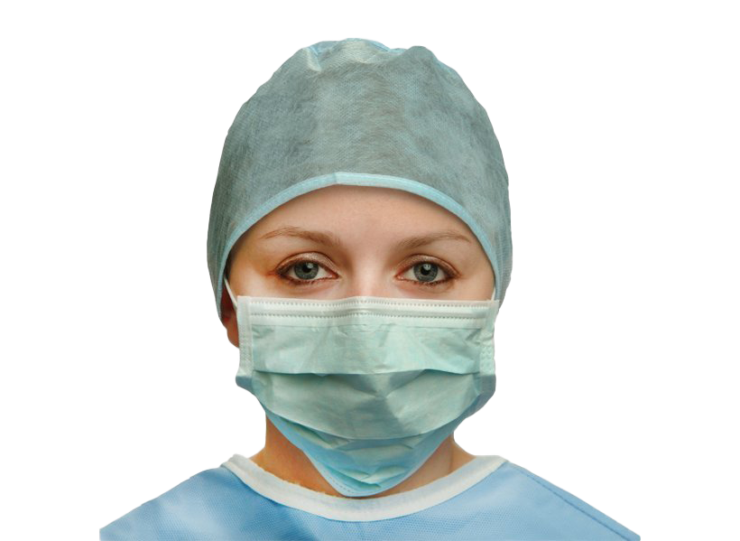

When we go back to the basics, the primary role of face masks is to prevent the transmission of SARS-CoV-2 via respiratory droplets, which can easily enter through the mouth and nose to infect new hosts.

This protection is provided thanks to the complete barrier between your nasal and oral cavities with the outside world.

However, if you wear the mask in a floppy manner that doesn’t cover your mouth and nose properly, your risk of catching the virus will increase.

The importance of properly wearing face masks, asking people to:

* **Put the mask over the nose and mouth, then secure it under the chin**
* **Try to fit it snugly against the sides of the face**

One major benefit of wearing face masks is to protect the people around you, especially if you have been exposed to someone carrying the virus or work in a crowded place (e.g., grocery stores, restaurants, airports).

Because of this risk/benefit analysis, many governments around the world released emergency laws that mandate the public to wear masks in an attempt to stop the further spread of COVID-19.

# 1.1 Objective and Scope of the Project

* + 1. **Objective**

To develop face mask detection technique using python .

* + - * To identify whether the person on video stream is wearing a face mask or not with the help of computer vision.
      * To implement this system at Cement Industries, Chemical Plants, Hospitals where chance of spread of disease .
      * To Implement alarm system and Email Notification system to notify administrator.

My aim is to classify whether the person on video stream is wearing a face mask or not with the help of computer vision and deep learning. If the camera captures a face without mask an Email notification will be sent out to the administrator and system alarm will ring.

# 1.1.2 Scope

A mask acts as a shield to keep the respiratory droplets from getting into the hands of others. When worn over the nose and mouth, studies show that masks minimize the spray of droplets.[2]Many developed and developing countries around the world have made wearing a mask mandatory while leaving the house or going to public places. Face masks are also used in a variety of industries. Every location, such as pharmaceutical companies, cement plants, chemical plants, hospitals, while cleaning, construction areas, contaminated and polluted areas, and so on, was restricted by the government. Staff must wear a face mask to protect themselves from toxic substances at work (coughing, wheezing, shortness of breath, chest tightness, or trouble breathing, for example)

# Chapter-2

**Literature Review**

According to [7] Human faces are difficult to model because there are so many factors that may alter, such as facial expression, lighting conditions, orientation and partial occlusions like shades, scarves, and masks. Face detection can be accomplished in two ways. 1. Image-based approach2. Feature-based approach. Author in [2] applied image based approach for face detection and performed this task on dataset which contains mask and no-mask images. According to author [5] MobileNetV2 expands on MobileNetV1's concepts by using depth-wise separable convolution as a building block. V2, on the other hand, adds two additional architectural features: 1.Shortcut connections between the bottlenecks and linear bottlenecks between the layers . MobileNetV2 has used at the place of convolution neural network [5]. The authors were able to create a VGG- 16 model for facemask detection that is both precise and fast. They also observed physical distancing between peoples [3].Deep learning algorithms try to take advantage of the uncertain structure in the input distribution to find good representations, often at multiple levels, with higher-level learned features described in terms of lower-level feature.

# 2.1 Dataset

The dataset has been taken from Kaggle and few open source image libraries and Google images. There are 3833 photographs in this dataset, divided into two categories:

* With mask photographs : **1915**
* Without mask photographs: **1918**

With mask folder contains all the images of people mask wearing on their faces . Without mask folder contains all the images of people no mask on their faces .

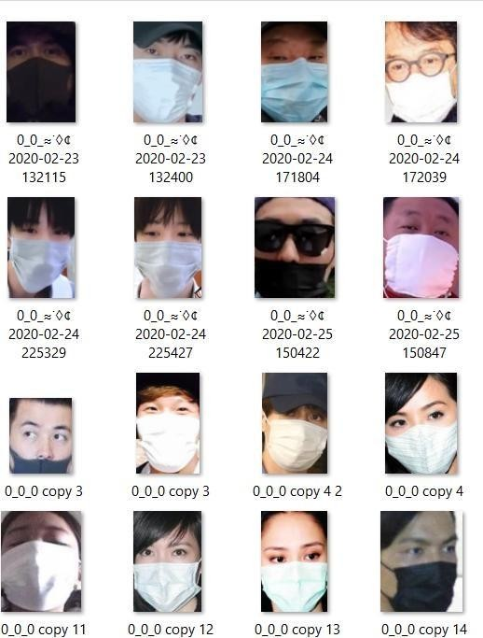

**Figure: 1** Depicts images of human wearing a mask

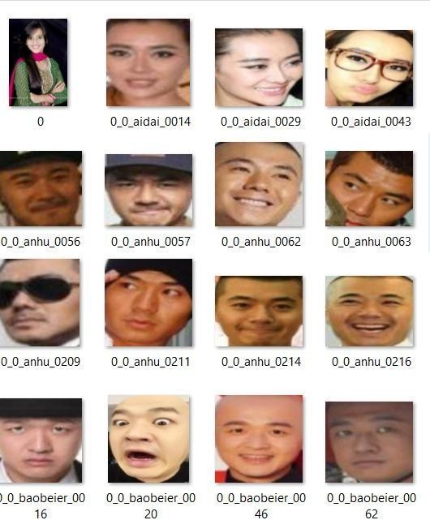

#### **Figure: 2** Depicts images of human not wearing a mask

**Chapter 3**

**Design of Project Model**

**3.1 Packages used**

#### 3.1.1 Computer Vision

**Computer vision** is an interdisciplinary research discipline that studies how computers can learn to interpret artificial images or videos at a high level. From an engineering standpoint, it aims to simplify functions that the human visual system can do. It is a field that include processing analyzing and understanding image in general high dimensional data from the real world in order to produce numerical and symbolic information or It is a scientific and computer technology that allows it to extract information from images.

3.1.1.1 Applications of Computer Vision

Computer vision is being used in more areas than you might expect. From detecting early signs of cancer to enabling automatic checkouts in retail places, computer vision has made its way into our lives. Here are some more computer vision applications:

1. Face recognition

Snapchat, Instagram, Facebook and many other social media apps use face-detection algorithms to recognize you in pictures and apply filters on your face.

1. Image retrieval

Google Images help you find relevant images when you upload an image. There are different algorithms that analyze the content in the image uploaded and return results based on the best-matched content.

1. Biometrics

Fingerprint and iris recognition are some common methods in biometric identification that uses computer vision.

1. Smart cars

Smart cars use computer vision to detect traffic signs and lights and other visual features when the cars go on auto mode.



#### 3.1.2 OpenCV

**OpenCV** (Open Source Computer Vision Library) is an open source computer vision and machine learning software library. OpenCV was created to provide a shared infrastructure for computer vision applications and to speed up the incorporation of machine perception into consumer products. Since OpenCV is a BSD-licensed software, it is simple for companies to use and change the code. It supports Windows, Linux, Android, and Mac OS and has C++, Python, Java, and MATLAB interfaces.

**3.1.2.1 Application of Open CV**

With the help of Open CV in python, its possible to process images, videos easily and can extract useful information out of that, as there are lots of functions available. Some of the common applications are,

1. Image Processing

Images can be read, write, show, and processed with the OpenCV, like can generate a new image from that either by changing its shape, colour, or extract something useful from the given one and write into a new image.

1. Fcae Detection

Either from the live streaming using web camera or from the locally stored videos/images utilizing Haar- Cascade Classifiers.

1. Object Detection

Open CV along with the YOLO, an object detection algorithm can be used to detect objects from the image, videos either moving or stationary objects.

1. Face Recoginition

It followed by face detection from the videos using open cv by drawing bounding boxes i.e. rectangle and then model training using [ML algorithms](https://www.analyticssteps.com/blogs/top-10-machine-learning-algorithms) to recognize faces.

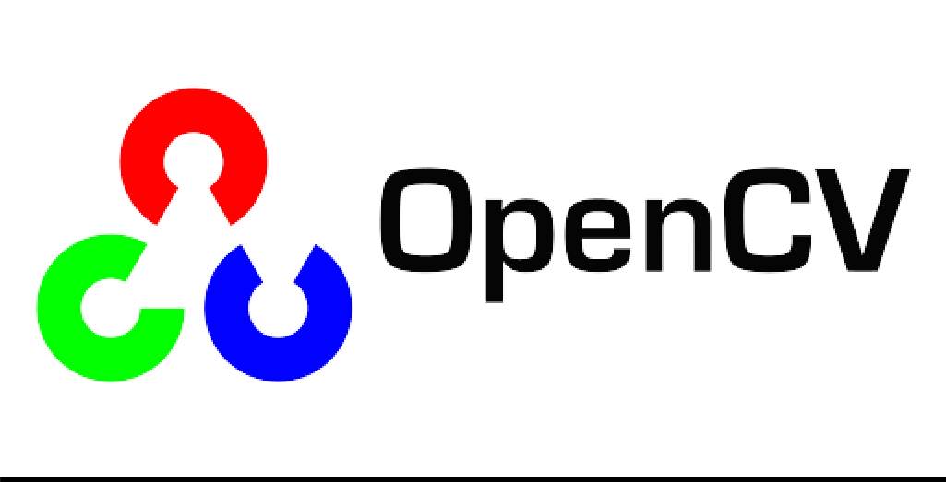

#### 3.1.3 Tensorflow

**TensorFlow** is a free and open-source software library for dataflow and differentiable programming across a range of tasks. It is a symbolic math library, and is also used for machine learning applications such as neural networks . Tensor Flow is capable of running on many CPUs and GPUs (with optional CUDA and SYCL extensions for general-purpose computing on graphics processing units). It enables developers to build machine learning software by using a variety of technologies, libraries, and community resources.

3.1.3.1 Application of TensorFlow

#### 1.Image Recognition

#### It’s one of the most popular Uses of TensorFlow. It is used by Mobile companies, social media, and other telecom houses. Image recognition consists of pixel and pattern matching to identify the image and its parts.

#### 2. Voice Recognition

TensorFlow has significant use in voice recognition systems like Telecom, Mobile companies, security systems, search engines, etc. It uses the voice recognition systems for giving commands, performing operations and giving inputs without using keyboards, mouse.

It is done using Automatic speech recognition which is trained using TensorFlow. These systems convert the human voice into text or computer understandable code by digitizing it.

#### 3.Video Detection

#### With increased technology, companies and businesses look forward to more secure and optimized systems. Hence, the motion detection is used widely at airport security checks, gaming controls, and movement detection.

#### 4 . Text-based applications

The text messages, reactions, comments, tweets, stock results etc are a means of data. This processing of data is done using TensorFlow for the analysis purpose and reaching the expected sales.

We do it using different techniques like sentiment analysis, a bag of words and many more. This can help to find out the risk associated with any organization by decoding the words used in texts.

#### 



#### 3.1.4 Keras

**Keras** is an API designed for human beings, not machines. Keras follows:

best practices for reducing cognitive load: it offers consistent & simple APIs, it minimizes the number of user actions required for common use cases, and it provides clear & actionable error messages. It also has extensive documentation and developer guides. Keras includes various implementations of widely used neural-network building blocks such as layers, objectives, activation functions, optimizers, and a host of tools to make dealing with image and text data simpler.

3.1.4.1 Application of Keras

Keras applications module is used to provide pre-trained model for deep neural networks. Keras models are used for prediction, feature extraction and fine tuning. This chapter explains about Keras applications in detail.

Keras productize the deep models on smartphones. Deep models require a lot of computation power to run, but with the help of Keras, we can make deep models a product that can be executed on smartphones.

Keras is used in the distributed training of deep learning models. Distributed training means that we can split our deep learning model into different parts and train it on systems all across the globe. This makes training of a deep learning model extremely fast. Along with saving time, we are also saving on the computational power of a system as it is not only our system that has to run such a heavy program. By distributing it across various systems, all the resources required to train a deep learning model go down significantly.

### Pre-trained models

Trained model consists of two parts model Architecture and model Weights. Model weights are large file so we have to download and extract the feature from ImageNet database. Some of the popular pre-trained models are listed below,

* ResNet
* VGG16
* MobileNet
* InceptionResNetV2
* InceptionV3



#### 

#### 3.1.5 Jupyter notebook

The **Jupyter Notebook** is a server-client application that allows editing and running notebook documents via a web browser . The Jupyter Notebook app can be executed on a local desktop requiring no internet access or can be installed on a remote server and accessed through the internet.

3.1.5.1 Applications of Jupyter Notebook

1. **Exploratory Data Analysis**

 Jupyter allows users to view the results of the code in-line without the dependency of other parts of the code. In the notebook, every cell of the code can be potentially checked at any time to draw an output.

1. **Language Independent**

Because of its representation in JSON format, Jupyter Notebook is platform-independent as well as language-independent.

1. **Data Visualisation**

 As a component, the shared notebook Jupyter supports visualisations and includes rendering some of the data sets like graphics and charts, which are generated from codes with the help of modules like Matplotlib, Plotly, or Bokeh.

1. **Live Interactions With Code**

Jupyter Notebook uses “ipywidgets” packages, which provide standard user interfaces for exploring code and data interactivity.

1. **Documenting code samples**

Jupyter makes it easy for users to explain their codes line-by-line with feedback attached all along the way.



# Chapter 4

# Proposed Methodology

The project Face mask detection has been achieved by adopting Deep Learning technique and MobileNetV2 Architecture. We have designed our project into three phases:

* 1. Data Preprocessing
     1. Training face mask detector
     2. Implementing face mask detector.

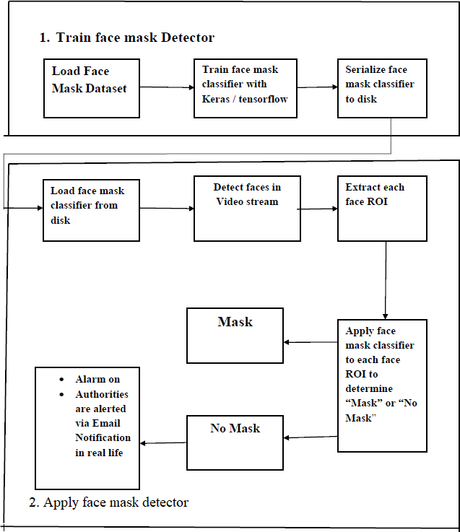

**Figure 3**: Decision flow chart of the proposed approach

First, we used a suitable algorithm to train the mask and non-mask images. After the model has been conditioned, pass on to the loading mask detector, which can detect and identify each face.

* 1. **Data Preprocessing**

Data preprocessing is a method for converting unclean data into a clean dataset. Data preprocessing entails converting data from available format to another format that is more user-friendly, desirable, and meaningful.

In the data preprocessing part, we converted all the images from the folders “with mask” and “without mask” into arrays so that with those array we created deep learning model .

1. Looping over the image path (With mask and without mask folder).

2. Resizing the input images uniformly to (224 x 224).

3. All the photographs in dataset is visualized as “with mask” and “without mask”. Initialized data and labels, labels are in alphabetical order so by using label binarizer to covert the data to numeric numbers(0,1).

4. Converting all images into array by using img_to_array function. This img_to_array function comes under keras.preprocessing.image module.

5. Appending the pre-processed input image . Finally Converting them into NumPy array.

6. Splitting the training and testing data.

## 4.2 Training of Model

Building the Model using MobileNetV2 Architecture :

After the input image is processed as an array we send the data into the MobilenetV2 and than we do max pooling on the same data and then flatten it to create fully connected layer which gives the output.

MobilenetV2 is faster than Convolution Neural Network. MobilenetV2 also uses less parameter. The weights of each layer in the model are predefined based on the Image Net dataset. The padding, strides, kernel height, input channels, and output channels are all represented by weights. MobileNetV2 was selected as the algorithm for creating a device- deployable model. On top of the MobileNetV2 model, a customized fully connected layer with four sequential layers was created. The layers are 1. Average Pooling layer with 7,7 weights 2. Linear layer with ReLu activation function 3. Dropout Layer 4.The final layer softmax function gives the result of two probabilities each one represents the classification of “Mask” or “No Mask”.Image data generator creates many images with the help of single image by changing properties of that image which later used for layer training, we use Adam optimizer to optimize the result. The image data generated before is flown to train the existing training data. Later we predict the output by evaluating the network using Numpy array.

I’ve specified three hyper parameter constants which include my initial learning rate to 1e-4, number of training epochs to 20, and batch size to 32 , These data are taken at such lower rate to get better accuracy.

We optimized MobileNetV2 on with mask/No mask dataset and attained a classifier that is 99% accurate.

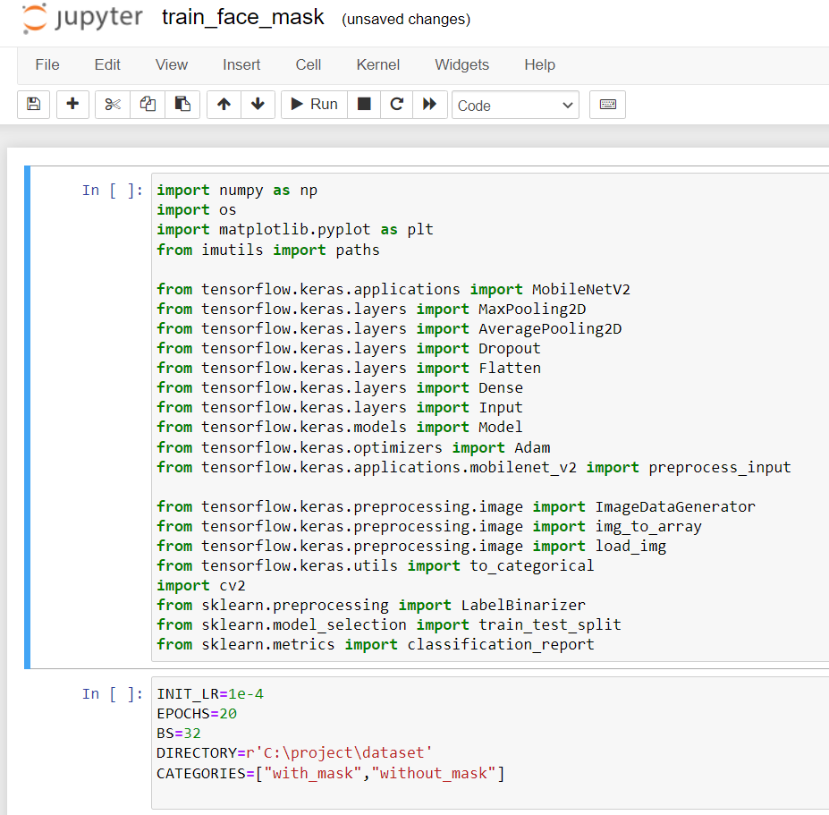

**Fig 4 :** Snippet of face mask detector training code

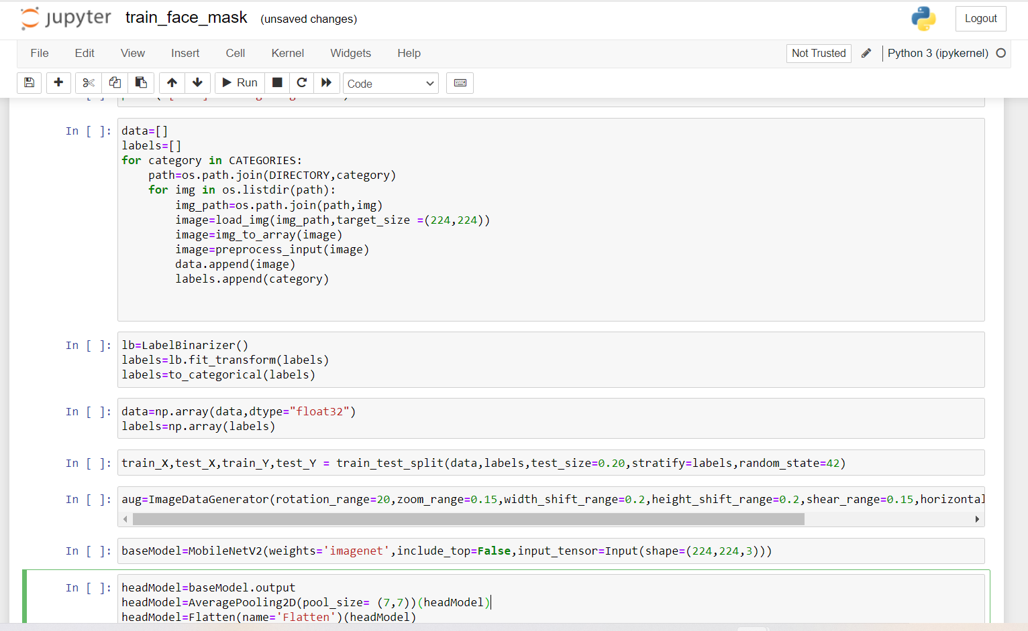

Figure 5: Snippet of data preprocessing code

## 4.3 Implementing face mask detector

1. Load face mask trained model and caffe model to detect faces in video

2. To identify the fcee/faces using openCv by collecting real time data through webcam.

3. Now the real time data (frame/sec) we collected from the webcam to classify it using trained model to predict the output of the given real time input .

4. As a output we get frame in which if a person wearing mask it shows “Mask” with a rectangle of green color on his/her face and if a person is not wearing Mask it shows “No Mask” with a rectangle of red color on his/her face particularly.

5. If in case a particular person is not wearing mask so system automatically generates Email to notify administrator and also rings alarm system to prevent carelessness of not wearing mask.

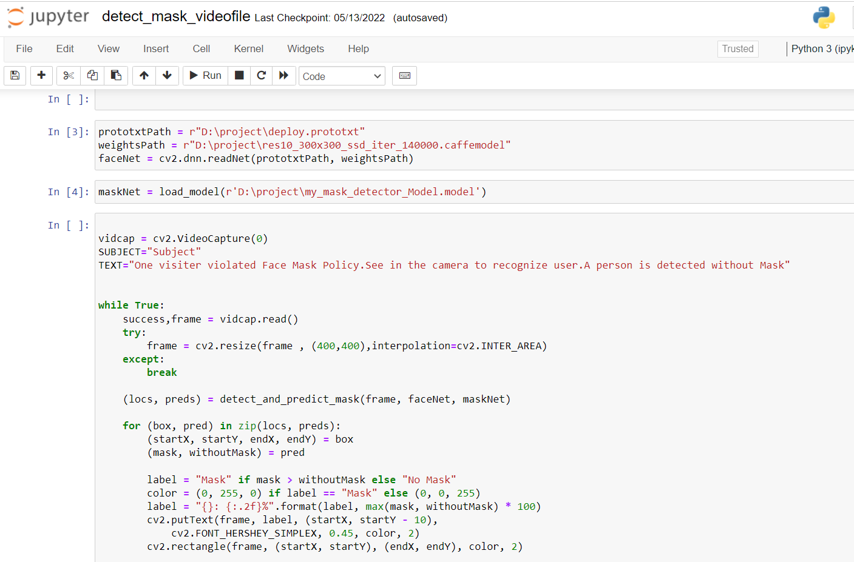

**Figure 6**: Snippet of Face mask detector Testing code

## 

## 4.4 Hardware and Software Used

* + 1. **Hardware Used**
* i5 9th or 10th Generation
* RAM minimum 8GB
* 64-bit Operating System
  + 1. **Software Used**
* Open CV
* Tensor Flow
* Keras
* Jupyter Notebook

**Chapter 5**

**Result and Conclusion**

* 1. **Result**

After successfully training, implementing and testing the code following output was obtained. The accuracy and iteration curves were plotted. Figure4 depicts the training loss and accuracy plot. The method attains 99% accuracy (shown in fig 7 ). Screenshots of the outputs have been displayed ahead. Figure 10 depicts that when a person I s wearing facemask the system indicates that particular person is wearing the facemask. Figure 11 depicts that when a person is not wearing facemask the system indicates that particular person is not wearing the facemask and tells that person to kindly wear the facemask. Successfully implemented alarm system in case of particular person not wearing mask so system automatically generates Email to notify administrator and also rings alarm system to prevent carelessness of not wearing mask.

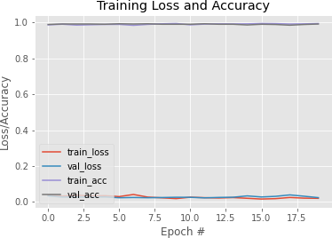

**Figure 7** : epochs # vs accuracy and loss

corresponding to dataset

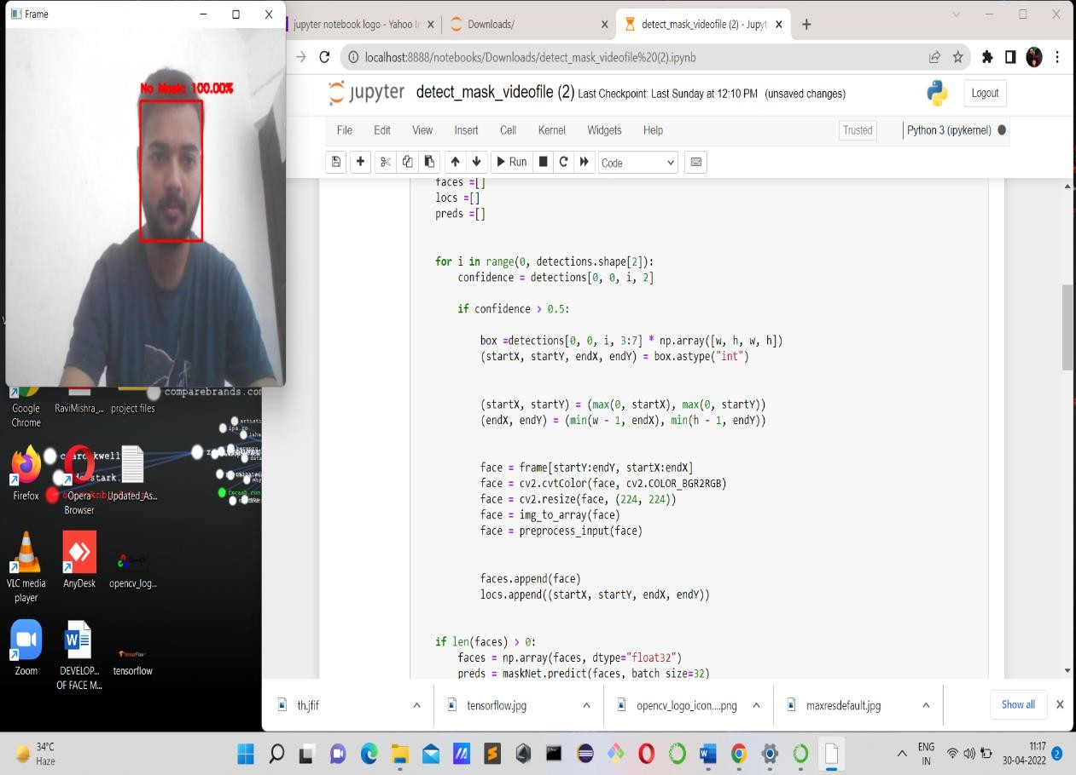

**Figure 8:** Analyzing the results of test photograph with a probability of 100% revealed that Mask was not worn

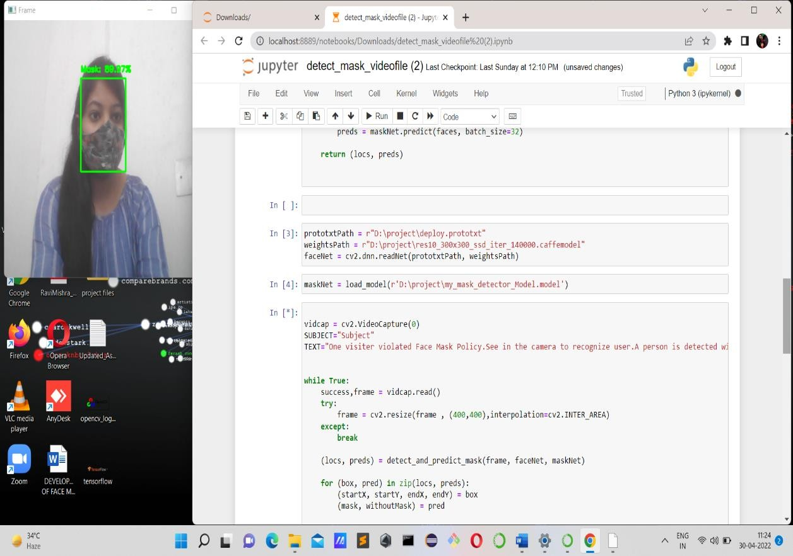

**Figure 9:** Analyzing the results of test photograph with a probability of 90% revealed that Mask was worn

## 

## Figure 10: Analyzing the results of test photograph with a probability of 100% when more than two faces are present.

## 5.2 Conclusion

This report represents a deep learning model to detect if a person is wearing a face mask or not. We adopted OpenCV, keras, tensor flow, and mobilenetV2 to specify whether people were wearing face masks or not. The model is tested with photographs and real time video s treams. The accuracy rate of detecting a person with a mask is 99% . This model was built using MobileNetV2 architecture. Successfully built alarm system to alert a person who didn’t wear mask and implemented Email notification system to notify respected authorities.

This system can prevent spread of covid-19. This framework may be used as an example of edge analytics. This system could be implemented at Cement Industries, Chemical Plants, Hospitals where chance of spread of disease, and at airport to detect travelers without masks.

**5.3 Future Works**

In future I thought to add up some extension to this project

* 1. To count the number of objects who aren't wearing mask and notify them using email to the observer
  2. To increase the accuracy and quality so that the current model can work with high definition camera which is established there on the traffic signals and nearby to the road to observe traffic.

**APPENDIX**

**Plagiarism Check**

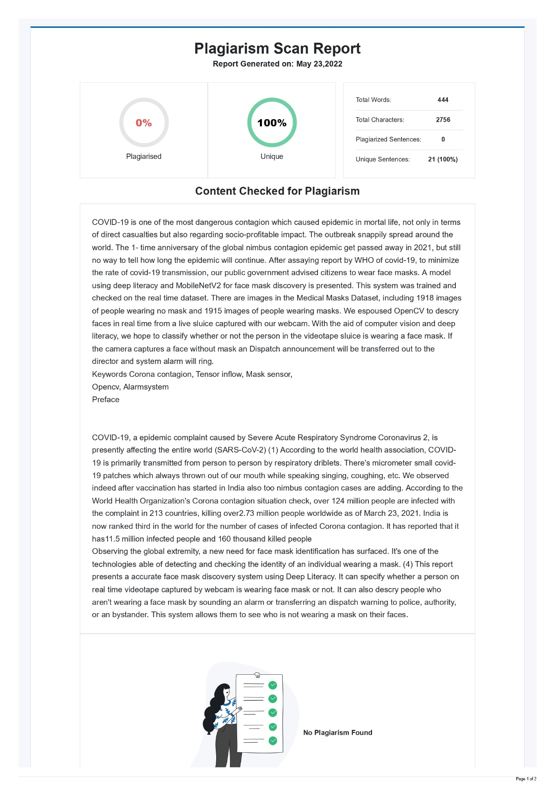

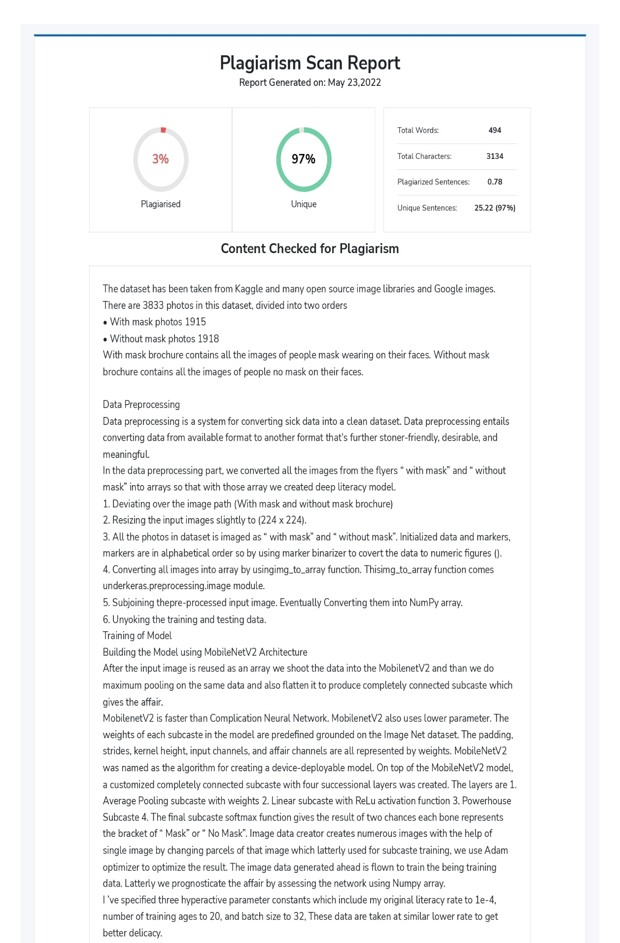

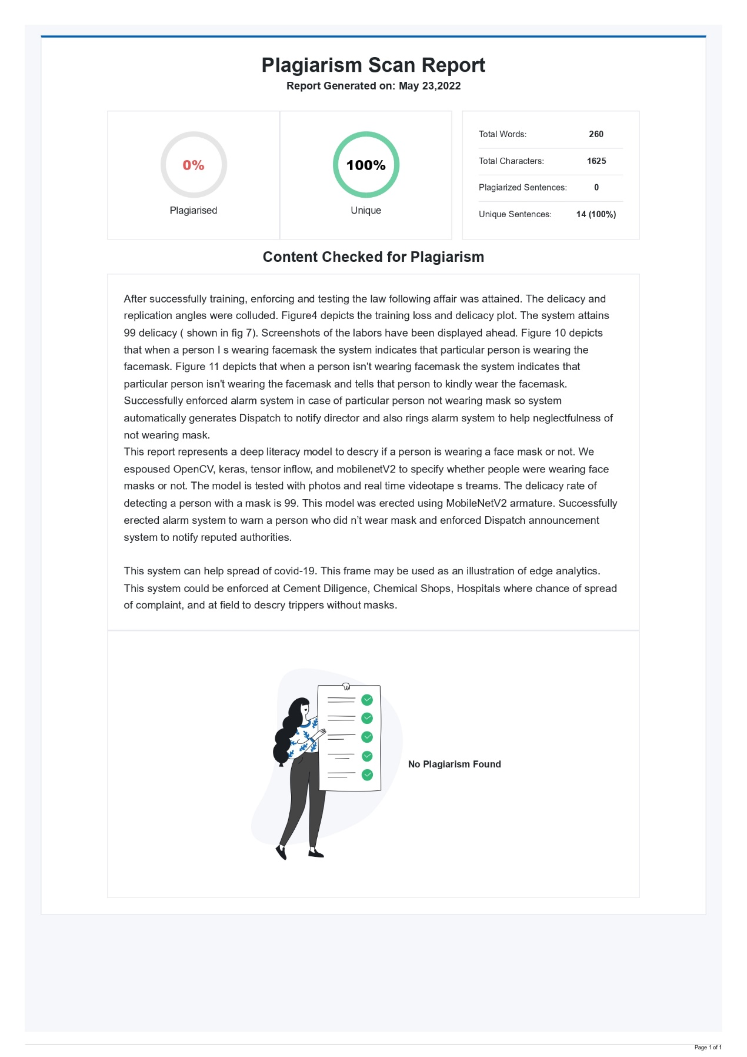

**References**

[1] M. S. Oberste ,P. A. Rota, S. S. Monroe, W. A. Nix, R. Campagnoli, S. Penaranda, B. Bankamp, J. P. Icenogle,K. Maher, M.-h. Chenet al., “Characterization of a novel coronavirus associated with severe acute respiratorysyndrome,”science, vol. 300 , no. 5624, pp. 1394–1399, 2003

[2] Arjya Das, Mohammad Wasif Ansari, Rohini Basak, “Covid-19 Face Mask Detection Using Tensorflow, Keras and OpenCV”,2020

[3] Sammy V. Militante, Nanette V. Dionisio ,“Deep Learning Implementation of Facemask and Physical Distancing Detection with Alarm Systems” , 2020

[4] Bosheng Qin, Dongxiao Li, “Identifying Facemask- Wearing Condition Using Image Super –Resolution with Classification Network to prevent COVID -19”, sensors, 2020,20,5236

[5] Vinitha.V1, Velantina.V2, “ COVID-19 FACEMASK DETECTION WITH DEEP

LEARNING AND COMPUTER VISION”, Vol . 07, 2020.

[6] Kinjal Goswami , A.M Sowjanya, “ DETECTION FACE MASK THROUGH MACHINE Learning” , Vol.02

,2020.

[7] Karim Hammoudi, Adnane Cabani, Halim Benhabiles and Mahmoud Melkemi, “Validating the Correct Wearing of Protection Mask by Taking a Selfie: Design of a Mobile Application “ CheckYourMask” to Limit the Spread of COVID-19”, 2020.

[8] Madhura Inamdar Ninad Mehandale, “Real-time face mask identification using FaceMasknet deep Learning network”