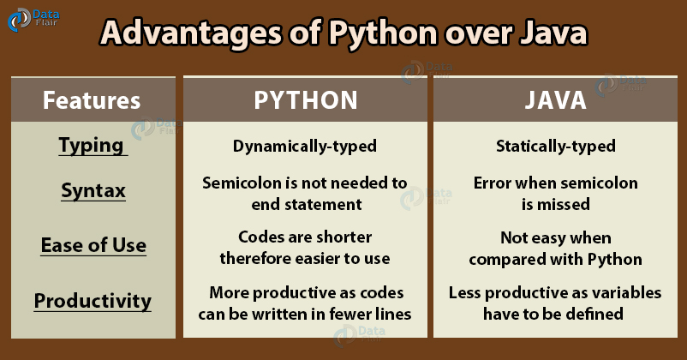

Advantages of Python over Java
Python Introduction
It can model real-world entities being an object-oriented programming language. It is also dynamically typed, carrying out type-checking at run-time. Different from Java, Python is an interpreted language that executes one line at a time in the Python Integrated Development Environment (IDLE)
Java is class-based and object-oriented. It follows the principle of “write once, run anywhere” (WORA) and is platform-independent. We can say that it is free to access and can run it on all platforms.

Web Development
Backend development can be covered by both languages. It is extremely hard to cover all the designing requirements from scratch and to also take care of reliability and effectiveness. To cover all these prospects, developers use frameworks that can do the same. The most popular ones are Django and Flask (Python). Basic functionalities like routing requests can be done with Flask, a micro-web framework. For more features, Django is used. It adds efficiency and security to the backend. It is equipped with a powerful ORM layer that eases the performance of operations on the data. As far as Java is concerned, Spring is a well-known Java backend framework but it is not as trending as Django nowadays. It is a more powerful option for building an enterprise-level application.

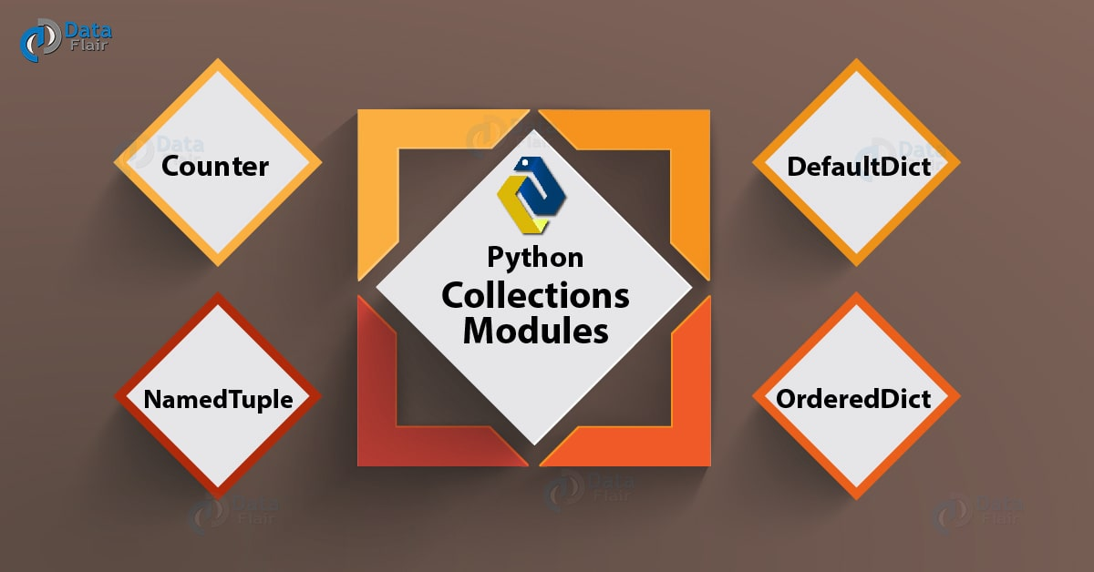

When it comes to speed, Java is the winner. Since Python is interpreted, we expect them to run slower than their counterparts in Java. They are also slower because the types are assumed at run time. This is extra work for the interpreter at runtime. The interpreter follows REPL (Read Evaluate Print Loop). Also, the IDLE has built-in syntax highlighting, and to get the previous and next commands, we press Alt+p and Alt+n respectively.

Besides differences, there are some similarities between Python and Java:
- In both languages, almost everything is an object
- Both offer cross-platform support
- Strings are immutable in both- Python and Java
- Both ship with large, powerful standard libraries
- Both are compiled to bytecode that runs on virtual machines

