https://towardsdatascience.com/getting-started-with-pypy-ef4ba5cb431c
CPython is not the fastest. PyPy is an alternate Python implementation that is both compliant and fast. PyPy depends on just-in-time (JIT) compilation that dramatically reduces the execution time for long-running operations.
In this tutorial, PyPy will be introduced for beginners to highlight how it is different from CPython.
PyPy supports hundreds of Python libraries, including NumPy.

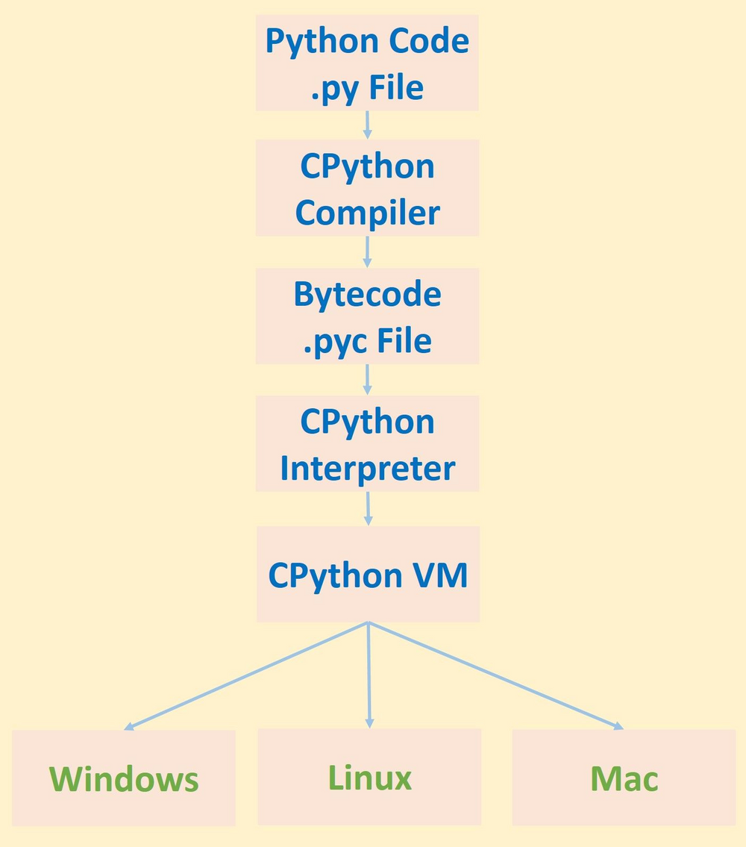
Above you can see a visualization of the execution pipeline of a Python script implemented using CPython.
Given a Python .py script, the source code is first compiled using the CPython compiler into bytecode. The bytecode is generated and saved in a file with a .pyc extension. The bytecode is then executed using the CPython interpreter within a virtual environment.
There are benefits to using the compiler to convert the source code into bytecode. If no compiler is used, then the interpreter will work directly on the source code by translating it line by line into machine code. The disadvantage of doing this is that some processes have to be applied for translating each line of source code into machine code, and such processes will be repeated for each line. For example, syntax analysis will be applied to each line independently from the other lines, and thus the interpreter takes a lot of time to translate the code. The compiler solves this issue as it is able to process all of the code at once, and thus syntax analysis will be applied only once rather than to each line of code. The generated bytecode from the compiler will thus be interpreted easily. Note that compiling the entire source code might not be helpful in some cases, and we’ll see a clear example of this when discussing PyPy.
After the bytecode is generated, it is executed by the interpreter running in the virtual machine. The virtual environment is beneficial, as it isolates the CPython bytecode from the machine, and thus makes Python cross-platform.
Unfortunately, just using a compiler to generate the bytecode is not enough to speed up the execution of CPython. The interpreter works by translating the code, each time it is executed, into machine code. Thus, if a line L takes X seconds to be executed, then executing it 10 times will have a cost of X*10 seconds. For long-running operations, this is too costly in its execution time.
Based on the drawbacks of CPython, let’s now take a look at PyPy.

Introduction to PyPy and its Features
PyPy is a Python implementation similar to CPython that is both compliant and fast. “Compliant” means that PyPy is compatible with CPython, as you can use nearly all CPython syntax in PyPy. There are some compatibility differences, as mentioned here. The most powerful advantage of PyPy is its speed. PyPy is much faster than CPython; we’ll see tests later on where PyPy performs about 7 times faster. In some cases it might even be tens or hundreds of times faster than CPython. So how does PyPy achieve its speed?

Speed
PyPy uses a just-in-time (JIT) compiler that is able to dramatically increase the speed of Python scripts.
The type of compilation used in CPython is ahead-of-time (AOT),meaning that all of the code will be translated into bytecode before being executed. JIT just translates the code at runtime, only when it is needed.
The source code might contain code blocks that are not executed at all, but which are still being translated using the AOT compiler. This leads to slower processing times. When the source code is large and contains thousands of lines, using a JIT makes a big difference. For AOT, the entire source code will be translated and thus take a lot of time. For JIT, just the needed parts of the code will be executed, making it a lot faster.
After PyPy translates a part of the code, it then gets cached. This means the code is translated only once, and then the translation is used later. The CPython interpreter repeats the translation each time the code is executed, an additional cause for its slowness.

Stackless
Standard Python uses the C stack. This stack stores the sequence of functions that are called from each other (recursion). Because the stack size is limited, you are limited in the number of function calls.
PyPy uses Stackless Python, a Python implementation that does not use the C stack. Instead, it stores the function calls in the heap alongside the objects. The heap size is greater than the stack size, and thus you can do more function calls.
Stackless Python also supports microthreads, which are better than regular Python threads. Within the single Stackless Python thread you can run thousands of tasks, called “tasklets,” with all of them running on the same thread.
Using tasklets allows running concurrent tasks. Concurrency means that two tasks work simultaneously by sharing the same resources. One task runs for some time, then stops to make room for the second task to be executed. Note that this is different from parallelism, which involves running the two tasks separately but at the same time.
Using tasklets reduces the number of threads created, and thus reduces the overhead of managing all these threads by the OS. As a result, speeding up the execution by swapping between two threads is more time-intensive than swapping between two tasklets.

